SUPPLEMENTAL DATA (APPENDICES 1–4)

APPENDIX 1

THE BIBLIOGRAPHY OF WILLIAM G. CHALONER FRS (1928–2016)

The following list is a compilation of the 176 substantive scientific publications authored or co-authored by Bill Chaloner arranged in chronological order. This listing excludes abstracts, book reviews, discussions, newsletter articles and secondary translations of the International Code of Botanical Nomenclature. These 176 items were issued between 1951 and 2016; hence this body of work represents a highly productive research career spanning a remarkable 66 years.

- Chaloner, W.G. 1951. On Spencerisporites, gen. nov., and S. karczewskii (Zerndt), the isolated spores of Spencerites insignis Scott. Annals and Magazine of Natural History Series 12, 4: 861–873.

- Chaloner, W.G. 1952. On Lepidocarpon waltoni, sp. n., from the Lower Carboniferous of Scotland. Annals and Magazine of Natural History Series 12, 5: 572–582.

- Chaloner, W.G. 1953. A new species of Lepidostrobus containing unusual spores. Geological Magazine, 90: 97–110.

- Chaloner, W.G. 1953. On the megaspores of four species of Lepidostrobus. Annals of Botany, 17: 263–294.

- Chaloner, W.G. 1953. On the megaspores of Sigillaria. Annals and Magazine of Natural History Series 12, 6: 881–897.

- Chaloner, W.G. 1954. Mississippian megaspores from Michigan and adjacent states. Contributions from the Museum of Paleontology University of Michigan, 12: 23–25.

- Chaloner, W.G. 1954. Notes on the spores of two British Carboniferous lycopods. Annals and Magazine of Natural History Series 12, 7: 81–91.

- Chaloner, W.G. 1956. On Sporangiostrobus langfordi sp. nov., a new fossil lycopod cone from Illinois. American Midland Naturalist, 55: 437–442.

- Chaloner, W.G. 1956. Triletes palaeocristatus Chaloner, new name. Micropaleontology, 2: 298.

- Chaloner, W.G. 1957. Palaeozoic fossil spores and pollens. Science Progress, 45: 518–525.

- Chaloner, W.G. 1958. A Carboniferous Selaginellites with Densosporites microspores. Palaeontology, 1: 245–253.

- Chaloner, W.G. 1958. Dr Marie Stopes (obituary). Proceedings of the Geologists’ Association, 70: 118–120.

- Chaloner, W.G. 1958. Isolated megaspore tetrads of Stauropteris burntislandica. Annals of Botany, 22: 197–204.

- Chaloner, W.G. 1958. Polysporia mirabilis Newberry, a fossil lycopod cone. Journal of Paleontology, 32: 199–209.

- Chaloner, W.G. 1958. The Carboniferous upland flora. Geological Magazine, 95: 261–262.

- Chaloner, W.G. 1959. Continental Drift. In: Johnson, M.L., Abercrombie, M. and Fogg, G.E. (editors). New Biology, 29: 7–30. Penguin Books, Harmondsworth, Middlesex, UK.

- Chaloner, W.G. 1959. Devonian megaspores from Arctic Canada. Palaeontology, 1: 321–332.

- Chaloner, W.G. 1960. The origin of vascular plants. Science Progress, 48: 524–354.

- Chaloner, W.G. and Lorch, J. 1960. An opposite-leaved conifer from the Jurassic of Israel. Palaeontology, 2: 236–242.

- Chaloner, W.G. 1961. Palaeo-ecological data from Carboniferous spores. In: Recent Advances in Botany. University of Toronto Press, Toronto, 980–983.

- Chaloner, W.G. 1962. A Sporangiostrobus with Densosporites microspores. Palaeontology, 5: 73–85.

- Chaloner, W.G. 1962. Rhaeto-Liassic plants from the Henfield Borehole. Bulletin of the Geological Survey of Great Britain, 19: 16–28.

- Chaloner, W.G. and Clarke, R.F.A. 1962. A new British Permian spore. Palaeontology, 4: 648–652.

- Chaloner, W.G. 1963. Early Devonian spores from a borehole in southern England. Grana Palynologica, 4: 100–110.

- Chaloner, W.G. and Pettitt, J.M. 1963. A Devonian seed megaspore. Nature, 198: 808–809.

- Chaloner, W.G. and Pettitt, J.M. 1964. A seed megaspore from the Devonian of Canada. Palaeontology, 7: 29–36.

- Pettitt, J.M. and Chaloner, W.G. 1964. The ultrastructure of the Mesozoic pollen Classopollis. Pollen et Spores, 6: 611–620.

- Chaloner, W.G. 1966. The Megaspore Flora. In: Wilson, H.B. and Robbie, J.A. (editors). Geology of the Country around Ballycastle (one-inch Geological Sheet 8). Memoirs of the Geological Survey, Her Majesty’s Stationery Office, Belfast, 78–81.

- Chaloner, W.G. and Streel, M. 1966. Lower Devonian spores from South Wales. Argumenta Palaeobotanica, 1: 87–101.

- Chaloner, W.G. 1967. Class Lycopsida. In: Banks, H.P., Chaloner, W.G. and Lacey, W.S. Chapter 4. Pteridophyta–1. In: Harland, W.B., Holland, C.H., House, M.R., Hughes, N.F., Reynolds, A.B., Rudwick, M.J.S., Satterthwaite, G.E., Tarlo, L.B.H. and Willey, E.C. (editors). The Fossil Record. Geological Society of London, 220–224.

- Chaloner, W.G. 1967. Lycophyta. In: Boureau, E., Jovet-Ast, S., Høeg, O.A. and Chaloner, W.G. (editors). Traité de Paléobotanique. Tome II, Bryophyta, Psilophyta, Lycophyta. Masson et Cie, Paris, 435–802.

- Chaloner, W.G. 1967. Spores and land-plant evolution. Review of Palaeobotany and Palynology, 1: 83–93.

- Mortimer, M.G. and Chaloner, W.G. 1967. Devonian megaspores from the Wyboston Borehole, Bedfordshire, England. Palaeontology, 10: 189–213.

- Boureau, E., Jovet-Ast, S., Høeg, O.A. and Chaloner, W.G. (editors). 1967. Traité de Paléobotanique. Tome II, Bryophyta, Psilophyta, Lycophyta. Masson et Cie, Paris, 845 p.

- Chaloner, W.G. 1968. British pre-Quaternary palynology: A historical review. Review of Palaeobotany and Palynology, 6: 21–40.

- Chaloner, W.G. 1968. The cone of Cyclostigma kiltorkense Haughton, from the Upper Devonian of Ireland. The Journal of the Linnean Society of London (Botany), 61: 25–36.

- Chaloner, W.G. 1968. The paleoecology of fossil spores. In: Drake, E.T. (editor). Evolution and Environment. Yale University Press, New Haven, 125–138.

- Chaloner, W.G. and Muir, M. 1968. 7. Spores and floras. In: Murchison, D.S. and Westoll, T.S. (editors). Coal and coal-bearing strata. Oliver and Boyd, Edinburgh, 127–146.

- Alvin, K.L., Barnard, P.D.W. and Chaloner, W.G. (editors). 1968. Studies on fossil plants. The Journal of the Linnean Society of London (Botany), 61, 226 p. Academic Press, London.

- Chaloner, W.G. 1969. 14. Triassic spores and pollen. In: Tschudy, R.H. and Scott, R.A. (editors). Aspects of Palynology. An Introduction to Plant Microfossils in Time. Wiley-Interscience, New York, 291–309.

- Chaloner, W.G. and Allen, K. 1969. Palaeobotany and phytochemical phylogeny. In: Harborne, J.B. (editor). Phytochemical Phylogeny. Academic Press, 21–30.

- Chaloner, W.G. 1970. The evolution of miospore polarity. Geoscience and Man, 1: 47–57.

- Chaloner, W.G. 1970. The rise of the first land plants. Biological Reviews, 45: 353–377.

- Alvin, K. and Chaloner, W.G. 1970. Parallel evolution in leaf venation: an alternative view of angiosperm origins. Nature, 226: 662–663.

- Boulter, M.C. and Chaloner, W.G. 1970. Neogene fossil plants from Derbyshire (England). Review of Palaeobotany and Palynology, 10: 61–78.

- Mortimer, M.G., Chaloner, W.G. and Llewellyn, P.G. 1970. Lower Carboniferous (Tournaisian) miospores and megaspores from Breedon Cloud Quarry, Leicestershire. Mercian Geologist, 3: 375–385.

- Chaloner, W.G. and Orbell, G. 1971. A palaeobiological definition of sporopollenin. In: Brooks, J., Grant, P.R., Muir, M., van Gijzel, P. and Shaw, G. (editors). Sporopollenin. Academic Press, London, 273–294.

- Mensah, M.K. and Chaloner, W.G. 1971. Lower Carboniferous lycopods from Ghana. Palaeontology, 14: 357–369.

- Chaloner, W.G. 1972. Devonian plants from Fair Isle, Scotland. Review of Palaeobotany and Palynology, 14: 49–61.

- Mortimer, M.G. and Chaloner, W.G. 1972. The palynology of the concealed Devonian rocks of southern England. Bulletin of the Geological Survey of Great Britain, 39: 1–56.

- Chaloner, W.G. and Creber, G.T. 1973. Growth rings in fossil woods as evidence of past climates. In: Tarling, D.H. and Runcorn, S.K. (editors). Implications of continental drift to the earth sciences. Volume 1. Academic Press, London and New York, 425–437.

- Chaloner, W.G. and Gay, M.M. 1973. Scanning electron microscopy of latex casts of fossil plant impressions. Palaeontology, 16: 645–649.

- Chaloner, W.G. and Lacey, W.S. 1973. The distribution of Late Palaeozoic floras. In: Hughes, N.F. (editor). Organisms and continents through time. Special Papers in Palaeontology, 12: 271–289.

- Chaloner, W.G. and Meyen, S.V. 1973. Carboniferous and Permian floras of the northern continents. In: Hallam, A. (editor). Atlas of Palaeobiogeography. Elsevier, 169–186.

- Chaloner, W.G., Mensah, M.K. and Crane, M.D. 1974. Non-vascular land plants from the Devonian of Ghana. Palaeontology, 17: 925–947.

- Chaloner, W.G. and Collinson, M.E. 1975. An illustrated key to the commoner British Upper Carboniferous plant compression fossils. Proceedings of the Geologists’ Association, 86: 1–44.

- Chaloner, W.G. and Collinson, M.E. 1975. Application of SEM to a sigillarian impression fossil. Review of Palaeobotany and Palynology, 20: 85–101.

- Kevan, P.G., Chaloner, W.G. and Savile, D.B.O. 1975. Interrelationships of early terrestrial arthropods and plants. Palaeontology, 18, 391–417.

- Chaloner, W.G. 1976. The evolution of adaptive features in fossil exines. In: Ferguson, I.K. and Muller, J. (editors). The evolutionary significance of the exine. Linnean Society Symposium Series, 1: 1–14.

- Niklas, K.J. and Chaloner, W.G. 1976. Chemotaxonomy of some problematic Palaeozoic plants. Review of Palaeobotany and Palynology, 22: 81–104.

- Niklas, K.J. and Chaloner, W.G. 1976. Simulations of the ontogeny of Spongiophyton, a Devonian plant. Annals of Botany, 40: 1–11.

- Chaloner, W.G. and Richardson, J.B. 1977. South-east England. In: House, M.R. (convenor and editor), Richardson, J.B., Chaloner, W.G., Allen, J.R.L., Holland, C.H. and Westoll, T.S. A correlation of the Devonian rocks in the British Isles. Geological Society of London Special Report, 8: 26–40.

- Andrews, H.N., Kasper, A.E., Forbes, W.H., Gensel, P.G. and Chaloner, W.G. 1977. Early Devonian flora of the Trout Valley Formation of northern Maine. Review of Palaeobotany and Palynology, 23: 255–285.

- Chaloner, W.G., Hill, A.J. and Lacey, W.S. 1977. First Devonian platyspermic seed and its implications in gymnosperm evolution. Nature, 265: 233–235.

- House, M.R. (convenor and editor), Richardson, J.B., Chaloner, W.G., Allen, J.R.L., Holland, C.H. and Westoll, T.S. 1977. A correlation of the Devonian rocks in the British Isles. Geological Society of London, Special Report, 8, 110 p.

- Chaloner, W.G., Hill, A. and Rogerson, E.C.W. 1978. Early Devonian plant fossils from a southern England borehole. Palaeontology, 21: 693–707.

- Chaloner, W.G. and Sheerin, A. 1979. Devonian macrofloras. In: House, M.R., Scrutton, C.T. and Bassett, M.G. (editors). The Devonian System. Special Papers in Palaeontology, 23: 145–161.

- Pal, A.K. and Chaloner, W.G. 1979. A Lower Carboniferous Lepidodendropsis flora in Kashmir. Nature, 281: 295–297.

- Smith, P.H. and Chaloner, W.G. 1979. Is Piriurella Cookson & Eisenack an alga or a fungus? Neues Jahrbuch für Geologie und Paläontologie Monatshefte, 11: 701–704.

- Chaloner, W.G., Leistikow, K.U. and Hill, A. 1979. Brasilodendron gen. nov. and B. pedroanum (Carruthers) comb. nov., a Permian lycopod from Brazil. Review of Palaeobotany and Palynologv, 28: 117–136.

- Chaloner, W.G. and Macdonald, P. 1980. Plants invade the land. Her Majesty’s Stationery Office for the Royal Scottish Museum, Edinburgh, 16 p.

- Cope, M.J. and Chaloner, W.G. 1980. Fossil charcoal as evidence of past atmospheric composition. Nature, 283: 647–649.

- Chaloner, W.G., Forey, P.L., Gardiner, B.G., Hill, A.J. and Young, V.T. 1980. Devonian fish and plants from the Bokkeveld Series of South Africa. Annals of the South African Museum, 81: 127–157.

- El-Khayal, A.A., Chaloner, W.G. and Hill, C.R. 1980. Palaeozoic plants from Saudi Arabia. Nature, 285: 33–34.

- Chaloner, W.G. and Sheerin, A. 1981. The evolution of reproductive strategies in early land plants. In: Scudder, G.G.E. and Reveal, J.L. (editors). Evolution Today. Carnegie-Mellon University, Pittsburgh, 93–100.

- Cope, M.J. and Chaloner, W.G. 1981. Fossil charcoal and the palaeoatmosphere (reply). Nature, 290: 428.

- Chaloner, W.G. and Cope, M.J. 1982. Interaction of plant evolution, wildfire, atmospheric composition and climate. Third North American Paleontological Convention, Proceedings, 1: 83–85.

- Chaloner, W.G. and Meyer-Berthaud, B. 1983. Leaf and stem growth in the Lepidodendrales. The Botanical Journal of the Linnean Society of London, 86: 135–148.

- Rex, G.M. and Chaloner, W.G. 1983. The experimental formation of plant compression fossils. Palaeontology, 26: 231–252.

- Scott, A.C. and Chaloner, W.G. 1983. The earliest fossil conifer from the Westphalian B of Yorkshire. Proceedings of the Royal Society of London B, 220: 163–182.

- Voss, E.G., Burdet, H.-M., Chaloner, W.G., Demoulin, V., Hiepko, P., McNeill, J., Meikle, R.D., Nicholson, D.H., Rollins, R.C., Silva, P.C. and Greuter, W. (editors). 1983. International Code of Botanical Nomenclature (Sydney Code). Adopted by the Thirteenth International Botanical Congress, Sydney, Australia, August 1981. Regnum Vegetabile 111, 472 p. Bohn, Scheltema and Holkema, Utrecht, The Netherlands.

- Chaloner, W.G. 1984. Plants, animals and time (Thirteenth Birbal Sahni Memorial Lecture). The Palaeobotanist, 32: 197–202.

- Creber, G.T. and Chaloner, W.G. 1984. Climatic indications from growth rings in fossil woods. In: Brenchley, P.J. (editor). Fossils and climate. John Wiley, Chichester, 49–74.

- Creber, G.T. and Chaloner, W.G. 1984. Influence of environmental factors on the wood structure of living and fossil trees. The Botanical Review, 50: 357–448.

- Chaloner, W.G. 1985. Problems with permineralization of peat. Philosophical Transactions of the Royal Society of London B, 311: 139–141.

- Chaloner, W.G. 1985. Thomas Maxwell Harris. 8 January 1903 – 1 May 1983. Elected F.R.S. 1948. Biographical Memoirs of Fellows of the Royal Society, 31: 229–260.

- Chaloner, W.G. and Lawson, J.D. 1985. Introduction. In: Chaloner, W.G. and Lawson, J.D. (editors). Evolution and environment in the late Silurian and early Devonian. Philosophical Transactions of the Royal Society of London B, 309: 5–9.

- Chaloner, W.G. and Lawson, J.D. (editors). 1985. Evolution and environment in the late Silurian and early Devonian. Philosophical Transactions of the Royal Society of London B, 309, 342 p.

- Cope, M.J. and Chaloner, W.G. 1985. Wildfire, an interaction of biological and physical processes. In: Tiffney, B.H. (editor). Geological Factors and the Evolution of Plants. Yale University Press, Hartford, Connecticut, 257–278.

- Creber, G.T. and Chaloner, W.G. 1985. Tree growth in the Mesozoic and Early Tertiary and the reconstruction of palaeoclimates. Palaeogeography, Palaeoclimatology, Palaeoecology, 52: 35–60.

- Scott, A.C., Chaloner, W.G., and Paterson, S. 1985. Evidence of pteridophyte–arthropod interactions in the fossil record. Proceedings of the Royal Society of Edinburgh, 86B: 133–140.

- Chaloner, W.G. 1986. Electrostatic forces in insect pollination and their significance in exine ornament. In: Blackmore, S. and Ferguson, I.K. (editors). Pollen and Spores: Form and Function. Linnean Society Symposium Series, 12: 103–108. Academic Press, Orlando, Florida.

- Chaloner, W.G. 1986. Reassembling the whole fossil plant, and naming it. In: Spicer, R.A. and Thomas, B.A. (editors). Systematic and taxonomic approaches in palaeobotany. Systematics Association Special Volume, 31: 67–78. Oxford University Press, Oxford.

- Chaloner, W.G. 1986. The Lepidodendrid tree. Compte Rendu Colloque International de l'Arbre, September 1985. Naturalia Monspeliensia, 475–486.

- Chaloner, W.G. and Pettitt, J.M. 1987. The inevitable seed. Bulletin de la Société Botanique de France. Actualités Botaniques, 134: 39–49.

- Chaloner, W.G. and Turner, S. 1987. An enigmatic Triassic lycopod axis from Australia. Review of Palaeobotany and Palynology, 51: 51–58.

- Creber, G.T. and Chaloner, W.G. 1987. The contribution of growth-ring studies to the reconstruction of past climates. In: Ward, R.G.W. (editor). Applications of tree ring studies: current research in dendrochronology and related areas. British Archaeological Report, International Series, 333: 37–67.

- Friis, E.M., Chaloner, W.G., and Crane, P.R. 1987. Introduction to angiosperms. In: Friis, E.M., Chaloner, W.G. and Crane, P.R. (editors). The Origins of Angiosperms and Their Biological Consequences. Cambridge University Press, Cambridge, 1–15.

- Friis, E.M., Chaloner, W.G., and Crane, P.R. (editors). 1987. The Origins of Angiosperms and their Biological Consequences. Cambridge University Press, Cambridge, 358 p.

- Chaloner, W.G. 1988. Early land plants: the saga of a great conquest. In: Greuter, W. and Zimmer, B. (editors). Proceedings of the 14th International Botanical Congress, Berlin 1987, 301–316. Koeltz Scientific Books, Berlin.

- Chaloner, W.G. and Creber, G.T. 1988. Fossil plants as indicators of late Palaeozoic plate positions. In: Audley-Charles, M.G. and Hallam, A. (editors). Gondwana and Tethys. Geological Society Special Publication, 37: 201–210.

- Berry, S., Chaloner, W.G. and Hawkes, J. 1988. On the origins of a learned society. New Scientist, 117: 49–53.

- Greuter, W., Burdet, H.-M., Chaloner, W.G., Demoulin, V., Grolle, R., Hawksworth, D.L., Nicolson, D.H., Silva, P.C., Stafleu, F.A., Voss, E.G. and McNeill, J. (editors). 1988. International Code of Botanical Nomenclature (Berlin Code). Adopted by the Fourteenth International Botanical Congress, Berlin, Germany, July–August 1987. Regnum Vegetabile, 118, 328 p. Koeltz Scientific Books, Königstein, Germany.

- Chaloner, W.G. 1989. Fossil charcoal as an indicator of palaeoatmospheric oxygen level. Journal of the Geological Society, London, 146: 171–174.

- Chaloner, W.G. and Cocks, L.R.M. 1989. Biota and palaeoatmospheres. Journal of the Geological Society, London, 146: 145–146.

- Chaloner, W.G. and Creber, G.T. 1989. The phenomenon of forest growth in Antarctica: a review. In: Crame, J.A. (editor). Origins and Evolution of the Antarctic Biota. Geological Society Special Publication, 47: 85–88.

- Chaloner, W.G. and Hallam, A. (editors). 1989. Evolution and extinction. Philosophical Transactions of the Royal Society of London B, 325: 239–488.

- Chaloner, W.G. 1990. Global change: the past as a key to the future? Science in Public Affairs, 5: 3–10.

- Chaloner, W.G. and Creber, G.T. 1990. Do fossil plants give a climatic signal? Journal of the Geological Society, London, 147: 343–350.

- Chaloner, W.G. 1991. Global change and the biosphere: Introduction. Annals of Botany 67, Supplement 1: 1–3.

- Chaloner, W.G. and Hemsley, A.R. 1991. Heterospory: cul-de-sac or pathway to the seed? In: Blackmore, S. and Barnes, S.H. (editors). Pollen and spores: patterns of diversification. Systematics Association Special Volume, 44: 151–167. Oxford University Press, Oxford.

- Jones, T.P. and Chaloner, W.G. 1991. Fossil charcoal, its recognition and palaeoatmospheric significance. Palaeogeography, Palaeoclimatology, Palaeoecology (Global and Planetary Change Section), 97: 39–50.

- Jones, T.P. and Chaloner, W.G. 1991. Les feux du passé. Recherche, 236: 1148–1156.

- Jones, T.P. and Chaloner, W.G. 1991. Los incendios forestales del pasado. Mundo Científico, 11: 1160–1168.

- Beerling, D.J., Chaloner, W.G., Huntley, B., Pearson, A. and Tooley, M.J. 1991. Tracking stomatal densities through a glacial cycle: their significance for predicting the response of plants to changing CO₂ concentrations. Global Ecology and Biogeography Letters, 1: 136–142.

- Boulter, M.C., Chaloner, W.G. and Holmes, P.L. 1991. The IOP fossil record: are fossil plants a special case? In: Hawksworth, D.L. (editor). Improving the stability of names: needs and options. Regnum Vegetabile, 123: 231–242. Koeltz Scientific Books, Königstein, Germany.

- Chaloner, W.G., Friis, E.M. and Hemsley, A.R. 1991. Cycadocephalus Nathorst, a fern not a bennettite. Neues Jahrbuch für Geologie und Paläontologie Abhandlungen, 183: 347–362.

- Chaloner, W.G., Scott, A.C. and Stephenson, J. 1991. Fossil evidence for plant-arthropod interactions in the Palaeozoic and Mesozoic. Philosophical Transactions of the Royal Society of London B, 333: 177–186.

- Gensel, P.G., Chaloner, W.G. and Forbes, W.H. 1991. Spongiophyton from the late Lower Devonian of New Brunswick and Quebec, Canada. Palaeontology, 34: 149–168.

- Beerling, D.J. and Chaloner, W.G. 1992. Stomatal density as an indicator of atmospheric CO₂ concentration. The Holocene, 2: 71–78.

- Chaloner, W.G. and Hemsley, A.R. 1992. A permineralized cycad seed from the Middle Jurassic of the Queen Charlotte Islands, British Columbia, Canada. Courier Forschungsinstitut Senckenberg, 147: 233–239.

- Beerling, D.J., Chaloner, W.G., Huntley, B., Pearson, J.A., Tooley, M.J. and Woodward, F.I. 1992. Variations in the stomatal density of Salix herbacea L. under the changing atmospheric CO₂, concentrations of late- and post-glacial time. Philosophical Transactions of the Royal Society of London B, 336: 215–224.

- Hemsley, A.R., Chaloner, W.G., Scott, A.C. and Groombridge, C.J. 1992. Carbon-13 solid-state nuclear magnetic resonance of sporopollenins from modern and fossil plants. Annals of Botany, 69: 545–549.

- Scott, A.C., Stephenson, J. and Chaloner, W.G. 1992. Interaction and coevolution of plants and arthropods during the Palaeozoic and Mesozoic. Philosophical Transactions of the Royal Society of London B, 335: 129–165.

- Beerling, D.J. and Chaloner, W.G. 1993. Evolutionary responses of stomatal density to global CO₂ change. The Biological Journal of the Linnean Society of London, 48: 343–353.

- Beerling, D.J. and Chaloner, W.G. 1993. Stomatal density responses of Egyptian Olea europaea L. leaves to CO₂ change since 1327 BC. Annals of Botany, 71: 431–435.

- Beerling, D.J. and Chaloner, W.G. 1993. The impact of atmospheric CO₂ and temperature change on stomatal density: observations from Quercus robur Lammas leaves. Annals of Botany, 71: 231–235.

- Beerling, D.J., Chaloner, W.G., Huntley, B., Pearson, J.A. and Tooley, M.J. 1993. Stomatal density responds to the glacial cycle of environmental change. Proceedings of the Royal Society of London B, Biological Sciences, 251: 133–138.

- Beerling, D.J., Mattey, D.P. and Chaloner, W.G. 1993. Shifts in the δ¹³C composition of Salix herbacea L. leaves in response to spatial and temporal gradients of atmospheric CO₂ concentration. Proceedings of the Royal Society of London B. Biological Sciences, 253: 53–60.

- Hemsley, A.R., Barrie, P.J., Chaloner, W.G. and Scott, A.C. 1993. The composition of sporopollenin and its use in living and fossil plant systematics. Grana, 32, Supplement 1: 2–11.

- Chaloner, W.G. 1994. Fossil plants as palaeoenvironmental indicators. In: Boulter, M.C. and Fisher, H.C. (editors). Cenozoic Plants and Climates of the Arctic. NATO ASI Series, I 27: 13–20. Springer-Verlag, Berlin-Heidelberg.

- Beerling, D.J. and Chaloner, W.G. 1994. Atmospheric CO₂ changes since the last glacial maximum: evidence from the stomatal density record of fossil leaves. Review of Palaeobotany and Palynology, 81: 11–17.

- Greuter, W., Barrie, F.R., Burdet, H.-M., Chaloner, W.G., Demoulin, V., Hawksworth, D.L., Jørgensen, P.M., Nicolson, D.H., Silva, P.C., Trehane, P. and McNeill, J. (editors). 1994. International Code of Botanical Nomenclature (Tokyo Code). Adopted by the Fifteenth International Botanical Congress, Yokohama, Japan, August–September 1993. Regnum Vegetabile, 131, 389 p. Koeltz Scientific Books, Königstein, Germany.

- Hawksworth, D.L. (compiler and editor), with the assistance of Chaloner, W.G., Krauss, O., McNeill, J., Mayo, M.A., Nicolson, D.H., Sneath, P.H.A., Trehane, R.P. and Tubbs, P.K. 1994. A draft glossary of terms used in bionomenclature. International Union of Biological Sciences Monograph, 9, 74 p. International Union of Biological Sciences, Paris.

- Hemsley, A.R., Barrie, P.J., Scott, A.C. and Chaloner, W.G. 1994. Studies of fossil and modern spore and pollen wall biomacromolecules using ¹³C solid state NMR. In: Eglinton, G. and Kay, R.L.F. (editors). Biomolecular Palaeontology. NERC Special Publication, 94: 15–19.

- Chaloner, W.G. 1995. Marie Stopes (1880–1958): The American connection. In: Lyons, P.C., Morey, E.D. and Wagner, R.H. (editors). Historical Perspective of Early Twentieth Century Carboniferous Paleobotany in North America (W.C. Darrah volume). Geological Society of America Memoir, 185: 127–134.

- McElwain, J.C. and Chaloner, W.G. 1995. Stomatal density and index of fossil plants track atmospheric carbon dioxide in the Palaeozoic. Annals of Botany, 76: 389–395.

- McElwain, J.C. and Chaloner, W.G. 1996. The fossil cuticle as a skeletal record of environmental change. Palaios, 11: 376–388.

- Hemsley, A.R., Scott, A.C., Barrie, P.J. and Chaloner, W.G. 1996. Studies of fossil and modern spore wall biomacromolecules using ¹³C solid state NMR. Annals of Botany, 78: 83–94.

- Moore, P.D., Chaloner, W.G. and Stott, P. 1996. Global Environmental Change. Wiley, London, 256 p.

- Chaloner, W.G. and McElwain, J. 1997. The fossil plant record and global climatic change. Review of Palaeobotany and Palynology, 95: 73–82.

- Jones, T.P., Chaloner, W.G. and Kuhlbusch, T.A.J. 1997. Proposed bio-geological and chemical based terminology for fire-altered plant matter. In: Clark, J.S., Cachier, H., Goldammer, J.G. and Stocks, B. (editors). Sediment records of biomass burning and global change. NATO ASI Series, I 51: 9–22. Springer-Verlag, Berlin-Heidelberg.

- Robinson, J.M., Chaloner, W.G. and Jones, T.P. 1997. Pre-Quaternary records of wildfire. In: Clark, J.S., Cachier, H., Goldammer, J.G. and Stocks, B. (editors). Sediment Records of Biomass Burning and Global Change. NATO ASI Series, I 51: 253–270. Springer-Verlag, Berlin-Heidelberg.

- Chaloner, W.G. 1998. Part VI. Lindley and Hutton’s ‘Fossil Flora of Great Britain’. In: Stearn, W.T. (editor). John Lindley 1799–1865: gardener-botanist and pioneer orchidologist. Antique Collector’s Club in association with the Royal Horticultural Society, Woodbridge, Suffolk, UK, 160–174.

- Chaloner, W.G. 1998. TIGGER an Overview. The Globe, 41: 6–7.

- Beerling, D.J., Chaloner, W.G. and Woodward, F.I. (editors). 1998. Vegetation-climate-atmosphere interactions: past, present and future. Philosophical Transactions of the Royal Society of London B, 353, 171 p.

- Chaloner, W.G., Greuter, W., Nicolson, D.H. and Traverse, A. 1998. Proposals regarding the nomenclature of fossil plants. Taxon, 47: 907–910.

- Chaloner, W.G. 1999. Plant and spore compression in sediments. In: Jones, T.P. and Rowe, N.P. (editors). Fossil Plants and Spores: Modern Techniques. Geological Society, London, 36–40.

- Chaloner, W.G. 1999. Taxonomic and nomenclatural alternatives. In: Jones, T.P. and Rowe, N.P. (editors). Fossil Plants and Spores: Modern Techniques. Geological Society, London, 179–183.

- Chaloner, W.G. 1999. The architecture of the Archaeopteris/Callixylon tree. In: Keurmann, M.H. and Hemsley, A.R. (editors). The Evolution of Plant Architecture. Royal Botanic Gardens, Kew, 65–74.

- Chaloner, W.G. 1999. The evolution of the carbon cycle. Acta Palaeobotanica, Supplement 2: 623–628.

- Oliver, H.R., Chaloner, W.G., and Rose, J. 1999. TIGGER: NERC-stimulated research into the geological perspective of terrestrial global environmental research. Journal of the Geological Society, London, 156: 341–344.

- Beerling, D.J., Osborne, C.P. and Chaloner, W.G. 2001. Evolution of leaf-form in land plants linked to atmospheric CO₂ decline in the Late Palaeozoic era. Nature, 410: 352–354.

- Beerling, D.J., Osborne, C.P. and Chaloner, W.G. 2001. Response. Do drought-hardened plants suffer from fever? Trends in Plant Science, 6: 507–508.

- Chen, L.-Q., Li, C.-S., Chaloner, W.G., Beerling, D.J., Sun, Q.-G., Collinson, M.E. and Mitchell, P.L. 2001. Assessing the potential for the stomatal characters of extant and fossil Ginkgo leaves to signal atmospheric CO₂ change. American Journal of Botany, 88: 1309–1315.

- Chaloner, W.G. 2002. Carbon dioxide and the evolution of plants. Open University Geological Society Journal, Symposium Edition, 23(2): 16–21.

- Chaloner, W.G. 2003. The role of carbon dioxide in plant evolution. In: Rothschild, L.J. and Lister, A.M. (editors). Evolution on Planet Earth. The Impact of the Physical Environment. Academic Press, London, 65–83.

- Chaloner, W.G. 2004. Proposals to clarify the application of the term “morphotaxon” in fossil plant nomenclature. Taxon, 53: 850–851.

- Fletcher, B.J., Beerling, D.J. and Chaloner, W.G. 2004. Stable carbon isotopes and the metabolism of the terrestrial Devonian organism Spongiophyton. Geobiology, 2: 107–119.

- Osborne, C.P., Beerling, D.J., Lomax, B.H. and Chaloner, W.G. 2004. Biophysical constraints on the origin of leaves inferred from the fossil record. Proceedings of the National Academy of Sciences, 101: 10360–10362.

- Osborne, C.P., Chaloner, W.G. and Beerling, D.J. 2004. Falling atmospheric CO₂ – the key to megaphyll leaf origins. In: Hemsley, A.R. and Poole, I. (editors). The evolution of plant physiology. From whole plants to ecosystems. Linnean Society Symposium Series, 21: 197–215. Elsevier, London.

- Chaloner, W.G. 2005. The palaeobotanical work of Marie Stopes. In: Bowden, A.J., Burek, C.V. and Wilding, R. (editors). History of Palaeobotany: Selected Essays. Geological Society, London, Special Publications, 241: 127–135.

- Chaloner, W.G. and Pearson, H.L. 2005. John Lindley, the reluctant palaeobotanist. In: Bowden, A.J., Burek, C.V. and Wilding, R. (editors). History of Palaeobotany: Selected Essays. Geological Society, London, Special Publications, 241: 29–39.

- Chaloner, W.G. 2008. Marie Stopes – palaeobotanist. Open University Geological Society Journal, 29(2): 26–30.

- Chaloner, W.G. and Crane, P.R. 2009. Darwin’s “Abominable Mystery”. The Linnean, 25: 21–23.

- Crane, P.R., Friis, E.M. and Chaloner, W.G. 2010. Introduction. Darwin and the evolution of flowers. Philosophical Transactions of the Royal Society B, 365: 347–350.

- Crane, P.R., Friis, E.M. and Chaloner, W.G. (editors). 2010. Discussion Meeting Issue. Darwin and the evolution of flowers. Philosophical Transactions of the Royal Society B, 365: 345–543.

- Scott, A.C., Kenig, F., Plotnick, R.E., Glasspool, I.J., Chaloner, W.G. and Eble, C.F. 2010. Evidence of multiple late Bashkirian to early Moscovian (Pennsylvanian) fire events preserved in contemporaneous cave fills. Palaeogeography, Palaeoclimatology, Palaeoecology, 291: 72–84.

- Mander, L., Collinson, M.E., Chaloner, W.G., Brain, A.P.R. and Long, D.G. 2012. The ultrastructure and botanical affinity of the problematic mid-Mesozoic palynomorph Ricciisporites tuberculatus Lundblad. International Journal of Plant Sciences, 173: 429–440.

- Chaloner, W.G. 2013. Three palynological puzzles. International Journal of Plant Sciences, 174: 602–607.

- Chaloner, W.G. and Drysdale, D. 2013. Foreword. In: Belcher C.M. (editor). Fire Phenomena and the Earth System. Wiley-Blackwell, Chichester, ix–xi.

- Chaloner, W.G. and Kenrick, P. 2015. Did Captain Scott’s Terra Nova expedition discover Nothofagus in Antarctica? The Linnean, 31(2): 11–17.

- Riding, J.B., Chaloner, W.G., Farley, M.B., Rich, F.J and Strother, P.K. 2016. A biography and obituary of Alfred Traverse (1925–2015). Palynology, 40: iii–xi.

- Roos, C.I., Scott, A.C., Belcher, C.M., Chaloner, W.G., Aylen, J., Bliege Bird, R., Coughlan, M.R., Johnson, B.R., Johnston, F.H., McMorrow, J., Steelman, T. and the Fire and Mankind Discussion Group. 2016. Living on a flammable planet: interdisciplinary, cross-scalar and varied cultural lessons, prospects, and challenges. Philosophical Transactions of the Royal Society B, 371: 20150469. http://dx.doi.org/10.1098/rstb.2015.0469.

- Scott, A.C., Chaloner, W.G., Belcher, C.M. and Roos, C.I. 2016. The interaction of fire and mankind: Introduction. Philosophical Transactions of the Royal Society B, 371: 20150162. http://dx.doi.org/10.1098/rstb.2015.0162.

- Scott, A.C., Chaloner, W.G., Belcher, C.M. and Roos, C.I. 2016. The interaction of fire and mankind. Philosophical Transactions of the Royal Society B, 371: 20160149. http://dx.doi.org/10.1098/rstb.2016.0149.

APPENDIX 2

MORE ON THE NEVES EFFECT (SECTION 9.3)

Bill Chaloner’s insightful reinterpretations of the data on Pennsylvanian spores from central England, originally published by Neves (1958), were first published as Chaloner (1958). This topic was covered in the main paper in section 9.3.
Interestingly, pages 13, 14 and 15 of Bill’s reprint of Neves (1958) (Fig. A2.1) have been annotated in pencil, and a sketch made on the blank inside back cover (Figs. A2.2 to A2.5). Bill flagged up the percentages of Florinites and Lycospora in the three depositional settings in table 1 on page 13 (Fig. A2.2). He also marked key text on the abundance of Florinites on page 14 (Fig. A2.3), and circled the numbers of pollen-spore species in each of the three facies types on page 15 (Fig. A2.4). The latter numbers, 43, 50 and 72, also appear in Fig. 3 of the main paper. However, by far the most interesting annotation is the uppermost of the two rough, pencilled sketchs on the inside back cover (Fig. A2.5). This was clearly the preliminary drawing for Chaloner & Muir (1968, fig. 4) which was published 10 years after Neves (1958), and is the basis of Fig. 3 of the main paper. These very revealing annotations strongly suggest that Bill reached his conclusions very soon after receiving his copy of Neves (1958).
Figs. A2.1 to A2.5 are reproduced from the article ‘Upper Carboniferous plant spore assemblages from the Gastrioceras subcrenatum horizon, north Staffordshire’ by Roger Neves in Geological Magazine, volume 95, issue 1, pages 1 to 19, published on 19th February 1958 with the kind permission of Cambridge University Press, License Number 4270260274566.

References

Chaloner WG. 1958. The Carboniferous upland flora. Geological Magazine 95:261–262 (freely available to download at: https://www.cambridge.org/core/services/aop-cambridge-core/content/view/4EB6F9D8772BCFAAA20963763CF56EFE/S0016756800066176a.pdf/carboniferous_upland_flora.pdf)

Chaloner WG, Muir M. 1968. Spores and floras. In: Murchison DS, Westoll TS (editors). Coal and coal-bearing strata. Oliver and Boyd, Edinburgh, 127–146.

Neves R. 1958. Upper Carboniferous plant spore assemblages from the Gastrioceras subcrenatum horizon, north Staffordshire. Geological Magazine 95:1–19 (freely available to download at: https://www.cambridge.org/core/services/aop-cambridge-core/content/view/7F4D618E2678DCEB794B4F608443CA23/S0016756800062488a.pdf/upper_carboniferous_plant_spore_assemblages_from_the_gastrioceras_subcrenatum_horizon_north_staffordshire.pdf)

Traverse A. 1988. Paleopalynology. Unwin Hyman, Boston, 600 p.

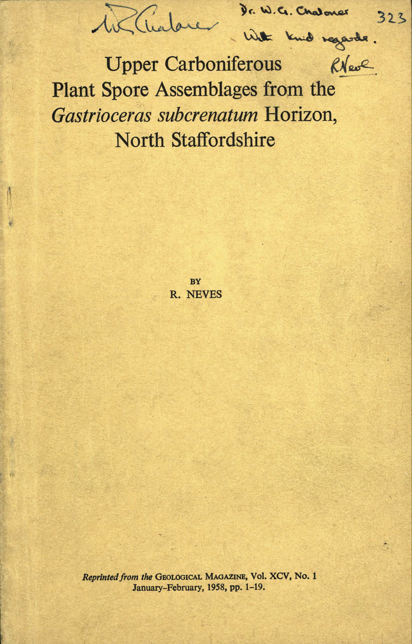

Fig. A2.1. The front cover of the original reprint of Neves (1958), which Roger Neves sent to Bill Chaloner. Note the inscription from Roger Neves and Bill’s signature. The number 323 is an accession number in Bill’s highly organised reprint collection, which is now housed at the British Geological Survey, Nottingham, UK.

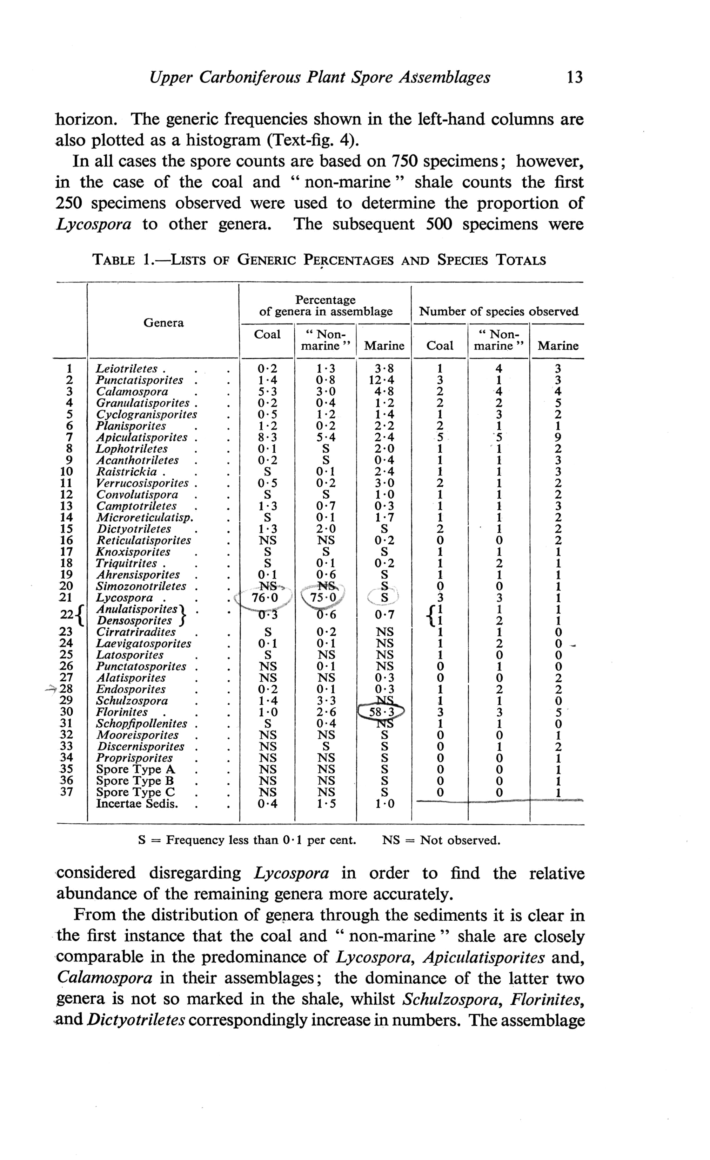

Fig. A2.2. Page 13 of Bill’s copy of Neves (1958). Note the circling of the percentages of Florinites and Lycospora in the three depositional settings in table 1. Endosporites has also been highlighted.

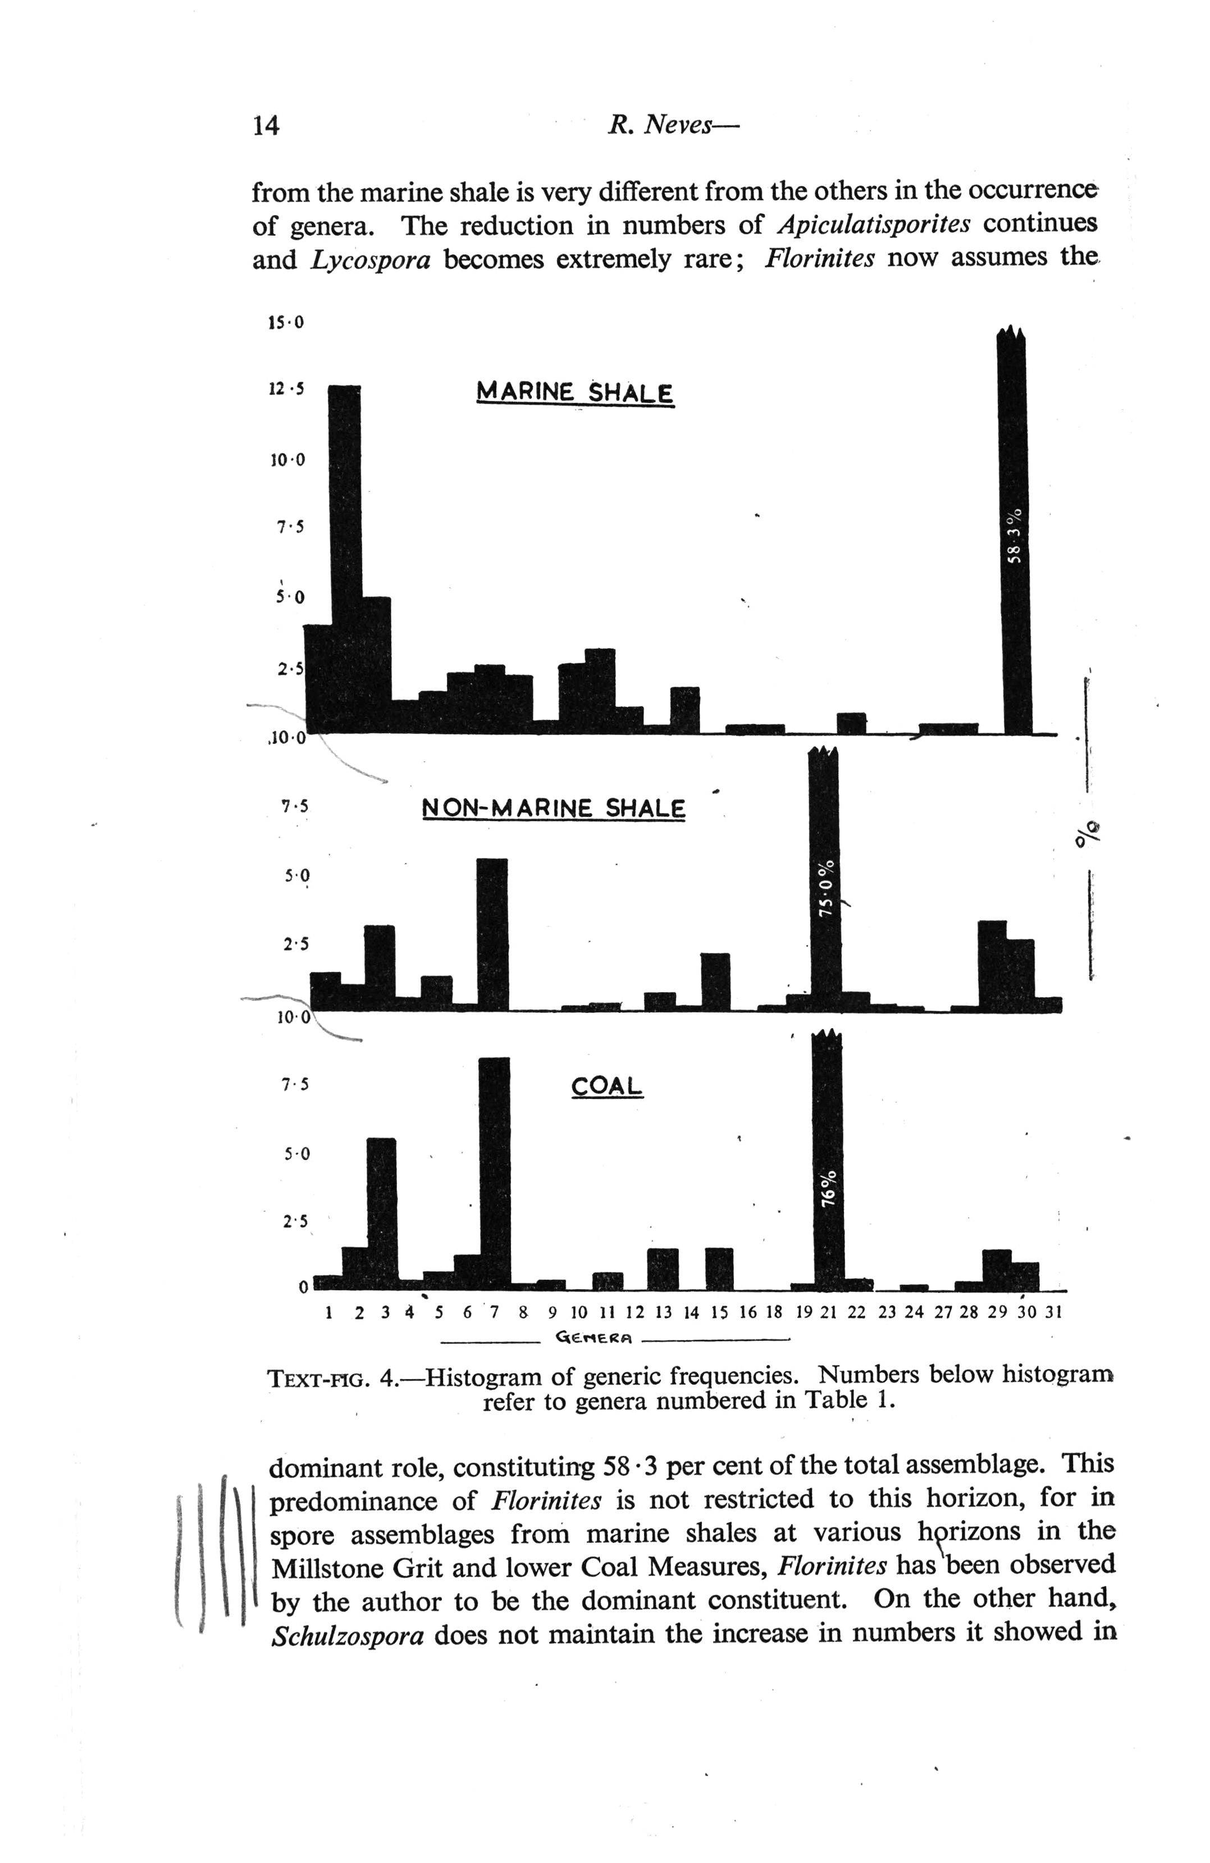

Fig. A2.3. Page 14 of Bill’s copy of Neves (1958). Note the emphasising of the text on the abundance of Florinites.

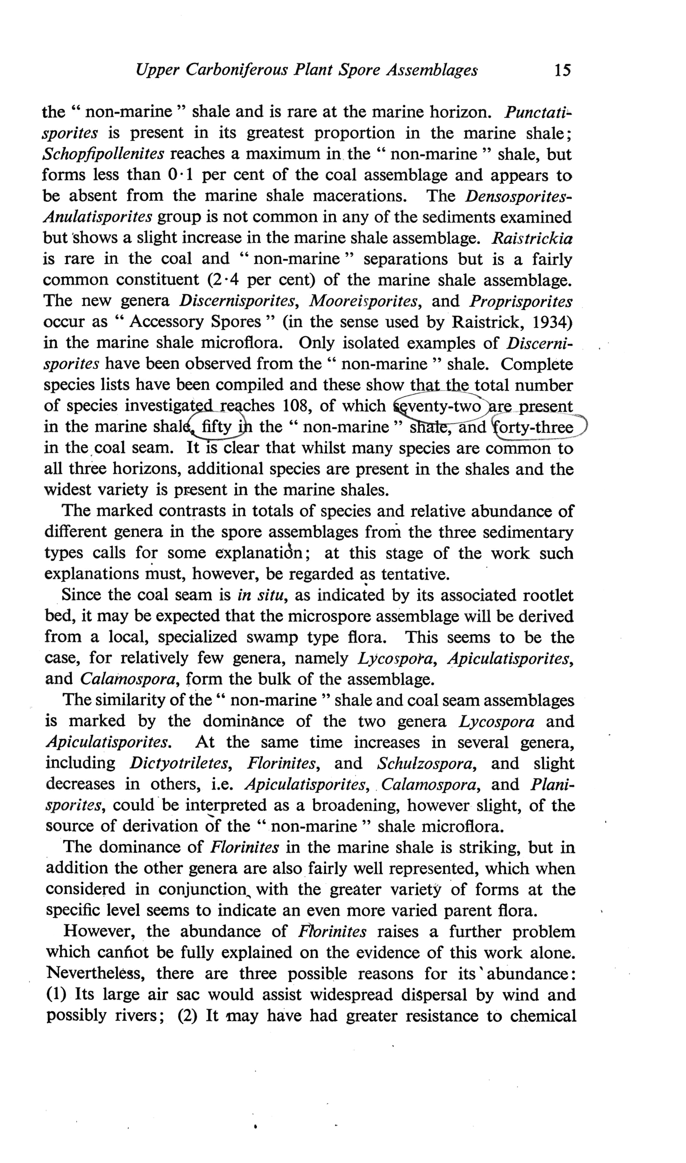

Fig. A2.4. Page 15 of Bill’s copy of Neves (1958). Note the circling of the numbers of pollen-spore species in each of the three facies.

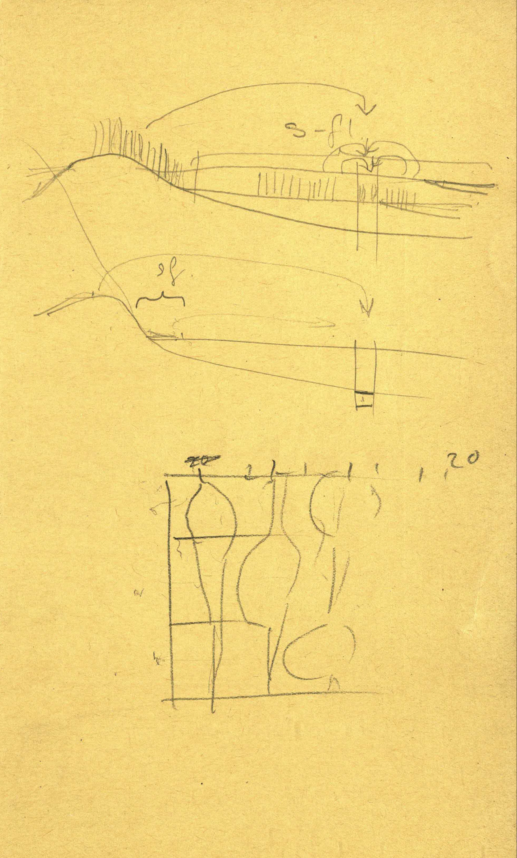

Fig. A2.5. The inside back cover of Bill’s copy of Neves (1958). Note the two sketches in pencil. The uppermost one is clearly a prototype of of Chaloner & Muir (1968, fig. 4). This diagram was reproduced in Traverse (1988, fig. 17.15), and is the basis of Fig. 5 of the main text. The lowermost sketch did not make it into any publication of Bill’s, and is presumably based on data in Neves (1958).

APPENDIX 3

THE BILL CHALONER REPRINT COLLECTION

Bill Chaloner was meticulous in looking after his vast accumulation of scientific papers. He organized his huge collection by topic, e.g. Devonian spores, Modern pollen etc. In late 2017, this unique collection of over 300 box files was donated to the British Geological Survey for safekeeping, and to ensure that it is available for perusal by the public by prior arrangement. The image below (Fig. A3.1) is a photograph taken by Peter Holmes of part of the reprint collection when it was at Royal Holloway. The collection of Bill Chaloner’s personal papers (letters, notes, reminiscences etc.) is archived at Royal Holloway.

APPENDIX 4

MORE IMAGES OF BILL CHALONER AND AL TRAVERSE AT THE 12TH IPC

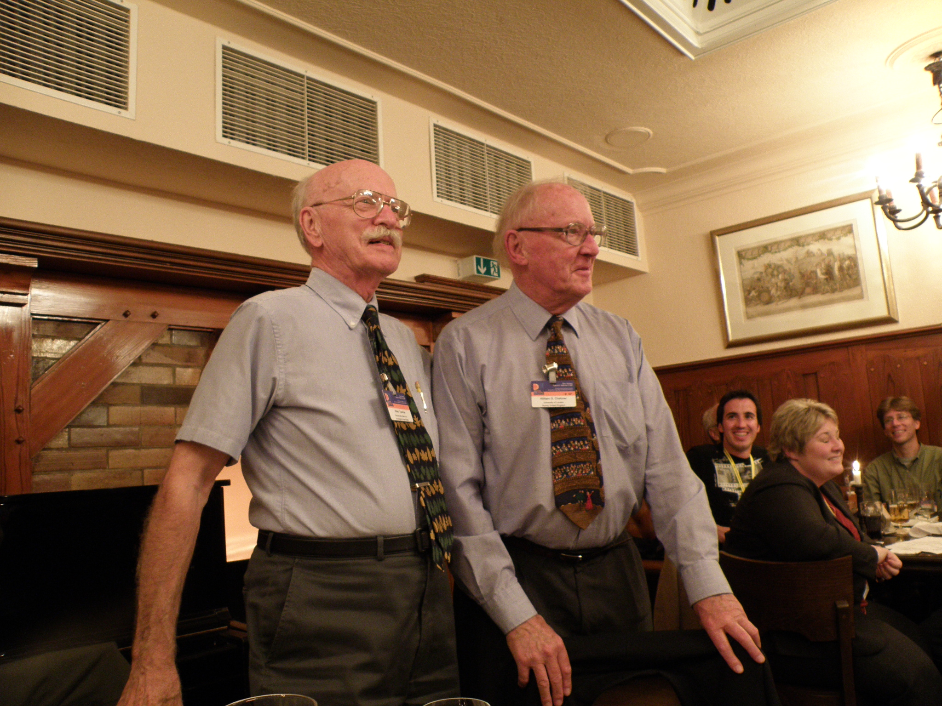

Fig. A4.1. Al Traverse (left) and Bill Chaloner (right) pictured together at the AASP Business Luncheon held during the 12th International Palynological Congress (IPC) in Bonn on the evening of Thursday 4th September 2008 (see Figure 10 of the main paper). Photographer: James B. Riding.

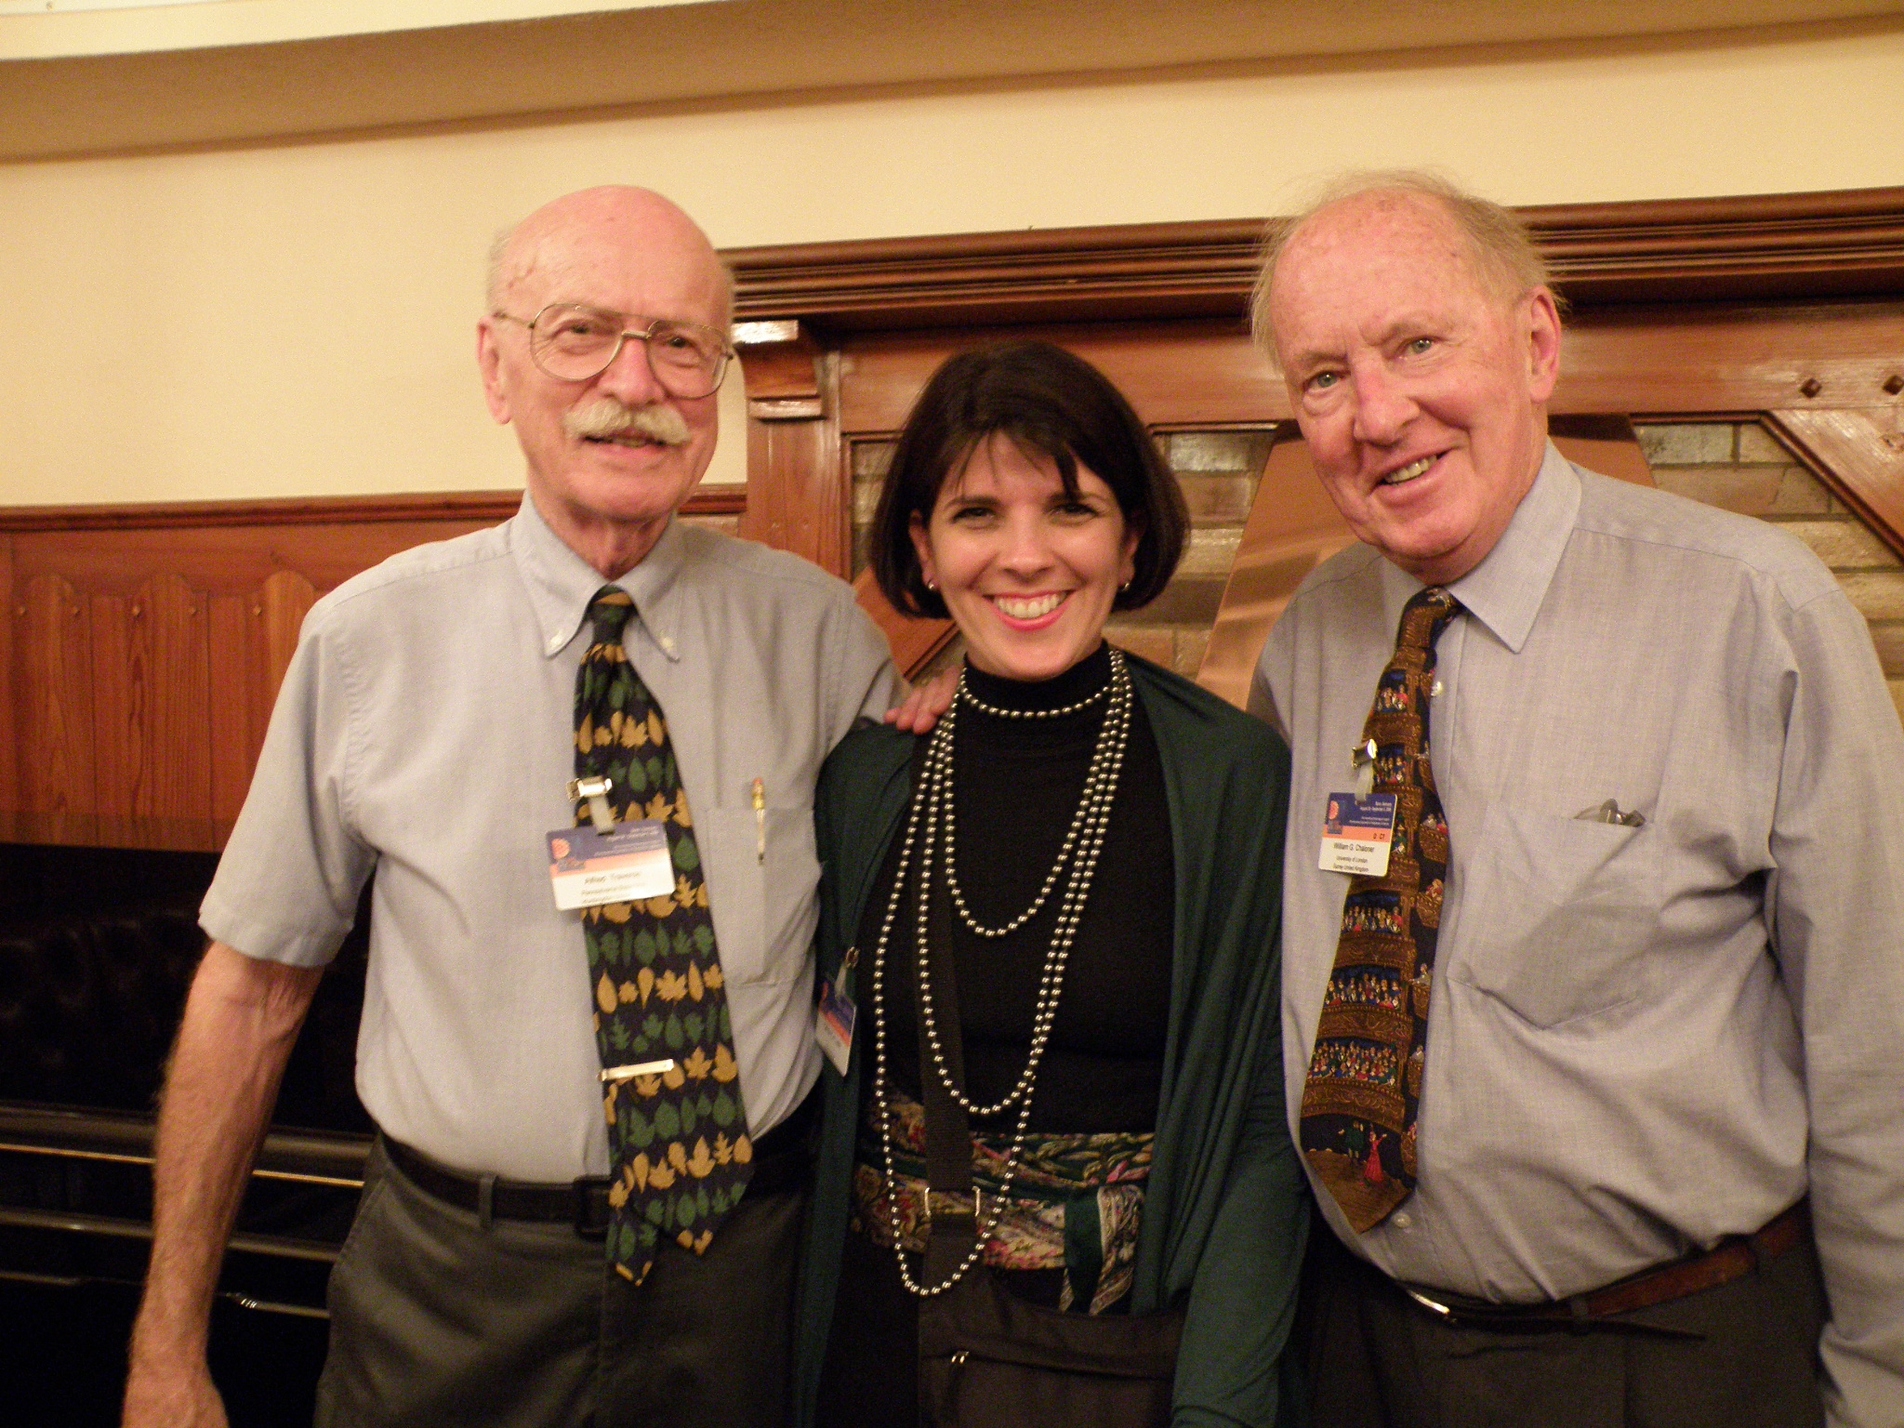

Fig. A4.2. From left to right, Al Traverse, Fátima P.R. Leite and Bill Chaloner pictured together at the AASP Business Luncheon held during the 12th International Palynological Congress (IPC) in Bonn on the evening of Thursday 4th September 2008 (see Figure 10 of the main paper). Photographer: James B. Riding.

