**SUPPORTING INFORMATION**

**AKT2 siRNA delivery with amphiphilic-based polymeric micelles show efficacy against Cancer Stem Cells**

Diana Rafael1,2*, Petra Gener2,3*, Fernanda Andrade3,Joaquin Seras-Franzoso2, Sara Montero2, Yolanda Fernández2,3,4, Manuel Hidalgo5, Diego Arango6, Joan Sayós7, Ibane Abasolo2,3,4, Simó Schwartz Jr.2,3**, and Mafalda Videira1**

*1Research Institute for Medicines and Pharmaceutical Sciences, Faculdade de Farmácia, Universidade de Lisboa (iMed.ULisboa), Lisbon, Portugal*

*2Drug Delivery and Targeting Group, Molecular Biology and Biochemistry Research Centre for Nanomedicine (CIBBIM-Nanomedicine), Vall d’Hebron Institut de Recerca, Universitat Autònoma de Barcelona, Barcelona, Spain*

*3Networking Research Centre for Bioengineering, Biomaterials, and Nanomedicine (CIBER-BBN), Instituto de Salud Carlos III, Zaragoza , Spain*

*4Functional Validation & Preclinical Research (FVPR), CIBBIM-Nanomedicine, Vall d’Hebron Institut de Recerca, Universitat Autònoma de Barcelona, Barcelona, Spain*

*5Division of  Hematology and Oncology,  Rosenberg Clinical Cancer Center Beth Israel Deaconess Medical Center, Boston, MA, USA*

*6Biomedical Research in Digestive Tract Tumors, CIBBIM-Nanomedicine, Vall d’Hebron Institut de Recerca, Universitat Autònoma de Barcelona, Barcelona, Spain*

*7Immune Regulation and Immunotherapy, CIBBIM-Nanomedicine, Vall d’Hebron Institut de Recerca, Universitat Autònoma de Barcelona, Barcelona, Spain*

* These authors contributed equally to this work

** Corresponding authors: simo.schwartz@vhir.org and mafaldavideira@campus.ul.pt

**Mafalda Ascensão Videira, Ph.D., mafaldavideira@campus.ul.pt**

Assistant Professor of Pharmaceutics, iMed.ULisboaResearch Institute for Medicines**,** Pharmacological and Regulatory Sciences Group (PharmaRegSci)**,** Faculdade de Farmácia da Universidade de Lisboa, Av. Prof. Gama Pinto, 1649-003 Lisboa, Portugal.

**Simó Schwartz Jr, M.D. Ph.D.,** **simo.schwartz@vhir.org**

Director, Molecular Biology and Biochemistry Research Center for Nanomedicine (CIBBIM-Nanomedicine); Hospital Universitari Vall d'Hebron, Vall d'Hebron Institut de Recerca (VHIR), Passeig de la Vall d’Hebron, 119-129, 08035 Barcelona, Spain.

**SUPPORTING METHODS**

**Information S1: MTT cell viability assays**

5000 cells/well were seeded in 96-well in microtiter plate and after they attached, they were incubated in the presence or absence of PM:siControl, PEI, F127 and PEI:siControl complexes for 24 hours. Subsequently, the medium was changed and the cells left to grow for 72 hours. Complete medium was used as negative control and 10% DMSO as positive control of toxicity. After the incubation, 0.5 mg/mL 3-(4,5-dimethythiazol-2-yl)-2,5-diphenyl tetrazolium bromide (MTT) was added to each well. Plates were incubated for an additional 4 h at 37ºC and 180 μL of DMSO (Sigma) was added to each well. The absorbance at 580 nm of each well was read on a microplate reader ELx800 (BioTek). Cell viability was calculated a minimum of 3 biological replicates with 6 technical replicates for each assay. The results of cell viability were used for the determination of IC50 index by nonlinear regression of the concentration-effect curve fit using Prism 6.02 software (GraphPad Software, Inc.). Final results are expressed as the mean±SEM.

**Information S2. Maximum Tolerated Dose (MTD) determination for *in vivo* administration**

Female athymic nude mice (Hsd:Athymic Nude-Foxn1 nu/nu; Harlan Interfauna Iberica) were kept in pathogen-free conditions and used at 6 weeks of age. Animal care was handled in accordance to guidelines for the Care and Use of Laboratory Animals of the Vall d’Hebron University Hospital based on Federation of Laboratory Animal Science Associations (FELASA) recommendations and the European Union legislation (European Parliament and Council Directive 2010/63/EU). The experimental procedures were approved by the Animal Experimentation Ethical Committee of the institution. Animals were randomly divided in 4 groups (n=3) and intravenously administered in the tail vein with PBS 1X (control group) or PM at doses of 20, 40 or 80 mg per kilogram of body weight (single administration). Body weight changes and side effects were monitored during 12 days post-administration. For side effects evaluation the reduction of voluntary movement, irregular breathing, motor disturbances, seizures, sudden death, flushed skin, lacrimation, dehydration and hunched position was monitored.

**Information S3: Cell cultures**

Cells were cultured in RPMI medium (Lonza) supplemented with 10% FBS (Lonza), 6mM L-Glutamine (Lonza), 0.1 mM Non Essential Amino acids (NEAA) (Lonza) and and 1% penicillin-streptomycin. MCF7 cells were cultured in DMEM F12 complete medium (Life Technologies) supplemented with a 10% of fetal bovine serum (FBS) (Lonza) and 1% penicillin-streptomycin. Blasticidin (10 µg/mL) (Life Technologies) was used as a selective antibiotic for ALDH1A1/tdTomato and GFP expressing cell lines, respectively. All cell lines were maintained in atmosphere with 5% of CO2 at 37ºC.

CSC models were generated previously from breast tumor cell lines (MCF7, MDA-MB-231). Briefly; tdTomato reporter cDNA was cloned under the minimal ALDH1A1 promoter (Gener et al., 2015). The resulting ALDH1A1/tdTomato plasmid was transfected with Lipofectamine 2000 (Invitrogen), and cells were cultured under selective pressure with Blasticidin (10 µg/mL) for 2 weeks. Positive tdTomato cells (tdTomato+) were sorted by FACS and reseeded to reproduce the mother cell line in which tumoral non-CSC show no expression of tdTomato (tdTomato-).

**Information S4:** **GFP silencing assessment**

The expression of GFP in cells after transfection was assessed with a fluorescence microscope (Olympus, USA). A video of the cells during 72 hours after transfection was recorded using Motorized Fluorescent Microscope BX61 (Olympus, USA) in order to confirm GFP decreasing over the time. Fluorescence intensity per cell over all the time of the experiment was quantified using the ImageJ 1.48v software (National Institutes of Health, MD, USA). The intensity of cells’ fluorescence was also measured using a Fluorescent Microplate reader FLX800 (BioTek, Germany).

### Information S5: Micelles Internalization

To assess the internalization behavior of PM in MCF-7 and MDA-MB-231 cells, 5-DTAF-fluorescentely labeled polymer was used. F127 was fluorescently conjugated with 5-DTAF in an aqueous medium via nucleophilic aromatic substitution by an addition-elimination pathway as previously described (Andrade et al., 2015). Briefly, a stock solution of 20 g/L 5-DTAF in DMSO was diluted in 0.1M sodium bicarbonate (pH 9.3) and added to a 6 % (w/v) F127 solution in 0.1M sodium bicarbonate (pH 9.3) to a final molar ratio of 1:2 (F127:5-DTAF). The reaction proceeded overnight in the dark at room temperature. The labeled polymer was purified from the excess of unreacted 5-DTAF by dialysis (12,000-14,000 MWCO Spectra/Por® membrane from Spectrum Europe BV) against Type I ultrapure water. The dialyzed polymer solutions were lyophilized and stored in closed containers protected from light.

Flow cytometry analysis was used to verify internalization of 5-DTAF PM in MDA-MB-231 and MCF7 ALDH1A1 cells with around 50% of tdTomato+ cells. 2x105 cells were seeded in complete medium in 96 well plates for 24 hours to allow adhesion. Micelles were added to cells at different time points: 1, 3, 10, 30 minutes and, 1, 2, 4, 6, 8 and 20 hours. Then, cells were washed with 1x PBS, detached with 0.25% trypsin-EDTA, and re-suspended in PBS supplemented with 10% FBS and DAPI (1 μg/mL) used for vital staining. The plate was analyzed in a cytometer Fortessa (BD Biosciences). Data was analyzed with FCS Express 4 Flow Research Edition software (De Novo Software). Contaminants were removed by forward and side scatter gating. For each sample, at least 10000 individual cells were collected and the mean fluorescence intensity was evaluated.

**Information S6: Fluorescence-Activated Cell Sorting (FACS)**

In order to sort the tdTomato+ CSC, MCF7-ALDH1A1/tdTomato and MDA-MB-231-ALDH1A1/tdTomato cells were washed with PBS (Lonza) and trypsinized with 1X trypsin-EDTA (Life Technologies). Then they were resuspended in PBS-FBS (10%), and DAPI was added to marked non-viable cells. First, cell debris and doublets were removed by forward and side scatter gating and just alive cells (DAPI negative cells) were admitted for sorting. TdTomato fluorescence was detected through the CYG-A channel and sorted using the cytometer FACSAria (BD Biosciences).

**Information S7:** **RNA extraction and quantitative RT-PCR (qRT-PCR)**

Total RNA was extracted from cells using the RNeasy Micro Kit (Qiagen) and the obtained RNA was reverse transcribed with the High Capacity cDNA Reverse Transcription Kit (Applied Biosystems) according to the manufacturer's instructions. Subsequently qPCR was performed using AKT2 specific primers (hAKT2 F: CAAGGATGAAGTCGCTCACACA; hAKT2 R: GAACGGGTGCCTGGTGTTC) using SYBR Green method. Transcriptional quantification relative to both, GADPH (hGADPH F: ACCCACTCCTCCACCTTTGAC; hGADPH R: CATACCAGGAAATGAGCTTGACAA) and actin (hactin F: CATCCACGAAACTACCTTCAACTCC; hactin R: GAGCCGCCGATCCACAC) was performed using Qbase™ software, based on the ΔΔCt method, calculating relative normalized quantities (NRQ) of mRNA expression (26).

### Information S8: Invasion Assay

Invasive potential of sorted CSCs was assessed using the CytoSelect™ Laminin Cell Invasion Assay Kit (Cell Biolabs, USA). Briefly, the inserts were placed in a 24 well plate and 2.5x104 cells, previously transfected (24 hours before) with the PM-siAKT2 and the PM-siControl, were added to the upper chamber to obtain a final concentration of 200 nM of siRNA per well. After 48 hours incubation, the invasive cells were dissociated from the membrane, lysed and quantified using the CyQuant® GR Fluorescent Dye using a fluorescent microplate reader FLX800 (BioTek).

**SUPPORTING FIGURES**

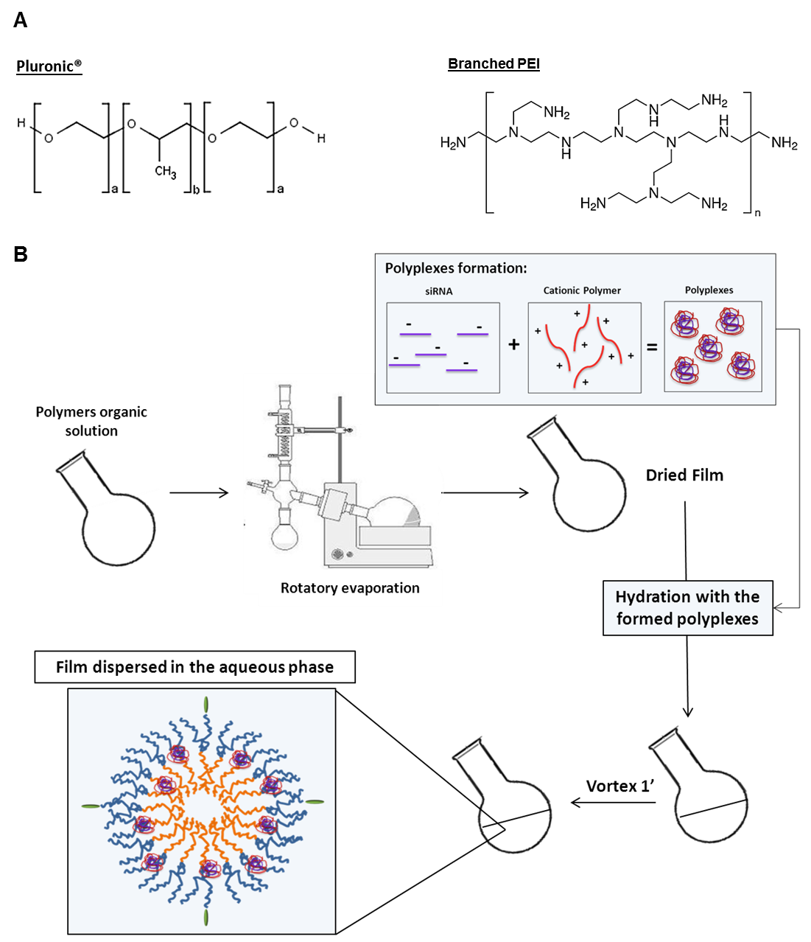

**Supplemental Figure 1: Schematic representation of polymers structure and micelles production.**

**A:** Pluronic® and PEI chemical structure. **B:** PM preparation method: PM were prepared using the thin-film hydration technique. The solvent was removed under vacuum in a rotary evaporator and the formed film was left to eliminate any remaining solvent. The film was then hydrated with the previously prepared polyplexes and vortexed. The obtained dispersion was filtered through a 0.22 μm syringe filter for sterilization and remove possible aggregates.

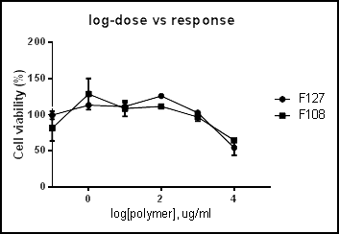

**Supplemental Figure 2:** **Comparative cytotoxicity assay *in vitro*.**

IC50 plots of Pluronic® F127 and F108 in MDA-MB-231 cells. Results are expressed as mean±SD, n=3. F127 and F108 IC50 > 10 mg/ml, respectively.

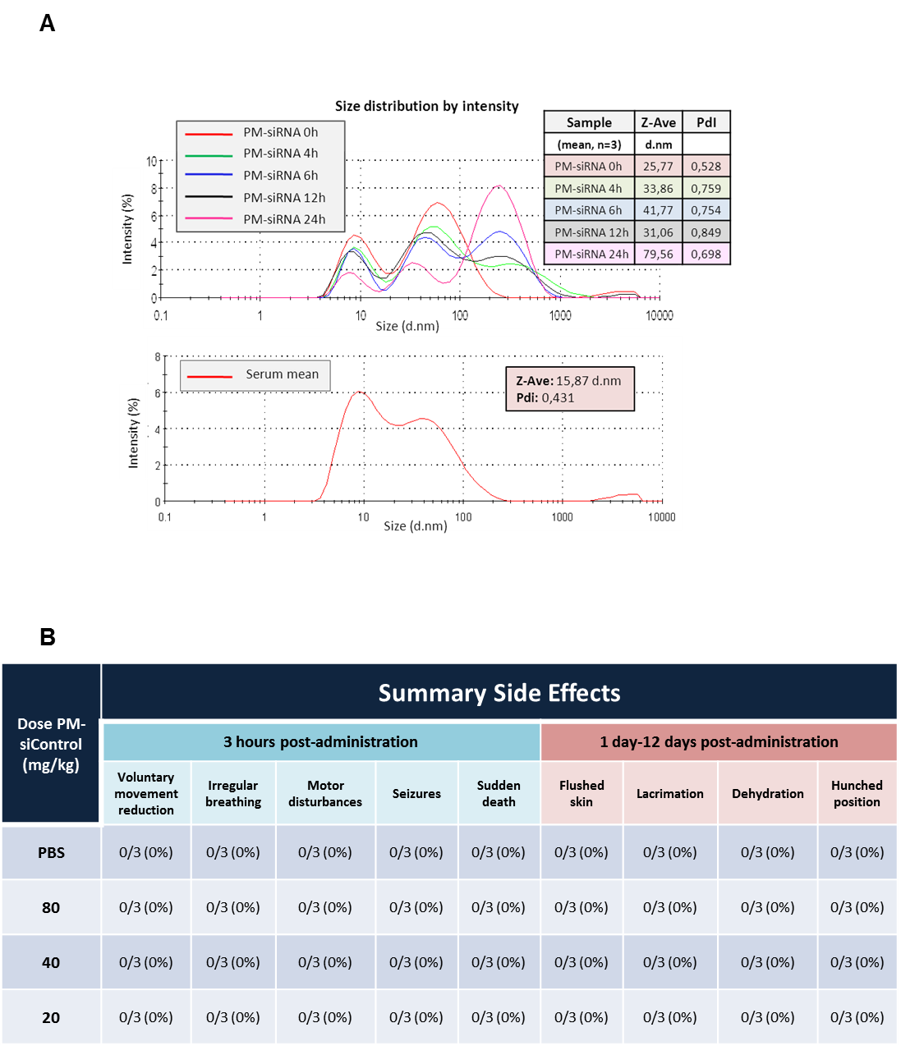

**Supplemental Figure 3: PM-siRNA Serum Stability Assay and toxicity *in vivo*.**

**A:** The graphs represent the DLS size distributions by intensity after incubation at different time-points. PMs with siRNA (scramble sequence) mean curves at different time-points (0-24h) and Medium-serum 50% curve, respectively. All measurements were performed in triplicate, with three technical samples.

**B:** The table shows the register of adverse side effects monitored during the time of the experiment. Results are expressed as mean ± sd (n=3).

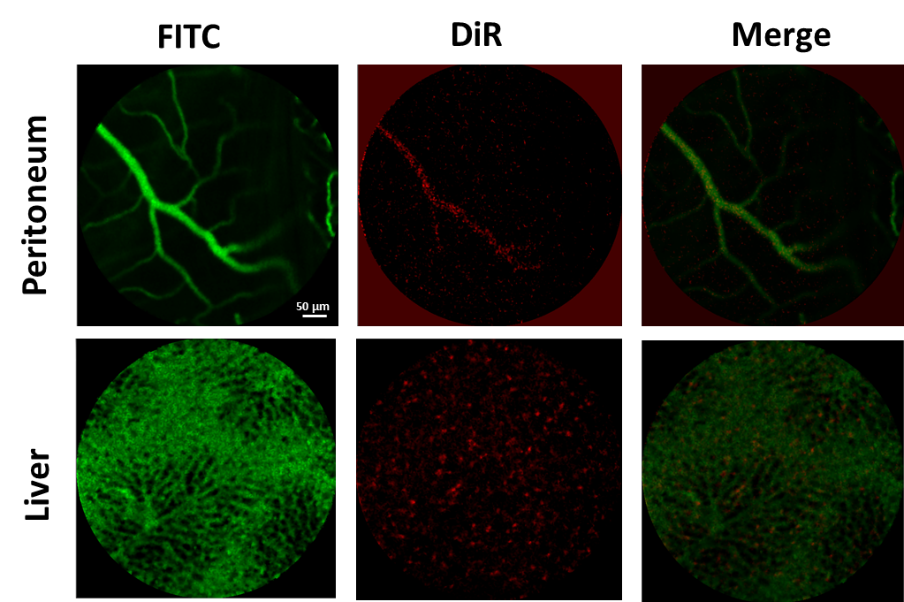

**Supplemental Figure 4: PM-siAKT2 distribution in vivo**

Real time fibered confocal fluorescence microscopic (FCFM) images of mice administered with DiR labelled PM and FITC-Dextran, 4 h and 1 h prior to in vivo imaging, respectively. In the peritoneum, red signal corresponding to DiR labeled PM is mainly localized into the vessels (see white arrows), indicating that, contrary to what happens in the tumors, in tissues with regular vasculature the PM extravasation is not facilitated. In the liver, DiR signal appears in aggregates into the hepatic sinusoids, indicating that PM clearance is facilitated by the reticulo-endothelial system in the liver.

**References**

ANDRADE, F., NEVES, J., GENER, P., SCHWARTZ, S., JR., FERREIRA, D., OLIVA, M. & SARMENTO, B. 2015. Biological assessment of self-assembled polymeric micelles for pulmonary administration of insulin. *Nanomedicine,* 11**,** 1621-31.

GENER, P., GOUVEIA, L. P., SABAT, G. R., DE SOUSA RAFAEL, D. F., FORT, N. B., ARRANJA, A., FERNANDEZ, Y., PRIETO, R. M., ORTEGA, J. S., ARANGO, D., ABASOLO, I., VIDEIRA, M. & SCHWARTZ, S., JR. 2015. Fluorescent CSC models evidence that targeted nanomedicines improve treatment sensitivity of breast and colon cancer stem cells. *Nanomedicine,* 11**,** 1883-92.