SUPPLEMENTAL DATA

Appendix 1 The major publications of Vera I. Ilyina

This Appendix is a chronologically arranged list of Vera Ilyina’s 42 substantive scientific publications. This excludes abstracts and similar items of grey literature. Note that the English transliteration of some of her papers quote her family name as Il’ina.

Ilyina, V.I. 1961. Jurassic palynological assemblages of north-eastern Kazakhstan. Geology and Geophysics, 1961.5: 57–64 (in Russian with an English abstract).

Vdovin, V.V. and Ilyina, V.I. 1967. On the question of the lower boundary of the Tyazhin Formation. Mesozoic and Cenozoic Stratigraphy of Middle Siberia. Nauka Publishing House, Novosibirsk, USSR, 94–96 (in Russian).

Ilyina, V.I. 1968. A comparative analysis of spore and pollen assemblages of the Jurassic beds of the southern part of Western Siberia. Nauka Publishing House, Moscow, USSR, 111 p. (in Russian).

Ilyina, V.I. 1969. Climate of Western and Middle Siberia at the Early Jurassic time based on palynological data. Geology and Geophysics, 1969.10(118): 10–17 (in Russian).

Ilyina, V.I. 1969. Spores and pollen assemblages of the Lower Jurassic sediments of the middle course of the river Viluy. In: Spore and pollen assemblages of the Mesozoic of Siberia and the Far East. Nauka Publishing House, Moscow, USSR, 70–78 (in Russian).

Ilyina, V.I. and Teslenko, Yu.V. 1969. To the history of the evolution of the Jurassic flora of Kuzbass. In: Spores and pollen assemblages of the Mesozoic of Siberia and the Far East. Nauka Publishing House, Moscow, USSR, 89–102 (in Russian).

Ilyina, V.I. 1970. On the age of Jurassic sediments of South-Eastern Margin of the West Siberian Lowland. Geology and Geophysics, 1970.3(123): 124–130 (in Russian).

Ilyina, V.I. 1971. Palynological characteristics of the Jurassic in Siberia. In: Mesozoic microfossils in Siberia and the Far East. Nauka Publishing House, Moscow, USSR, 6–51 (in Russian).

Ilyina, V.I. and Teslenko, Yu.V. 1971. On the Lower–Middle Division of the Jurassic system in the non-marine Jurassic beds. Geology and Geophysics, 1971.8(140): 3–10 (in Russian).

Ilyina, V.I. 1973. Biostratigraphical significance of Toarcian spore-pollen assemblages of Siberia. In: Mesozoic Palynology. Nauka Publishing House, Moscow, USSR, 75–79 (in Russian).

Ilyina, V.I. 1976. Palynological characteristics. Stratigraphy of the Jurassic System of the North of the U.S.S.R. Nauka Publishing House, Moscow, USSR, 326–343 (in Russian).

Ilyina, V.I. 1978. Palynological evidence reasoning the stratigraphic subdivision of the Jurassic in northern middle Siberia. Geology and Geophysics, 1978.9(225): 16–22 (in Russian with an English abstract).

Ilyina, V.I. 1979. Pollen of the genus Eucommidites in the Jurassic sediments of Siberia and its stratigraphic significance. In: Stratigraphy and palynology of the Mesozoic and Cenozoic of Siberia. Nauka Publishing House, Novosibirsk, USSR, 5–18 (in Russian).

Ilyina, V.I. 1979. The first pollen finds of the genus Chasmatosporites in the Jurassic of Siberia. In: Stratigraphy and palynology of the Mesozoic and Cenozoic of Siberia. Nauka Publishing House, Novosibirsk, USSR, 19–25 (in Russian).

Il’ina, V.I. 1981. Subdivision and correlation of Jurassic strata in Central and Eastern Siberia on the basis of palynology. Geology and Geophysics, 1981.5(257): 9–19 (in Russian with an English abstract).

Zakharov, V.A., Ilyina, V.I., Meledina, S.V., Nalnjaeva, T.I., and Shurigin, B.N. 1984. The Jurassic System. In: Phanerozoic of Siberia, Part 2. Mesozoic and Cenozoic. Nauka Publishing House, Novosibirsk, USSR, 16–54 (in Russian).

Ilyina, V.I. 1985. Jurassic palynology of Siberia. Transactions of the Institute of Geology and Geophysics, Academy of Sciences of the USSR, Siberian Branch, Volume 638, 237 p. Nauka Publishing House, Moscow, USSR (in Russian with an English abstract and table of contents).

Ilyina, V.I. 1985. Jurassic marine and non-marine palynostratigraphy of Siberia. Geology and Geophysics, 26: 12–21 (in Russian with an English abstract).

Ilyina, V.I. 1985. Revision, phylogenetic relationships, range and stratigraphic significance of pollen of the genus Quadraeculina Maljavkina. In: Palynostratigraphy of Mesozoic and Cenozoic of Siberia. Nauka Publishing House, Novosibirsk, USSR, 4–20 (in Russian).

Ilyina, V.I. 1986. Subdivision and correlation of the marine and non-marine Jurassic sediments in Siberia based on palynological evidence. Review of Palaeobotany and Palynology, 46: 357–364.

Ilyina, V.I. 1988. Microphytoplankton of the Jurassic and Cretaceous boundary deposits in the section of the Cape Urdjuk-Khaya (the Paxa Peninsula). In: Chlonova, A.F. (editor). Palynology in the USSR. Papers of the Soviet Palynologists to the VII International Palynological Congress, Brisbane, Australia, 1988. Nauka Publishing House, Siberian Branch, Novosibirsk, USSR, 103–107 (in Russian with an English abstract).

Ilyina, V.I. 1991. Dinocyst zonation of the Bathonian–Oxfordian sediments of the Russian Platform. In: Stratigraphy and palaeogeography of the terrigenous successions of the oil-bearing basins of the U.S.S.R. Vses Nauch-Issled Geologiy-Razved Instituti (VNIGRI), Leningrad, USSR, 42–64 (in Russian).

Ilyina, V.I., Kul`kova, I.A. and Lebedeva, N.K. 1994. Microphytofossils and detail stratigraphy of marine Mesozoic and Cenozoic of Siberia. Transactions of the United Institute of Geology, Geophysics and Mineralogy, Russian Academy of Sciences, Siberian Branch, Issue 818, 192 p. (in Russian with an English abstract and list of contents).

Kontorovich, A.E., Andrusevich, V.E., Afanasiev, S.A., Vakulenko, L.G., Danilova, V.P., Zlobina, O.N., Ilyina, V.I., Levchuk, M.A., Kazanskii, Yu.P., Kazarbin, V.V., Karogodin, Yu.N., Moskvin, V.I., Melenevskii, V.N., Solotchina, E.P., Fomin, A.N. and Shurygin, B.N. 1995. Geology and conditions of the formation of the giant Talinsky Zone of gas and oil accumulation in the Lower Jurassic continental deposits (West Siberia). Russian Geology and Geophysics, 36(6): 2–25.

Kontorovich, A.E., Ilyina, V.I., Moskvin, V.I., Andrusevich, V.E., Borisova, L.S., Danilova, V.P., Kazanskii, Yu.P., Melenevskii, V.N., Solotchina, E.P. and Shurygin B.N. 1995. Reference section and oil-producing potential of the Lower Jurassic deposits of the Nyurolka sedimentary subbasin (West Siberian Plate). Russian Geology and Geophysics, 36(6): 110–126.

Shurygin, B.N., Nikitenko, B.L., Ilyina, V.I. and Moskvin, V.I. 1995. Problems of the stratigraphy of the Lower and Middle Jurassic of southeastern of West Siberia. Geology and Geophysics, 36(11): 34–51 (in Russian with an English abstract).

Riding, J.B. and Ilyina, V.I. 1996. Protobatioladinium elatmaensis sp. nov., a dinoflagellate cyst from the Bathonian of Russia. Journal of Micropalaeontology, 15: 150.

Shurigin, B.N., Meledina, S.V., Nikitenko, B.L., Ilyina, V.I. and Nal’njaeva, T.I. 1996. The Lower and Middle Jurassic zonal scales in Siberia. In: Geology and problems with the search for new large oil and gas deposits in Siberia, Part 1. SNIIGGIMS, Novosibirsk, 72–75 (in Russian).

Shurigin, B.N., Nikitenko, B.L. and Ilyina, V.I. 1996. New information on the Lower and Middle Jurassic stratigraphical scheme in West Siberia. In: Geology and problems with the search for new large oil and gas deposits in Siberia, Part 1. SNIIGGIMS, Novosibirsk, 64–68 (in Russian).

Zakharov, V.A., Bogomolov, Yu.I., Il’ina, V.I., Konstantinov, A.G., Kurushin, N.I., Lebedeva, N.K., Meledina, S.V., Nikitenko, B.L., Sobolev, E.S. and Shurygin, B.N. 1997. Boreal zonal standard and biostratigraphy of the Siberian Mesozoic. Russian Geology and Geophysics, 38(5): 927–956 and 965–993.

Meledina, S.V., Ilyina, V.I. and Nal`nyaeva, T.I. 1998. Parallel biostratigraphic scales of the Boreal Bathonian and Callovian in the north Pechora region as a tool for interregional correlation. Stratigraphy and Geological Correlation, 6(3): 234–248.

Riding, J.B. and Ilyina, V.I. 1998. A new dinoflagellate cyst from the Upper Bathonian (Middle Jurassic) strata of the Russian Platform. Journal of Micropaleontology, 17: 86.

Riding, J.B., Fedorova, V.A. and Ilyina, V.I. 1999. Jurassic and lowermost Cretaceous dinoflagellate cyst biostratigraphy of the Russian Platform and northern Siberia. American Association of Stratigraphic Palynologists Contributions Series, No. 36, 179 p.

Il’ina, V.I. and Shurygin, B.N. 2000. The Ilansk Formation and its stratotype (Lower Jurassic, southern Siberia). Russian Geology and Geophysics, 41(8): 1159–1166.

Shurygin, B.N, Nikitenko, B.L., Devyatov, V.P., Ilyina, V.I., Meledina, S.V., Gaideburova, E.A., Dzyuba, O.S., Kazakov, A.M. and Mogucheva, N.K. 2000. Stratigraphy of oil and gas basins of Siberia. Jurassic System. Novosibirsk Publishing House of the Siberian Branch of the Russian Academy of Sciences, Department "Geo", 476 p. (in Russian with an English abstract and list of contents).

Beisel, A.L., Zanin, Yu.N., Zamirailova, A.G., Il’ina, V.I., Lebedeva, N.K., Levchuk, L.K., Levchuk, M.A., Meledina, S.V., Nikitenko, B.L., Shurygin, B.N. and Yan, P.A. 2002. Reference section for the Upper Jurassic and Callovian in northern West Siberia. Russian Geology and Geophysics, 43(9): 811–825.

Nikitenko, B.L., Il’ina, V.I. and Glinskikh, L.A. 2002. Stratigraphy, microfossils, and biofacies in the reference section of Callovian and Upper Jurassic from the Tyumen’ superdeep well (West Siberia). Geologiya i Geofizika, 43(8): 762–790 (in Russian with an English abstract).

Ilyina, V.I., Nikitenko, B.L., and Glinskikh, L.A. 2005. Foraminifera and dinoflagellate cyst zonation and stratigraphy of the Callovian to Volgian reference section in the Tyumenskaya superdeep well (West Siberia, Russia). In: Powell, A.J., and Riding, J.B. (editors). Recent Developments in Applied Biostratigraphy. The Micropalaeontological Society, Special Publications. The Geological Society, London, 109–144.

Zakharov, V.A., Shurygin, B.N., Meledina, S.V., Rogov, M.A., Kiselev, D.N., Nikitenko, B.L., Dzyuba, O.S. and Ilyina, V.I. 2005. The Boreal Standard of the Jurassic System. In: Zakharov, V.A., Rogov, M.A. and Dzyuba, O.S. (editors). Jurassic System of Russia: problems of stratigraphy and palaeogeography. First All-Russian Meeting, Geological Institute of the Russian Academy of Sciences, Moscow, November 21st–22nd, 2005, 89–96 (in Russian)

Zakharov, V.A., Shurygin, B.N., Il’ina, V.I. and Nikitenko, B.L. 2006. Pliensbachian-Toarcian biotic turnover in North Siberia and the Arctic region. Stratigraphy and Geological Correlation, 14(4): 399–417.

Nikitenko, B.L., Pestchevitskaya, E.B., Lebedeva, N.K. and Ilyina, V.I. 2008. Micropalaeontological and palynological analyses across the Jurassic-Cretaceous boundary on Nordvik Peninsula, Northeast Siberia. Newsletters on Stratigraphy, 42(3): 181–222.

Appendix 2 – Taxonomic appendix

A list of all palynomorphs below the species level mentioned in the text, with their full author citations. The taxa are listed alphabetically in two groups. References to the dinoflagellate cyst author citations can be found in Williams et al. (2017).

Acritarch:
Fromea tornatilis (Drugg 1978) Lentin & Williams 1981

Dinoflagellate cysts:
Dingodinium? spinosum (Duxbury 1977) Davey 1979
Moesiodinium raileanui Antonesçu 1974
Nannoceratopsis deflandrei Evitt 1961
Nannoceratopsis deflandrei Evitt 1961 subsp. anabarensis Ilyina et al. 1994
Nannoceratopsis gracilis Alberti 1961
Nannoceratopsis senex van Helden 1977
Oligosphaeridium patulum Riding & Thomas 1988
Paragonyaulacysta? borealis (Brideaux & Fisher 1976) Stover & Evitt 1978
Parvocysta nasuta Bjaerke 1980
Pareodinia ceratophora Deflandre 1947
Phallocysta eumekes Dörhöfer & Davies 1980
Susadinium scrofoides Dörhöfer & Davies 1980
Tubotuberella rhombiformis Vozzhennikova 1967
Valvaeodinium aquilonium (Dörhöfer & Davies 1980) Below 1987

Reference
Williams, G.L., Fensome, R.A., MacRae, R.A. 2017. The Lentin and Williams index of fossil dinoflagellates 2017 edition. American Association of Stratigraphic Palynologists Contributions Series, No. 48, 1097 p.

Appendix 3 – Selected photographs featuring Vera Ivanovna Ilyina

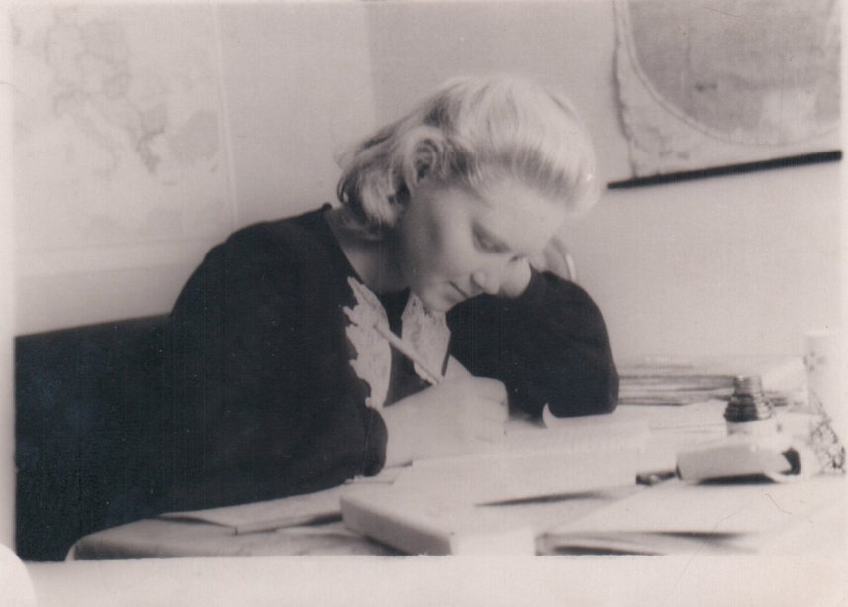
- Vera I. Ilyina at work at Novosibirsk in 1954.

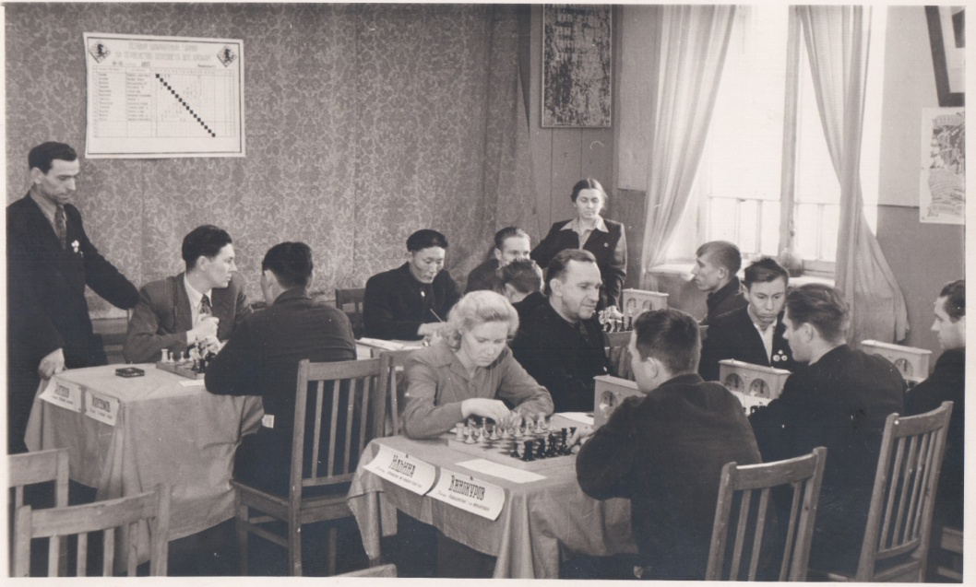
- Vera I. Ilyina (centre) competing in a chess match at Novosibirsk in 1955.

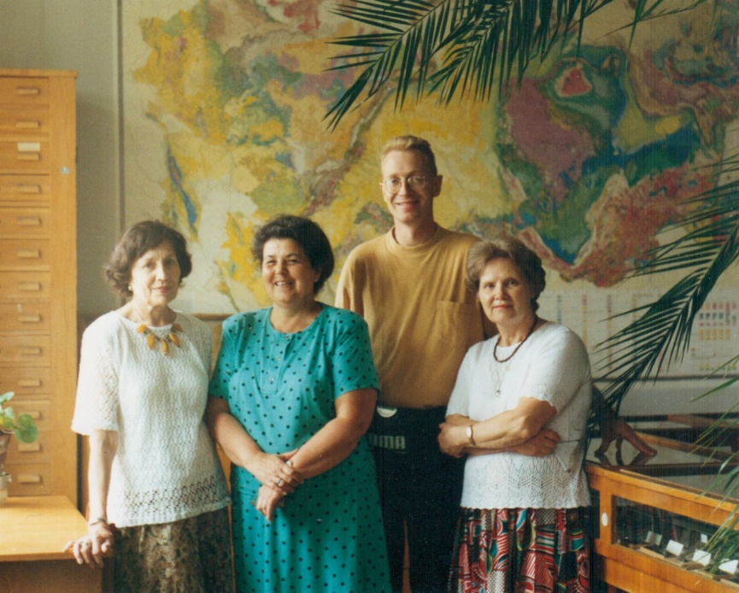
- In the palaeontology museum at the Institute of Geology and Geophysics at Academgorodok in front of a geological map of the USSR during July 1995; left to right: Tamara Ivanovna Nal’nyaeva; Svetlana V. Meledina; James B. Riding; and Vera I. Ilyina.

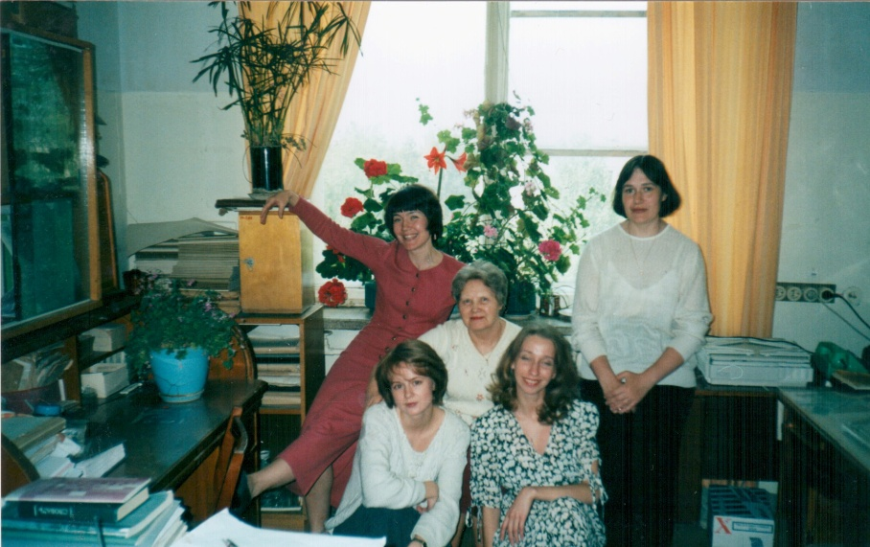
- Vera I. Ilyina (centre) at work in the Institute of Geology and Geophysics surrounded by her young palynologist mentees around 2000 (anticlockwise from Vera’s top right: Natalia K. Lebedeva; Anna N. Trubicyna; Ekaterina B. Pestchevitskaya; and Anna V. Shushakova)

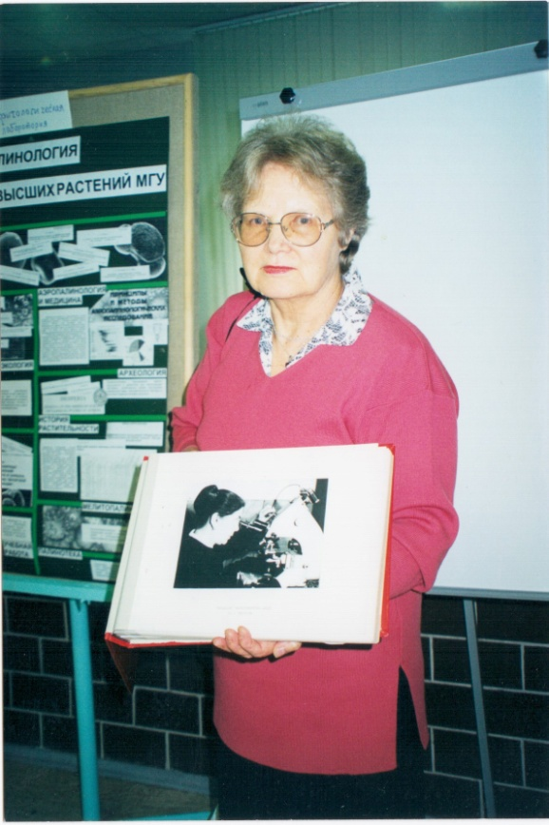
- Vera I. Ilyina at a scientific meeting in Russia proudly holding a photograph of her mentor Tamara F. Vozzhennikova.

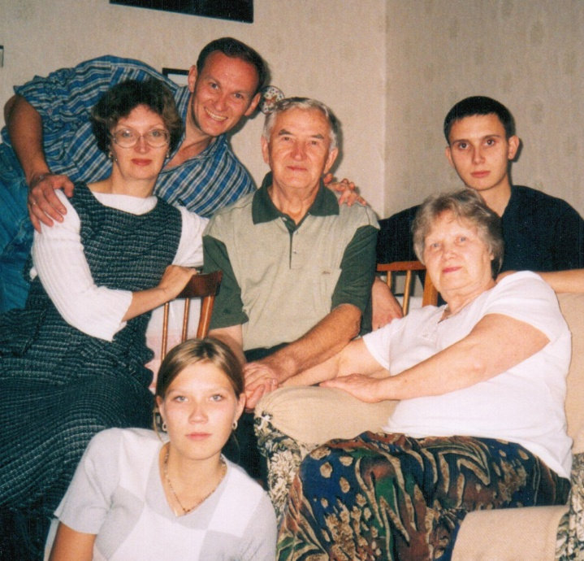
- Vera I. Ilyina (bottom left) surrounded by her family (anticlockwise from Vera: grandson Kirill; late husband Victor; son-in-law Sergey; daughter Olga; and grandaughter Polina).

