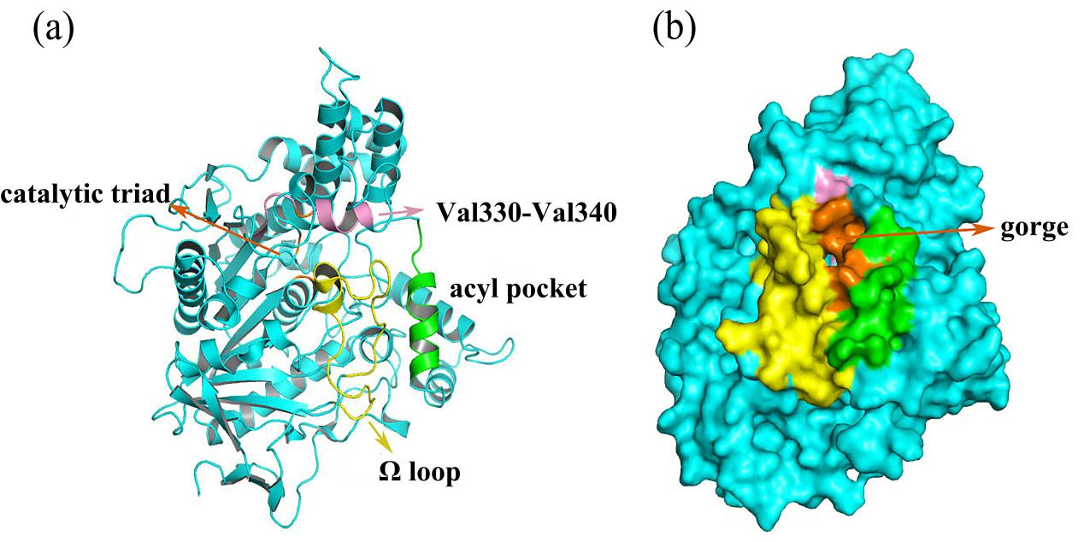
Figure S1. Overall structure of AChE with its important regions highlighted in different colors, residues 69 to 96 are Ω loop (yellow) and the catalytic triad is composed by residues of Ser203, Glu334 and His447 (orange), Val330-Val340 are labeled (pink), the residues from Gln279 to Gln291 are composed area of acyl pocket (green) (a), the vital gorge are depicted in (b).

Figure S2. Chemical structures of the four fullerene derivatives.

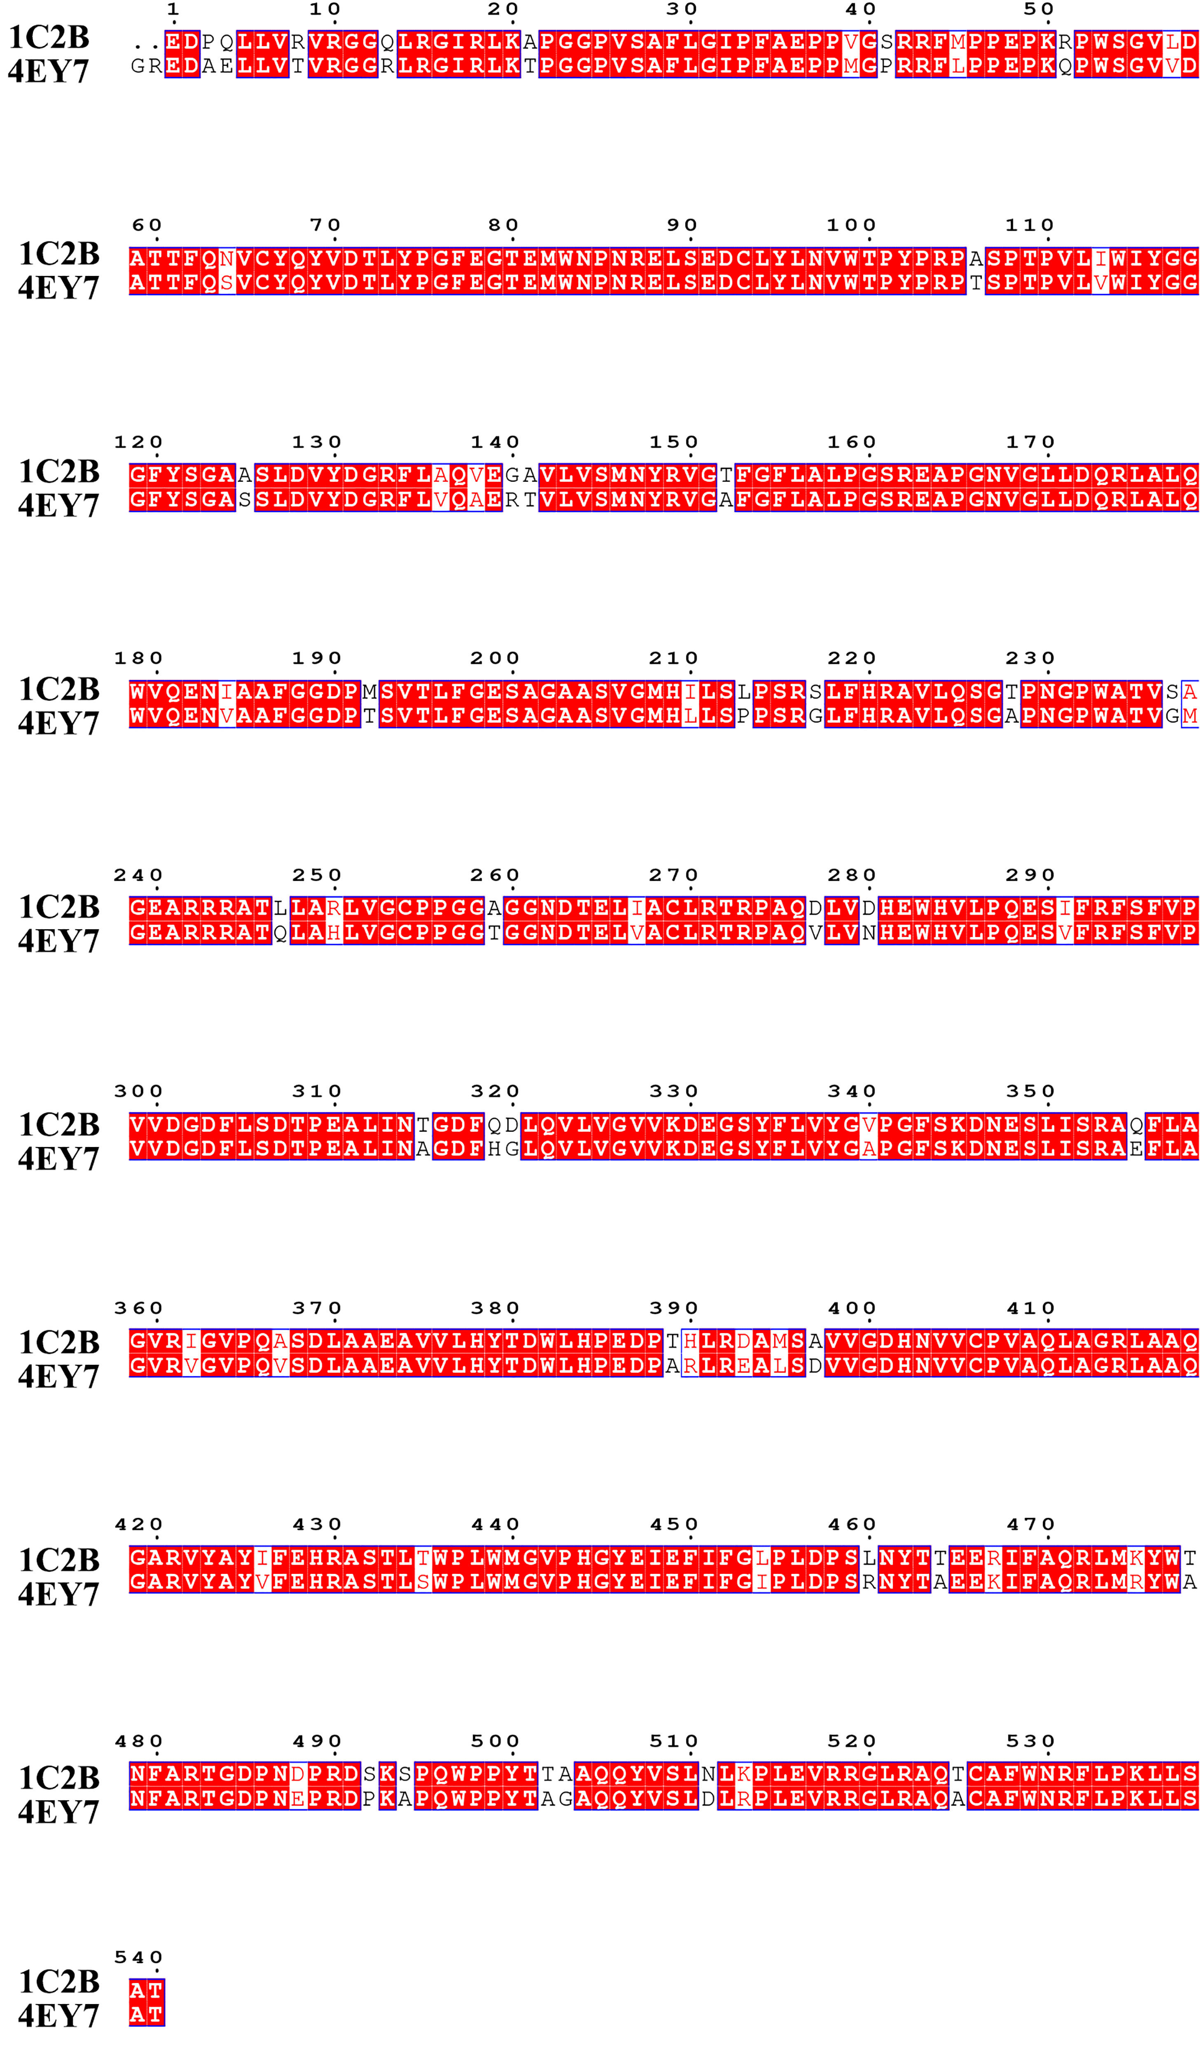
Figure S3. structure-based sequence alignment of the catalytic modules of 1C2B and 4EY7.

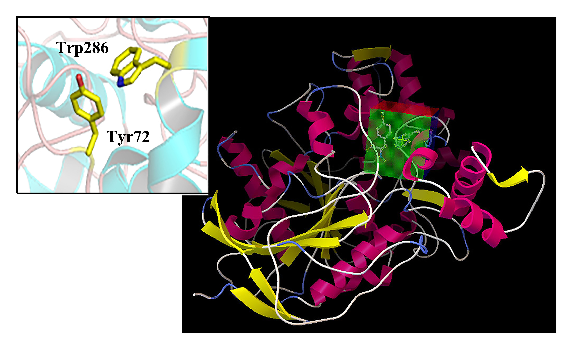
Figure S4. Docking grid for AChE.

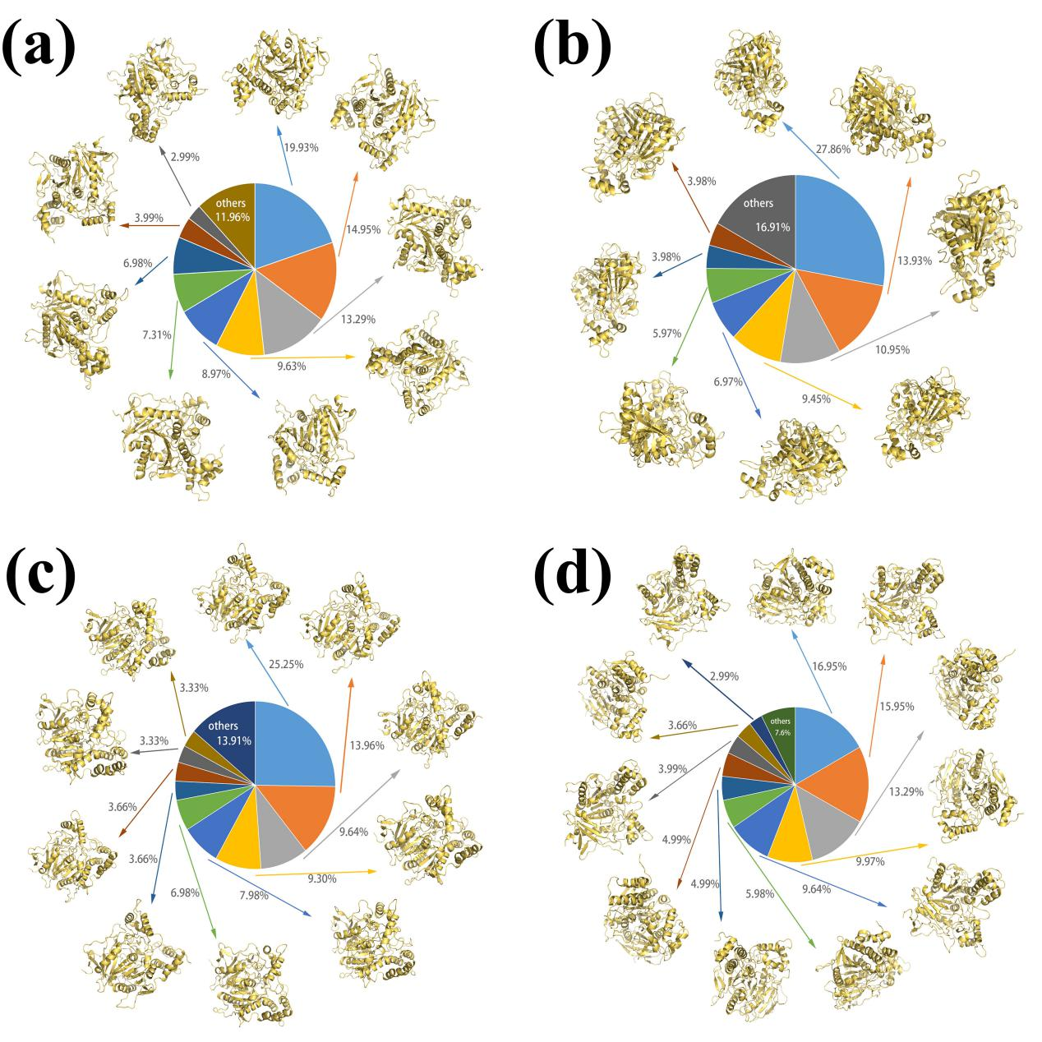
Figure S5. Representative clusters obtained in the equilibrium trajectory. (a)-(d) corresponds to complex1-complex4, respectively.

Figure S6. The distance between residue Glu334 and His447 in (a) complex1 (b) complex2 (c) complex3 and (d) complex4 systems.

Table S1. Proportion of Each Variance and the Total Variance Proportion of the First Five Eigenvectors of the Four Complex Systems.
Eigenvector | AChE/Com1  Proportion of variance | AChE/Com2  Proportion of variance | AChE/Com3  Proportion of variance | AChE/Com4  Proportion of variance
1 | 40.3 | 26.9 | 32.0 | 34.2
2 | 11.8 | 12.0 | 10.0 | 14.8
3 | 5.5 | 6.5 | 6.6 | 6.7
4 | 4.5 | 4.3 | 4.2 | 4.6
5 | 8.7 | 11.2 | 9.8 | 8.7
Total | 70.8 | 60.9 | 62.6 | 69

Table S2. Average Number of Hydrogen Bonds in all Snapshots in the Simulations of AChE/com1~ AChE/com4 Systems.

Complex | Average number of hydrogen bonds
AChE/inhibitor1 | 0.5503
AChE/inhibitor2 | 0
AChE/inhibitor3 | 0
AChE/inhibitor4 | 4.7585

