Supporting Information

Aspergilolide, a steroid lactone produced by an endophytic fungus Aspergillus sp. MBL1612 isolated from Paeonia ostii

Pei-Liang Zhangª, Gang Wang^{a, b}, Feng-Qing Xu^{a, b}, Jin-Song Liu^{a, b}, Ju-tao Wang ^{a, b}, Rui Zhangª, Hai-Tao Liuª, Guo-Kai Wang^{a, b} *, Pei-Yun Wu^{a, b} *
ªAnhui Key Laboratory of Modern Chinese Materia Medica, School of Pharmacy, Anhui University of Chinese Medicine, Hefei, PR. China
^{b} Synergetic Innovation Center of Anhui Authentic Chinese Medicine Quality Improvement, Hefei 230012, PR. China
* To whom correspondence should be addressed. E-mail: wanggk@ahtcm.edu.cn (G.-K. Wang); peiyunwu@sina.com (P.-Y. Wu)
Tel.: +86-551-68129167; Fax: +86-551-68129125
Address: School of Pharmacy, Anhui University of Chinese Medicine, Hefei, Anhui 230012, P.R.China.
Abstract: A new steroid lactone with unique skeleton aspergilolide (1), and 9 known compounds helvolic acid (2), verruculogen (3), tryprostatin B (4), 13-oxofumitremorgin B (5), fumitremorgin C (6), demethoxy fumitremorgin C (7), terezine D (8), aszonalenin (9), 12, 13- dihydroxy-fumitremorgin C (10) from cultures of the endophytic fungus Aspergillus sp. MBL1612. The structure of these compounds were elucidated through spectroscopic methods such as NMR and HRMS. All of the compounds were isolated from this genus for the first time. The cytotoxicity on five human cancer cell lines of new compound were detected.
Key words: Edophytic fungus; Aspergillus sp. MBL1612; Aspergilolide; Cytotoxicity

Table S1 ¹H NMR (500 MHz) and ¹³C NMR (125 MHz) data for compound 1 in CDCl₃ P3
Fig S1 Key HMBC and COSY correlations of compound 1 P4
Fig S2 Key ROESY correlations of compound 1 P4
Fig S3 Chemical structures of compounds 2-10 P5
Fig S4 ORD of compound 1 P6
Fig S5 IR of compound 1 P6
Fig S6 UV of compound 1 P7
Fig S7 HRESIMS of compound 1 P8
Fig S8 ¹H NMR (500 MHz) spectrum of compound 1 in CDCl₃ P9
Fig S9 ¹³C NMR (125 MHz) spectrum of compound 1 in CDCl₃ P9
Fig S10 HSQC spectrum of compound 1 in CDCl₃ P10
Fig S11 ¹H-¹H COSY spectrum of compound 1 in CDCl₃ P10
Fig S12 HMBC spectrum of compound 1 in CDCl₃ P11
Fig S13 ROESY spectrum of compound 1 in CDCl₃ P11

Table S1 ¹H NMR (500 MHz) and ¹³C NMR (125 MHz) data for compound 1 in CDCl₃ (J in Hz)
Position | δ_{H} | δ_{C}
1 | 7.31 (d, 10.1) | 156.7 (d)
2 | 5.88 (d,10.0) | 128.1 (d)
3 | - | 201.2 (s)
4 | 2.75 (m) | 40.5 (d)
5 | 2.31 (dd, 12.4, 1.5) | 47.2 (d)
6 | 5.28 (d, 1.5) | 73.3 (d)
7 | - | 208.5 (s)
8 | - | 52.4 (s)
9 | 2.57 (dd, 13.0, 3.2) | 42.1 (d)
10 | - | 38.4 (s)
11 | 2.23 (m) | 23.9 (t)
12 | 2.01 (m) | 22.1 (t)
 | 1.81 (dd, 12.8, 3.5)
13 | 2.95 (dd, 12.7, 3.2) | 43.5 (d)
14 | - | 53.1 (s)
15 | 2.48 (m) | 36.5 (t)
 | 1.76 (m)
16 | 4.93 (dd, 10.9, 4.0) | 81.6 (d)
17 | - | 167.3 (s)
18 | - | 125.2 (s)
19 | - | 176.1 (s)
20 | 0.82 (s) | 20.4 (q)
21 | 1.42 (s) | 27.7 (q)
22 | 2.38 (m) | 24.3 (t)
23 | 2.23 (m) | 27.4 (t)
24 | 5.11 (m) | 123.2 (d)
25 | - | 133.2 (s)
26 | 1.68 (s) | 25.8 (q)
27 | 1.60 (s) | 18.0 (q)
28 | 1.29(d, 6.9) | 13.3 (q)
29 | 1.31 (s) | 18.4 (q)
30 | - | 168.9 (s)
31 | 2.11 (s) | 20.9 (q)

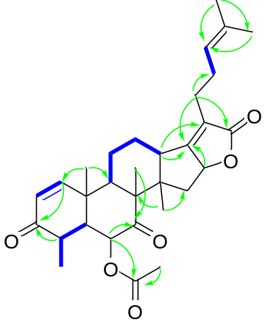
¹H-¹H COSY HMBC
Fig S1 Key HMBC and COSY correlations of compound 1

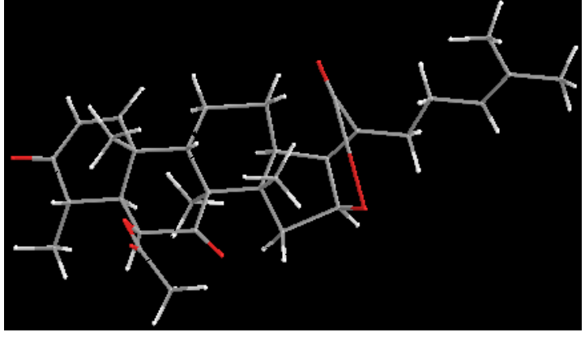
Fig S2 Key ROESY correlations of compound 1
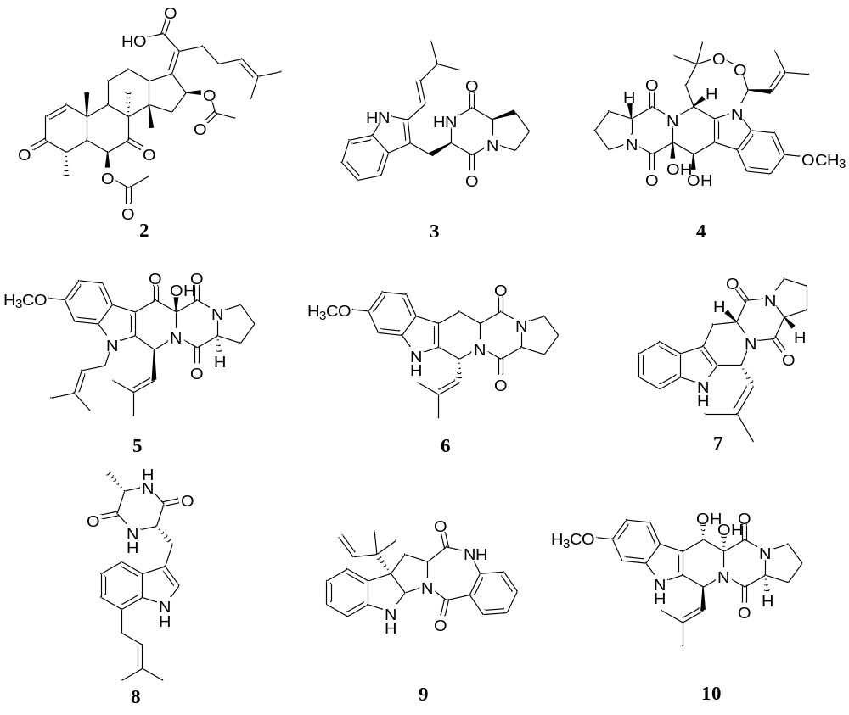
Fig S3 Chemical structures of compounds 2-10

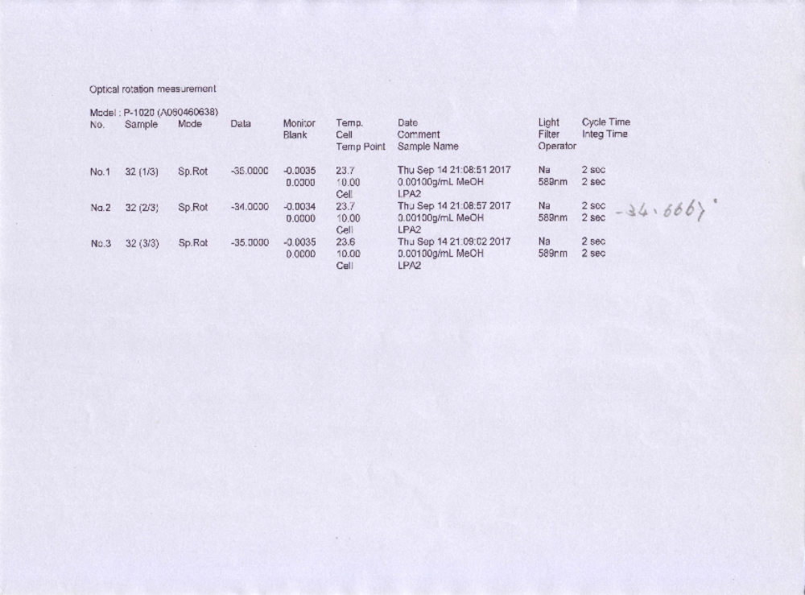Fig S4 ORD of compound 1
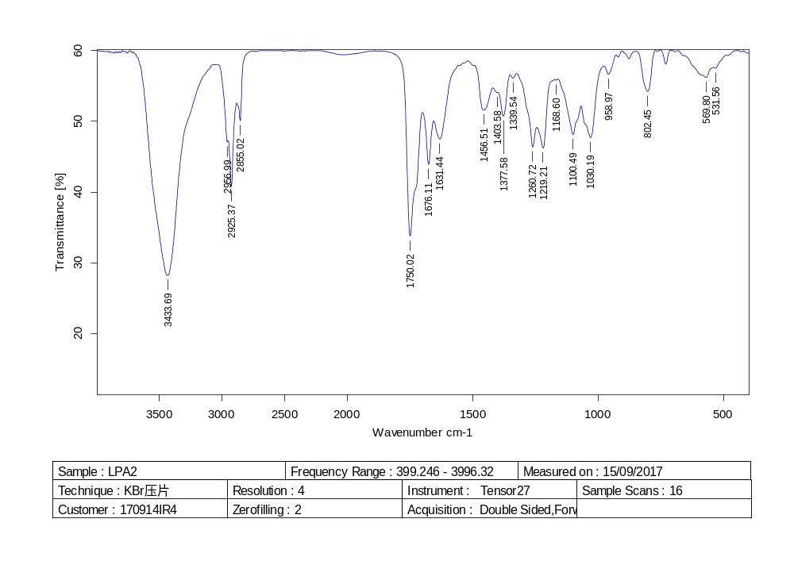
Fig S5 IR of compound 1
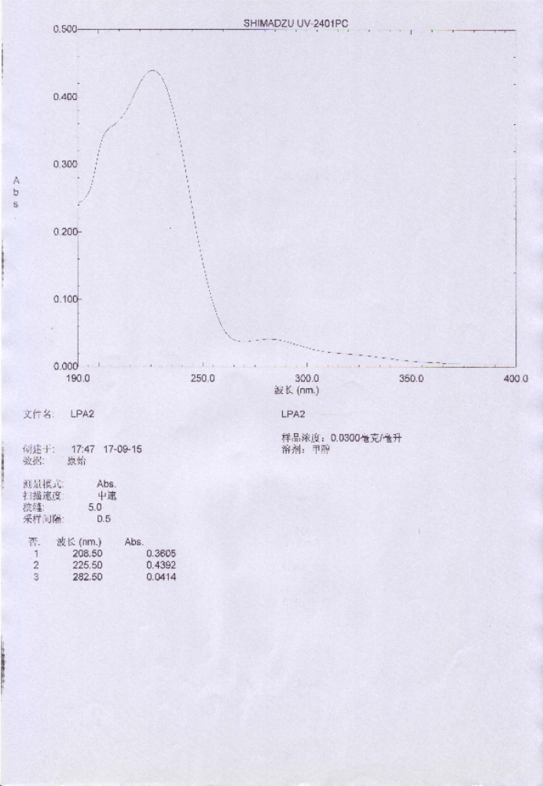
Fig S6 UV of compound 1
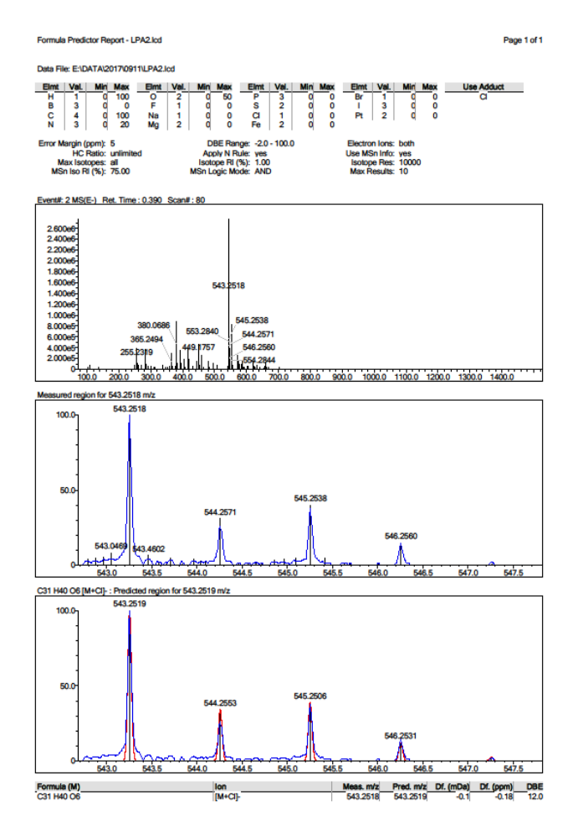
Fig S7 HRESIMS of compound 1
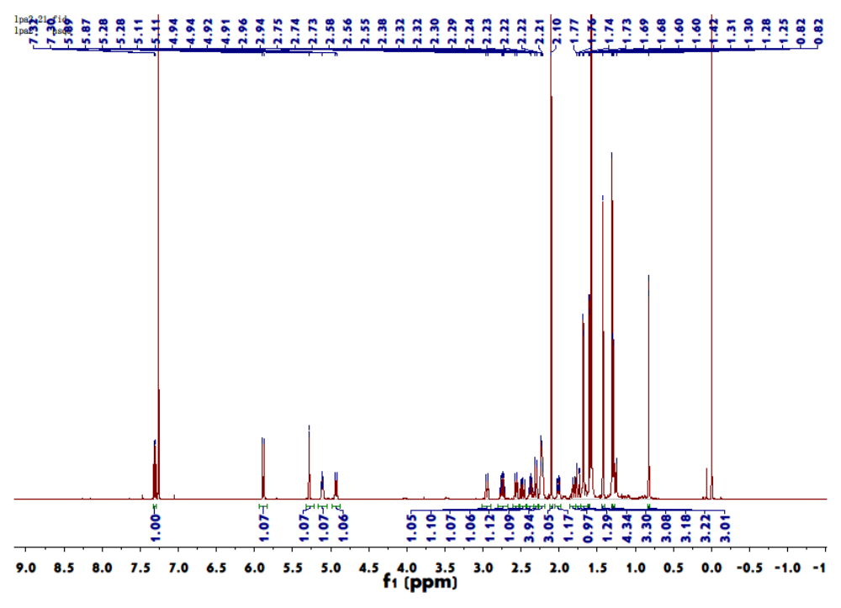Fig S8 ¹H NMR (500 MHz) spectrum of compound 1 in CDCl₃
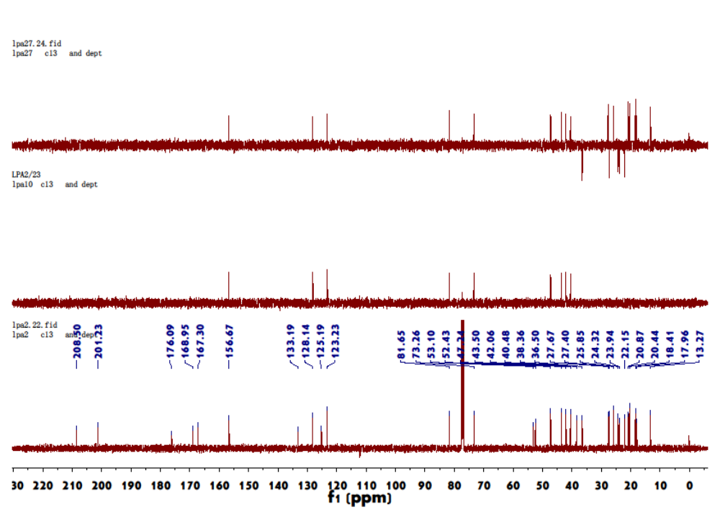 Fig S9 ¹³C NMR (125 MHz) spectrum of compound 1 in CDCl₃
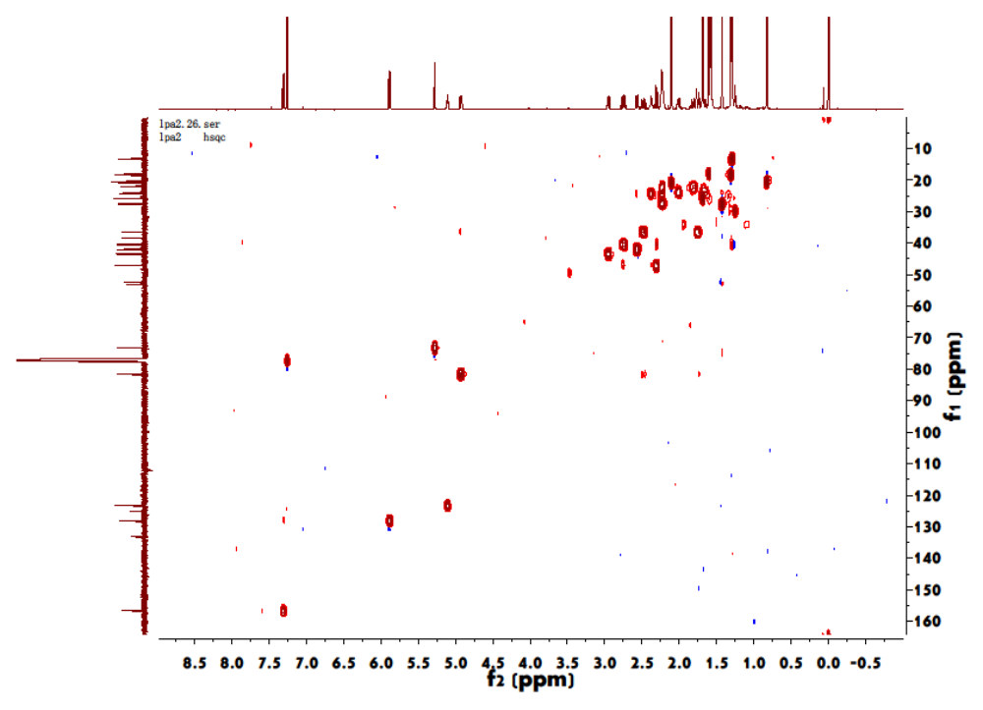Fig S10 HSQC spectrum of compound 1 in CDCl₃
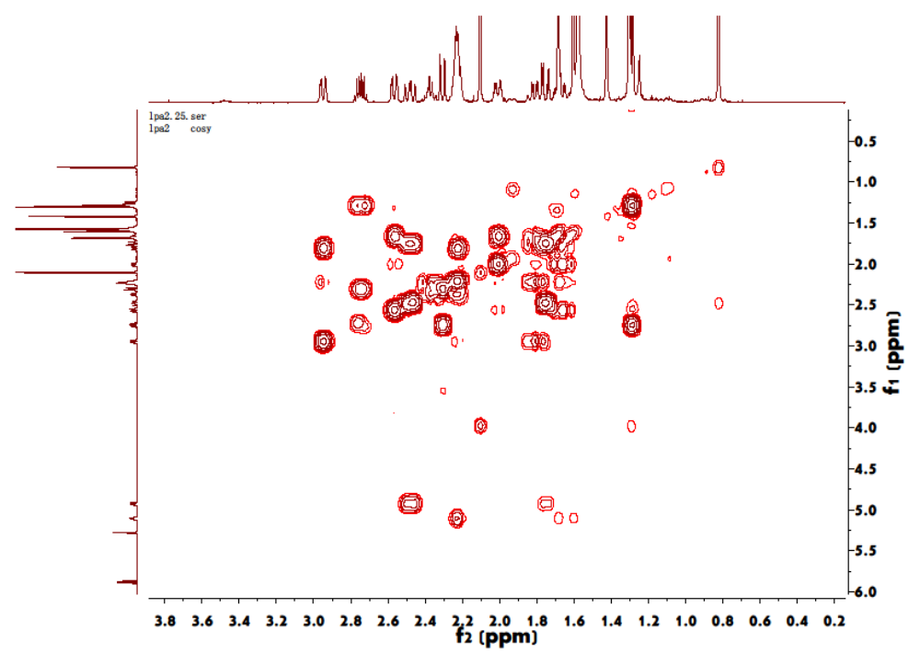Fig S11 ¹H-¹H COSY spectrum of compound 1 in CDCl₃
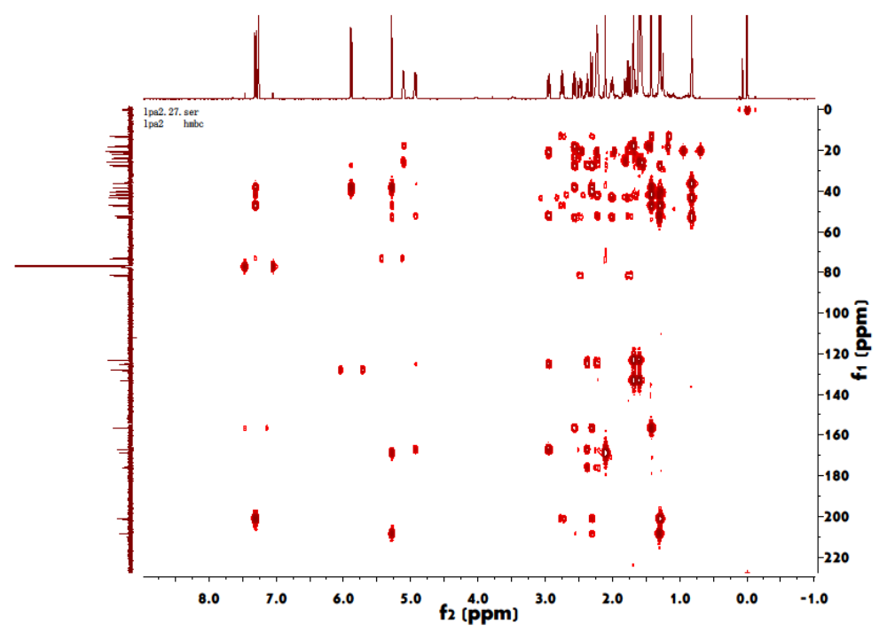Fig S12 HMBC spectrum of compound 1 in CDCl₃
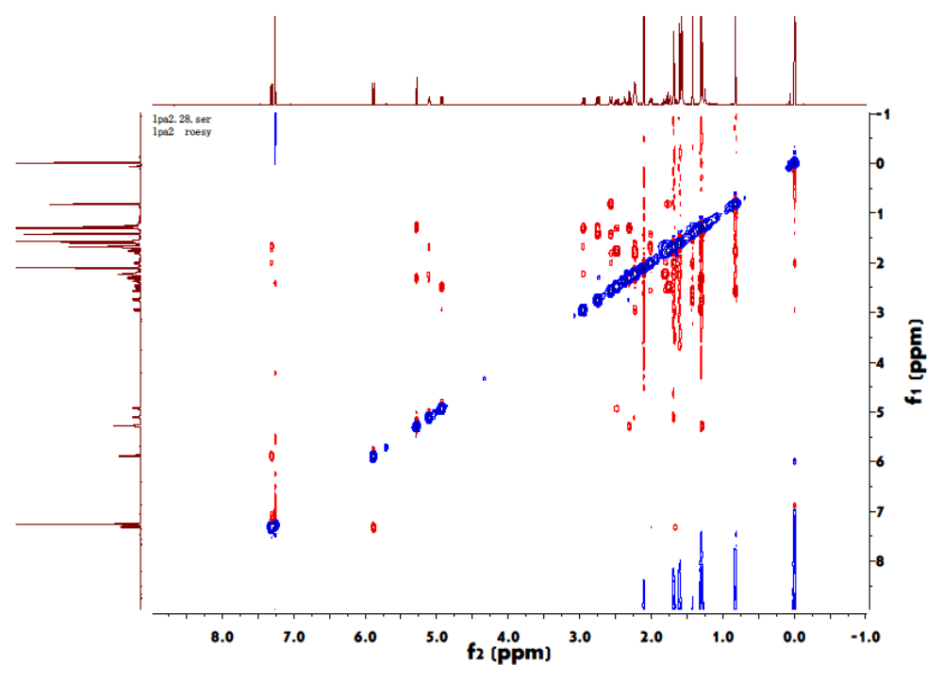Fig S13 ROESY spectrum of compound 1 in CDCl₃

