**Annexure**

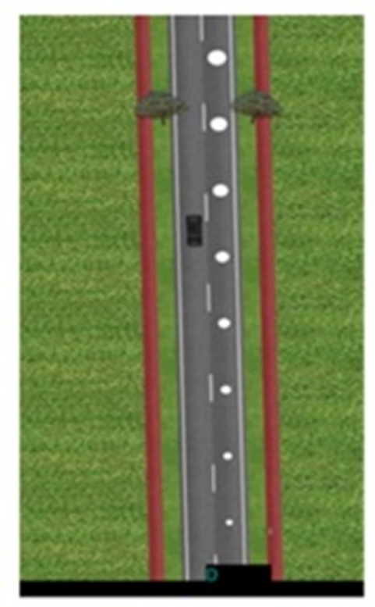

Figure A1: Top view of Optical Circles

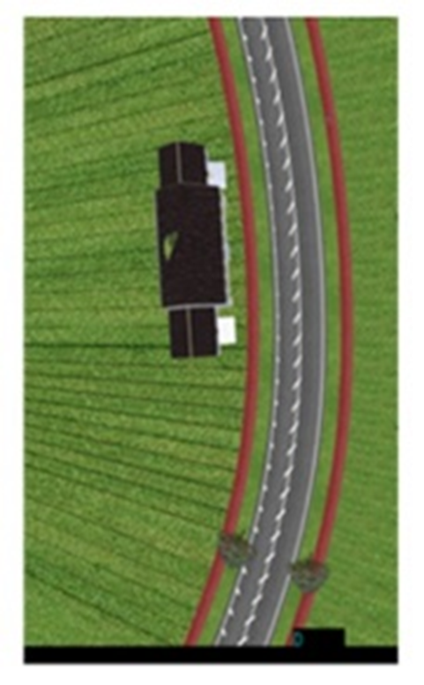

Figure A2: Top view of Herringbone

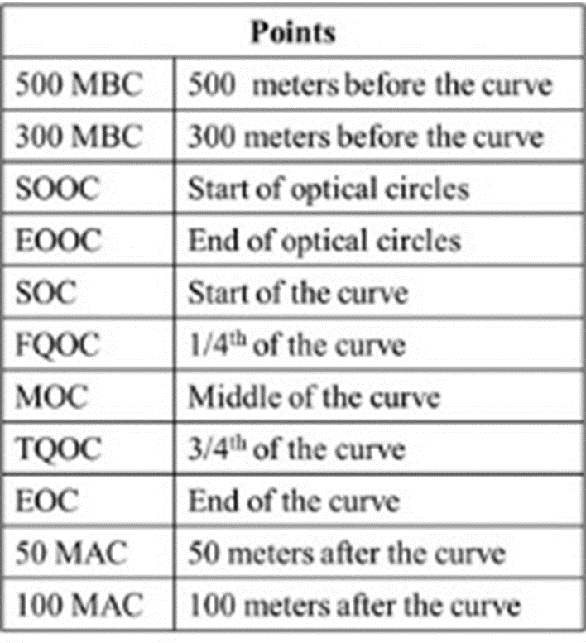

Figure A3: Description of 11 data points before, at and after the curves

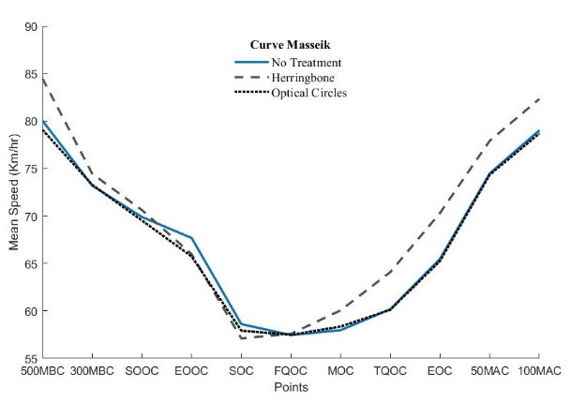

Figure A4: Mean Speed at the curve Masseik

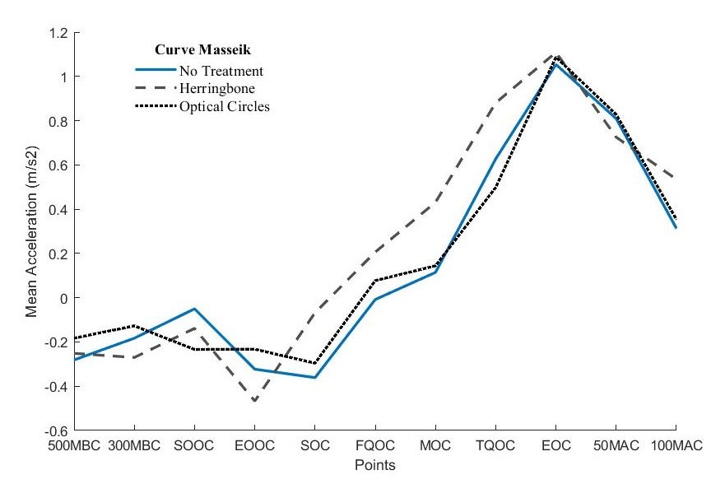

Figure A5: Mean Acceleration at the curve Masseik

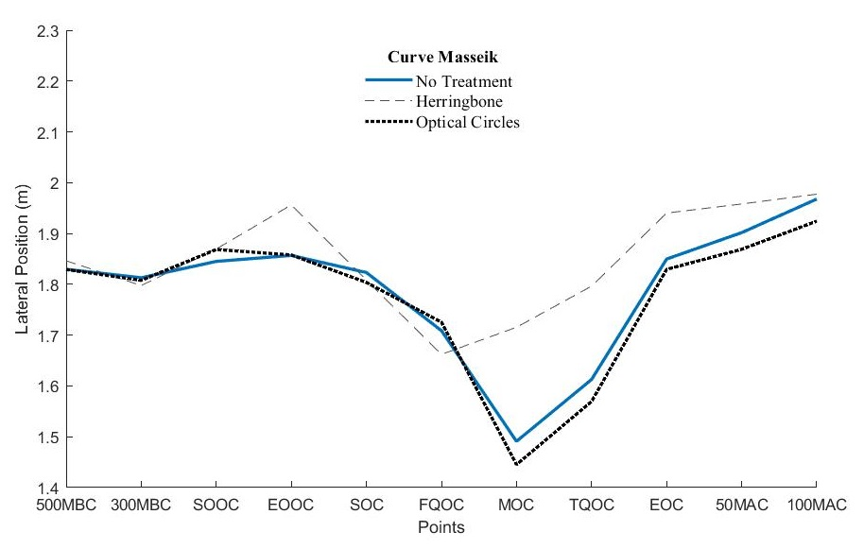

Figure A6: Lateral Position at the curve Masseik