Supporting Information

Polyurethane Acrylate-supported rGO/TiO₂ Electrical Conductive and Antibacterial Nanocomposites

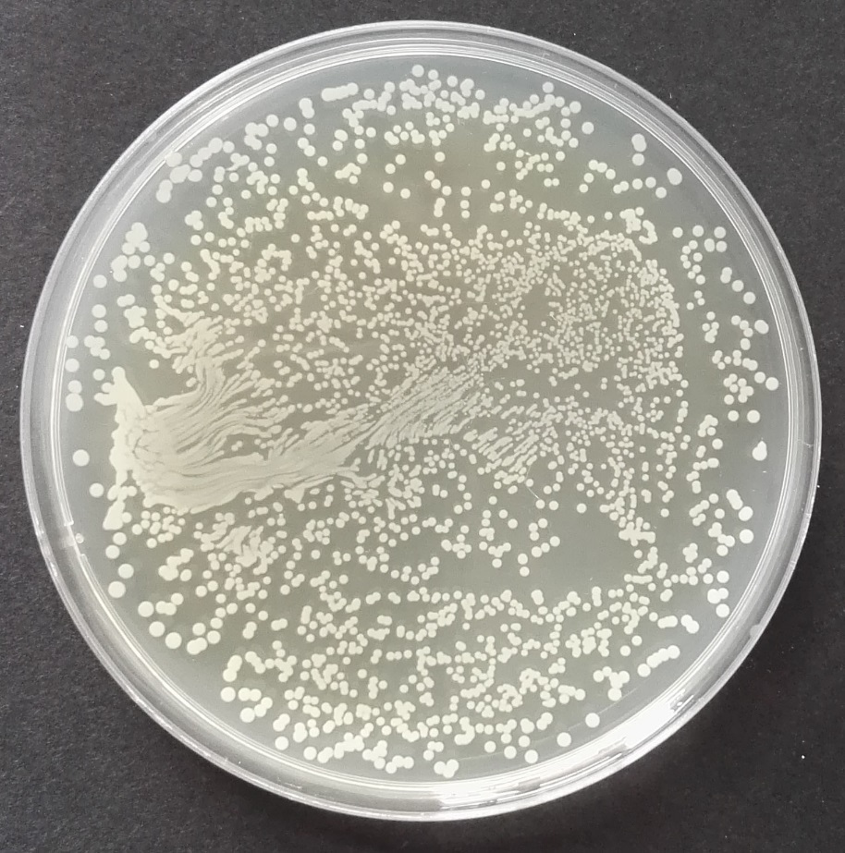

Figure S1 The optical images of S. aureus incubated on agar plates after 150 min treated with PUA-Ag/TiO₂ nanocomposite films under the experiment condition of visible light illumination.

