Supplemental Material File (SMF) of the article:
Synthesis, kinetics and a full mechanistic investigation of four-component reaction for preparation of 2-amino-3-cyanopyridine derivatives in the presence of a green catalyst
Sadegh Talaiefar, Sayyed Mostaf Habibi-khorassani*, Mehdi Sharaki and Ebrahim Mollashahi
Department of Chemistry,The University of Sistan and Baluchestan, P. O. Box 98135-674, Zahedan, Iran.
*Corresponding author e-mail: smhabibi@chem.usb.ac.ir

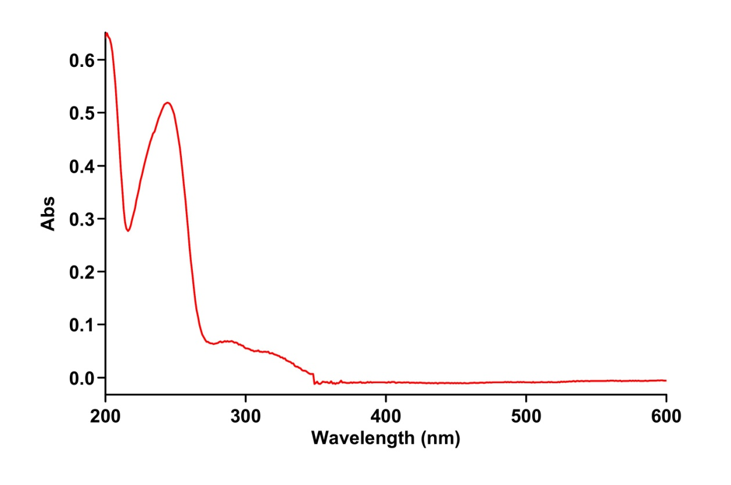
Fig.S₁ : UV spectrm of 5×10⁻³ M mlaoonitrile (2) in a mixture of H2O/ Ethanol (50/50).
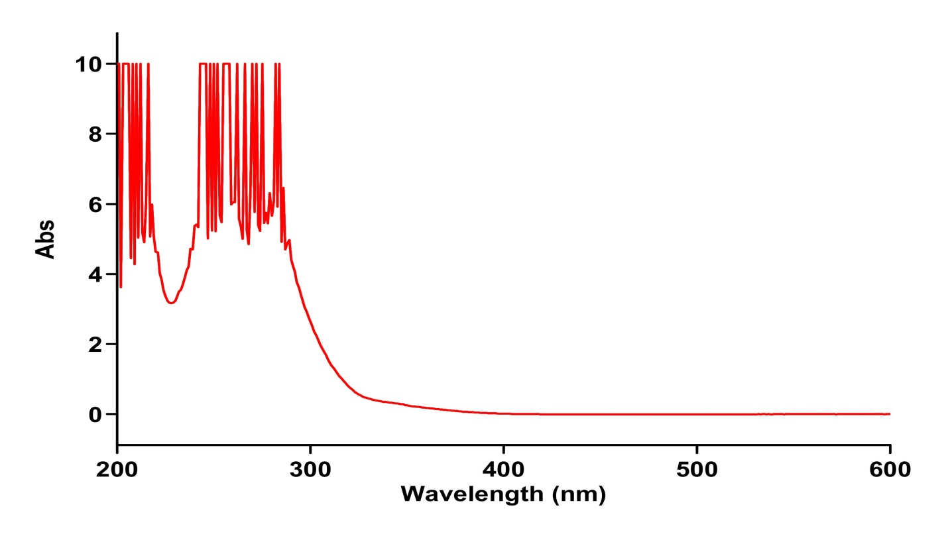
Fig.S₂ : UV spectrm of 5×10⁻³ M 4-nitrobenzaldeyd (2) in a mixture of H2O/ Ethanol (50/50).
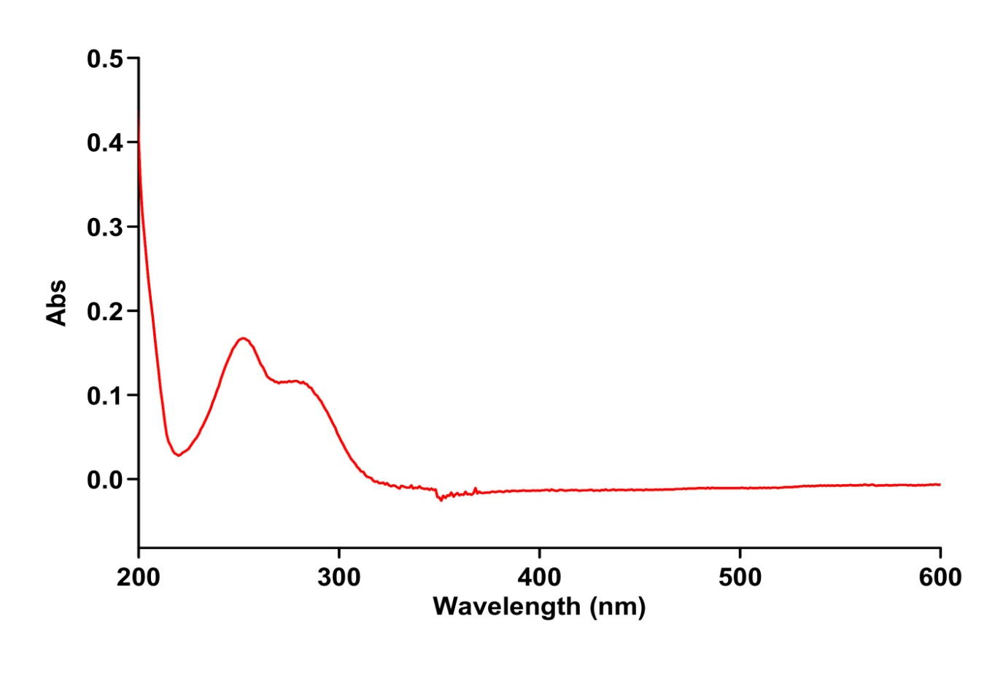
Fig.S₃ : UV spectrm of 5×10⁻³ M cyclohexanone (3) in a mixture of H2O/ Ethanol (50/50).
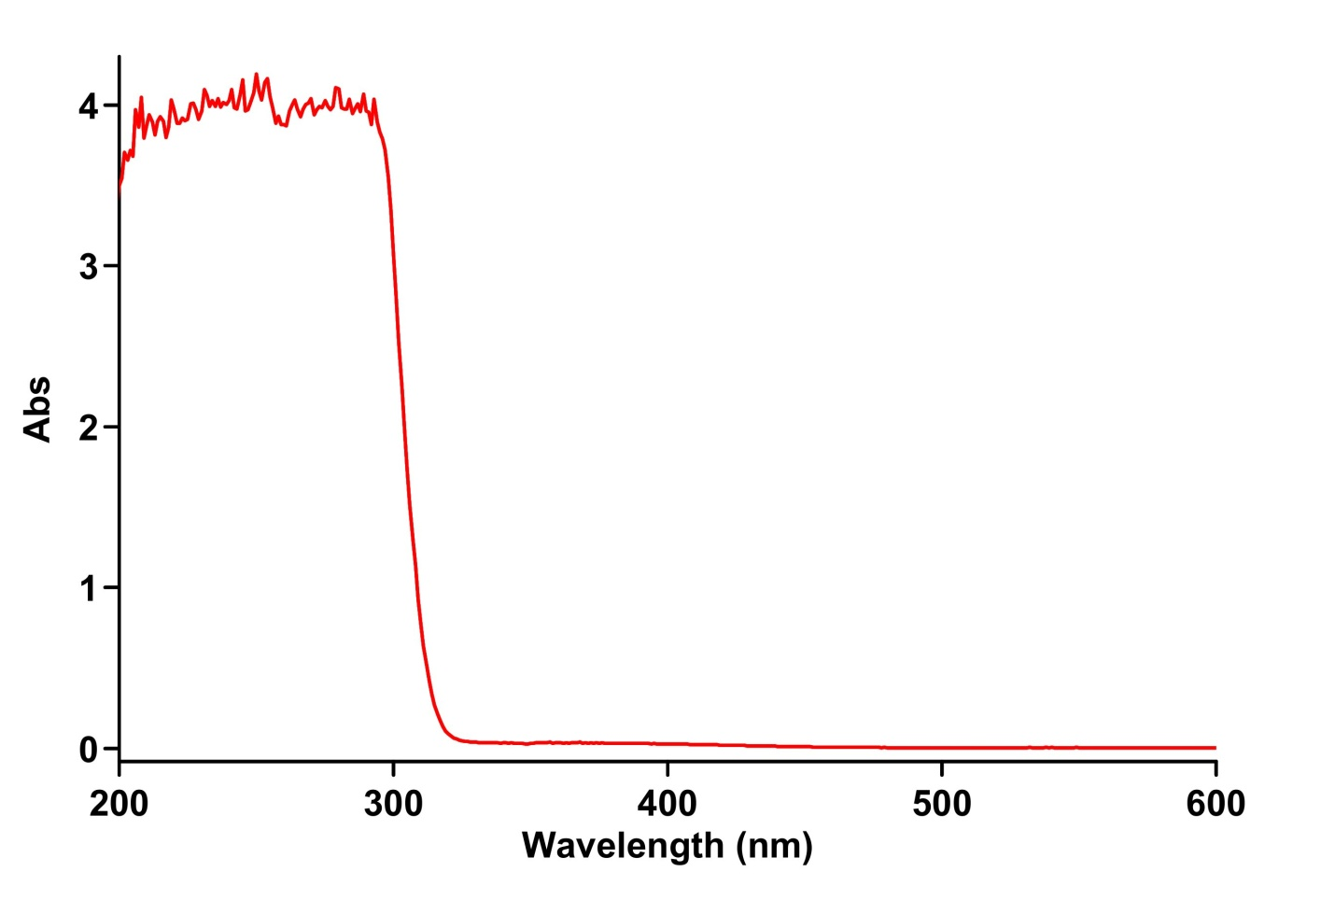
Fig.S₄ : UV spectrm of 5×10⁻³ M aniline (4) in a mixture of H2O/ Ethanol (50/50).
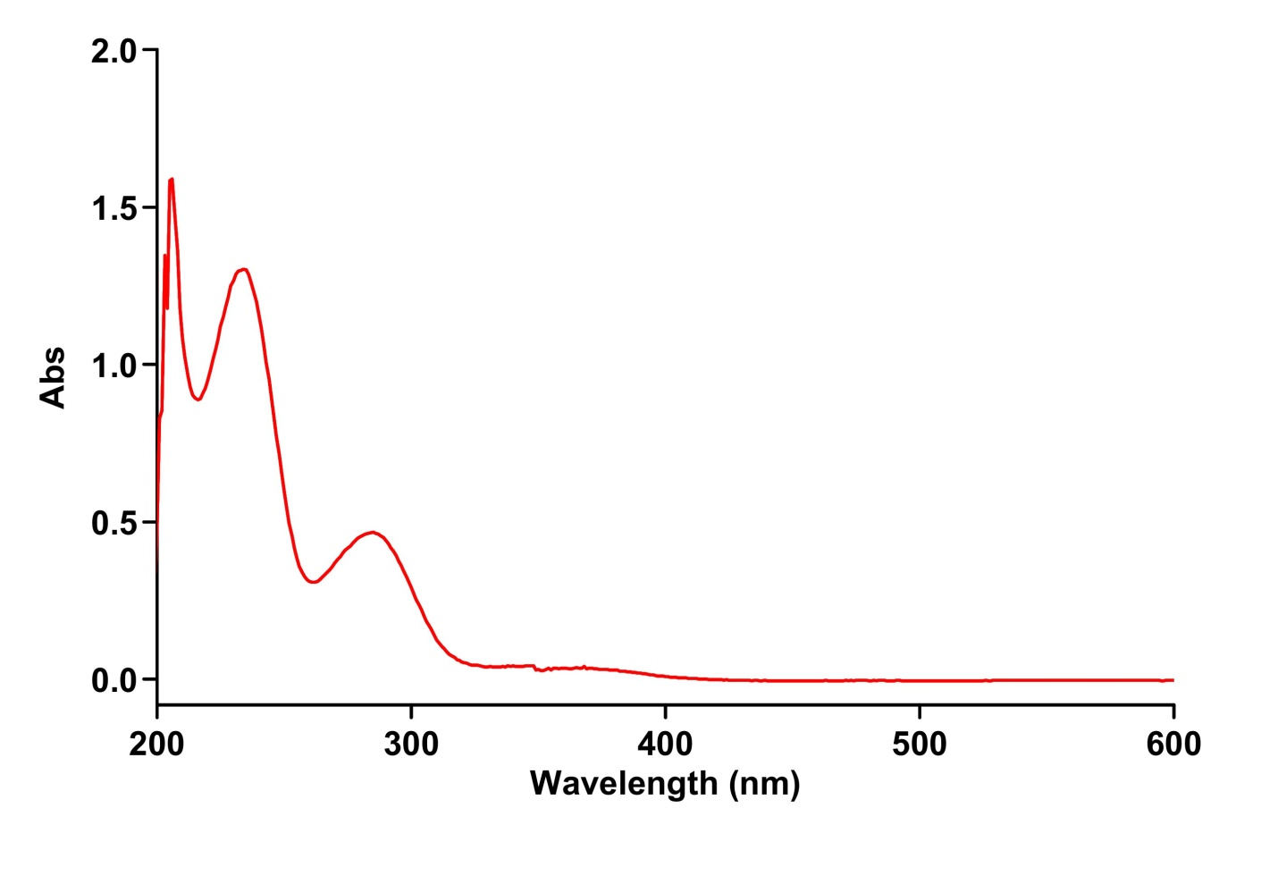
Fig.S₅ : UV spectrm of 5×10⁻³ M maltose in a mixture of H2O/ Ethanol (50/50).

Fig.S₆. UV spectra of the reaction progress between (1), (2), (3) and (4) the presence of maltose catalyst, the upward arrow indicates product increasing with the passage time.

Fig.S₇ : Second- order fitting curve (solid line) on experimental absorbance curve for the product (5) formation versus time at 410 nm and 30 C under pseudo-order condition with respect to aniline [(4), 2.5×10⁻⁴ M]

Fig.S₈. Second- order fitting curve (solid line) on experimental absorbance curve for the product (5) formation versus time at 410 nm and 30 C under pseudo-order condition with respect to cyohexanone[(3), 2.5×10⁻⁴ M]
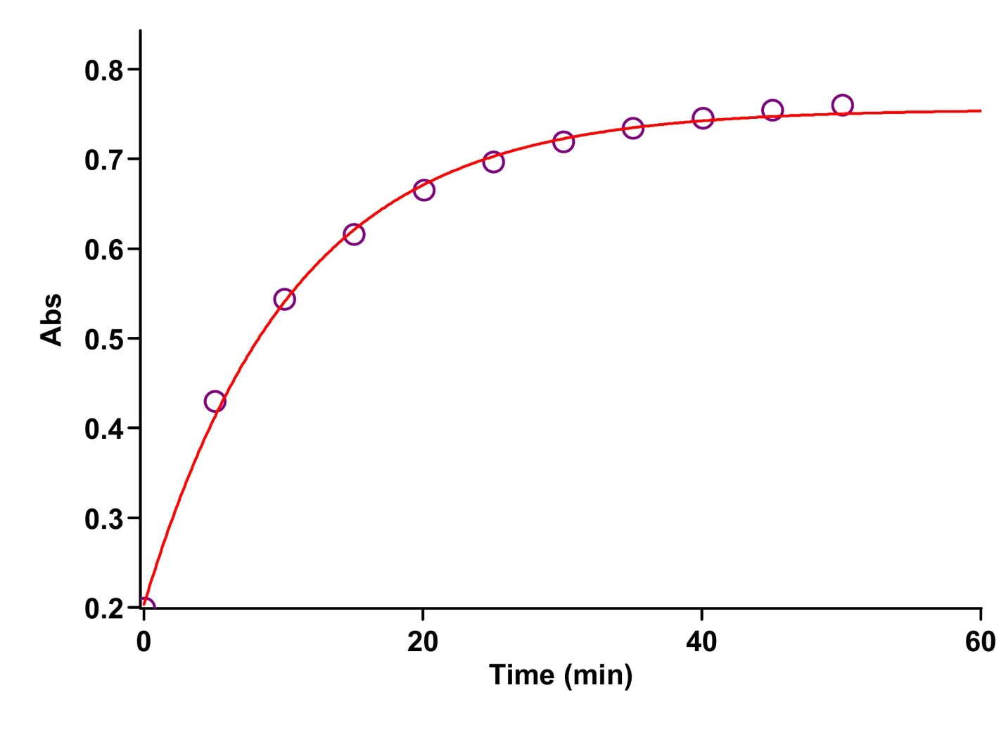

Fig.S₉ : First- order fitting curve (solid line) on experimental absorbance curve for the product (5) formation versus time at 410 nm and 30 C under pseudo-order condition with respect to 4-nitrobezaldehyde [(2), 2.5×10⁻⁴ M]

Fig.S₁₀ : Dependence of ln k on reciprocal temperature in order to evaluate Ea/R from the slope according to the Arrhenius equation .

Fig.S₁₁ : Dependence of ln k/T on reciprocal temperature in order to evaluate activation parameters (ΔH‡ and ΔS‡, respectively) from the slope and intercept according to the Eyring equation, for the reaction between 4-nitro benzaldehyde (2), malononitrile (1), cyclohexanone (3) and aniline (4) in the presence of maltose as a catalyst in a mixture of water and ethanol (50 : 50).

Fig.S₁₂ : Dependence of ln k/T on reciprocal temperature in order to evaluate activation parameters (ΔH‡ and ΔS‡, respectively) from the slope and intercept according to the Eyring equation, for the reaction between 4-nitro benzaldehyde (2), malononitrile (1), cyclohexanone (3) and aniline (4) in the presence of maltose as a catalyst in a mixture of water and ethanol (20 : 80).

Fig.S₁₃ : Dependence of ln k/T on reciprocal temperature in order to evaluate activation parameters (ΔH‡ and ΔS‡, respectively) from the slope and intercept according to the Eyring equation, for the reaction between 4-nitro benzaldehyde (2), malononitrile (1), cyclohexanone (3) and aniline (4) in the presence of maltose as a catalyst in a mixture of ethanol.

The procedur for deriving the various rate laws:
If the step 10 being the RDS, previous step (step 9) should be the reversible process, herein, the rate law can be written from the following simplied reaction mechanism:

$$Rate= k_{10}\left[I_{9}\right]\left[Cat\right] 〈1〉$$
$$\frac{d\left[I_{9}\right]}{dt}= k_{9}\left[I_{8}\right]\left[Cat\right]- k_{-9}\left[I_{9}\right]\left[Cat\right]-k_{10}\left[I_{9}\right]\left[Cat\right]=0 〈2〉$$
$$\left[I_{9}\right]= \frac{k_{9}\left[I_{8}\right]}{\left(k_{-9}+k_{10}\right) } 〈3〉$$
$$Rate= \frac{k_{10}k_{9}\left[I_{8}\right]}{\left(k_{-9}+k_{10}\right) }\left[Cat\right] 〈4〉$$
$$\frac{d\left[I_{8}\right]}{dt}= k_{8}\left[I_{7}\right]- k_{9}\left[I_{8}\right]\left[Cat\right]-k_{-9}\left[I_{9}\right]\left[Cat\right]=0 〈5〉$$
If $k_{9}≥ k_{-9}$
$$\left[I_{8}\right]= \frac{k_{8}\left[I_{7}\right]}{ k_{9}\left[Cat\right] } 〈6〉$$
$$Rate= \frac{k_{10}k_{8}\left[I_{7}\right]}{\left(k_{-9}+k_{10}\right)} 〈7〉$$
$$\frac{d\left[I_{7}\right]}{dt}=k_{7}\left[I_{6}\right]\left[4\right]\left[Cat\right]- k_{8}\left[I_{7}\right]=0 〈8〉$$
$$\left[I_{7}\right]= \frac{k_{7}\left[I_{6}\right]\left[4\right]\left[Cat\right]}{k_{8} } 〈9〉$$
$$Rate= \frac{k_{10}k_{7}\left[I_{6}\right]\left[4\right]\left[Cat\right]}{\left(k_{-9}+k_{10}\right)} 〈10〉$$
$$\frac{d\left[I_{6}\right]}{dt}= = k_{6}\left[I_{5}\right]- k_{7}\left[I_{6}\right]\left[4\right]\left[Cat\right]=0 〈11〉$$
$$\left[I_{6}\right]= \frac{k_{6}\left[I_{5}\right]}{k_{7}\left[I_{6}\right]\left[4\right]\left[Cat\right]} 〈12〉$$
$$Rate= \frac{k_{10}k_{6}\left[I_{5}\right]}{\left(k_{-9}+k_{10}\right)} 〈13〉$$
$$\frac{d\left[I_{5}\right]}{dt}= k_{5}\left[I_{4}\right]\left[Cat\right]-k_{6}\left[I_{5}\right]=0 〈14〉$$
$$\left[I_{5}\right]= \frac{k_{5}\left[I_{4}\right]\left[Cat\right]}{k_{6}} 〈15〉$$
$$Rate= \frac{k_{10}k_{5}\left[I_{4}\right]\left[Cat\right]}{\left(k_{-9}+k_{10}\right)} 〈16〉$$
$$\frac{d\left[I_{4}\right]}{dt}= k_{4}\left[I_{3}\right]\left[Cat\right]-k_{5}\left[I_{4}\right]\left[Cat\right]=0 〈17〉$$
$$\left[I_{4}\right]= \frac{k_{4}\left[I_{3}\right]}{k_{5}} 〈18〉$$
$$Rate= \frac{k_{10}k_{4}\left[I_{3}\right]\left[Cat\right]}{\left(k_{-9}+k_{10}\right)} 〈19〉$$
$$\frac{d\left[I_{3}\right]}{dt}= k_{3}\left[I_{2}\right]\left[3\right]\left[Cat\right]-k_{4}\left[I_{3}\right]\left[Cat\right]=0 〈20〉$$
$$\left[I_{3}\right]= \frac{k_{3}\left[I_{2}\right]\left[3\right]}{k_{4}} 〈21〉$$
$$Rate= \frac{k_{10}k_{3}\left[I_{2}\right]\left[3\right]\left[Cat\right]}{\left(k_{-9}+k_{10}\right)} 〈22〉$$
$$\frac{d\left[I_{2}\right]}{dt}= k_{2}\left[I_{1}\right]\left[Cat\right]-k_{3}\left[I_{2}\right]\left[3\right]\left[Cat\right]=0 〈23〉$$
$$\left[I_{2}\right]= \frac{k_{3}\left[I_{2}\right]\left[3\right]}{k_{2}} 〈24〉$$
$$Rate= \frac{k_{10}k_{2}\left[I_{1}\right]\left[Cat\right]}{\left(k_{-9}+k_{10}\right)} 〈25〉$$
$$\frac{d\left[I_{1}\right]}{dt}= k_{1}\left[1\right]\left[2\right]\left[Cat\right]-k_{-1}\left[I_{1}\right]\left[Cat\right]-k_{2}\left[I_{1}\right]\left[Cat\right]=0 〈26〉$$
$$\left[I_{1}\right]= \frac{k_{1}\left[1\right]\left[2\right]}{\left(k_{-1}+k_{2}\right)} 〈27〉$$
$$Rate= \frac{k_{10}k_{1}\left[1\right]\left[2\right]\left[Cat\right]}{\left(k_{-9}\right)} 〈28〉$$

If the step₉ bing the RDS, previous step (step ₈) should be revesiable process, hear the rate law can be written from the following simplied reaction mechanism:

$$Rate= k_{9}\left[I_{8}\right]\left[Cat\right] 〈29〉$$
$$\frac{d\left[I_{8}\right]}{dt}= k_{8}\left[I_{7}\right]+k_{-8}\left[I_{8}\right]\left[H_{2}\right]-k_{9}\left[I_{8}\right]\left[Cat\right] =0 〈30〉$$
$$\left[I_{8}\right]= \frac{k_{8}\left[I_{7}\right]}{\left(k_{-8}\left[H_{2}\right]-k_{9}\left[Cat\right]\right)} 〈31〉$$
$$Rate= \frac{k_{9}k_{8}\left[I_{7}\right]\left[Cat\right]}{\left(k_{-8}\left[H_{2}\right]-k_{9}\left[Cat\right]\right)} 〈33〉$$
$$\frac{d\left[I_{7}\right]}{dt}= k_{7}\left[I_{6}\right]\left[4\right]\left[Cat\right]+k_{-8}\left[I_{8}\right]\left[H_{2}\right]-k_{8}\left[I_{7}\right]\left[Cat\right] =0 〈34〉$$
If $k_{8}≥ k_{-8}$
$$\left[I_{7}\right]= \frac{k_{7}\left[I_{6}\right]\left[4\right]}{k_{8}\left[I_{7}\right]} 〈35〉$$
$$Rate= \frac{k_{9}k_{8}k_{7}\left[I_{6}\right]\left[4\right]\left[Cat\right]}{\left(k_{-8}\left[H_{2}\right]-k_{9}\left[Cat\right]\right)} 〈36〉$$
$$\frac{d\left[I_{6}\right]}{dt}= = k_{6}\left[I_{5}\right]- k_{7}\left[I_{6}\right]\left[4\right]\left[Cat\right]=0 〈37〉$$
$$\left[I_{6}\right]= \frac{k_{6}\left[I_{5}\right]}{k_{7}\left[I_{6}\right]\left[4\right]\left[Cat\right]} 〈38〉$$
$$Rate= \frac{k_{9}k_{8}k_{6}\left[I_{5}\right]}{\left(k_{-8}\left[H_{2}\right]-k_{9}\left[Cat\right]\right)} 〈39〉$$
$$\frac{d\left[I_{5}\right]}{dt}= k_{5}\left[I_{4}\right]\left[Cat\right]-k_{6}\left[I_{5}\right]=0 〈40〉$$
$$\left[I_{5}\right]= \frac{k_{5}\left[I_{4}\right]\left[Cat\right]}{k_{6}} 〈41〉$$
$$Rate= \frac{k_{9}k_{8}k_{5}\left[I_{4}\right]\left[Cat\right]}{\left(k_{-8}\left[H_{2}\right]-k_{9}\left[Cat\right]\right)} 〈42〉$$
$$\frac{d\left[I_{4}\right]}{dt}= k_{4}\left[I_{3}\right]\left[Cat\right]-k_{5}\left[I_{4}\right]\left[Cat\right]=0 〈43〉$$
$$\left[I_{4}\right]= \frac{k_{4}\left[I_{3}\right]}{k_{5}} 〈44〉$$
$$Rate= \frac{k_{9}k_{8}k_{4}\left[I_{3}\right]\left[Cat\right]}{\left(k_{-8}\left[H_{2}\right]-k_{9}\left[Cat\right]\right)} 〈45〉$$
$$\frac{d\left[I_{3}\right]}{dt}= k_{3}\left[I_{2}\right]\left[3\right]\left[Cat\right]-k_{4}\left[I_{3}\right]\left[Cat\right]=0 〈46〉$$
$$\left[I_{2}\right]= \frac{k_{3}\left[I_{2}\right]\left[3\right]}{k_{4}} 〈47〉$$
$$Rate= \frac{k_{9}k_{8}k_{3}\left[I_{2}\right]\left[3\right]\left[Cat\right]}{\left(k_{-8}\left[H_{2}\right]-k_{9}\left[Cat\right]\right)} 〈48〉$$
$$\frac{d\left[I_{2}\right]}{dt}= k_{2}\left[I_{1}\right]\left[Cat\right]-k_{3}\left[I_{2}\right]\left[3\right]\left[Cat\right]=0 〈49〉$$
$$\left[I_{2}\right]= \frac{k_{3}\left[I_{2}\right]\left[3\right]}{k_{2}} 〈50〉$$
$$Rate= \frac{k_{9}k_{8}k_{2}\left[I_{1}\right]\left[Cat\right]}{\left(k_{-8}\left[H_{2}\right]-k_{9}\left[Cat\right]\right)} 〈51〉$$
$$\frac{d\left[I_{1}\right]}{dt}= k_{1}\left[1\right]\left[2\right]\left[Cat\right]-k_{-1}\left[I_{1}\right]\left[Cat\right]-k_{2}\left[I_{1}\right]\left[Cat\right]=0 〈52〉$$
$$\left[I_{1}\right]= \frac{k_{1}\left[1\right]\left[2\right]}{\left(k_{-1}+k_{2}\right)} 〈53〉$$
$$Rate= \frac{k_{9}k_{8}k_{2}k_{1}\left[1\right]\left[2\right]\left[Cat\right]}{\left(k_{-8}\left[H_{2}\right]-k_{9}\left[Cat\right]\right)\left(k_{-1}+k_{2}\right)} 〈54〉$$
$$Rate= \frac{k_{9}k_{8}k_{2}k_{1}\left[1\right]\left[2\right]\left[Cat\right]}{\left(k_{-8}\left[H_{2}\right]\right)} 〈55〉$$

If the step₈ bing the RDS, previous step (step ₇) should be revesiable process, hear the rate law can be written from the following simplied reaction mechanism:

$$Rate= k_{8}\left[I_{7}\right] 〈56〉$$
$$\frac{d\left[I_{7}\right]}{dt}= k_{7}\left[I_{6}\right]\left[4\right]\left[Cat\right]-k_{-7}\left[I_{7}\right]\left[Cat\right]-k_{8}\left[I_{7}\right] =0 〈57〉$$
$$\left[I_{7}\right]= \frac{k_{7}\left[I_{6}\right]\left[4\right]\left[Cat\right]}{\left(k_{-7}\left[Cat\right]+k_{8}\right)} 〈58〉$$
$$Rate= \frac{{k_{8}k}_{7}\left[I_{6}\right]\left[4\right]\left[Cat\right]}{\left(k_{-7}\left[Cat\right]+k_{8}\right)} 〈59〉$$
$$\frac{d\left[I_{6}\right]}{dt}= k_{6}\left[I_{5}\right]-k_{7}\left[I_{6}\right]\left[4\right]\left[Cat\right]+k_{-7}\left[I_{7}\right]\left[Cat\right] =0 〈60〉$$
If $k_{7}≥ k_{-7}$
$$\left[I_{6}\right]= \frac{k_{6}\left[I_{5}\right]}{k_{7}\left[I_{6}\right]\left[4\right]\left[Cat\right]} 〈61〉$$
$$Rate= \frac{k_{8}k_{6}\left[I_{5}\right]}{\left(k_{-7}\left[Cat\right]+k_{8}\right)} \frac{d\left[I_{5}\right]}{dt}= k_{5}\left[I_{4}\right]\left[Cat\right]-k_{6}\left[I_{5}\right]=0 〈62〉$$
$$\left[I_{5}\right]= \frac{k_{5}\left[I_{4}\right]\left[Cat\right]}{k_{6}} 〈63〉$$
$$R= \frac{k_{8}k_{5}\left[I_{4}\right]\left[Cat\right]}{\left(k_{-7}\left[Cat\right]+k_{8}\right)} 〈64〉$$
$$\frac{d\left[I_{4}\right]}{dt}= k_{4}\left[I_{3}\right]\left[Cat\right]-k_{5}\left[I_{4}\right]\left[Cat\right]=0 \left[I_{4}\right]= \frac{k_{4}\left[I_{3}\right]}{k_{5}} 〈65〉$$
$$Rate= \frac{k_{8}k_{4}\left[I_{3}\right]\left[Cat\right]}{\left(k_{-7}\left[Cat\right]+k_{8}\right)} 〈66〉$$
$$\frac{d\left[I_{3}\right]}{dt}= k_{3}\left[I_{2}\right]\left[3\right]\left[Cat\right]-k_{4}\left[I_{3}\right]\left[Cat\right]=0 〈67〉$$
$$\left[I_{2}\right]= \frac{k_{3}\left[I_{2}\right]\left[3\right]}{k_{4}} 〈68〉$$
$$Rate= \frac{k_{8}k_{3}\left[I_{2}\right]\left[3\right]\left[Cat\right]}{\left(k_{-7}\left[Cat\right]+k_{8}\right)} 〈69〉$$
$$\frac{d\left[I_{2}\right]}{dt}= k_{2}\left[I_{1}\right]\left[Cat\right]-k_{3}\left[I_{2}\right]\left[3\right]\left[Cat\right]=0 〈70〉$$
$$\left[I_{2}\right]= \frac{k_{3}\left[I_{2}\right]\left[3\right]}{k_{2}} 〈71〉$$
$$Rate= \frac{k_{8}k_{2}\left[I_{1}\right]\left[Cat\right]}{\left(k_{-7}\left[Cat\right]+k_{8}\right)} 〈72〉$$
$$\frac{d\left[I_{1}\right]}{dt}= k_{1}\left[1\right]\left[2\right]\left[Cat\right]-k_{-1}\left[I_{1}\right]\left[Cat\right]-k_{2}\left[I_{1}\right]\left[Cat\right]=0 〈73〉$$

$$\left[I_{1}\right]= \frac{k_{1}\left[1\right]\left[2\right]}{\left(k_{-1}+k_{2}\right)} 〈74〉$$
$$Rate= \frac{k_{8}k_{2}k_{1}\left[1\right]\left[2\right]\left[Cat\right]}{\left(k_{-7}\left[Cat\right]+k_{8}\right)\left(k_{-1}+k_{2}\right)} 〈75〉$$
$$Rate= \frac{k_{8}k_{2}k_{1}\left[1\right]\left[2\right]\left[Cat\right]}{\left(k_{-7}\left[Cat\right]\right)} 〈76〉$$

If the step₇ bing the RDS, previous step (step ₆) should be revesiable process, hear the rate law can be written from the following simplied reaction mechanism:

$$Rate= k_{7}\left[I_{6}\right]\left[4\right]\left[Cat\right] 〈77〉$$
$$\frac{d\left[I_{6}\right]}{dt}=k_{6}\left[I_{5}\right]-k_{7}\left[I_{6}\right]\left[4\right]\left[Cat\right]-k_{-6}\left[I_{6}\right]\left[Cat\right] =0 〈78〉$$
$$\left[I_{6}\right]\left[Cat\right]= \frac{k_{6}\left[I_{5}\right]}{\left(k_{7}\left[4\right]+k_{-6}\right)} 〈79〉$$
$$Rate= \frac{k_{7}k_{6}\left[4\right]\left[I_{5}\right]}{\left(k_{7}\left[4\right]+k_{-6}\right)} 〈80〉$$
$$\frac{d\left[I_{5}\right]}{dt}= k_{5}\left[I_{4}\right]-k_{6}\left[I_{5}\right]+k_{-6}\left[I_{6}\right]\left[Cat\right] =0 〈81〉$$
I f $k_{6} k_{-6}$
$$\left[I_{5}\right]= \frac{k_{5}\left[I_{4}\right]}{k_{6}} 〈82〉$$
$$Rate= \frac{k_{7}k_{5}\left[4\right]\left[I_{4}\right]}{\left(k_{7}\left[4\right]+k_{-6}\right)} 〈83〉$$
$$\frac{d\left[I_{4}\right]}{dt}= k_{4}\left[I_{3}\right]\left[Cat\right]-k_{5}\left[I_{4}\right]\left[Cat\right]=0 〈84〉$$
$$\left[I_{4}\right]= \frac{k_{4}\left[I_{3}\right]}{k_{5}} 〈85〉$$
$$Rate= \frac{k_{7}k_{4}\left[4\right]\left[I_{3}\right]\left[Cat\right]}{\left(k_{7}\left[4\right]+k_{-6}\right)} 〈86〉$$
$$\frac{d\left[I_{3}\right]}{dt}= k_{3}\left[I_{2}\right]\left[3\right]\left[Cat\right]-k_{4}\left[I_{3}\right]\left[Cat\right]=0 〈87〉$$
$$\left[I_{2}\right]= \frac{k_{3}\left[I_{2}\right]\left[3\right]}{k_{4}} 〈88〉$$
$$Rate= \frac{k_{7}k_{3}\left[I_{2}\right]\left[3\right]\left[Cat\right]}{\left(k_{7}\left[4\right]+k_{-6}\right)} 〈89〉$$
$$\frac{d\left[I_{2}\right]}{dt}= k_{2}\left[I_{1}\right]\left[Cat\right]-k_{3}\left[I_{2}\right]\left[3\right]\left[Cat\right]=0 〈90〉$$
$$\left[I_{2}\right]= \frac{k_{3}\left[I_{2}\right]\left[3\right]}{k_{2}} 〈91〉$$
$$Rate= \frac{k_{7}k_{2}\left[I_{1}\right]\left[Cat\right]}{\left(k_{7}\left[4\right]+k_{-6}\right)} 〈92〉$$
$$\frac{d\left[I_{1}\right]}{dt}=k_{1}\left[1\right]\left[2\right]\left[Cat\right]-k_{-1}\left[I_{1}\right]\left[Cat\right]-k_{2}\left[I_{1}\right]\left[Cat\right]=0 〈93〉$$
$$\left[I_{1}\right]= \frac{k_{1}\left[1\right]\left[2\right]}{\left(k_{-1}+k_{2}\right)} 〈94〉$$
$$Rate= \frac{k_{7}k_{2}k_{1}\left[1\right]\left[2\right]\left[Cat\right]}{\left(k_{7}\left[4\right]+k_{-6}\right)\left(k_{-1}+k_{2}\right)} 〈95〉$$
$$Rate= \frac{k_{7}k_{2}k_{1}\left[1\right]\left[2\right]\left[Cat\right]}{\left(k_{-6}\right)} 〈95〉$$

If the step₆ bing the RDS, previous step (step ₅) should be revesiable process, hear the rate law can be written from the following simplied reaction mechanism:
$$Rate= k_{6}\left[I_{5}\right] 〈96〉$$
$$\frac{d\left[I_{5}\right]}{dt}= k_{5}\left[I_{4}\right]\left[Cat\right]-k_{-5}\left[I_{5}\right]\left[Cat\right]-k_{6}\left[I_{5}\right] =0 〈97〉$$
$$\left[I_{5}\right]= \frac{k_{5}\left[I_{4}\right]\left[Cat\right]}{\left(k_{-5}\left[Cat\right]+k_{-6}\right)} 〈98〉$$
$$Rate= \frac{k_{6}k_{5}\left[I_{4}\right]\left[Cat\right]}{\left(k_{-5}\left[Cat\right]+k_{-6}\right)} 〈99〉$$
$$\frac{d\left[I_{4}\right]}{dt}=k_{4}\left[I_{3}\right]\left[Cat\right]-k_{5}\left[I_{4}\right]\left[Cat\right]-k_{-5}\left[I_{5}\right]\left[Cat\right]=0 〈100〉$$
I f $k_{5} k_{-5}$
$$\left[I_{4}\right]= \frac{k_{4}\left[I_{3}\right]}{k_{5}} 〈101〉$$
$$Rate= \frac{k_{6}k_{4}\left[I_{3}\right]\left[Cat\right]}{\left(k_{-5}\left[Cat\right]+k_{-6}\right)} 〈102〉$$
$$\frac{d\left[I_{3}\right]}{dt}= k_{3}\left[I_{2}\right]\left[3\right]\left[Cat\right]-k_{4}\left[I_{3}\right]\left[Cat\right]=0 〈103〉$$
$$\left[I_{2}\right]= \frac{k_{3}\left[I_{2}\right]\left[3\right]}{k_{4}} 〈104〉$$
$$Rate= \frac{k_{6}k_{3}\left[I_{2}\right]\left[3\right]\left[Cat\right]}{\left(k_{-5}\left[Cat\right]+k_{-6}\right)} 〈105〉$$
$$\frac{d\left[I_{2}\right]}{dt}= k_{2}\left[I_{1}\right]\left[Cat\right]-k_{3}\left[I_{2}\right]\left[3\right]\left[Cat\right]=0 〈106〉$$
$$\left[I_{2}\right]= \frac{k_{3}\left[I_{2}\right]\left[3\right]}{k_{2}} 〈107〉$$
$$Rate= \frac{k_{6}k_{2}\left[I_{1}\right]\left[Cat\right]}{\left(k_{-5}\left[Cat\right]+k_{-6}\right)} 〈108〉$$
$$\frac{d\left[I_{1}\right]}{dt}=k_{1}\left[1\right]\left[2\right]\left[Cat\right]-k_{-1}\left[I_{1}\right]\left[Cat\right]-k_{2}\left[I_{1}\right]\left[Cat\right]=0 〈109〉$$
$$\left[I_{1}\right]= \frac{k_{1}\left[1\right]\left[2\right]}{\left(k_{-1}+k_{2}\right)} 〈110〉$$
$$Rate= \frac{k_{6}k_{2}k_{1}\left[1\right]\left[2\right]\left[Cat\right]}{\left(k_{-5}\left[Cat\right]+k_{-6}\right)\left(k_{-1}+k_{2}\right)} 〈111〉$$
$$Rate= \frac{k_{6}k_{2}k_{1}\left[1\right]\left[2\right]\left[Cat\right]}{\left(k_{-5}\left[Cat\right]+k_{-6}\right)} 〈112〉$$
If the step₅ bing the RDS, previous step (step ₄) should be revesiable process, hear the rate law can be written from the following simplied reaction mechanism:

$$Rate= k_{5}\left[I_{4}\right]\left[Cat\right] 〈113〉$$
$$\frac{d\left[I_{4}\right]}{dt}= k_{4}\left[I_{3}\right]\left[Cat\right]-k_{5}\left[I_{4}\right]\left[Cat\right]-k_{-4}\left[I_{4}\right]\left[Cat\right]=0 〈114〉$$
$$\left[I_{4}\right]= \frac{k_{4}\left[I_{3}\right]}{\left(k_{5}+k_{-4}\right)} 〈115〉$$
$$Rate= \frac{{k_{5}k}_{4}\left[I_{3}\right]\left[Cat\right]}{\left(k_{5}+k_{-4}\right)} 〈116〉$$
$$\frac{d\left[I_{3}\right]}{dt}= k_{3}\left[I_{2}\right]\left[3\right]\left[Cat\right]-k_{4}\left[I_{3}\right]\left[Cat\right]-k_{-4}\left[I_{4}\right]\left[Cat\right]=0 〈117〉$$
I f $k_{4} k_{-4}$
$$\left[I_{4}\right]= \frac{k_{4}\left[I_{3}\right]}{k_{5}} 〈118〉$$
$$Rate= \frac{k_{5}k_{3}\left[I_{2}\right]\left[3\right]\left[Cat\right]}{\left(k_{5}+k_{-4}\right)} 〈119〉$$
$$\frac{d\left[I_{2}\right]}{dt}= k_{2}\left[I_{1}\right]\left[Cat\right]-k_{3}\left[I_{2}\right]\left[3\right]\left[Cat\right]=0 〈120〉$$
$$\left[I_{2}\right]= \frac{k_{3}\left[I_{2}\right]\left[3\right]}{k_{2}} 〈121〉$$
$$Rate= \frac{k_{5}k_{2}\left[I_{1}\right]\left[Cat\right]}{\left(k_{5}+k_{-4}\right)} 〈122〉$$
$$\frac{d\left[I_{1}\right]}{dt}= k_{1}\left[1\right]\left[2\right]\left[Cat\right]-k_{-1}\left[I_{1}\right]\left[Cat\right]-k_{2}\left[I_{1}\right]\left[Cat\right]=0 〈123〉$$
$$\left[I_{1}\right]= \frac{k_{1}\left[1\right]\left[2\right]}{\left(k_{-1}+k_{2}\right)} 〈124〉$$
$$Rate= \frac{k_{5}k_{2}k_{1}\left[1\right]\left[2\right]\left[Cat\right]}{\left(k_{5}+k_{-4}\right)\left(k_{-1}+k_{2}\right)} 〈125〉$$

$$Rate= \frac{k_{5}k_{2}k_{1}\left[1\right]\left[2\right]\left[Cat\right]}{\left(k_{-4}\right)} 〈126〉$$
If the step₄ bing the RDS, previous step (step ₃) should be revesiable process, hear the rate law can be written from the following simplied reaction mechanism:
$$Rate= k_{4}\left[I_{3}\right]\left[Cat\right] 〈127〉$$
$$\frac{d\left[I_{3}\right]}{dt}= k_{3}\left[I_{2}\right]\left[3\right]\left[Cat\right]-k_{4}\left[I_{3}\right]\left[Cat\right]-k_{-3}\left[I_{3}\right]\left[Cat\right]=0 〈128〉$$
$$\left[I_{3}\right]= \frac{k_{3}\left[I_{2}\right]\left[3\right]}{\left(k_{-3}+k_{4}\right)} 〈129〉$$
$$Rate= \frac{{k_{4}k}_{3}\left[I_{2}\right]\left[3\right]\left[Cat\right]}{\left(k_{-3}+k_{4}\right)} 〈130〉$$
$$\frac{d\left[I_{2}\right]}{dt}= k_{2}\left[I_{1}\right]\left[Cat\right]-k_{3}\left[I_{2}\right]\left[3\right]\left[Cat\right]-k_{-3}\left[I_{3}\right]\left[Cat\right]=0 〈131〉$$
I f $k_{3} k_{-3}$
$$\left[I_{2}\right]= \frac{k_{2}\left[I_{1}\right]}{k_{3}\left[3\right]} 〈132〉$$
$$Rate= \frac{{k_{4}k}_{2}\left[I_{1}\right]\left[Cat\right]}{\left(k_{-3}+k_{4}\right)} 〈133〉$$
$$\frac{d\left[I_{1}\right]}{dt}= k_{1}\left[1\right]\left[2\right]\left[Cat\right]-k_{-1}\left[I_{1}\right]\left[Cat\right]-k_{2}\left[I_{1}\right]\left[Cat\right]=0 〈134〉$$
$$\left[I_{1}\right]= \frac{k_{1}\left[1\right]\left[2\right]}{\left(k_{-1}+k_{2}\right)} 〈135〉$$
$$Rate= \frac{{{k_{1}k}_{4}k}_{2}\left[Cat\right]\left[1\right]\left[2\right]}{\left(k_{-3}+k_{4}\right)\left(k_{-1}+k_{2}\right)} 〈136〉$$
$$Rate= \frac{{{k_{1}k}_{4}k}_{2}\left[Cat\right]\left[1\right]\left[2\right]}{\left(k_{-3}\right)} 〈136〉$$
If the step₃ bing the RDS, previous step (step ₂) should be revesiable process, hear the rate law can be written from the following simplied reaction mechanism:

$$Rate= k_{3}\left[I_{2}\right]\left[3\right]\left[Cat\right] 〈137〉$$
$$\frac{d\left[I_{2}\right]}{dt}=k_{2}\left[I_{1}\right]\left[Cat\right]-k_{3}\left[I_{2}\right]\left[3\right]\left[Cat\right]-k_{-2}\left[I_{2}\right]\left[Cat\right]\left[H_{2}O\right]=0 〈138〉$$
$$\left[I_{2}\right]= \frac{k_{2}\left[I_{1}\right]}{\left(k_{3}\left[3\right]+k_{-2}\left[H_{2}O\right]\right)} 〈139〉$$
$$R= \frac{k_{2}k_{3}\left[3\right]\left[I_{1}\right]\left[Cat\right]}{\left(k_{3}\left[3\right]+k_{-2}\left[H_{2}O\right]\right)} 〈140〉$$
$$\frac{d\left[I_{1}\right]}{dt}=k_{1}\left[1\right]\left[2\right]\left[Cat\right]-k_{-1}\left[I_{1}\right]\left[Cat\right]-k_{2}\left[I_{1}\right]\left[Cat\right]-k_{-2}\left[I_{2}\right]\left[Cat\right]\left[H_{2}O\right]=0 〈141〉$$
I f $k_{2} k_{-2}$
$$\left[I_{1}\right]= \frac{k_{1}\left[1\right]\left[2\right]}{\left(k_{-1}+k_{2}\right)} 〈142〉$$
$$Rate= \frac{k_{1}k_{2}k_{3}\left[1\right]\left[2\right]\left[3\right]\left[Cat\right]}{\left(k_{3}\left[3\right]+k_{-2}\left[H_{2}O\right]\right)\left(k_{-1}+k_{2}\right)} 〈143〉$$
$$Rate= \frac{k_{1}k_{2}k_{3}\left[1\right]\left[2\right]\left[3\right]\left[Cat\right]}{\left(k_{-2}\left[H_{2}O\right]\right)} 〈144〉$$
If the step₂ bing the RDS, previous step (step ₁) should be revesiable process, hear the rate law can be written from the following simplied reaction mechanism :

$$Rate= k_{2}\left[I_{1}\right]\left[Cat\right] 〈145〉$$
$\frac{d\left[I_{1}\right]}{dt}=k_{1}\left[1\right]\left[2\right]\left[Cat\right]-k_{-1}\left[I_{1}\right]\left[Cat\right]-k_{2}\left[I_{1}\right]\left[Cat\right]-k_{-2}\left[I_{2}\right]\left[Cat\right]\left[H_{2}O\right]=0$ $〈145〉$
I f $k_{2} k_{-2}$
$$\left[I_{1}\right]= \frac{k_{1}\left[1\right]\left[2\right]}{\left(k_{-1}+k_{2}\right)} 〈146〉$$
$$R= \frac{k_{2}k_{1}\left[1\right]\left[2\right]\left[Cat\right]}{\left(k_{-1}+k_{2}\right)} 〈147〉$$

If the step₂ bing the RDS, previous step (step ₁ should be revesiable process, hear the rate law can be written from the following simplied reaction mechanism:

$$R=k_{1}\left[Cat\right]\left[1\right]\left[2\right]$$

