Supporting information
SrFe₁₂O₁₉ as an efficient catalytic system for the synthesis of highly functionalized 2-naphthol Mannich basesunder solvent free condition

- 1-((2,3-dichlorophenyl)(piperidin-1-yl)methyl)naphthalen-2-ol (4h)

IR:
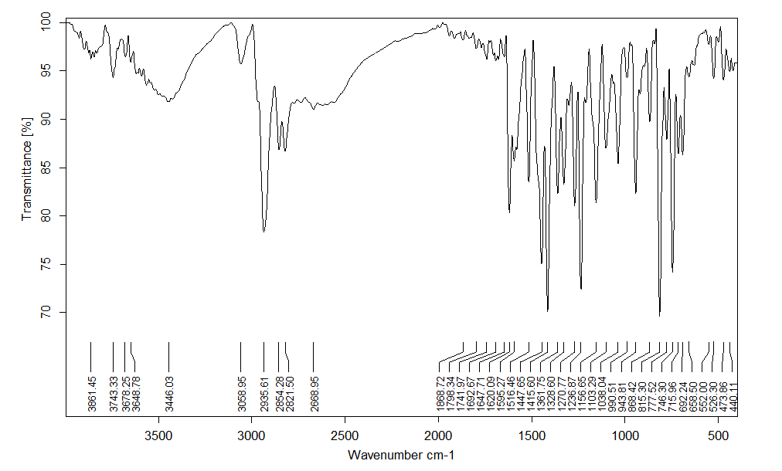

¹HNMR:

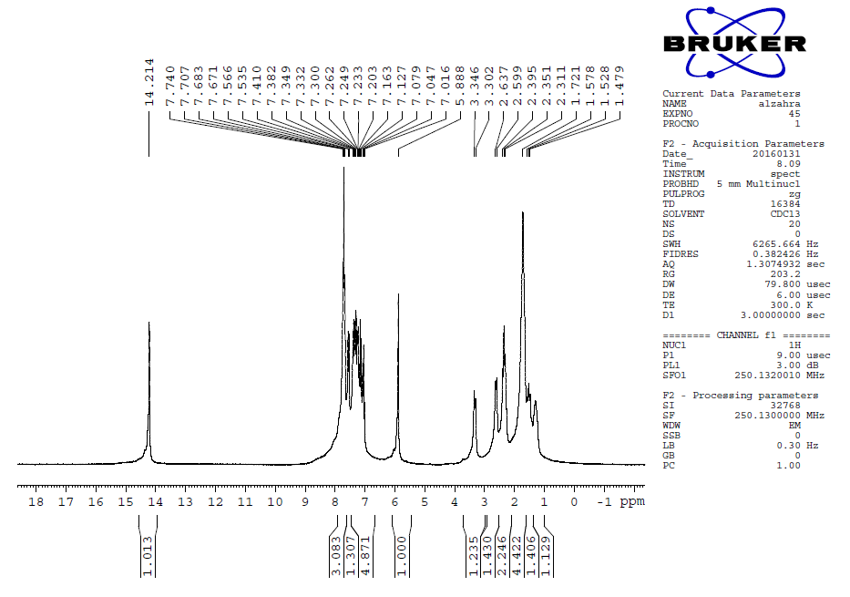
¹³CNMR:
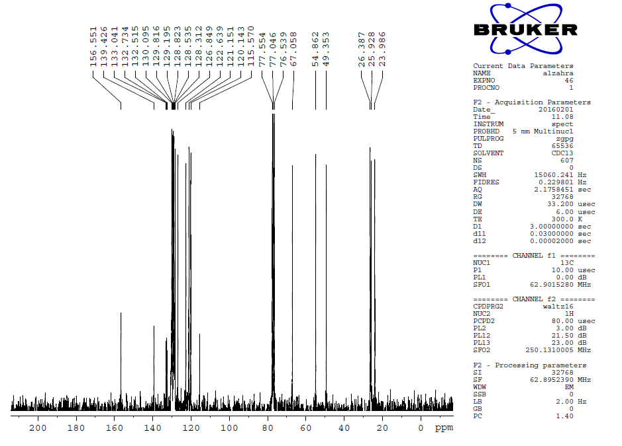

Mass:
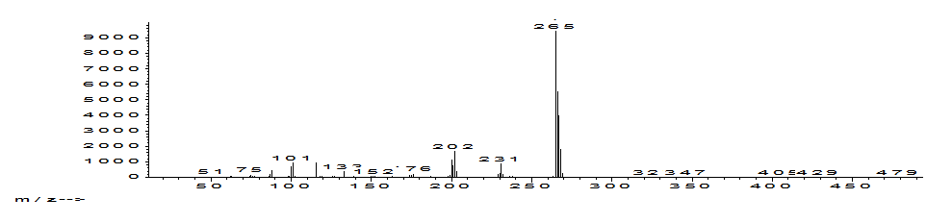

- 1-((3-nitrophenyl)(piperidin-1-yl)methyl)naphthalen-2-ol (4i)

IR:
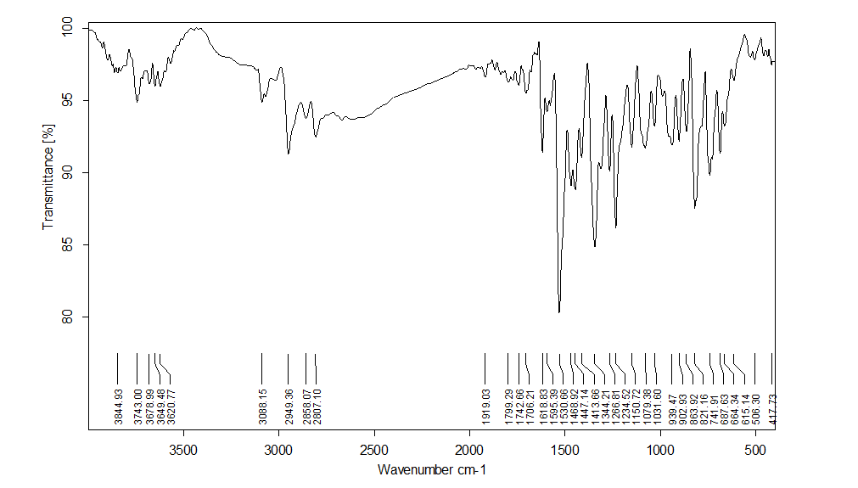

¹HNMR:

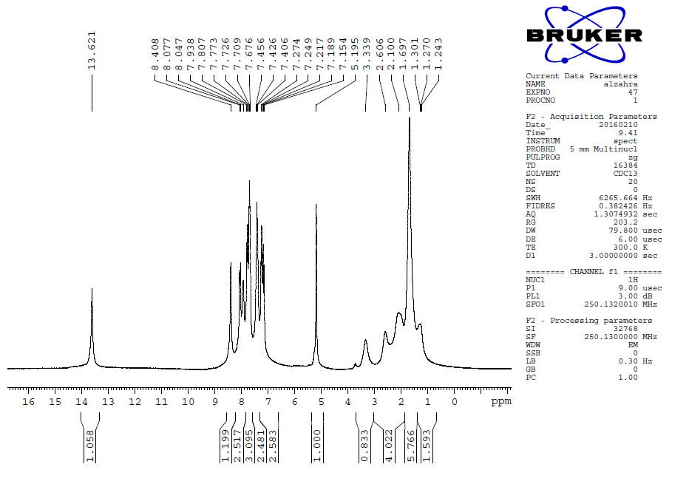
¹³CNMR:

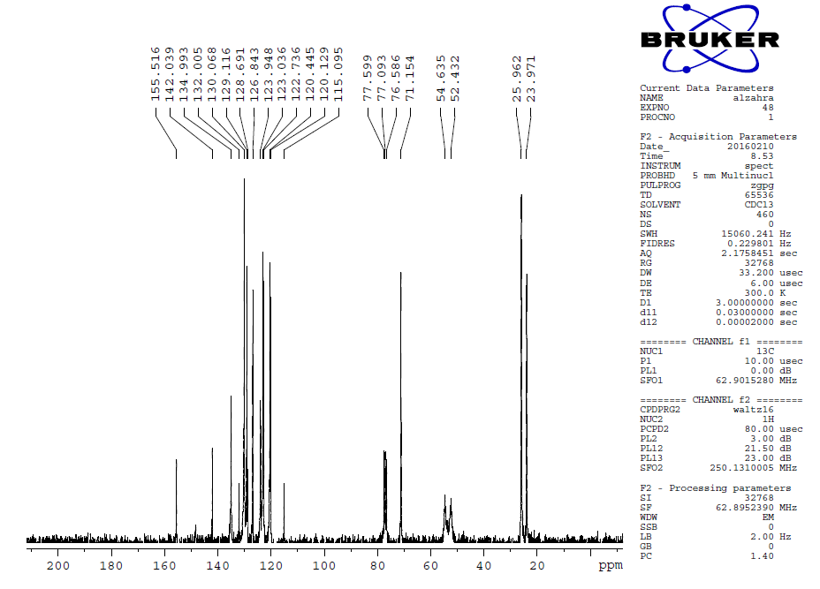

Mass:
