Supplementary Materials for ‘‘Conversational latencies get revised as response latencies unfold’ by Bögels, Kendrick & Levinson

Instructions for Participants (translated from Dutch)
[Instruction screen 1]
In this experiment, you will listen to sound fragments coming from the Corpus Gesproken Nederlands (CGN). The CGN is a project that has established a database with about 1000 hours of speech between 1998 and 2004, under which hundreds of phone calls. Its goal was to enable more research about the Dutch language. Some people participated multiple times, with the same or different partners. Every conversation lasted 10 minutes and was then ended automatically. Participants could determine freely what to talk about.
Press the right button to continue.
[Instruction screen 2]
For the current experiment, we have selected fragments from this corpus, in which speakers make appointments/dates with each other. We only selected fragments in which a question is asked and the answer is ‘yes’ or ‘no’.
Before hearing the fragment, you will first see what the context of this fragment was: what happened just before. This is shown with pictures of two people calling and text balloons with what they are saying to each other, see below. Sometimes, there are thinking balloons as well, this means that the person only thinks it and does not say it out loud. At the bottom you will always see a picture of a loudspeaker next to the person that will be talking next. You will then hear that next utterance (question) and its answer, as soon as you have pressed the right button. See below for an example of such a context and fragment.
Context:
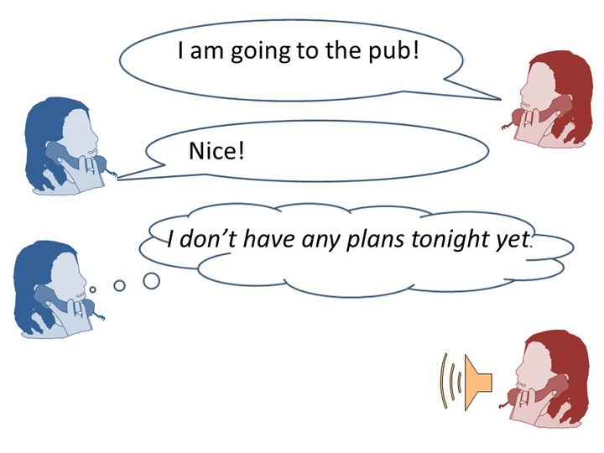
Listening fragment:
Woman on the right: Would you like to come along?
Woman on the left: Yes.
Press the right button to continue.
[Instruction screen 3]
So, it goes as follows. You will always first see the context on the screen, which you can look at, at your own pace. Try to form a good image of the situation, you can take your time for that. Then press the right button to continue. Be aware that the context will disappear and will not return anymore! A cross will appear on the screen. Look carefully at the cross and try not to blink! Then the sound fragment will be played. Listen to this carefully and make sure you do not blink until the sign !!blink!! appears on the screen. Then make sure to blink a bit until this sign disappears. That makes it easier not to blink again afterwards. Finally, in some cases then a statement will appear about the sound fragment. This can be ‘true’ or ‘false’. Use the button box to indicate what you think.
The whole task takes about 60 minutes and there are two short breaks during the experiment. We will start with a practice block first. Please indicate if you still have any questions.

Materials
All context pictures can be found online via the following link:
https://hdl.handle.net/1839/EB49C5EA-92DE-4235-A0D3-F6A5D60518C7

All wav-files used in the experiment (120 questions, each followed by 4 different answer types) can be found via the following link:

https://hdl.handle.net/1839/A457B793-E1EF-4E10-928F-024E74D380BE

Explanation of the files, file names etc. can be found here:

https://hdl.handle.net/1839/B9A90B16-76EF-418A-A919-36D6BC658205

These instructions indicate that the blink sign appeared in the trial structure before a statement (if there was one). However, in reality (and as described in the Procedure section of the article), the blink sign always appeared at the end of the trial, so after any statements. Participants did not report on this mistake and apparently had no problems understanding the procedure after having experienced the practice block.

