Appendix

Additional analyses

Pre-Immersion Differences Between Groups
Age. Due to the non-normal distribution of the variables, non-parametric tests were conducted. The results of a Kruskal-Wallis test indicated that the age of the AMB (M = 27.25; SD = 9.03; Mdn = 24.00), PLE (M = 26.45; SD = 6.98; Mdn = 23.50), and UNP (M = 24.80; SD = 7.83; Mdn = 21.50) groups did not differ in a statistically significant manner (H(2) = 2.20, p = .33).
Tendency to be immersed. The results of the one-way ANOVA confirmed that the tendency to be immersed did not differ between the AMB, PLE, and UNP groups (respectively M = 51.70, SD = 16.35; M = 56.95, SD = 16.31; M = 58.05, SD = 11.92; F(2, 57) = 1.02, p = .37, = .04).
Tendency to be absorbed. The results of the one-way ANOVA confirmed that the tendency to be absorbed did not differ between the AMB, PLE, and UNP groups (respectively M = 1.53, SD = .54; M = 1.61, SD = .16; M = 1.68, SD = .11; F(2, 56) = .32, p = .73, = .01).

Immersion Induced Negative Side Effects
ITC-SOPI. The results of the one-way ANOVA confirmed that the levels of Negative Effect did not differ between the AMB, PLE, and UNP groups (respectively M = 2.02, SD = .73; M = 1.98, SD = .73; M = 2.12, SD = .90; F(2,57) = .17, p = .84, = .01).
Simulator Sickness Questionnaire. Due to the non-normal distribution of the variables, non-parametric tests were conducted. The results of a Kruskal-Wallis test indicated that, pre-immersion, cybersickness levels among the AMB (M = .16; SD = .13; Mdn = .13), PLE (M = .17; SD = .12; Mdn = .13), and UNP (M = .18; SD = .15; Mdn = .19) groups did not differ in a statistically significant manner (H(2) = .28, p = .87). Post-immersion, cybersickness levels among the AMB (M = .34; SD = .22; Mdn = .28), PLE (M = .29; SD = .21; Mdn = .28), and UNP (M = .34; SD = .25; Mdn = .28) groups also did not statistically significantly differ (H(2) = .55, p = .76). Within groups, Wilcoxon tests detected statistically significant differences between pre- and post-immersion cybersickness for the AMB (z = -3.38, p = .00, r = -.53), PLE (z = -2.47, p = .01, r = -.39), and UNP (z = -2.92, p = .00, r = -.46) groups. Overall, these results suggest that cybersickness levels do not differ between the groups.

Characteristics of Olfactory Stimuli Detected In Virtuo
PLE and UNP groups. The detection rates, rate of association with a memory, and presumed source of odour are shown in Table A.

Table A
Detection, Association to Memory, and Source of Odours Detected In Virtuo
Measure |  | Pleasant odour  (cinnamon apple pie) | Unpleasant odour  (urine)
Detection rate
 | All participants within condition | 75% | 80%
 | Males within condition | 71.43% | 71.43%
 | Females within condition | 76.92% | 84.62%
Rate of association to memory |  | 53.33% | 50.00%
Participants’ presumed source of odour
 | Element of VE | 73.33% | 37.50%
 | Element of physical world | 0% | 6.25%
 | Imaginary source | 13.33% | 37.50%
 | Unknown | 13.33% | 18.75%

Comparison between the characteristics of the PLE and UNP odours. Due to the non-normal distribution within the groups and in order to compare the characteristics of the PLE and UNP odours, non-parametric comparisons were conducted. These confirmed that, as assessed by the PLE (n = 15) and UNP (n = 16) participants who detected the odour in virtuo, the PLE odour was statistically significantly more pleasant (Mdn = 5.00) than the UNP odour (Mdn = 1.00; U = 0.00, z = -4.84, p = .00, d = -4.39, r = -.91), more familiar (Mdn = 5.00) than the UNP odour (Mdn = 3.00; U = 33.50, z = -3.48, p = .00, d = -1.62, r = -.63), and more congruent with the visual scene (Mdn = 5.00) than the UNP odour (Mdn = 2.00; U = 10.50, z = -4.44, p = .00, d = -2.39, r = -.77). The PLE and UNP odours did not statistically significantly differ in terms of Intensity (respectively Mdns = 5.00 and 5.00; U = 115.50, z = -.19, p = .85, d = .11, r = .05). Mean values and standard errors are shown in Fig. A.
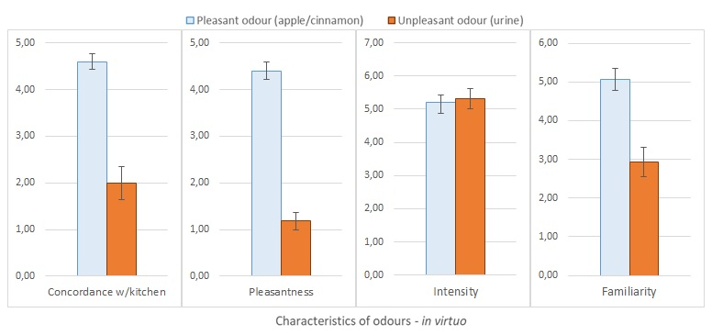

Figure A. Characteristics of olfactory stimuli presented in virtuo. These are based on the participants who reported having detected an odour in the kitchen (for pleasant odour, n = 15; for unpleasant odour, n =16). Standard errors are represented in the figure by the error bars attached to each column.

Relationship between presence and the characteristics of the odours. Spearman correlations between measures of presence and characteristics of odours were performed for each group separately. Results indicate that the effect of intensity on spatial presence was driven by the UNP odour. Paired with the significant, negative correlation observed with pleasantness, this support the idea that negative odour have a stronger cognitive and affective impact on humans than positive ones, which makes sense from an evolutionary perspective. Detailed results are shown in Table B.
Table B
Spearman Correlations between Measures of Presence and Characteristics of Odours
Group | Measure | Concordance | Pleasantness | Intensity | Familiarity
PLE | Brief measure of Presence (residual gain) | .04 | .37 | .02 | .25
 | ITC Spatial Presence | .04 | .26 | .23 | .01
UNP | Brief measure of Presence (residual gain) | .06 | -.63* | .40 | -.09
 | ITC Spatial Presence | .27 | -.35 | .54* | .47
Note. Correlations are based on the participants who detected an odour in virtuo (PLE = 15; UNP = 16).
* p < .05.

Characteristics of Olfactory Stimuli Detected In Vivo
PLE group. For the participants in this group, the in vivo detection rate of the same olfactory stimulus that they had been exposed to in the kitchen was 100% (20 out of 20). Fifteen of the group’s members (75%) stated that the odour was associated with a memory.
UNP group. For the participants in this group, the in vivo detection rate of the same olfactory stimulus that they had been exposed to in the kitchen was 100% (20 out of 20). Sixteen of the group’s members (80%) stated that the odour was associated with a memory.
Comparison between the characteristics of the PLE and UNP odours. Due to the non-normal distribution of the characteristics of the odours, and in order to compare the characteristics of the PLE and UNP odours, non-parametric comparisons were conducted. These confirmed that, as assessed by the participants in the PLE (n = 20) and UNP (n = 20) groups when they were exposed to the odour in vivo (post-questionnaires), the PLE odour was statistically significantly more pleasant (Mdn = 4.00) than the UNP odour (Mdn = 1.00; U = 17.00, z = -5.02, p = .00, d = -2.79, r = -.81) and more congruent (Mdn = 4.50) with the visual scene than the UNP odour (Mdn = 2.00; U = 74.00, z = -3.50, p = .00, d = -1.36, r = -.56). However, the PLE and UNP odours did not statistically significantly differ in terms of Intensity (respectively Mdns = 5.00 and 6.00; U = 147.00, z = -1.49, p = .14, d = .57, r = .27) or Familiarity (respectively Mdns = 5.00 and 4.00; U = 148.50, z = -1.43, p = .15, d = -.38, r = -.19). Mean values and standard errors are shown in Fig. B.
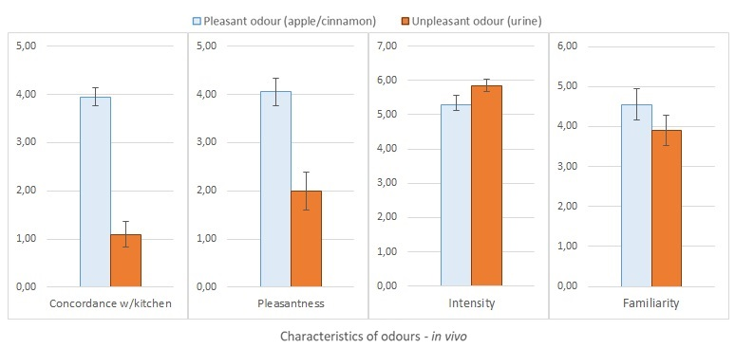

Figure B. Characteristics of olfactory stimuli presented in vivo. These are based on a 30-second exposure to the same stimulus that participants had been exposed to in virtuo. This time, however, participants had been made aware of the exposure to an olfactory stimulus (for pleasant odour, n = 20; for unpleasant odour, n = 20). Standard errors are represented in the figure by the error bars attached to each column.

