Supporting Information for
The Environmental Impact of China’s Resources’ Domestic Extraction

S1. Accounting and adjustment of non-metallic minerals’ DE
The category of non-metallic minerals we collected from China Land & Resources Almanac was classified as the materials used in different ways, like “Limestone for fertilizer” and “Limestone for building stone”. Most of these materials which come from the same category also have the same exploitation process and exploitation ‘s LCA. Hence, we merged these materials into a total material, and then correspond to the same LCA data.
The DE of some non-metallic minerals was not recorded completely during 1992-2015. Their DE in some year was missing or unreasonable. To make sure the DE of non-metallic minerals was continuous and credible, we neglected some material and estimated some materials’ DE. The DE of materials we neglected was less than 1% of their specific category during 1992-2015. Hence, we think their DE has little impacts to the DE of their total category and neglected them during 1992-2015. For the materials which DE was more than 1% of their specific category but missing in some years, we estimated and complement their missing part. If the DE of missing part’s adjacent years were complete, we complemented the missing part with the average DE of adjacent years. If the missing part was continuous over many years, we estimated and complemented them according to the output value of the nonmetal mining sector during these years and the DE and our value in adjacent years.
According to the situation of infrastructure construction during 1992-2015 in China, the DE of “limestone for cement”, “clay for bricks and tiles” and “sand for building” from China Land & Resources Almanac is too small and unreasonable. Hence, we adjusted and replaced these DE with a detailed method in S2.
All the adjustment of non-metallic minerals was shown in table 1, while “neglect” presents the materials we neglected their DE, “estimate” presents the materials we supplement their missing part in some years, and “replace” presents the materials we adjusted and replaced their DE according to the situation of infrastructure construction in China.
[Insert Figure S1 here]
Table S1: the adjustments and results of non-metallic minerals’ DE (thousand tons)

S2. Adjustment of “limestone for cement”, “clay for bricks and tiles” and “sand for building”

limestone for cement
We adjusted the DE of limestone for cement according to the cement production in China with a coefficient presents the limestone’s weight to product one-ton cement. The data of cement production came from China statistical yearbook, and cement includes “White Portland cement”, “Grey Portland cement including blended cement”, “Alumina cement” and “Other hydraulic cement”.

clay for bricks and tiles
We adjusted the DE of clay for bricks and tiles according to the three kinds of bricks’ production as the following equation, and the bricks we collected include “full and lug bricks”,” roof bricks” and” ceiling bricks”.
$$DE=C×P+\sum{{C'}_{m}×{P'}_{m}+\sum{{C''}_{n}×{P''}_{n}}}$$
Where $C,C^{'},C''$ were the coefficient presents the clay’s weight to product on-ton three kinds of bricks, and $P,P',P''$ presents three kinds of bricks’ production, respectively. m was the different type of roof bricks, it includes “glazed bricks”,” floor bricks”,” non-refractory clay flooring blocks”,” non-refractory clay roofing tiles” and” non-refractory clay constructional products”. n was the different type of ceiling bricks, it includes “ceiling bricks (area)”and “ceiling bricks (volume)”.
The production of full and lug bricks came from the investigation result of building materials association, and the production of crude clay came from Almanac of China building materials industry.

sand for building
We adjusted the DE of sand for building into two parts. One part was the estimation of sand and gravel based on the consumption of cement, and another part was the estimation of sand and gravel for road construction and for annual maintenance. We summed up two parts’ estimation to present the DE of sand for building.
We used a coefficient to presents the sand’s weight to product one-ton cement in the first part, and we estimated the consumption of cement with production, imports and exports of cement. The data of cement production came from China statistical yearbook, the data of cement imports and exports came from UN Comtrade, and the cement’s category we collected was same as the category in the adjustment of limestone for cement.
We calculated the estimation of sand and gravel for road construction and for annual maintenance according to the following equation.
$$DE=\sum{C_{m}}×L_{m}+\sum{M_{m}×{L'}_{m}}$$
Where $C_{m}$ presents the coefficient of sand’s consumption for one-km m-type road construction, while $M_{m}$ presents the coefficient of sand’s consumption for one-km m-type road maintenance. $L_{m}$was the length of newly built roads and ${L'}_{m}$ was the length of roads receiving annual maintenance each year. m presents different levels of roads in this study, and it includes “Highways”,” National roads”,” Federal state roads”,” District roads” and “Local roads”.
[Insert Figure S2 here]
Table S2: DE we adjusted and in China Land & Resources Almanac (million tons)

S3. Adjustment of metallic minerals’ DE between ore and concentrate
The DE of metallic minerals from China Land & Resources Almanac was primary minerals’ DE, but the LCA we found in eFootprint was concentrate minerals’ LCA. To make sure the consistency between MFA and LCA materials’ category, we estimated the DE of primary minerals to concentrate minerals with the ore grade of primary and concentrate metallic minerals according to the following equation.
$${DE}_{c,m}=\frac{{DE}_{p,m}×G_{p,m}}{G_{c,m}}$$
Where ${DE}_{c,m}$ is the DE of m-type concentrate minerals, and ${DE}_{p,m}$is the DE of m-type primary minerals. $G_{p,m}$and $G_{c,m}$is the ore grade of m-type primary and concentrate metallic minerals.
The gold ores’ LCA from eFootprint the primary minerals’ LCA. Hence, we didn’t adjust it. The ore grade of iron ores was derived from China Steel Yearbook. The ore grade of silver ores and rare earth was derived from related references, and the ore grade of other minerals was derived from The Yearbook of Nonferrous Metals Industry of China. In addition, we complemented the missing part with the average ore grade of adjacent years, because the ore grade in some years was missing.
[Insert Figure S3 here]
Table S3: the grade of metallic minerals in 1992 and 2015

S4. The environmental impacts of materials’ exploiting per ton
[Insert Figure S4 here]
Table S4: the environmental impacts of materials’ exploiting per ton. Note: GWP represents Global Warming Potential; ADP represents Abiotic Depletion Potential; RI represents Respiratory Inorganics.

S5. Result of Metallic Minerals
In this part, we focused on metallic minerals to analysis the similarity which these material display, and to find out the specific material which leading the increasing tendency of metallic minerals’ DE and environmental impacts. Our study contained thirteen kinds of metallic minerals: iron ores, copper ores, nickel ores, lead ores, zinc ores, tin ores, gold ores, silver ores, bauxite and other aluminum ores, tungsten ores, antimony ores, molybdenum ores, rare earth.
[Insert Figure S1 here]
Figure S1. DE and environmental impacts of metallic minerals exploited in China, 1992-2015.
Fig.1 shows the domestic extraction and its environmental impacts of metallic minerals exploit in China during 1992-2015. The metallic minerals’ DE was increased by 467% from 0.3 billion tons in 1992 to 1.8 billion tons in 2015 with an average annual growth rate of 8.7% per year. From a specific metallic minerals’ viewpoint, iron ores was the main contributor of material extraction. It contributed 75% (1.4 billion tons) of metallic minerals’ DE in 2015, and approximately 78% (1.2 billion tons) of the DE increase during 1992-2015. Copper ores as the second contributor, contributed 8% (0.2 billion tons) of metallic minerals’ DE and approximately 7% (0.1 billion tons) of the DE increase. In addition, antimony ores’ extraction had the fastest rate of the DE increase, it was increased by 952% during 1992-2015, meanwhile, iron ores was increased by 559% at the same time.
The results of GWP had the same tendency as that of DE. The GWP of metallic minerals’ DE was increased by 452% from 15 million tons CO₂ eq in 1992 to 84 million tons CO₂ eq in 2015 with an average annual growth rate of 9.0% per year. From a specific metallic minerals’ viewpoint, iron ores was the main contributor of GWP. It contributed 72% (61 million tons CO₂ eq) of metallic minerals’ GWP in 2015, and approximately 74% (52 million tons CO₂ eq) of the GWP increase during 1992-2015. Molybdenum ores as the second contributor, contributed 10% (9 million tons CO₂ eq) of metallic minerals’ GWP and approximately 10% (7 million tons CO₂ eq) of the GWP increase.
The results of ADP show an unstable increasing tendency which different from the smooth increasing result of DE, GWP and RI. The ADP of metallic minerals’ DE was increased by 38% from 67 thousand tons Sb eq in 1992 to 93 thousand tons Sb eq in 2015 with an average annual growth rate of 2.1% per year. From a specific metallic minerals’ viewpoint, antimony ores were the main leader of ADP. It contributed 34% (32 thousand tons Sb eq) of metallic minerals’ ADP in 2015. But antimony ores’ increasing tendency was unstable, its’ ADP in 2015 was only 66% of that in 1992, it stopped 65% (17 thousand tons Sb eq) of the ADP increase during 1992-2014. Gold ores only contributed 19% (18 thousand tons Sb eq) of metallic minerals’ ADP in 2015, but it led approximately 45% (12 thousand tons Sb eq) of the ADP increase during 1992-2015.
The results of RI show the same tendency as the results of metallic minerals’ DE. The RI of metallic minerals’ DE was increased by 493% from 46 thousand tons PM2.5 eq to 280 thousand tons PM2.5 eq in 2015 with an average annual growth rate of 9.0% per year. From a specific metallic minerals’ viewpoint, iron ores was the main contributor of RI. It contributed 85% (230 thousand tons PM2.5 eq) of metallic minerals’ RI in 2015, and approximately 87% (200 thousand tons PM2.5 eq) of the RI increase during 1992-2015. Gold as the second contributor, only contributed 4% (11 thousand tons PM2.5 eq) of metallic minerals’ RI and approximately 3% (7 thousand tons PM2.5 eq) of the RI increase.

S6. Result of Non-metallic Minerals
Non-metallic minerals’ extraction was the principal part of Chinese material extraction. In this part, we focused on non-metallic minerals to analysis the similarity which these material display, and to find out the specific material which leading the increasing tendency of non-metallic minerals’ DE and environmental impacts. Our study contained thirty-three kinds of non-metallic minerals. Sand and gravel, clays, limestone and gypsum were the major study object.
[Insert Figure S2 here]
Figure S2. DE and environmental impacts of non-metallic minerals exploited in China, 1992-2015.
Fig.2 shows the domestic extraction and its environmental impacts of non-metallic minerals exploit in China during 1992-2015. The non-metallic minerals’ DE was increased by 408% from 4.7 billion tons in 1992 to 24 billion tons in 2015 with an average annual growth rate of 7.8% per year. From a specific non-metallic minerals’ viewpoint, sand and gravel was the main contributor of non-material extraction. It contributed 67% (16 billion tons) of non-metallic minerals’ DE in 2015, and approximately 72% (14 billion tons) of the DE increase during 1992-2015. Limestone and gypsum as the second contributor, contributed 16% (3.8 billion tons) of non-metallic minerals’ DE and approximately 17% (3.2 billion tons) of the DE increase.
The results of GWP had the same tendency as that of DE. The GWP of non-metallic minerals’ DE was increased by 454% from 22 million tons CO₂ eq in 1992 to 120 million tons CO₂ eq in 2015 with an average annual growth rate of 8.3% per year. From a specific non-metallic minerals’ viewpoint, sand and gravel was the main contributor of GWP. It contributed 69% (86 million tons CO₂ eq) of non-metallic minerals’ GWP in 2015, and approximately 73% (74 million tons CO₂ eq) of the GWP increase during 1992-2015. Limestone and gypsum as the second contributor, contributed 16% (20 million tons CO₂ eq) of non-metallic minerals’ GWP and approximately 17% (18 million tons CO₂ eq) of the GWP increase.
The results of ADP show an unstable increasing tendency which different from the smooth increasing result of DE, GWP and RI. The ADP of non-metallic minerals’ DE was increased by 150% from 2 thousand tons Sb eq in 1992 to 5 thousand tons Sb eq in 2015 with an average annual growth rate of 4.7% per year. From a specific non-metallic minerals’ viewpoint, fluorite was the main leader of ADP. It contributed 74% (4 thousand tons Sb eq) of non-metallic minerals’ ADP in 2015, and approximately 83% (3 thousand tons Sb eq) of the ADP increase during 1992-2015. Pyrites as the second contributor, contributed 13% (710 tons Sb eq) of non-metallic minerals’ ADP and approximately 1% (40 tons Sb eq) of the ADP increase.
The results of RI show the same tendency as the results of non-metallic minerals’ DE. The RI of non-metallic minerals’ DE was increased by 506% from 110 thousand tons PM2.5 eq to 660 thousand tons PM2.5 eq in 2015 with an average annual growth rate of 8.7% per year. From a specific non-metallic minerals’ viewpoint, sand and gravel was the main contributor of RI. It contributed 72% (470 thousand tons PM2.5 eq) of non-metallic minerals’ RI in 2015, and approximately 74% (410 thousand tons PM2.5 eq) of the RI increase during 1992-2015. Limestone and gypsum as the second contributor contributed 17% (110 thousand tons PM2.5 eq) of non-metallic minerals’ RI and approximately 18% (96 thousand tons PM2.5 eq) of the RI increase.

S7. Result of Fossil Fuels
In this part, we focused on fossil fuels to analysis the similarity which these material display, and to find out the specific material which leading the increasing tendency of fossil fuels’ DE and environmental impacts. Our study contained three kinds of fossil fuels: coal, crude oil, natural gas liquids.
[Insert Figure S3 here]
Figure S3. DE and environmental impacts of fossil fuels exploited in China, 1992-2015.
Fig.3 shows the domestic extraction and its environmental impacts of fossil fuels exploit in China during 1992-2015. The fossil fuels’ DE was increased by 219% from 1.3 billion tons in 1992 to 4.1 billion tons in 2015 with an average annual growth rate of 5.6% per year. From a specific fossil fuels’ viewpoint, coal was the main contributor to fossil fuels’ extraction. It contributed 92% (3.7 billion tons) of fossil fuels’ DE in 2015, and approximately 94% (2.6 billion tons) of the DE increase during 1992-2015. Crude oil as the second contributor, contributed 5.3% (0.21 billion tons) of fossil fuels’ DE and approximately 2.5% (0.07 billion tons) of the DE increase.
The GWP of fossil fuels’ DE was increased by 164% from 310 million tons CO₂ eq in 1992 to 820 million tons CO₂ eq in 2015 with an average annual growth rate of 4.6% per year. From a specific fossil fuels’ viewpoint, coal was the main contributor of GWP. It contributed 72% (590 million tons CO₂ eq) of fossil fuels’ GWP in 2015, and approximately 81% (420 million tons CO₂ eq) of the GWP increase during 1992-2015. Crude oil as the second contributor, contributed 24% (200 million tons CO₂ eq) of fossil fuels’ GWP and approximately 13% (64 million tons CO₂ eq) of the GWP increase.
The ADP of fossil fuels’ DE was increased by 148% from 2 thousand tons Sb eq in 1992 to 6 thousand tons Sb eq in 2015 with an average annual growth rate of 4.3% per year. From a specific fossil fuels’ viewpoint, coal was the main leader of ADP. It contributed 59% (4 thousand tons Sb eq) of fossil fuels’ ADP in 2015, and approximately 69% (3 thousand tons Sb eq) of the ADP increase during 1992-2015. Crude oil as the second contributor, contributed 32% (2 thousand tons Sb eq) of fossil fuels’ ADP and approximately 18% (650 tons Sb eq) of the ADP increase.
The RI of fossil fuels’ DE was increased by 147% from 56 thousand tons PM2.5 eq to 140 thousand tons PM2.5 eq in 2015 with an average annual growth rate of 4.2% per year. From a specific fossil fuels’ viewpoint, coal was the main contributor of RI. It contributed 41% (57 thousand tons PM2.5 eq) of fossil fuels’ RI in 2015, and approximately 49% (40 thousand tons PM2.5 eq) of the RI increase during 1992-2015. Crude oil as the second contributor contributed 39% (53 thousand tons PM2.5 eq) of fossil fuels’ RI and approximately 21% (17 thousand tons PM2.5 eq) of the RI increase.

Tables
Table S1: the adjustments and results of non-metallic minerals’ DE (thousand tons)
materials in this study | materials from China Land & Resources Almanac | adjustment | Domestic Extraction in 1992 | Domestic Extraction in 2015
magnesite |  |  | 2881 | 10058
fluorite |  |  | 1317 | 3980
 | Common fluorite |  | 1317 | 3980
 | Optic fluonte | neglect | 2 | 2
limestone |  |  | 539198 | 3774094
 | Limestone for glass |  | 31 | 99
 | Tourmaline limestone |  | 1675 | 17821
 | Limestone for fertilizer |  | 187 | 9
 | Limestone for building stone |  | 124121 | 843503
 | Limcstonc for tlux | estimate | 16545 | 61352
 | Facing limestone |  | 213 | 2354
 | Limestone for cement | replace | 366782 | 2807434
 | Limestone for mortar |  | 25502 | 34945
 | Limestone for soda ash |  | 4142 | 6579
dolomite |  |  | 14281 | 77407
 | Dolostone for glass |  | 295 | 2128
 | Dolostone for chemical industry |  | 185 | 521
 | Dolostone for building |  | 7626 | 52902
 | Metallurgical, dolomite |  | 6175 | 21856
quartzite |  |  | 4251 | 17317
 | Vein quartz for glass |  | 414 | 906
 | Quarzite for glass |  | 2378 | 11949
 | Quartzite for fertilizer |  | 66 | 160
 | Vein quartz for cement | neglect | 0 | 42
 | Metallurgical, vein quartz |  | 248 | 297
 | Metallurgical, quartzite |  | 1144 | 4005
clays |  |  | 1691867 | 2878659
 | Attapulgite clay |  | 45 | 367
 | Muscovite clay mine | neglect | 0 | 0
 | Clay for thermal insulating  material |  | 1 | 0
 | Sepiolitc clay |  | 8 | 0
 | Rectorite clay |  | 3 | 0
 | Fireelay |  | 3901 | 1119
 | Clay for cement |  | 3947 | 4595
 | Earthenware clay | replace | 0 | 0
 | lllite clay |  | 16 | 105
 | Clay for metallurgy |  | 1168 | 30
 | Clay for bricks and tiles | replace | 1682778 | 2872443
pyrites |  |  | 7692 | 8156
barite |  |  | 1898 | 2268
trona |  |  | 1667 | 2728
shale |  |  | 31235 | 124182
 | Potassium bearing sandshalc |  | 77 | 14
 | Shale for building | estimate | 1274 | 7230
 | Shale for cement |  | 2023 | 6063
 | Shale for ceramsite | estimate | 216 | 199
 | Shale for bricks and tiles |  | 27644 | 110675
phosphorite |  |  | 17268 | 68285
feldspar |  |  | 687 | 2684
gypsum |  |  | 9504 | 16332
calcite |  |  | 1294 | 6262
sand and gravel |  |  | 2228413 | 15905929
 | Sand for glass |  | 1914 | 5650
 | Sandstone for glass |  | 969 | 4239
 | Sandstone for fertilizer | neglect | 117 | 24
 | Sandstone for building | neglect | 0 | 0
 | Sand for building | replace | 2196098 | 15862356
 | Sandstone for building | neglect | 0 | 72226
 | Cement standard sand |  | 123 | 59
 | Sand for cement |  | 377 | 3414
 | Sandstone for cement |  | 1244 | 20608
 | Sandstone for ceramics |  | 188 | 765
 | Sandstone for metallurgy |  | 613 | 742
 | Sandstone for casting |  | 165 | 929
 | Sand for bricks and tiles |  | 20747 | 502
 | Sandstone for bricks and tiles |  | 5974 | 6665
serpentine |  |  | 461 | 1001
 | Serpentinite for fertilizer | estimate | 159 | 26
 | Serpcntinite for flux |  | 271 | 598
 | Facing serpentinite |  | 31 | 377
mirabilite |  |  | 4530 | 11063
sylvite |  |  | 2732 | 75686
graphite |  |  | 2036 | 4081
wollastonite |  |  | 542 | 1356
talcum |  |  | 1354 | 1846
asbestos |  |  | 4647 | 5020
pyrophyllite |  | estimate | 655 | 775
diopside |  |  | 221 | 409
kaolin |  |  | 3369 | 6414
ceramic clay |  |  | 1889 | 10470
bentonite |  |  | 859 | 1755
diabase |  |  | 5834 | 6017
 | Diabase for building |  | 2546 | 4784
 | Facing diabase |  | 3281 | 1028
 | Diabase for cement |  | 0 | 205
 | Diabase for casting |  | 7 | 0
andesite |  |  | 8313 | 47308
 | Andesitc for building |  | 8300 | 47278
 | Facing andesite | estimate | 13 | 30
diorite |  |  | 1285 | 21371
 | Diorite for building |  | 1285 | 21371
 | Facing diorite | neglect | 0 | 152
granite |  |  | 99900 | 353289
 | Granule for building | estimate | 95828 | 305013
 | Facing granite |  | 4072 | 48276
tuff |  |  | 4008 | 327621
 | Tuff for glass | neglect | 0 | 0
 | Tutf for building | estimate | 3875 | 326456
 | Tuff for cement |  | 134 | 1165
marble |  |  | 8189 | 46599
 | Marble for glass |  | 16 | 639
 | Marble for building |  | 1140 | 14751
 | Facing marble |  | 3290 | 11581
 | Marble for cement |  | 3742 | 19629

Table S2: DE we adjusted and in China Land & Resources Almanac (million tons)
 | Domestic Extraction we adjusted |  |  | Domestic Extraction in China Land & Resources Almanac
 | Limestone for cement | Clay for bricks and tiles | Sand for building | Limestone for cement | Clay for bricks and tiles | Sand for building
1992 | 366.8 | 1682.8 | 2196.1 | 199.6 | 323.6 | 146.5
1993 | 437.8 | 2028.9 | 2678.0 | 386.1 | 625.8 | 283.3
1994 | 501.2 | 2351.6 | 2992.4 | 417.1 | 676.1 | 306.1
1995 | 566.0 | 2507.7 | 3402.8 | 368.2 | 596.9 | 270.2
1996 | 584.5 | 2389.5 | 3540.2 | 440.0 | 713.3 | 322.9
1997 | 609.0 | 2315.2 | 3837.1 | 496.5 | 804.8 | 364.3
1998 | 637.8 | 2506.5 | 4292.7 | 309.3 | 501.4 | 227.0
1999 | 681.9 | 2353.4 | 4247.4 | 346.4 | 827.5 | 241.4
2000 | 710.4 | 2333.1 | 4366.1 | 482.1 | 750.2 | 252.9
2001 | 786.6 | 2173.5 | 5583.8 | 381.8 | 702.8 | 301.7
2002 | 862.8 | 2111.9 | 5247.1 | 382.6 | 689.7 | 280.2
2003 | 1025.9 | 2214.5 | 6104.9 | 469.0 | 607.3 | 338.2
2004 | 1150.5 | 2456.5 | 6896.2 | 445.0 | 449.4 | 238.6
2005 | 1271.9 | 2581.2 | 7638.3 | 479.4 | 405.0 | 245.0
2006 | 1471.8 | 2753.9 | 8580.1 | 582.8 | 418.1 | 226.1
2007 | 1619.8 | 2551.8 | 10111.0 | 632.1 | 417.6 | 218.9
2008 | 1694.0 | 2627.9 | 10403.3 | 657.2 | 510.1 | 278.9
2009 | 1956.3 | 2662.4 | 11976.3 | 739.6 | 431.6 | 275.0
2010 | 2239.5 | 2668.8 | 13350.0 | 872.6 | 430.4 | 317.9
2011 | 2498.1 | 2725.0 | 14167.8 | 986.1 | 375.2 | 270.6
2012 | 2629.7 | 2657.4 | 14914.5 | 1035.4 | 346.9 | 201.1
2013 | 2878.9 | 2724.5 | 16050.6 | 1157.9 | 261.8 | 184.0
2014 | 2965.6 | 2734.1 | 16495.0 | 1224.9 | 182.0 | 151.2
2015 | 2807.4 | 2872.4 | 15862.3 | 1211.9 | 124.3 | 113.9

Table S3: the grade of metallic minerals in 1992 and 2015
 | 1992 |  | 2015
 | Grade of Ore | Grade of Concentrate | Grade of Ore | Grade of Concentrate
iron ores | 29.92% | 65.19% | 28.79% | 61.97%
copper ores | 0.63% | 22.32% | 0.54% | 21.55%
nickel ores | 1.52% | 6.29% | 1.00% | 6.78%
lead ores | 2.39% | 63.38% | 2.62% | 61.30%
zinc ores | 4.46% | 50.33% | 4.88% | 49.58%
tin ores | 0.47% | 44.48% | 0.52% | 42.58%
silver ores | 0.01% | 100.00% | 0.01% | 100.00%
bauxite ores | 33.30% | 100.00% | 55.27% | 100.00%
tungsten ores | 0.29% | 69.29% | 0.29% | 58.00%
antimony ores | 2.27% | 16.51% | 1.90% | 25.71%
molybdenum ores | 0.24% | 47.30% | 0.12% | 52.08%
rare earth | 5.00% | 100.00% | 5.00% | 100.00%

Table S4: the environmental impacts of materials’ exploiting per ton. Note: GWP represents Global Warming Potential; ADP represents Abiotic Depletion Potential; RI represents Respiratory Inorganics.
material | origin | reference year | database | GWP (kg CO2 eq) | ADP (kg Sb eq) | RI (kg PM2.5 eq)
iron ores | China | 2013 | CLCD-China-ECER | 0.094617663 | 1.64732E-06 | 0.000363063
copper ores | China | 2013 | CLCD-China-ECER | 0.891083701 | 0.000767205 | 0.001138992
nickel ores | China | 2013 | CLCD-China-ECER | 0.320443764 | 0.000396663 | 0.000985852
lead ores | China | 2013 | CLCD-China-ECER | 0.624571943 | 0.010876854 | 0.001677361
zinc ores | China | 2013 | CLCD-China-ECER | 0.772017412 | 0.003434388 | 0.002063038
tin ores | China | 2013 | CLCD-China-ECER | 4.719319364 | 0.070864175 | 0.012023234
gold ores | China | 2013 | CLCD-China-ECER | 0.032673347 | 0.000149524 | 9.37831E-05
silver ores | Swedish | 2014 | Ecoinvent | 167.4036566 | 0.659913802 | 1.094757038
bauxite ores | China | 2013 | CLCD-China-ECER | 0.049390331 | 1.53186E-05 | 0.000304839
tungsten ores | China | 2013 | CLCD-China-ECER | 12.0062203 | 0.163529987 | 0.010917271
antimony ores | China | 2013 | CLCD-China-ECER | 2.506962455 | 0.519578778 | 0.006297934
molybdenum ores | China | 2013 | CLCD-China-ECER | 46.47221059 | 0.04235747 | 0.050203677
rare earth | China | 2014 | Ecoinvent | 7.307328513 | 0.000155743 | 0.006724618
magnesite | China | 2013 | CLCD-China-ECER | 0.005417321 | 1.43812E-08 | 2.97973E-05
fluorite | China | 2013 | CLCD-China-ECER | 0.012707639 | 0.000982528 | 4.88053E-05
limestone | China | 2013 | CLCD-China-ECER | 0.005417321 | 1.43812E-08 | 2.97973E-05
dolomite | China | 2013 | CLCD-China-ECER | 0.005417321 | 1.43812E-08 | 2.97973E-05
quartzite | China | 2013 | CLCD-China-ECER | 0.002870796 | 6.67104E-09 | 2.86213E-05
clays | China | 2013 | CLCD-China-ECER | 0.002586624 | 1.07661E-08 | 9.3783E-06
pyrites | China | 2013 | CLCD-China-ECER | 0.032410917 | 8.66224E-05 | 9.39002E-05
barite | China | 2013 | CLCD-China-ECER | 0.024832672 | 2.91924E-08 | 6.00061E-05
trona | China | 2013 | CLCD-China-ECER | 0.030251111 | 1.88084E-08 | 4.65091E-05
shale | China | 2013 | CLCD-China-ECER | 0.00490015 | 1.97112E-08 | 1.79438E-05
phosphorite | China | 2013 | CLCD-China-ECER | 0.01578689 | 4.63665E-06 | 6.30135E-05
feldspar | China | 2013 | CLCD-China-ECER | 0.005417321 | 1.43812E-08 | 2.97973E-05
gypsum | China | 2013 | CLCD-China-ECER | 0.031645131 | 7.38895E-08 | 9.23274E-05
calcite | China | 2013 | CLCD-China-ECER | 0.024832672 | 2.91924E-08 | 6.00061E-05
sand and gravel |  |  |  | 0.005417321 | 1.43816E-08 | 2.97973E-05
serpentine |  |  |  | 0.005417321 | 1.43816E-08 | 2.97973E-05
mirabilite |  |  |  | 0.005417321 | 1.43816E-08 | 2.97973E-05
sylvite |  |  |  | 0.005417321 | 1.43816E-08 | 2.97973E-05
graphite | Other countries | 2014 | Ecoinvent | 0.040745312 | 2.08408E-07 | 6.86317E-05
wollastonite |  |  |  | 0.005417321 | 1.43816E-08 | 2.97973E-05
talcum |  |  |  | 0.005417321 | 1.43816E-08 | 2.97973E-05
asbestos | Global | 2014 | Ecoinvent | 0.038962472 | 2.07612E-07 | 6.38574E-05
pyrophyllite |  |  |  | 0.005417321 | 1.43816E-08 | 2.97973E-05
diopside |  |  |  | 0.005417321 | 1.43816E-08 | 2.97973E-05
kaolin | Other countries | 2014 | Ecoinvent | 0.233575461 | 1.29704E-06 | 0.000296649
ceramic clay |  |  |  | 0.002586624 | 1.0767E-08 | 9.3783E-06
bentonite | Other countries | 2014 | Ecoinvent | 0.031417888 | 5.00173E-07 | 5.42385E-05
diabase |  |  |  | 0.005417321 | 1.43816E-08 | 2.97973E-05
andesite |  |  |  | 0.005417321 | 1.43816E-08 | 2.97973E-05
diorite |  |  |  | 0.005417321 | 1.43816E-08 | 2.97973E-05
granite |  |  |  | 0.005417321 | 1.43816E-08 | 2.97973E-05
tuff |  |  |  | 0.005417321 | 1.43816E-08 | 2.97973E-05
marble |  |  |  | 0.005417321 | 1.43816E-08 | 2.97973E-05
coal | China | 2013 | CLCD-China-ECER | 0.157801726 | 9.53804E-07 | 1.51325E-05
crude oil | China | 2013 | CLCD-China-ECER | 0.912066882 | 9.18684E-06 | 0.000246578
natural gas liquids | China | 2013 | CLCD-China-ECER | 0.345171387 | 5.23199E-06 | 0.00027534

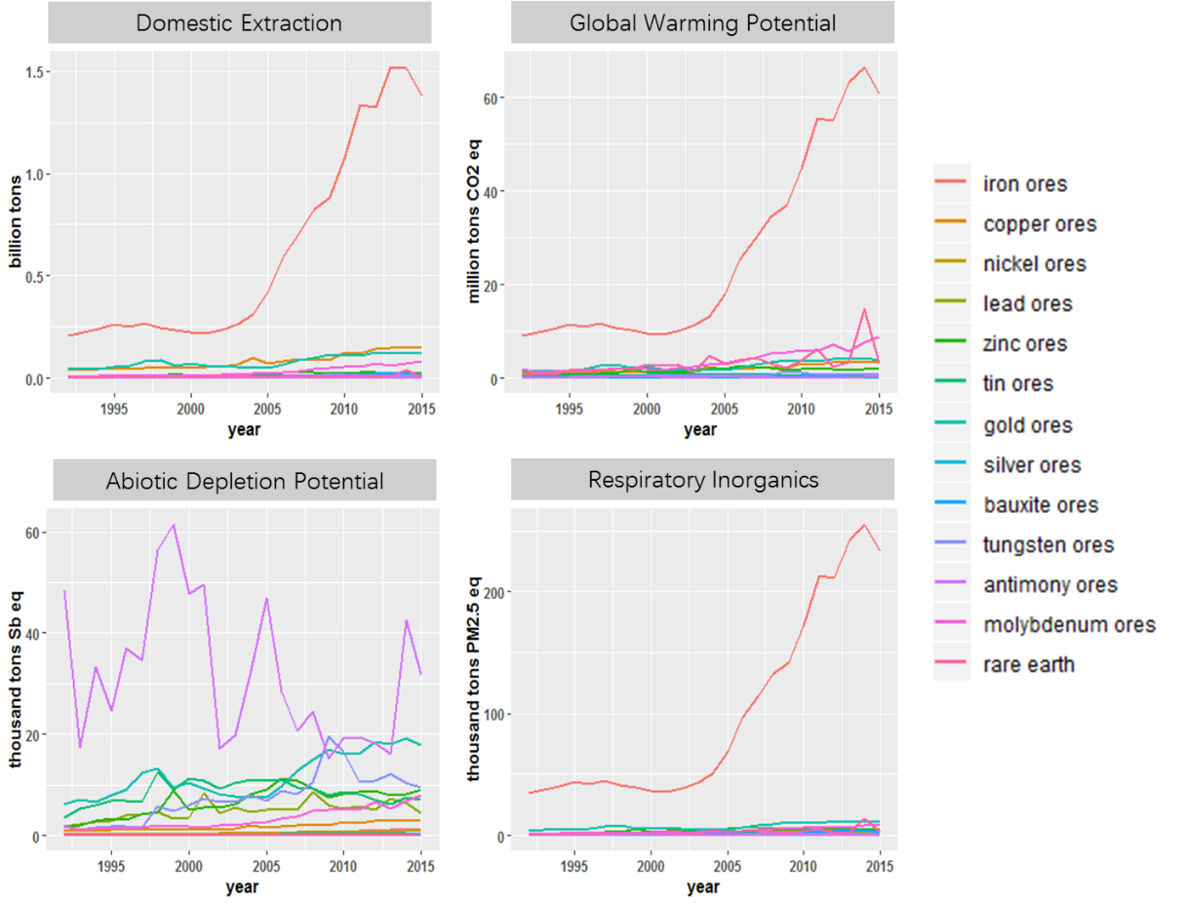
Figure S1. DE and environmental impacts of metallic minerals exploited in China, 1992-2015.
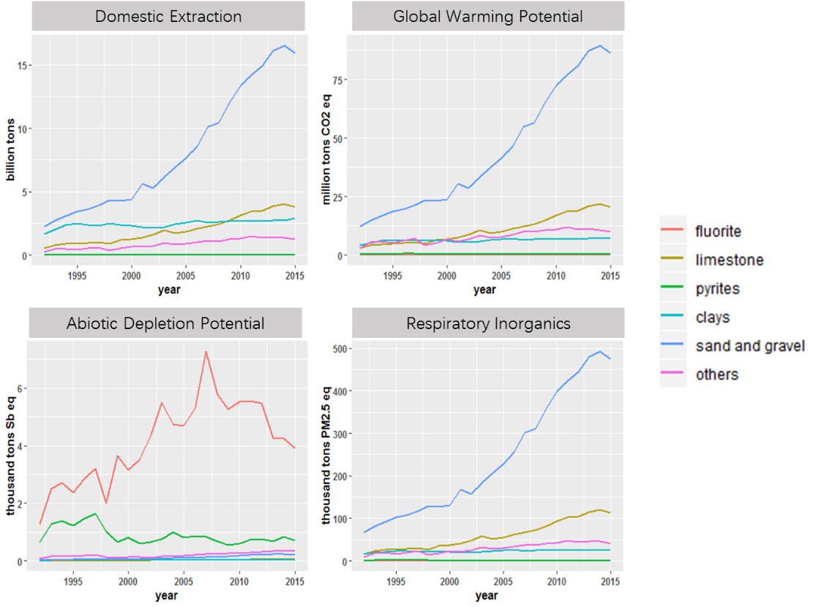
Figure S2. DE and environmental impacts of non-metallic minerals exploited in China, 1992-2015.
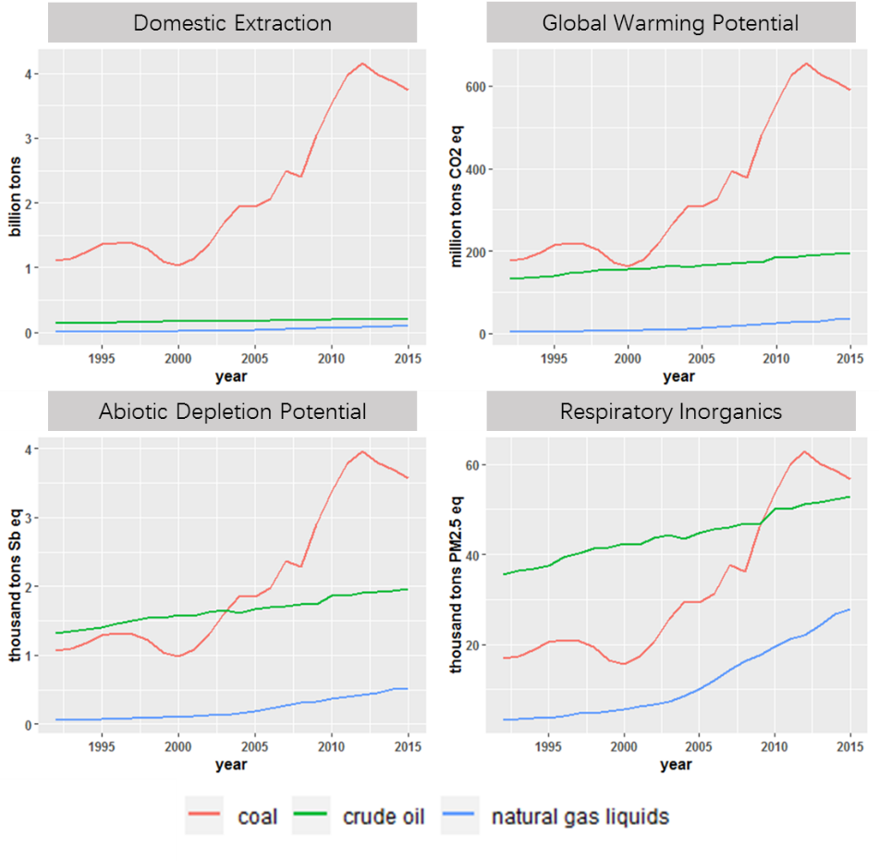
Figure S3. DE and environmental impacts of fossil fuels exploited in China, 1992-2015.

