Sigma-1 receptor ablation impairs autophagosome clearance

Huan Yang^{1,#}, Hongtao Shen^{1,#}, Jing Li¹, and Lian-Wang Guo^{1,2,*}

¹Department of Surgery and Departemnt of Physiology & Cell Biology, College of Medicine; Davis Heart and Lung Research Institute, Wexner Medical Center. The Ohio State University, Columbus, OH 43210, USA.
²McPherson Eye Research Institute, University of Wisconsin, Madison, WI 53705

Short title: Role of the Sigma-1 receptor in autophagy

# These authros are co-first authors.

* Corresponding author:

Lian-Wang Guo, Ph.D.

Department of Surgery and Departement of Physiology & Cell Biology

The Ohio State University

473 West 12th Ave, 611B DHLRI

Columbus, OH 43210, USA
Tel: +1 614 292 5276. Email: lianwang.guo@osumc.edu

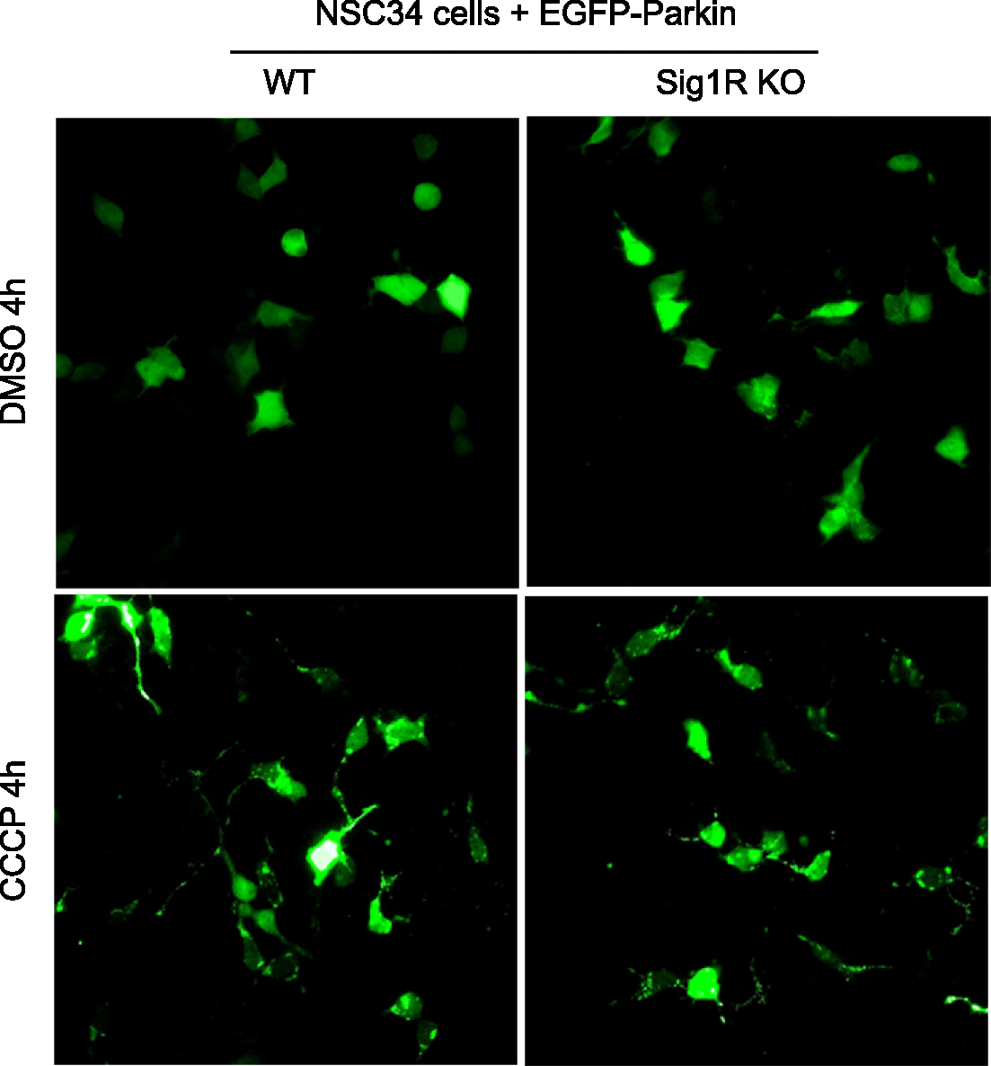

Supplemental Figure S1. There is no difference in Parkin recruitment in CCCP-treated WT and Sig1R KO NSC34 cells
Cells were treated and imaged as described in Figure 3A. Punctate appearance of the fluorescent signal (see CCCP-treated cells) indicates Parkin recruitment to mitochondria. This figure shows the “full picture” of Figure 3A with more cells included.

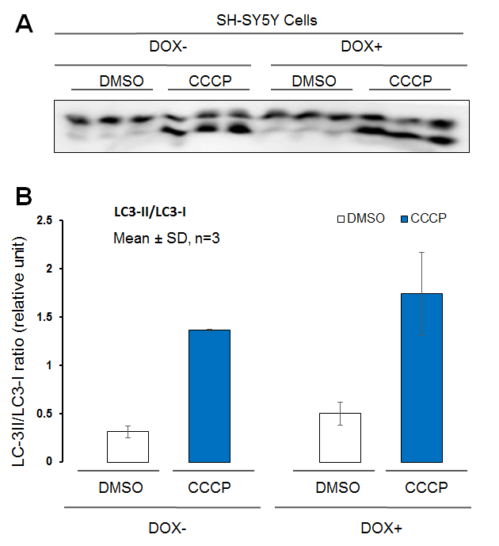

Figure S2. LC3-II/LC3-I ratios in Sig1R KO and WT SH-SY5Y cells under CCCP stimulation
Experiments were performed as described for Figure 4C. Total cell lysates were collected and subjected to Western blotting for determination of LC3-I and LC-3II protein levels (A), and their densitometry intensities were used for quantification of the LC3-II/LC3-I ratio (B). Data are presented as mean ± standard deviation; n = 3 repeats.

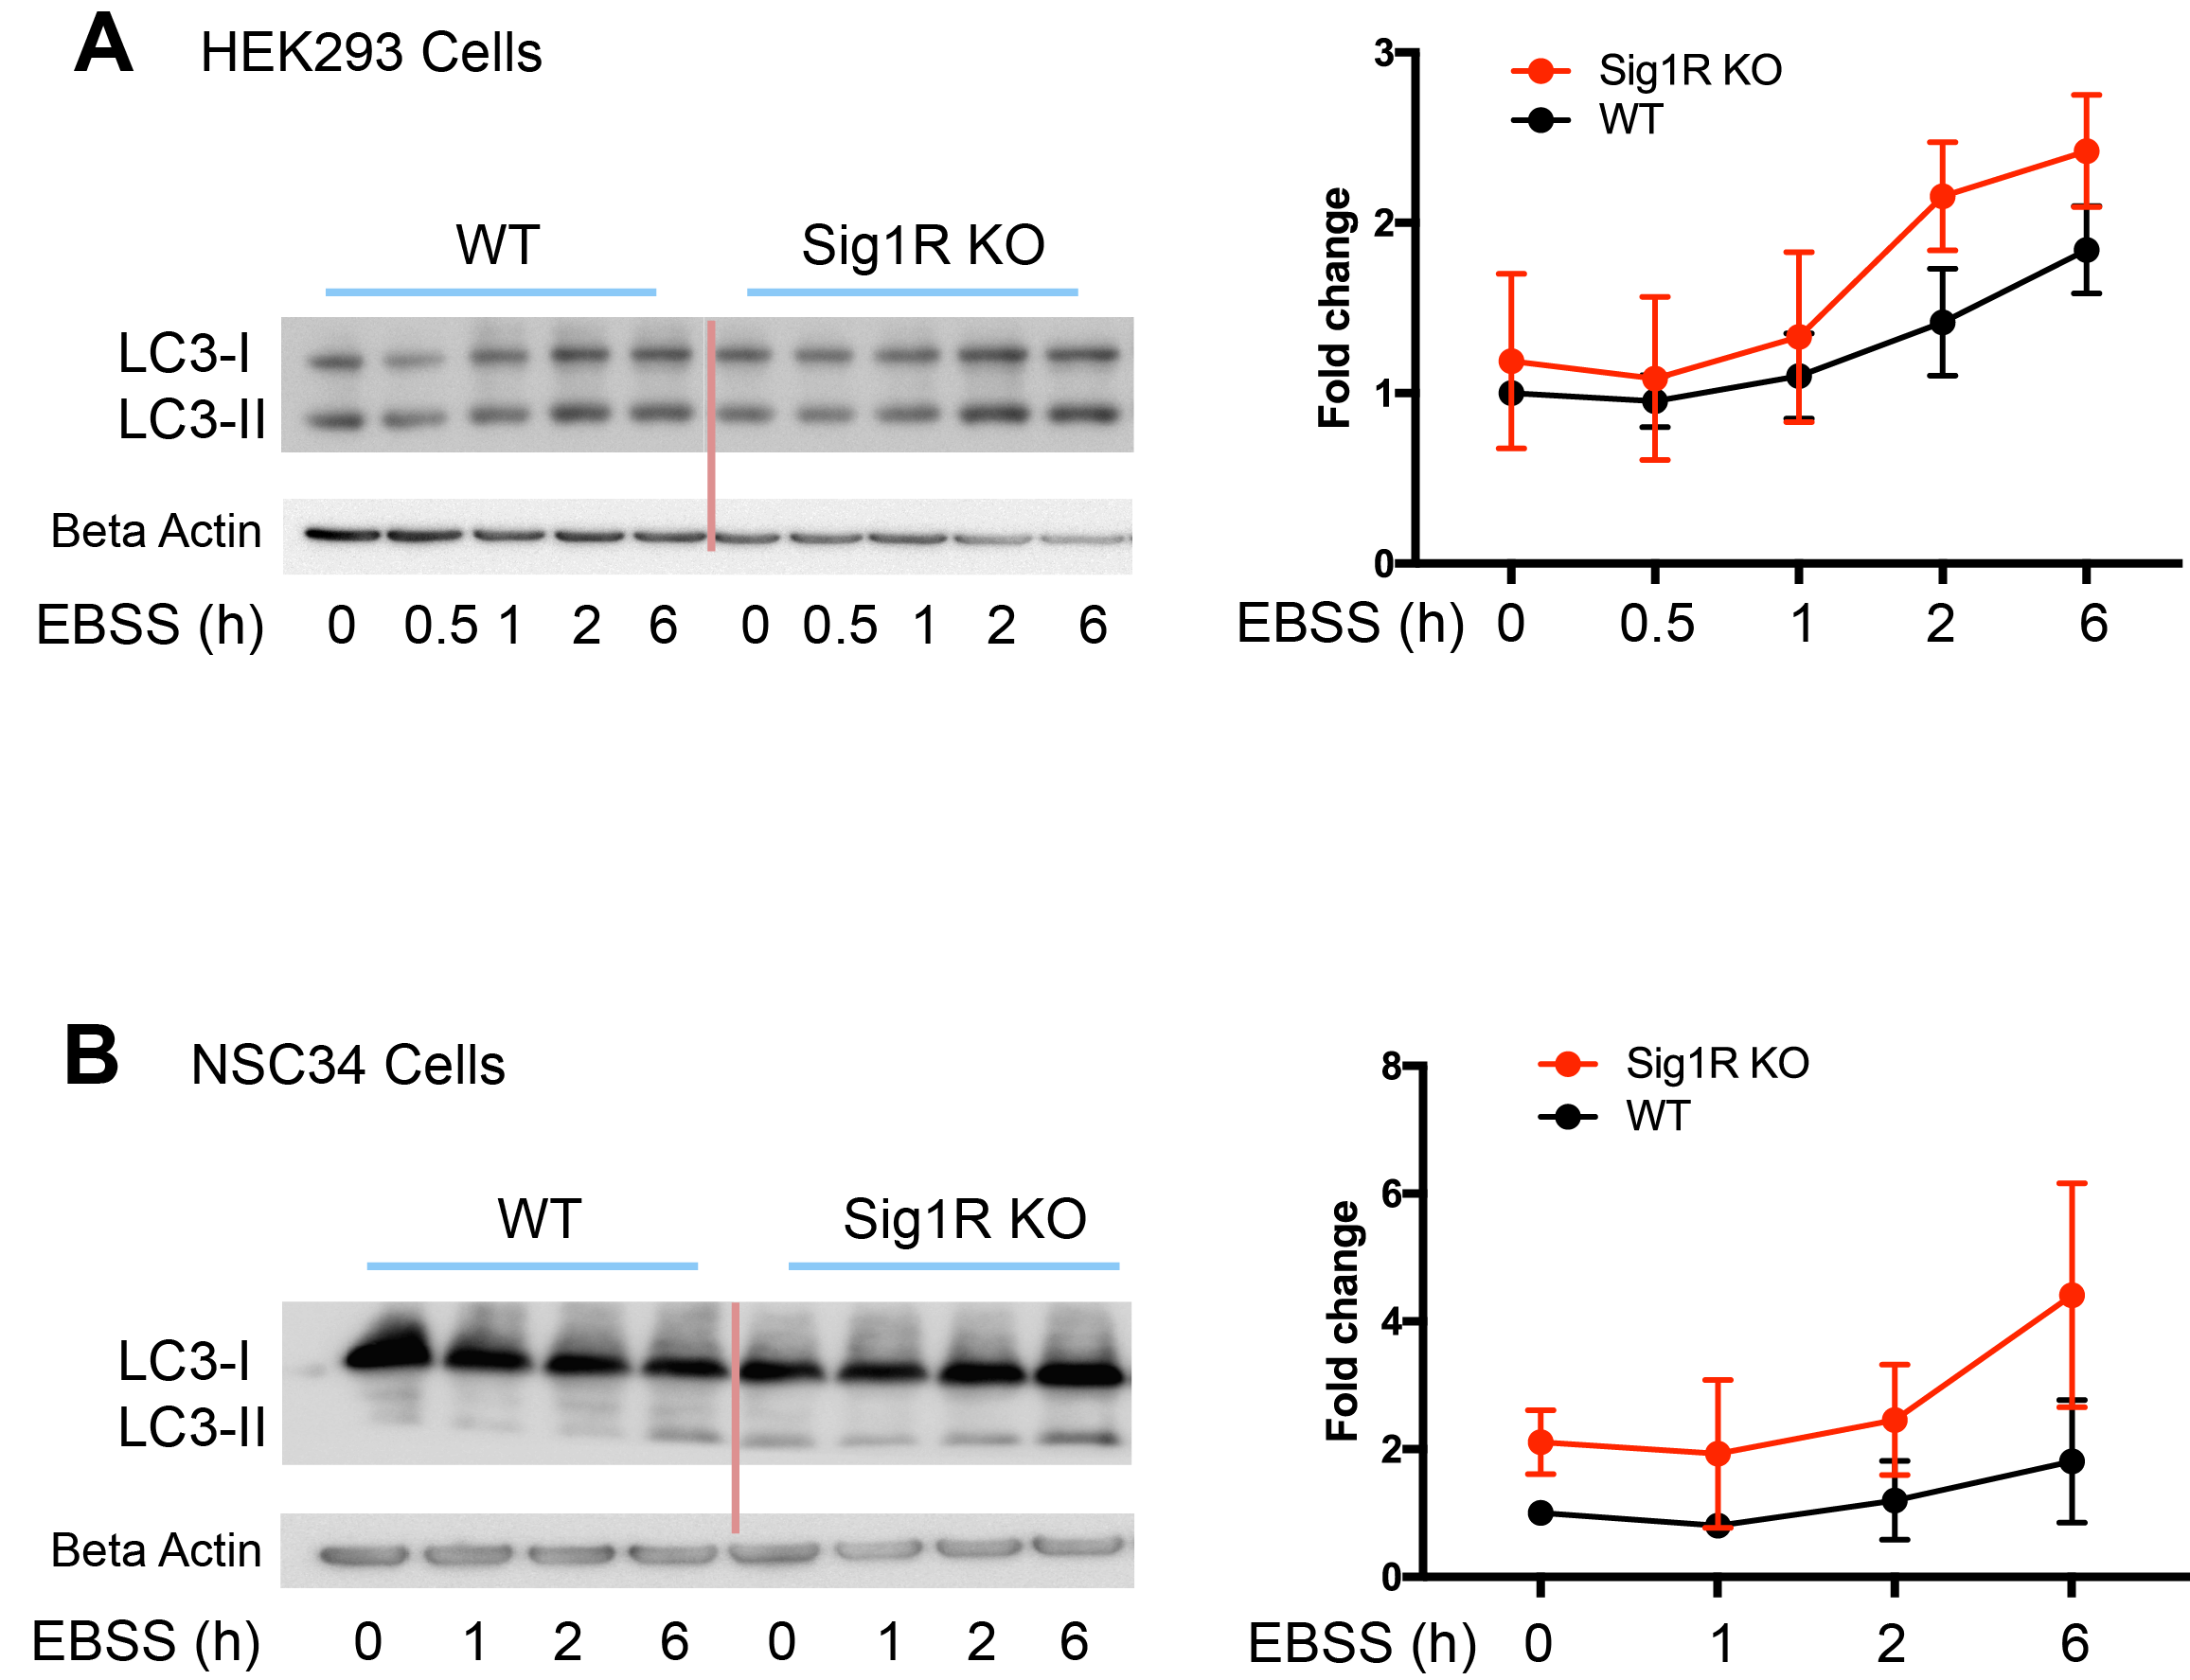

Figure S3. Increased LC3-II/LC3-I ratio in Sig1R KO cells compared to WT cells under starvation conditions
WT and Sig1R KO HEK293 (A) or NSC34 cells (B) were washed 3 times with Earle's Balanced Salt Solution (EBSS), an amino acid and serum free, glucose-containing buffer, and starved in the same buffer for various hours as indicated in the figure. Total cell lysates were collected and subjected to Western blotting for determination of LC3-I and LC-3II protein levels. The experiment using each cell type was repeated 2 times.

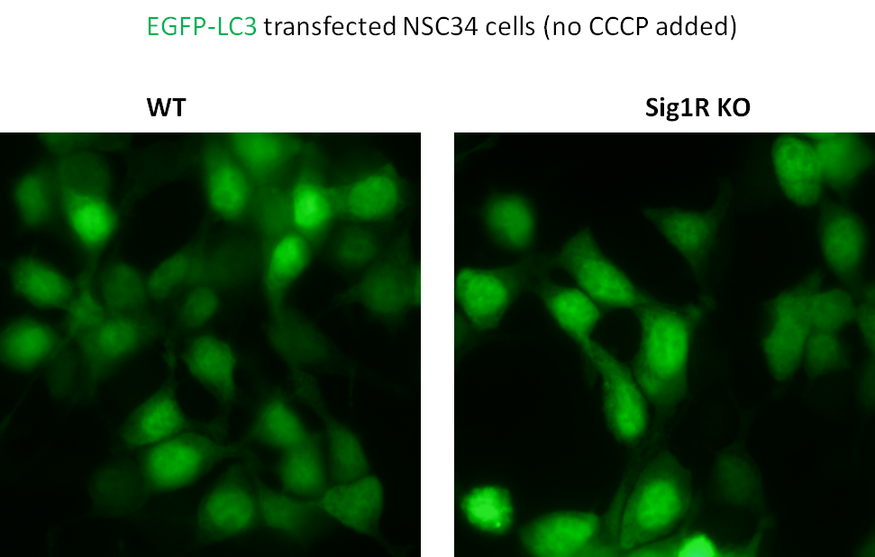

Figure S4. EGFP-LC3 distribution in WT and Sig1R KO NSC34 cells under the basal condition
Experiments were performed as described in Figure 7A. After 24h transfection with EGFP-LC3, cells were cultured for another 12 hours (DMSO added) prior to fluorescence microscopy. These images show similar smearing fluorescent signals of EGFP-LC3 in WT and KO cells, indicating a lack of autophagosome formation.

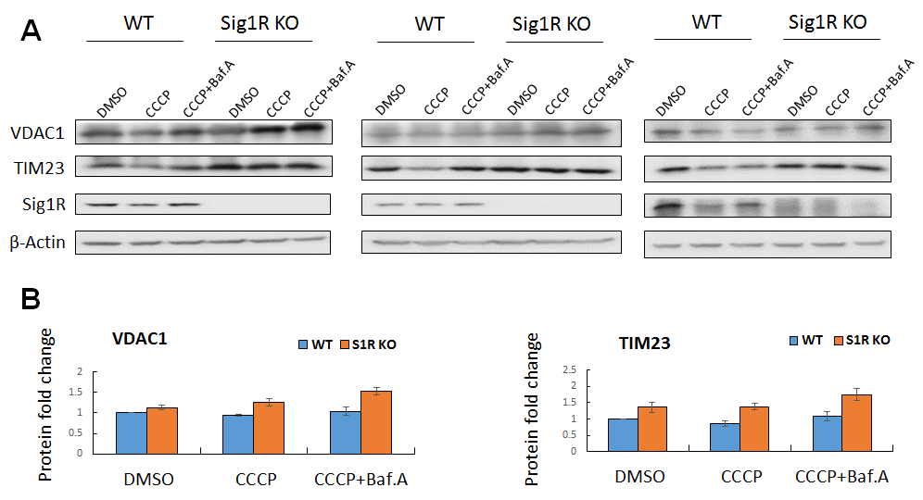

Figure S5. Baf.A further enhances mitochondrial marker accumulation in Sig1R KO NSC34 cells
WT and Sig1R KO NSC34 cells were treated with vehicle or CCCP (20µM) for 12h (Baf.A was added at 8h), and then subjected to Western blot analysis. Shown are 3 independent experiments. For quantification, : Mean ± SEM, n=3.

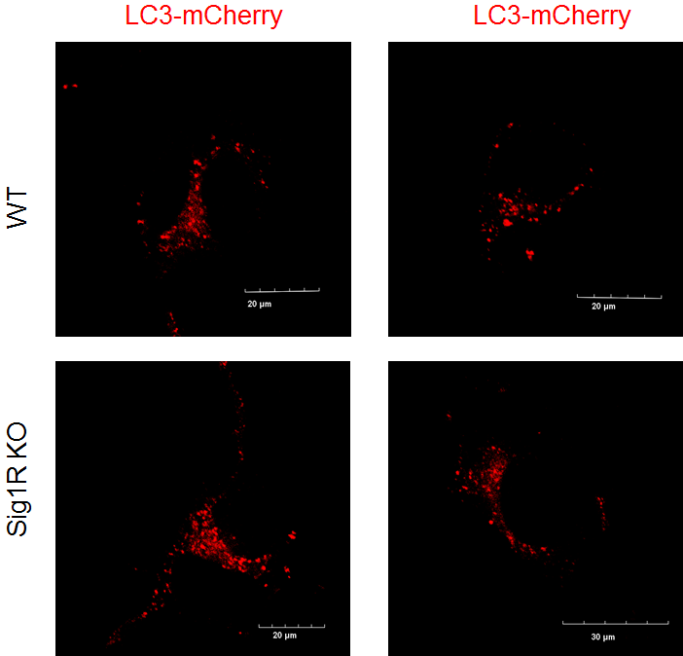

Figure S6. Subcellular distribution of autophagosomes in WT and Sig1R KO NSC34 cells
under CCCP treatment

Experiments were performed as described in Figure 7A. After 24h transfection with LC3-mCherry, cells were treated with CCCP for another 12 hours prior to fluorescence microscopy. These images show similar autophagosome positioning (punctate signal) in WT and KO cells.

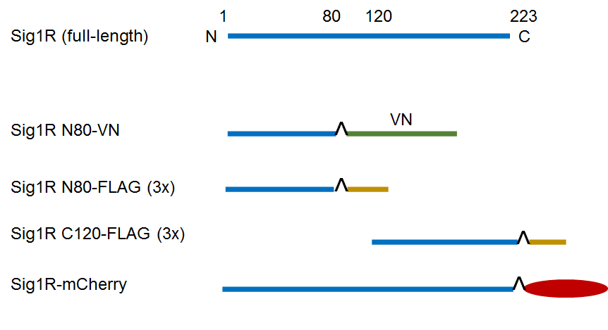
Figure S7. Schematic of Sig1R-expressing constructs
The constructs of FLAG-tagged Sig1R and Sig1R fused with VN or mCherry were generated as described in Methods. N80, N-terminal amino acids 1-80; C120, C-terminal half of molecule (amino acids 120-223).

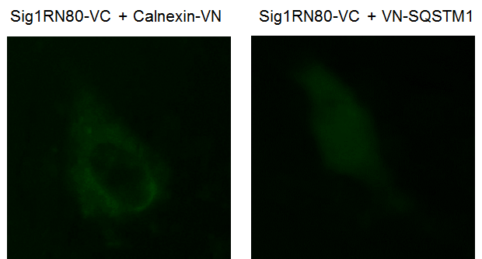

Figure S8. Negative controls of the BiFC assay
The images show a lack of positive BiFC signal from the pair of Sig1R N80 (fused with VC) and an irrelevant protein (fused with VN). The pairs of constructs were co-transfected into NSC34 cells. Live cell BiFC imaging experiments were performed as described for Figure 9. VC was fused to the C-terminus of Sig1R N80; VN was fused to the C-terminus of Calnexin, or the N-terminus of SQSTM1. Calnexin is an ER membrane protein with its C-terminus localized in the cytosol. SQSTM1 is primarily a cytosolic protein.

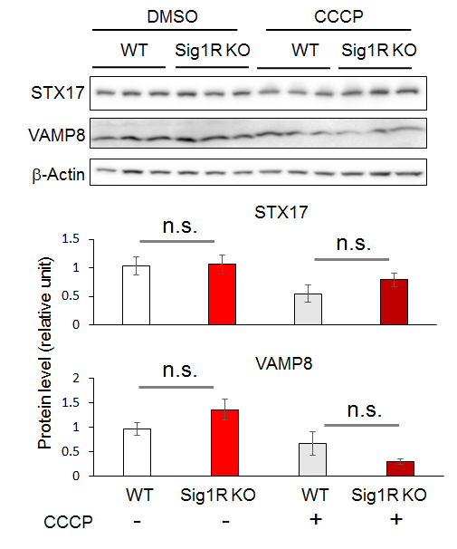

Figure S9. VAMP8 and STX17 protein levels are not affected by Sig1R KO
Shown are Western blots from one of two independent experiments that produced similar results, the other shown in Figure 10A. Prior to Western blotting, NSC34 cells were treated with vehicle (DMSO) or 20 µM CCCP for 12h. Triplicate samples of each condition were loaded on the same gel; mean ± SD; n=3; n.s., not significant.

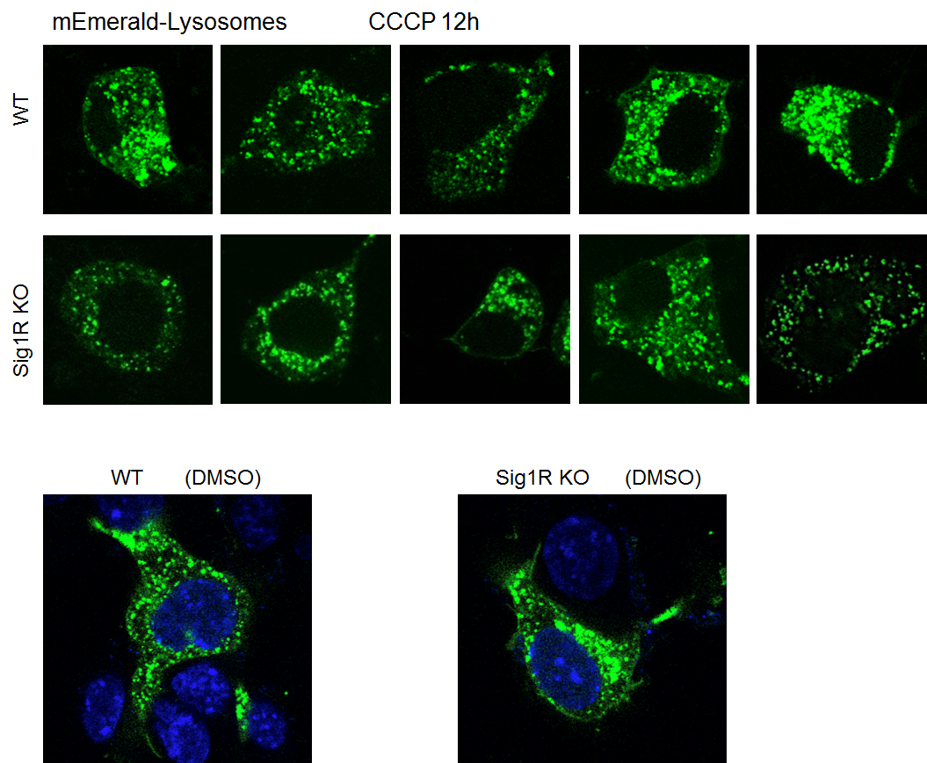

Figure S10. Subcellular distribution of lysosomes in WT and Sig1R KO NSC34 cells
Experiments were performed as described in Figure 7B. After 24h transfection with mEmerald-lysosomes, cells were treated with DMSO or CCCP for another 12 hours prior to live cell fluorescence microscopy. These images of multiple cells show similar lysosome positioning in WT and KO cells.

