Supplementary Material

Effects of grazing exclusion on vegetation composition and seed bank in a mountain mesic grassland in Argentina

Figure S1. Photographs of (a) the 12YO exclosures, (b) the 2YO exclosures and (c) the grazed area.
(a)
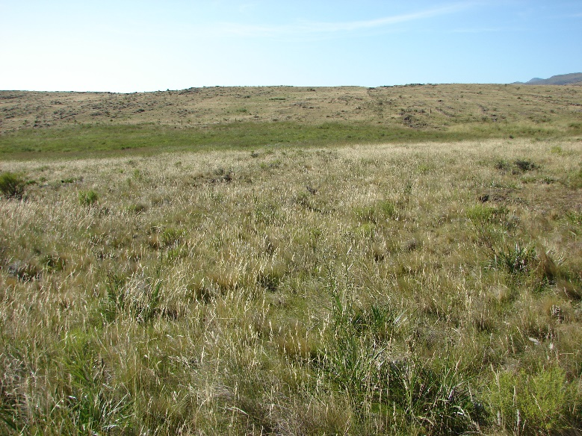
(b)
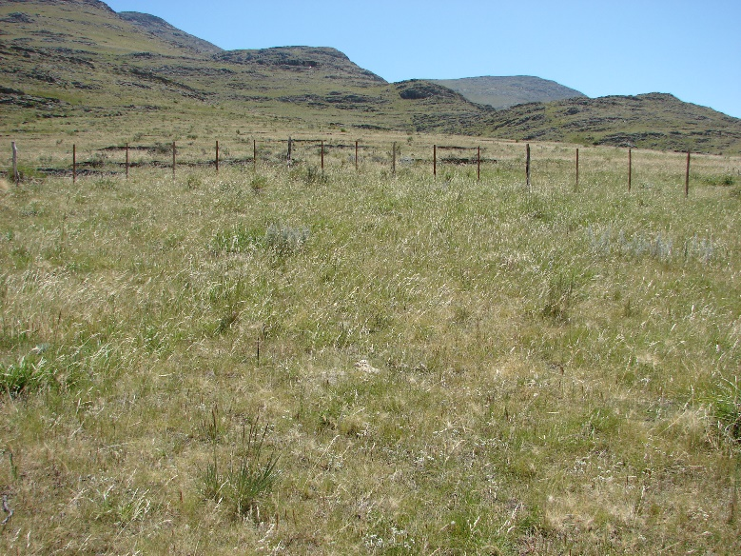
(c)
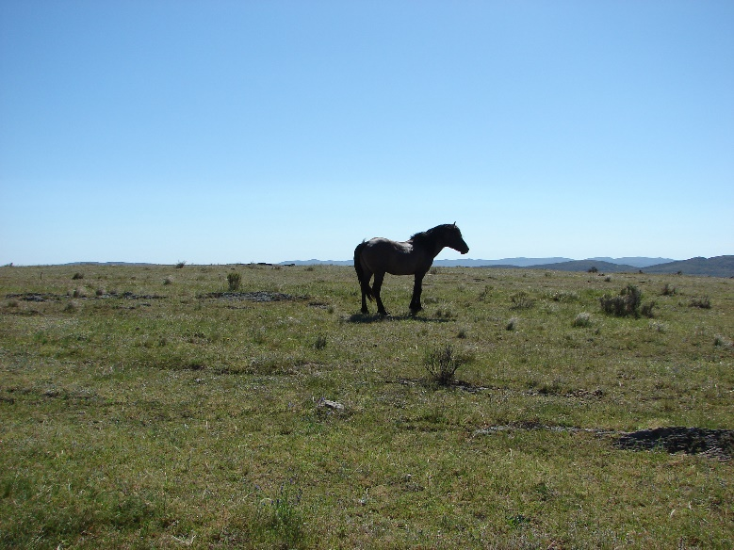

Table S1. Seed density of 12 years-old exclosures (12YO), 2 years-old exclosures (2YO), the grazed areas (Gr) and total seed density for the seed bank samples.

Grazing treatment | Seed density (seeds.m⁻²)
 | Soil seed bank |  |  | Litter seed bank
 | Mean | Maximum | Minimum | Mean | Maximum | Minimum
12YO | 6935 | 11841 | 2674 | 2428 | 4074 | 1273
2YO | 14413 | 26611 | 8785 | 16272 | 40744 | 3820
Gr | 10856 | 20372 | 4584 | 7835 | 16043 | 3183
Total | 10735 | 26611 | 2674 | 8845 | 40744 | 1273

Table S2. Results of ANOVA on the effect of Grazing (grazed area, 2YO and 12 YO exclosures) and Fraction (soil and litter) and their interaction on seed density per square meter. Significant effects (P< 0.05) are given in bold type. Den d.f.; denominator degree of freedom in the F- test F= F-test ratio; MS= mean square; Num d.f. = numerator degree of freedom in the F- test; P= error probability.

 |  |  |  | Forb |  |  | Grass |  |  | Shrub |  |  | Total
 | Num d.f. | Den d.f. |  | F | P |  | F | P |  | F | P |  | F | P
Grazing [G] | 2 | 6 |  | 13.2 | <0.01 |  | 7.0 | <0.05 |  | 35.5 | <0.01 |  | 15.4 | <0.01
Fraction [F] | 1 | 42 |  | 39.1 | <0.01 |  | 2.0 | 0.16 |  | 25.9 | <0.01 |  | 33.17 | <0.01
G×F | 2 | 42 |  | 3.5 | <0.05 |  | 9.5 | <0.01 |  | 1.59 | 0.22 |  | 12.17 | <0.01

