Supporting Information

A new neolignan glycoside from Dolomiaea souliei
Man Yiª, Fan-Cheng Meng^{a,}*, Shen-Yue Quª, Yun-Yi Taoª, Zhi-Hua-Liao^{b}, Min Chen^{a,}*.
ª College of Pharmaceutical Sciences, Key Laboratory of Luminescent and Real-Time Analytical Chemistry (Ministry of Education), Southwest University, Chongqing 400715, P.R. China
^{b} School of Life Sciences, Southwest University, Chongqing 400715, P.R. China.

*Corresponding author
Fan-Cheng Meng, Ph. D
College of Pharmaceutical Sciences,
Southwest University,
No. 2 Tiansheng Road, Chongqing 400715, P. R. China
Tel: +86-13068300182
E-mail: Jian_chilixiang@163.com

Min Chen, Ph. D and Professor
College of Pharmaceutical Sciences,
Southwest University,
No. 2 Tiansheng Road, Chongqing 400715, P. R. China
Tel: +86-23-68250579
E-mail:

ABSTRACT
One new neolignan glycoside, dolomiside A (1), together with 11 known phenylpropanoid glycosides were isolated from Dolomiaea souliei (Franch.) Shih. The structures of these isolates were determined by UV, CD, HR-ESI-TOFMS, 1D and 2D NMR analysis.
KEYWORDS
Dolomiaea souliei; Neolignans; Dolomiside A ; Phenylpropanoid glycosides

Contents
Figure S1. ¹H-NMR spectrum of compound 1 (400 MHz, CD₃OD).
Figure S2. ¹³C-NMR spectrum of compound 1 (101 MHz, CD₃OD).
Figure S3. HSQC spectrum of compound 1 (400 MHz, CD₃OD).
Figure S4. HMBC spectrum of compound 1 (400 MHz, CD₃OD).
Figure S5. NOSEY spectrum of compound 1 (400 MHz, CD₃OD).
Figure S6. HR-ESI-TOFMS spectrum of compound 1.
Figure S7. UV spectrum of compound 1.
Figure S8. IR spectrum of compound 1.
Figure S9. The experimental CD spectrum of (7R, 8R)-1.
Figure S10. Key HMBC and ¹H-¹H-COSY correlations of compound 1.
Figure S11. Key NOESY correlations of compound 1.
Figure S12. TLC Verification of Compound 1.
Figure S13. HPLC Verification of Compound 1.
Table S1. ¹H- and ¹³C-NMR data (400 and 101Hz, resp., in CD₃OD) of compound 1 (δ in ppm, J in Hz)

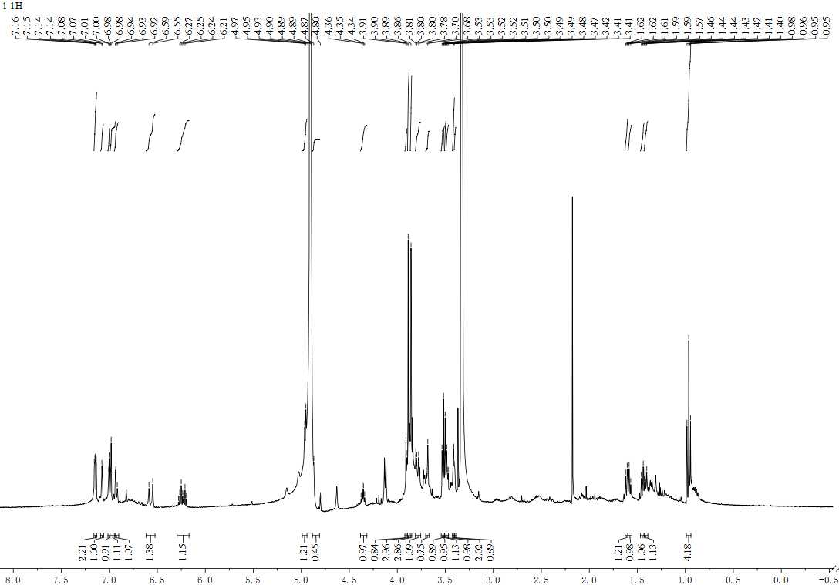Figure S1. ¹H-NMR spectrum of compound 1 (400 MHz, CD₃OD).
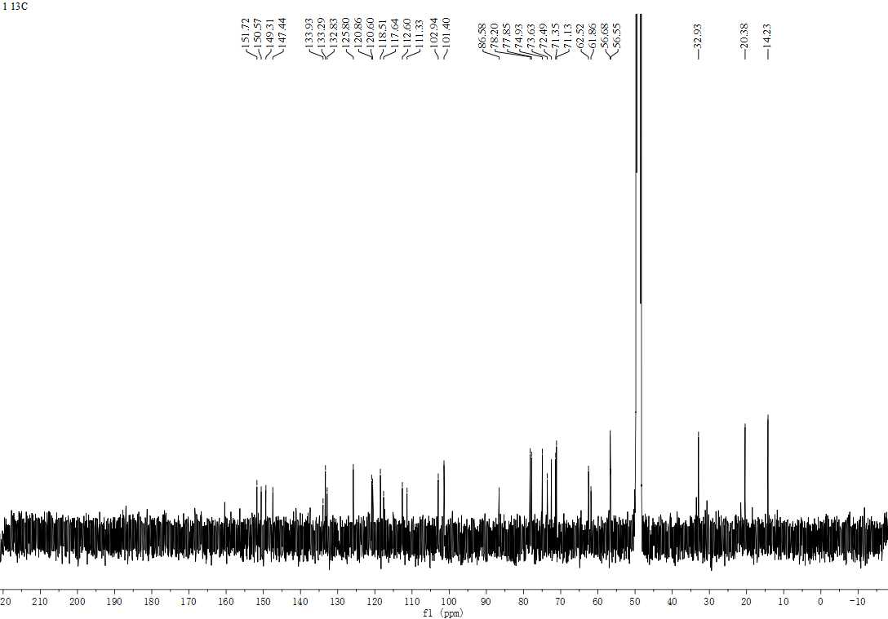Figure S2. ¹³C-NMR spectrum of compound 1 (101 MHz, CD₃OD).
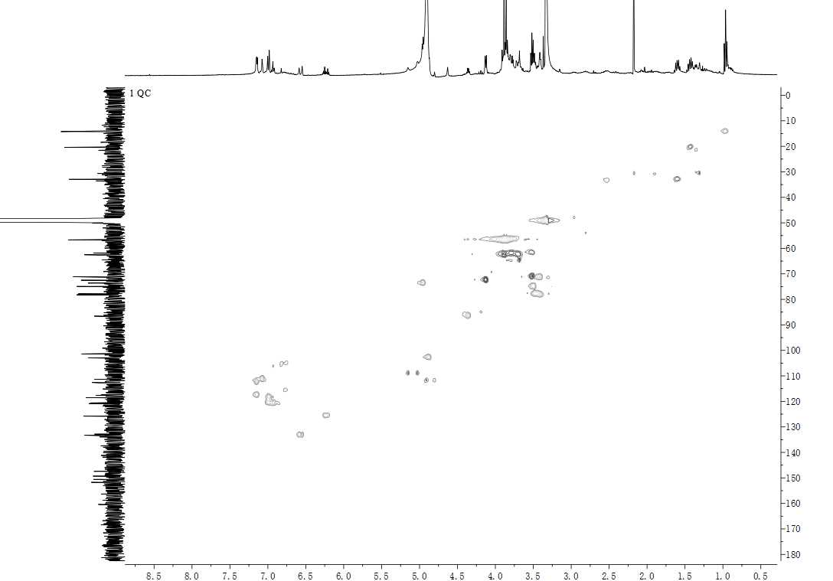Figure S3. HSQC spectrum of compound 1 (400 MHz, CD₃OD).
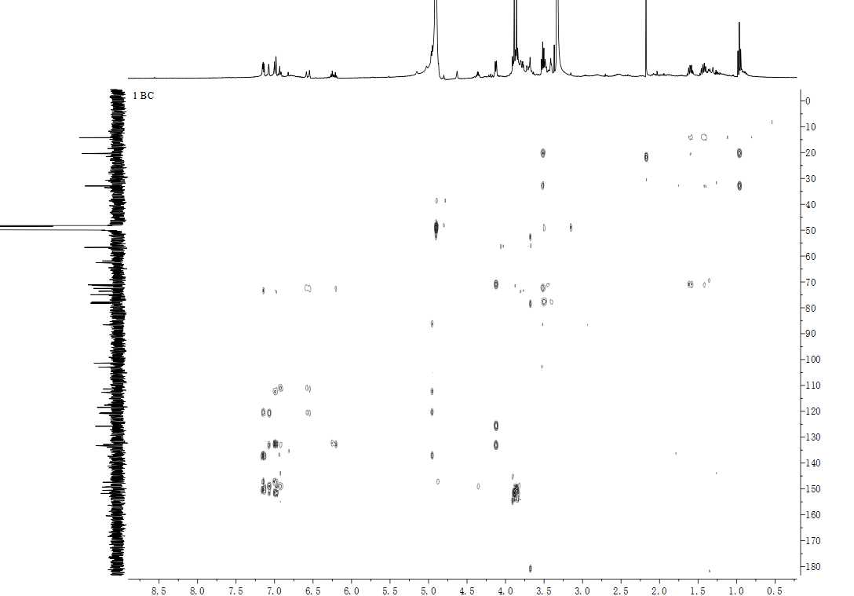Figure S4. HMBC spectrum of compound 1 (400 MHz, CD₃OD).
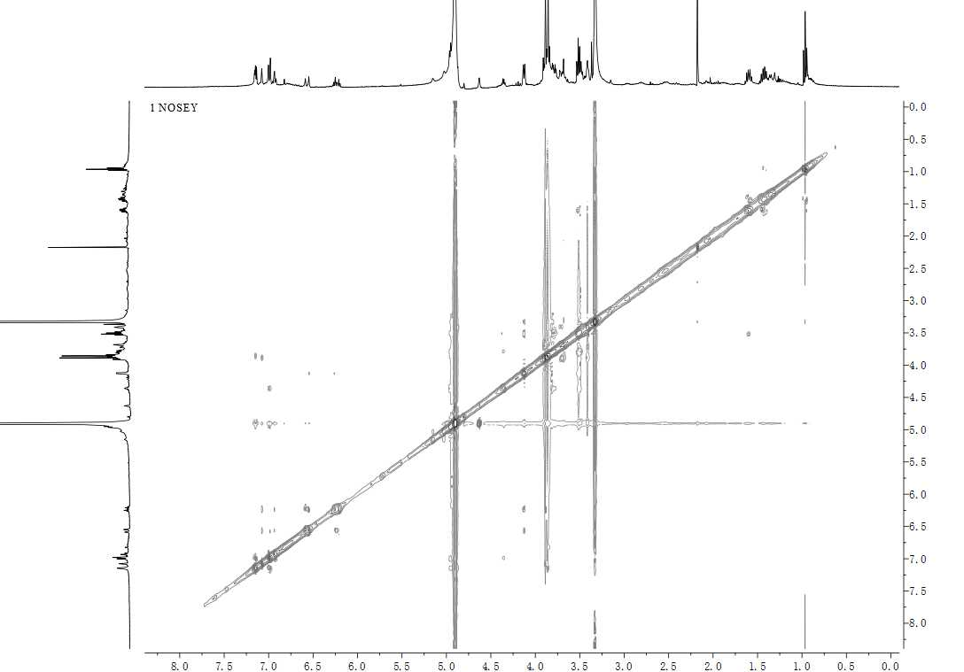Figure S5. NOESY spectrum of compound 1 (400 MHz, CD₃OD).
Figure S6. HR-ESI-TOFMS spectrum of compound 1.

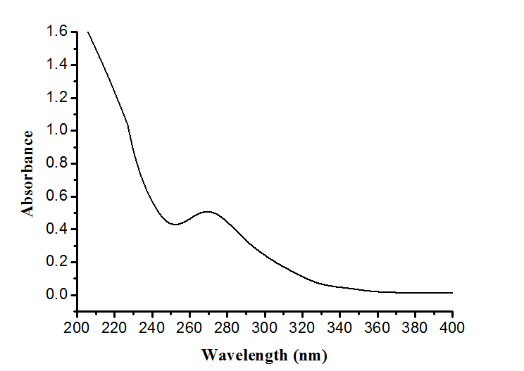
Figure S7. UV spectrum of compound 1.
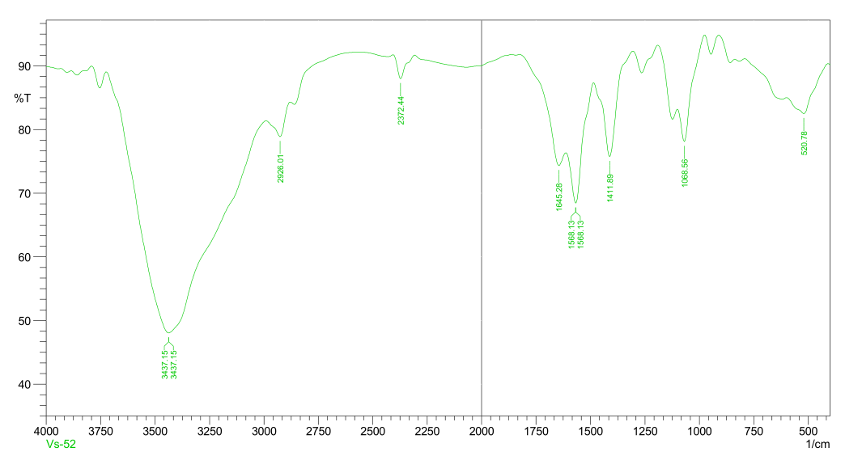
Figure S8. IR spectrum of compound 1.

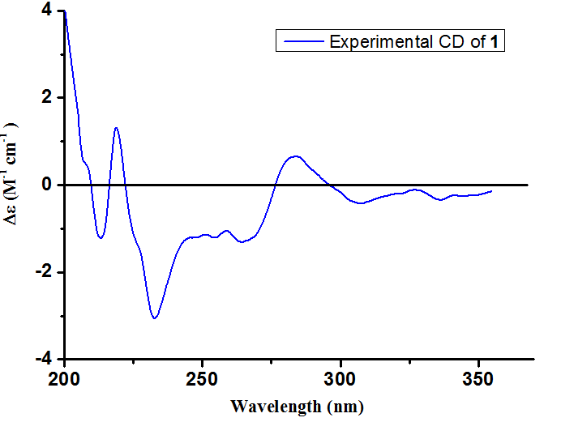
Figure S9. The experimental CD spectrum of (7R, 8R)-1

Figure S10. Key HMBC and ¹H-¹H-COSY correlations of compound 1.

Figure S11. Key NOESY correlations of compound 1.

Verification method and result by TLC: The crude extract was dissolved in water and extracted with ethyl acetate for five times. The remaining water fraction was concentrated in vacuum, followed by dissolving with ethanol and acetone, take the supernatant after centrifugation and concentrated in vacuum to afford B, then identified by TLC, the results showed that A (compound 1) was weakly visualized in B.
Figure S12. TLC Verification of Compound 1.

Verification method and result by HPLC: The HPLC analysis was conducted on a Shimadzu LC-20AD (Shimadzu Crop., Kyoto, Japan) with an ODS column (RP-C18, 250 × 4.6 mm, YMC, 5 μm) equipped with a binary pump and a multi-wavelength UV detector (254nm), eluted with MeOH:H2O (0-50min 30:70-80:20; 50-60min 100:0) and the flow rate of 1.0 mL/min. The results showed that A (compound 1) was visualized in B.
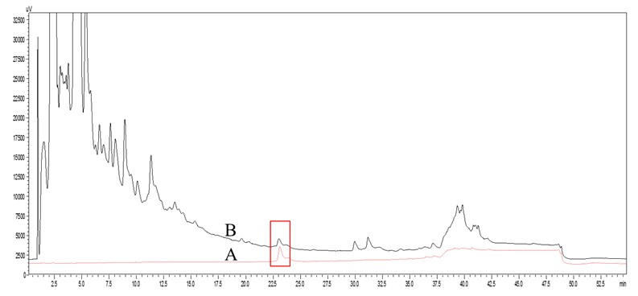
Figure S13. HPLC Verification of Compound 1.
Table S1. ¹H- and ¹³C-NMR data (400 and 101Hz, resp., in CD₃OD) of compound 1 (δ in ppm, J in Hz).
Atom | ¹H-NMR | ¹³C-NMR
1 |  | 132.8
2 | 7.15 (d, J= 2.0 Hz, 1H) | 112.6
3 |  | 150.5
4 |  | 147.4
5 | 6.99 (d, J= 8.3 Hz, 1H) | 118.5
6 | 6.93 (dd, J= 8.4, 2.1 Hz, 1H) | 120.6
7 | 4.96 (d, J = 5.3 Hz, 1H) | 73.6
8 | 4.36 (ddd, J= 5.1,4.3 Hz, 1H) | 86.5
9 | 3.78 (dd, J= 11.8, 4.3 Hz, 1H), 3.53 (overlap, 1H) | 61.8
1' |  | 133.9
2' | 7.08 (d, J= 1.9 Hz, 1H) | 111.3
3' |  | 151.7
4' |  | 149.3
5' | 7.15 (d, J= 8.4 Hz, 1H) | 117.6
6' | 6.99 (dd, J= 8.4, 1.9 Hz, 1H) | 120.8
7' | 6.57 (d, J= 15.8 Hz, 1H) | 133.2
8' | 6.23 (dt, J= 15.9, 6.1 Hz, 1H) | 125.8
9' | 4.13 (dd, J= 6.1, 1.5 Hz, 2H) | 72.4
1''' | 3.52 (overlap, 2H) | 71.1
2''' | 1.59 (2H) | 32.9
3''' | 1.43 (2H) | 20.3
4''' | 0.96 (t, J= 7.4 Hz, 3H) | 14.2
1'' | 4.87 (d, J=7.6 Hz, 1H) | 102.9
2'' | 3.50 (overlap, 1H) | 74.9
3'' | 3.41 (m, 1H) | 78.2
4'' | 3.42 (m, 1H) | 71.3
5'' | 3.48 (m, 1H) | 77.8
6'' | 3.90 (overlap, 1H), 3.69 (dd, J= 11.7, 5.0 Hz, 1H) | 62.5
3-OMe | 3.89 (s, 3H) | 56.5
3'-OMe | 3.86 (s, 3H) | 56.6

