Supplementary data

Fluorescence, turn-on detection of melamine based on its dual functions as fluorescence enhancer of DNA-AgNCs and Hg(II)-scavenger

Sehan Jeong,ª Wooyoung Kwon,ª Sung Hyun Hwang,ª Jiye Shin,ª Yong Hwan Kim,^{b} Miran Lee,^{b} and Ki Soo Park^{a,}*

ª Department of Biological Engineering, College of Engineering, Konkuk University, Seoul 05029, Republic of Korea
^{b} Daisung Green Tech, Gyeonggi-do 13216, Republic of Korea

*Corresponding Author
Prof. Ki Soo Park
Department of Biological Engineering, College of Engineering, Konkuk University
Seoul 05029, Republic of Korea
Tel: +82-2-450-3742,
Fax: +82-2-450-3742,
E-mail: kskonkuk@gmail.com or akdong486@konkuk.ac.kr

Table S1. Comparison of the developed method with previous ones for the detection of melamine.
Signaling methods | Key materials | Linear range | LOD | Reference
Colorimetry | Gold nanoparticles | 7.9-634.3 μM | 3.17 μM | [1]
Colorimetry | Silver nanoparticles (AgNPs) | 4.0-170 μM | 2.32 μM | [2]
Surface Enhanced Raman Spectroscopy | AgNPs coated poly(styrene-co-acrylic acid) nanospheres | - | 0.1 μM | [3]
Fluorometry | Bovine serum albumin-gold nanoclusters | 0.5-10 μM | 0.2 μM | [4]
Fluorometry | Graphene quantum dots | 0.15-20 μM | 0.12 μM | [5]
Fluorometry | CdTe quantum dots | 0.792-9.5 μM | 0.31 μM | [6]
Fluorometry | DNA-AgNCs  (5’-AAT TCC CCC CCC CCC CAA TT-3’) | 0.2-4 μM | 0.1 μM | [7]
Fluorometry | DNA-AgNCs  (5’-CCC TTA ATC CCC-3’) | 0.15-15 μM | 0.049 μM | This work

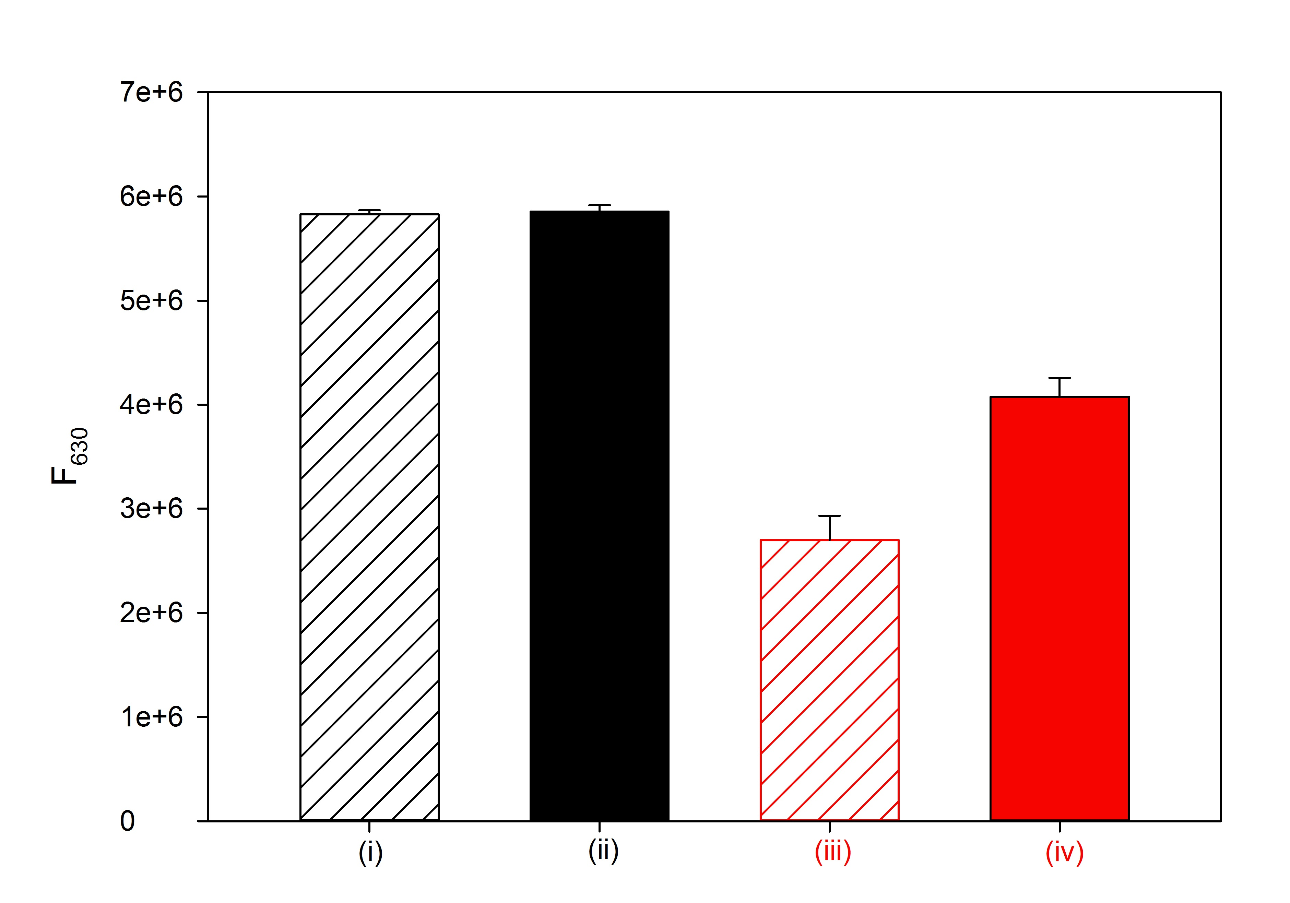
Figure S1. The fluorescence intensity at 630 nm (F₆₃₀) of DNA-AgNCs (i), DNA-AgNCs + melamine (ii), DNA-AgNCs + Hg(II) (iii), and DNA-AgNCs + melamine + Hg(II) (iv). The control DNA (5’-CCC CCC CCC CCC-3’) that does not contain thymine residues were employed and the fluorescence intensities of the corresponding DNA-AgNCs were measured under the different conditions (i-iv). The excitation wavelength is 545 nm and the concentrations of DNA-AgNCs, Hg(II) and melamine are 0.2x, 150 nM, and 30 μM, respectively.

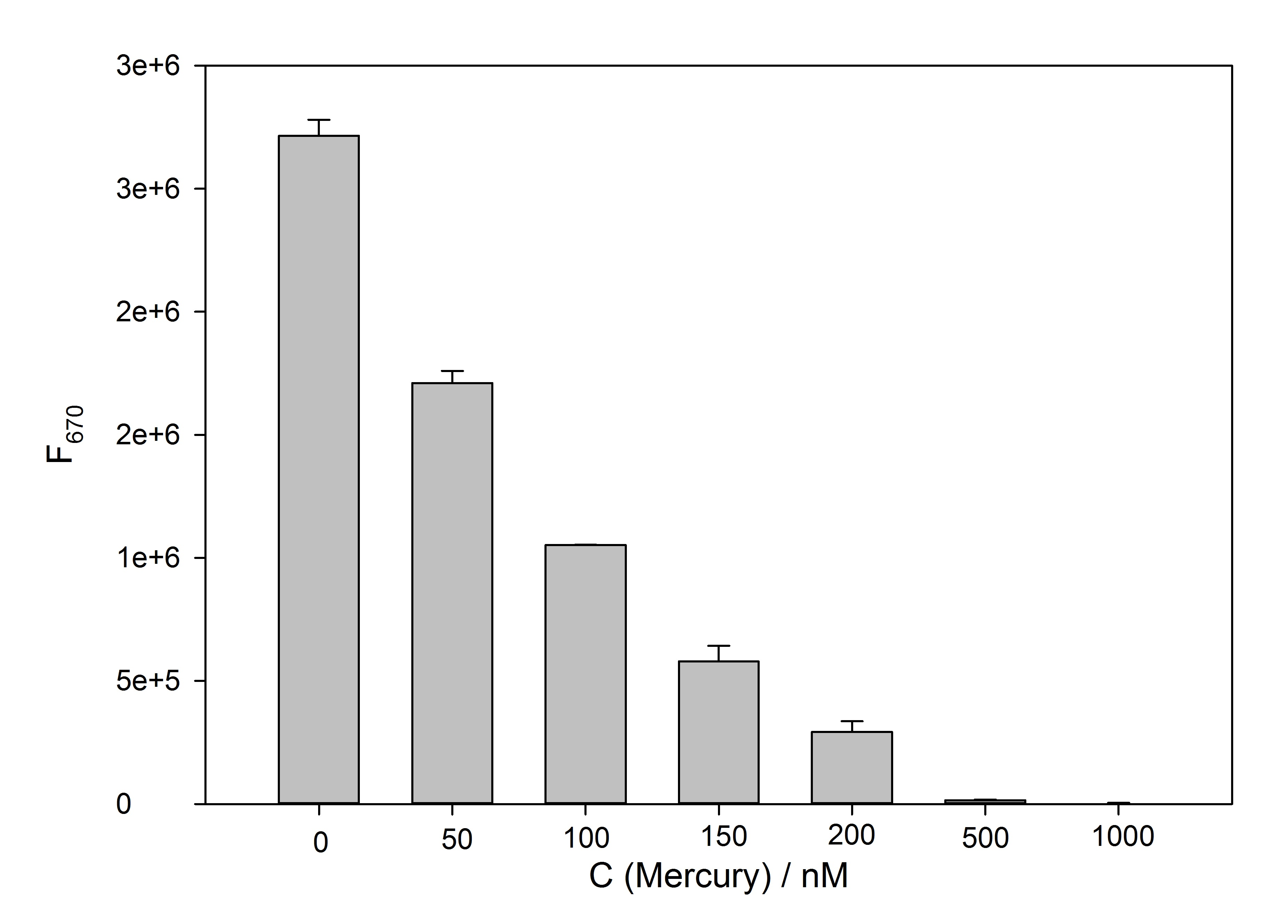Figure S2. Fluorescence intensities at 670 nm (F₆₇₀) of DNA-AgNCs (0.2x) in the presence of Hg(II) at different concentrations.

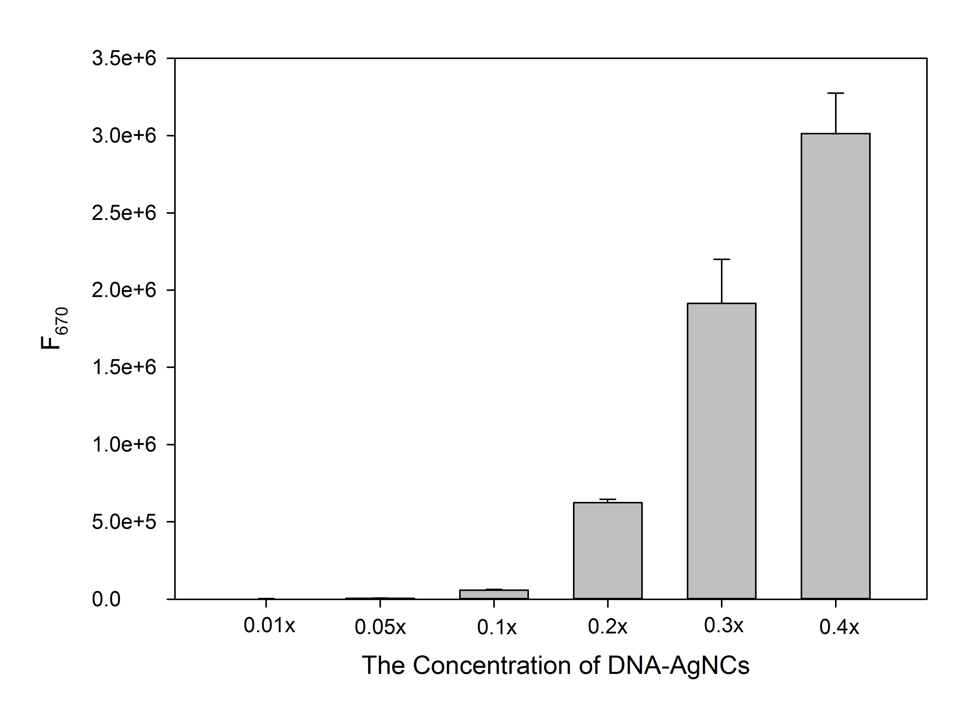
Figure S3. Fluorescence intensities at 670 nm (F₆₇₀) of DNA-AgNCs at different concentrations in the presence of Hg(II) (150 nM).
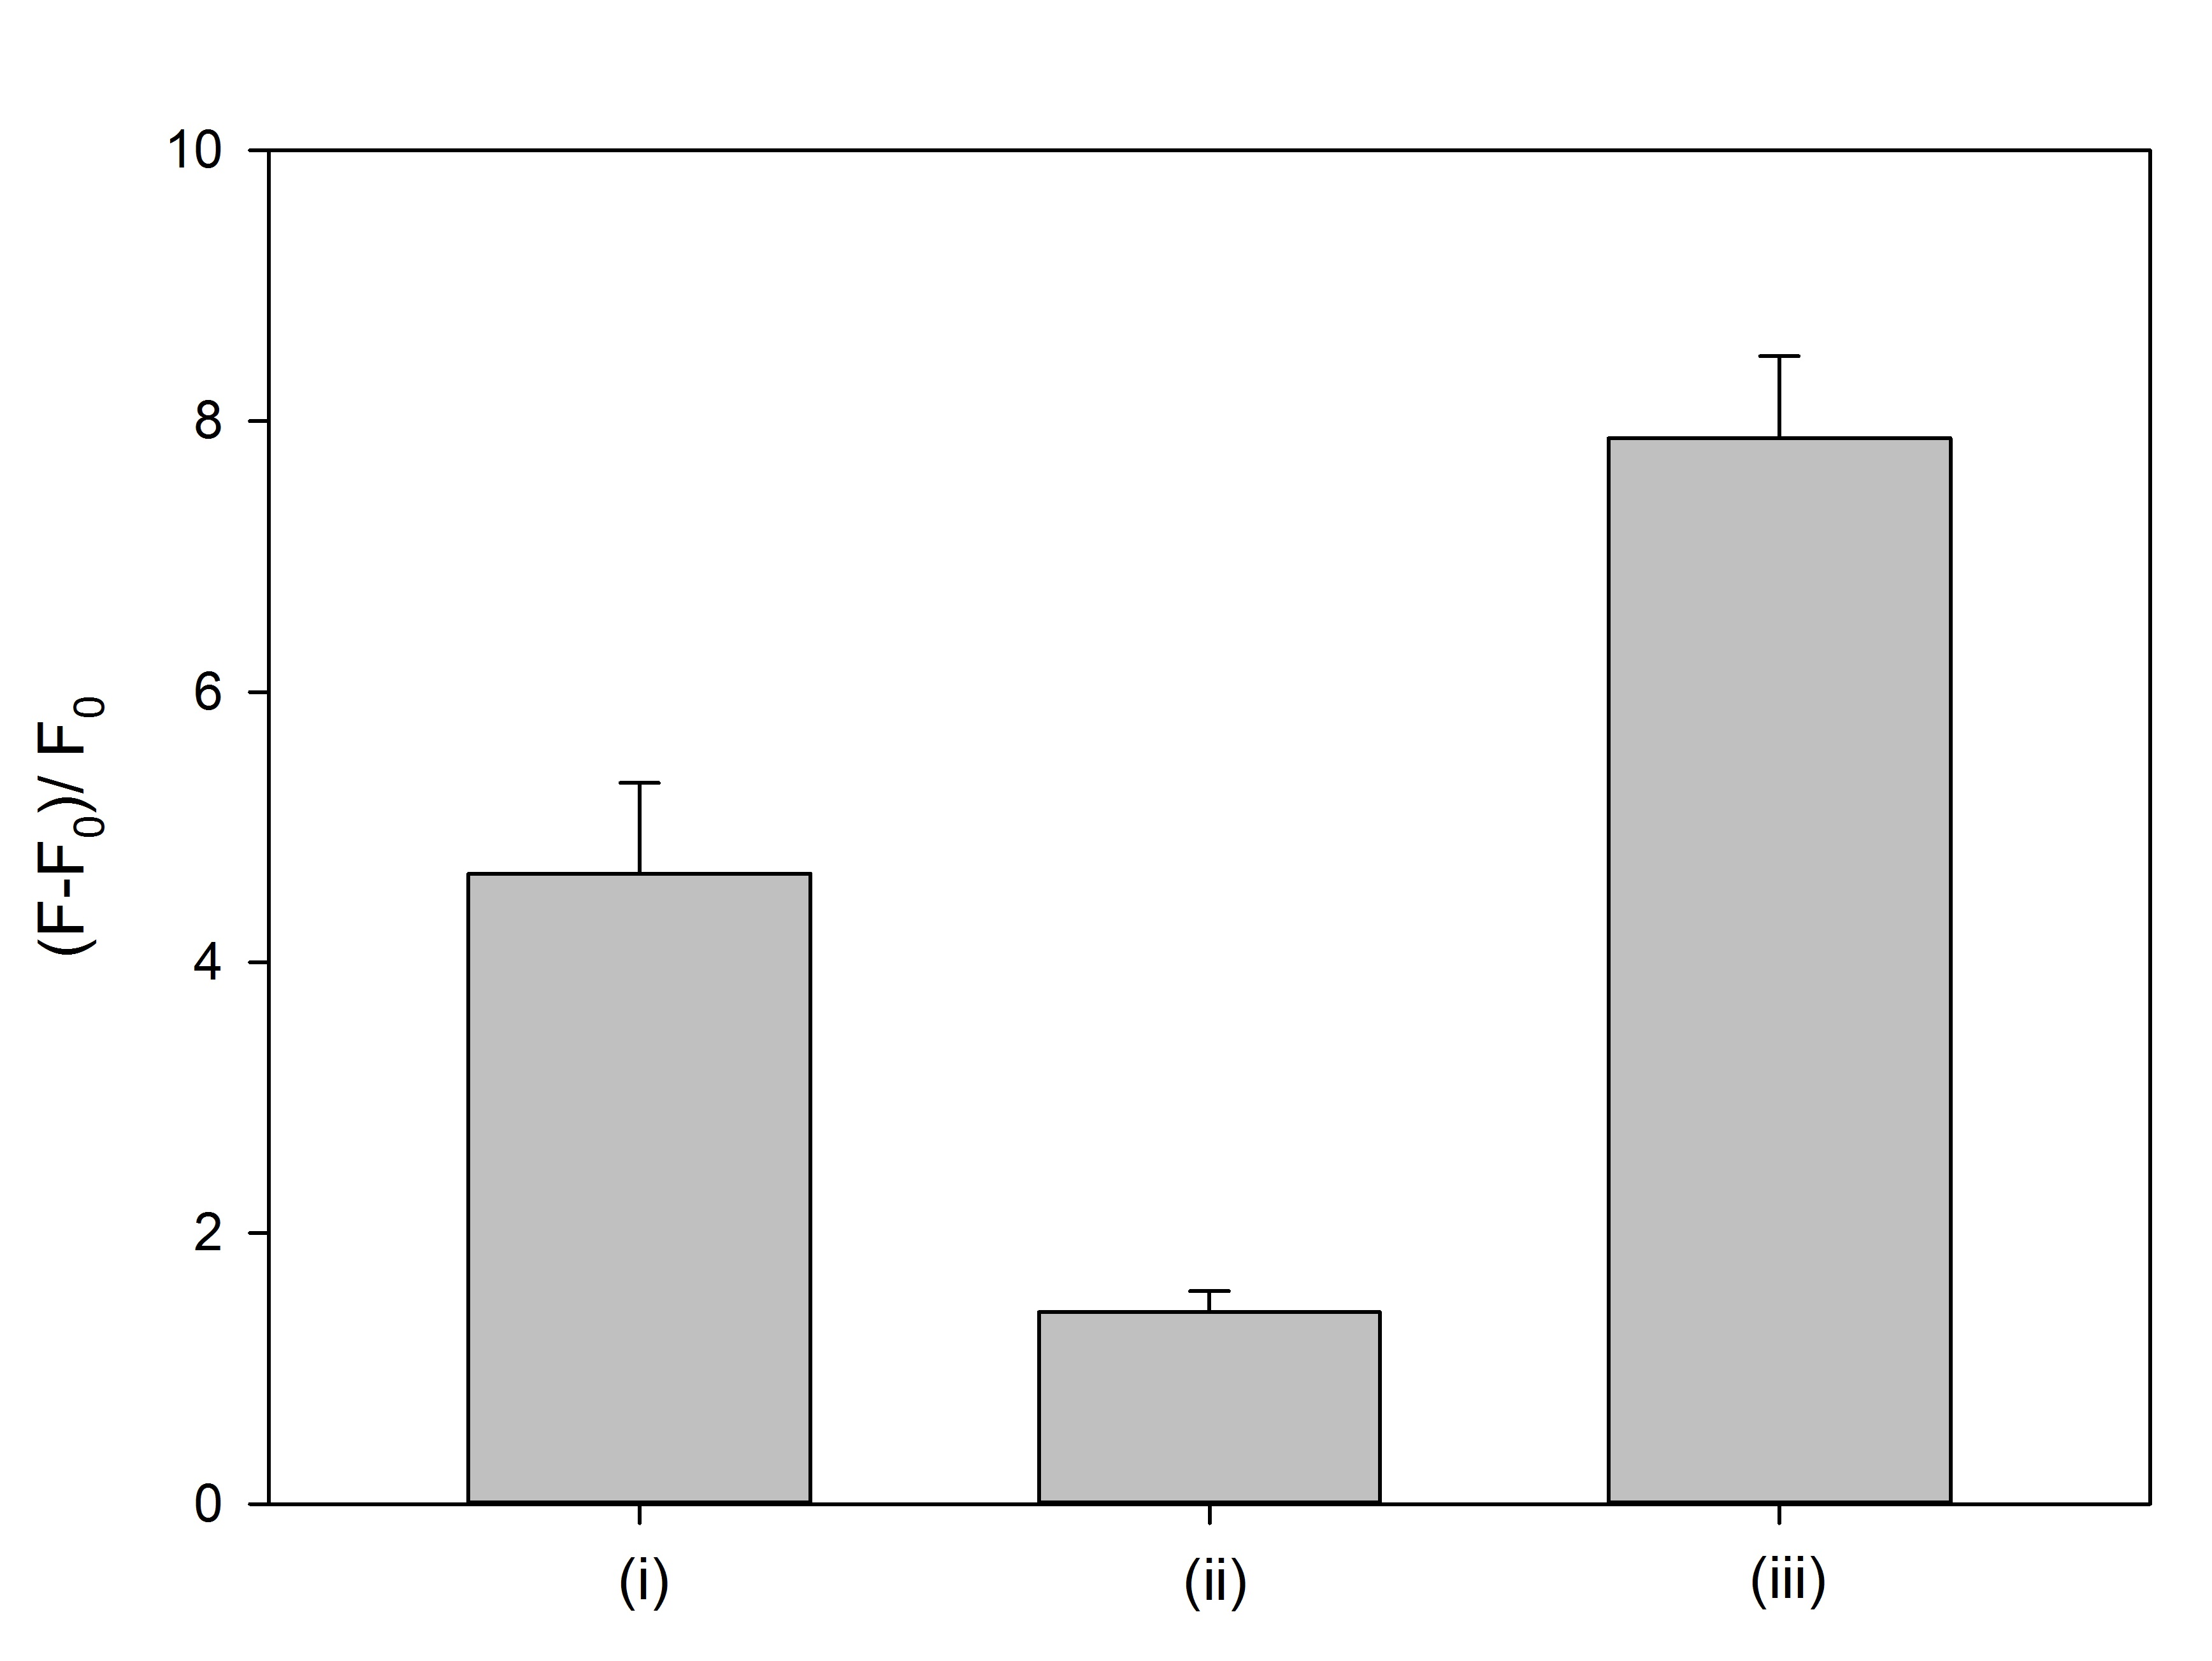

Figure S4. The effect of addition steps on the melamine-promoted fluorescence enhancement. (i) Hg(II) was subsequently applied to the pre-mixed solution of DNA-AgNCs with melamine, (ii) melamine was subsequently applied to the pre-mixed solution of DNA-AgNCs with Hg(II), and (iii) DNA-AgNCs were subsequently applied to the pre-mixed solution of melamine and Hg(II).
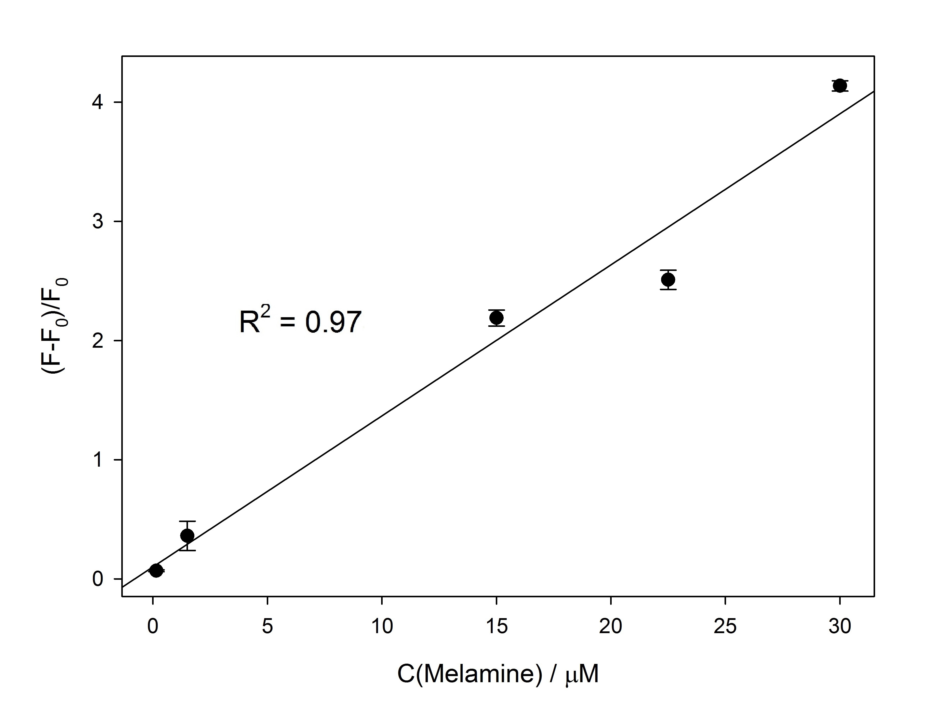
Figure S5. The linear relationship between (F-F₀)/F₀ and the concentration of melamine, C(Melamine), in the diluted milk sample (1%). The plot of (F-F₀)/F₀ vs. C(Melamine) shows an excellent linear relationship by the linear equation, (F-F₀)/F₀ = 0.1268 x C(Melamine) + 0.1001.
References
[1] Chi H, Liu B, Guan G, Zhang Z, Han MY, A simple, reliable and sensitive colorimetric visualization of melamine in milk by unmodified gold nanoparticles, Analyst 2010; 135:1070-1075
[2] Ping H, Zhang M, Li H, Li S, Chen Q, Sun C, Zhang T, Visual detection of melamine in raw milk by label-free silver nanoparticles, Food Control 2012; 23:191–197
[3] Li J, Ma W, et al. Detecting trace melamine in solution by SERS using Ag Nanoparticle coated poly(styrene-co-acrylic acid) nanospheres as novel active substrates, Langmuir 2011; 27:14539-14544
[4] Dai H, Shi Y, Wang Y, et al. Label-free turn-on fluorescent detection of melamine based on the anti-quenching ability of Hg²⁺ to gold nanoclusters, Biosens. Bioelectron. 2014; 53:76-81
[5] Li L, Wu G, Hong T, Yin Z, Sun D, Abdel-Halim ES, Zhu JJ, Graphene quantum dots as fluorescence probes for turn-off sensing of melamine in the presence of Hg²⁺, ACS Appl. Mater. Interfaces 2014; 6:2858–2864
[6] Zhang, M, Cao X, Li H, Guan F, Guo J, Shen F, Luo Y, Sun C, Zhang L, Sensitive fluorescent detection of melamine in raw milk based on the inner filter effect of Au nanoparticles on the fluorescence of CdTe quantum dots. Food Chem. 2012; 135:1894–1900
[7] Xie P, Zhan Y, Wu M, et al. The detection of melamine base on a turn-on fluorescence of DNA-Ag nanoclusters. J. Lumin. 2017;186:103-108

