Supplement Materials

Figure S1. Sequencing map of four plasmids.

The sequence map for Wild-type plasmid of CYP2C19*2

The sequence map for mutant plasmid of CYP2C19*2
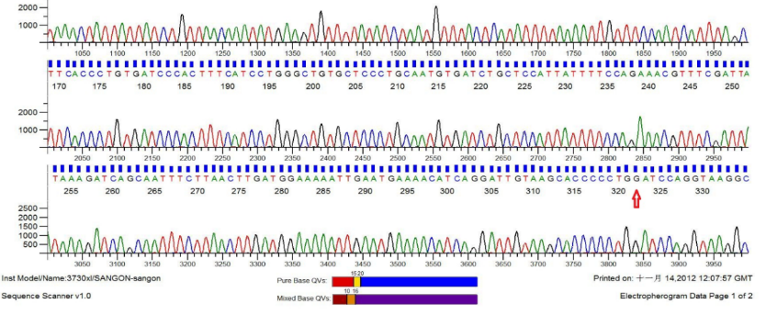

The sequence map for Wild-type plasmid of CYP2C19*3
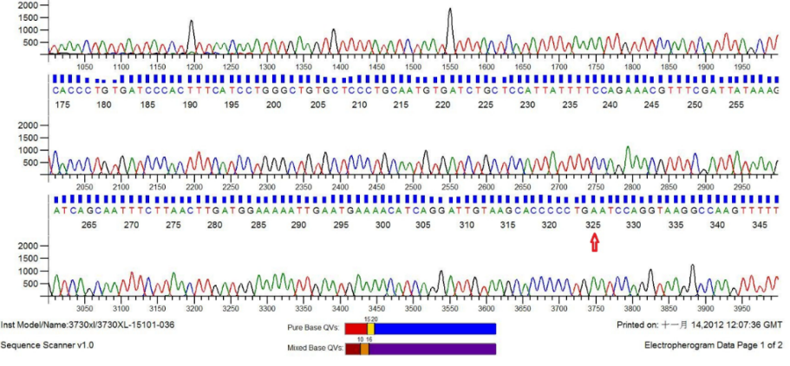

The sequence map for mutant plasmid of CYP2C19*3

Figure S2. The magnetic signals by magnetic reader.

Figure S3. Screening of specific primers.

Figure S4. The brightness of T line at different primer concentrations.
Figure S5. The brightness of T line at different annealing temperatures.

Figure S6. The brightness of T line at different cycle numbers.

Figure S7. The genotyping results of ARMS-LFA system with three batches of strips.

