Supporting Information

Triphenylamine-substituted 2-pyridyl-1,2,3-triazole copper(I) complexes – An experimental and computational investigation

JOSEPH I. MAPLEY, DANIEL A.W. ROSS, C. JOHN McADAM, KEITH C. GORDON and JAMES D. CROWLEY*

Contents

1 Experimental Spectra 3
1.1 [Cu(pytri)(diMesbpy)](PF₆) 3
1.2 [Cu(pytri)(POP)](PF₆) 4
1.3 [Cu(TPA-pytri)(diMesbpy)](PF₆) 7
1.4 Synthesis of [Cu(TPA-pytri)(POP)](PF₆) 9
2 X-ray Data 11
2.1 [Cu(pytri)(diMesbpy)](PF₆).CHCl₃ 11
2.2 [Cu(pytri)(POP)](PF₆) 12
2.3 Crystallographic Data 13
3 Electrochemistry 14
3.1 POP Ligand 14
3.2 TPA-pytri Ligand 15
3.3 [Cu(pytri)(diMesbpy)](PF₆) 16
3.4 [Cu(pytri)(POP)](PF₆) 17
3.5 [Cu(TPA-pytri)(diMesbpy)](PF₆) 18
3.6 [Cu(TPA-pytri)(POP)](PF₆) 19
4 Spectroscopy 19
4.1 Emission 20
4.2 Resonance Raman 22
5 Computational Modelling 24
5.1 Predicted Raman Spectra 24
5.2 Predicted Transitions 27
5.3 Molecular Orbitals 29
6 References 31

Experimental Spectra

[Cu(pytri)(diMesbpy)](PF₆)

Figure S1 ¹H NMR (400 MHz, CDCl₃, 298 K) of [Cu(pytri)(diMesbpy)](PF₆).

Figure S2 ¹³C NMR (101 MHz, CDCl₃, 298 K) of [Cu(pytri)(diMesbpy)](PF₆).

Figure S3 HR ESI-MS (acetone/CH₃CN) of [Cu(pytri)(diMesbpy)](PF₆).

[Cu(pytri)(POP)](PF₆)

Figure S4 ¹H NMR (400 MHz, d₆‐acetone, 298 K) of [Cu(pytri)(POP)](PF₆).

Figure S5 ¹³C NMR (101 MHz, d₆‐acetone, 298 K) of [Cu(pytri)(POP)](PF₆).

Figure S6 HR ESI-MS (CH₃OH) of [Cu(pytri)(POP)](PF₆).

[Cu(TPA-pytri)(diMesbpy)](PF₆)

Figure S7 ¹H NMR (400 MHz, CDCl₃, 298 K) of [Cu(TPA-pytri)(diMesbpy)](PF₆).
Figure S8 ¹³C NMR (101 MHz, CDCl₃, 298 K) of [Cu(TPA-pytri)(diMesbpy)](PF₆).

Figure S9 HR ESI-MS (acetone/CH₃OH) of [Cu(TPA-pytri)(diMesbpy)](PF₆).

Synthesis of [Cu(TPA-pytri)(POP)](PF₆)

Figure S10 ¹H NMR (400 MHz d₆‐acetone, 298 K) of [Cu(TPA-pytri)(POP)](PF₆).
Figure S11 ¹H NMR (400 MHz CDCl₃, 298 K) of [Cu(TPA-pytri)(POP)](PF₆), as requested by reviewer to show solvents observed in the elemental analysis data can be detected by NMR.

Figure S12 ¹³C NMR (101 MHz, d₆‐acetone, 298 K) of [Cu(TPA-pytri)(POP)](PF₆).

Figure S13 HR ESI-MS (acetone/CH₃OH) of [Cu(TPA-pytri)(POP)](PF₆).

X-ray Data

[Cu(pytri)(diMesbpy)](PF₆).CHCl₃

CCDC #: 1877487. Slow evaporation of a chloroform solution of [Cu(pytri)(diMesbpy)][PF₆] gave orange/red block like crystals of [Cu(pytri)(diMesbpy)][PF₆]. X-ray data were collected at 90 K on an Agilent Technologies Supernova system using Cu Kα radiation with exposures over 1.0º, and data were treated using CrysAlisPro^{[1]} software. The structure was solved using SHELXT within OLEX2 and weighted full-matrix refinement on F² was carried out using SHELXL-97^{[2]} running within the OLEX2 package.^{[3]} All non-hydrogen atoms were refined anisotropically. Hydrogen atoms attached to carbons were placed in calculated positions and refined using a riding model. The structure was solved in the monoclinic space group P2₁/n and refined to an R1 value of 5.7%. The asymmetric unit consists of one [Cu(pytri)(diMesbpy)](PF₆) and one chloroform solvent molecule.

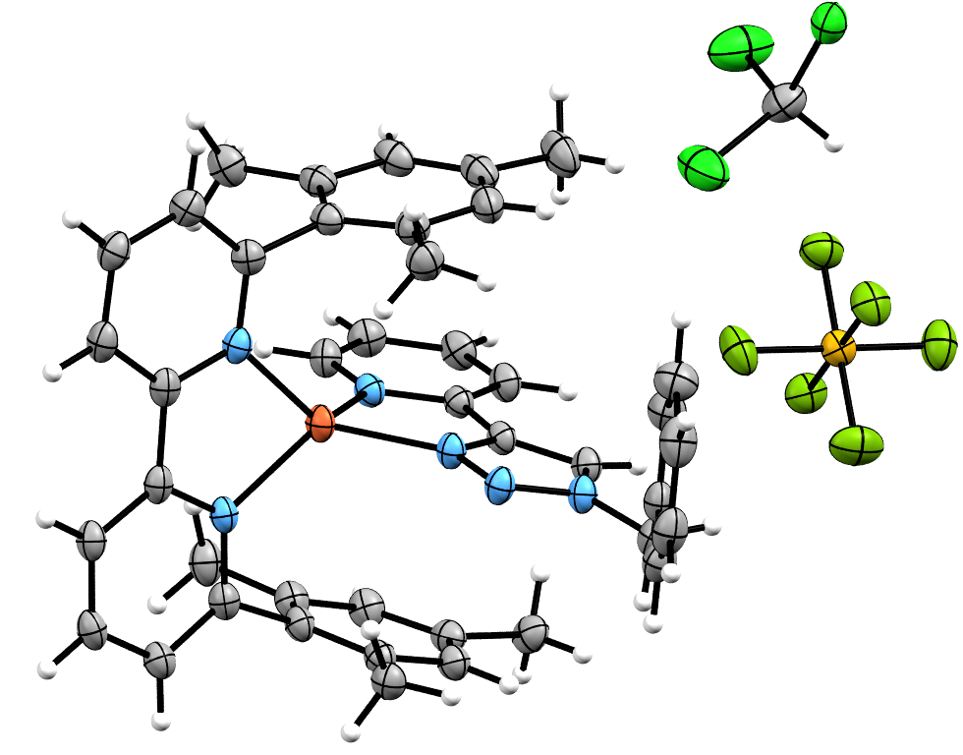

Figure S14 ORTEP^{[4]} plot of the asymmetric unit of [Cu(pytri)(diMesbpy)](PF₆).CHCl₃. Ellipsoids shown at 50% probability level. Colour scheme: carbon grey, hydrogen white, chlorine bright green, phosphorus yellow, fluorine dull green, nitrogen blue, copper orange.

[Cu(pytri)(POP)](PF₆)

CCDC #: 1877486. Diffusion of diethyl ether into a chloroform solution of [Cu(pytri)(POP)](PF₆) gave colourless block like crystals of [Cu(pytri)(POP)](PF₆). X-ray data were collected at 100 K on an Agilent Technologies Supernova system using Cu Kα radiation with exposures over 1.0º, and data were treated using CrysAlisPro^{[1]} software. The structure was solved using SHELXT within OLEX2 and weighted full-matrix refinement on F² was carried out using SHELXL-97^{[2]} running within the OLEX2 package.^{[3]} All non-hydrogen atoms were refined anisotropically. Hydrogen atoms attached to carbons were placed in calculated positions and refined using a riding model. The structure was solved in the monoclinic space group P2₁/c and refined to an R1 value of 3.4%. The asymmetric unit consists of one [Cu(pytri)(diMesbpy)][PF₆].

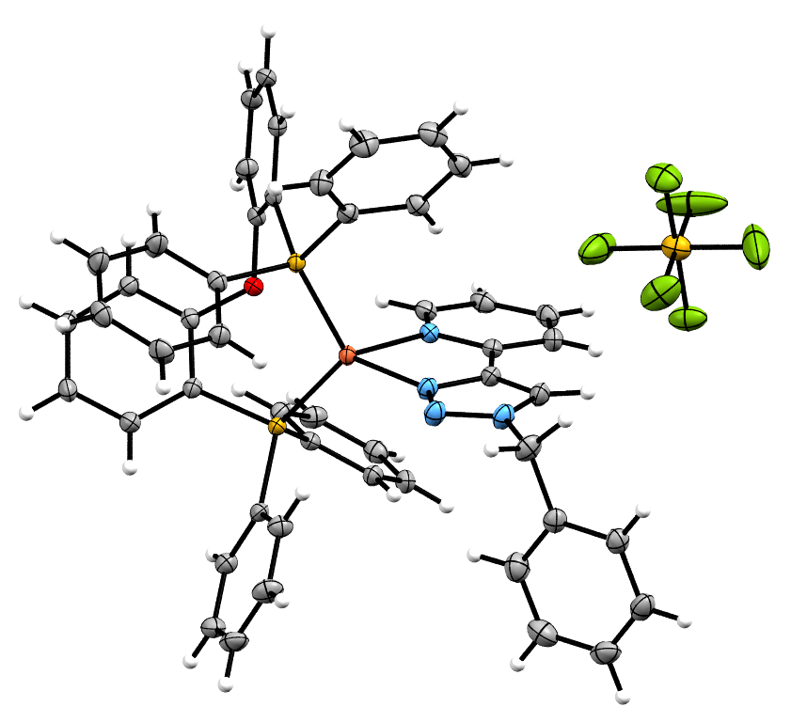

Figure S15 ORTEP^{[4]} plot of the asymmetric unit of [Cu(pytri)(POP)](PF₆). Ellipsoids shown at 50% probability level. Colour scheme: carbon grey, hydrogen white, phosphorus yellow, fluorine dull green, nitrogen blue, oxygen red, copper orange.

Crystallographic Data

Table S1 – Crystallographic data for the [Cu(pytri)(diMesbpy)](PF₆).CHCl₃ and [Cu(pytri)(POP)](PF₆) complexes.
 | [Cu(pytri)(diMesbpy)](PF₆).CHCl₃ | [Cu(pytri)(POP)](PF₆)
Identification code | DR-009 | DR025_Cu
CCDC # | 1877487 | 1877486
Empirical formula | C₄₃H₄₁Cl₃CuF₆N₆P | C₅₀H₄₀CuF₆N₄OP₃
Formula weight | 956.68 | 983.31
Temperature/K | 89.9(3) | 99.9(2)
Crystal system | monoclinic | monoclinic
Space group | P2₁/n | P2₁/c
a/Å | 11.7707(3) | 10.43450(10)
b/Å | 23.9800(5) | 16.7203(2)
c/Å | 15.5335(4) | 25.3149(3)
α/° | 90 | 90
β/° | 105.286(2) | 92.7290(10)
γ/° | 90 | 90
Volume/Å³ | 4229.39(18) | 4411.63(9)
Z | 4 | 4
ρ_{calc}g/cm³ | 1.502 | 1.480
μ/mm⁻¹ | 3.404 | 2.323
F(000) | 1960.0 | 2016.0
Crystal size/mm³ | 0.25 × 0.235 × 0.155 | 0.167 × 0.094 × 0.062
Radiation | CuKα (λ = 1.54184) | CuKα (λ = 1.54184)
2Θ range for data collection/° | 6.956 to 150.166 | 8.484 to 146.182
Index ranges | -14 ≤ h ≤ 14, -29 ≤ k ≤ 29, -19 ≤ l ≤ 13 | -12 ≤ h ≤ 12, -18 ≤ k ≤ 20, -31 ≤ l ≤ 31
Reflections collected | 34502 | 39016
Independent reflections | 8518 [R_{int} = 0.0614, R_{sigma} = 0.0373] | 8652 [R_{int} = 0.0372, R_{sigma} = 0.0221]
Data/restraints/parameters | 8518/0/547 | 8652/0/586
Goodness-of-fit on F² | 1.049 | 1.023
Final R indexes [I>=2σ (I)] | R₁ = 0.0569, wR₂ = 0.1487 | R₁ = 0.0338, wR₂ = 0.0900
Final R indexes [all data] | R₁ = 0.0654, wR₂ = 0.1573 | R₁ = 0.0355, wR₂ = 0.0914
Largest diff. peak/hole / e Å⁻³ | 1.20/-0.57 | 0.73/-0.46

Electrochemistry
All cyclic and differential-pulse voltammetric experiments were performed in CH₂Cl₂ solutions at 20 ◦C with a concentration of 1 mM of electroactive analyte and 0.1 M NBu₄PF₆ as the supporting electrolyte. A three-electrode cell was used with Cypress Systems 1.4 mm diameter glassy carbon working, Ag/AgCl reference and platinum wire auxiliary electrodes. Voltammograms were recorded with the aid of a Powerlab/4sp computer-controlled potentiostat (AD instruments, Castle Hill, NSW, Australia). Potentials for all complexes were referenced to the reversible formal potential (taken as E◦ = 0.00 V) of the [Fc*]^{+/0} redox couple of decamethylferrocene.^{[5]}

POP Ligand

Figure S16 Cyclic voltammogram of POP (black trace) with differential pulse voltammogram (red trace) overlay (1 mM CH₂Cl₂ solution, 100 mVs^{‐1}, Bu₄NPF₆).

TPA-pytri Ligand

Figure S17 Cyclic voltammogram of TPA-pytri (black trace) with differential pulse voltammogram (red trace) overlay (1 mM CH₂Cl₂ solution, 100 mVs^{‐1}, Bu₄NPF₆).

[Cu(pytri)(diMesbpy)](PF₆)

Figure S18 Cyclic voltammogram of [Cu(pytri)(diMesbpy)](PF₆) (black trace) with differential pulse voltammogram (red trace) overlay (1 mM CH₂Cl₂ solution, 100 mVs^{‐1}, Bu₄NPF₆).

[Cu(pytri)(POP)](PF₆)

Figure S19 Cyclic voltammogram of [Cu(pytri)(POP)](PF₆) (black trace) with differential pulse voltammogram (red trace) overlay (1 mM CH₂Cl₂ solution, 100 mVs^{‐1}, Bu₄NPF₆).

[Cu(TPA-pytri)(diMesbpy)](PF₆)

Figure S20 Cyclic voltammogram of [Cu(TPA-pytri)(diMesbpy)](PF₆) (black trace) with differential pulse voltammogram (red trace) overlay (1 mM CH₂Cl₂ solution, 100 mVs^{‐1}, Bu₄NPF₆).

[Cu(TPA-pytri)(POP)](PF₆)

Figure S21 Cyclic voltammogram of [Cu(TPA-pytri)(POP)](PF₆) (black trace) with cyclic voltammogram of the TPA-pytri oxidation isolated (green trace) and differential pulse voltammogram (red trace) overlay (1 mM CH₂Cl₂ solution, 100 mVs^{‐1}, Bu₄NPF₆).

Spectroscopy
Spectroscopic grade dichloromethane was used for all spectroscopic measurements. Spectral data was analysed and manipulated using GRAMS v9.2 (Thermo Fisher Scientific) and OriginPro v9.0 (OriginLab Corporation).
Uv-vis spectra were recorded on a Lambda 950 UV-vis spectrophotometer (PerkinElmer, Waltham, MA, USA) at room temperature in a 1 cm quartz cuvette. A scan rate of 100 nm min⁻¹ was employed between 300 and 800 nm. Extinction coefficients were determined by measuring a series of samples between 1 × 10⁻⁵ and 1 × 10⁻⁶ M.
Excitation and emission spectra were recorded on a FS5 fluorimeter (Edinburgh Instruments, UK), with a Xenon Arc lamp light source. Quantum yields were measured with the use of an integrating sphere. Degassing of samples was achieved by bubbling argon through them for 10 minutes. Lifetimes were recorded using TCSPC photon counting on a FS5 fluorimeter with 325.4 nm excitation provided by an EPLED-320 diode laser (Edinburgh Instruments, UK). The instrument response function was measured using a solution of Ludox (40% weight in water).
FT-Raman spectra were measured using a Bruker Optics MultiRAM spectrometer (Bruker, Billerica, MA, USA) and a liquid-nitrogen-cooled Model D418T germanium detector. The system was controlled by Bruker Opus v7.5 software. A 1064 nm Nd:YAG laser was used with a power of 150 mW. Spectra were measured with 1024 scans and a spectral resolution of 4 cm⁻¹.
Resonance Raman spectra were collected using a setup described previously.^{[6]} In summary, the laser beam was focused on a spinning NMR tube in a 135° backscattering geometry with a 50 µm entrance slit. Solid state diodes provided excitations wavelengths of 458 and 515 nm (Cobolt, Solna, Sweden), 448 nm (CrystaLaser, Reno, NV, USA) and 406 nm (Ondax, Monrovia, California). Notch filters (Kaiser Optical Inc., Ann Arbor, MI, USA) or long-pass filters (Semrock, Inc., Rochester, NY, USA) matched to these wavelengths was used to remove the laser excitation line. The beam was dispersed using 1200 mm⁻¹ grating onto a PyLoN 400BR CCD (Princeton Instruments, Trenton, NJ, USA), cooled with liquid nitrogen to -120°C; Winspec/32 software was used to control the CCD equipment. Sample concentrations were typically 1 × 10⁻⁵ M and spectra were obtained at room temperature. Spectra were calibrated at each excitation wavelength, using reference peaks of a 1:1 mixture of toluene and acetonitrile to within a pixel.

Emission

Figure S22 Excitation-emission map of [Cu(TPA-pytri)(diMesbpy)](PF₆) (0.01 mM, CH₂Cl₂).

Figure S23 Excitation-emission map of [Cu(TPA-pytri)(POP)](PF₆) (0.01 mM, CH₂Cl₂).

Resonance Raman

Figure S24 Resonance Raman spectra of [Cu(pytri)(POP)](PF₆) (0.01 mM in CH₂Cl₂) at a range of excitation wavelengths. FT-Raman (FTR) of powder sample measured at 1064 nm. Solvent peaks labelled with *.

Figure S25 Resonance Raman spectra of [Cu(TPA-pytri)(diMesbpy)](PF₆) (0.01 mM in CH₂Cl₂) at a range of excitation wavelengths. FT-Raman (FTR) of powder sample measured at 1064 nm. Solvent peaks labelled with *.

Figure S26 Resonance Raman spectra of [Cu(TPA-pytri)(POP)](PF₆) (0.01 mM in CH₂Cl₂) with 355 nm excitation and FT-Raman (FTR) of powder sample measured at 1064 nm. Solvent peaks labelled with *.

Computational Modelling

Geometry optimisations and vibrational calculations were performed using density functional theory (DFT) calculations with B3LYP^{[7]} or CAM-B3LYP^{[8]} functionals. Both functionals employed the basis set 6-31G(d) and were conducted with and without a solvent field implemented using a polarised continuum model.^{[9]}. These were implemented with Gaussian 09 D0.1 (Gaussian Inc, Wallingford, CT, USA).^{[10]} Scaling factors of 0.975 and 0.95 for B3LYP and CAM-B3LYP, respectively, were applied to calculated vibrational frequencies as recommended previously.^{[11]} The vibrational modes were visualised using Molden.^{[12]}
Time-dependent DFT (TD-DFT) methods were implemented on the optimised structures, using both B3LYP and CAM-B3LYP functionals to approximate electronic transition energies and oscillator strengths for each compound investigated.

Predicted Raman Spectra

Figure S27 Calculated and experimental Raman spectra of [Cu(pytri)(diMesbpy)](PF₆). Calculated spectra obtained using B3LYP or CAM-B3LYP functionals. FT-Raman of powder sample measured at 1064 nm.

Figure S28 Calculated and experimental Raman spectra of [Cu(pytri)(POP)](PF₆). Calculated spectra obtained using B3LYP or CAM-B3LYP functionals. FT-Raman of powder sample measured at 1064 nm.

Figure S29 Calculated and experimental Raman spectra of [Cu(TPA-pytri)(diMesbpy)](PF₆). Calculated spectra obtained using B3LYP or CAM-B3LYP functionals. FT-Raman of powder sample measured at 1064 nm.

Figure S30 Calculated and experimental Raman spectra of [Cu(TPA-pytri)(POP)](PF₆). Calculated spectra obtained using B3LYP or CAM-B3LYP functionals. FT-Raman of powder sample measured at 1064 nm.

Predicted Transitions

Figure S31 Comparison of experimental electronic absorption spectra with calculated transitions for B3LYP (red trace) and CAM-B3LYP (blue trace).

Table S2 Predicted electronic transitions for [Cu(pytri)(diMesbpy)]⁺ calculated with TD-DFT (B3LYP / 6-31G(d)).
λ | f | Major contributors (% contribution) | Mulliken charge density change (%)
/ nm |  |  | Cu | diMesbpy | PyTri
635 | 0.0001 | HOMO->LUMO (97%) | 75-->5 (-70) | 17-->94 (77) | 8-->1 (-7)
510 | 0.0126 | H-1->LUMO (10%), H-1->L+1 (84%) | 77-->4 (-73) | 10-->11 (1) | 13-->85 (72)
506 | 0.1126 | H-1->LUMO (65%), H-1->L+1 (12%), HOMO->L+1 (20%) | 77-->5 (-72) | 11-->64 (53) | 12-->32 (20)
447 | 0.0103 | H-1->LUMO (17%), HOMO->L+1 (66%) | 76-->4 (-72) | 15-->24 (9) | 9-->72 (63)
392 | 0.0163 | H-3->L+1 (13%), H-1->L+2 (21%), HOMO->L+3 (44%) | 75-->2 (-73) | 17-->40 (23) | 8-->57 (49)
371 | 0.0211 | H-1->L+2 (58%), HOMO->L+5 (19%) | 77-->2 (-75) | 12-->64 (52) | 11-->33 (22)
363 | 0.0277 | H-1->L+4 (87%) | 74-->1 (-73) | 14-->91 (77) | 12-->8 (-4)
347 | 0.0162 | HOMO->L+5 (71%) | 77-->2 (-75) | 15-->16 (1) | 8-->82 (74)
Table S3 Predicted electronic transitions for [Cu(pytri)(POP)]⁺ calculated with TD-DFT (B3LYP / 6-31G(d)).
λ | f | Major contributors (% contribution) | Mulliken charge density change (%)
/ nm |  |  | Cu | POP | PyTri
425 | 0.079 | HOMO->LUMO (92%) | 81-->26 (-55) | 10-->1 (-9) | 9-->73 (64)
421 | 0.006 | H-1->LUMO (91%) | 69-->26 (-43) | 5-->1 (-4) | 26-->73 (47)
389 | 0.006 | H-2->LUMO (95%) | 95-->26 (-69) | 4-->1 (-3) | 1-->73 (72)
361 | 0.020 | HOMO->L+1 (97%) | 82-->1 (-81) | 11-->1 (-10) | 7-->98 (91)
330 | 0.039 | HOMO->L+2 (48%), HOMO->L+3 (42%) | 83-->10 (-73) | 10-->49 (39) | 7-->41 (34)
326 | 0.033 | H-4->LUMO (57%), HOMO->L+3 (28%) | 90-->21 (-69) | 8-->12 (4) | 3-->68 (65)
314 | 0.048 | HOMO->L+4 (85%) | 81-->5 (-76) | 10-->92 (82) | 8-->4 (-4)
309 | 0.033 | HOMO->L+5 (86%) | 82-->4 (-78) | 11-->92 (81) | 8-->4 (-4)
283 | 0.037 | HOMO->L+8 (77%) | 76-->6 (-70) | 11-->85 (74) | 13-->9 (-4)
281 | 0.045 | HOMO->L+7 (10%), HOMO->L+9 (69%) | 78-->3 (-75) | 12-->40 (28) | 9-->57 (48)

Table S4 Predicted electronic transitions for [Cu(TPA-pytri)(diMesbpy)]⁺ calculated with TD-DFT (B3LYP / 6-31G(d)).
λ | f | Major contributors (% contribution) | Mulliken charge density change (%)
/ nm |  |  | Cu | diMesbpy | PyTri | TPA
520 | 0.133 | H-2->LUMO (49%), HOMO->L+1 (36%) | 72-->4 (-68) | 12-->55 (43) | 10-->34 (24) | 6-->7 (1)
503 | 0.038 | H-2->LUMO (10%), H-2->L+1 (73%) | 75-->3 (-72) | 10-->17 (7) | 11-->66 (55) | 3-->14 (11)
455 | 0.044 | H-2->LUMO (18%), H-2->L+1 (13%), | 71-->3 (-68) | 12-->30 (18) | 9-->55 (46) | 7-->12 (5)
 |  | HOMO->L+1 (49%)
422 | 0.529 | H-1->L+1 (94%) | 9-->3 (-6) | 2-->2 (0) | 8-->79 (71) | 81-->17 (-64)
366 | 0.037 | H-2->L+4 (82%) | 75-->1 (-74) | 10-->93 (83) | 12-->6 (-6) | 3-->0 (-3)
358 | 0.171 | H-1->L+3 (78%), HOMO->L+3 (10%) | 20-->2 (-18) | 4-->2 (-2) | 8-->87 (79) | 68-->10 (-58)

Table S5 Predicted electronic transitions for [Cu(TPA-pytri)(POP)]⁺ calculated with TD-DFT (B3LYP / 6-31G(d)).
λ | f | Major contributors (% contribution) | Mulliken charge density change (%)
/ nm |  |  | Cu | POP | PyTri | TPA
437 | 0.553 | HOMO->LUMO (88%) | 4-->2 (-2) | 5-->2 (-3) | 6-->80 (74) | 84-->16 (-68)
412 | 0.054 | H-2->LUMO (35%), H-1->LUMO (58%) | 28-->2 (-26) | 59-->2 (-57) | 10-->80 (70) | 4-->16 (12)
408 | 0.065 | H-2->LUMO (58%), H-1->LUMO (30%) | 17-->2 (-15) | 64-->2 (-62) | 12-->80 (68) | 7-->16 (9)
362 | 0.148 | HOMO->L+1 (94%) | 0-->4 (4) | 0-->1 (1) | 6-->86 (80) | 93-->9 (-84)
326 | 0.061 | H-1->L+3 (79%), HOMO->L+3 (11%) | 37-->81 (44) | 45-->1 (-44) | 7-->18 (11) | 11-->1 (-10)
316 | 0.087 | H-1->L+4 (70%) | 33-->53 (20) | 43-->1 (-42) | 7-->36 (29) | 17-->10 (-7)
303 | 0.221 | HOMO->L+12 (97%) | 0-->0 (0) | 0-->0 (0) | 6-->0 (-6) | 93-->100 (7)
295 | 0.512 | H-6->LUMO (12%), H-4->LUMO (15%), | 1-->26 (25) | 12-->1 (-11) | 12-->38 (26) | 75-->35 (-40)
 |  | HOMO->L+13 (48%), HOMO->L+14 (10%)

Molecular Orbitals

Table S6 Molecular orbitals for [Cu(pytri)(diMesbpy)]⁺ calculated with TD-DFT (B3LYP / 6-31G(d)).
MO | Energy | Mulliken Charge density (%)
 | /eV | Cu | diMesbpy | PyTri
L+4 | -1.17 | 1 | 98 | 2
L+3 | -1.27 | 1 | 2 | 97
L+2 | -1.41 | 2 | 98 | 0
L+1 | -1.84 | 4 | 1 | 95
LUMO | -2.26 | 5 | 94 | 1
HOMO | -5.26 | 75 | 17 | 8
H-1 | -5.37 | 77 | 10 | 13
H-2 | -5.96 | 90 | 6 | 3
H-3 | -6.07 | 90 | 5 | 5
H-4 | -6.48 | 82 | 15 | 2

Table S7 Molecular orbitals for [Cu(pytri)(POP)]⁺ calculated with TD-DFT (B3LYP / 6-31G(d)).
MO | Energy | Mulliken Charge density (%)
 | /eV | Cu | POP | PyTri
L+4 | -1.13 | 5 | 94 | 1
L+3 | -1.19 | 13 | 19 | 68
L+2 | -1.27 | 5 | 80 | 15
L+1 | -1.36 | 1 | 1 | 98
LUMO | -1.95 | 26 | 1 | 73
HOMO | -4.96 | 82 | 11 | 7
H-1 | -5.05 | 68 | 4 | 28
H-2 | -5.56 | 95 | 4 | 1
H-3 | -5.69 | 94 | 1 | 5
H-4 | -6.52 | 98 | 2 | 0

Table S8 Molecular orbitals for [Cu(TPA-pytri)(diMesbpy)]⁺ calculated with TD-DFT (B3LYP / 6-31G(d)).
MO | Energy | Mulliken Charge density (%)
 | /eV | Cu | diMesbpy |  | PyTri |  | TPA
L+4 | -1.18 | 1 | 98 | 1 |  | 0
L+3 | -1.37 | 2 | 1 | 87 |  | 10
L+2 | -1.41 | 2 | 97 | 1 |  | 0
L+1 | -1.97 | 3 | 1 | 79 |  | 17
LUMO | -2.25 | 5 | 93 | 2 |  | 0
HOMO | -5.23 | 67 | 15 | 8 |  | 10
H-1 | -5.30 | 9 | 2 | 8 |  | 81
H-2 | -5.38 | 76 | 9 | 12 |  | 3
H-3 | -5.94 | 90 | 7 | 3 |  | 0
H-4 | -6.05 | 89 | 5 | 5 |  | 1

Table S9 Molecular orbitals for [Cu(TPA-pytri)(POP)]⁺ calculated with TD-DFT (B3LYP / 6-31G(d)).
MO | Energy | Mulliken Charge density (%)
 | /eV | Cu | POP | PyTri | TPA
L+4 | -1.04 | 1 | 62 | 37 | 0
L+3 | -1.14 | 1 | 82 | 17 | 1
L+2 | -1.25 | 1 | 98 | 1 | 0
L+1 | -1.42 | 1 | 4 | 86 | 9
LUMO | -2.03 | 2 | 2 | 80 | 16
HOMO | -5.3 | 0 | 0 | 6 | 93
H-1 | -5.65 | 51 | 42 | 6 | 0
H-2 | -5.99 | 78 | 6 | 16 | 0
H-3 | -6.14 | 73 | 22 | 5 | 0
H-4 | -6.69 | 22 | 3 | 38 | 37

References

[1] CrysAlisPRO, Oxford Diffraction /Agilent Technologies UK Ltd, Yarnton, England.
[2] G. Sheldrick, Acta Cryst. 2008, A64, 112-122.
[3] O. V. Dolomanov, L. J. Bourhis, R. J. Gildea, J. A. K. Howard, H. Puschmann, J. Appl. Crystallogr. 2009, 42, 339-341.
[4] L. Farrugia, J. Appl. Cryst. 1997, 30, 565.
[5] I. Noviandri, K. N. Brown, D. S. Fleming, P. T. Gulyas, P. A. Lay, A. F. Masters, L. Phillips, J. Phys. Chem. B 1999, 103, 6713-6722.
[6] a) M. R. Waterland, S. L. Howell, K. C. Gordon, J. Phys. Chem. A 2007, 111, 4604-4611; b) S. J. Lind, K. C. Gordon, M. R. Waterland, J. Raman Spectrosc. 2008, 39, 1556-1567.
[7] a) A. D. Becke, J. Chem. Phys. 1993, 98, 5648-5652; b) P. J. Stephens, F. J. Devlin, C. F. Chabalowski, M. J. Frisch, J. Chem. Phys. 1994, 98, 11623-11627.
[8] T. Yanai, D. P. Tew, N. C. Handy, Chem. Phys. Lett. 2004, 393, 51-57.
[9] J. Tomasi, B. Mennucci, R. Cammi, Chem. Rev. 2005, 105, 2999-3094.
[10] M. J. Frisch, G. W. Trucks, H. B. Schlegel, G. E. Scuseria, M. A. Robb, J. R. Cheeseman, G. Scalmani, V. Barone, B. Mennucci, G. A. Petersson, H. Nakatsuji, M. Caricato, X. Li, H. P. Hratchian, A. F. Izmaylov, J. Bloino, G. Zheng, J. L. Sonnenberg, M. Hada, M. Ehara, K. Toyota, R. Fukuda, J. Hasegawa, M. Ishida, T. Nakajima, Y. Honda, O. Kitao, H. Nakai, T. Vreven, J. A. Montgomery, J. E. Peralta, F. Ogliaro, M. Bearpark, J. J. Heyd, E. Brothers, K. N. Kudin, V. N. Staroverov, R. Kobayashi, J. Norm, K. Raghavachari, A. Rendell, J. C. Burant, S. S. Iyengar, J. Tomasi, M. Cossi, N. Rega, J. M. Millam, M. Klene, J. E. Knox, J. B. Cross, V. Bakken, C. Adamo, J. Jaramillo, R. Gomperts, R. E. Stratmann, O. Yazyev, A. J. Austin, R. Cammi, C. Pomelli, J. W. Ochterski, R. L. Martin, K. Morokuma, V. G. Zakrzewski, G. A. Voth, P. Salvador, J. J. Dannenberg, S. Dapprich, A. D. Daniels, Ö. Farkas, J. B. Foresman, J. V. Ortiz, J. Cioslowski, D. J. Fox, revision D. 01 ed., Gaussian Inc, Wallingford, CT, 2013.
[11] A. P. Scott, L. Radom, J. Phys. Chem. 1996, 100, 16502-16513.
[12] G. Schaftenaar, J. H. Noordik, J. Comput.-Aided Mol. Des. 2000, 14, 123-134.

