Supplementary information
Alborixin clears amyloid-β by inducing autophagy through PTEN-mediated inhibition of the AKT pathway
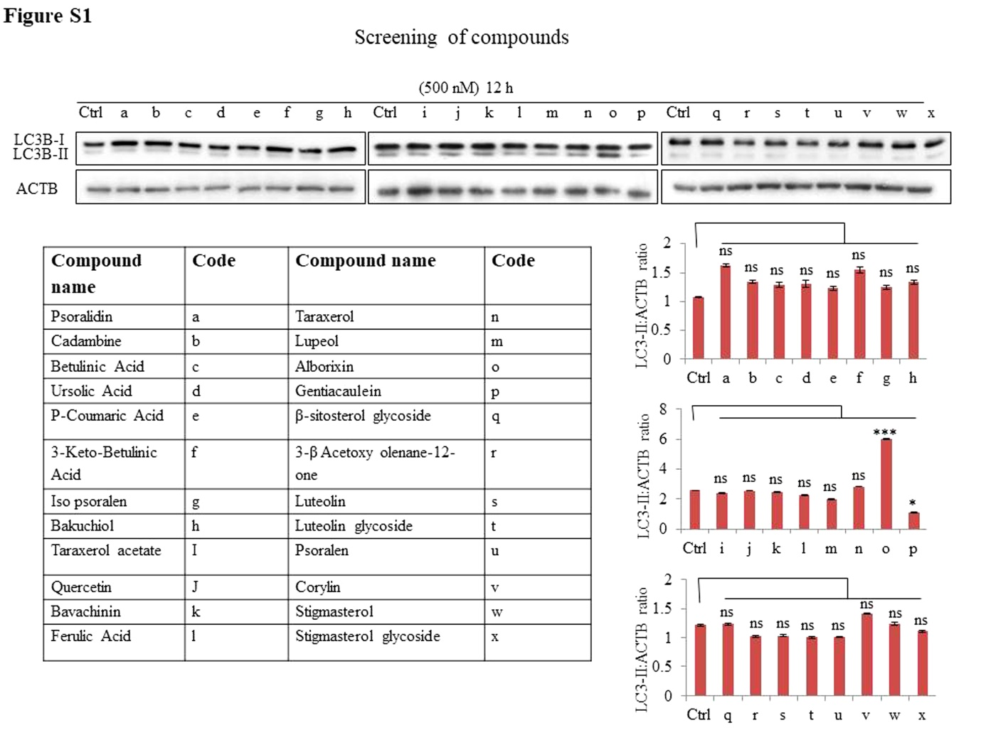
Figure S1. Screening of compounds for autophagy induction in N9 cells. Indicated compounds were used at 500 nM to treat N9 cells for 12 h and LC3B-II expression was analysed by western blotting. LC3B-II expression was normalized by dividing band density of LC3B-II by that of ACTB. Western blot data presented here are only representative; data were quantified from 3 independent experiments (3n) as shown in the densitometry graphs. Statistical significance was calculated by using Bonferroni test and p value<0.05 was considered to be significant with ***p<0.001, **p<0.01, *p<0.05.

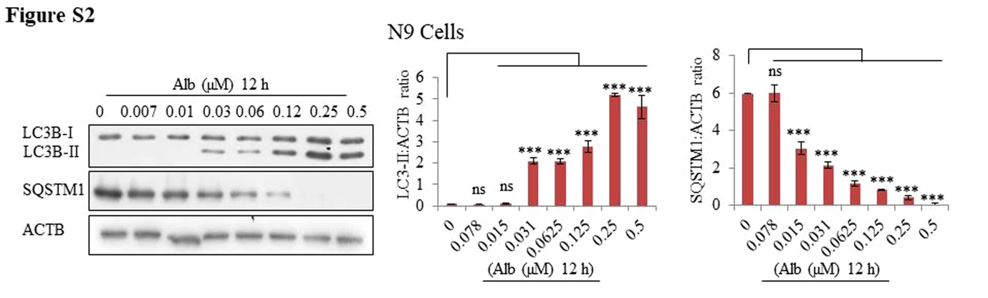
Figure S2. Alborixin induced autophagy in N9 cells. Western blot analysis for LC3B-II and SQSTM1 after treatment with alborixin at the indicated concentrations in mouse microglial N9 cells. Data have been quantified from at least 3 independent experiments (3n) and are presented here as mean±SD. Densitometry of western blots was done by using ImageJ software. Statistical comparisons were made between control and treated samples, by using Bonferroni test. p value<0.05 was considered to be significant with ***p<0.001, **p<0.01, *p<0.05.

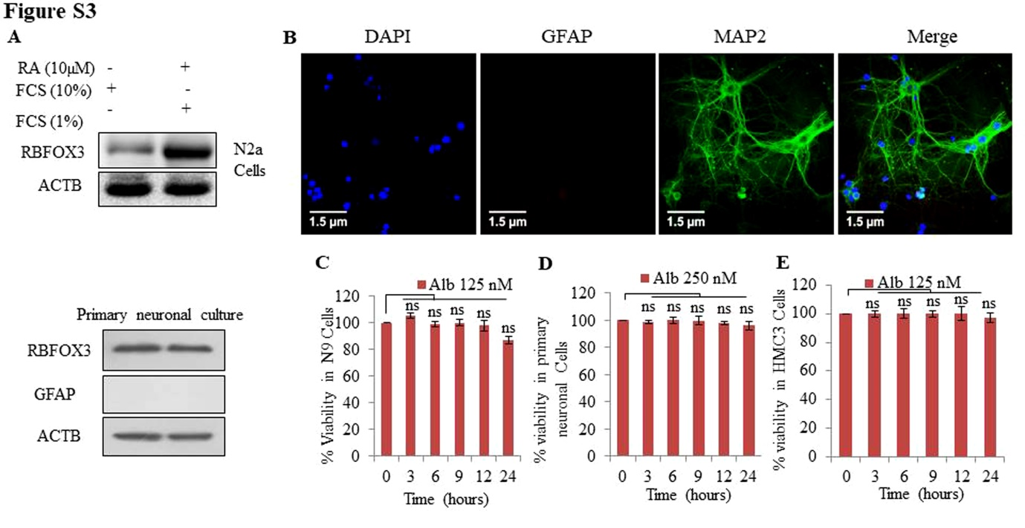
Figure S3. Western blot analysis of neuronal markers in primary neuronal cells and differentiated neuroblastoma N2a. (A) The cells were differentiated with 1% of FCS and 10 µM of retinoic acid for 4 days before being analysed for neuronal marker RBFOX3. N2a cells showed high expression of RBFOX3, thus, indicating differentiation into neurons. Primary neuronal culture was also checked for the expression of GFAP as an astroglial marker along with RBFOX3 as a neuronal marker. (B) Immunofluorescence staining of primary neurons with MAP2 and GFAP for analyzing the purity of primary neuronal culture. Green fluorescence indicate MAP2 staining, whereas GFAP (red fluorescence of Alexa Fluor 555-tagged secondary antibody). The scale bar shown in the confocal images is equal to 40 μm. (C, D and E) Time-dependent effect of alborixin on viability of microglial N9 cells, primary neuronal cells, and HMC3 cells. Different cell types were treated with different concentrations (N9 and HMC3 cells, 125 nM and primary neuronal cells, 250 nM) of alborixin for the indicated time periods. Alborixin did not show significant toxic effect after 24 h of treatment of N9 cells, primary neuronal and HMC3 cells. MTT (3-(4, 5, -dimethylthiazole-2-yl)-2, 5 diphenyltetrazolium bromide) dye was added 4 h before termination of the experiment for assessment of cell viability. Statistical significance was calculated by using Bonferroni test and p value<0.05 was considered to be significant with ***p<0.001, **p<0.01, *p<0.05.

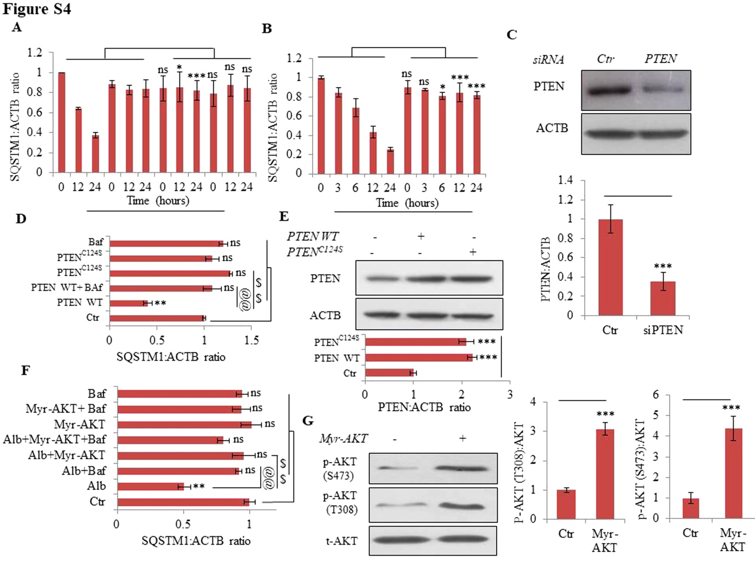
Figure S4. Quantification of western blots and transfection efficiency analysis. (A and B) Quantification of western blots of Figure 4A and B of SQSTM1. Quantification of SQSTM1 in HMC3 cells after treatment with alborixin in absence or presence of bafilomycin A1. (C) Efficiency of siPTEN in HMC3 cells was calculated by using western blot analysis and the samples were normalized by dividing with the value of internal loading control ACTB. (D) Quantification of SQSTM1 in HMC3 cells of Figure 4C in absence or presence of bafilomycin A1. (E) Efficiency of wild-type PTEN and PTEN mutant in HMC3 cells was calculated by western blot and the samples were normalized by dividing with the value of internal loading control ACTB. (F) Quantification of SQSTM1 from Figure 4D, data are mean±SD of 3 independent experiments (3n) in Myr-AKT delta4-129-transfected HMC3 cells treated with alborixin in the absence or presence of bafilomycin A₁. (G) Efficiency of Myr-AKT delta4-129 in HMC3 cells was calculated by western blot and the samples were normalized by dividing with the value of internal loading control ACTB, and statistical significance was calculated by using the Bonferroni test. p value<0.05 was considered to be significant with ***p<0.001, **p<0.01, *p<0.05.

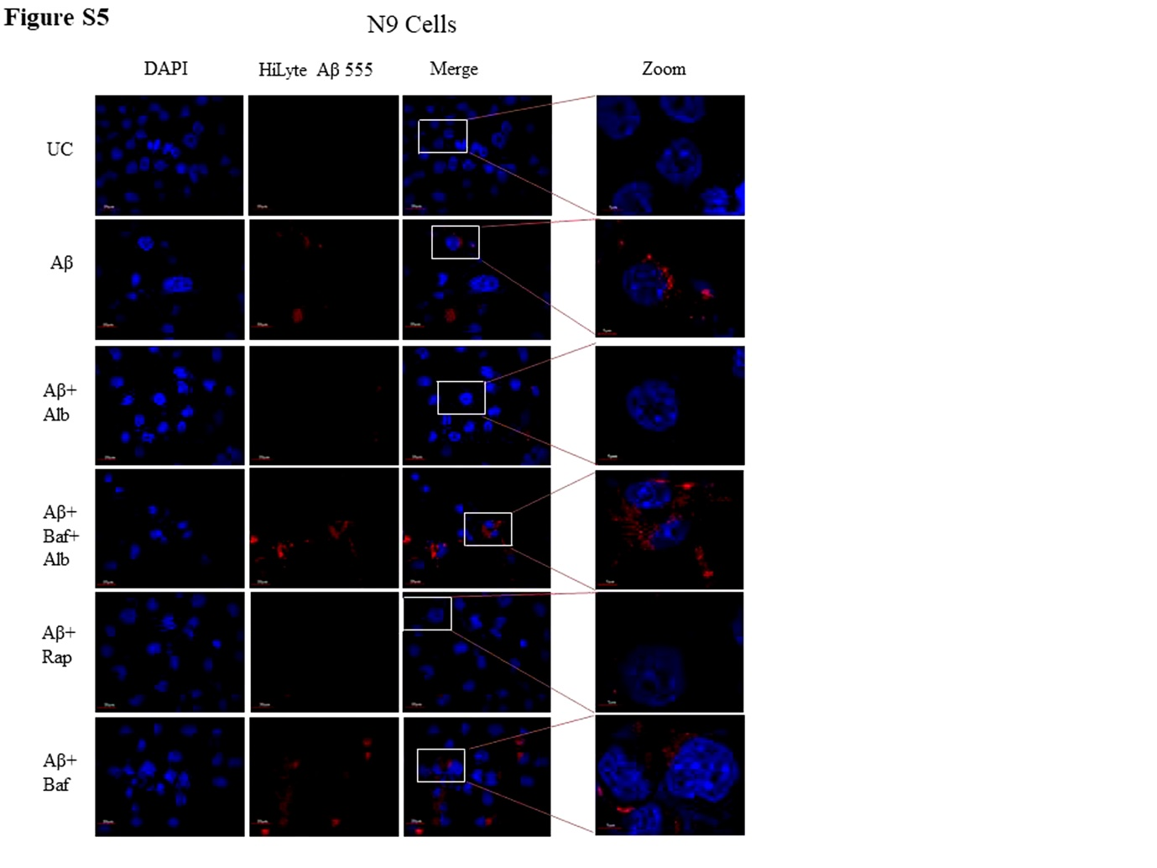
Figure S5. Detailed confocal microscopy image for clearance of HiLyte Aβ 555 in N9 cells from Figure 6A. Scale bar for confocal images: 20 µm for zoomed-out images and 5 µm for zoomed-in images.
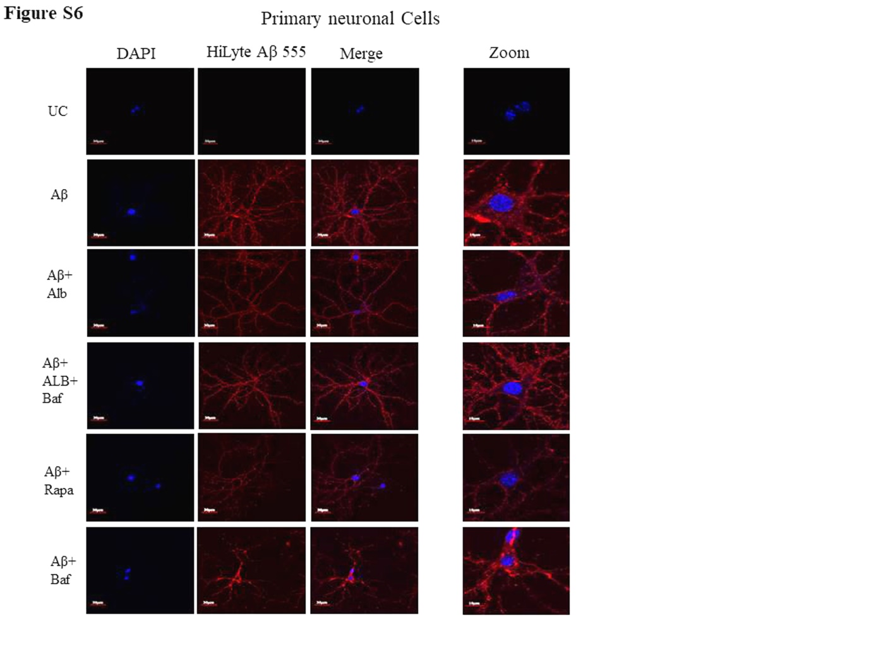
Figure S6. Detailed confocal microscopy image for clearance of HiLyte Aβ 555 in primary neuronal cells from Figure 6C. Scale bar for confocal images: 20 µm for zoomed-out images and 5 µm for zoomed-in images.
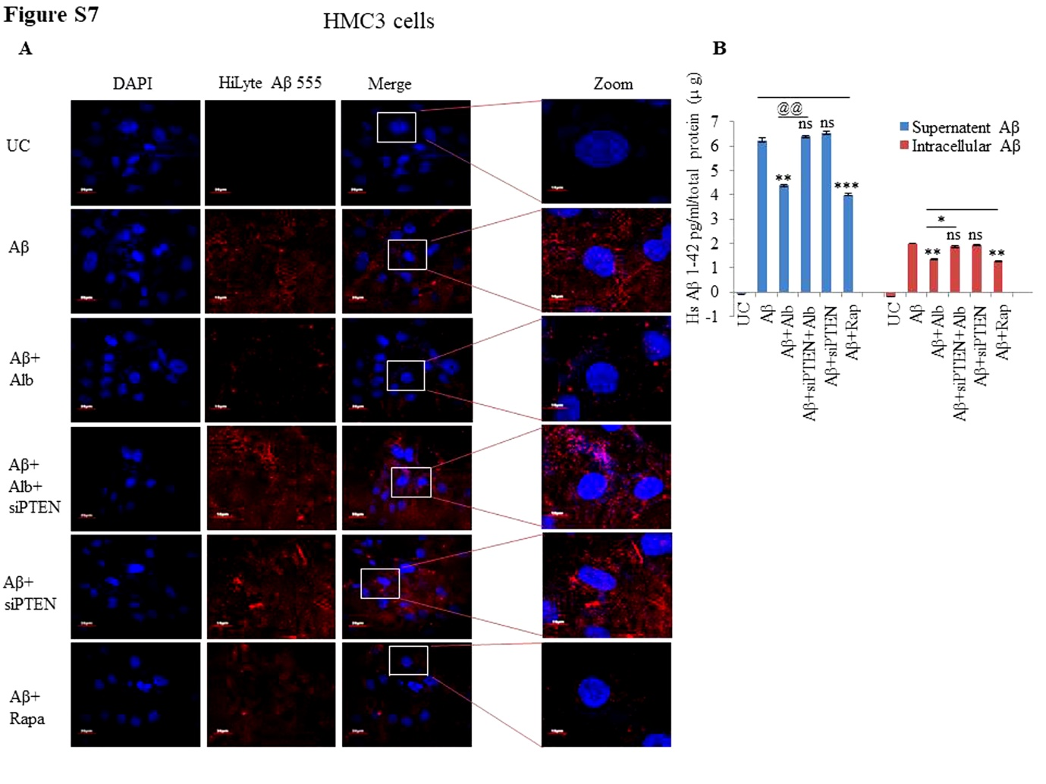
Figure S7. Effect of PTEN knockdown on clearance of Aβ by Alborixin. (A) Detailed confocal microscopy images to demonstrate clearance of HiLyte Aβ 555 in HMC3 cells from Figure 8A. Scale bar for confocal images: 20 µm for zoomed-out images and 5 µm for zoomed-in images. (B) ELISA of HMC3 cells treated under similar conditions was done to quantify Aβ present intracellularly and in the supernatant.
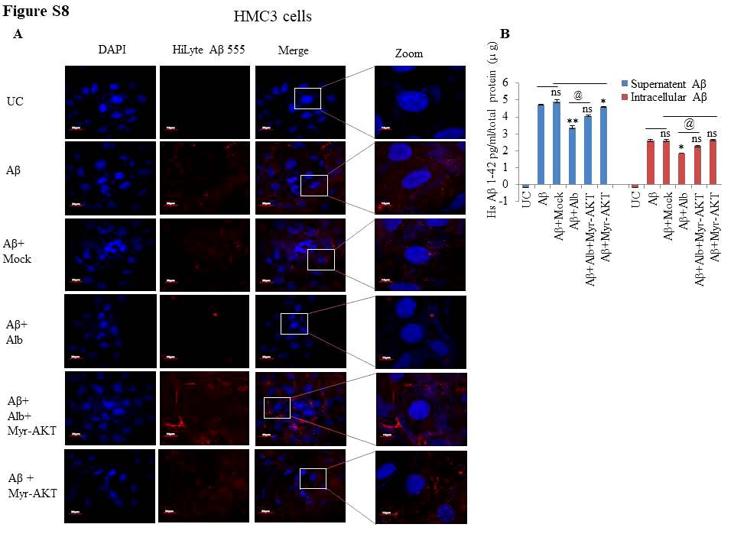
Figure S8. Effect of AKT overexpression on clearance of Aβ. (A) Detailed confocal microscopy images for clearance of Hilyte Aβ 555 in HMC3 cells from Figure 8B. Scale bar for confocal images: 20 µm for zoomed-out images and 5 µm for zoomed-in images. (B) ELISA of HMC3 cells treated under similar conditions was done to quantify intracellular and extracellular Aβ.
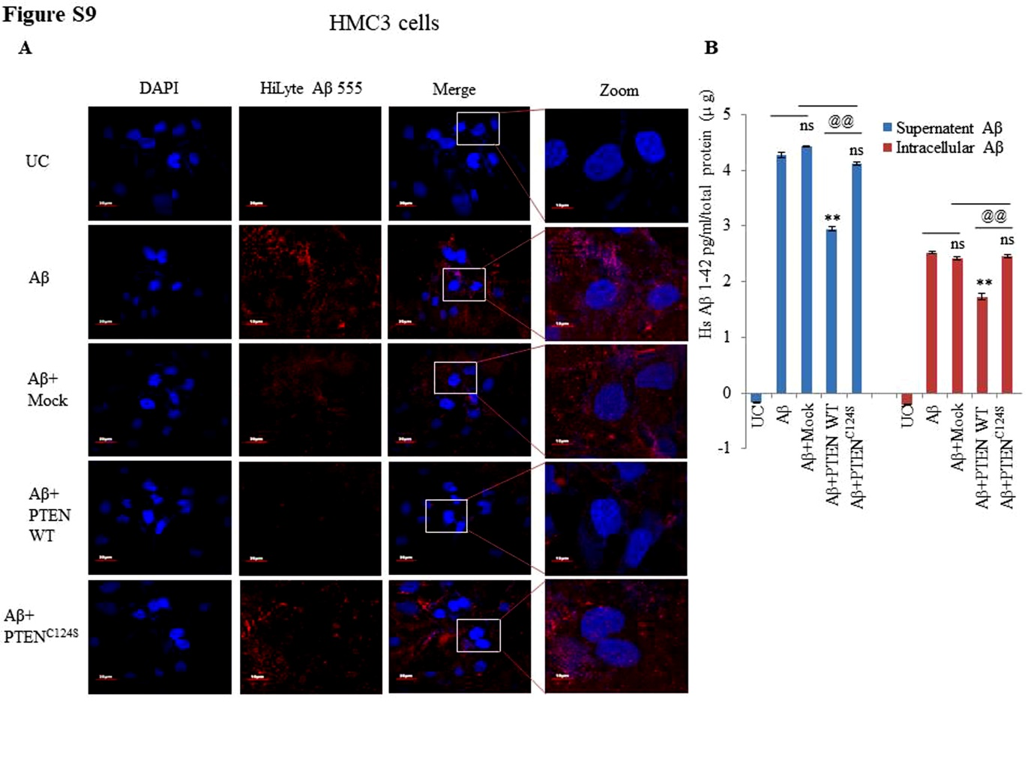Figure S9. Effect of PTEN upregulation and PTEN inactivation on clearance of Aβ by Alborixin. (A) Confocal microscopy images from Figure 8C for clearance of Hilyte Aβ 555 in HMC3 cells. Scale bar for confocal images: 20 µm for zoomed-out images and 5 µm for zoomed-in images. (B) ELISA of HMC3 cells treated under similar conditions was done to quantify Aβ present intracellularly and in the supernatant.
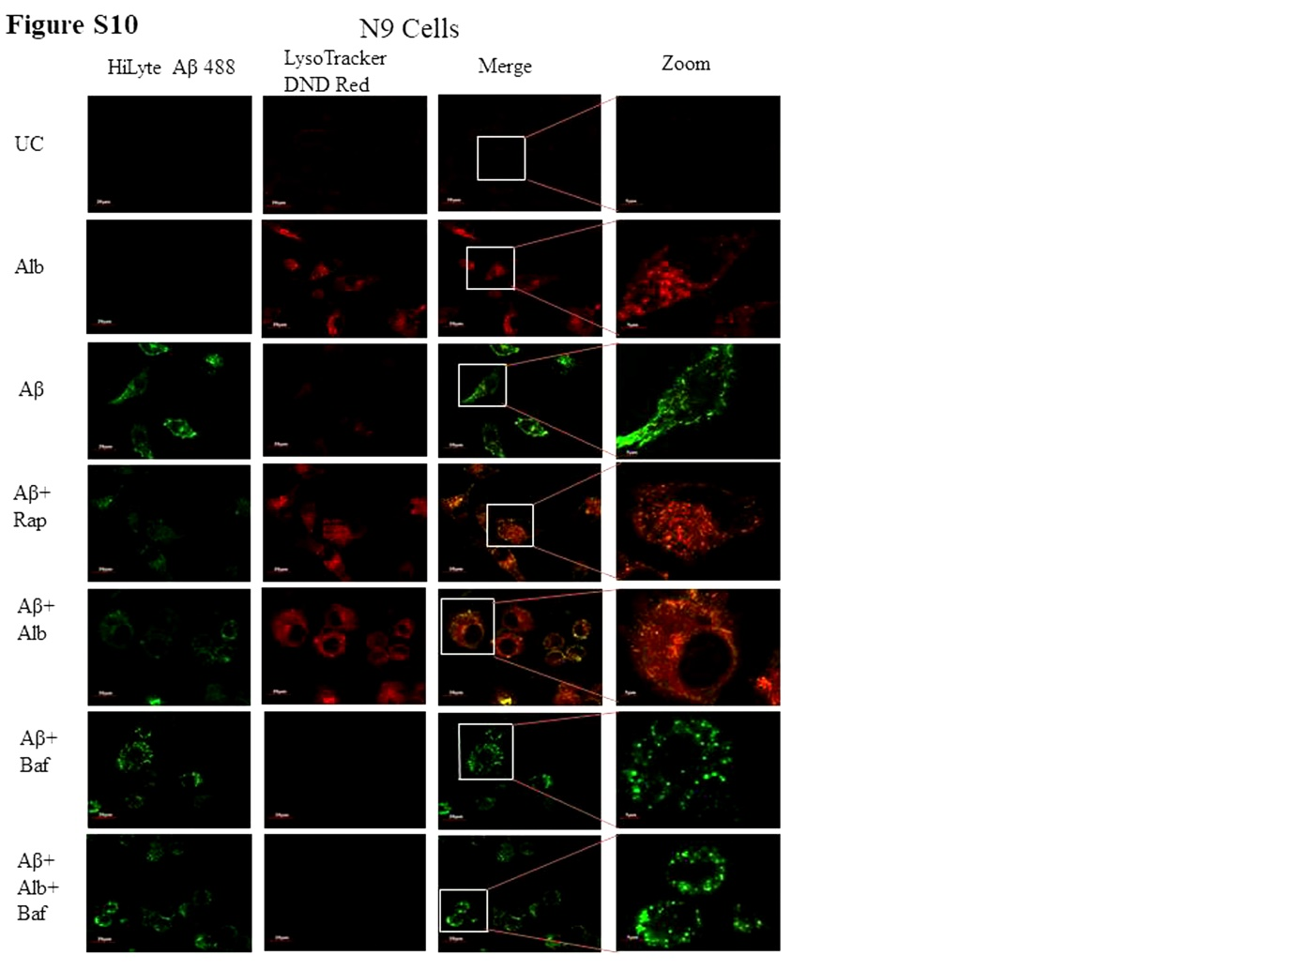
Figure S10. Confocal microscopy images displaying clearance of amyloid beta through formation of autolysosomes in N9 cells treated with alborixin. The red fluorescence of LysoTracker DND red, represents the acidic environment of autolysosomes, whereas green fluorescence seen here is of HiLyte Aβ 488 in N9 cells. These are the detailed images of Figure 9A. Scale bar for confocal images: 20 µm for zoomed-out images and 5 µm for zoomed-in images.
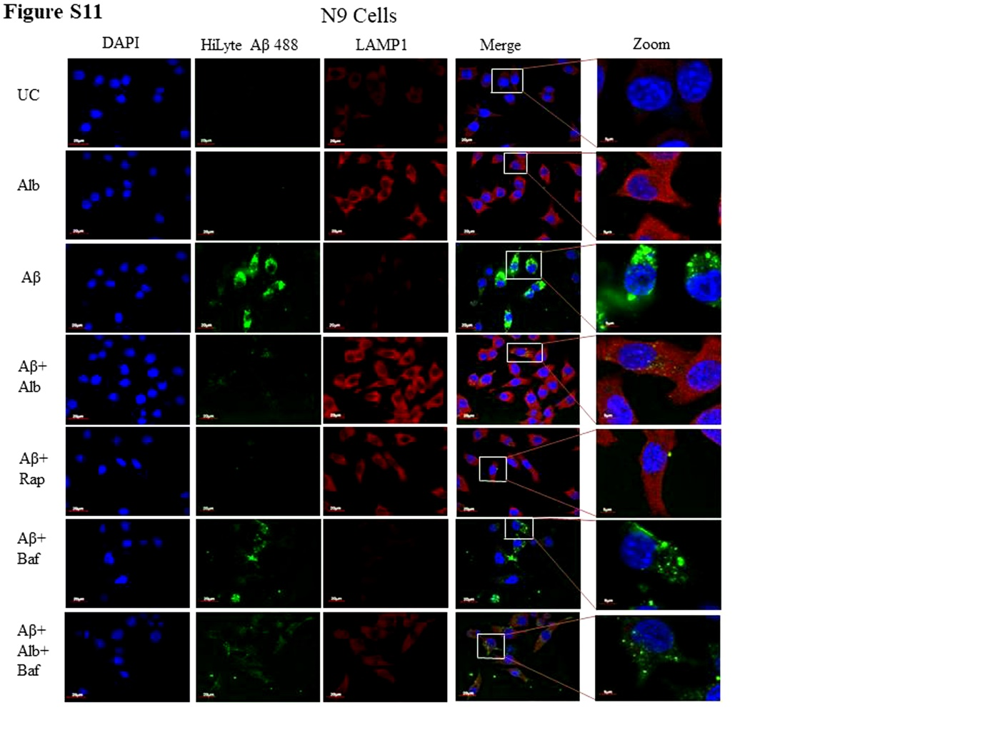
Figure S11. Immunofluorescence images of N9 cells taken by a confocal microscope showing increased expression of LAMP1 accompanied by clearance of amyloid beta in N9 cells treated with alborixin. The red fluorescence represents LAMP1 expression, whereas green fluorescence seen here is of HiLyte Aβ 488 and blue fluorescence represents DAPI stained nucleus in N9 cells. These are the detailed images of Figure 9B. Scale bar for confocal images: equal to 20 µm for zoomed-out images and 5 µm for zoomed-in images.
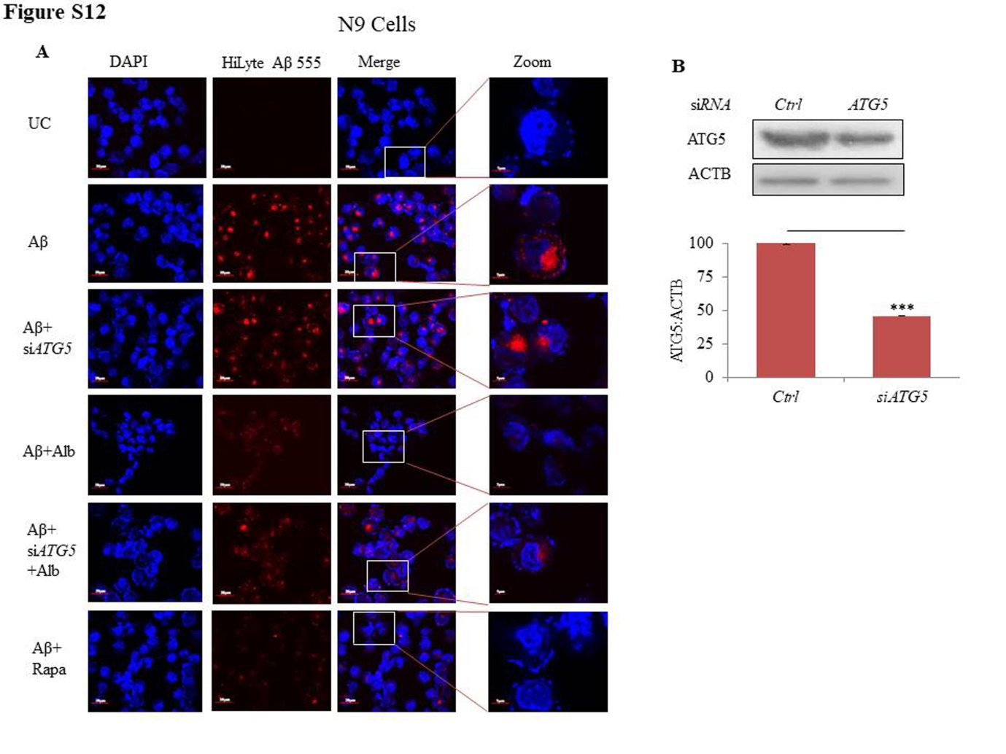
Figure S12. Effect of Atg5 knock down on clearance of amyloid beta. (A) Detailed confocal microscopy image for clearance of HiLyte Aβ 555 in N9 cells from Figure 10A. (B) Efficiency of siAtg5 in N9 cells was calculated by using western blot analysis and the samples were normalized by dividing with the value of internal loading control ACTB. Scale bar for confocal images: 20 µm for zoomed-out images and 5 µm for zoomed-in images.
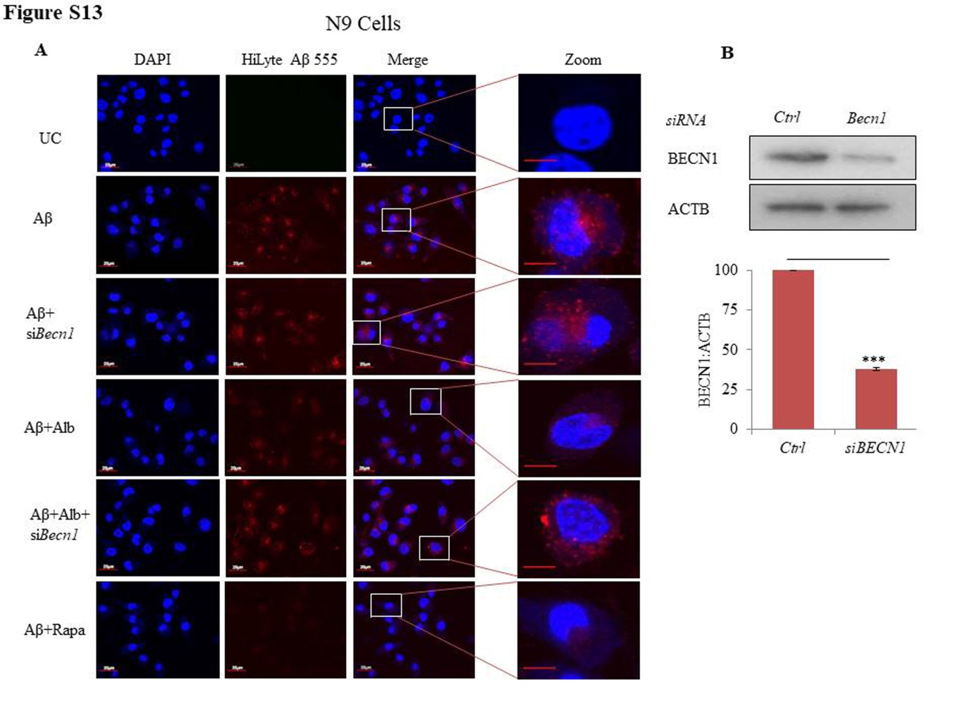
Figure S13. Effect of Becn1 knock down on clearance of amyloid beta in N9 cells. (A) Detailed confocal microscopy image for clearance of HiLyte Aβ 555 in N9 cells from Figure 10C. (B) Efficiency of siBecn1 in N9 cells was calculated by using western blot analysis and the samples were normalized by dividing with the value of internal loading control ACTB. Scale bar for confocal images: 20 µm for zoomed-out images and 5 µm for zoomed-in images.

Table S1. Fluorimetric measurement of Aβ fluorescence in the culture media of N9 cells treated with alborixin.

S NO. | Samples | Aβ HiLyte Fluor 555 fluorescence in culture media
1 | Aβ Alone | 100
2 | Aβ+Rap | 58.20±4.2**
3 | Aβ+Alb | 46.81±6.31***
4 | Aβ+Baf | 71.32±4.4*
5 | Aβ+Baf+Alb | 69.25±5.2*

