Supplementary data 1: ABTS Radical Scavenging Activities of C. gigantea Oil Compared with Quercertin

Supplementary data 2: DPPH Radical Scavenging Activity of C. gigantea seed oil

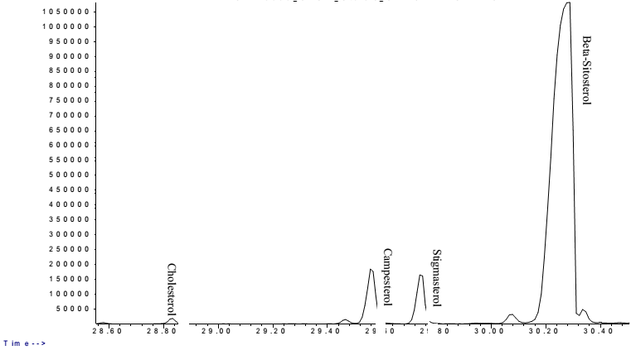
Supplementary data 3: Total Ion Chromatogram of the sterol constituent of C. gigantea seed oil

