Adsorption studies of dimethyl and methyl-ethyl ester molecules on silicene nanoring: Application of DFT study
V. Nagarajan, R. Chandiramouli*
School of Electrical & Electronics Engineering
SASTRA Deemed University, Tirumalaisamudram, Thanjavur -613 401, India
Email: rcmoulii@gmail.com
Supplemental Materials
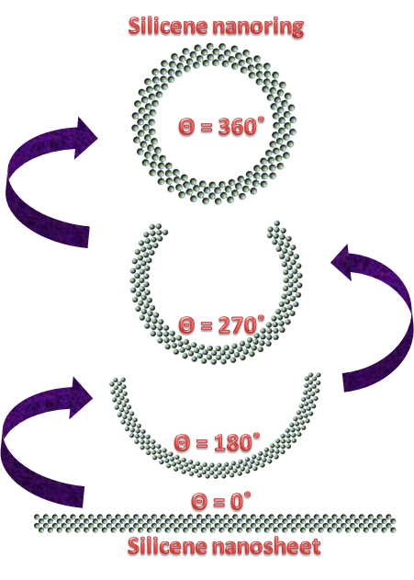
Figure S 1: Schematic diagram of formation of silicene nanoring.

Figure S 2: Phonon band structure of silicene nanoring.
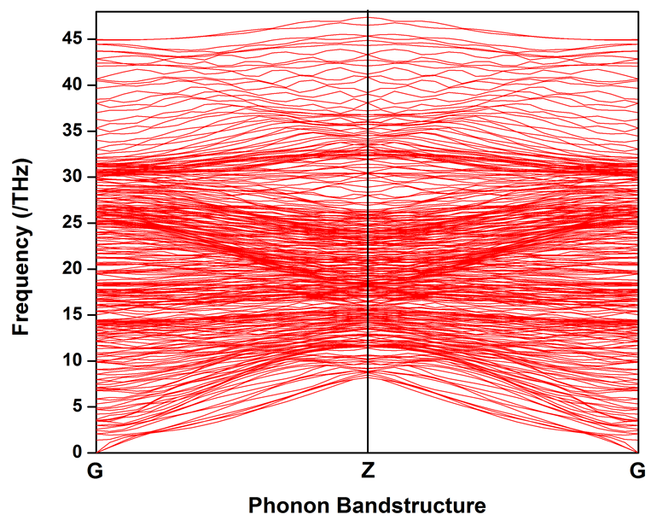
Figure S 3: Electron density of pristine SiNR.
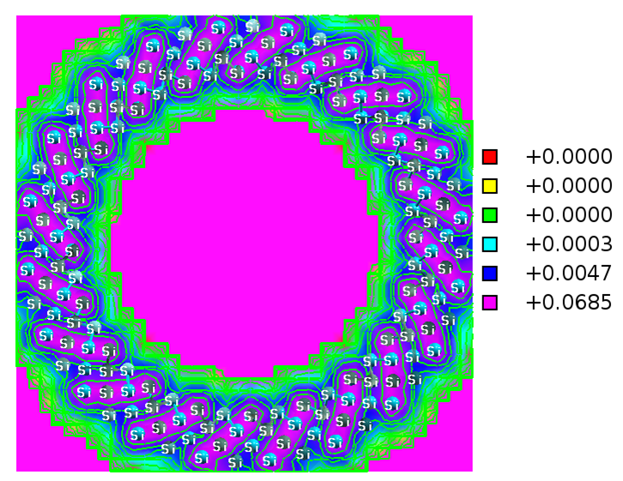

Figure S 4: Electron density of DME on position A1.
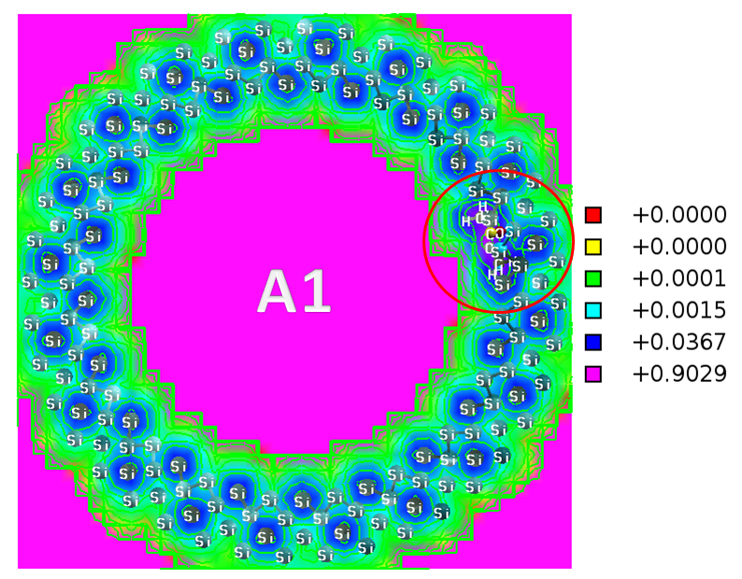

Figure S 5: Electron density of DME on position A2.
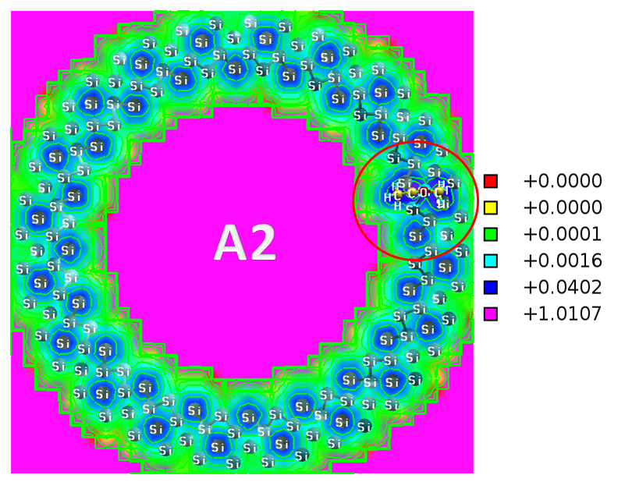

Figure S6: Electron density of MEE on position B1.
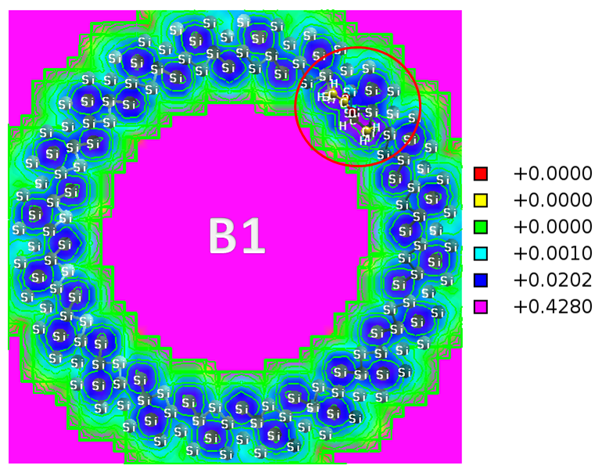

Figure S 7: Electron density of MEE on position B2.
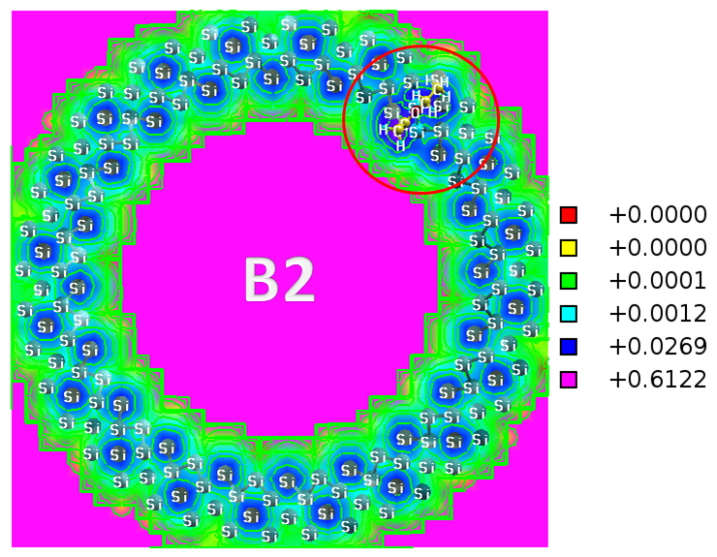

Table S 1: SiNR Co-ordinates Si₁₆₀.
Si 5.008518000 19.647724000 0.678825000
Si 5.939322000 14.968255000 0.678825000
Si 8.270605000 10.805449000 0.678825000
Si 11.774164000 7.566792000 0.678825000
Si 16.107048000 5.569306000 0.678825000
Si 20.845121000 5.008518000 0.678825000
Si 25.524590000 5.939322000 0.678825000
Si 29.687396000 8.270605000 0.678825000
Si 32.926053000 11.774164000 0.678825000
Si 34.923539000 16.107048000 0.678825000
Si 35.484327000 20.845121000 0.678825000
Si 34.553523000 25.524590000 0.678825000
Si 32.222240000 29.687396000 0.678825000
Si 28.718681000 32.926053000 0.678825000
Si 24.385797000 34.923539000 0.678825000
Si 19.647724000 35.484327000 0.678825000
Si 14.968255000 34.553523000 0.678825000
Si 10.805449000 32.222240000 0.678825000
Si 7.566792000 28.718681000 0.678825000
Si 5.569306000 24.385797000 0.678825000
Si 3.754225000 18.294442000 2.036475000
Si 5.164606000 13.293610000 2.036475000
Si 8.051300000 8.973367000 2.036475000
Si 12.131737000 5.756609000 2.036475000
Si 17.006497000 3.958216000 2.036475000
Si 22.198403000 3.754225000 2.036475000
Si 27.199235000 5.164606000 2.036475000
Si 31.519478000 8.051300000 2.036475000
Si 34.736236000 12.131737000 2.036475000
Si 36.534629000 17.006497000 2.036475000
Si 36.738620000 22.198403000 2.036475000
Si 35.328239000 27.199235000 2.036475000
Si 32.441545000 31.519478000 2.036475000
Si 28.361108000 34.736236000 2.036475000
Si 23.486348000 36.534629000 2.036475000
Si 18.294442000 36.738620000 2.036475000
Si 13.293610000 35.328239000 2.036475000
Si 8.973367000 32.441545000 2.036475000
Si 5.756609000 28.361108000 2.036475000
Si 3.958216000 23.486348000 2.036475000
Si 5.289779000 17.271361000 3.394125000
Si 6.941154000 12.795114000 3.394125000
Si 9.894941000 9.048253000 3.394125000
Si 13.862003000 6.397546000 3.394125000
Si 18.454017000 5.102464000 3.394125000
Si 23.221484000 5.289779000 3.394125000
Si 27.697731000 6.941154000 3.394125000
Si 31.444592000 9.894941000 3.394125000
Si 34.095299000 13.862003000 3.394125000
Si 35.390380000 18.454017000 3.394125000
Si 35.203066000 23.221484000 3.394125000
Si 33.551691000 27.697731000 3.394125000
Si 30.597904000 31.444592000 3.394125000
Si 26.630842000 34.095299000 3.394125000
Si 22.038828000 35.390380000 3.394125000
Si 17.271361000 35.203066000 3.394125000
Si 12.795114000 33.551691000 3.394125000
Si 9.048253000 30.597904000 3.394125000
Si 6.397546000 26.630842000 3.394125000
Si 5.102464000 22.038828000 3.394125000
Si 4.262628000 15.738526000 4.751775000
Si 6.437947000 11.019894000 4.751775000
Si 9.964936000 7.204420000 4.751775000
Si 14.498349000 4.665587000 4.751775000
Si 19.594423000 3.651915000 4.751775000
Si 24.754319000 4.262628000 4.751775000
Si 29.472950000 6.437947000 4.751775000
Si 33.288426000 9.964936000 4.751775000
Si 35.827258000 14.498349000 4.751775000
Si 36.840930000 19.594423000 4.751775000
Si 36.230217000 24.754319000 4.751775000
Si 34.054898000 29.472950000 4.751775000
Si 30.527909000 33.288426000 4.751775000
Si 25.994496000 35.827258000 4.751775000
Si 20.898422000 36.840930000 4.751775000
Si 15.738526000 36.230217000 4.751775000
Si 11.019894000 34.054898000 4.751775000
Si 7.204420000 30.527909000 4.751775000
Si 4.665587000 25.994496000 4.751775000
Si 3.651915000 20.898422000 4.751775000
Si 2.626653000 16.741632000 0.678825000
Si 4.572065000 11.468361000 0.678825000
Si 8.051793000 7.054347000 0.678825000
Si 12.725216000 3.931665000 0.678825000
Si 18.134868000 2.405986000 0.678825000
Si 23.751213000 2.626653000 0.678825000
Si 29.024484000 4.572065000 0.678825000
Si 33.438498000 8.051793000 0.678825000
Si 36.561180000 12.725216000 0.678825000
Si 38.086859000 18.134868000 0.678825000
Si 37.866192000 23.751213000 0.678825000
Si 35.920780000 29.024484000 0.678825000
Si 32.441052000 33.438498000 0.678825000
Si 27.767629000 36.561180000 0.678825000
Si 22.357977000 38.086859000 0.678825000
Si 16.741632000 37.866192000 0.678825000
Si 11.468361000 35.920780000 0.678825000
Si 7.054347000 32.441052000 0.678825000
Si 3.931665000 27.767629000 0.678825000
Si 2.405986000 22.357977000 0.678825000
Si 1.649274000 15.001484000 2.036475000
Si 4.180258000 9.511355000 2.036475000
Si 8.283910000 5.072048000 2.036475000
Si 13.558537000 2.118116000 2.036475000
Si 19.487820000 0.938708000 2.036475000
Si 25.491361000 1.649274000 2.036475000
Si 30.981490000 4.180258000 2.036475000
Si 35.420797000 8.283910000 2.036475000
Si 38.374729000 13.558537000 2.036475000
Si 39.554137000 19.487820000 2.036475000
Si 38.843571000 25.491361000 2.036475000
Si 36.312587000 30.981490000 2.036475000
Si 32.208934000 35.420797000 2.036475000
Si 26.934308000 38.374729000 2.036475000
Si 21.005025000 39.554137000 2.036475000
Si 15.001484000 38.843571000 2.036475000
Si 9.511355000 36.312587000 2.036475000
Si 5.072048000 32.208934000 2.036475000
Si 2.118116000 26.934308000 2.036475000
Si 0.938708000 21.005025000 2.036475000
Si 2.295311000 19.541121000 3.394125000
Si 3.391851000 14.028443000 3.394125000
Si 6.138234000 9.124423000 3.394125000
Si 10.265625000 5.309103000 3.394125000
Si 15.370005000 2.955951000 3.394125000
Si 20.951724000 2.295311000 3.394125000
Si 26.464402000 3.391851000 3.394125000
Si 31.368422000 6.138234000 3.394125000
Si 35.183742000 10.265625000 3.394125000
Si 37.536894000 15.370005000 3.394125000
Si 38.197534000 20.951724000 3.394125000
Si 37.100994000 26.464402000 3.394125000
Si 34.354611000 31.368422000 3.394125000
Si 30.227220000 35.183742000 3.394125000
Si 25.122840000 37.536894000 3.394125000
Si 19.541121000 38.197534000 3.394125000
Si 14.028443000 37.100994000 3.394125000
Si 9.124423000 34.354611000 3.394125000
Si 5.309103000 30.227220000 3.394125000
Si 2.955951000 25.122840000 3.394125000
Si 1.057746000 17.975293000 4.751775000
Si 2.698725000 12.156823000 4.751775000
Si 6.057394000 7.130219000 4.751775000
Si 10.804984000 3.387521000 4.751775000
Si 16.476768000 1.295089000 4.751775000
Si 22.517552000 1.057746000 4.751775000
Si 28.336022000 2.698725000 4.751775000
Si 33.362626000 6.057394000 4.751775000
Si 37.105324000 10.804984000 4.751775000
Si 39.197756000 16.476768000 4.751775000
Si 39.435099000 22.517552000 4.751775000
Si 37.794120000 28.336022000 4.751775000
Si 34.435451000 33.362626000 4.751775000
Si 29.687861000 37.105324000 4.751775000
Si 24.016077000 39.197756000 4.751775000
Si 17.975293000 39.435099000 4.751775000
Si 12.156823000 37.794120000 4.751775000
Si 7.130219000 34.435451000 4.751775000
Si 3.387521000 29.687861000 4.751775000
Si 1.295089000 24.016077000 4.751775000

