Section 1 Methodology for land surface temperature mapping at medium spatial resolution from Landsat 8 thermal data.
Emissivity for bands 10 and 11 of Landsat 8 sensor was estimated using the NDVI thresholds method that involves the assignment of emissivity values for different types of land cover based on NDVI values obtained from red and near-infrared bands of satellite images of the study area. Typically, NDVI is used to determine the locations of bare ground and fully vegetated areas, to which respective emissivity values are assigned. The intermediary emissivity values are calculated from predefined equations, taking into the account the vegetation fraction within a given pixel. In this study we used the simplified NDVI thresholds method, as presented in Sobrino et al. (2008), with a modification to allow for the assignment of emissivity values for pixels occupied by water as well as built-up areas rather than soil (Equation 1). Based on visual inspection of the available imagery, NDVI threshold for water-occupied pixels was set to ≤-0.0001, built-up pixels to the range between -0.0001 and 0.05, and purely vegetated pixels to >0.5. Emissivity values for the pure land cover pixels were calculated as averages of data supplied by the MODIS UCSB Emissivity Library (https://icess.eri.ucsb.edu/modis/EMIS/html/em.html) for wavelengths equivalent to the thermal bands of Landsat 8. The emissivity for built-up areas was calculated as a mean of corresponding emissivity measurements for asphalt and apache interlocking pavement (0.973 and 0.965 respectively for bands 10 and 11), the emissivity for vegetation as a mean for oak and pine trees (0.976 and 0.975), and for water as a mean of values provided for water (0.987 and 0.992). Emissivity layers were derived from NDVI calculated at a 30 m resolution from Landsat 8 imagery acquired for each date considered in this study. Subsequently, the mean and difference between emissivity for band 10 and 11 were calculated. The resulting layers at 30m resolution were sharper than the thermal bands of the Landsat 8, which were captured at 100m resolution and subsequently resampled to 30m by the data provider, and therefore mismatching the thermal information available from Landsat 8. In order to mitigate this mismatch we have upscaled the 30m resolution emissivity mean and difference layers by first resampling them to 10m with the nearest neighbour method retaining the 30m pixel values, then aggregating to 100m resolution with a mean function, and finally resampling back to 30m resolution with the bilinear convolution method to match the processing method of Landsat 8 TIR bands.
(1)
$ε_{i,j}=\left\{\begin{aligned}ε_{w}, NDVI≤{NDVI}_{w} \\ ε_{b i,j}, {NDVI}_{w}≤NDVI≤{NDVI}_{b} \\ ε_{b i,j}+\left(ε_{v i,j}-ε_{b i,j}\right)P_{v},{NDVI}_{b}≤NDVI≤{NDVI}_{v} \\ ε_{v i,j}, NDVI>{NDVI}_{v}\end{aligned}\right.$
Where:
ɛ_{i,j} – emissivity for bands i and j;
ɛ_{w i,j} – emissivity value for water for bands i and j, obtained from spectral libraries;
ɛ_{b i,j} – emissivity value for built-up areas for bands i and j, obtained from spectral libraries;
ɛ_{v i,j} – emissivity value for vegetation for bands i and j, obtained from spectral libraries;
NDVI – NDVI pixel value at a given location;
NDVI_{b} – NDVI threshold value for built-up areas;
NDVI_{v} – NDVI threshold value for vegetation;
P_{v} – vegetation fraction, calculated based on NDVI values (Equation 2).
$P_{v}={\left[\frac{NDVI-{NDVI}_{min}}{{NDVI}_{max}-{NDVI}_{min}}\right]}^{2}$(2)
Where:
Pv – vegetation fraction in a pixel at a given location, after Yu et al. (2014);
NDVI – NDVI pixel value at a given location;
NDVImin – NDVI threshold value equivalent to pure built-up pixels (0.05);
NDVImax – NDVI threshold value equivalent to pure vegetated pixels (0.5).

Water vapour values derived from the Near Infrared Total Precipitable Water Vapour Test Result (MOD05_L2) dataset derived from Terra MODIS used for atmospheric correction of Landsat 8 images are listed in Table 1 below.

Table 1 Mean and standard deviation of water vapour values of Milton Keynes (MK), Bedford (BD) and Luton (LT) for the four dates of interest [g cm⁻²]
Date | MK | BD | LT
06-Jun-13 | 1.741 ± 0.0062 | 1.625 ± 0.0071 | 1.808 ± 0.0033
08-Jul-13 | 3.392 ± 0.0056 | 3.494 ± 0.0088 | 3.436 ± 0.0039
01-Feb-14 | 0.838 ± 0.0049 | 0.746 ± 0.0018 | 0.721 ± 0.0020
19-Jan-15 | 0.696 ± 0.0023 | 0.722 ± 0.0019 | 0.669 ± 0.0018

Section 2 Spectral indices used in LST downscaling.
Table 1 List of LST predictors used in LST downscaling for Milton Keynes, Bedford and Luton.
Spectral Index | Formula* | References
Normalised Difference Vegetation Index | $$NDVI= \frac{\left(NIR-Red\right)}{\left(NIR+Red\right)}$$ | (Purevdorj et al., 1998)
Normalised Difference Built-Up Index (NDBI) | $$NDBI=\frac{\left(SWIR 1-NIR\right)}{\left(SWIR 1+NIR\right)}$$ | Zha et al. (2003)
Clay minerals ratio | $$CMR= \frac{SWIR 1}{SWIR 2}$$ | Drury (1987)
Ferrous minerals ratio | $$FMR= \frac{SWIR 1}{NIR}$$
Iron Oxide Ratio | $$IOR= \frac{Red}{Blue}$$
Built-Up Area Extraction Index (BAEI) | $$BUAEI= \frac{\left(Red+L\right)}{\left(Green+SWIR 1\right)}$$ | Bouzekri et al. (2015)
Percent Manmade (MNMD) | Percentage of either water or impervious land cover features within 2m resolution pixels derived from OS MasterMap | Chun and Guldmann (2014)
Percent Water (WTR)
*Blue – band 2 equivalent of Landsat 8, 0.45–0.51 µm; Green – band 3 equivalent of Landsat 8, 0.53–0.59 µm; Red – band 4 equivalent of Landsat 8, 0.63–0.67 µm; NIR – band 5 equivalent of Landsat 8, 0.85–0.88 µm; SWIR 1 – band 6 equivalent of Landsat 8, 1.57–1.65 µm; SWIR 2 – band 7 equivalent of Landsat 8, 2.11–2.29 µm; L – an arithmetic constant equal to 0.3.

Section 3 Results of the adjustment of the very high resolution spectral indices for the temporal mismatch caused by different dates of aerial and satellite data acquisition
Table 1 Correlation coefficients calculated between pairs of spectral indices derived from the Landsat 8 imagery and (1) aggregated original spectral indices derived from hyperspectral imagery (Orig.), (2) aggregated adjusted spectral indices derived from very high resolution hyperspectral imagery (Adj.), and (3) differences in the magnitude of the correlation coefficients calculated between adjusted and original spectral indices (Diff.). Negative values of the differences indicate cases were the adjustment procedure decreased the resemblance of the original very high resolution spectral indices to the equivalent indices derived from satellite data.
Date | Town | Bedford |  |  | Luton |  |  | Milton Keynes
 | Spectral index | Orig. | Adj. | Diff. | Orig. | Adj. | Diff. | Orig. | Adj. | Diff.
02-Feb-14 | BUAEI | 0.10 | 0.36 | 0.26 | 0.13 | 0.51 | 0.38 | 0.15 | 0.49 | 0.34
 | CMR | 0.36 | 0.40 | 0.04 | 0.35 | 0.34 | -0.01 | 0.37 | 0.27 | -0.10
 | FMR | 0.10 | 0.96 | 0.86 | 0.21 | 0.89 | 0.69 | 0.37 | 0.91 | 0.53
 | IOR | 0.27 | 0.68 | 0.41 | 0.47 | 0.67 | 0.19 | 0.31 | 0.58 | 0.27
 | NDBI | 0.07 | 0.90 | 0.83 | 0.17 | 0.75 | 0.58 | 0.33 | 0.63 | 0.30
 | NDVI | 0.30 | 0.74 | 0.44 | 0.31 | 0.56 | 0.25 | 0.47 | 0.61 | 0.14
19-Jan-15 | BUAEI | 0.15 | 0.29 | 0.14 | 0.18 | 0.44 | 0.25 | 0.24 | 0.47 | 0.23
 | CMR | 0.40 | 0.35 | -0.05 | 0.33 | 0.28 | -0.05 | 0.38 | 0.20 | -0.18
 | FMR | 0.19 | 0.95 | 0.76 | 0.20 | 0.91 | 0.71 | 0.40 | 0.43 | 0.03
 | IOR | 0.31 | 0.33 | 0.01 | 0.45 | 0.69 | 0.24 | 0.35 | 0.49 | 0.15
 | NDBI | 0.17 | 0.86 | 0.70 | 0.18 | 0.81 | 0.63 | 0.36 | 0.57 | 0.21
 | NDVI | 0.39 | 0.70 | 0.31 | 0.32 | 0.50 | 0.18 | 0.49 | 0.48 | -0.01
08-Jul-13 | BUAEI | 0.36 | 0.67 | 0.31 | 0.52 | 0.81 | 0.30 | 0.47 | 0.81 | 0.35
 | CMR | 0.71 | 0.72 | 0.02 | 0.72 | 0.73 | 0.01 | 0.64 | 0.59 | -0.06
 | FMR | 0.25 | 0.76 | 0.51 | 0.11 | 0.98 | 0.86 | 0.52 | 0.97 | 0.44
 | IOR | 0.23 | 0.91 | 0.68 | -0.05 | 0.91 | 0.96 | 0.23 | 0.86 | 0.63
 | NDBI | 0.19 | 0.99 | 0.80 | 0.05 | 0.96 | 0.91 | 0.46 | 0.87 | 0.40
 | NDVI | 0.53 | 0.86 | 0.33 | 0.37 | 0.83 | 0.46 | 0.65 | 0.76 | 0.11
06-Jun-13 | BUAEI | 0.33 | 0.70 | 0.37 | 0.44 | 0.83 | 0.39 | 0.49 | 0.80 | 0.31
 | CMR | 0.67 | 0.76 | 0.09 | 0.71 | 0.43 | -0.28 | 0.64 | 0.58 | -0.05
 | FMR | 0.36 | 0.98 | 0.62 | 0.29 | 0.96 | 0.67 | 0.55 | 0.95 | 0.41
 | IOR | 0.35 | 0.96 | 0.61 | 0.23 | 0.84 | 0.61 | 0.38 | 0.86 | 0.48
 | NDBI | 0.32 | 0.97 | 0.65 | 0.23 | 0.96 | 0.73 | 0.51 | 0.87 | 0.37
 | NDVI | 0.59 | 0.88 | 0.29 | 0.49 | 0.84 | 0.35 | 0.69 | 0.81 | 0.13

Figures 1 to 4
Scatterplots and Pearson correlation coefficients calculated between pairs of spectral indices derived from the Landsat 8 imagery and (1) aggregated original spectral indices derived from hyperspectral imagery (dark grey, dashed regression line and cursive r values), (2) aggregated adjusted spectral indices derived from very high resolution hyperspectral imagery (light grey, solid regression line and bold r values). BD, LT, MK denote Bedford, Luton and Milton Keynes, respectively. X axis refers to the values of indices derived from hyperspectral aerial imagery, both original and adjusted for values of Landsat 8 indices at a given date, and Y axis shows the values of Landsat 8 derived spectral indices. Aggregation of spectral indices derived from aerial imagery refers to averaging of the fine resolution pixel values over 30m resolution grid cells aligned with Landsat 8 pixels carried out with the purpose of matching the spatial scales of these indices.

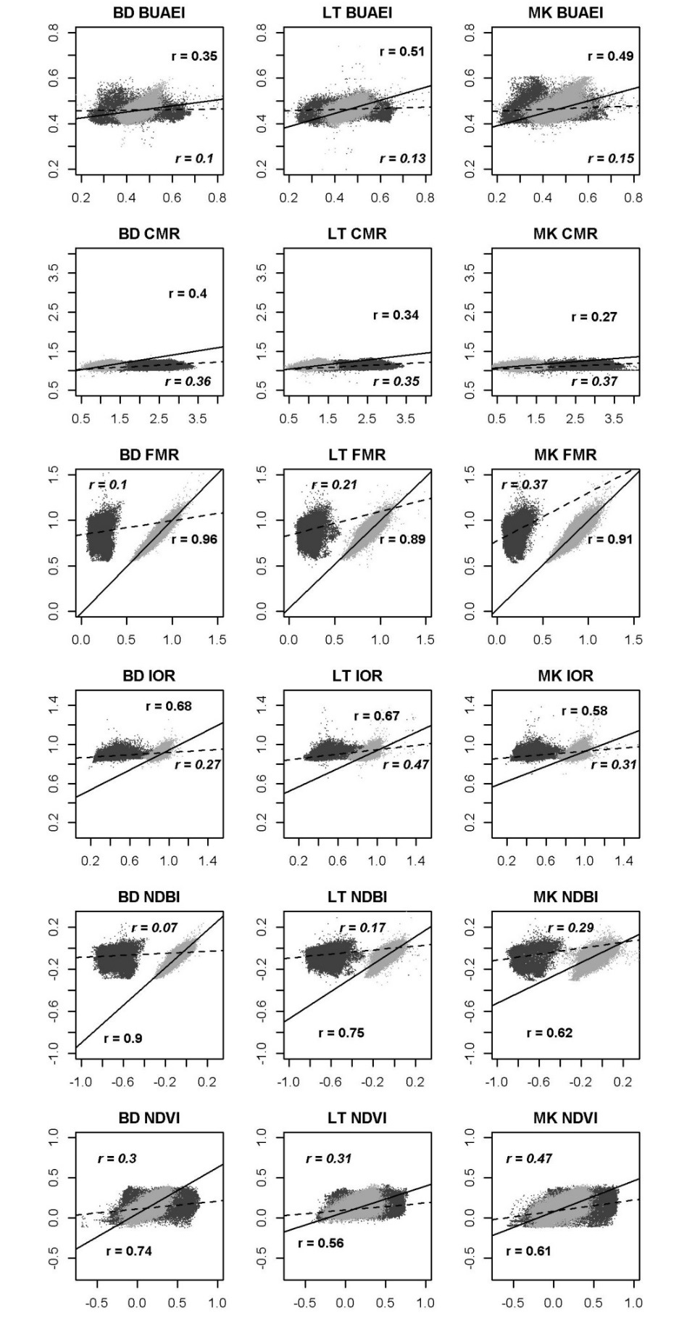
Figure 1 Comparison of Landsat 8 spectral indices (y axis) with equivalent aggregated spectral indices derived from aerial imagery (x axis) before (dark grey, dashed regression line) and after (light grey, solid regression line) adjustment for the values of Landsat 8 indices for satellite data captured on 02 Feb 2014. Full explanation of the figure given in the first paragraph of Section 3.

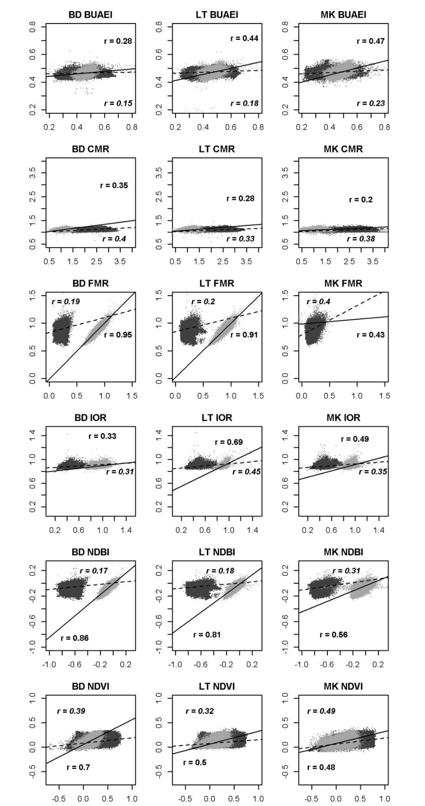
Figure 2 Comparison of Landsat 8 spectral indices (y axis) with equivalent aggregated spectral indices derived from aerial imagery (x axis) before (dark grey, dashed regression line) and after (light grey, solid regression line) adjustment for the values of Landsat 8 indices for satellite data captured on 19 Jan 2015. Full explanation of the figure given in the first paragraph of Section 3.

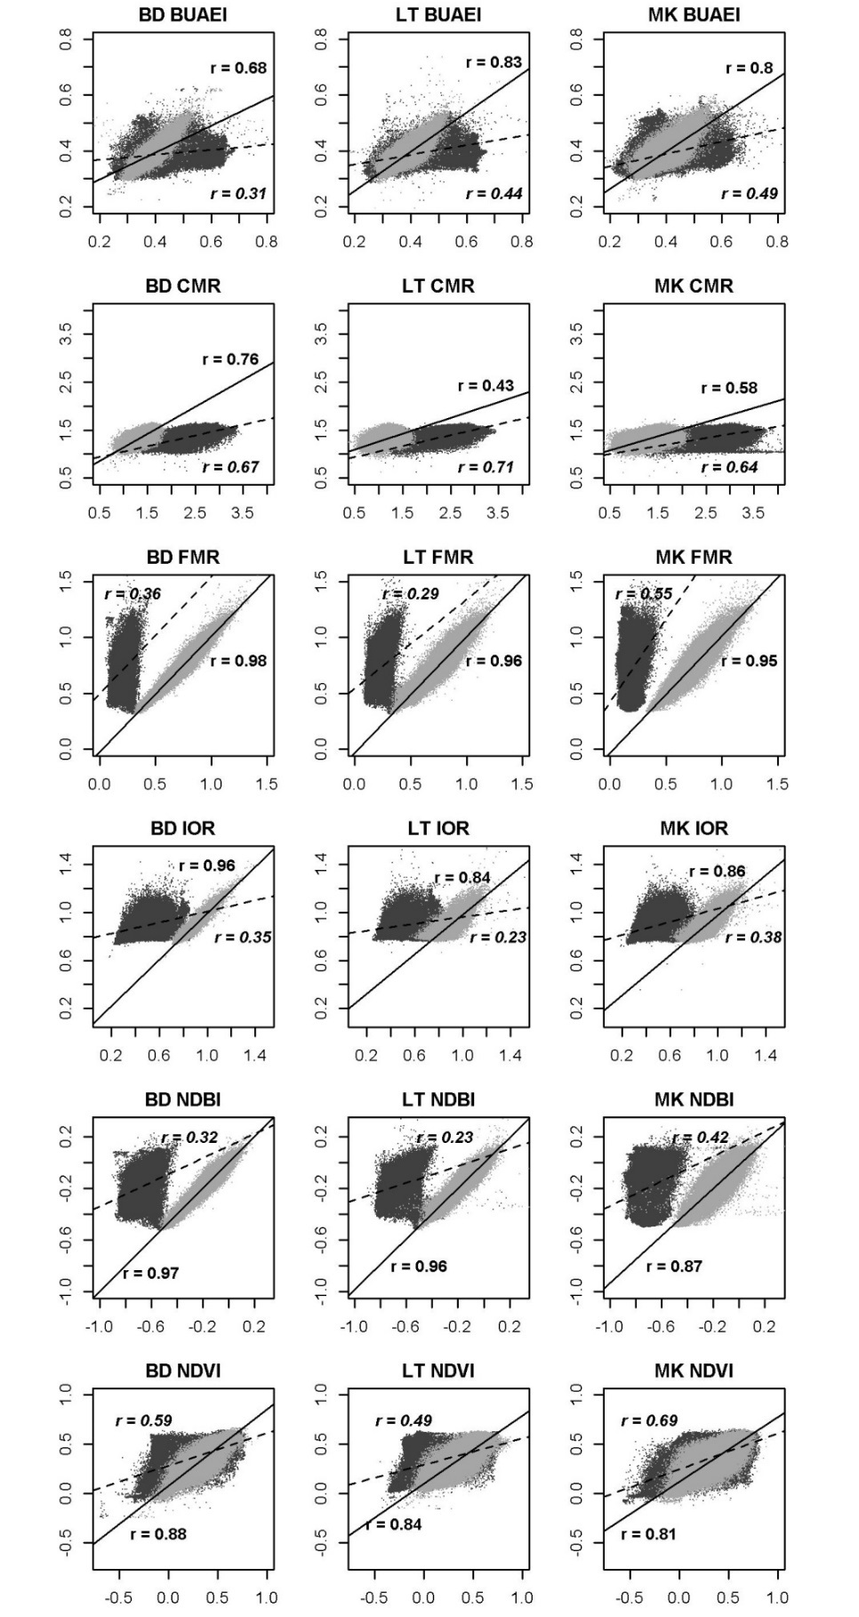
Figure 3 Comparison of Landsat 8 spectral indices (y axis) with equivalent aggregated spectral indices derived from aerial imagery (x axis) before (dark grey, dashed regression line) and after (light grey, solid regression line) adjustment for the values of Landsat 8 indices for satellite data captured on 06 Jun 2013. Full explanation of the figure given in the first paragraph of Section 3.

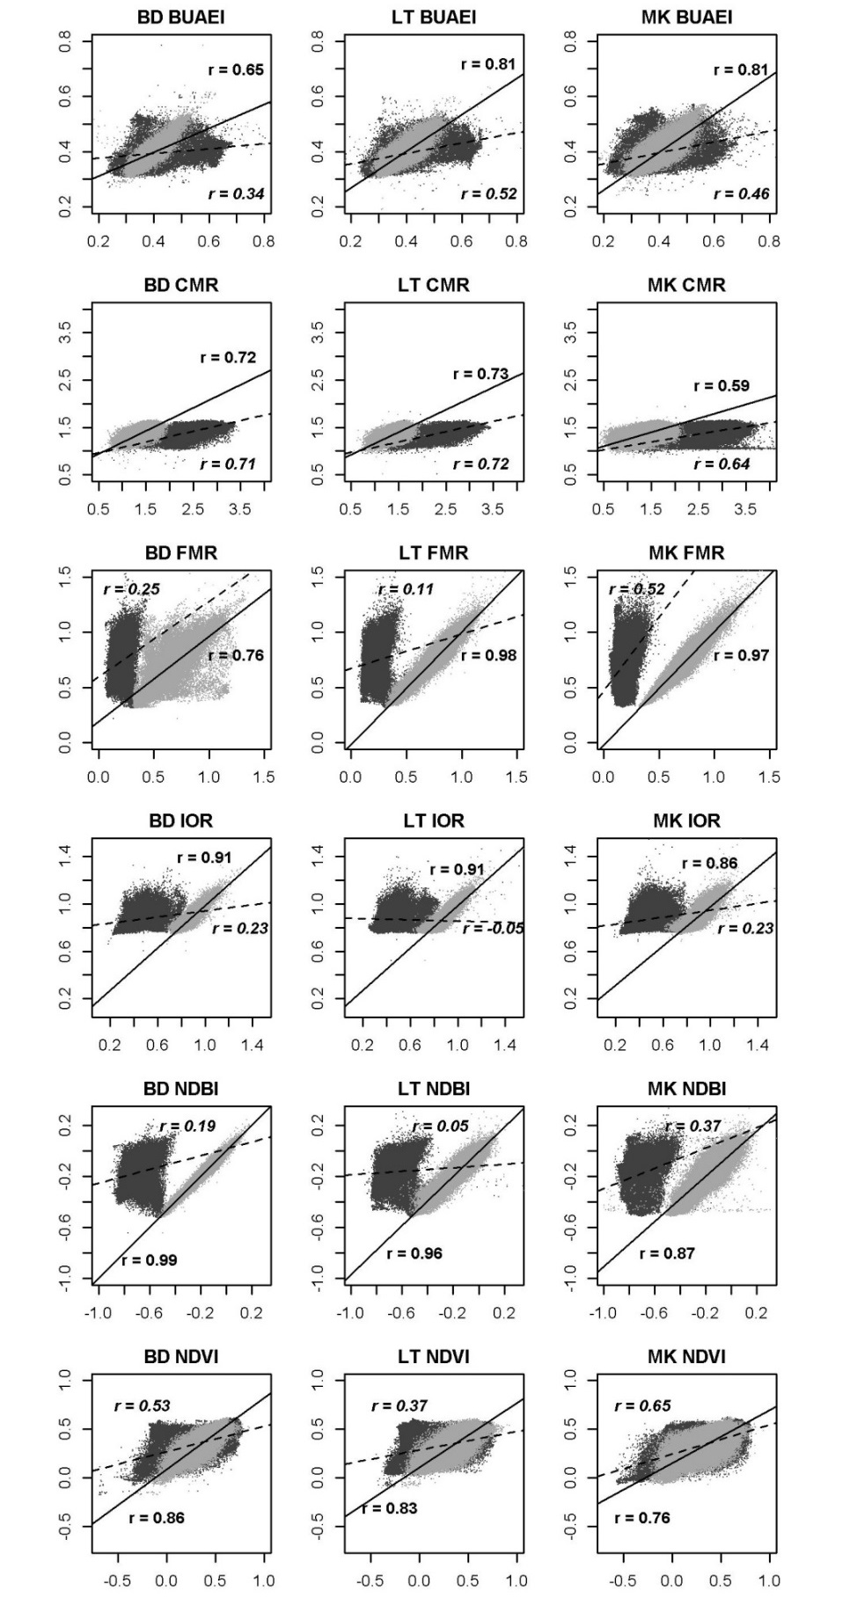
Figure 4 Comparison of Landsat 8 spectral indices (y axis) with equivalent aggregated spectral indices derived from aerial imagery (x axis) before (dark grey, dashed regression line) and after (light grey, solid regression line) adjustment for the values of Landsat 8 indices for satellite data captured on 08 Jul 2013. Full explanation of the figure given in the first paragraph of Section 3.

Section 4 Predictor importance in MARS models used in LST downscaling
Table 1 MARS equations, generated with Statistica software, used for LST downscaling in Bedford.
Bedford, 02 Feb 2014
LST_FEB_BD = 9.35352629553633e+000 +
8.95683970005979e-004*max(0, mnmd_BD-2.25480804443359e+001) - 5.24097858788039e-003*max(0, 2.25480804443359e+001-mnmd_BD) - 6.39257449247337e-002*max(0, CMR_FEB_BD-1.14625322818756e+000) - 1.97833755719236e-001*max(0, 1.14625322818756e+000-CMR_FEB_BD) + 5.13936482567572e-001*max(0, BUAEI_FEB_BD-4.63528275489807e-001) + 1.28112609091631e-001*max(0, 4.63528275489807e-001-BUAEI_FEB_BD) - 1.53055292433981e+002*max(0, wtr_BD-9.99995269775391e+001) + 7.18288508889315e-004*max(0, 9.99995269775391e+001-wtr_BD) + 5.75716901596961e-002*max(0, IOR_FEB_BD-9.55171287059784e-001) - 6.07758245703217e-001*max(0, 9.55171287059784e-001-IOR_FEB_BD) + 8.35419390247879e-001*max(0, NDVI_FEB_BD-2.74427950382233e-001) - 1.53167276534035e-001*max(0, 2.74427950382233e-001-NDVI_FEB_BD) - 2.83158217979280e-001*max(0, NDBI_FEB_BD+1.75494760274887e-001) - 1.18777247787260e+000*max(0, -1.75494760274887e-001-NDBI_FEB_BD) - 5.29308626464895e-001*max(0, NDVI_FEB_BD+9.92088541388512e-002) - 1.08476597446567e+000*max(0, BUAEI_FEB_BD-5.37508726119995e-002)
Bedford, 19 Jan 2015
LST_JAN_BD = 7.67710168366022e+000 -
5.15358008203914e-002*max(0, wtr_BD-4.99985694885254e+001) - 2.32889703826208e-002*max(0, 4.99985694885254e+001-wtr_BD) + 1.22429063438004e-003*max(0, mnmd_BD-2.25636844635010e+001) - 4.62090199942209e-003*max(0, 2.25636844635010e+001-mnmd_BD) + 3.20428497508927e-002*max(0, IOR_JAN_BD-1.08994817733765e+000) - 1.33310358542313e+000*max(0, 1.08994817733765e+000-IOR_JAN_BD) - 1.47578273637958e+000*max(0, BUAEI_JAN_BD-1.37384325265884e-001) + 5.16325893811117e-002*max(0, 1.37384325265884e-001-BUAEI_JAN_BD) - 3.06548876037324e-001*max(0, NDBI_JAB_BD-1.28105878829956e-002) - 1.48713379538319e+000*max(0, 1.28105878829956e-002-NDBI_JAB_BD) + 1.39500578663435e+000*max(0, NDVI_JAN_BD-2.54180788993835e-001) - 8.34433388312855e-001*max(0, 2.54180788993835e-001-NDVI_JAN_BD) + 9.44891659946003e-002*max(0, wtr_BD-7.66757125854492e+001) - 5.00234878377148e-002*max(0, CMR_JAN_BD-9.53488469123840e-001) - 3.46980646092921e-001*max(0, 9.53488469123840e-001-CMR_JAN_BD) - 1.55869193420676e+000*max(0, NDVI_JAN_BD+9.30313616991043e-002) + 1.17235457230060e+000*max(0, NDVI_JAN_BD-9.47636365890503e-002)
Bedford, 06 Jun 2013
LST_JUN_BD = 2.74564456032957e+001 +
1.37938421732014e+001*max(0, NDBI_JUN_BD+1.87999784946442e-001) - 2.52902501544114e+001*max(0, -1.87999784946442e-001-NDBI_JUN_BD) + 1.66761967051721e-001*max(0, wtr_BD-5.00000000000000e+001) + 8.60664731142638e-002*max(0, 5.00000000000000e+001-wtr_BD) + 1.77456437982270e+001*max(0, NDVI_JUN_BD-4.48368877172470e-001) - 6.36015439521035e+000*max(0, 4.48368877172470e-001-NDVI_JUN_BD) + 2.76197213946934e-003*max(0, mnmd_BD-2.27888813018799e+001) - 6.02990743682226e-002*max(0, 2.27888813018799e+001-mnmd_BD) - 1.55125110166977e+000*max(0, IOR_JUN_BD-9.44522440433502e-001) - 6.74228152875435e+000*max(0, 9.44522440433502e-001-IOR_JUN_BD) - 1.18416114227356e+001*max(0, NDBI_JUN_BD-3.24028730392456e-003) - 4.06784516593544e-001*max(0, CMR_JUN_BD-9.62374210357666e-001) - 2.82586472120663e+000*max(0, 9.62374210357666e-001-CMR_JUN_BD) - 2.91665710400558e-001*max(0, wtr_BD-7.68483734130859e+001) + 9.63784567429320e+000*max(0, BUAEI_JUN_BD-5.04963397979736e-001) + 1.31102542804218e+000*max(0, 5.04963397979736e-001-BUAEI_JUN_BD) - 4.90719999627658e+000*max(0, NDVI_JUN_BD-4.32529188692570e-002)

Bedford, 08 Jul 2013
LST_JUL_BD = 3.85861563882998e+001 +
1.39898352692557e+001*max(0, NDBI_JUL_BD+7.42961764335632e-002) - 2.35034260145147e+001*max(0, -7.42961764335632e-002-NDBI_JUL_BD) - 8.95147565943523e+000*max(0, mnmd_BD-4.90942627191544e-001) + 1.86981556674656e+001*max(0, 4.90942627191544e-001-mnmd_BD) + 7.03244444064443e+000*max(0, NDVI_JUL_BD-4.72034811973572e-001) - 9.81329721276825e-001*max(0, 4.72034811973572e-001-NDVI_JUL_BD) + 4.63012299453887e+000*max(0, IOR_JUL_BD-8.82818639278412e-001) - 1.13724079701179e+001*max(0, 8.82818639278412e-001-IOR_JUL_BD) - 9.98256939558051e+000*max(0, BUAEI_JUL_BD-2.89033681154251e-001) - 6.21249132903780e-001*max(0, 2.89033681154251e-001-BUAEI_JUL_BD) - 1.53884775181943e+000*max(0, CMR_JUL_BD-9.28904712200165e-001) - 2.01226835550789e+000*max(0, 9.28904712200165e-001-CMR_JUL_BD) + 1.75638761919558e+000*max(0, CMR_JUL_BD-1.45547020435333e+000) + 2.68184447275441e-002*max(0, wtr_BD-4.99985694885254e+001) + 1.97807334813855e-002*max(0, 4.99985694885254e+001-wtr_BD) + 1.00287328497026e+001*max(0, BUAEI_JUL_BD-5.13547539710999e-001) - 6.13881362926549e+000*max(0, NDBI_JUL_BD-2.72986888885498e-002)

Table 2 MARS equations, generated with Statistica software, used for LST downscaling in Luton.
Luton, 02 Feb 2014
LST_FEB_LT = 8.34809276475131e+000 +
1.02581217547888e-003*max(0, mnmd_LT-2.31616477966309e+001) - 5.51419655353715e-003*max(0, 2.31616477966309e+001-mnmd_LT) + 2.49324779018106e+000*max(0, NDVI_FEB_LT-1.72812387347221e-001) - 5.40698522222858e-001*max(0, 1.72812387347221e-001-NDVI_FEB_LT) + 1.02125303764020e-001*max(0, IOR_FEB_LT-1.02638590335846e+000) - 1.53974705131776e+000*max(0, 1.02638590335846e+000-IOR_FEB_LT) + 1.18860654420629e-001*max(0, BUAEI_FEB_LT-6.24055981636047e-001) + 2.13298337235517e+000*max(0, 6.24055981636047e-001-BUAEI_FEB_LT) + 9.08053605220683e+001*max(0, wtr_LT-9.99968032836914e+001) - 5.14688564319000e-003*max(0, 9.99968032836914e+001-wtr_LT) - 1.32392267340292e+000*max(0, NDVI_FEB_LT+8.89369174838066e-002) - 1.12737566112435e+000*max(0, NDVI_FEB_LT-2.70264536142349e-001)
Luton, 19 Jan 2015
LST_JAN_LT = 7.46164436708598e+000 +
1.65015094993469e-003*max(0, mnmd_LT-2.31478881835938e+001) - 1.20419028152070e-002*max(0, 2.31478881835938e+001-mnmd_LT) + 4.69883651685027e+000*max(0, NDVI_JAN_LT-8.35649073123932e-002) - 6.20133054732581e-001*max(0, 8.35649073123932e-002-NDVI_JAN_LT) - 1.47720681162434e+000*max(0, IOR_JAN_LT-1.06564664840698e+000) - 2.19941068365437e+000*max(0, 1.06564664840698e+000-IOR_JAN_LT) - 5.04318278286875e+000*max(0, BUAEI_JAN_LT-1.55521482229233e-001) - 2.90154353413655e+000*max(0, NDVI_JAN_LT+1.12471915781498e-001) - 2.47828563076748e+000*max(0, NDVI_JAN_LT-1.84967577457428e-001) + 2.39679452114741e-002*max(0, NDBI_JAN_LT+5.29110431671143e-002) + 1.60564047911816e+000*max(0, -5.29110431671143e-002-NDBI_JAN_LT) + 4.38758507450180e+000*max(0, BUAEI_JAN_LT-6.16560935974121e-001) + 1.05650096412307e+003*max(0, wtr_LT-9.99994277954102e+001) - 2.27350264254038e-003*max(0, 9.99994277954102e+001-wtr_LT) + 1.51042304013478e+000*max(0, IOR_JAN_LT-8.42680156230927e-001)

Luton, 06 Jun 2013
LST_JUN_LT = 3.15118816168130e+001 -
2.66849656853215e+000*max(0, NDBI_JUN_LT+1.36008799076080e-001) - 1.89203636225006e+001*max(0, -1.36008799076080e-001-NDBI_JUN_LT) + 2.02723778051538e+001*max(0, NDVI_JUN_LT-4.00124460458755e-001) - 6.90869459134091e+000*max(0, 4.00124460458755e-001-NDVI_JUN_LT) + 4.12257220151343e-003*max(0, mnmd_LT-2.34507999420166e+001) - 4.87447756108710e-002*max(0, 2.34507999420166e+001-mnmd_LT) - 4.83483670143644e+000*max(0, IOR_JUN_LT-8.77538561820984e-001) - 1.14113348493845e+001*max(0, 8.77538561820984e-001-IOR_JUN_LT) + 8.24853441604587e-001*max(0, CMR_JUN_LT-8.12690436840057e-001) - 3.56584609147563e+000*max(0, 8.12690436840057e-001-CMR_JUN_LT) + 1.30491266486665e+001*max(0, BUAEI_JUN_LT-4.44665998220444e-001) - 3.10165929121667e+000*max(0, 4.44665998220444e-001-BUAEI_JUN_LT) - 8.05475957955484e+000*max(0, NDVI_JUN_LT-4.63897250592709e-002) + 5.21677602196392e+000*max(0, IOR_JUN_LT-2.10069060325623e+000) + 6.90218689217178e+000*max(0, NDBI_JUN_LT+3.55976730585098e-001) - 3.86450973421080e+003*max(0, wtr_LT-9.99994277954102e+001) + 1.12636397403023e-003*max(0, 9.99994277954102e+001-wtr_LT)
Luton, 08 Jul 2013
LST_JUL_LT = 3.55455187680548e+001 -
3.42501085857586e+000*max(0, NDBI_JUL_LT+1.13112390041351e-001) - 2.09447624434404e+001*max(0, -1.13112390041351e-001-NDBI_JUL_LT) + 1.57288064405600e+001*max(0, NDVI_JUL_LT-3.95924627780914e-001) - 7.77385514361228e+000*max(0, 3.95924627780914e-001-NDVI_JUL_LT) + 4.77176445514039e-003*max(0, mnmd_LT-2.34982872009277e+001) - 3.74958552988311e-002*max(0, 2.34982872009277e+001-mnmd_LT) - 6.60341121052901e-001*max(0, IOR_JUL_LT-9.12221014499664e-001) - 5.84401133108461e+000*max(0, 9.12221014499664e-001-IOR_JUL_LT) + 4.46164062434845e+000*max(0, BUAEI_JUL_LT-3.02418857812881e-001) - 2.34529642674120e+001*max(0, 3.02418857812881e-001-BUAEI_JUL_LT) - 1.28323311268470e+000*max(0, CMR_JUL_LT-9.96365666389465e-001) - 2.51543254281204e+000*max(0, 9.96365666389465e-001-CMR_JUL_LT) - 7.73575511829594e+000*max(0, NDVI_JUL_LT-1.32234841585159e-002) + 6.66253062169172e+000*max(0, NDVI_JUL_LT-2.62203723192215e-001) + 8.00703372489208e+000*max(0, NDBI_JUL_LT+3.75013709068298e-001) + 1.71606243673268e+000*max(0, CMR_JUL_LT-1.56669938564301e+000)

Table 3 MARS equations, generated with Statistica software, used for LST downscaling in Milton Keynes.
Milton Keynes, 02 Feb 2014
LST_FEB_MK = 8.10769015412983e+000 -
3.10619831631067e-001*max(0, NDBI_FEB_MK+7.63151645660400e-002) + 2.68881493866209e-001*max(0, -7.63151645660400e-002-NDBI_FEB_MK) - 2.30835969238999e-001*max(0, IOR_FEB_MK-9.51169371604919e-001) - 5.06186521075420e-001*max(0, 9.51169371604919e-001-IOR_FEB_MK) + 5.40803610739142e-003*max(0, wtr_MK-4.99951629638672e+001) + 1.77065628779337e-003*max(0, 4.99951629638672e+001-wtr_MK)

Milton Keynes, 19 Jan 2015
LST_JAN_MK = 4.56567800366657e+000 +
2.11362122871733e+003*max(0, wtr_MK-9.99997100830078e+001) - 1.75524039760114e-003*max(0, 9.99997100830078e+001-wtr_MK) + 2.78749399458494e-001*max(0, CMR_JAN_MK-7.59739875793457e-001) - 1.72219794525527e-001*max(0, 7.59739875793457e-001-CMR_JAN_MK) + 7.35295374086938e-001*max(0, NDVI_JAN_MK-2.80027031898499e-001) - 7.79000956326649e-001*max(0, 2.80027031898499e-001-NDVI_JAN_MK) - 1.57652057582078e+000*max(0, NDBI_JAN_MK-1.74736976623535e-003) - 1.27987342341799e-001*max(0, 1.74736976623535e-003-NDBI_JAN_MK) - 2.05618175195483e+000*max(0, IOR_JAN_MK-9.30608332157135e-001) + 4.36876949393381e-001*max(0, 9.30608332157135e-001-IOR_JAN_MK) - 1.47855556818390e+000*max(0, NDVI_JAN_MK+1.31542295217514e-001) + 1.87147530046317e+000*max(0, NDVI_JAN_MK-1.65037542581558e-001) - 4.86585617907494e-001*max(0, CMR_JAN_MK-1.14544093608856e+000) + 1.72612328004810e+000*max(0, IOR_JAN_MK-7.94646203517914e-001) + 1.26552717616670e+000*max(0, NDBI_JAN_MK+1.32827818393707e-001)
Milton Keynes, 06 Jun 2013
LST_JUN_MK = 3.16145325502259e+001 +
5.00512031560374e+000*max(0, NDBI_JUN_MK+3.51608991622925e-002) - 1.56567633163297e+001*max(0, -3.51608991622925e-002-NDBI_JUN_MK) + 1.39179842479948e+001*max(0, NDVI_JUN_MK-4.75337445735931e-001) - 1.28662705555742e+000*max(0, 4.75337445735931e-001-NDVI_JUN_MK) - 2.09373196914596e+004*max(0, wtr_MK-9.99999008178711e+001) + 1.60000211454816e-002*max(0, 9.99999008178711e+001-wtr_MK) + 7.13789186921252e-001*max(0, CMR_JUN_MK-8.48855078220367e-001) - 2.95003930425920e+000*max(0, 8.48855078220367e-001-CMR_JUN_MK) + 3.16899856950515e-003*max(0, mnmd_MK-2.17027015686035e+001) - 4.22726522010481e-002*max(0, 2.17027015686035e+001-mnmd_MK) + 3.78557088036876e+000*max(0, IOR_JUN_MK-9.14385676383972e-001) - 1.01888761248971e+001*max(0, 9.14385676383972e-001-IOR_JUN_MK) + 1.21102374635811e+001*max(0, BUAEI_JUN_MK-5.13219833374023e-001) + 3.93010792397706e+000*max(0, 5.13219833374023e-001-BUAEI_JUN_MK) - 7.81921419847556e+000*max(0, NDVI_JUN_MK-4.63529378175735e-002) - 8.08360037250700e+000*max(0, NDBI_JUN_MK+2.04050838947296e-001) - 1.38445015709328e+001*max(0, BUAEI_JUN_MK-3.06692719459534e-001)
Luton, 08 Jul 2013
LST_JUL_MK = 3.49290373013733e+001 -
8.06396552008399e-001*max(0, NDBI_JUL_MK+1.08186483383179e-001) - 1.36793330751633e+001*max(0, -1.08186483383179e-001-NDBI_JUL_MK) + 1.14468832876355e+001*max(0, NDVI_JUL_MK-4.61925178766251e-001) - 2.16461509622334e+000*max(0, 4.61925178766251e-001-NDVI_JUL_MK) - 1.62318894331971e+004*max(0, wtr_MK-9.99999008178711e+001) + 9.93154087138701e-003*max(0, 9.99999008178711e+001-wtr_MK) - 3.16819938303890e-001*max(0, CMR_JUL_MK-8.74632298946381e-001) - 2.50435355816165e+000*max(0, 8.74632298946381e-001-CMR_JUL_MK) + 3.90368373521225e-003*max(0, mnmd_MK-2.17354965209961e+001) - 3.14110162149845e-002*max(0, 2.17354965209961e+001-mnmd_MK) + 2.96382485671142e+000*max(0, IOR_JUL_MK-8.93855333328247e-001) - 7.60542475665607e+000*max(0, 8.93855333328247e-001-IOR_JUL_MK) + 1.25305929620202e+001*max(0, BUAEI_JUL_MK-5.53946435451508e-001) - 2.10180249916012e+000*max(0, 5.53946435451508e-001-BUAEI_JUL_MK) - 5.65831990899602e+000*max(0, NDVI_JUL_MK-1.50935538113117e-002) - 1.31512797869724e+001*max(0, BUAEI_JUL_MK-2.92499601840973e-001) + 1.20225518173797e+000*max(0, CMR_JUL_MK-1.44332516193390e+000)

Table 4 Frequency of use of scaling factors in LST downscaling MARS models developed at 2 to 4m resolution.
Date | 06-Jun-13 |  |  | 08-Jul-13 |  |  | 19-Jan-15 |  |  | 02-Feb-14
Scaling factor (2 to 4 m) | MK | LT | BD | MK | LT | BD | MK | LT | BD | MK | LT | BD
BUAEI | 2 | 2 | 2 | 2 | 2 | 2 | 2 | 3 | 3 | 1 | 2 | 2
CMR | 2 | 2 | 0 | 2 | 2 | 2 | 0 | 0 | 0 | 0 | 2 | 0
FMR | 3 | 3 | 3 | 3 | 3 | 3 | 5 | 2 | 2 | 5 | 3 | 3
IOR | 2 | 3 | 2 | 2 | 3 | 2 | 3 | 3 | 3 | 2 | 2 | 2
MNMD | 2 | 2 | 2 | 2 | 2 | 2 | 2 | 2 | 2 | 0 | 2 | 2
NDBI | 2 | 2 | 2 | 2 | 2 | 3 | 2 | 2 | 3 | 2 | 3 | 3
NDVI | 3 | 2 | 3 | 3 | 2 | 2 | 0 | 3 | 2 | 2 | 2 | 2
WTR | 2 | 2 | 3 | 2 | 2 | 2 | 2 | 0 | 2 | 3 | 0 | 3
Total number of references | 18 | 18 | 17 | 18 | 18 | 18 | 16 | 15 | 17 | 15 | 16 | 17

Section 5 Performance of LST downscaling models
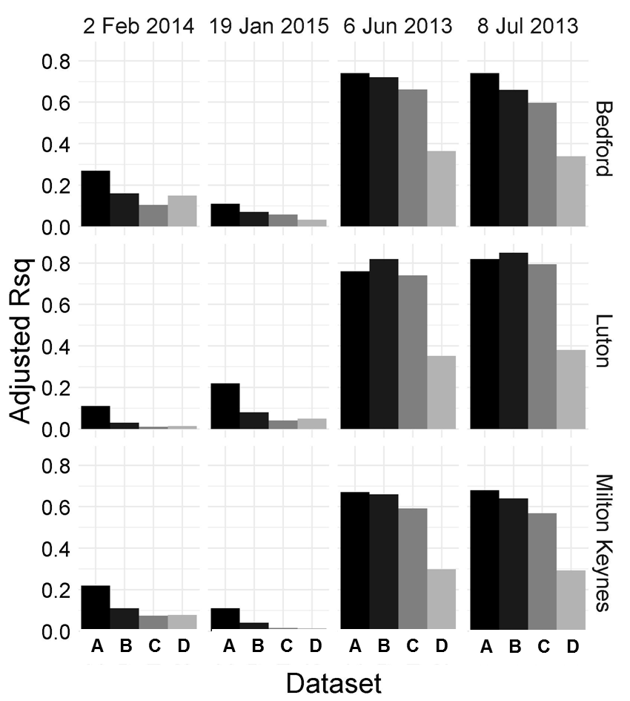
Figure 1 Adjusted R squared for different models tested in the study for all towns and dates: A – MARS 30m, B – MARS 2/4m adjusted, C – multiple regression (MR) 2/4m adjusted, D – MR 2/4m unadjusted.

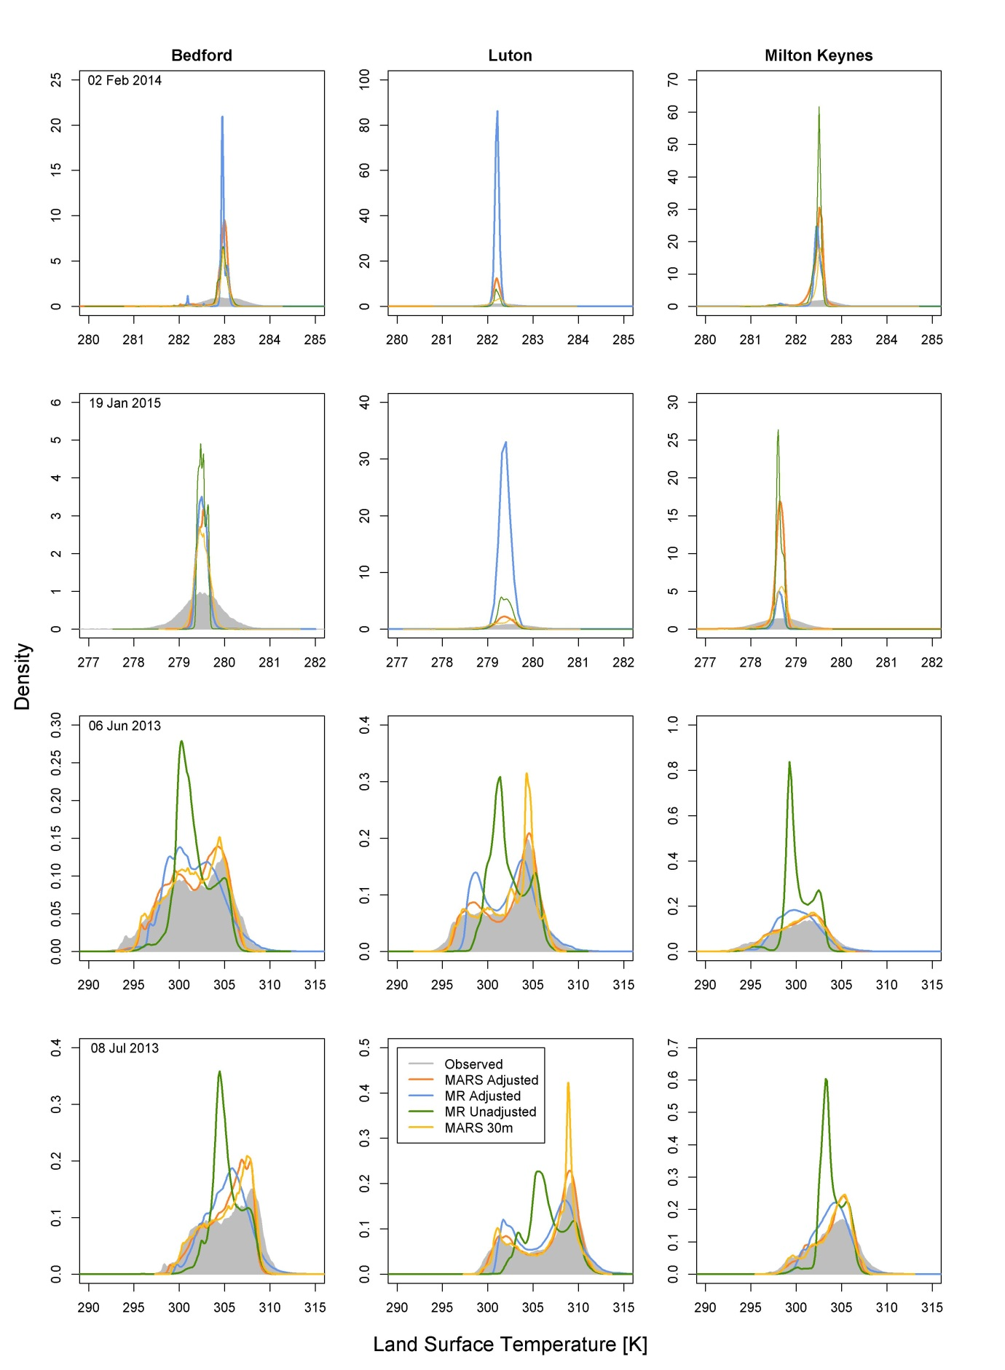
Figure 1 Distribution of LST values in the Landsat-derived (Observed) and downscaled maps without adjustment for residuals.

Section 6 Land surface temperature maps
Table 1 Basic statistics for LST derived from Landsat 8 TIR bands [K].
Date/Town |  |  | 02 Feb 2014 |  |  |  | 19-Jan-15 |  |  | 06-Jun-13 |  |  |  | 08-Jul-13
Statistic | BD | LT |  | MK | BD | LT |  | MK | BD |  | LT | MK | BD |  | LT | MK
Min | 277.7 | 268.7 |  | 264.1 | 275.2 | 268.2 |  | 255.9 | 291.4 |  | 290.2 | 282.6 | 297.2 |  | 294.8 | 291.6
Max | 284.5 | 284.1 |  | 285.2 | 283 | 282.8 |  | 283.7 | 313.2 |  | 319.2 | 312.4 | 315.7 |  | 322.7 | 317.3
Range | 6.8 | 15.4 |  | 21.1 | 7.8 | 14.6 |  | 27.8 | 21.8 |  | 29.0 | 29.8 | 18.5 |  | 27.9 | 25.7
Mean | 282.9 | 282.2 |  | 282.5 | 279.5 | 279.4 |  | 278.6 | 301.6 |  | 302.2 | 300.2 | 305.2 |  | 306.5 | 303.9
Std | 0.5 | 0.5 |  | 0.6 | 0.5 | 0.6 |  | 0.6 | 3.5 |  | 3.4 | 3 | 2.9 |  | 3.6 | 2.6

Table 2 Basic statistics for downscaled LST maps with the MARS_{2/4ma} models [K].
Date/Town |  |  | 02 Feb 2014 |  |  |  | 19-Jan-15 |  |  | 06-Jun-13 |  |  |  | 08-Jul-13
Statistic | BD | LT |  | MK | BD | LT |  | MK | BD |  | LT | MK | BD |  | LT | MK
Min | 278.6 | 278.4 |  | 275.2 | 278.7 | 277.3 |  | 273.9 | 289.4 |  | 292.4 | 288.1 | 290.9 |  | 297.4 | 294.0
Max | 285.9 | 285.3 |  | 300.9 | 280.5 | 282.2 |  | 287.3 | 317.6 |  | 331.0 | 313.7 | 313.8 |  | 329.6 | 316.4
Range | 7.2 | 6.9 |  | 25.7 | 1.8 | 4.8 |  | 13.4 | 28.2 |  | 38.5 | 25.5 | 22.9 |  | 32.2 | 22.4
Mean | 282.9 | 282.2 |  | 282.5 | 279.5 | 279.4 |  | 278.6 | 301.6 |  | 302.2 | 300.2 | 305.2 |  | 306.5 | 303.9
Std | 0.2 | 0.1 |  | 0.2 | 0.1 | 0.2 |  | 0.1 | 2.9 |  | 3.0 | 2.5 | 2.4 |  | 3.3 | 2.1

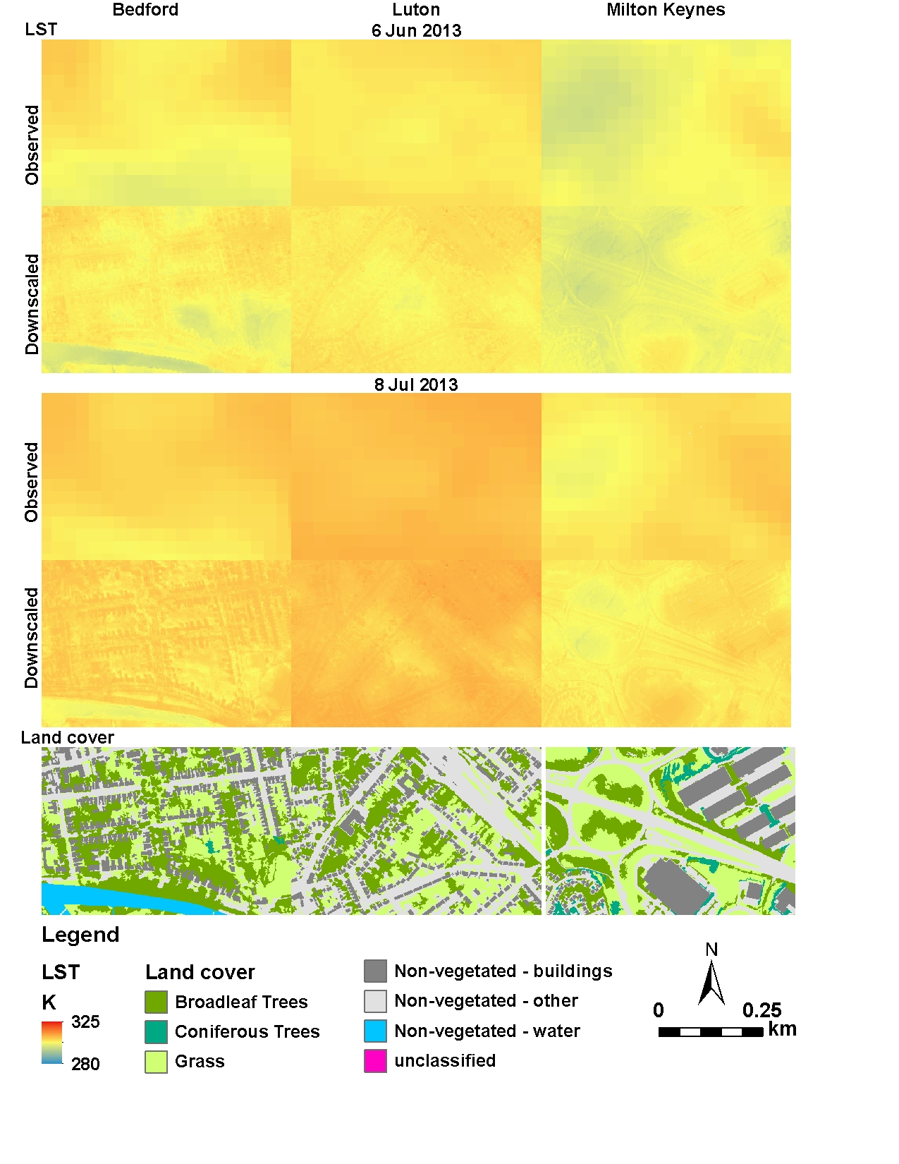
Figure 2 Large-scale comparison of the LST downscaled maps with the MARS method at target 2 to 4m spatial resolution for summer dates.
References
Bouzekri, S., Lasbet, A.A., Lachehab, A., 2015. A New Spectral Index for Extraction of Built-Up Area Using Landsat-8 Data. J. Indian Soc. Remote Sens. 43, 867–873. https://doi.org/10.1007/s12524-015-0460-6
Chun, B., Guldmann, J.-M., 2014. Spatial statistical analysis and simulation of the urban heat island in high-density central cities. Landsc. Urban Plan. 125, 76–88. https://doi.org/10.1016/j.landurbplan.2014.01.016
Drury, S.A. (Stephen A.., 1987. Image interpretation in geology. Allen & Unwin.
Purevdorj, T., Tateishi, R., Ishiyama, T., Honda, Y., 1998. Relationships between percent vegetation cover and vegetation indices. Int. J. Remote Sens. 19, 3519–3535. https://doi.org/10.1080/014311698213795
Sobrino, J.A., Jiménez-Muñoz, J.C., Sòria, G., Romaguera, M., Guanter, L., Moreno, J., Plaza, A., Martínez, P., 2008. Land surface emissivity retrieval from different VNIR and TIR sensors. pp. 316–327. https://doi.org/10.1109/TGRS.2007.904834
Yu, X., Guo, X., Wu, Z., 2014. Land Surface Temperature Retrieval from Landsat 8 TIRS—Comparison between Radiative Transfer Equation-Based Method, Split Window Algorithm and Single Channel Method. Remote Sens. 6, 9829–9852. https://doi.org/10.3390/rs6109829
Zha, Y., Gao, J., Ni, S., 2003. Use of normalized difference built-up index in automatically mapping urban areas from TM imagery. Int. J. Remote Sens. 24, 583–594. https://doi.org/10.1080/01431160304987

