Synthesis and Antioxidant Activity of Some New Thioglycoluril Derivatives

Imene Boudebouzª*, Salah Arrousª, Olesya Voronova^{b}, Evgenii Plotnikov^{b}

ªDepartment of Chemistry, Faculty of Science, Tomsk State University, Lenin Avenue 36, Tomsk 634050, Russia; ^{b}Department of Chemistry, Faculty of Science, Tomsk Polytechnic University, Lenin Avenue 30, Tomsk 634050, Russia.
Imene Boudebouz. Tel. +7-913-863-6923; e-mail: imene_boudebouz@yahoo.ca

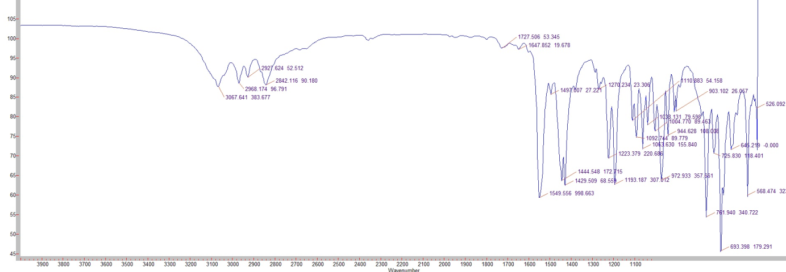
Figure 4. IR spectrum of compound 2a.

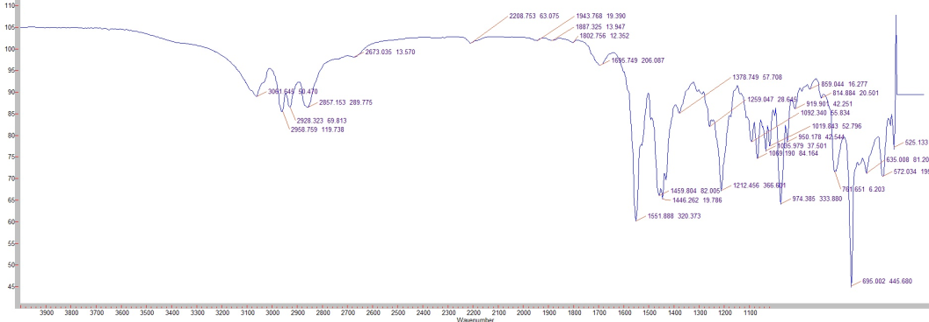
Figure 7. IR spectrum of compound 2b.

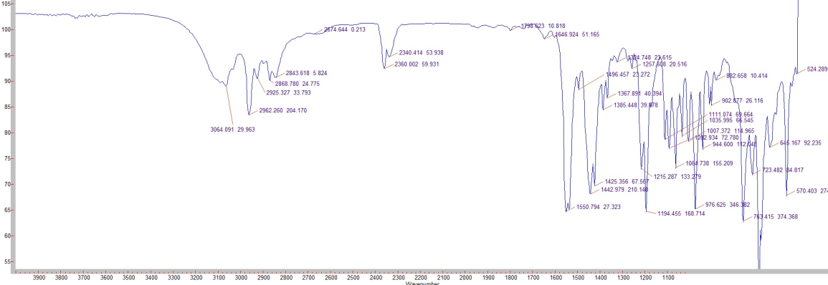
Figure 10. IR spectrum of compound 2c.

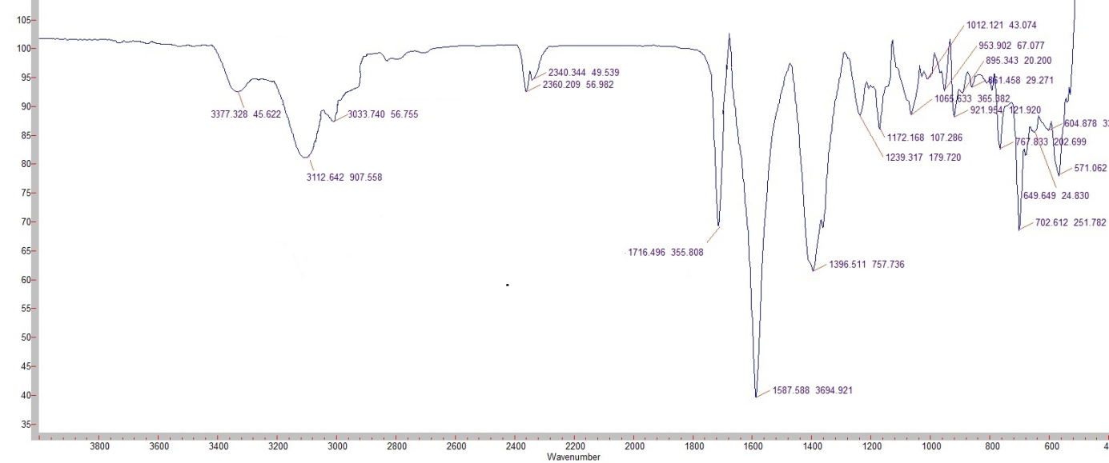
Figure 16. IR spectrum of compound 2d.

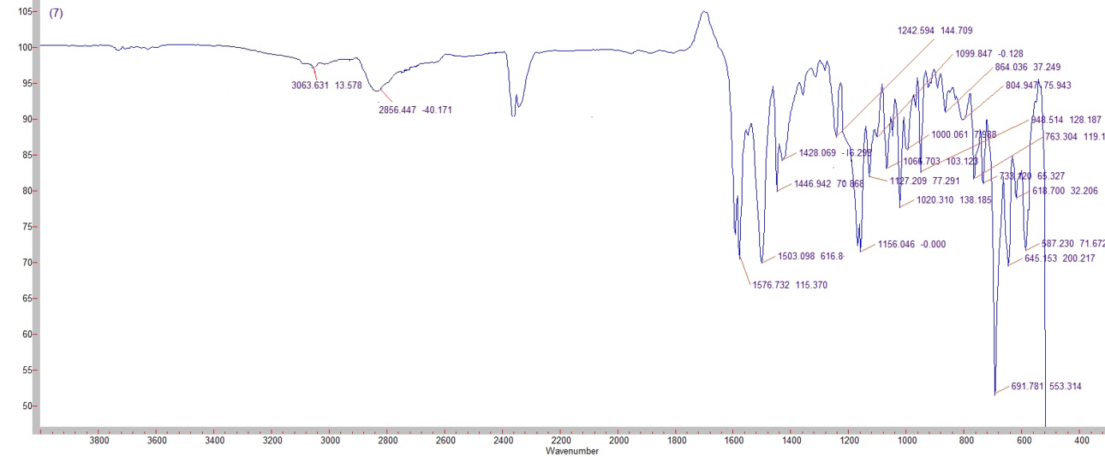
Figure 13. IR spectrum of compound 2e.

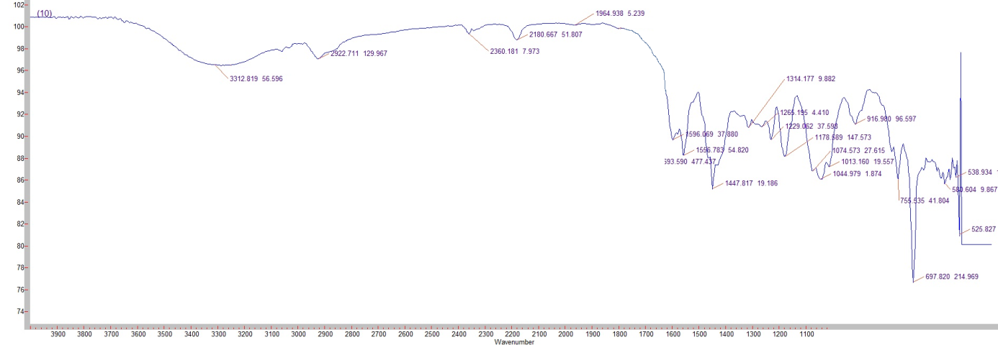
Figure 19. IR spectrum of compound 2f.

