Supplement
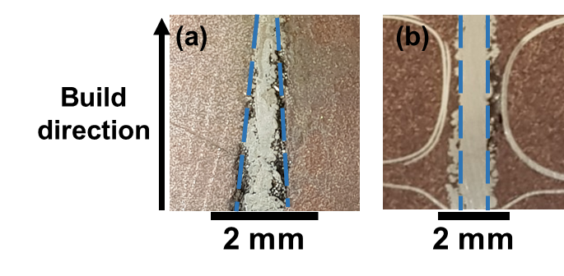
Figure S1. Cross sectional images of DED-printed pure tungsten samples. (a) Triangular structure fabricated at F = 228 J/mm² and (b) structure with constant width fabricated at F = 237 J/mm².

Figure S2. Samples fabricated at 21.6 m/s in carrier gas velocity.

Figure S3. Samples fabricated at 7.2 m/s in carrier gas velocity.

Figure S4. Typical cross-sectional images of DED-printed samples, showing gas porosities and lack of fusion porosities.
Figure S5. Oxygen content obtained from pure tungsten powders and DED-printed samples fabricated at different laser powers (V_{L} =150 mm/min in, M = 9 g/min and V_{C} =7.2 m/s).

