Supplementary Material
Nature of Science across Contexts (NOSC)

1. The diagram below shows the atom as having a nucleus in the center with electrons moving around it.
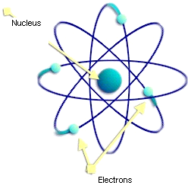
(a) How did scientists determine this atomic structure?
(b) Do you think scientists are certain (sure) about the structure of the atom? Explain what makes them sure or unsure.
(c) Different scientists reached different shapes or models of the atom at different times. How can you explain that scientists came up with different models even though they were looking at the same data about the atom?

2. The dinosaurs lived millions of years ago.
(a) How do scientists know that dinosaurs really existed?
(b) Do you think scientists are certain (sure) about the way dinosaurs look? Explain what makes them certain or uncertain.
(c) Scientists agree that the dinosaurs became extinct about 65 million years ago. However, scientists disagree about what had caused this to happen. One group of scientists suggests that a huge meteorite hit the earth and caused the extinction. Another group of scientists suggests that violent volcanic eruptions caused the extinction. How is it possible for scientists to reach different conclusions when both groups were using the same data?

3. Global warming refers to the warming of the Earth over the past 100 years.
(a) How do scientists know that global warming is happening?
(b) Do you think scientists are certain (sure) about global warming? Explain what makes them certain or uncertain.
(c) Scientists disagree about what is causing global warming. Some scientists say that humans are warming the planet by the continuous burning of fossil fuels. Another group of scientists say that the causes for global warming are natural and are not related to humans. How is it possible for scientists to arrive at different conclusions when they are looking at the same data?
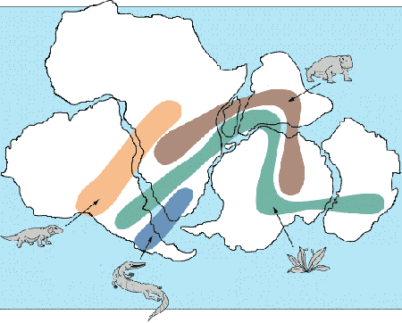
4. Plate tectonics is the theory that the Earth's surface is made up of large pieces which are called plates. The size and position of the plates on which the continents (picture) are located change over time.
The constant movement of the plates is responsible
for the formation of mountains, islands, volcanoes,
and earthquakes.
(a) How do scientists know about the constant movement of plates?
(b) Do you think scientists are certain (sure) about the theory of plate tectonics? Explain what makes them certain or uncertain.

(c) Different scientists reached different theories about the Earth at different times. How can you explain that scientists came up with different theories even though they were looking at the same data about the Earth?

5. Genetic engineering involves the techniques used by scientists to change and improve the basic composition of a living cell.
(a) How do scientists know about the effects of genetic engineering?
(b) Are scientists certain (sure) about the effects of genetic engineering? Explain what makes them certain or uncertain.
(c) Scientists disagree about the issue of genetically modified food. Some scientists say that this new technology can develop and improve food, with great benefits for humans and the environment. Another group of scientists say that there are harmful side effects of genetically modified food to humans, animals, and the environment. How is it possible for scientists to reach different conclusions even though they are looking at the same data about genetically modified food?

