Electronically varied manganese tris-arylacetamide tripodal complexes

Anthony F. Cannella,† Roshaan Surendhran,† Samantha N. MacMillan,§ Rupal Gupta,¶ David C. Lacy*†
†Department of Chemistry, University at Buffalo, State University of New York, Buffalo, New York 14260, United States
§Department of Chemistry and Chemical Biology, Cornell University, Ithaca, New York 14853, United States
¶Department of Chemistry, College of Staten Island, City University of New York, Staten Island, NY 10314, United States

E-mail: DCLAcy@buffalo.edu

Contents | Page
Methods | S2
Figure S1. EPR | S3
Figure S2. Electrochemistry of Mn compounds | S4
Figure S3 Electrochemistry of Fe compounds | S5
References | S6

Methods

Crystallographic methods
Low-temperature X-ray diffraction data for [Me₄N]₂[MnL^{NO2}(OAc)] (Mn^{NO2}) and [Me₄N]₂[CoL^{NO2}(OAc)] (Co^{NO2}) were collected at University at Buffalo on a Bruker SMART APEX2 CCD diffractometer installed at a rotating anode source (MoKα radiation, α=0.71073 Å) at 90 K. The diffraction images were processed and scaled using the APEX2 software. The structures were solved by direct methods using SHELXS¹ and refined against F² on all data by full-matrix least squares with SHELXL² following established refinement strategies.³ All non-hydrogen atoms were refined anisotropically. All hydrogen atoms bound to carbon were included in the model at geometrically calculated positions and refined using a riding model. The isotropic displacement parameters of all hydrogen atoms were fixed to 1.2 times the Ueq value of the atoms they are linked to (1.5 times for methyl groups). The unit cell of [Me₄N]₂[MnL^{NO2}(OAc)] (Mn-NO₂) contains disordered solvent molecules that could not be satisfactorily modeled; they have been treated as diffuse contributions to the overall scattering without specific atom positions using the solvent mask routine in Olex2.⁴⁻⁵

EPR.

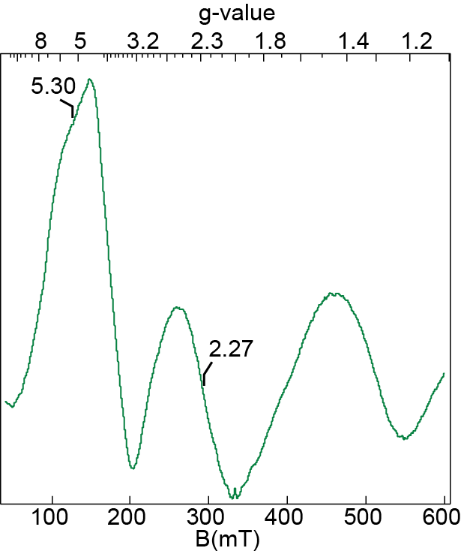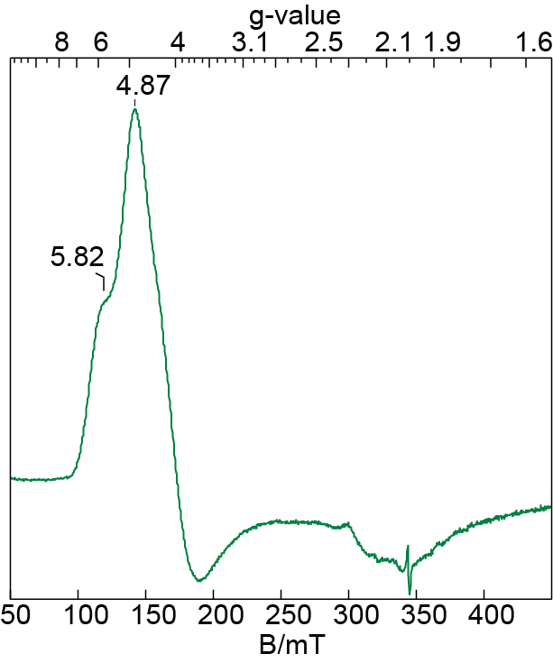

Figure S1. From left to right: X-band EPR spectra of [MnL^{NO2}(OAc)]^{2–} (DMA, 4 K) and [CoL^{NO2}(OAc)]^{2–} (DMA, 16 K).

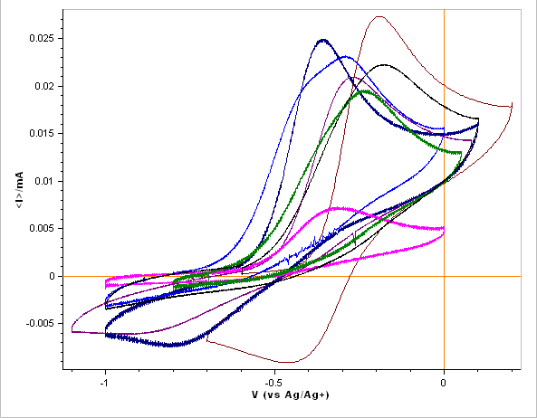

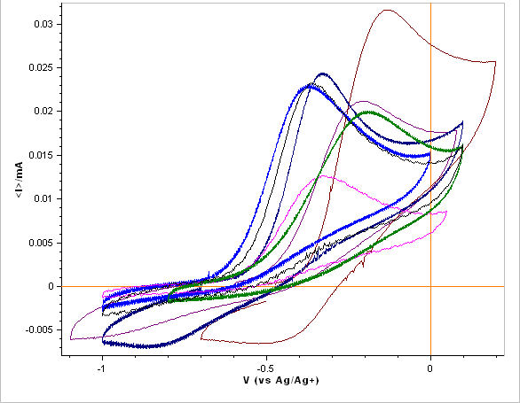

Figure S2. (Top) 4 mM Mn compounds (Bottom) 4 mM Mn compounds with 1 eq of TMAOAc Color Scheme: R=H (Black), NO₂ (Maroon), Cl (Navy), Br (Purple), Me (Fuchsia), Et (Green), OMe (Blue).

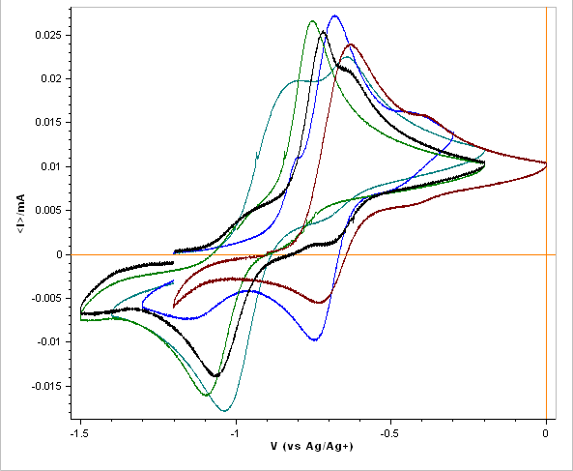

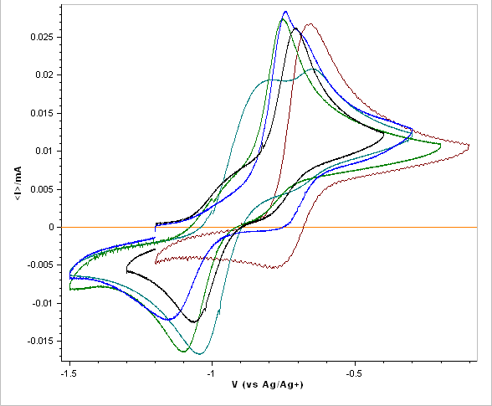

Figure S3. (Top) 4 mM Fe compounds (Bottom) 4 mM Fe compounds with 1 eq TMAOAc. Color Scheme: R=H (Black), NO₂ (Maroon), F (Teal), Et (Green), OMe (Blue).

References
- Sheldrick, G.M. Acta Cryst. 2008, A64, 112-122.
- Sheldrick, G.M. Acta Cryst. 2014, C71, 3-8.
- Müller, P. Crystallography Reviews 2009, 15, 57-83.
- Spek, A. L. Acta Cryst. 2015, C71, 9-18.
- Dolomanov, O. V.; Bourhis, L. J.; Gildea, R. J.; Howard, J. A. K.; Puschmann, H. J. Appl. Crystallogr. 2009, 42, 339-341.

