Supplementary figures

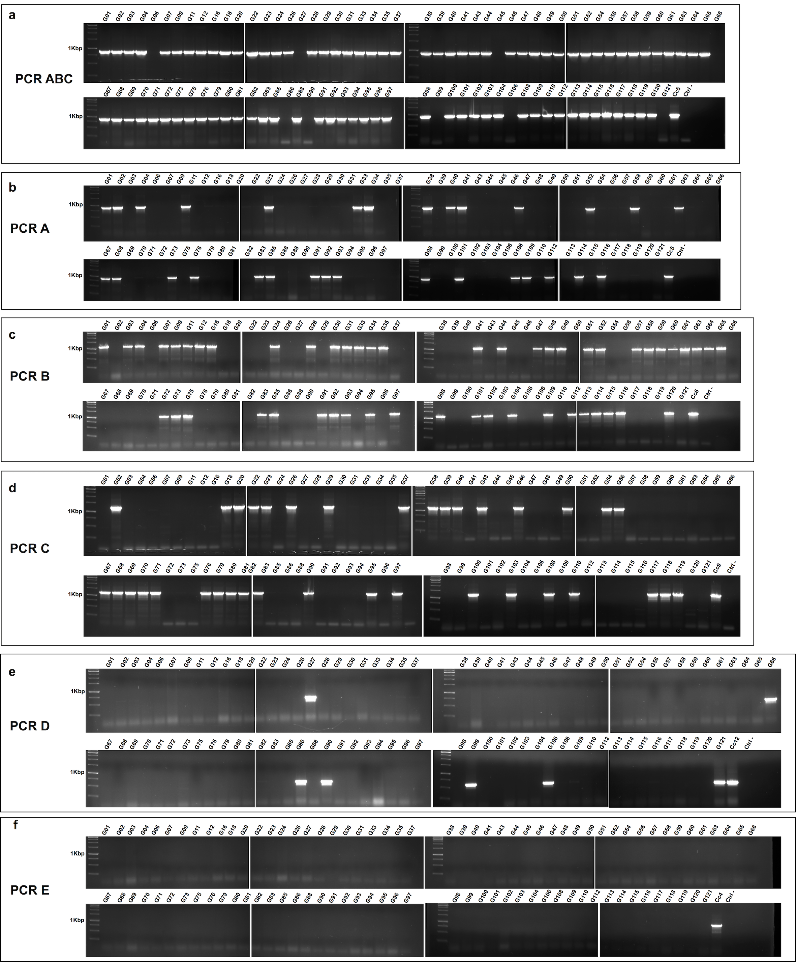

Figure S1. Capsular typing by PCR of 96 human isolated C. canimorsus strains from the CCUG collection.
Detection of capsular serovars A to E was performed using the oligonucleotides given in Supplementary Table S2.

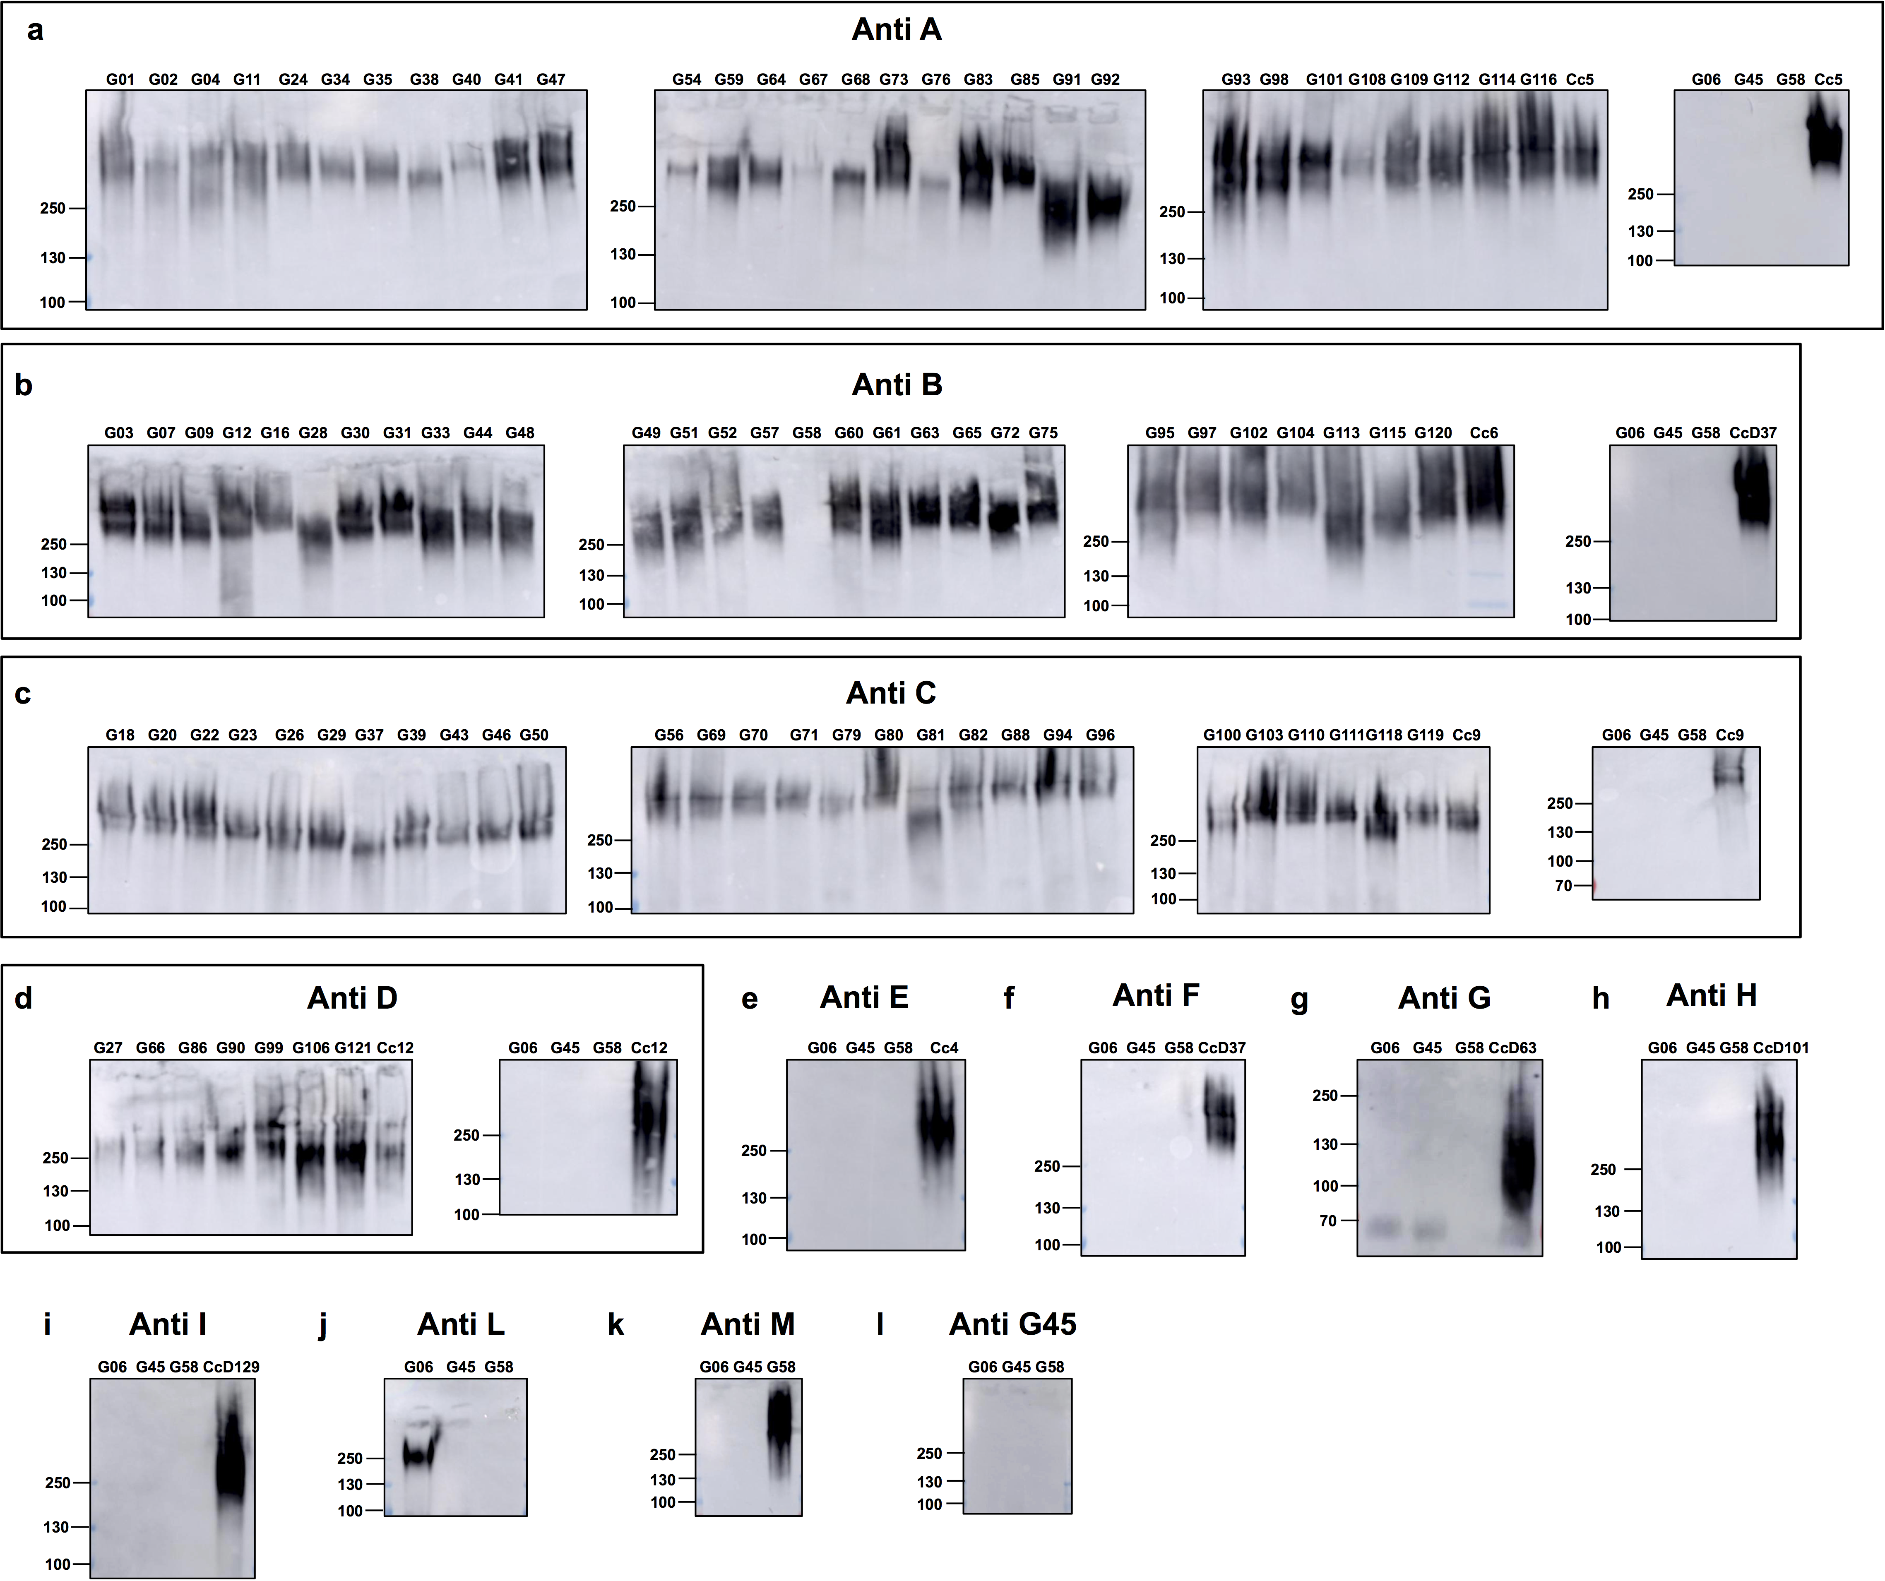

Figure S2. Capsular typing by Western-blot of 96 human isolated C. canimorsus strains from the CCUG collection.
Western blot analysis of proteinase K-treated lysates of C. canimorsus isolates was performed using the following sera: Y1C12-adsorbed anti-Cc5 (a), Cc6 ΔwbuB-adsorbed anti-Cc6 (b), Cc9 ΔwbuB-adsorbed anti-Cc9 (c), Cc12 ΔwbtA-adsorbed anti-Cc12 (d), anti-Cc4 adsorbed with human isolates Cc1-25 except Cc4 (e), anti CcD37 adsorbed with human isolates Cc1-25 (f), anti-CcD63 adsorbed with human isolates Cc1-25 (g), anti-CcD101 adsorbed with human isolates Cc1-25 (h), anti CcD129 adsorbed with human isolates Cc1-25 (i), anti-G06 adsorbed with human isolates Cc1-25 (j), anti-G58 adsorbed with human isolates Cc1-25 (k), anti-G45 (l). Numbers correspond to molecular weight markers in thousands.

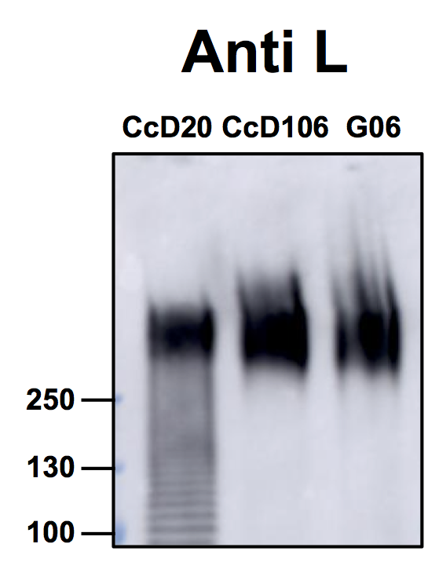

Figure S3. Capsular serovar L detection by Western-blot in dog- isolated C. canimorsus strains.
Western blot analysis of proteinase K-treated lysates of C. canimorsus isolates CcD20 and CcD106 was performed using anti-G06 adsorbed with human isolates Cc1-25 serum. Numbers correspond to molecular weight markers in thousands.

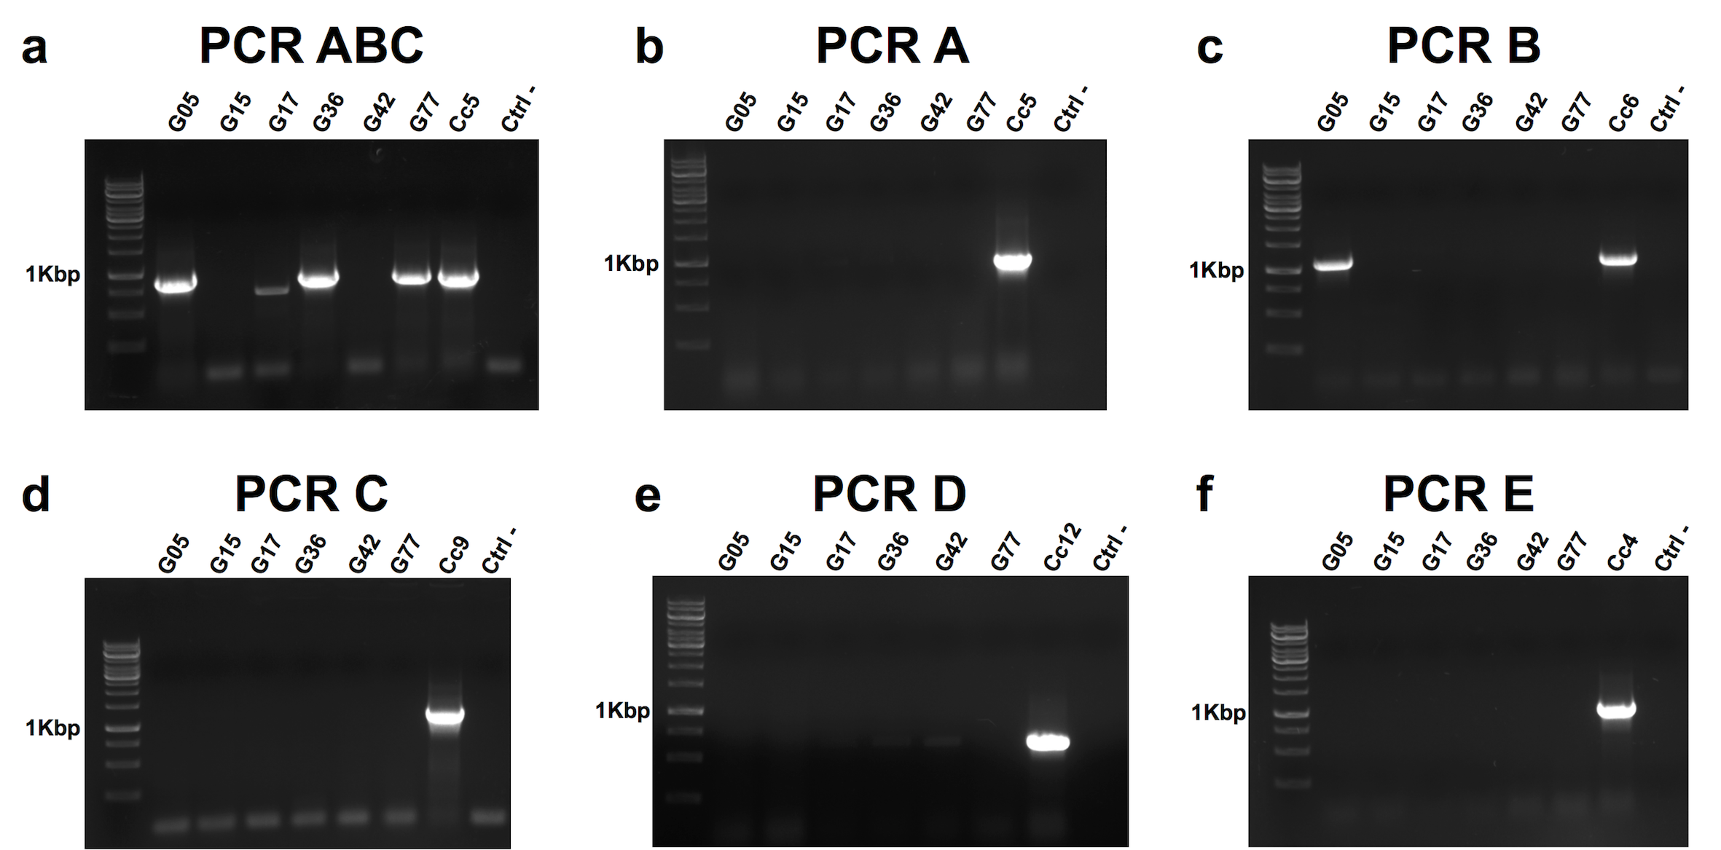

Figure S4. Capsular typing by PCR of 6 human isolated C. canis strains from the CCUG collection.
Detection of capsular serovars A to E was performed using the oligonucleotides given in Supplementary Table S2.
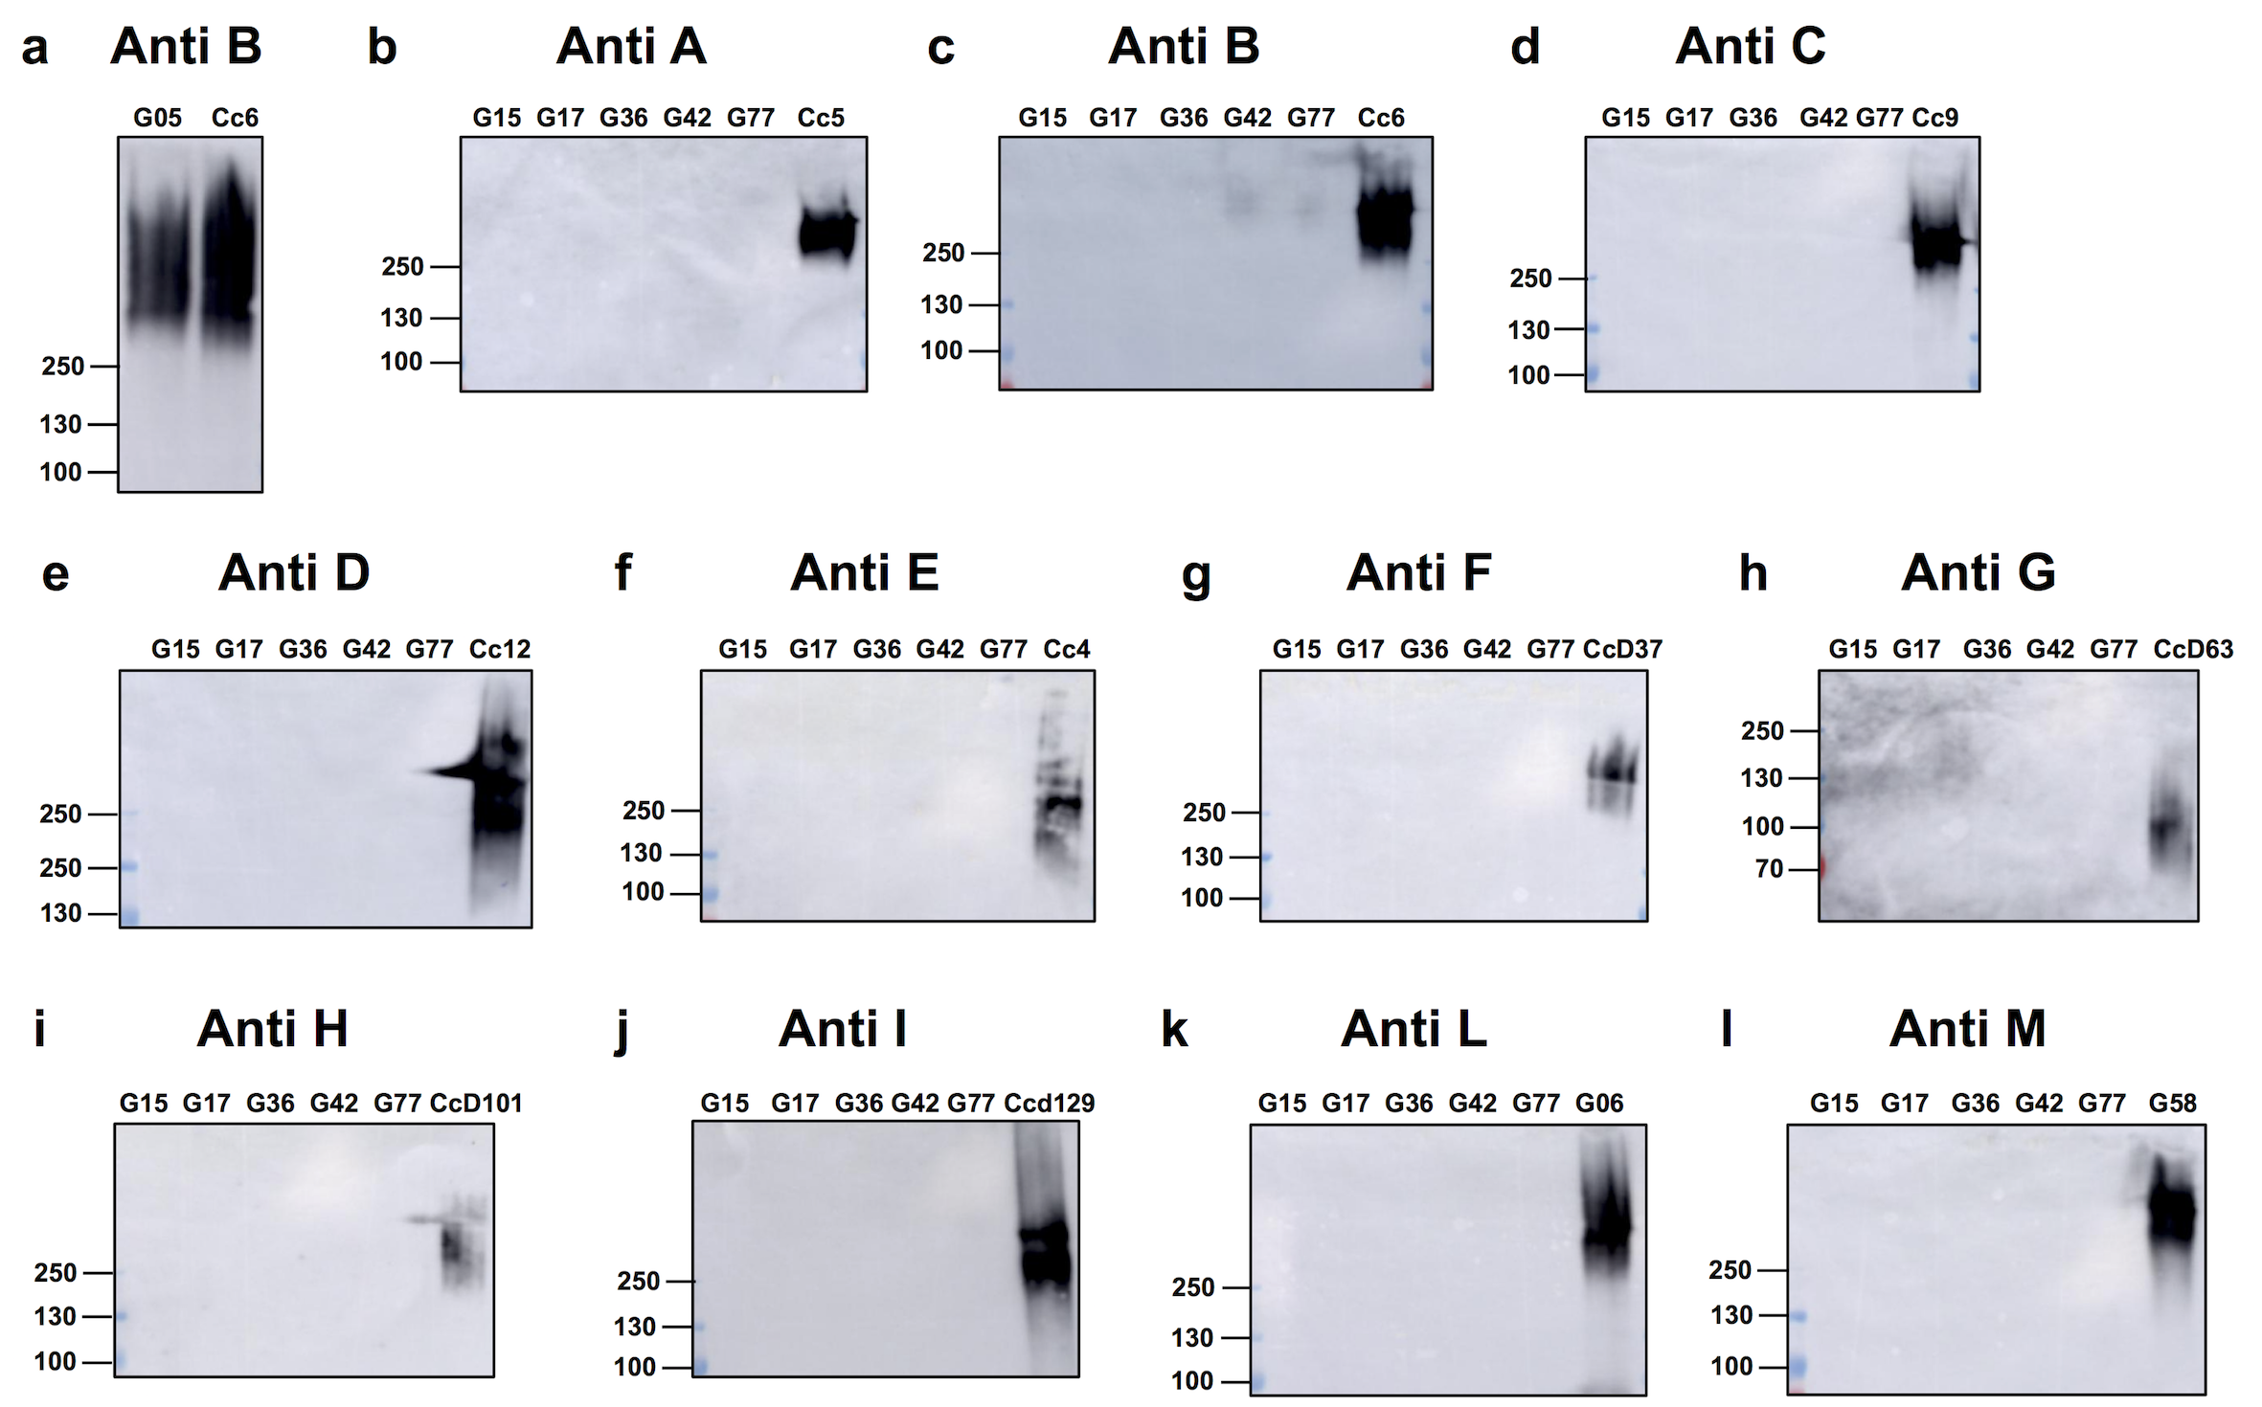

Figure S5. Capsular typing by Western-blot of 6 human isolated C. canis strains from the CCUG collection.
Western blot analysis of proteinase K-treated lysates of C. canis isolates was performed using the following sera: Cc6 ΔwbuB-adsorbed anti-Cc6 (a and c), Y1C12-adsorbed anti-Cc5 (b), Cc9 ΔwbuB-adsorbed anti-Cc9 (d), Cc12 ΔwbtA-adsorbed anti-Cc12 (e), anti-Cc4 adsorbed with human isolates Cc1-25 except Cc4 (f), anti-CcD37 adsorbed with human isolates Cc1-25 (g), anti-CcD63 adsorbed with human isolates Cc1-25 (h), anti-CcD101 adsorbed with human isolates Cc1-25 (i), anti-CcD129 adsorbed with human isolates Cc1-25 (j), anti-G06 adsorbed with human isolates Cc1-25 (k), anti-G58 adsorbed with human isolates Cc1-25 (l). Numbers correspond to molecular weight markers in thousands.

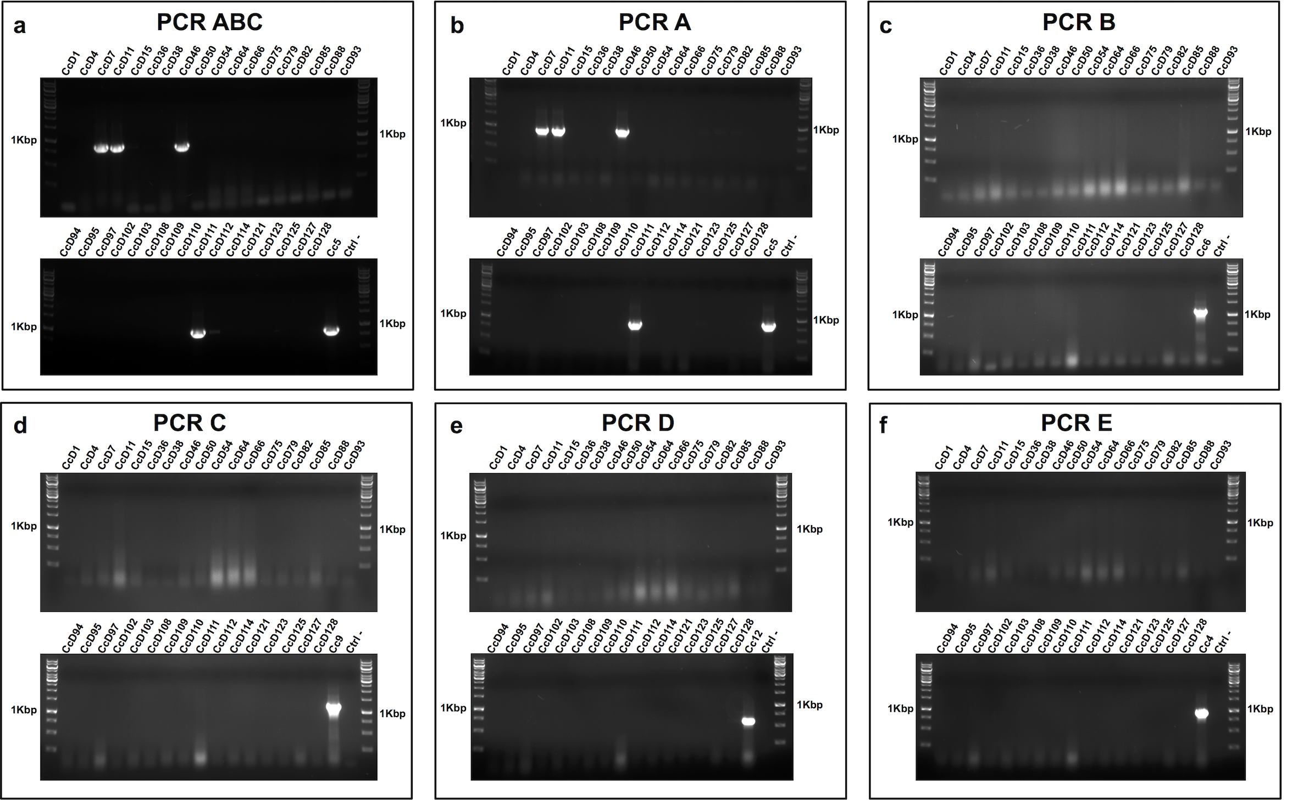

Figure S6. Capsular typing by PCR of 34 dog-isolated C. canis strains.
Detection of capsular serovars A to E was performed using the oligonucleotides given in Supplementary Table S2.

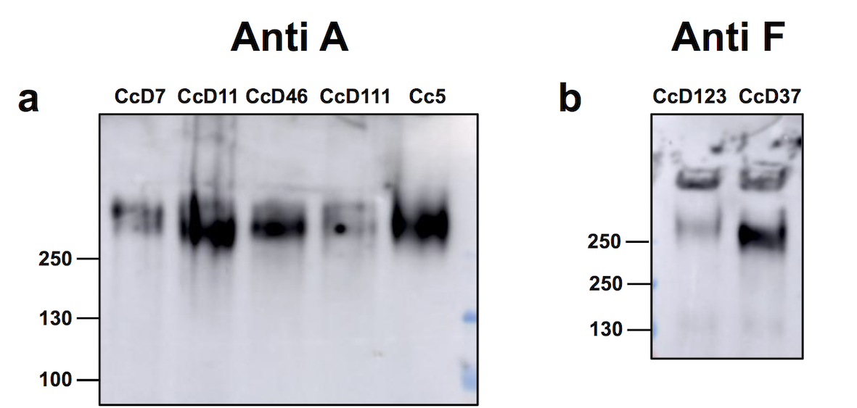

Figure S7. Capsular serovar A and F detection by Western-blot in dog- isolated C. canis strains.
Western blot analysis of proteinase K-treated lysates of C. canis isolates was performed using Y1C12-adsorbed anti-Cc5 (a) or anti-CcD63 adsorbed with human isolates Cc1-25 sera (b). Numbers correspond to molecular weight markers in thousands.

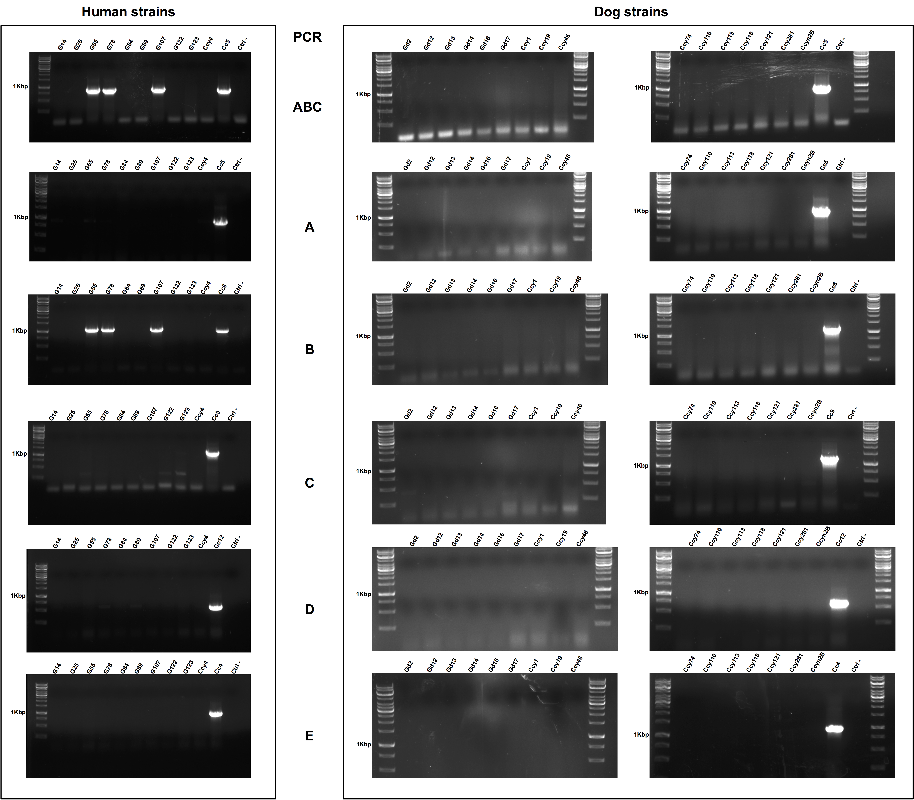

Figure S8. Capsular typing by PCR of 10 human-isolated and 16 dog-isolated C. cynodegmi strains.
Detection of capsular serovars A to E was performed using the oligonucleotides given in Supplementary Table S2.

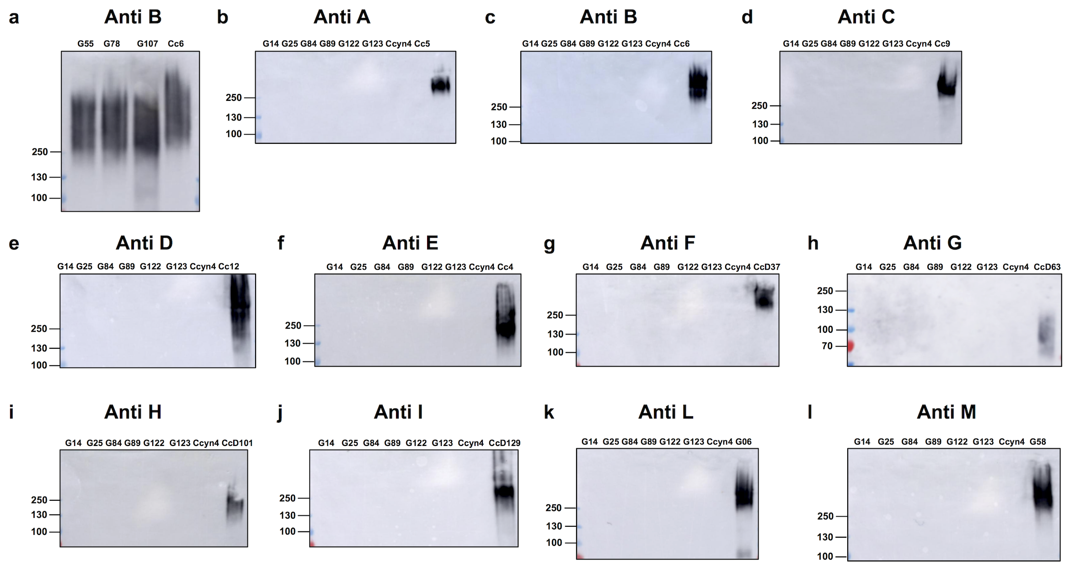

Figure S9. Capsular typing by Western-blot of 10 human-isolated C. cynodegmi strains.
Western blot analysis of proteinase K-treated lysates of C. cynodegmi isolates was performed using the following sera:, Cc6 ΔwbuB-adsorbed anti-Cc6 (a and c), Y1C12-adsorbed anti-Cc5 (b) Cc9 ΔwbuB-adsorbed anti-Cc9 (d), Cc12 ΔwbtA-adsorbed anti-Cc12 (e), anti-Cc4 adsorbed with human isolates Cc1-25 except Cc4 (f), anti-CcD37 adsorbed with human isolates Cc1-25 (g), anti-CcD63 adsorbed with human isolates Cc1-25 (h), anti-CcD101 adsorbed with human isolates Cc1-25 (i), anti-CcD129 adsorbed with human isolates Cc1-25 (j), anti-G06 adsorbed with human isolates Cc1-25 (k), anti-G58 adsorbed with human isolates Cc1-25 (l). Numbers correspond to molecular weight markers in thousands.

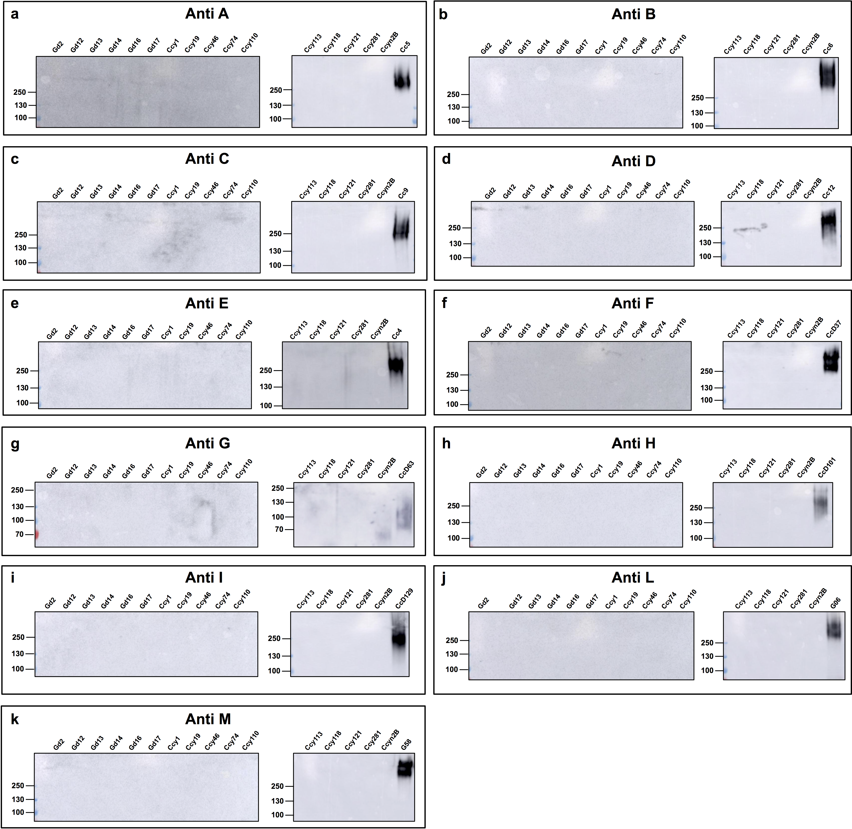

Figure S10. Capsular typing by Western-blot of 16 dog-isolated C. cynodegmi strains.
Western blot analysis of proteinase K-treated lysates of C. cynodegmi isolates was performed using the following sera: Y1C12-adsorbed anti-Cc5 (a), Cc6 ΔwbuB-adsorbed anti-Cc6 (b), Cc9 ΔwbuB-adsorbed anti-Cc9 (c), Cc12 ΔwbtA-adsorbed anti-Cc12 (d), anti-Cc4 adsorbed with human isolates Cc1-25 except Cc4 (e), anti-CcD37 adsorbed with human isolates Cc1-25 (f), anti-CcD63 adsorbed with human isolates Cc1-25 (g), anti-CcD101 adsorbed with human isolates Cc1-25 (h), anti-CcD129 adsorbed with human isolates Cc1-25 (i), anti-G06 adsorbed with human isolates Cc1-25 (j), anti-G58 adsorbed with human isolates Cc1-25 (k). Numbers correspond to molecular weight markers in thousands.

