Supplementary Material

Supplementary Table. Details of the MERS-CoV RNA-positive dromedary samples in Isiolo county collected April 20-21, 2017
Sample ID | Sex | Age | Sub location | Herd size | RNA concentration (RNA copies/ml) | Confirmation of MERS-CoV sequence
011/LOM/C20/F<1 | Female | <1yr | Lombolio | 70 | 5.0E+07 | full genome
011/DAB/C8/F<1 | Female | <1yr | Dabel | 128 | 3.7E+06 | full genome
011/LOM/C19/F<1 | Female | <1yr | Lombolio | 70 | 7.6E+05 | SNP pattern of Lombolio LOM/C20#
011/DAB/C11/M<1 | Male | <1yr | Dabel | 128 | 1.9E+05 | SNP pattern of DAB/C8#
011/DAB/C7/F>3 | Female | >3yrs | Dabel | 128 | 1.2E+05 | SNP pattern of DAB/C8#
011/DAB/C10/F>3 | Female | >3yrs | Dabel | 128 | 1,9E+04* | not done
011/DAB/C13/F>3 | Female | >3yrs | Dabel | 128 | 1,9E+04* | not done
#SNP: Detection of three single nucleotide polymorphisms in the spike and open reading frame 3 genomic region. Nucleotide genome positions according to MERS-CoV/EMC2012 (GenBank accession no. JX869059): 24,698 (Spike); 25,621 (ORF3), and 25,722 (ORF3).
*Presence of MERS-CoV could not be confirmed in a second real-time RT-PCR.

Supplementary Figure

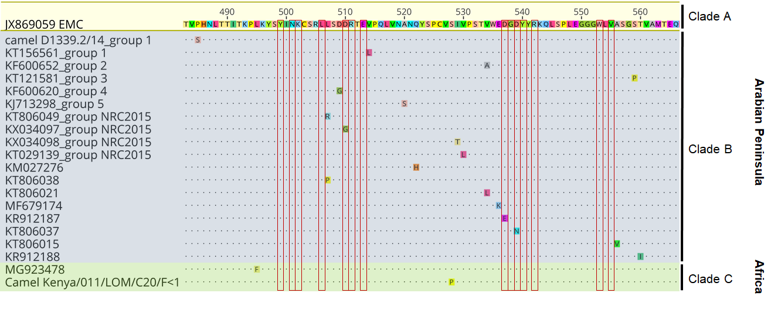
Supplementary Figure. Amino acid alignment of the core part of the receptor-binding domain (RBD) of the MERS-Coronavirus spike protein. In order to identify unique amino acid exchanges all published MERS-CoV spike sequences were initially aligned using the EMC strain as reference (not shown, Geneious version R9). In total, 91 MERS-CoV sequences had unique mutations within the core sequence of the RBD (amino acid positions 483-567). For clarity and to avoid redundancy, the figure includes either single sequences or examples of sequence clusters that have the same unique mutation. As both Kenyan MERS-CoV strains (Camel Kenya/011/LOM/C20/F<1 and Camel Kenya/011/DAB/C8/F<1) shared the S528P mutation, only one sequence was included (Camel Kenya/011/LOM/C20/F<1). The 14 essential amino acids responsible for direct interaction between the MERS-CoV spike RBD and the dipeptidyl peptidase 4 receptor are marked with red boxes.

