Supplemental Table 1: Representative Usage of iVFTs with K–12 students in prior study
Grade level and Course/Setting | How was the VFT used? | Successes in using the VFTs
7th grade science | 5 days at the end of the year after studying rock types and astronomy; Upheaval dome | Great discussions about scientific processes in the science community. Some things we know for sure other topics we are still learning/debating.
Gifted 5-8th grade and general education 7th grade | 3-4 times per week for 4 weeks with 30-40 min class  Upheaval Dome lab | Field guide was a hit and helped students have info, findings, and reflections.; Tie in with other topics (e.g. ELA) helped
7th grade science | Both labs in a single day. Upheaval Dome was done at the end of the unit on rocks soils, minerals, etc. Bizarre animals was done at the end of the school year. | Students loved the online learning and visiting other places of world virtually to learn about science.
7th grade science | Upheaval Dome done my enrichment class for class weeks – this was additional time outside of science time | Students were active and minds engaged in lessons/lab. They developed a deeper knowledge of the material and this allowed for better academic conversation between students defending their ideas
5-8th grade informal STEM room | Upheaval dome in informal STEM room in 20-minute blocks with students visiting over their lunch recess. Some student visited once a week, other every 3-4 weeks. Used as a directed activity (students have a choice of what to do) | Used VFT to focus on the two major theories of Upheaval Dome’s formation. Them we let the kids explore the VFT independently and helped them or answered questions.
7th and 8th grade science | Upheaval Dome and Bizarre Animals. Upheaval Dome was used in 8th grade Geologic Time Unit, spent 3 weeks. Bizarre Animals was done at the end of the school year in 7th grade for one week because it wasn’t part of the curriculum. I might be able to use if for classification in the future. | VFTs were amazing. I believe just from the students’ reaction and comments that the students learned. The students were definitely interested and on task.
8th grade ELA, 6-8th grade science club online and 4th – 8th grade blended learning session | For ELA, Upheaval Dome for two 30-minute sessions using VFT snippets. For science club, Upheaval Dome | For ELA students, it helped strengthen students’ skills in making observations and compare and contrast related text. For science and ELA students it was great to have students look at Upheaval dome and understand the argument. The VFTs provide content and context for teachers to provide students with a rich differentiated and engaging learning opportunity. They open students’ eyes to a higher level academic world (these are used by University courses).

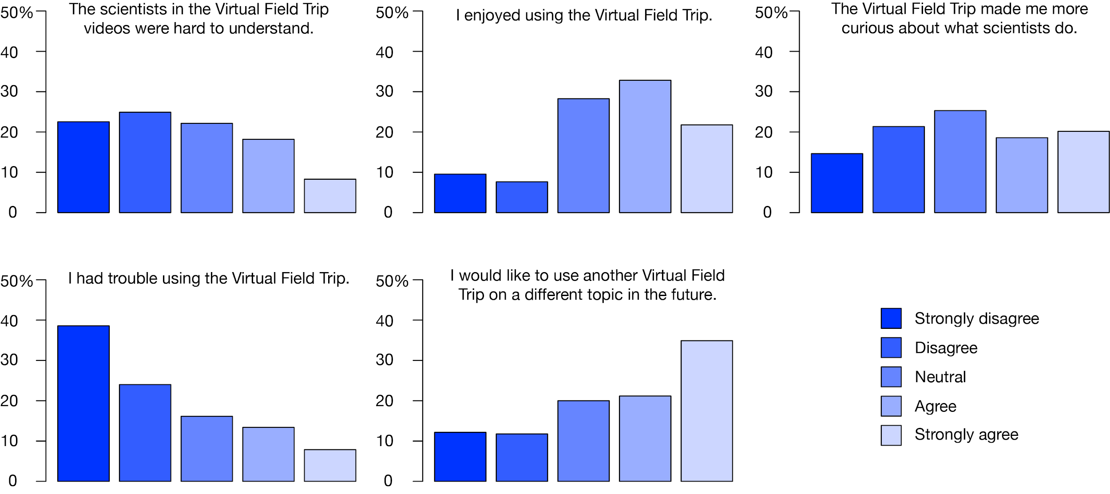
Figure S1. Student feedback following use of the Bizarre Animals and Upheaval Dome VFTs.

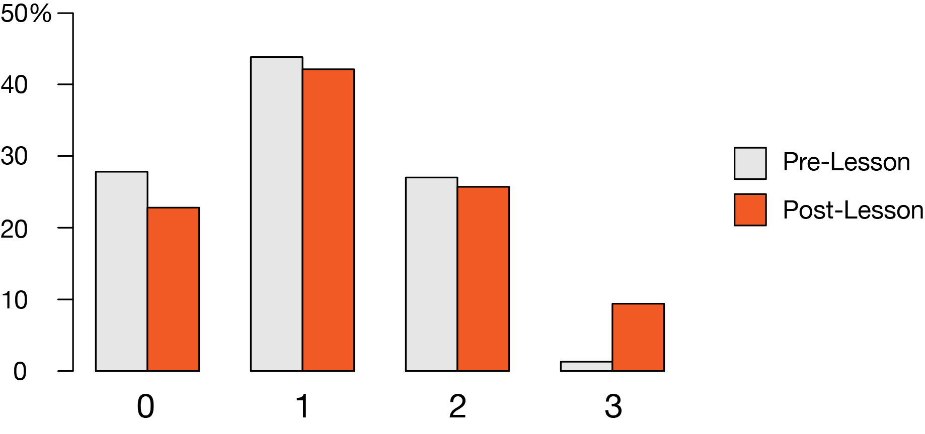
Figure S2. Students’ scores on an open-ended prompt about nature of science. Collected before and after completing the Upheaval Dome VFT.

