Supplemental Material

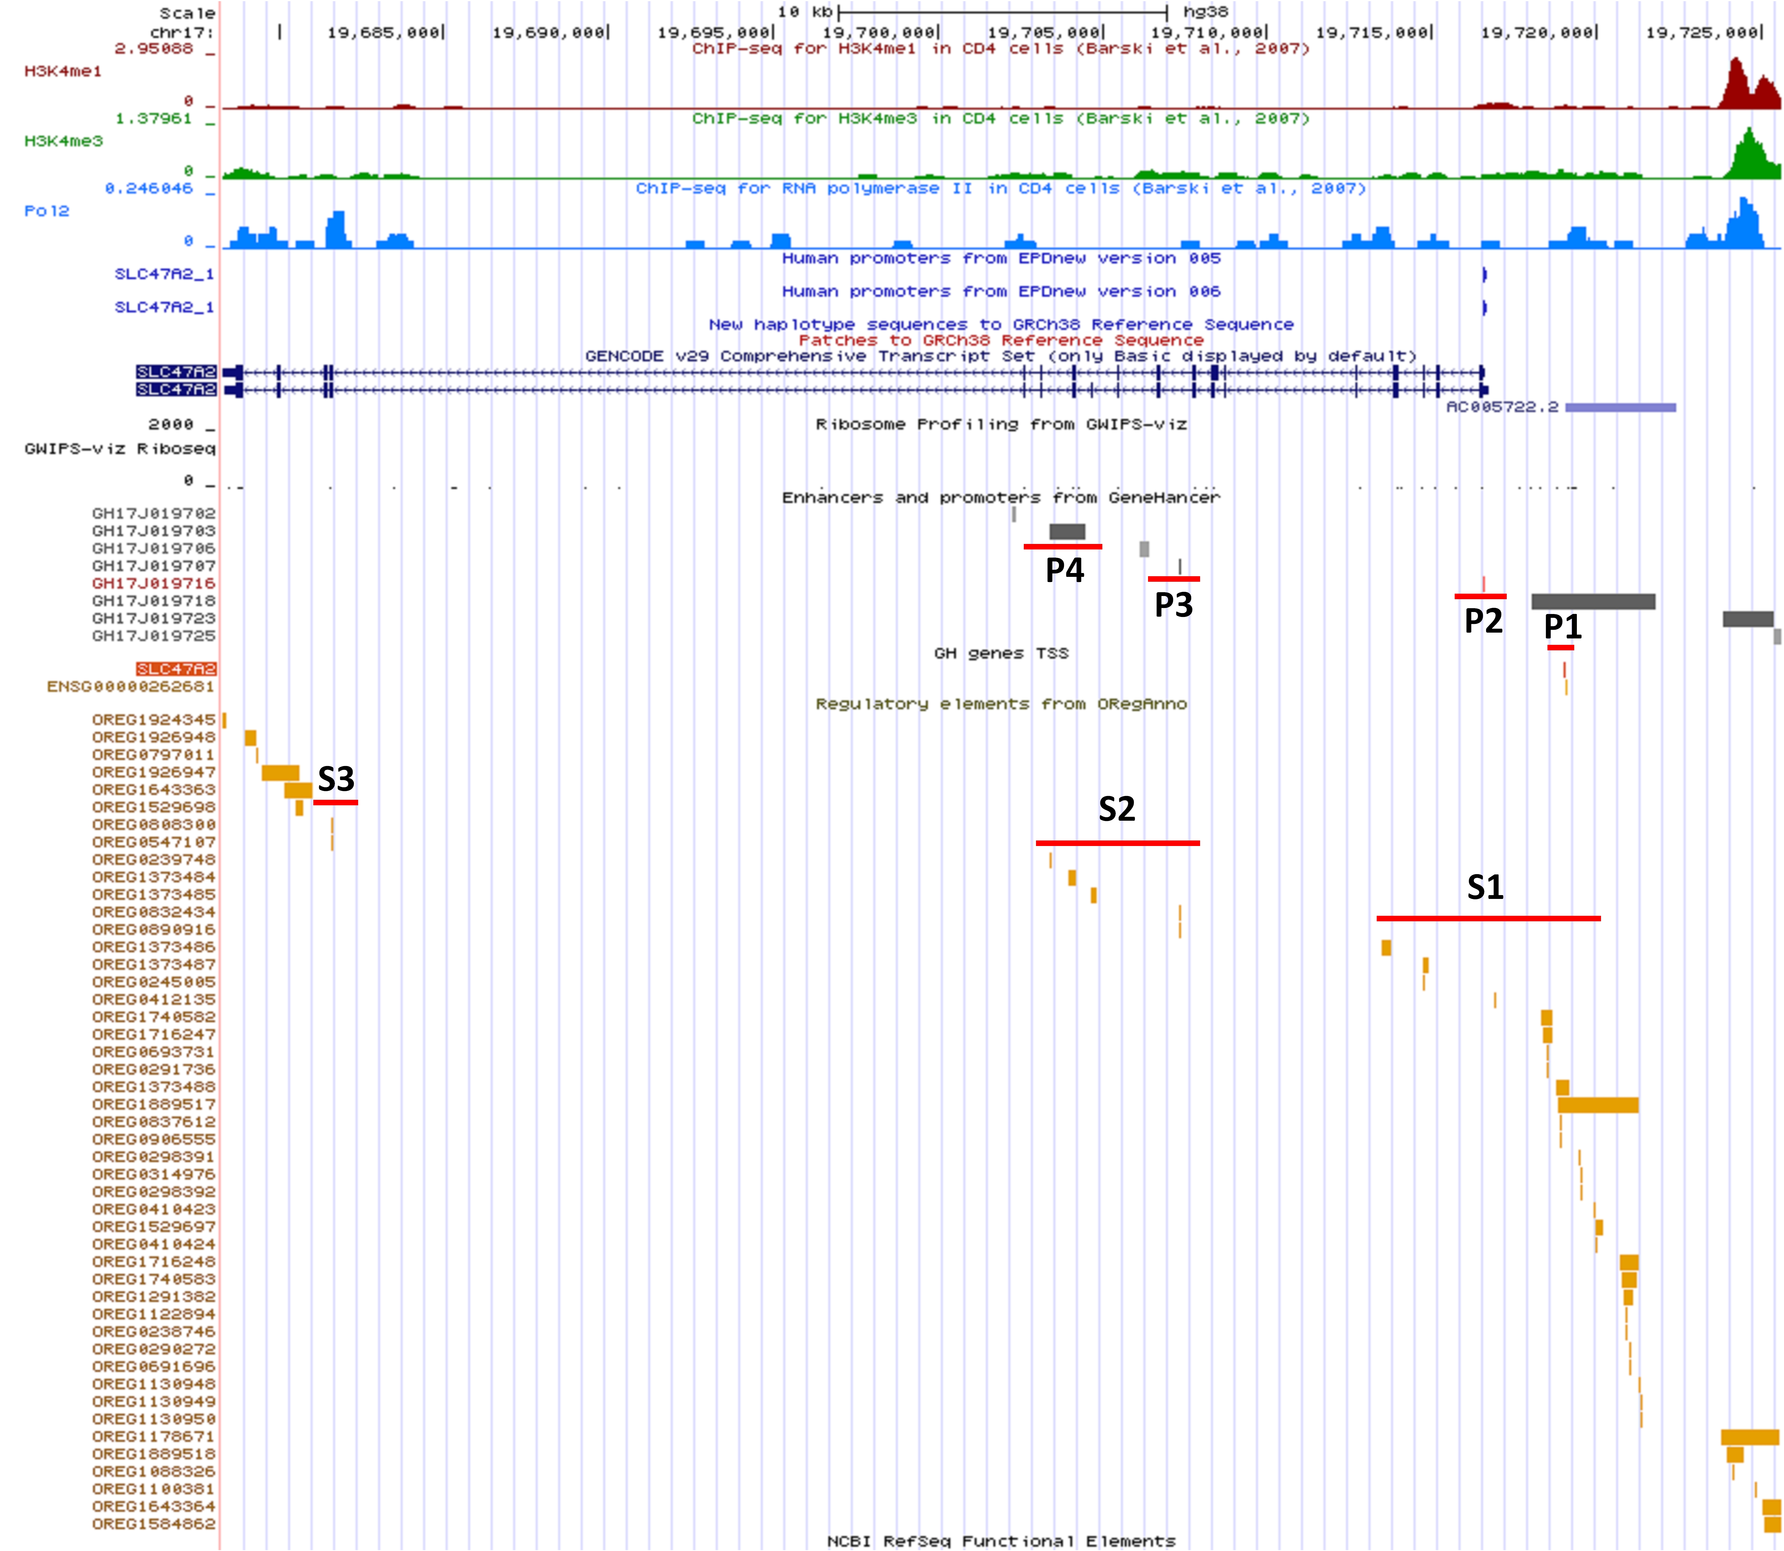
Figure S1. The annotation information of SLC47A2 locus from the UCSC genome browser.

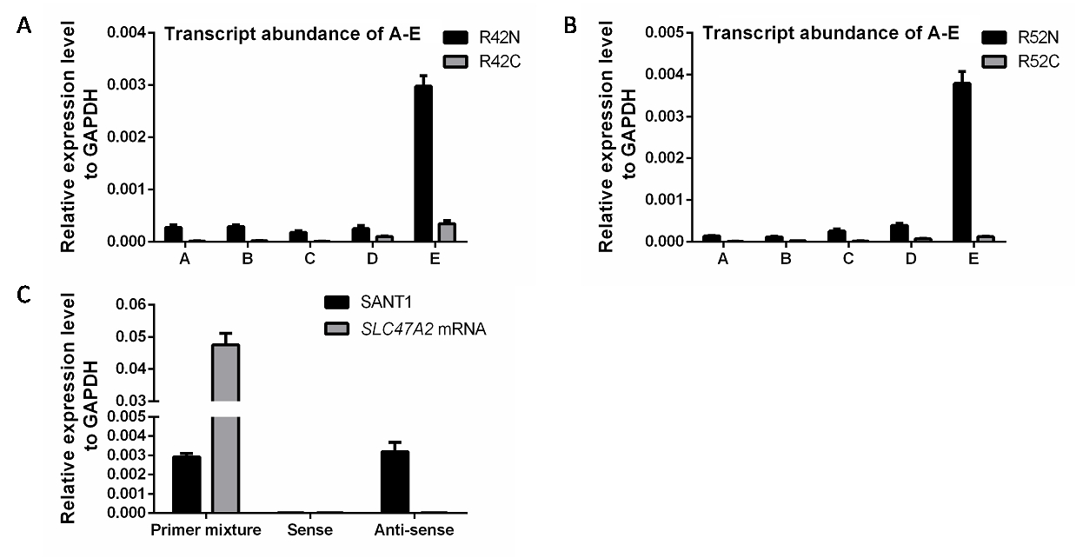
Figure S2. The transcript abundance and of strand specific qPCR of SANT1. (A) The transcript abundance of non-mRNA sequences in paired tissues. (B) The strand specific qPCR of SANT1. Total RNAs from R39N tumor-adjacent tissue (with higher SANT1 expression than RCC tissue) were reverse transcribed by Oligo dT Primer/Random 6 mers mixture, Sense or Anti-sense primer of site E, independently. The cDNAs were further amplified by site E or SLC47A2 mRNA primer pairs, respectively.

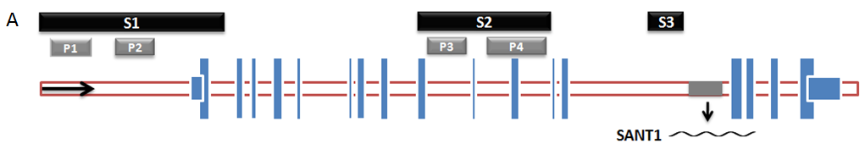
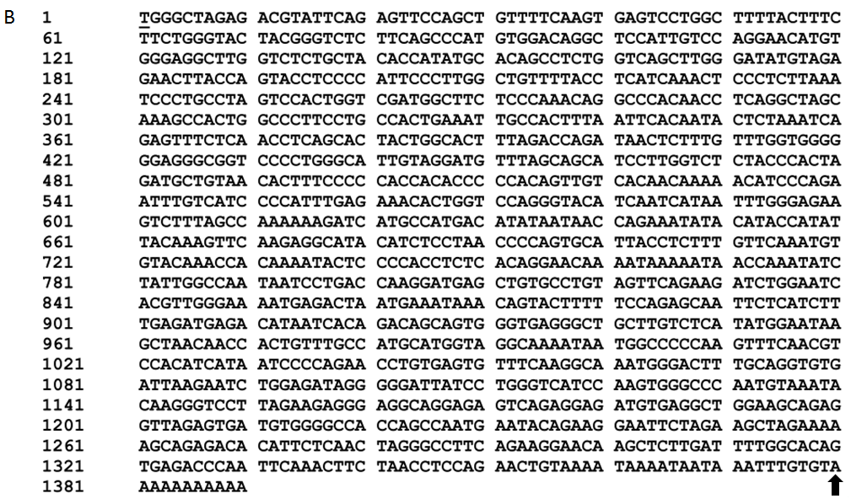
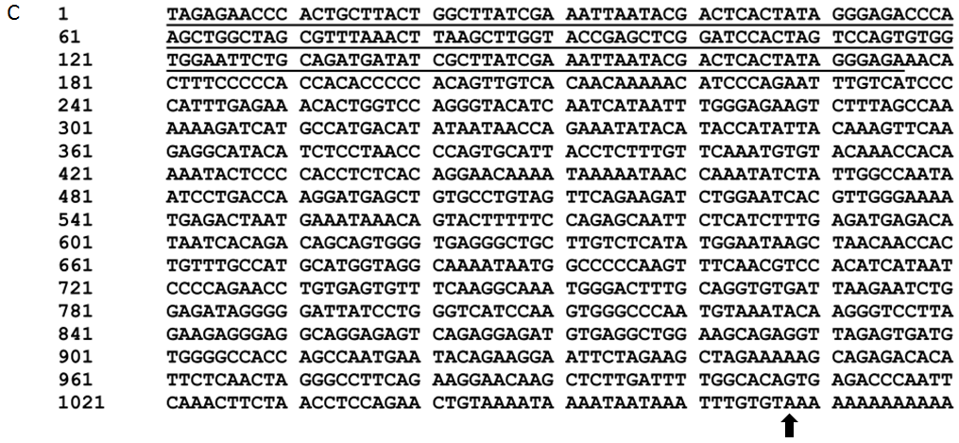
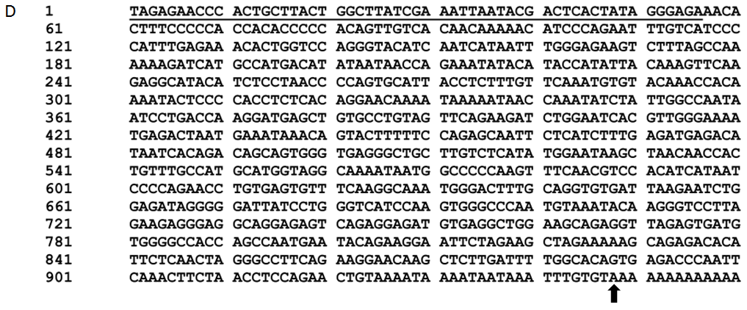
Figure S3. The sequences of SANT1 and two SANT1 mutants. (A) The location of SANT1 in SLC47A2 gene locus, (B-D) Schematic representation of experimentally identified transcripts of SANT1 (B), SANT1-S1 (C) and SANT1-S2 (D) that transcribed by pcDNA3.1 (+). The SANT1 has a conserved polyadenylation signal, which contains two AAUAAA motifs and a GU-rich element. The SANT1s are initiation from the transcriptional start site in expression vector, and the upstream regions that transcribed from pcDNA3.1 (+) are underlined. The arrowed sites in each transcript are the first nucleotide of polyadenylation tail.

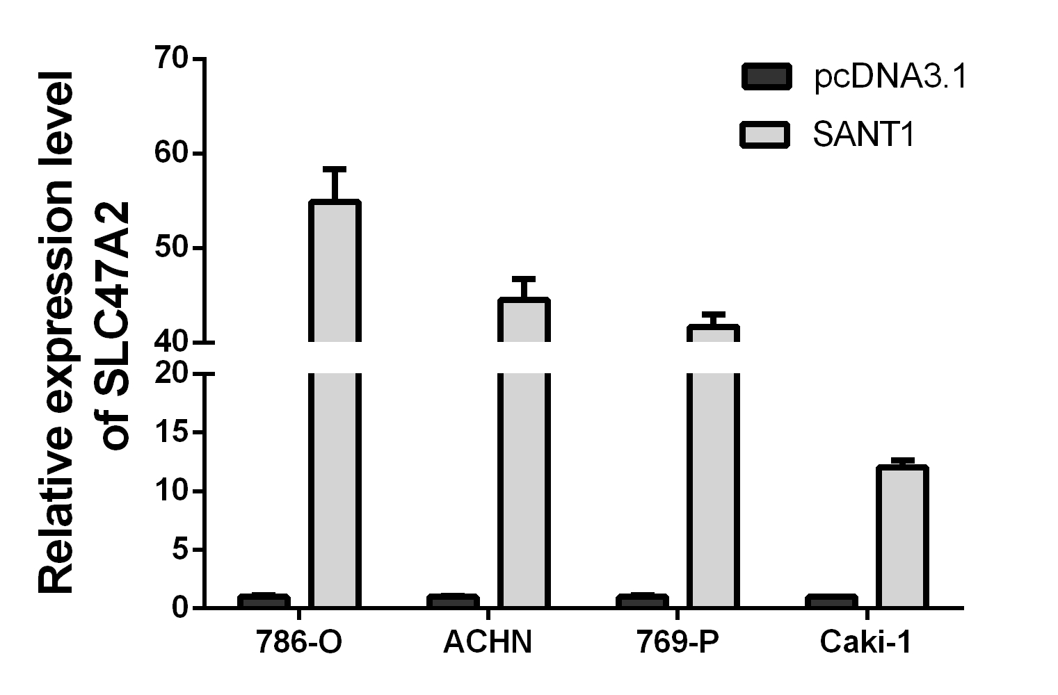
Figure S4. SANT1 upregulated the expression of SLC47A2 mRNA at 72h.

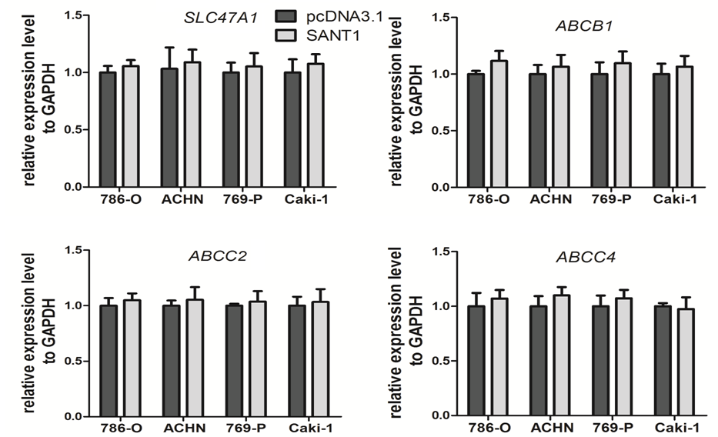
Figure S5. The abundant expression of SANT1 had no function in regulating the expression levels of SLC47A1, ABCB1, ABCC2 and ABCC4.

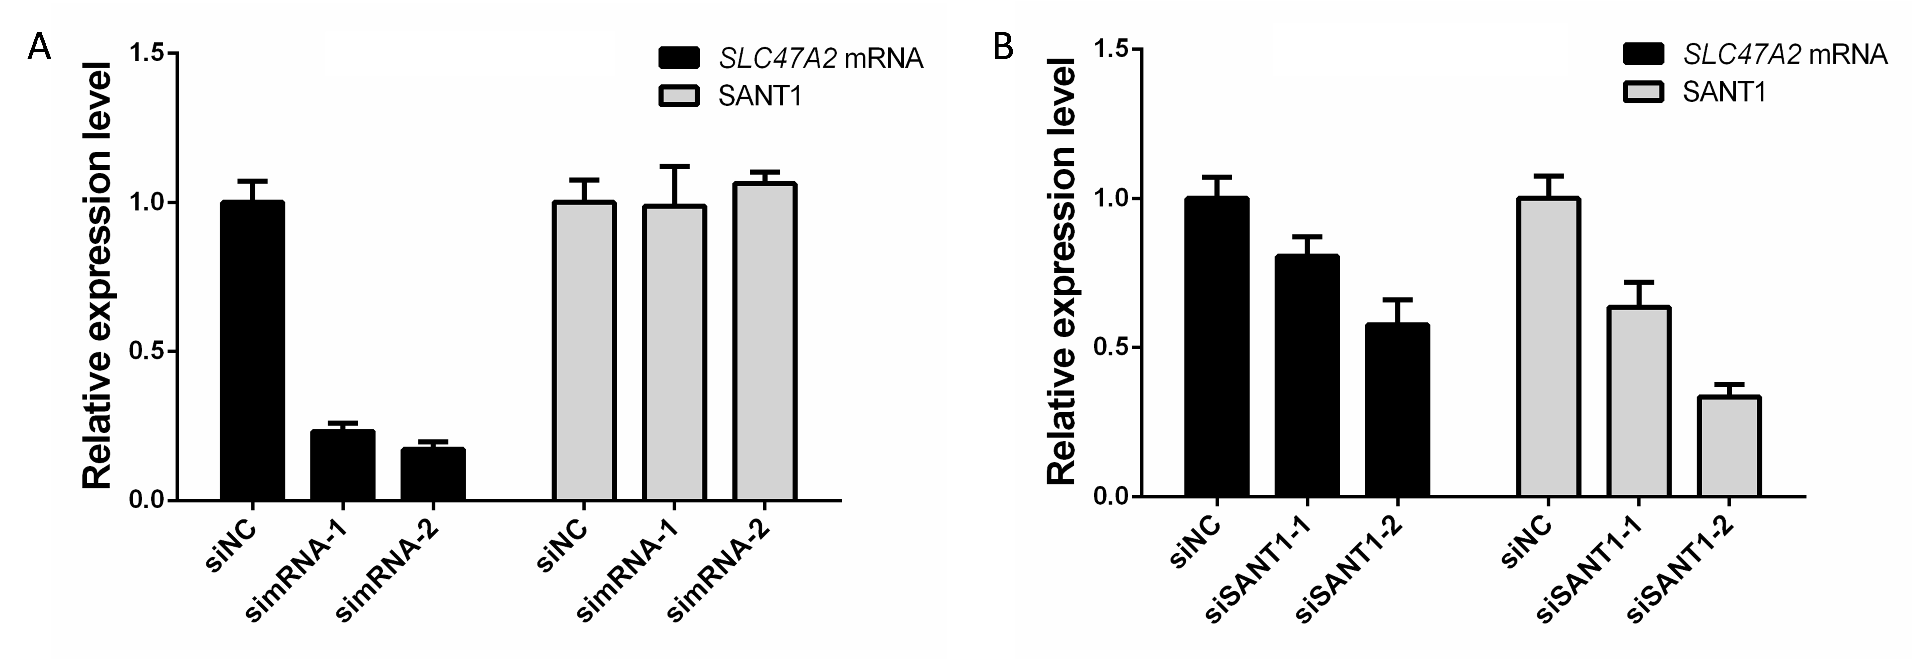
Figure S6. The simRNAs and siSANT1s targeted knockdown the expression of SLC47A2 coding gene and SANT1, respectively. (A) The simRNAs specifically inhibited the expression of SLC47A2 mRNA, but not SANT1. (B) The siSANT1s could knockdown the expression of SANT1, as well as SLC47A2 mRNA.

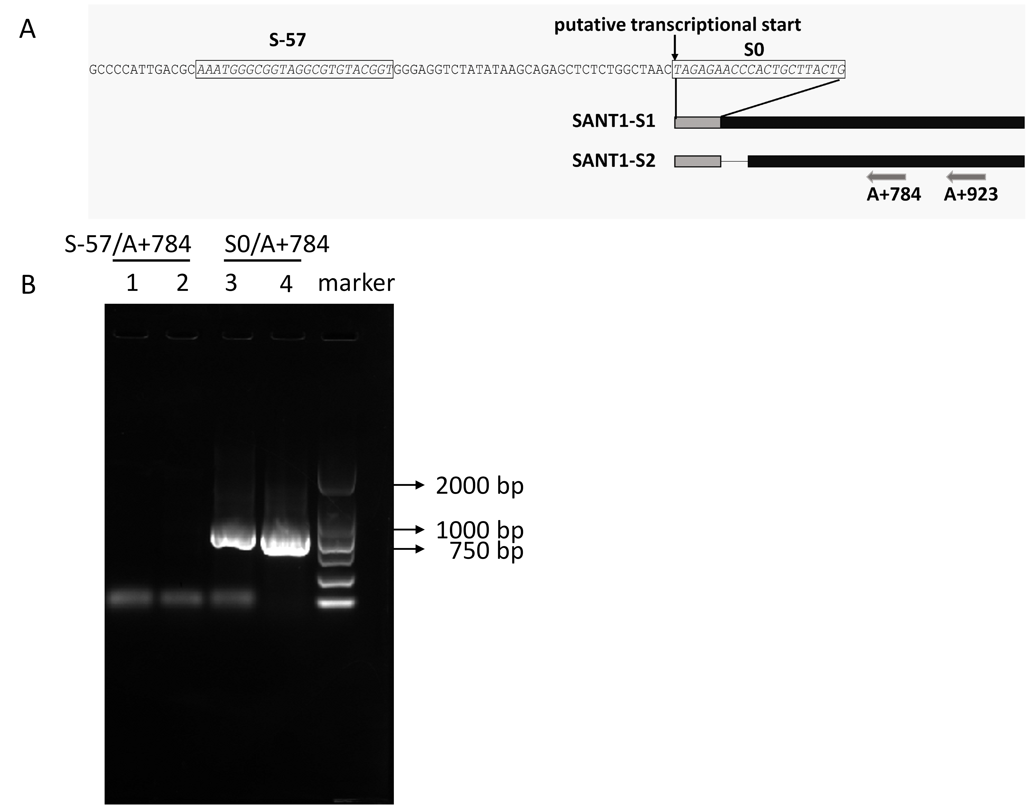
Figure S7. Analyze the rescued transcripts by PCR. The total RNAs were treated by DNase Ⅰ and reverse transcribed using the primer A923. The PCR detections were carried out using S0/A784 or S-57/A784. (A) The location of primers. (B) Lane 1: SANT1-S1 amplified by S-57/A+784; lane 2: SANT1-S2 amplified by S-57/A+784; lane 3: SANT1-S1 amplified by S0/A+784; lane 4: SANT1-S2 amplified by S0/A+784; marker: DL2000 (Takara).

Table S1. Patients' clinical information
Donor Number | Age | Gender | TNM stage | Subtype |  | Donor Number | Age | Gender | TNM stage | Subtype
1 | 37 | Male | T3N0M0 | clear cell |  | 34 | 52 | Female | T1BN0M1 | clear cell
3 | 66 | Female | T1N0M0 | clear cell |  | 35 | 61 | Female | T1bN0M0 | clear cell
4 | 70 | Female | T4N0M0 | clear cell |  | 36 | 58 | Female | T1aN0M0 | clear cell
6 | 64 | Female | T1N0M0 | clear cell |  | 37 | 43 | Female | T1aN0M0 | clear cell
7 | 52 | Female | T1N0M0 | clear cell |  | 38 | 63 | Female | T1aN0M0 | clear cell
8 | 50 | Male | T1N0M0 | papillary |  | 39 | 66 | Male | T1N0M0 | clear cell
9 | 60 | Male | T1N0M0 | clear cell |  | 40 | 50 | Female | T1N0M0 | clear cell
10 | 62 | Male | T1N0M0 | clear cell |  | 41 | 47 | Male | T1N0M0 | clear cell
11 | 70 | Male | T3N0M0 | clear cell |  | 42 | 44 | Female | T1N0M0 | clear cell
13 | 60 | Male | T1N0M0 | clear cell |  | 43 | 49 | Male | T3N0M0 | clear cell
14 | 47 | Male | T1N0M0 | clear cell |  | 44 | 51 | Male | T1N0M0 | unclassified
15 | 49 | Female | T1N0M0 | clear cell |  | 45 | 44 | Female | T1N0M0 | clear cell
16 | 56 | Male | T3N0M0 | clear cell |  | 46 | 48 | Male | T1N0M0 | clear cell
17 | 47 | Female | T2N0M0 | clear cell |  | 47 | 56 | Male | T2N2M0 | clear cell
18 | 67 | Male | T1N0M0 | clear cell |  | 49 | 42 | Male | T4N0M0 | clear cell
19 | 57 | Male | T2N0M0 | clear cell |  | 52 | 63 | Female | T1N0M0 | unclassified
20 | 37 | Female | T2N0M0 | clear cell |  | 53 | 27 | Female | T2N0M0 | chromophobe
21 | 60 | Male | T1N0M0 | clear cell |  | 54 | 45 | Female | T4N2M0 | clear cell
22 | 44 | Male | T1N0M0 | clear cell |  | 55 | 63 | Female | T4N2M1 | clear cell
23 | 54 | Male | T1N0M0 | clear cell |  | 56 | 62 | Male | T3aN2M0 | clear cell
24 | 49 | Male | T1N0M0 | clear cell |  | 57 | 61 | Male | T3aN0M0 | unclassified
25 | 52 | Male | T1N0M0 | unclassified |  | 58 | 55 | Female | T1N0M0 | clear cell
26 | 48 | Female | T1N0M0 | clear cell |  | 59 | 66 | Male | T4N0M0 | papillary
27 | 41 | Male | T1N0M0 | clear cell |  | 61 | 65 | Male | T3aN0M0 | papillary
29 | 42 | Male | T1N0M0 | clear cell |  | 62 | 49 | Male | T1aN0M0 | clear cell
30 | 63 | Male | T1N0M0 | clear cell |  | 63 | 72 | Male | T1aN0M0 | unclassified
32 | 61 | Female | T1N1M0 | papillary |  | 64 | 45 | Female | T1bN0M0 | clear cell
33 | 71 | Female | T1BN0M0 | clear cell

Table S2. The primer sequences
For ChIP | Sense | Anti-sense
GAPDH promoter | TACTAGCGGTTTTACGGGCG | TCGAACAGGAGGAGCAGAGAGCGA
P1 | CTGAAGAAGCTGCACCTGGAGACGT | TGCACCTCCTCCAACAGGCTCTAC
P2 | CAGGAATGAGGTGGGCAAGCA | GGCCCACCACTCAACACAGATCAT
P3 | CTGGCCAACATGGCGAAAC | GCTGGAGTGCAGTGGCGCAATTATA
P4 | AGACACAGCCATCGTCTTGCTTATG | CGGTTTTTGTGACTCCTTTGCTTAA
-4500 | GGCGCCTCAGGGATTTAGCAGTTGT | AAAGGACAGTTGGGGAGGATTGAGC
-3781 | CAGCTGATAGCAGGCACCCAC | CCCTAGTCTAGCTGTGTCTGCAGTC
-2624 | GACAGCATTGGAAGCTCTGGAG | GGAACCTGAGATACTTTGAGCGG
-1388 | AAGAGGTAGGCTGACCATGAGAACT | GATGACACCAAACAGGAGGAAGTAC
-4450 (SFPQ/E2F1 binding) | AGGGATTTAGCAGTTGTTGGTCAC | AAGGACAGTTGGGGAGGATTGA
-3100 (E2F1 binding) | TAAGCTGATAGCAGGCACCCAC | TCATGAGTCTGTGCGGCGA
-2300 (E2F1 binding) | GACTGAAGGGTGGCATGTTGC | ATACTTTGAGCGGAGCTGCACAT
-1400 (E2F1 binding) | TTCAGGAGGATTTGCGGCTG | CCTAGAGGAAAGAAGACATTTTATCACCA
-70 (E2F1 binding) | AGTCACTGTGGGCACCATCAC | TGGCAACTTGTGGGATGAGC
For Real-Time PCR | Sense | Anti-sense
Site A | CTGAAGCTATCTCTGTCTCCCGAAG | CCTGTGTGTGAGTCCTGGCGTA
Site B | ATGGCTGTGCTTTCTGAGACTGG | GCATCTGAGGCGTTCATTTGG
Site C | GTGGTTCCCAGTGTGTCCTCA | CCCTTCAATTAGCCTCTTGTCTATG
Site D | GGTAGTATCACTCCTCCAACATCGC | GAAAGGAAAAGCCATCCAGCAGC
Site E | TTACTTTCTTCTGGGTACTACGGGT | CAGTGGACTAGGCAGGGATTTAA
GAPDH mRNA | AAGGGCATCCTGGGCTACACT | CCTGTTGCTGTAGCCAAATTCGT
SLC47A2 mRNA | GCTGCCTTTGTTGCTTATACTGC | GGATGACCAGCTGTTTCACTGATAG
For Plasmids Construction
mRNA-S | TTAGGTACCAGTGCCCTAGGAGGCAGGGCT
mRNA-A | TTATCTAGATGCCCAGGAAATGTGTAATCTTTAATATAACAGT
SANT1-S | GCAGAGCTCTCTGGCTAACTGGGCTAGAGACGT
SANT1-A | TTTCTCGAGACACAAATTTATTATTTTATTTTACAGT
SANT1-S1 | TGATATCGCTTATCGAAATTAATACGACTCACTATAGGGAGAAACACTTTCCCCCACCA
SANT1-A1 | TTTGATATCACACAAATTTATTATTTTATTTTACAGT
SANT1-S2 | GCAGAGCTCTCTGGCTAACTAGAGAACCCACTGCTTACTGGCTTATCGAAAT
SANT1-A2 | ATGGTGATGATGTCTAGACTCGAGC
S0 | TAGAGAACCCACTGCTTACTG
S-57 | AAATGGGCGGTAGGCGTGTACGGT
A+784 | CTATCTCCAGATTCTTAATCACACCTG
A+923 | TCTGTATTCATTGGCTGGTGGC
For RACE
NUP | AAGCAGTGGTATCAACGCAGAGT
3-AD | AAGCAGTGGTATCAACGCAGAGTACTTTTTTTTTTTTTTTTVN
3RACE-S1 | ATCCATGTGTGGGCTAGAGACGTAT
3RACE-S2 | GCTGTTTTACCTCATCAAACTCCCTCTTA
3RACE-S3 | CTCTTAAATCCCTGCCTAGTCCACT
5-AD | AAGCAGTGGTATCAACGCAGAGTAGGGGGGGGGGH
5RACE-A1 | GGAAAGTGTTACAGCATCTAGTG
5RACE-A2 | GTGCTGAGGTTGAGAAACTCTGATTTAGAG
5RACE-A3 | AGAGTATTGTGAATTAAAGTGGCAATTTC
5RACE-A4 | GGCAATTTCAGTGGCAGGAAGG
5RACE-A5 | CAGTGGACTAGGCAGGGATTTAA
For CLIP
ASO-1 | Biotin 5’-AGGATTATTGGCCAATAGATATTTGGTTATT-3’
ASO-2 | Biotin 5’-GAACAAAGAGGTAATGCACTGGGGTT-3’
siRNA
siNC | UUCUCCGAACGUGUCACGUdTdT
simRNA-1 | CUGCUGCCUUUGUUGCUUAdTdT
simRNA-2 | GUUCUGGUCAAGCUGGAGUUdTdT
siSANT1-1 | GAGGCAUACAUCUCCUAACdTdT
siSANT1-2 | GCCACCAGCCAAUGAAUACdTdT

Table S3. The interactions between SANT1s and proteomes.
Transcript | NO. | Protein | Z-score | Discriminative Power | Interaction Strength | RPISeq score | Transcriptional regulation
SANT1 | 1 | LN28B |  |  |  |  | NO
SANT1 | 2 | SFPQ |  |  |  |  | YES
SANT1 | 3 | SRSF9 |  |  |  |  | YES
SANT1 | 4 | KHDR3 |  |  |  |  | NO
SANT1 | 5 | SRSF2 |  |  |  |  | YES
SANT1-S1 | 1 | SFPQ | 3 | 100 | 94 | 95 | Yes
SANT1-S1 | 2 | ESRP2 | 2.17 | 99 | 88 | 90 | No
SANT1-S1 | 3 | NOVA2 | 1.03 | 97 | 95 | 93 | No
SANT1-S1 | 4 | PTBP1 | 1.04 | 97 | 68 | 92 | No
SANT1-S1 | 5 | KHDR3 | 0.75 | 95 | 87 | 92 | No
SANT1-S1 | 6 | U2AF2 | 0.5 | 90 | 90 | 91 | No
SANT1-S1 | 7 | CELF1 | 0.43 | 87 | 86 | 89 | No
SANT1-S1 | 8 | PCBP1 | 0.25 | 77 | 81 | 88 | No
SANT-S2 | 1 | SFPQ | 0.24 | 77 | 24 | 90 | Yes
The Discriminative Powers above 75% represent high-confidence predictions.
The Strength values above 50% indicate high specificity for the interaction.
(http://service.tartaglialab.com/static_files/shared/faqs.html)

