Electronic supplement
Supporting Information

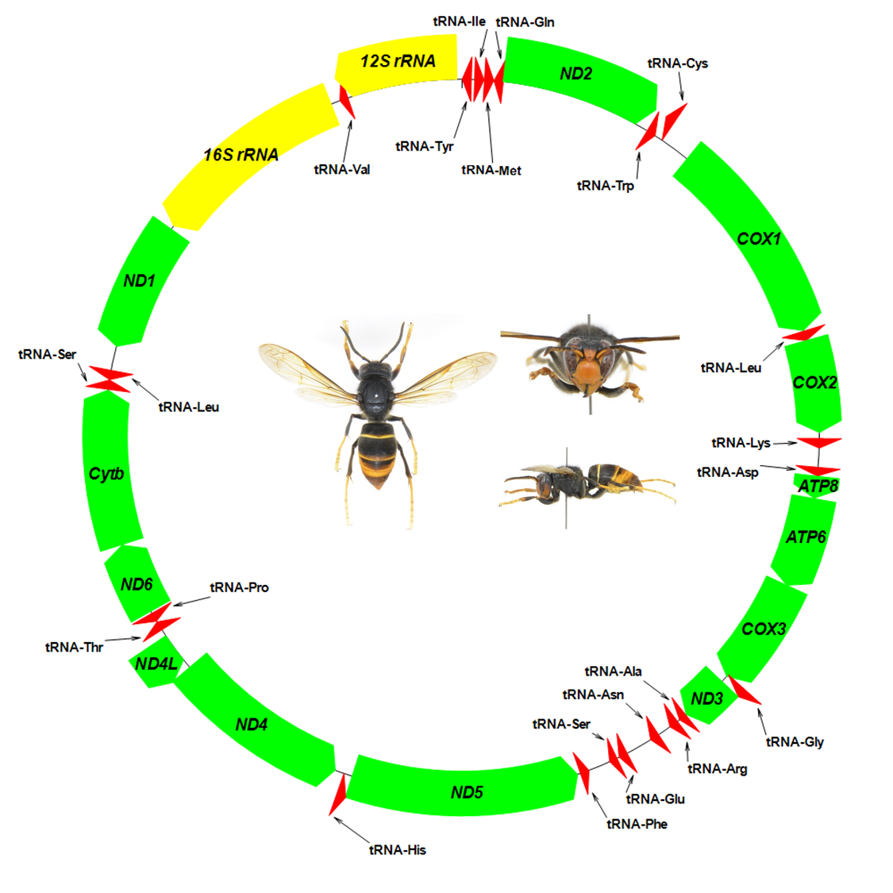

S1. Physical map of the mitochondrial genome of Vespa velutina from Jersey Island, UK. Genes noted on the outside of the main circle are encoded in the heavy (H) strand; genes noted on the inside of the circle are encoded in the light (L) strand. The 13 protein-coding genes are labelled in green, the 22 tRNA genes are labelled in red, and 16 SrRNA (Lr RNA) and 12S rRNA (Sr RNA) genes are labelled in yellow. (Colour figure online).

S2. Mitochondrial genome summery of Vespa velutina from Iki Island, Japan (AP018460) and Jersey Island, UK (AP018461).
Feature | Strand | Anticodon | Codon |  | Iki Island, Japan (AP018460) |  | Jersey Island, UK (AP018461) |  | Mutation sites (Indel) | Genetic distance
 |  |  | Start | Stop | Start - Stop | Size (bp) | Start - Stop | Size (bp)
tRNA-Tyr (Y) | L | GTA | - | - | 1 - 67 | 67 | 1 - 67 | 67
tRNA-Ile (I) | H | GAT | - | - | 92 - 160 | 69 | 92 - 160 | 69
tRNA-Met (M) | H | CAT | - | - | 164 - 231 | 68 | 164 - 231 | 68
tRNA-Gln (Q) | L | TTG | - | - | 234 - 301 | 68 | 234 - 301 | 68
ND2 | H | - | ATC | TAA | 301 - 1398 | 1098 | 301 - 1398 | 1098 | 0 | 0
tRNA-Trp (W) | H | TCA | - | - | 1422 - 1489 | 68 | 1422 - 1489 | 68
tRNA-Cys (C) | L | GCA | - | - | 1483 - 1551 | 69 | 1483 - 1551 | 69
COI | H | - | ATG | TAA | 1778 - 3316 | 1539 | 1778 - 3316 | 1539 | 4 | 0.0026
tRNA-Leu (L₂) | H | TAA | - | - | 3322 - 3392 | 71 | 3322 - 3392 | 71
COII | H | - | ATT | TAA | 3393 - 4073 | 681 | 3393 - 4073 | 681 | 3 | 0.0044
tRNA-Lys (K) | H | CTT | - | - | 4118 - 4187 | 70 | 4118 - 4187 | 70
tRNA-Asp (D) | H | GTC | - | - | 4329 - 4391 | 63 | 4321 - 4383 | 63
ATP8 | H | - | ATT | TAA | 4394 - 4555 | 162 | 4386 - 4547 | 162 | 0 | 0
ATP6 | H | - | ATG | TAA | 4559 - 5224 | 666 | 4551 - 5216 | 666 | 1 | 0.0015
COIII | H | - | ATG | TAA | 5225 - 6025 | 801 | 5217 - 6017 | 801 | 0 | 0
tRNA-Gly (G) | H | TCC | - | - | 6009 - 6075 | 67 | 6001 - 6067 | 67
ND3 | H | - | ATT | TAA | 6076 - 6432 | 357 | 6068 - 6424 | 357 | 0 | 0
tRNA-Ala (A) | H | TGC | - | - | 6437 - 6494 | 58 | 6429 - 6486 | 58
tRNA-Arg (R) | H | TCG | - | - | 6514 - 6581 | 68 | 6506 - 6573 | 68
tRNA-Asn (N) | H | GTT | - | - | 6683 - 6751 | 69 | 6675 - 6742 | 68
tRNA-Glu (E) | H | TTC | - | - | 6950 - 7014 | 65 | 6943 - 7007 | 65
tRNA-Ser (S1) | H | TCT | - | - | 7033 - 7091 | 59 | 7026 - 7084 | 59
tRNA-Phe (F) | L | GAA | - | - | 7256 - 7321 | 66 | 7249 - 7314 | 66
ND5 | L | - | ATT | TAA | 7344 - 9020 | 1677 | 7337 - 9013 | 1677 | 4 | 0.0024
tRNA-His (H) | L | GTG | - | - | 9018 - 9083 | 66 | 9011 - 9076 | 66
ND4 | L | - | ATG | TAA | 9152 - 10468 | 1317 | 9150 - 10466 | 1317 | 1 | 0.0008
ND4L | L | - | ATT | TAA | 10462 - 10758 | 297 | 10460 - 10756 | 297 | 0 | 0
tRNA-Thr (T) | H | TGT | - | - | 10810 - 10877 | 68 | 10808 - 10875 | 68
tRNA-Pro (P) | L | TGG | - | - | 10884 - 10950 | 67 | 10882 - 10948 | 67
ND6 | H | - | ATG | TAA | 10968 - 11522 | 555 | 10967 - 11521 | 555 | 0 | 0
Cytb | H | - | ATG | TAA | 11500 - 12642 | 1143 | 11499 - 12641 | 1143 | 4 | 0.0035
tRNA-Ser (S₂) | H | TGA | - | - | 12649 - 12717 | 69 | 12648 - 12716 | 69
tRNA-Leu (L₁) | L | TAG | - | - | 12720 - 12788 | 69 | 12719 - 12787 | 69
ND1 | L | - | ATA | TAA | 12969 - 13919 | 951 | 12968 - 13918 | 951 | 0 | 0
L-rRNA | L | - | - | - | 13949 - 15423 | 1475 | 13948 - 15418 | 1471 | 1 (4) | 0.0007
tRNA-Val (V) | L | TAC | - | - | 15493 - 15554 | 62 | 15488 - 15549 | 62
S-rRNA | L | - | - | - | 15513 - 16365 | 853 | 15508 - 16360 | 853 | 0 | 0

S3. Genetic distance (percent difference in nucleotide sequence) across all mitochondrial genes among 6 individuals of V. velutina ((a): Japan, South Korea and United Kingdom), and among 6 species of genus Vespa ((b): Vespa affinis, Vespa bicolor, Vespa ducalis, Vespa orientalis, Vespa mandarinia and Vespa velutina). Black dots and black squares indicate the average. The bars indicate maximum and minimum.

