Supplementary Materials: Scenarios for resilient drought and water scarcity management in England and Wales

Table S1. List of Participants
Name | Institution/Organisation
Gemma Coxon | University of Bristol / MaRIUS
Catharina Landstrom | University of Oxford / MaRIUS
Lola Rey | Cranfield University / MaRIUS
Mohammed Mortazavi-Naeini | University of Oxford / MaRIUS
Jianjun Yu | University of Oxford / MaRIUS
Kevin Grecksch | University of Oxford / MaRIUS
Ian Pemberton | Ofwat
Ben Piper | Atkins
Meyrick Gough | Southern Water
Neil Edwards | RWE Generation UK
Bill Baker | NERA
Sarah Heinemann | DEFRA
Victoria Williams | Environment Agency
Paul Crockett | Environment Agency

Table S2. Drivers and influencing factors
Policy | Policy choice: Design event definition
 | Flood and drought policy
 | Flood and drought policy not seen as the same cycle (no wholistic thinking)
 | Cost of failure
 | Changes in water regulation and use
 | Abstraction licencing system
 | New/changing environmental legislation (e.g. WFD)
 | Policy beyond water (incl. land use)
Weather / Climate | Extreme weather events
 | Extreme droughts
 | Rainfall Patterns
 | Climate change and weather variability
 | Climate change
 | Knowledge of water resources status (incl. climate change)
 | Climate change - influence on water availability
 | Population and climate change (less rainfall, more hot days)
 | Weather manipulation
 | Changes in water quality
Economic Development | Industry development
 | Have we cracked electricity storage?
 | Size and shape of economy
 | Changes to the economic impact of drought (resilience)
 | Intergenerational funding (who pays for tomorrow)
 | Abstraction increases (private and agriculture)
 | Technology
 | Can we share resources (institutions, markets, co-operation)
 | Willingness to share (geographical)
 | Power generation mix (dependency on water)
 | Population and demography
 | Population growth
 | Demand for water abstraction (public water supply)
 | Progress in Electrification (Demand)
 | Intensive farming
 | Private abstraction demands (power, agriculture, fracking)
 | Agricultural demand increase (less water resources, groundwater deterioration)
Behaviour | Society’s expectations
 | Level of environmental protection by society
 | Water use culture
 | Consumption per person change
 | Water use behaviour and value
 | Customer inertia to change (”water is free” & “it rains all the time”)
 | Billing and volumetric (S.E.P.)
 | Increasing customer demands (technology, urbanisation)
 | Eating habits
Environmental Needs | Unsustainable environment
 | Land use change (ecological)
 | Demand for environmental quality by 2065
 | Changing needs of the environment for other water users
 | Land uses changes (urbanisation)
 | Capability of species for adaptation
 | Competition (food chain, hunting, etc.)
Intervention | Cost of capital for infrastructure
 | Innovation and technology
 | Adaptive Planning
 | Characteristic of design events
 | Definition of “Sustainable“ Level of Leakage
 | Technology – forecasting
 | Infrastructure development
 | Probably not what we can think of in the present, i.e. the unknown

Table S3. List of drivers and their importance as assessed by the participants
Driver | Point based assessment
Society’s expectations / Water use culture | 9
Extreme weather events (droughts) | 8
Flood and drought policy | 6
Willingness to share water | 5
Cost of failure | 5
Policy choice: design event definition | 4
Unsustainable environment | 3
Billing and volumetric | 2
Demand for environmental quality | 2
Abstraction increases | 1
Intergenerational funding | 1
Innovation and technology | 1
Knowledge of water resources status | 1
Electricity storage | 0
Customer inertia to change | 0
Water use behaviour | 0
Economic impact of drought | 0
Rainfall patterns | 0
Size and shape of economy | 0
Changing needs of the environment | 0
Land use change (ecological) | 0
Cost of capital for infrastructure | 0
Industry development | 0
Funding for infrastructure | 0
Climate change and water | 0

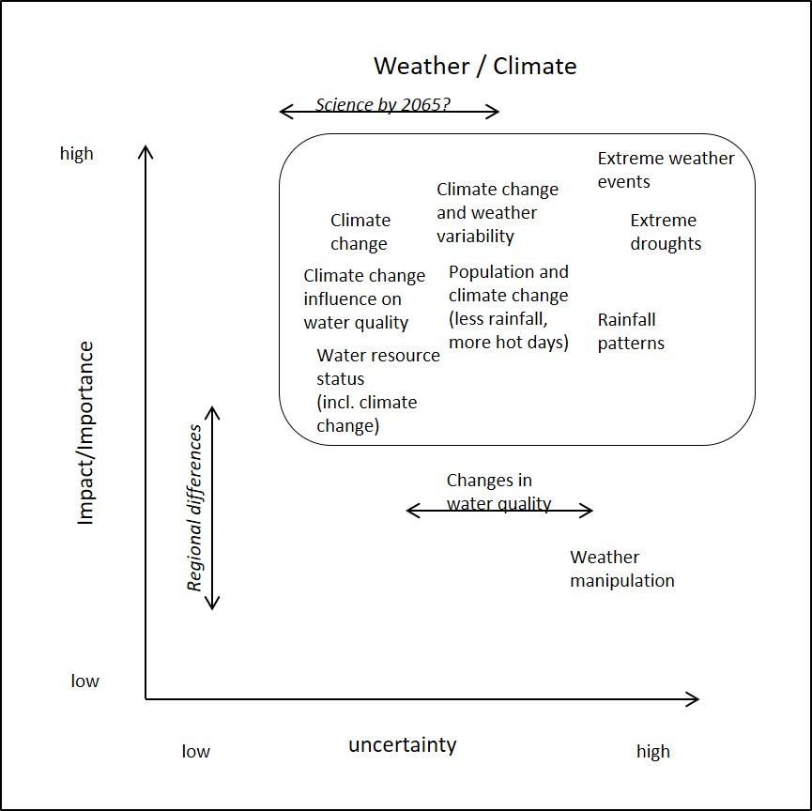
Figure S1. Matrix of influencing factors “Weather/Climate”
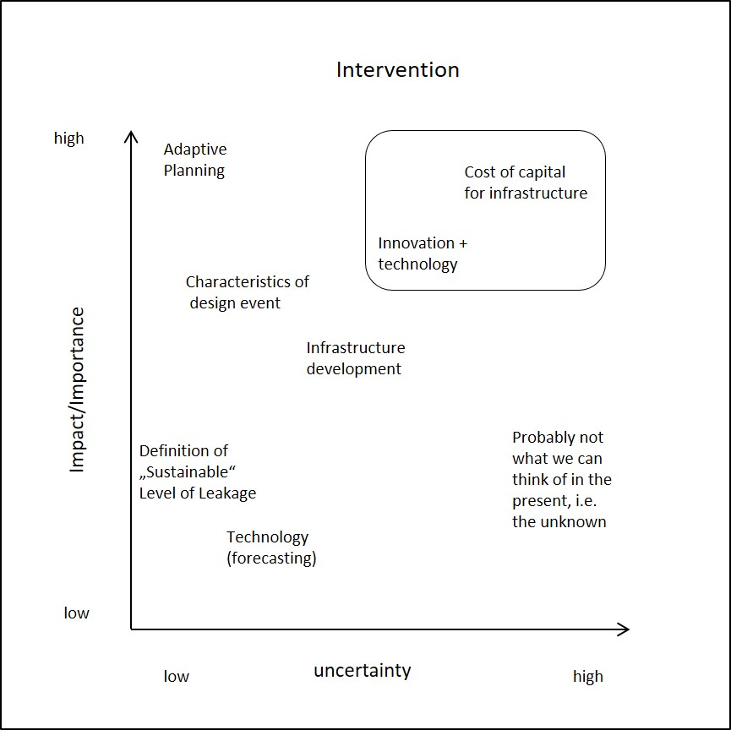
Figure S2. Matrix of influencing factors “Intervention”

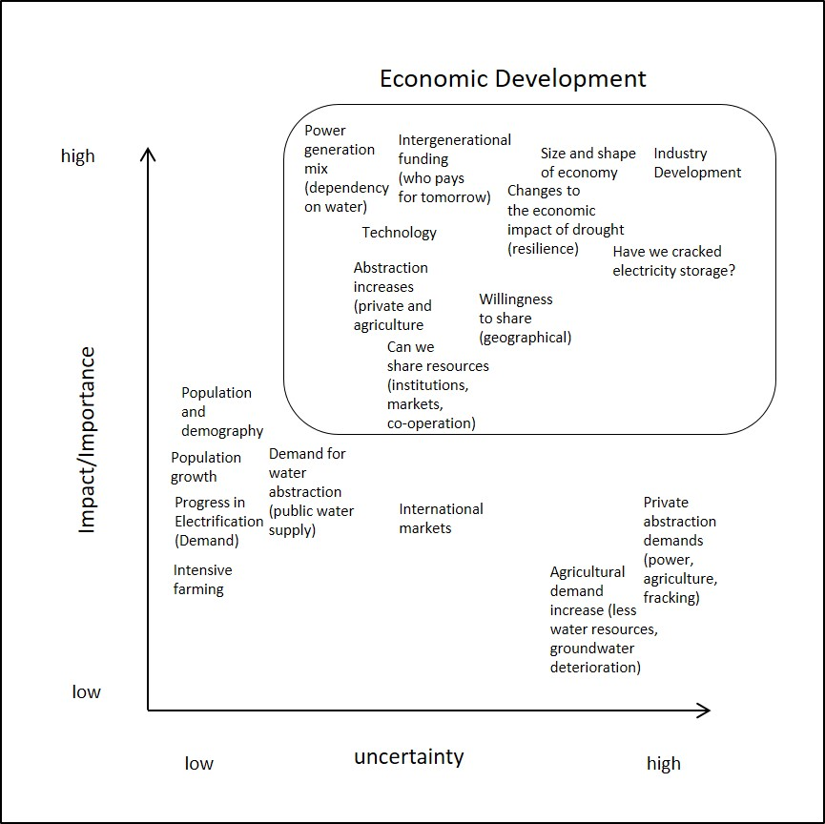
Figure S3. Matrix of influencing factors “Economic Development”

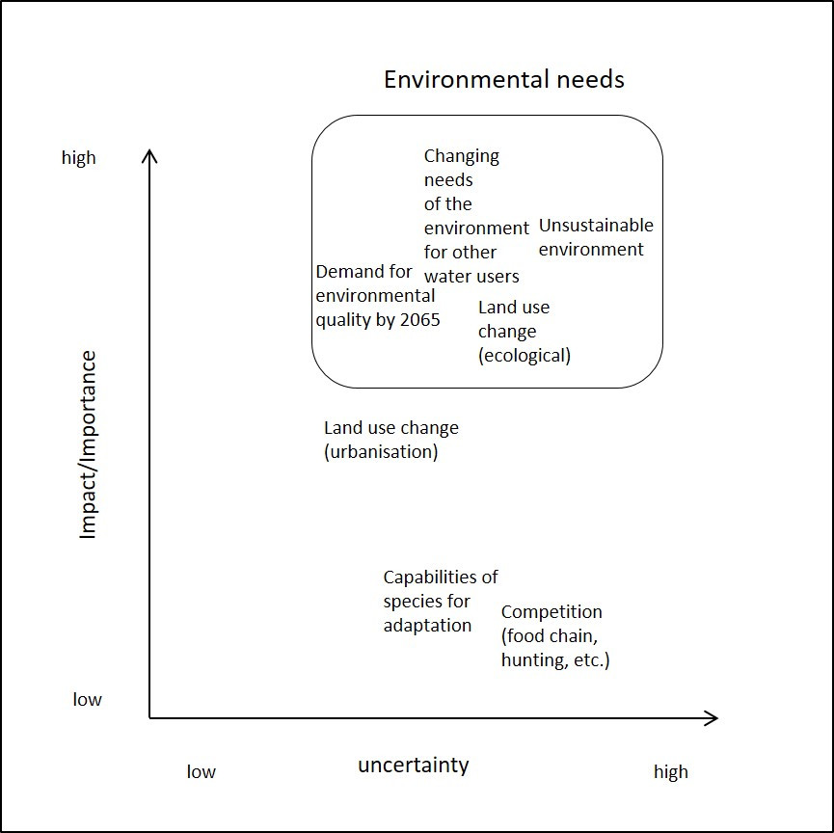
Figure S4. Matrix of influencing factors “Environmental needs”

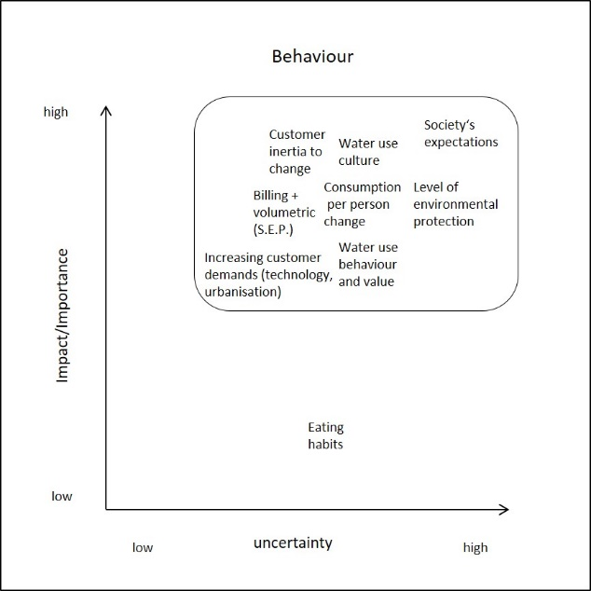
Figure S5. Matrix of influencing factors “Behaviour”

Supplementary material scenario description - Developments with regard to drivers and tendencies
The following contains description of each critical driver (Table 4) and how it develops under each scenario.

Scenario 1: “Accepting Decline”
Flood and Drought Policy: Floods and droughts have hit England and Wales frequently over the last decades. Yet, flood and drought policy are treated as separate entities. Flood policy is based on dredging rivers to alleviate those affected quicker. Drought policy relies on emergency measures such as standpipes and rota cuts.

Willingness to Share Water: The willingness to share water has strongly decreased. Water companies struggle to meet demand within their water resources zones and hence only reluctantly share water. Adding to that are customer expectations to be supplied with the water they pay for, high leakage and a deteriorated infrastructure.

Cost of failure: The frequency of extreme events has increased. Given the public’s lack of interest in water related issues public spending for further new and innovative flood defences and drought prevention measures could not be justified. However due to the increased frequency of extreme events the costs for the current flood and drought policies increase to uphold and restore the existing housing stock and infrastructure.

Policy choice: design event definition: The drought event that is being planned for and its probability of actually happening have not changed much over the decades. It follows traditional standards to determine the probability of extreme events using statistical analysis based on historical observations and regardless of coping with potential climatic changes. The policy choice made is to save vital infrastructure and secure drinking water supply even if it means tankering by lorries or stand pipes.

Unsustainable environment: The general state of the environment has deteriorated. Environmental issues are low on the policy agenda and due to a lack of public interest in environmental issues. Policies focus on engineering based solutions following an extreme event neglecting environmental issues for the benefit of creating jobs.

Billing and volumetric: Metering has not made many advances over the decades and millions of households are still unmetered. Public awareness of the benefits of metering is low and unmetered households emphasise and defend their right to water without being metered.

Demand for environmental quality: The demand for environmental quality has strongly decreased. People accept an unsustainable environment and the deterioration of ecosystem services over the creation of jobs after frequent extreme events. The awareness of the interconnectedness of environmental issues, the water-energy-food-nexus, is almost non-existent. People expect public water supply at all (environmental) costs. The use of household water filters has strongly increased due to the low drinking water quality.

Scenario 2: “Rising to the challenge”
Flood and Drought Policy: Flood and drought policy are integrated and subject to long term planning, monitoring and frequent review. Floodplains have been restored where possible and allow to hold back water for water scarce times. This also reduces the impacts of extreme weather events. Drought policy is characterised by a mixture of supply and demand measures and puts emphasis on the value of water and on measures for specific abstractor groups such as farmers or large industrial water consumers.

Willingness to Share Water: The willingness to share water is very high. The government, the public and water companies acknowledge the need to share water across water resources zones in order to alleviate areas affected by drought. Sharing water is seen as a key drought management option.

Cost of failure: Although the frequency of extreme events increases, the costs of failure decrease. The society is well prepared for extreme weather events and major disruptions of for example productions processes are kept to a minimum. Water saving devices are widespread as are grey water reuse schemes. People are willing to proactively save water thereby helping to keep the costs of extreme weather events down.

Policy choice: design event definition: Each extreme weather event triggers a review of current drought policies. Hence, the probability and the consequences of the drought event that is planned for is always state of the art and anticipating the latest research on droughts. Therefore, by recognising the increased frequency of extreme weather events and its implications, an alliance of government, science and water companies ensures the highest standards in the design event definition that also tackle uncertainties.

Unsustainable environment: England and Wales have turned into a sustainable and green society. People cherish nature and value natural resources. Being water aware, i.e. knowing about the linkages between water, energy and food, using water saving devices and integrating environmental protection and nature-based solutions into other policies, is an essential part of school and university curricula. People anticipated the link of proactively preventing drought and being prepared for the next extreme weather event.

Billing and volumetric: Every household and every business customer is metered in England and Wales. The water consumption behaviour of households is investigated for better pricing strategies and water use efficiency. This allows water companies to better plan their supply and demand balance and customers have a much better overview over the costs of water and how much water they use. This also enables them to appreciate water far better.

Demand for environmental quality: The demand for environmental quality has strongly increased. Society is willing to save water to ensure its quality. Greywater reuse schemes and water saving devices are actively promoted and accepted by customers and help protecting the environment.

Scenario 3: “Enjoying their luck”
Flood and Drought Policy: There is recognition that flood and drought policy should be integrated. People are aware of the link between the two policies and demand a better integration of both. As the number of extreme weather events has decreased plans for large infrastructure projects such as flood alleviation schemes were dropped. Drought management has been reduced to a core set of necessary measures (permits, orders), which are only used in very rare events.

Willingness to Share Water: The willingness to share water has strongly increased though the actual need for water transfers is low. However, the government, the public and water companies acknowledge the need to share water across water resources zones in order to alleviate areas affected by the rare drought events.

Cost of failure: As England and Wales do not suffer from a lot of extreme weather events, the cost of failure has been reduced to almost zero. Society demanded better protection from extreme weather events such as droughts and due to the low frequency of extreme weather events the government was willing to spend it on proactive and preventative measures thereby reducing the cost of failure.

Policy choice: design event definition: As the occasional extreme weather event still hits England and Wales, the design event definition has been upgraded to meet these events and to mitigate the consequences. One of the consequences is that the investment for water infrastructure is increased. However, because there are only occasional extreme weather events such a design only makes a marginal contribution.

Unsustainable environment: England and Wales have kept a good level of sustainability and environmental protection over the decades, yet as extreme weather events have decreased, popular demand for further environmental protection and higher sustainability standards have also decreased. However, people are actively engaged in environmental protection and water saving.

Billing and volumetric: The number of metered households has remained relatively constant and water saving, the decreased number of extreme weather events and a good level of environmental protection, led water companies to the decision to not actively push for increased metering. Customers can demand it though.

Demand for environmental quality: The demand for environmental quality has increased. People are expecting a good water quality and are doing their fair share to save water from overabstraction. Water saving devices are widely used although water companies have actively promoted them.

Scenario 4: “Passive Acceptance”
Flood and Drought Policy: Floods and droughts have hit England and Wales less frequently over the last decades. Yet, flood and drought policy are treated as separate entities. Flood policy is based on dredging rivers and rebuilding destroyed infrastructure. However, both measures need to be within the current government’s budget. Drought policy relies on temporary use bans, drought orders and permits, though the latter ones are hardly applied.

Willingness to Share Water: The willingness to share water is low. Although water companies meet demands within their water resources zones they only reluctantly share water. Customers expect to be delivered with the water they pay for which water companies interpret as a duty to keep water within a water resource zone.

Cost of failure: Extreme weather events have decreased but as society’s expectations towards water are low, the costs of failure have remained at a steady level. People do not expect government to spend more on effective drought management but simply to alleviate the worst effects of a drought.

Policy choice: design event definition: The design event definition has not been updated or changed over the decades because there was no necessity to do so since the number of extreme weather events went down. However, this means that society suffers from high costs of failure after occasional extreme weather events. Also, there is no expectation from society to do so, as allocating more funds into the prevention of extreme weather events is hardly justifiable.

Unsustainable environment: The general state of the environment has slightly deteriorated. Environmental issues are low on the political agenda and due to a lack of public interest in environmental issues. The low frequency of extreme weather events has decreased demands in sustainable living and national or regional sustainability strategies.

Billing and volumetric: The number of metred households has not changed much over the decades. For an industrialised country numbers are very low. Water companies do not actively encourage customers to switch over to meters.

Demand for environmental quality: The demand for environmental quality has strongly decreased. The low number of extreme weather events has decreased the awareness of the interconnectedness of environmental issues. Water supply is usually met but any further efforts to save water are low. Water companies have stopped funding water education programmes as the public response has slowed down.

The drivers in the grey shaded areas are the drivers from the top right quadrant.
The list is reduced to 25 drivers because some drivers were seen as representing and meaning the same as another driver and were subsequently discarded.

