Supplementary Material

Supplementary Figure 1
(a)
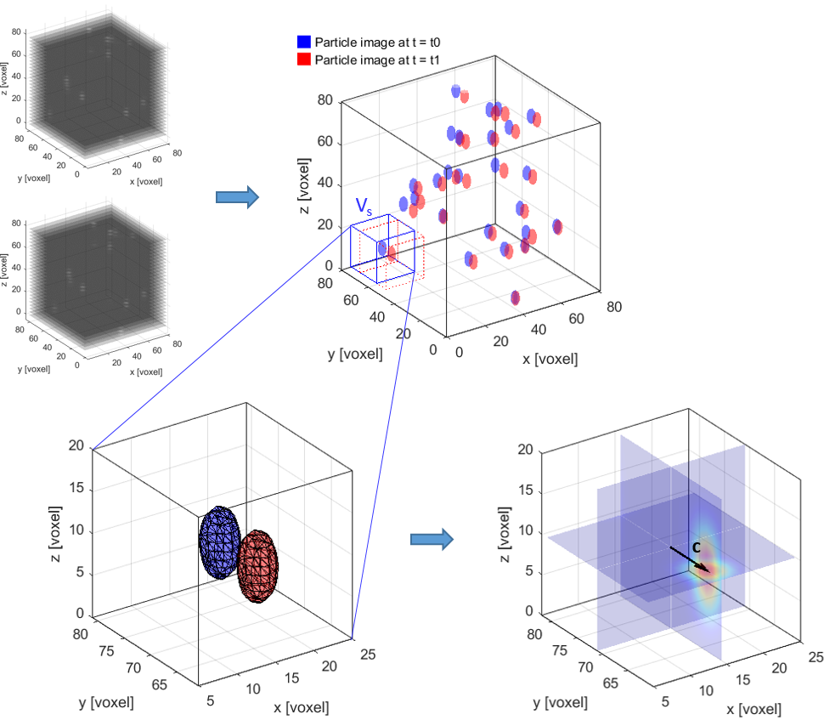
(d)
(c)
(b)
Supplementary Figure 0.1 - Principle of digital volume correlation (DVC): A pair of particle image stacks (a) is processed as 3D intensity distributions (b). The motion of an image subvolume Vs from the time point t0 (blue) to time point t1 (red) can be derived from calculating the cross-correlation of the two corresponding intensity distributions (c). The maximum of the resulting cross-correlation (d) is then used to determine the displacement vector c for the subvolume Vs.

Supplementary Figure 2
(b) PDVC
- GDVC
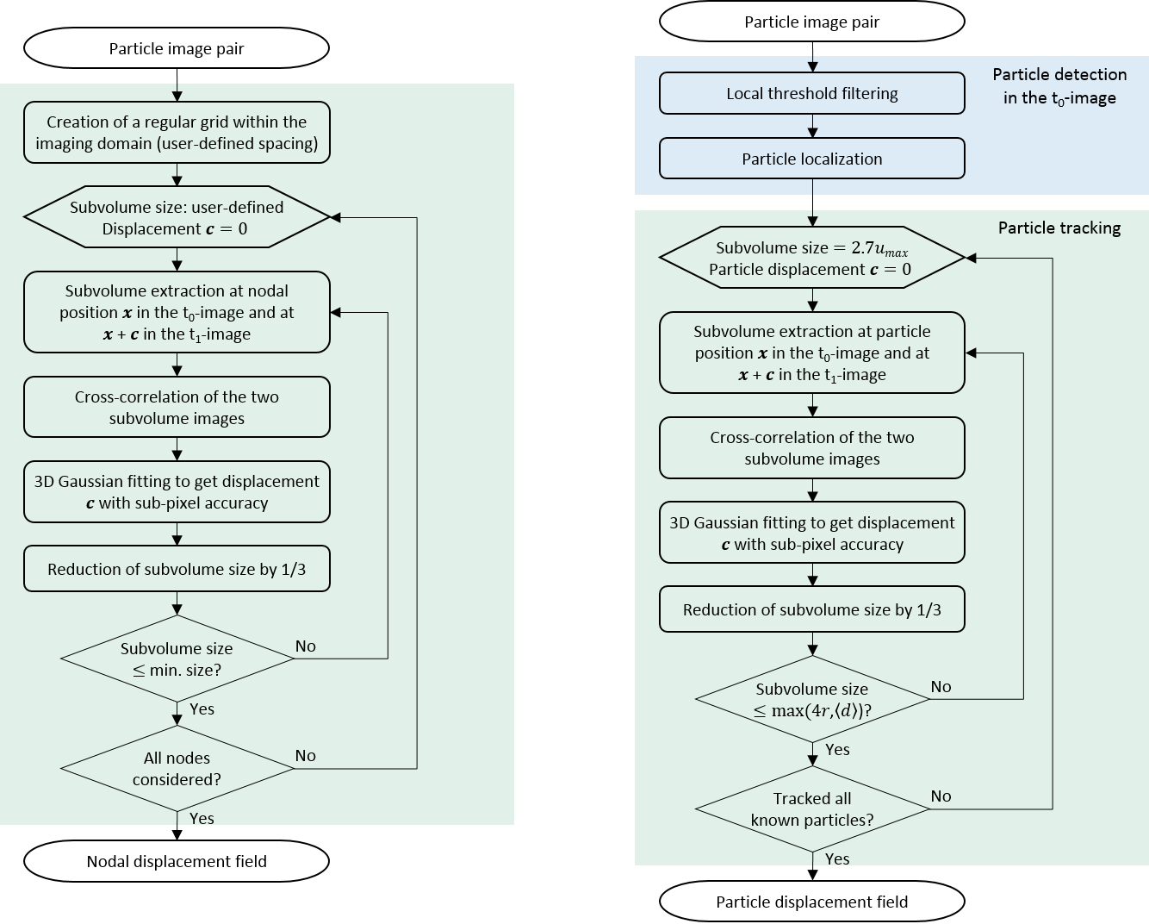
Supplementary Figure 0.2- Flowcharts illustrating the implemented principles of displacement field calculation: (a) Grid-based Digital Volume Correlation (GDVC), (b) Particle-based Digital Volume Correlation (PDVC)

Supplementary Figure 3
(b)
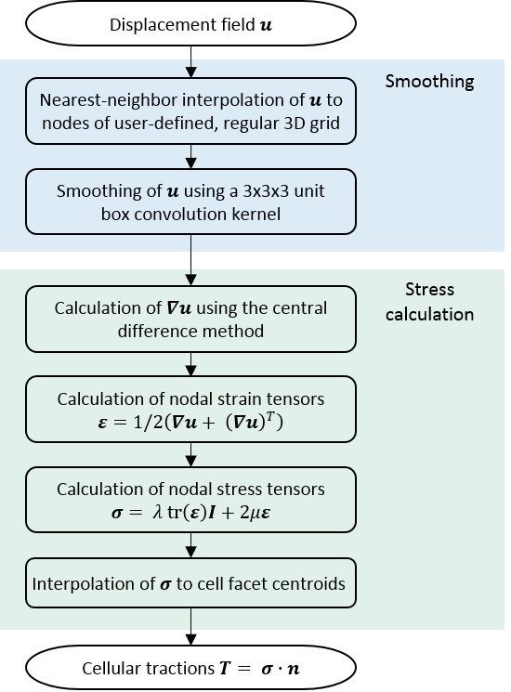
(a)
Supplementary Figure 0.3 - Flowcharts illustrating the (a) direct differentiation method for traction stress reconstruction (FDM).

Supplementary Figure 4
(b)
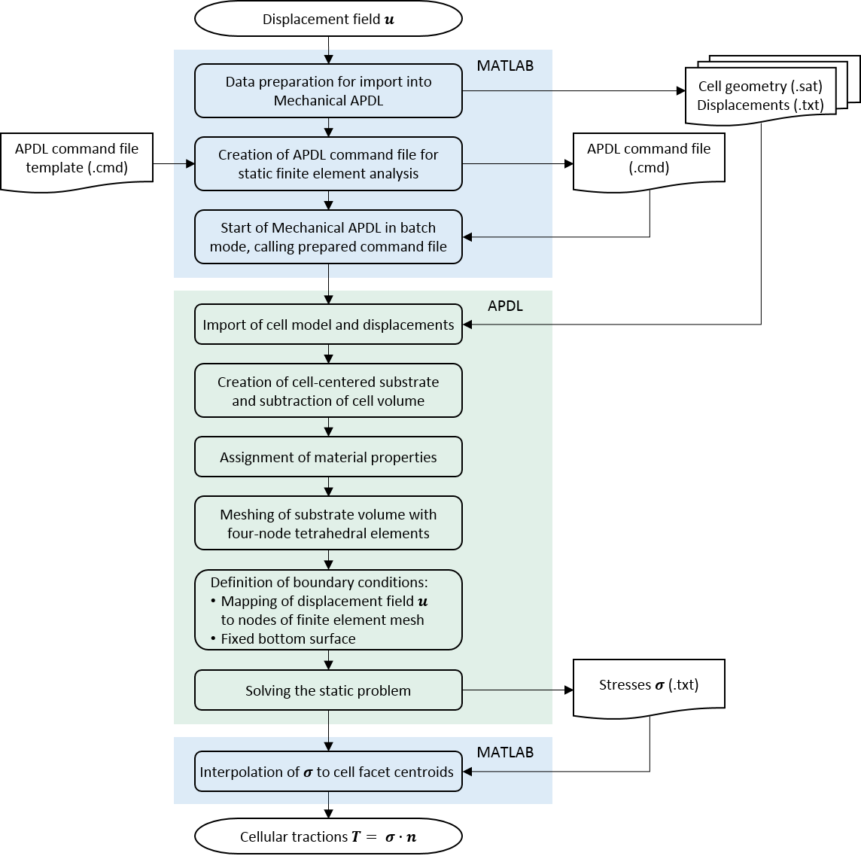
(a)
Supplementary Figure 4 - Flowcharts illustrating the FEA method for traction stress reconstruction (FEA).

Supplementary Figure 5
Supplementary Figure 5 – Comparison of our grid-based digital volume correlation (GDVC) algorithm to the fast iterative digital volume correlation (FIDVC) algorithm (Bar-Kochba et al. 2015), for both displacement performance (left) and traction (right). Our proposed GDVC algorithm performs better than FIDVC concerning error, but with an increased computational cost.

Supplementary Figure 6
Supplementary Figure 6 – Relative performance in traction reconstruction for both digital volume correlation algorithms shown in Supplementary Figure 5. Similarly, our grid-based digital volume correlation (GDVC) algorithm outperforms the fast iterative digital volume correlation (FIDVC), for both traction reconstruction methods described in the main text. For higher bead densities, the discrepancy between the two methods is smaller but a considerable gap remains. Again, the finite difference method (FDM) yields less error than the finite element method (FEA), for both displacement methods concerned.

Supplementary Code
The Matlab and Ansys Code used in this paper is available on GitHub: https://github.com/clhole/TFM3D

Supplementary Datasets
The Dataset used in this paper is available online: https://doi.org/10.3929/ethz-b-000289734.

