Additional file 1: Hemoglobin levels and total leucocyte count across the species at presentation

 | P. falciparum  (n=29)  n (%) | P. vivax  (n=98)  n (%) | Mixed  (n=5)  n (%)
MALES
>13 gm/dL | 22(75.9) | 56(57.1) | 3(60)
10.1-13 gm/dL | 6(20.7) | 36(36.7) | 2(40)
7.1-10 gm/dL | 1(3.4) | 6(6.1) | 0
<7 gm/dL | 0 | 0 | 0
 | P. falciparum  (n=8)  n (%) | P. vivax  (n=18)  n (%) | Mixed  (n=1)  n (%)
FEMALES
>12 gm/dL | 5(62.5) | 5(27.8) | 1(100)
10.1-12 gm/dL | 2(25) | 11(61.1) | 0
7.1-10 gm/dL | 1(12.5) | 2(11.1) | 0
<7 gm/dL | 0 | 0 | 0
 | P. falciparum  (n=37)  n (%) | P. vivax  (n=116)  n (%) | Mixed  (n=6)  n (%)
Leucopenia n(%) <4000 cells/mm³ | 9(24.3) | 26(22.4) | 1(16.7)
Normal n(%) 4000-11000 cells/mm³ | 28(75.7) | 89(76.7) | 4(66.6)
Leucocytosis n(%) >11000 cells/mm³ | 0 | 1(0.8) | 1(16.7)

Additional file 2a. Scatter plot depicting the platelet count vs duration of fever in Plasmodium falciparum patients

Additional file 2b. Scatter plot depicting the platelet count vs duration of fever in Plasmodium vivax patients

Additional file 3: Correlation of platelet count and platelet indices

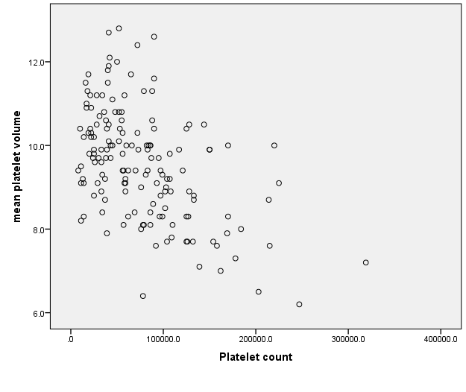
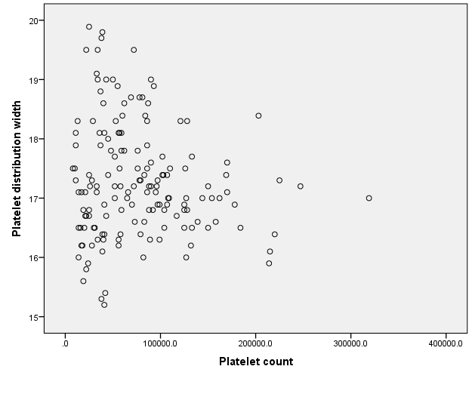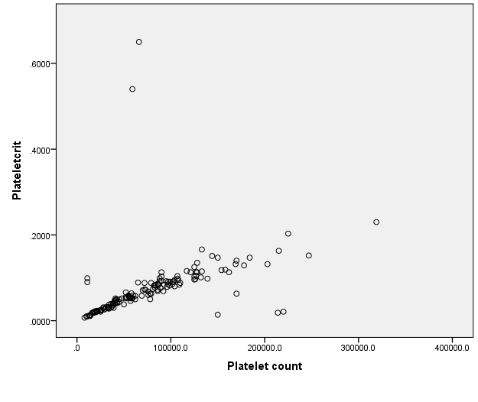

Additional file 4: Platelet parameters with respect to spontaneous bleeding
Abnormal bleeding | PLT cells/mm³ | PCT (%) | MPV(fl) | PDW (%)
Subdural hematoma (n=1) | 13000 | 0.012 | 9.2 | 18.3
Haemoptysis (n=1) | 11000 | 0.01 | 9.5 | 17.3
Bleeding PR (n=1) | 37000 | 0.032 | 8.7 | 18.8
Hematuria (n=2) | 33000 | 0.03 | 9.1 | 18.1
With bleeding ( mean)
 | 29000 | 0.02 | 9.1 | 18.1
No evidence of bleeding | 69500 | 0.06 | 9.6 | 17.2

