Online Appendix for
“Mandates Matter: Perceived Victory Magnitude and Expectations of Government Performance”

This Online Appendix accompanying the paper “Mandates Matter: Perceived Victory Magnitude and Expectations of Government Performance” contains supplementary information and estimation results aimed at complementing the analyses presented in the manuscript.
Section A1 provides additional details about the definition and coding of the dependent and independent variables included in our empirical analysis, along with summary statistics and illustrations of our experimental conditions (treatments and control).
Section A2 discusses the manipulation checks conducted through the CrowdFlower crowdsourcing platform in order to assess the – informational content, tone, effectiveness – of our treatments.
Section A3 reports additional estimation results.

A1. Definition and coding of the dependent and independent variables, summary statistics, and additional details about the experimental conditions
The dependent and all the independent variables (treatment-effect moderators and controls) included in our empirical analysis were obtained from the background questionnaire administered to all the participants in our experiment.

Dependent variable:
Confidence in the Conservative government’s ability to fulfil its campaign promises. Based on responses to the question: “To what extent do you agree/disagree that the Conservative government will be able to fulfil all of its campaign promises?” Coded on a 5-point ascending scale, ranging from 1=“Strongly Disagree” to 5=“Strongly Agree”.

Moderators of treatment effects:
Conservative identifier. Based on responses to the questions: “Do you generally think of yourself as closer to one of the parties than to the others?”, and “Which party is that?” Coded as 1 if participants reported that they felt close to the Conservative Party, 0 otherwise.

Labour identifier. Based on responses to the questions: “Do you generally think of yourself as closer to one of the parties than to the others?”, and “Which party is that?” Coded as 1 if participants reported that they felt close to the Labour Party, 0 otherwise.

Independents. Based on responses to the question: “Do you generally think of yourself as closer to one of the parties to than the others?” Coded as 1 if participants reported that they did not feel close to any party.

Electoral winner. Coded as 1 for subjects who voted for the Conservative Party in the 2015 UK general election, and 0 otherwise.

Electoral loser. Coded as 1 for subjects who voted for any party other than the Tories in the 2015 UK general election, and 0 otherwise.

Trust in Newspapers. Based on responses to the question: “How much do you trust that newspapers cover political affairs accurately and fairly?” Responses coded on a 4 point scale, with values: 1 = “Not at all”; 2 = “Not much”; 3 = “Some trust”; and 4 = “A lot”.

Trust in the Media. Obtained by averaging responses to questions asking subjects about their degree of trust in the accuracy and fairness of the coverage of political affairs by newspapers (see previous question), TV and radio. Responses to each of these questions are coded on a 4 point scale, with values: 1 = “Not at all”; 2 = “Not much”; 3 = “Some trust”; and 4 = “A lot”.

Regular reader of The Guardian. Based on responses to the questions: “Do you read a newspaper regularly?”, and “Which newspaper do you regularly read?” Coded as 1 for subjects who stated that they regularly read The Guardian, and 0 otherwise.

Regular reader of The Telegraph. Based on responses to the questions: “Do you read a newspaper regularly?”, and “Which newspaper do you regularly read?” Coded as 1 for subjects who stated that they regularly read The Telegraph, and 0 otherwise.

Political interest. Based on responses to the question “How interested are you in politics?” Coded on a 5-point scale, ranging from 1=“Not Interested at All” to 5=“Very Interested”. For the analysis in Figure 4 of the paper (see also Table A11), this variable was dichotomised, distinguishing between “interested” and “very interested” subjects, and the rest. For robustness, we repeated the analysis using the variable coded on the “original” 5-point scale. The main substantive findings reported in Figure 4 of the paper and in Section A3 of this Online Appendix remain unchanged.

News consumption. Based on responses to the question(s): “How often (if at all) do you follow political news on TV/Radio/Newspapers (including online)?” Responses coded on a 9 point scale, with values: 1 = “Do not follow political news”; 2 = “Less than once a week”; 3 = “Once a week”; 4 = “Two days a week”; 5 = “Three days a week”; 6 = “Four days a week”; 7 = “Five days a week”; 8 = “Six days a week”; 9=“Every Day of the Week”. For the analysis in Figure 4 of the paper (see also Table A11), this variable was dichotomised, distinguishing between subjects who followed political news at least three days a week and the rest. For robustness, we repeated the analysis using alternative operationalisations for this variable (e.g., distinguishing between subjects who followed the news at least 4/5/6/7 days a week and the rest). The main substantive findings reported in Figure 4 of the paper and in Section A3 of this Online Appendix are not sensitive to the particular coding of News consumption.

Education. Indicators for subjects with “A-levels (or similar)”, “Vocational or technical qualifications”, and “University (including post-graduate)”. The baseline category is “GCSE or lower”. For the analysis in Figure 4 of the paper (see also Table A11), this variable was dichotomised, distinguishing between “A-levels and below” for “low sophisticates” and “Higher than A-levels” for “high sophisticates”. For robustness, we replicated the analysis classifying only respondents with university education as “high sophisticates”, and also estimated the moderating effect of the “original” Education variable (with 4 categories). The main substantive conclusions remain unchanged.
Additional control variables:
Age, measured in years.

Voted in 2015. 1 if the subject turned out to vote in the 2015 UK election, 0 otherwise.

Dummies for Female and Married participants, for subjects who identified their ethnicity as Non-white, and for members of a trade Union.

Other variables:
In addition to the moderators of treatment effects and the controls included in the model specifications presented in Section A3 below and discussed in the “Empirical Analysis” section of the paper, other variables were used to test for covariate imbalances and to compute other quantities of interest (reported, for instance, in the concluding section of the manuscript). These additional covariates are:

Income: Indicators for respondents whose household income falls in the following categories: “Under £10,000”, “£10,000 - £19,000”, “£20,000-£39,000”, “£40,000-£59,000”. Reference category: “£60,000 and above”.

Newspaper Readership: Dummies for participants who reported being frequent readers of The Guardian, The Daily Mirror, The Telegraph, The Daily Mail, or The Sun. These are among the most widely circulated British newspapers (ABC 2015) and have very marked ideological biases – with The Guardian and The Mirror seen as Britain’s most left-wing newspapers, and The Telegraph, The Sun and The Mail located at the other extreme of the ideological spectrum (Smith 2017). Cowley and Kavanagh (2016, 332) argue that this specific group of newspapers actively attempted to frame the events around the 2015 election in ways that reinforced the interpretation of their favoured parties (Labour, in the case of The Guardian and The Mirror, and the Conservatives, in the case of the other three newspapers).

Table A1. Distribution of subjects by experimental condition
Experimental Condition | Number of Subjects
Narrow victory with The Guardian as source | 436
Decisive victory with The Telegraph as source | 443
Narrow victory with no source | 234
Decisive victory with no source | 236
Control | 481
Total | 1,830
Notes: The table displays the distribution of participants across experimental conditions. Variations in the number of subjects across conditions are due to the design of a more general project on the role of the media in the 2015 election, not to systematic differences in response rates between groups. As is well known, the power of a factorial experiment depends on the overall sample size, not on the number of subjects in each condition (Collins et al. 2014). In fact, unequal randomization may actually be beneficial from an inferential standpoint (Dumville et al. 2006). Summary statistics presented in Table A2 below show no systematic covariate imbalances across experimental – treatment and control – groups.

Table A2. Summary statistics for baseline covariates across experimental conditions
 | (1) | (2) | (3) | (4) | (5) | (6)
 | “Narrow victory with The Guardian as source” | “Decisive victory with The Telegraph as source” | “Narrow victory with no source” | “Decisive victory with no source” | Control | p-value (comparisons across the five conditions)
Ageª
18-29 | 4.41 (20.61) | 5.48 (22.84) | 4.94 (21.80) | 3.66 (18.89) | 6.88 (25.38) | 0.58
30-44 | 19.12 (39.47) | 21.23 (41.04) | 17.28 (38.05) | 29.27 (45.78) | 21.25 (41.04) | 0.54
45-59 | 34.56 (47.73) | 30.82 (46.33) | 37.04 (48.59) | 25.61 (43.92) | 41.25 (49.38) | 0.20
Femaleª | 47.79 (50.14) | 50.00 (50.17) | 53.09 (50.22) | 46.34 (50.17) | 46.88 (50.06) | 0.88
Educationª
GCSE or below | 25.93 (43.99) | 30.14 (46.04) | 29.63 (45.95) | 29.27 (45.78) | 28.30 (45.19) | 0.58
A-level or similar | 17.04 (37.74) | 11.64 (32.19) | 11.11 (31.62) | 12.20 (32.92) | 11.95 (32.54) | 0.47
University or professional qualification | 47.41 (50.12) | 45.21 (49.94) | 45.68 (50.12) | 47.56 (50.25) | 50.94 (50.15) | 0.17
Incomeª
Under £10,000 | 5.79 (23.44) | 8.76 (28.37) | 8.00 (27.31) | 8.97 (28.77) | 9.68 (29.66) | 0.22
£10,000 - £19,000 | 21.49 (41.24) | 29.93 (45.96) | 26.67 (44.52) | 28.21 (45.29) | 18.71 (39.13) | 0.67
£20,000-£39,000 | 50.41 (50.21) | 40.15 (49.20 | 40.00 (49.32) | 43.59 (49.91) | 41.29 (49.40) | 0.49
£40,000 - £59,000 | 14.05 (34.89) | 13.14 (33.91) | 18.67 (39.23) | 11.54 (32.16) | 21.94 (41.52) | 0.36
Marriedª | 70.59 (45.73) | 73.97 (44.03) | 80.25 (40.06) | 69.51 (46.32) | 75.00 (43.44) | 0.50
Unionª members | 16.30 (37.07) | 19.86 (40.03) | 18.75 (39.28) | 13.58 (34.47) | 16.88 (37.57) | 0.79
News consumption^{b} | 5.60 (2.79) | 5.37 (2.85) | 5.43 (3.07) | 5.31 (3.03) | 5.87 (2.93) | 0.53
Voted in 2015ª | 86.03 (34.80) | 87.67 (32.99) | 92.59 (26.35) | 87.65 (33.10) | 90.00 (30.09) | 0.62
Vote choiceª
Conservative | 39.02 (48.98) | 40.58 (49.28) | 33.77 (47.60) | 31.51 (46.78) | 30.52 (46.20) | 0.34
Labour | 24.39 (43.12) | 27.54 (44.83) | 29.87 (46.07) | 34.25 (47.78) | 28.57 (45.32) | 0.68
Lib. Dem. | 9.76 (29.79) | 6.52 (24.78) | 3.90 (19.48) | 10.96 (31.45) | 9.74 (29.75) | 0.41
UKIP voters | 10.57 (30.87) | 12.32 (32.99) | 18.18 (38.82) | 12.33 (33.10) | 16.88 (37.58) | 0.42
Notes: Columns (1)-(5) report sample means and standard deviations (in parenthesis) for selected covariates under each experimental condition. Column (6) displays the p-values for chi-squared tests of independence between the five experimental (treatments and control) conditions. Some scholars (e.g. Ho et al. 2007; Imai, King, and Stuart 2008) argue that the p-values cannot be strictly interpreted as true probabilities used to decide whether or not differences across experimental conditions are “statistically significant”. Nonetheless, these p-values still provide valuable information to help detect problems of implementation and to identify potentially relevant differences in the covariate distribution between treatment and control groups (Sekhon 2007; Hansen and Bowers 2008). In this sense, it is reassuring to see that the tests do not point to systematic differences in the average background characteristics of individuals assigned to the treatment and control groups. Fitting multinomial logit models for treatment assignment (Gerber, Karlan, and Bergan 2009) yields a p-value of 0.79 for the joint significance of the covariates.
ª As percentage of subjects assigned to each experimental condition.
^{b} Average weekly frequency (in days) within each experimental condition.

Figure A1. News article used in the “Narrow victory with Figure A2. News article used in the “Decisive victory
The Guardian as source” treatment condition with The Telegraph as source” treatment condition
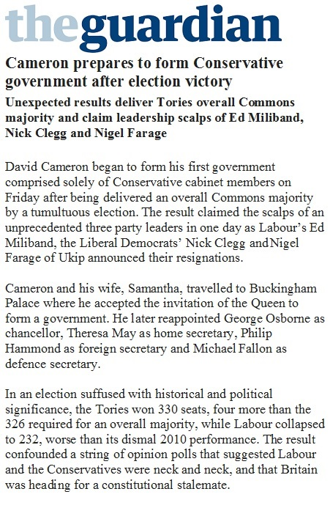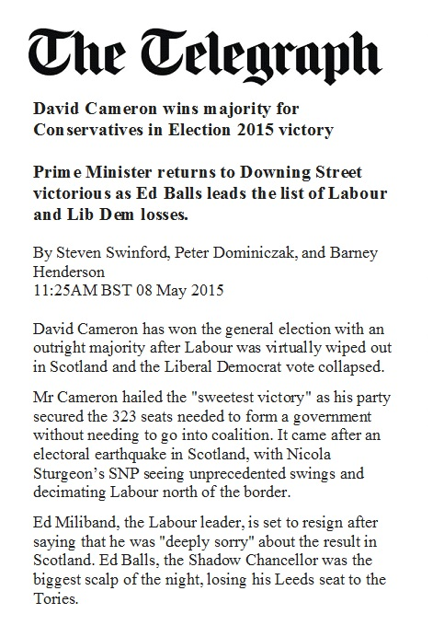

Figure A3. (Mock) news article used in the “Narrow majority Figure A4. (Mock) news article used in the “Decisive majority
with no source” treatment condition with no source” treatment condition
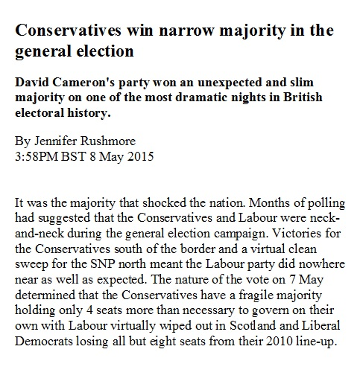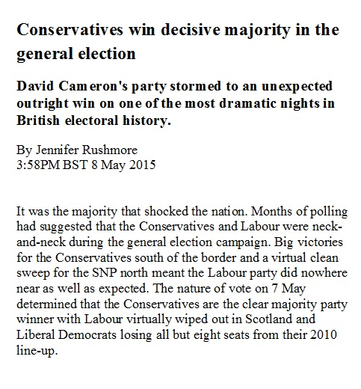

Figure A5. “Placebo” article used in the “Control” condition
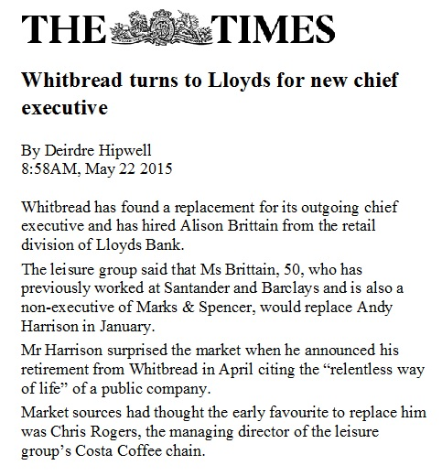

A2. Manipulation checks conducted using CrowdFlower

As mentioned in the “Research Design” section of the paper, we resorted to CrowdFlower (www.crowdflower.com) to check whether or not the different news stories associated with the treatment conditions in our experiment induced different perceptions regarding the decisiveness of the in-party’s victory in 2015 UK election. We do not claim that participants on CrowdFlower are necessarily akin to experimental subjects (but see Buhrmester, Kwang, and Gosling 2001; Mason and Suri 2012). However, crowdsourcing platforms have become increasingly accepted and used in experimental political science (e.g., Mullinix et al. 2015). Mason and Suri (2012), in particular, highlight the value of crowdsourcing platforms as a tool to aid in (online) experimental design.

Between May 15 and May 25, 2015, we randomly assigned 260 CrowdFlower contributors – all based in the UK – to receive an article associated with each of the four treatment conditions included in our experimental design: (i) “Narrow victory with The Guardian as source”; (ii) “Decisive victory with The Telegraph as source”; (iii) “Narrow victory with no source”; and (iv) “Decisive victory with no source” (see Figures A1 – A4 in Section A1 of this Online Appendix). Additionally, another group of 100 contributors were randomly assigned to receive “anonymised” versions of the articles published by either The Guardian or The Telegraph, in which all information about the source of the information was removed. That is, this additional group of contributors received the articles portrayed in Figures A1 and A2 above (different from the “mock” articles displayed in Figures A3 and A4), but with the labels identifying the news outlets removed.

After reading the corresponding articles, contributors were requested to complete a 15-item multiple choice questionnaire asking them about the article’s content, effectiveness, evaluative tone, and credibility of the source. A basic summary of the instructions received by the participants in this pre-test is displayed in Figure A6.

Figure A6. Instructions for CrowdFlower contributors
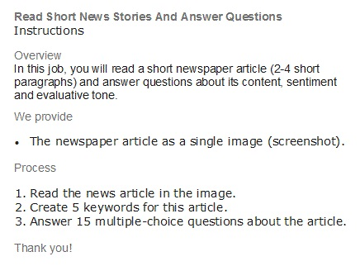

Participants were paid £0.65 (about US$1, based on the exchange rate prevailing at the time of the pre-test) for completing this task. In order to verify that contributors had actually read the piece and to check the quality of their responses, we embedded a “captcha” or “reverse Turing test” question (Mason and Suri 2012) in the text of each news story. Specifically, each article included a sentence towards the end of the second paragraph that read: “The answer to question seven is two”. Item seven of the questionnaire then asked contributors: “Based on the information in the article, what number is the correct answer to this question?”
We retained the responses from 300 contributors (200 of those who received the articles used as treatments in our survey experiment, and all of those who received the “anonymised” versions of the articles from The Guardian and The Telegraph) who completed the survey and correctly answered the “captcha” question, and whose judgment was not classified as “tainted” – i.e., unreliable – by CrowdFlower. Additionally, we inspected the pattern of contributors’ responses and the time they spent completing the questionnaire to further screen out poor/low effort responses (Zhu and Carterette 2010; Mason and Suri 2012). The basic findings reported below are robust to alternative quality assurance criteria.
The first of the 15 multiple choice questions contributors had to answer after reading the texts was: “What is the primary focus of the article?” Table A3 below shows the distribution of responses for the four articles associated with each treatment condition in our survey experiment. The majority of the participants in the pre-test (52%) chose the option “The new Conservative government majority” as the main topic of the piece, while 34.5% selected “The performance of Labour and the Conservatives in the 2015 election” as response. None of the other options we provided (“Labour leadership’s reaction to the electoral defeat”, “UK Politics”, and “Other”) was chosen by more than 5.5% of the participants. “The new Conservative government majority” was in fact the preferred alternative among contributors assigned to each and every one of the treatment conditions.
Table A3. Perceptions about the article’s primary topic, by treatment condition
Treatment condition | Primary topic of the article
 | The new Conservative government majority | The performance of Labour and the Conservatives in the 2015 election | Labour leadership’s reaction to the electoral defeat | UK Politics | Other
Narrow victory with The Guardian as source (N=50) | 50% | 30% | 2% | 10% | 8%
Decisive victory with The Telegraph as source (N=50) | 52% | 38% | 10% | 0% | 0%
Narrow victory with no source (N=50) | 52% | 34% | 2% | 6% | 6%
Decisive victory with no source (N=50) | 54% | 36% | 0% | 6% | 4%
All treatment conditions (N=200) | 52% | 34.5% | 3.5% | 5.5% | 4.5%

It is particularly reassuring that a majority of the CrowdFlower contributors who received the articles published by The Guardian and The Telegraph identified “The new Conservative government majority” as the main topic, since both pieces also provided additional contextual information (see Figures A1 and A2) and were less exclusively centered on the majority status of the new government than the two fictitious article excerpts (Figures A3 and A4). The proportion of contributors who selected this response option is statistically indistinguishable across treatments (p-value = 0.98, adjusted for multiple testing).
Given the primary focus of our study and the rationale behind our experimental manipulations, the most important item included in the questionnaire administered during this pre-test was: “Based on the information provided in the article, how would you describe the size of the Conservative electoral victory, on a scale from 1 (very narrow) to 10 (very decisive)?” The average scores for each treatment condition were: 4.24 for the “Narrow victory with no source”; 4.50 for the “Narrow victory with The Guardian as source”; 7.34 for the “Decisive victory with no source”; and 7.42 for the “Decisive victory with The Telegraph as source”. These values are aligned with the intended messages embedded in each article: CrowdFlower contributors who received the two news stories expected to portray the Conservative electoral victory as less (more) decisive exhibited lower (higher) average scores.
To assess the statistical significance of these differences, Table A4 reports the (two-sided) p-values from pairwise t-tests for differences in average scores across treatments, adjusted to account for multiple testing. Participants who received the news articles corresponding to the “Decisive victory with no source” and the “Decisive victory with The Telegraph as source” treatments perceived the Tory win as significantly more decisive than those who read the stories associated with the “Narrow victory with The Guardian as source” and “Narrow victory with no source” conditions. On the other hand, average perceptions were statistically indistinguishable between the contributors who received the two articles (with and without an identifiable source of information) portraying the Conservative victory as decisive. Differences between contributors assigned to the “Narrow victory with no source” and those assigned to the “Narrow victory with The Guardian as source” conditions were also not statistically significant.
Table A4. Tests for differences in the perceived decisiveness of the Conservative electoral victory across treatment conditions
Treatment condition | Average score (std. dev. in parentheses) | Pairwise differences (p-values)
 |  | Narrow victory with The Guardian as source | Decisive victory with The Telegraph as source | Narrow victory with no source | Decisive victory with no source
Narrow victory with The Guardian as source | 4.50 (2.75) |  | 0.04 | 0.30 | 0.04
Decisive victory with The Telegraph as source | 7.42 (2.16) | 0.04 |  | 0.02 | 0.84
Narrow victory with no source | 4.24 (2.28) | 0.30 | 0.02 |  | 0.02
Decisive victory with no source | 7.34 (2.16) | 0.04 | 0.84 | 0.02
Notes: Responses coded on a scale from 1 (“Very narrow”) to 10 (“Very decisive”). The p-values are adjusted following Benjamini and Hochberg (1995)’s method to account for multiple testing. Results are similar using alternative adjustments – e.g., Holm (1979), Hochberg (1988), Hommel (1988), Benjamini and Yekutieli (2001).

The evidence presented in Table A4 thus indicates that individuals assigned to the different treatments actually perceived variations in the decisiveness/narrowness of the Tory victory in 2015, and that these differences were in the intended direction. This is a critical finding, given that the results of our survey experiment – and, consequently, the substantive conclusions drawn from our analysis – are entirely dependent on these differences.
In order to explore this issue further and, in particular, to determine whether the significant differences in the perceived decisiveness of the Tory win reported in Table A4 were indeed due to differences in the way in which the electoral victory was described in the four articles, we also examined other potentially relevant features of the messages.
First, we compared the perceived effectiveness or applicability of the (emphasis) frames contained in the experimental manipulations. Following Chong and Druckman (2007, 640), we measured applicability based on contributors’ responses to the question: “How effective is this article in providing information about the new government's ability/capacity to run the country, on a scale from 1 (definitely not effective) to 10 (definitely effective)?” Table A5, which reports the two-sided p-values from pairwise t-tests (adjusted to account for multiple testing), shows no significant differences across the four treatment conditions.

Table A5. Tests for differences in the effectiveness of the articles across treatment conditions
Treatment condition | Average score (std. dev. in parentheses) | Pairwise differences (p-values)
 |  | Narrow victory with The Guardian as source | Decisive victory with The Telegraph as source | Narrow victory with no source | Decisive victory with no source
Narrow victory with The Guardian as source | 5.62 (2.49) |  | 0.73 | 0.60 | 0.35
Decisive victory with The Telegraph as source | 5.80 (2.70) | 0.73 |  | 0.73 | 0.30
Narrow victory with no source | 6.10 (3.16) | 0.60 | 0.73 |  | 0.26
Decisive victory with no source | 4.96 (2.34) | 0.35 | 0.30 | 0.26
Notes: Scores range from 1 (“Definitely not effective”) to 10 (“Definitely effective”). The p-values are adjusted following Benjamini and Hochberg (1995)’s method to account for multiple testing. Results are similar using alternative adjustments (e.g., Holm 1979; Hochberg 1988; Hommel 1988; Benjamini and Yekutieli 2001).

We also asked contributors to rate the tone used in each article to refer to the new Conservative government - on a scale from 1 (very negative) to 10 (very positive) - in order to gauge the “directionality” (Druckman 2009) of the frames. Table A6, which reports two-sided p-values from pairwise t-tests (adjusted for multiple testing), shows again no significant differences across the four treatment conditions.

Table A6. Tests for differences in the tone used to refer to the Conservative government across treatment conditions
Treatment condition | Average score (std. dev. in parentheses) | Pairwise differences (p-values)
 |  | Narrow victory with The Guardian as source | Decisive victory with The Telegraph as source | Narrow victory with no source | Decisive victory with no source
Narrow victory with The Guardian as source | 6.92 (1.58) |  | 0.80 | 0.80 | 0.80
Decisive victory with The Telegraph as source | 7.06 (1.67) | 0.80 |  | 0.80 | 0.85
Narrow victory with no source | 6.72 (2.35) | 0.80 | 0.80 |  | 0.80
Decisive victory with no source | 7.12 (1.59) | 0.80 | 0.85 | 0.80
Notes: Scores range from 1 (“Very negative tone”) to 10 (“Very positive tone”). The p-values are adjusted following Benjamini and Hochberg (1995)’s method to account for multiple testing. Results are similar using alternative adjustments (e.g., Holm 1979; Hochberg 1988; Hommel 1988; Benjamini and Yekutieli 2001).

The results in Tables A5 and A6 are important, as they indicate that the differences in the perceived decisiveness of the incumbent party’s victory reported in Table A4 were not driven by variations in the effectiveness of the messages or the tone used to refer to the Conservative government, but due instead to differences in the way in which the articles associated with the different treatment conditions depicted the Tory win.
In addition, we asked CrowdFlower contributors to indicate how much they trusted the source of the information about the electoral outcome on a scale ranging from 1 (very little) to 10 (a lot). Table A7, which again reports (adjusted) p-values from pairwise t-tests, shows that whereas The Telegraph (The Guardian) was perceived to be the most (least) reliable source of information on average, differences between the four treatments were statistically insignificant.

Table A7. Tests for differences in the reliability of the source of the different articles
Treatment condition | Average score (std. dev. in parentheses) | Pairwise differences (p-values)
 |  | Narrow victory with The Guardian as source | Decisive victory with The Telegraph as source | Narrow victory with no source | Decisive victory with no source
Narrow victory with The Guardian as source | 6.60 (2.04) |  | 0.14 | 0.88 | 0.10
Decisive victory with The Telegraph as source | 7.44 (2.17) | 0.14 |  | 0.26 | 0.62
Narrow victory with no source | 6.96 (2.28) | 0.88 | 0.26 |  | 0.14
Decisive victory with no source | 6.78 (2.06) | 0.10 | 0.62 | 0.14
Notes: Scores range from 1 (“I trust the source very little”) to 10 (“I trust the source a lot”). The p-values are adjusted following Benjamini and Hochberg (1995)’s method to account for multiple testing. Results are similar using alternative adjustments – e.g., Holm (1979), Hochberg (1988), Hommel (1988), Benjamini and Yekutieli (2001).

The absence of systematic differences in the perceived trustworthiness of the source is particularly interesting in view of the fact that two of the stories appeared in prominent newspapers with opposing ideological slants – which CrowdFlower contributors, being UK residents (like our experimental subjects), would easily recognize. As already noted, individuals could not identify the publisher of the other two (“mock”) articles – corresponding to the “Narrow victory with no source” and the “Decisive victory with no source” treatments.
Finally, Figure A7 compares the perceived decisiveness of the Conservative victory and the credibility of the source among CrowdFlower contributors who read the “original” articles published in The Guardian and The Telegraph (which included the newspaper outlet labels) and those who received a version of the same articles without newspaper identifiers. Differences in the perceived decisiveness of the Tory victory and in the reliability of the source across the two groups of participants were not statistically significant.

Figure A7. p-values for pairwise t-tests comparing responses between individuals reading the articles published by The Guardian/The Telegraph with and without newspaper labels

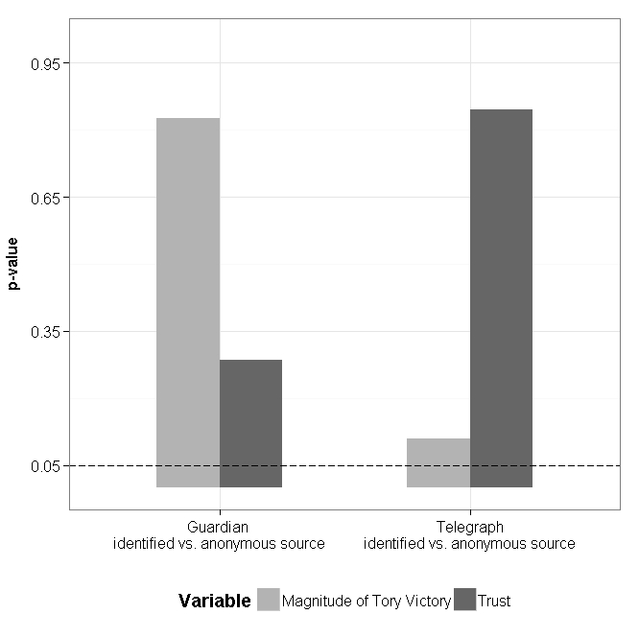
Notes: The sample size for these comparisons is 200, with 50 contributors assigned to each of the two versions (identified/anonymous) of the articles published by The Guardian and The Telegraph. The p-values are adjusted following Benjamini and Hochberg (1995)’s method to account for multiple testing.

The results emerging from Table A7 and Figure A7 are in some sense consistent with the findings reported in the paper regarding the insignificant role of trust in the press and in the media as moderators of treatment effects.
A3. Additional estimation results
Because the models estimated to test our hypotheses involve a large number of parameters, the presentation of the results in the manuscript is graphical. Tables A8 – A12 and Figures A8 – A15 below include additional results that complement the information presented in the “Empirical Analysis” section of the main text, and that were relegated to this Online Appendix due to space constraints.

Table A8. Parameter estimates from ordinary/binary logit and linear regression models assessing the effect of the experimental manipulations on expectations about the Conservative government’s ability to fulfil its campaign promises
 | (1) | (2) | (3)
 | Ordered logit | Binary logit | OLS
Intercept |  | 0.01  (0.09) | 2.60***  (0.05)
Narrow victory with The Guardian as source | 0.06  (0.12) | 0.01  (0.14) | 0.04  (0.08)
Decisive victory with The Telegraph as source | 0.23**  (0.12) | 0.26*  (0.14) | 0.16**  (0.08)
Narrow victory with no source | 0.10  (0.15) | 0.25  (0.16) | 0.06  (0.09)
Decisive victory with no source | 0.18  (0.15) | 0.24  (0.16) | 0.12  (0.10)
N. observations | 1,728 | 1,728 | 1,728
Log-likelihood | -2,597.49 | -1,190.41
Likelihood ratio chi2 | 4.51 | 6.62
R²
Pseudo-R² | 0.01 | 0.01 | 0.01
Notes: The dependent variable is built from subjects’ responses to the question “To what extent do you agree/disagree that the Conservative government will be able to fulfil all of its campaign promises?” In column (1), the dependent variable is coded on its “original” 5-point scale (see Section A1 above); these estimates are used to compute the differences in probabilities displayed in Figure 1 of the manuscript. In the second column, the dependent variable is dichotomised using a median split (Barabas and Jerit 2010). In column (3), the dependent variable is treated as continuous. Standard errors are presented in parentheses. List-wise deletion was used for observations with missing (response) values. Using multiple imputation (van Buuren and Groothuis-Oudshoorn 2011) leaves the substantive findings essentially unchanged. Significance levels: *** at 1%, ** at 5%, * at 10%.
Figure A8. Average treatment effects obtained from the binary logit model
(Table A8, column 2).
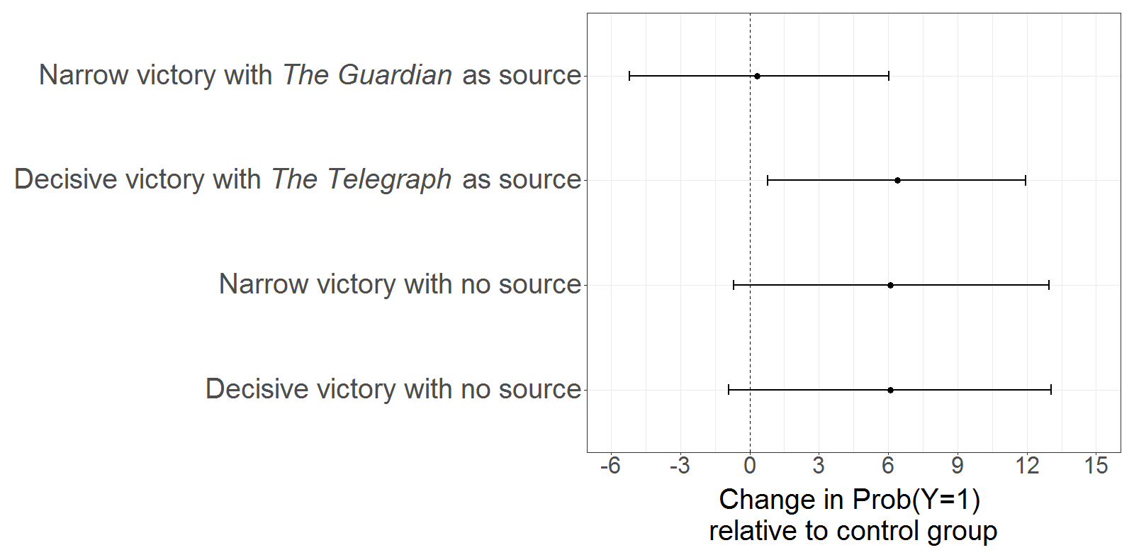
Notes: The figure plots average differences in between each of the treatment conditions and the control group, where is the dichotomised dependent variable resulting from applying a median split (Barabas and Jerit 2010) to responses to the question “To what extent do you agree/disagree that the Conservative government will be able to fulfil all of its campaign promises?” Circles represent point estimates, in percentage points; horizontal lines correspond to the 90% confidence intervals.

Table A9. Parameter estimates from ordered logit models accounting for the role of partisanship and vote choice as moderators of treatment effects.
 | (1) | (2)
Narrow victory with The Guardian as source | 0.20  (0.19) | 0.05  (0.28)
Decisive victory with The Telegraph as source | 0.35*  (0.19) | 0.26  (0.17)
Narrow victory with no source | 0.19  (0.23) | 0.26  (0.20)
Decisive victory with no source | 0.10  (0.23) | -0.03  (0.21)
Conservative | 1.84***  (0.22)
Labour | -0.55**  (0.22)
Electoral winner |  | 2.06***  (0.20)
Narrow victory with The Guardian as source * Conservative | -0.29  (0.32)
Decisive victory with The Telegraph as source * Conservative | -0.27  (0.31)
Narrow victory with no source * Conservative | -0.18  (0.37)
Decisive victory with no source * Conservative | -0.05  (0.38)
Narrow victory with The Guardian as source * Labour | -0.61*  (0.32)
Decisive victory with The Telegraph as source * Labour | -0.37  (0.33)
Narrow victory with no source * Labour | -0.07  (0.38)
Narrow victory with The Guardian as source * Electoral winner |  | 0.06  (0.28)
Decisive victory with The Telegraph as source * Electoral winner |  | -0.12  (0.28)
Narrow victory with no source * Conservative * Electoral winner |  | -0.12  (0.33)
Decisive victory with no source * Electoral winner |  | 0.18  (0.34)
Age | -0.01  (0.01) | 0.01  (0.01)
Education: A-levels or similar | -0.08  (0.16) | -0.04  (0.17)
Education: Vocational or technical qualifications | 0.09  (0.16) | -0.07  (0.17)
Education: University (including post-graduate) | -0.11  (0.12) | -0.11  (0.12)
Male | -0.10  (0.09) | -0.02  (0.10)
Married | 0.35***  (0.11) | 0.20*  (0.12)
Union member | 0.14  (0.13) | 0.10  (0.13)
Non-white | -0.88***  (0.25) | -0.84***  (0.27)
Political interest | 0.05  (0.06) | 0.02  (0.06)
News consumption | -0.24  (0.14) | -0.26  (0.15)
Trust in Newspapers | 0.50***  (0.07) | 0.47***  (0.08)
Voted in the 2015 UK election | 0.02  (0.15)
N. observations | 1,243 | 1,445
Log-likelihood | -2,218.56 | -2,214.52
Likelihood ratio chi2 | 455.60 | 463.69
Pseudo-R² | 0.09 | 0.09
Notes: Standard errors are reported in parentheses. In column (1), the sample includes only subjects (self-)identified with Conservative and Labour parties as well as independents (the reference category). These estimates are then used to compute the differences in probabilities (average marginal effects) reported in the upper panel of Figure 2 of the main text and the probabilities displayed in Figure A9 below. The main substantive conclusions are similar if use a split-sample approach, fitting the model separately for Conservatives, Labour identifiers, and independents.
In column (2), the sample comprises only subjects who turned out to vote in the 2015 UK election, and the analysis focuses on the differential effects of treatments on electoral “winners” and “losers”. These estimates are used to compute the average marginal effects displayed in the lower panel of Figure 2 of the manuscript and the probabilities presented in Figure A10 below.
In both specifications, we used list-wise deletion to handle observations with missing values (in either the dependent or independent variables). For robustness, we repeated the analysis using multiple imputation (van Buuren and Groothuis-Oudshoorn 2011); the main finings remain essentially identical.
Significance levels: *** at 1%, ** at 5%, * at 10%.
Figure A9. Probability of agreeing/strongly agreeing that the Conservative government will be able fulfil its campaign promises, by experimental condition and partisanship.
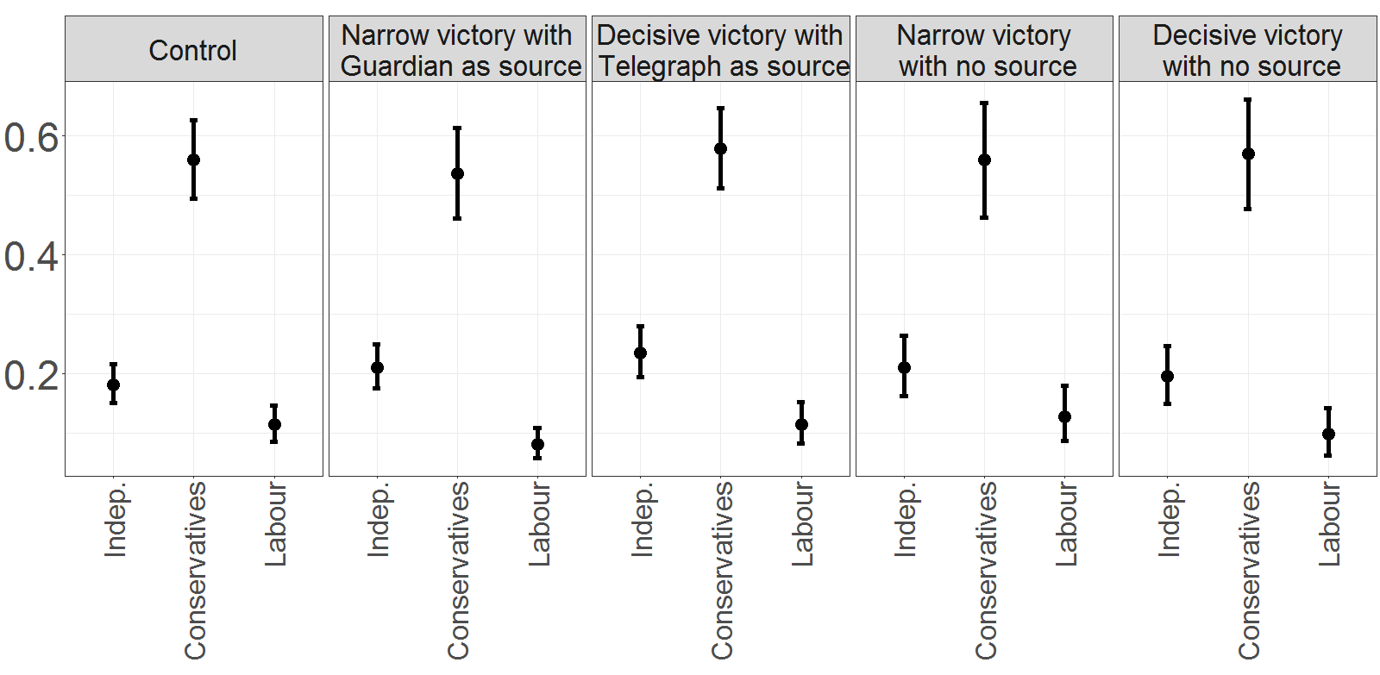
Notes: The figure plots the average probability of agreeing/strongly agreeing with the statement “The Conservative government will be able to fulfil all of its campaign promises” under each experimental condition (control and treatments), by partisanship. Circles represent point estimates; vertical lines correspond to the 90% confidence intervals. The probabilities are computed based on the parameter estimates reported in column 1 of Table A9.

Figure A10. Probability of agreeing/strongly agreeing that the Conservative government will be able fulfil its campaign promises among electoral “winners” and “lowers”.
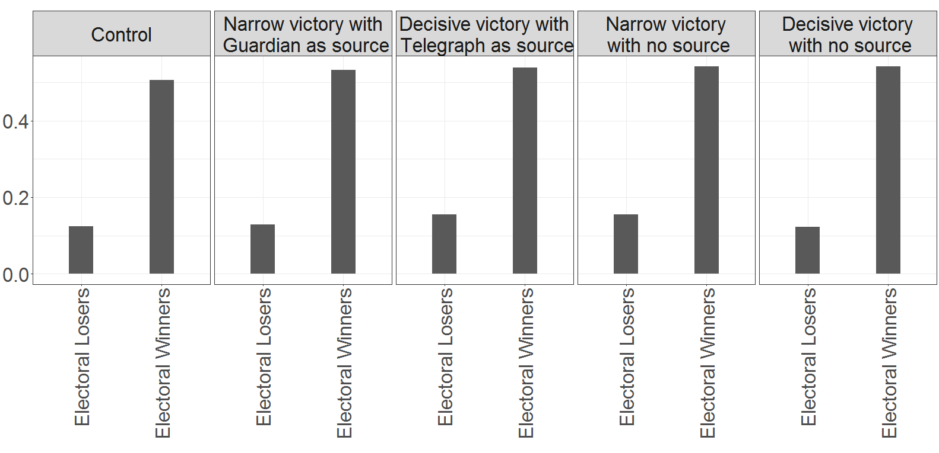
Notes: The figure plots the average probability of agreeing/strongly agreeing with the statement “The Conservative government will be able to fulfil all of its campaign promises” under each experimental condition, distinguishing between subjects who voted for the Conservatives (“electoral winners”) and those who voted for any of the other contestants (“losers”) in the 2015 UK general election. The probabilities are computed based on the parameter estimates reported in column 2 of Table A9.

Table A10. Parameter estimates from ordered logit models accounting for the role of
trust in the press/in the media as moderators of treatment effects.
 | (1) | (2) | (3)
Narrow victory with The Guardian as source | 0.39  (0.36) | -0.15  (0.73) | -0.03  (0.14)
Decisive victory with The Telegraph as source | 0.06  (0.34) | 0.33  (0.60) | 0.09  (0.14)
Narrow victory with no source | -1.48***  (0.47) | -1.38*  (0.78) | 0.18  (0.17)
Decisive victory with no source | 0.06  (0.48) | 0.11  (0.74) | 0.03  (0.17)
Trust in Newspapers: Not much | 0.04  (0.27)
Trust in Newspapers: Some | 0.46*  (0.27)
Trust in Newspapers: A lot | 1.72***  (0.50)
Narrow victory with The Guardian as source * Trust in Newspapers: Not Much | 0.33  (0.42)
Decisive victory with The Telegraph as source * Trust in Newspapers: Not Much | 0.05  (0.40)
Narrow victory with no source * Trust in Newspapers: Not Much | 1.86***  (0.53)
Decisive victory with no source * Trust in Newspapers: Not Much | 0.19  (0.54)
Narrow victory with The Guardian as source * Trust in Newspapers: Some | 0.59  (0.42)
Decisive victory with The Telegraph as source * Trust in Newspapers: Some | 0.22  (0.40)
Narrow victory with no source * Trust in Newspapers: Some | 1.85***  (0.54)
Decisive victory with no source * Trust in Newspapers: Some | -0.20  (0.53)
Narrow victory with The Guardian as source * Trust in Newspapers: A lot | -0.20  (0.71)
Decisive victory with The Telegraph as source * Trust in Newspapers: A lot | 0.30  (0.75)
Narrow victory with no source * Trust in Newspapers: A lot | 1.17  (0.80)
Decisive victory with no source * Trust in Newspapers: A lot | 0.20  (0.92)
Trust in the Media |  | 0.14  (0.42)
Narrow victory with The Guardian as source * Trust in the Media |  | 0.11  (0.74)
Decisive victory with The Telegraph as source * Trust in the Media |  | -0.29  (0.62)
Narrow victory with no source * Trust in the Media |  | 1.59**  (0.80)
Decisive victory with no source * Trust in the Media |  | -0.03  (0.76)
Regular reader of The Guardian |  |  | -1.06***  (0.32)
Narrow victory with The Guardian as source * Regular reader of The Guardian |  |  | 0.52  (0.52)
Decisive victory with The Telegraph as source * Regular reader of The Guardian |  |  | 0.82*  (0.45)
Narrow victory with no source * Regular reader of The Guardian |  |  | 0.01  (0.61)
Decisive victory with no source * Regular reader of The Guardian |  |  | 0.61  (0.54)
Regular reader of The Telegraph |  |  | 0.28  (0.32)
Narrow victory with The Guardian as source * Regular reader of The Telegraph |  |  | -0.02  (0.52)
Decisive victory with The Telegraph as source * Regular reader of The Telegraph |  |  | 0.04  (0.48)
Narrow victory with no source * Regular reader of The Telegraph |  |  | -0.44  (0.53)
Decisive victory with no source * Regular reader of The Telegraph |  |  | 1.02  (0.67)
Age | -0.01  (0.01) | -0.01  (0.01) | 0.01  (0.01)
Education: A-levels or similar | -0.10  (0.16) | -0.17  (0.18) | -0.13  (0.16)
Education: Vocational or technical qualifications | 0.07  (0.17) | 0.05  (0.18) | 0.08  (0.16)
Education: University (including post-graduate) | -0.11  (0.12) | -0.23*  (0.13) | -0.10  (0.11)
Male | -0.12  (0.10) | -0.17  (0.10) | -0.18*  (0.09)
Married | 0.34***  (0.11) | 0.27**  (0.12) | 0.27**  (0.11)
Union member | 0.12  (0.12) | 0.17  (0.14) | 0.17  (0.13)
Non-white | -0.90***  (0.25) | -0.98***  (0.26) | -0.96***  (0.24)
Political interest | 0.05  (0.05) | 0.08  (0.06) | 0.08  (0.05)
News consumption | -0.21  (0.14) | -0.20  (0.14) | -0.19  (0.13)
Voted in the 2015 UK election | 0.02  (0.15) | 0.01  (0.16) | 0.02  (0.14)
N. observations | 1,546 | 1,333 | 1,612
Log-likelihood | -2,074.94 | -1,827.24 | -2,200.27
Likelihood ratio chi2 | 517.88 | 364.98 | 463.00
Pseudo-R² | 0.11 | 0.09 | 0.09
Notes: The table presents parameter estimates from ordered logit models examining the role of trust in newspapers (column 1) and in the media more generally (column 2) as moderators of treatment effects; standard errors are reported in parentheses. In column (1), “Trust in Newspapers” is coded on the original 4-point scale (see Section A1 above). “Trust in the Media” (column 2) is computed by averaging responses to questions asking subjects about their degree of trust in the accuracy and fairness of the political coverage of newspapers, TV, and radio (Section A1). Following Miller and Krosnick (2000), the variable is then dichotomised, taking the value of 1 for subjects whose levels of trust in the accuracy and fairness of the political coverage of newspapers, TV and radio is above the median. The estimates in column (1) are used as basis to produce Figure 3 in the main text and Figure A11 in this Online Appendix; Figure A12 below is based on the estimates in column (2).
Additionally, column (3) explores whether the effect of the “Narrow victory with The Guardian as source” treatment was strongest (weakest) among regular readers of The Guardian (The Telegraph), and whether the effect of the “Decisive victory with The Telegraph as source” treatment was strongest (weakest) among regular readers of The Telegraph (The Guardian). One might expect this to be the case if the level of trust in these newspapers is a relevant moderator of treatment effects, as it is reasonable to assume that usual readers would tend to trust the information published by their preferred paper and discount the information/electoral interpretation appearing in a broadsheet with the opposite editorial line. The estimates in column (3) do not support this claim. Including also readers of other left- (e.g., The Mirror) or right-leaning (e.g., The Mail, The Sun) newspapers does not alter this conclusion.
For all specifications, we used list-wise deletion to handle observations with missing values (in either the dependent or independent variables). We replicated the analysis using multiple imputation (van Buuren and Groothuis-Oudshoorn 2011), with similar results.
Significance levels: *** at 1%, ** at 5%, * at 10%.

Figure A11. Differences in the probability of agreeing/strongly agreeing that the Conservative government will be able fulfil its campaign promises between subjects with the lowest and highest levels of trust in the press, for each experimental condition
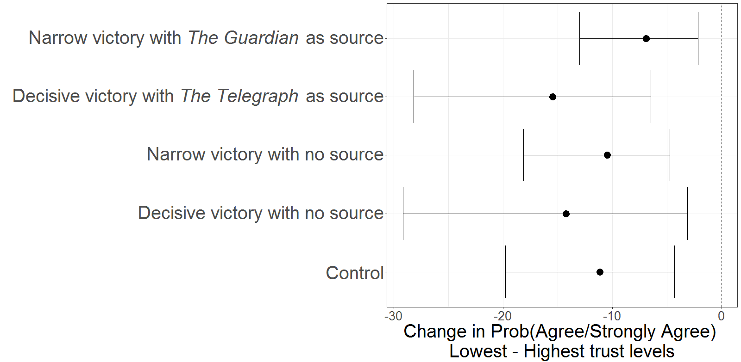
Notes: For every experimental condition, the figure plots differences in the average probability of agreeing/strongly agreeing with the statement “The Conservative government will be able to fulfil all of its campaign promises” between subjects with the lowest levels of trust in newspapers and those with the highest levels of trust in the press. These differences are based on the parameter estimates reported in column 1 of Table A10. Circles represent point estimates for the differences (probabilities for participants with low trust minus probabilities for highly trusting subjects), in percentage points; horizontal lines correspond to the 90% confidence intervals.

Figure A12. Moderating influence of trust in the media on treatment effects
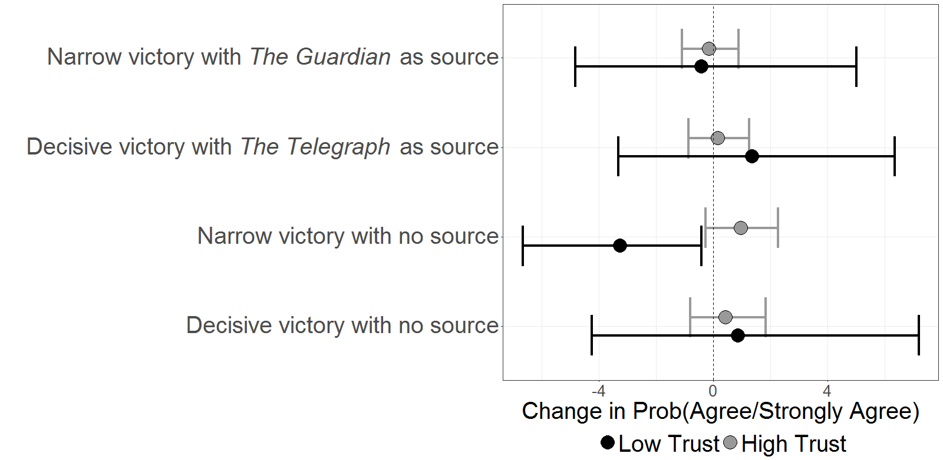
Notes: The figure plots differences in the average probability of agreeing/strongly agreeing with the statement “The Conservative government will be able to fulfil all of its campaign promises” between each of the four treatment conditions and the control group, by level of trust in the political coverage of the mass media (newspapers, TV and radio). Circles represent point estimates, in percentage points; horizontal lines correspond to the 90% confidence intervals. Estimates are based on the specification reported in column (2) of Table A10.

Table A11. Parameter estimates from ordered logit models accounting for the role of political sophistication as a moderator of treatment effects.
 | (1) | (2) | (3) | (4)
Narrow victory with The Guardian as source | 0.06  (0.27) | 0.44  (0.91) | 0.21  (0.26) | 0.21  (0.26)
Decisive victory with The Telegraph as source | 0.61**  (0.28) | 0.46  (1.17) | 0.39  (0.25) | 0.40  (0.25)
Narrow victory with no source | -0.31  (0.33) | 0.14  (1.30) | -0.09  (0.31) | -0.09  (0.31)
Decisive victory with no source | -0.04  (0.32) | 2.54**  (1.01) | 0.62**  (0.29) | 0.63**  (0.30)
Political interest | 0.08  (0.22) | 0.01  (0.06) | 0.04  (0.06) | 0.04  (0.06)
Narrow victory with The Guardian as source * Pol. interest | -0.12  (0.31)
Decisive victory with The Telegraph as source * Pol. interest | -0.55*  (0.32)
Narrow victory with no source * Pol. interest | 0.56  (0.37)
Decisive victory with no source * Pol. interest | 0.07  (0.37)
News consumption | -0.22  (0.14) | -0.21  (0.14) | -0.23  (0.14) | -0.23  (0.14)
Narrow victory with The Guardian as source * News consumption |  | -0.46  (0.92)
Decisive victory with The Telegraph as source * News consumption |  | -0.30  (1.18)
Narrow victory with no source * News consumption |  | -0.01  (1.31)
Decisive victory with no source * News consumption |  | -2.58**  (1.02)
Education: Higher than A-levels |  |  | 0.13  (0.20)
Narrow victory with The Guardian as source * Education: Higher than A-levels |  |  | -0.30  (0.30)
Decisive victory with The Telegraph as source * Education: Higher than A-levels |  |  | -0.27  (0.30)
Narrow victory with no source * Education: Higher than A-levels |  |  | 0.16  (0.36)
Decisive victory with no source * Education: Higher than A-levels |  |  | -0.67*  (0.35)
Education: A-levels or similar | -0.08  (0.16) | -0.10  (0.16) |  | 0.34  (0.30)
Education: Vocational or technical qualifications | 0.08  (0.16) | 0.06  (0.16) |  | 0.89**  (0.35)
Education: University (including post-graduate) | -0.09  (0.12) | -0.13  (0.12) |  | -0.05  (0.21)
Narrow victory with The Guardian as source * Education: A-levels or similar |  |  |  | -0.35  (0.44)
Decisive victory with The Telegraph as source * Education: A-levels or similar |  |  |  | -1.01**  (0.45)
Narrow victory with no source * Education: A-levels or similar |  |  |  | -0.39  (0.57)
Decisive victory with no source * Education: A-levels or similar |  |  |  | -0.50  (0.57)
Narrow victory with The Guardian as source * Education: Vocational or technical qualifications |  |  |  | -0.67  (0.49)
Decisive victory with The Telegraph as source * Education: Vocational or technical qualifications |  |  |  | -1.48***  (0.48)
Narrow victory with no source * Education: Vocational or technical qualifications |  |  |  | -0.49  (0.56)
Decisive victory with no source * Education: Vocational or technical qualifications |  |  |  | -1.37**  (0.54)
Narrow victory with The Guardian as source * University (including post-graduate) |  |  |  | -0.05  (0.32)
Decisive victory with The Telegraph as source * University (including post-graduate) |  |  |  | -0.05  (0.31)
Narrow victory with no source * University (including post-graduate) |  |  |  | 0.39  (0.38)
Decisive victory with no source * University (including post-graduate) |  |  |  | -0.61*  (0.37)
Conservative | 1.69***  (0.12) | 1.71***  (0.12) | 1.70***  (0.12) | 1.70***  (0.12)
Labour | -0.80***  (0.12) | -0.82***  (0.12) | -0.81***  (0.12) | -0.81***  (0.12)
Age | -0.01  (0.01) | -0.01  (0.01) | -0.01  (0.01) | -0.01  (0.01)
Male | -0.07  (0.09) | -0.09  (0.10) | -0.08  (0.09) | -0.08  (0.10)
Married | 0.34***  (0.11) | 0.34***  (0.11) | 0.36***  (0.11) | 0.35***  (0.11)
Union member | 0.14  (0.13) | 0.15  (0.13) | 0.12  (0.12) | 0.14  (0.13)
Trust in Newspapers | 0.50***  (0.07) | 0.46***  (0.06) | 0.50***  (0.07) | 0.52***  (0.07)
Voted in the 2015 UK election | 0.07  (0.15) | 0.05  (0.15) | 0.02  (0.15) | 0.03  (0.15)
N. observations | 1,546 | 1,546 | 1,546 | 1,546
Log-likelihood | -2,084.6 | -2,085.0 | -2,086.6 | -2,076.2
Likelihood ratio chi2 | 498.46 | 500.88 | 494.49 | 515.42
Pseudo-R² | 0.11 | 0.11 | 0.10 | 0.11
Notes: Column (1) uses political interest as a measure of sophistication; column (2) uses news consumption as proxy; column (3) uses respondents’ education level. Standard errors are reported in parentheses. Note that, when political interest, news consumption and education are used as proxies for sophistication, they are dichotomised (with higher values coded as 1; see Section A1 above) to facilitate the interpretation of their role as treatment effect moderators. When these variables enter as controls, we operationalise them using their “original” coding - as in previous analyses (Tables A9 and A10). The substantive conclusions emerging from columns (1)-(3) (and from Figures 4 in the main text and A13 in this Online Appendix) are robust to alternative operationalisations of these correlates of political sophistication. This is illustrated in column (4), which explores the moderating influence of the more disaggregated Education variable (see Section A1). When assessing the moderating influence of each of the proxies for sophistication, we include the other two as controls (coded on their “original” scale), along with trust in the press (Miller and Krosnick 2000). All the specifications used list-wise deletion to handle observations with missing values (in either the dependent or independent variables). We repeated the analysis using multiple imputation (van Buuren and Groothuis-Oudshoorn 2011), with similar results.
Significance levels: *** at 1%, ** at 5%, * at 10%.

Figure A13. Differences in the probability of agreeing/strongly agreeing with the statement “The Conservative government will be able to fulfil all of its campaign promises” between low and high sophisticates under each experimental condition.
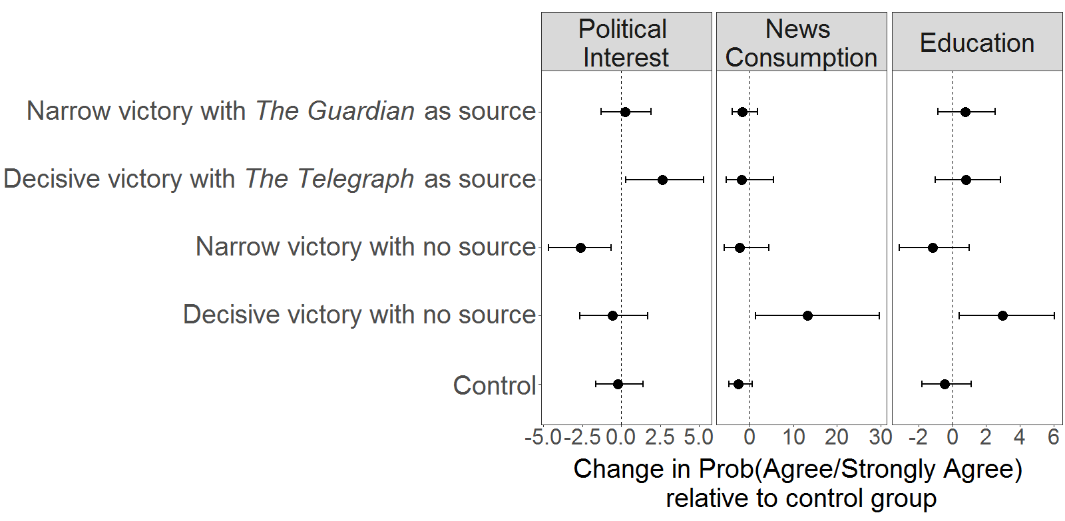
Notes: For every experimental condition, the figure plots differences in the probability of agreeing/strongly agreeing with the statement “The Conservative government will be able to fulfil all of its campaign promises” between low and high sophisticates - i.e., the difference between the probabilities of agreeing/strongly agreeing with the statement among low sophisticates minus the corresponding probabilities for high sophisticates. Political sophistication is alternatively proxied by three variables: political interest (left column), news consumption (middle column), and education (right column). Circles represent point estimates, in percentage points; horizontal lines correspond to the 90% confidence intervals. Estimates are based on the specifications in columns (1)-(3) of Table A11.

Table A12. Parameter estimates from ordered logit models accounting for the simultaneous influence of trust in the press and political sophistication as moderators of treatment effects.
 | (1) | (2) | (3)
Narrow victory with The Guardian as source | -0.78  (0.58) | 0.41  (1.22) | -0.29  (0.62)
Decisive victory with The Telegraph as source | 0.52  (0.64) | 0.38  (1.36) | 0.19  (0.62)
Narrow victory with no source | -2.59***  (0.99) | -0.84  (1.78) | -1.00  (0.88)
Decisive victory with no source | 0.25  (0.79) | 3.30**  (1.57) | 0.90  (1.33)
Political interest | -0.67  (0.50) | 0.05  (0.06) | 0.07  (0.06)
Narrow victory with The Guardian as source * Pol. interest | 0.56  (0.75)
Decisive victory with The Telegraph as source * Pol. interest | -0.55  (0.75)
Narrow victory with no source * Pol. interest | 1.55  (1.14)
Decisive victory with no source * Pol. interest | -0.38  (1.00)
Trust in Newspapers: A lot | -0.41  (0.47) | -0.63  (1.38) | -0.03  (0.47)
Narrow victory with The Guardian as source * Trust in Newspapers: A lot | 1.05  (0.66) | 0.14  (1.78) | 0.63  (0.68)
Decisive victory with The Telegraph as source * Trust in Newspapers: A lot | 0.06  (0.71) | -0.45  (2.17) | 0.25  (0.68)
Narrow victory with no source * Trust in Newspapers: A lot | 2.60**  (1.06) | 2.00  (2.59) | 1.81*  (0.93)
Decisive victory with no source * Trust in Newspapers: A lot | -0.20  (0.86) | -0.84  (2.09) | -0.90  (1.36)
Political interest* Trust in Newspapers: A lot | 0.95*  (0.55)
Narrow victory with The Guardian as source * Pol. interest * Trust in Newspapers: A lot | -0.82  (0.83)
Decisive victory with The Telegraph as source * Pol. interest * Trust in Newspapers: A lot | 0.05  (0.83)
Narrow victory with no source * Pol. interest * Trust in Newspapers: A lot | -1.12  (1.20)
Decisive victory with no source * Pol. interest * Trust in Newspapers: A lot | 0.41  (1.07)
News consumption | -0.06  (0.14) | 0.92  (0.99) | -0.10  (0.14)
Narrow victory with The Guardian as source * News consumption |  | -0.84  (1.27)
Decisive victory with The Telegraph as source * News consumption |  | -0.40  (1.41)
Narrow victory with no source * News consumption |  | -0.76  (1.84)
Decisive victory with no source * News consumption |  | -3.50**  (1.65)
News consumption * Trust in Newspapers: A lot |  | 0.81  (1.40)
Narrow victory with The Guardian as source * News consumption * Trust in Newspapers: A lot |  | 0.33  (1.83)
Decisive victory with The Telegraph as source * News consumption * Trust in Newspapers: A lot |  | 0.63  (2.21)
Narrow victory with no source * News consumption * Trust in Newspapers: A lot |  | -0.12  (2.63)
Decisive victory with no source * News consumption * Trust in Newspapers: A lot |  | 1.10  (2.16)
Education: Higher than A-levels |  |  | -0.23  (0.50)
Narrow victory with The Guardian as source * Education: Higher than A-levels |  |  | -0.13  (0.77)
Decisive victory with The Telegraph as source * Education: Higher than A-levels |  |  | -0.16  (0.74)
Narrow victory with no source * Education: Higher than A-levels |  |  | -0.61  (1.04)
Decisive victory with no source * Education: Higher than A-levels |  |  | -0.88  (1.43)
Education: Higher than A-levels * Trust in Newspapers: A lot |  |  | 0.40  (0.55)
Narrow victory with The Guardian as source * Education: Higher than A-levels * Trust in Newspapers: A lot |  |  | -0.22  (0.83)
Decisive victory with The Telegraph as source * Education: Higher than A-levels * Trust in Newspapers: A lot |  |  | -0.17  (0.81)
Narrow victory with no source * Education: Higher than A-levels * Trust in Newspapers: A lot |  |  | -0.03  (1.10)
Decisive victory with no source * Education: Higher than A-levels * Trust in Newspapers: A lot |  |  | 0.97  (1.47)
Conservative | 1.78***  (0.12) | 1.80***  (0.12) | 1.81***  (0.12)
Labour | -0.79***  (0.12) | -0.81***  (0.12) | -0.81***  (0.12)
Age | 0.01  (0.01) | 0.01  (0.01) | 0.01  (0.01)
Education: A-levels or similar | -0.11  (0.16) | -0.14  (0.16)
Education: Vocational or technical qualifications | 0.06  (0.16) | 0.04  (0.17)
Education: University (including post-graduate) | -0.13  (0.12) | -0.15  (0.12)
Male | -0.11  (0.09) | -0.15  (0.10) | -0.12  (0.10)
Married | 0.30***  (0.11) | 0.34***  (0.11) | 0.35***  (0.11)
Union member | 0.13  (0.12) | 0.16  (0.13) | 0.12  (0.13)
Voted in the 2015 UK election | 0.03  (0.15) | 0.02  (0.18) | -0.01  (0.15)
N. observations | 1,546 | 1,546 | 1,546
Log-likelihood | -2,094.1 | -2,108.1 | -2,099.1
Likelihood ratio chi2 | 479.60 | 486.64 | 469.57
Pseudo-R² | 0.10 | 0.10 | 0.10
Notes: As in Table A11, column (1) uses political interest as a measure of sophistication; column (2) uses news consumption as proxy; column (3) uses respondents’ education level. Note that, when political interest, news consumption and education are used as proxies for political sophistication, they are dichotomised to facilitate the interpretation of their role as treatment effect moderators. Similarly, “Trust in Newspapers” is coded as 1 for respondents who have “a lot” of confidence in the political coverage of the press, and 0 otherwise. As in Table A11, the proxies for sophistication are measured in their “original” scales when they enter as controls. The fundamental conclusions emerging from columns (1)-(3) are robust to alternative operationalisations of the moderating variables. All specifications use list-wise deletion to handle observations with missing values (in either the dependent or independent variables); we repeated the analysis using multiple imputation (van Buuren and Groothuis-Oudshoorn 2011), with similar results.
Significance levels: *** at 1%, ** at 5%, * at 10%.
Figure A14 below reports average marginal effects computed from the estimates reported in this table. Figure A15 summarizes the results of similar specifications, but replacing “Trust in Newspapers” with “Trust in the Media” (i.e., newspapers, TV and radio) more generally.

Figure A14. Joint moderating impact of political sophistication and trust in newspapers
on treatment effects
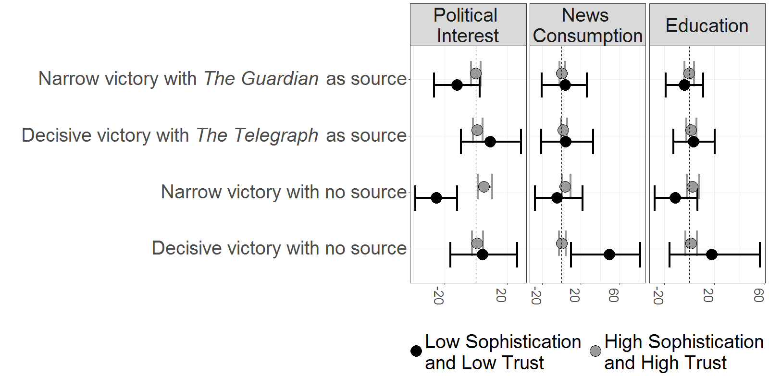
Notes: The figure plots differences in the probability of agreeing/strongly agreeing with the statement “The Conservative government will be able to fulfil all of its campaign promises” under each treatment vis-à-vis the control condition, for subjects with the lowest levels of political sophistication and trust in newspapers (in black) and those with the highest levels of sophistication and confidence in the press (in grey). Political sophistication is measured by three alternative variables: political interest (left column), news consumption (middle column), and education (right column). Circles represent point estimates, in percentage points; horizontal lines correspond to the 90% confidence intervals. Estimates are based on the specifications reported in Table A12. As seen in the figure, the hypothesis that treatment effects are strongest among subjects with high levels of both trust in the press and political sophistication – based on Miller and Krosnick (2000) – is not supported by the empirical analysis, irrespective of the variable used as proxy for sophistication.

Figure A15. Joint moderating influence of political sophistication and media trust
on treatment effects
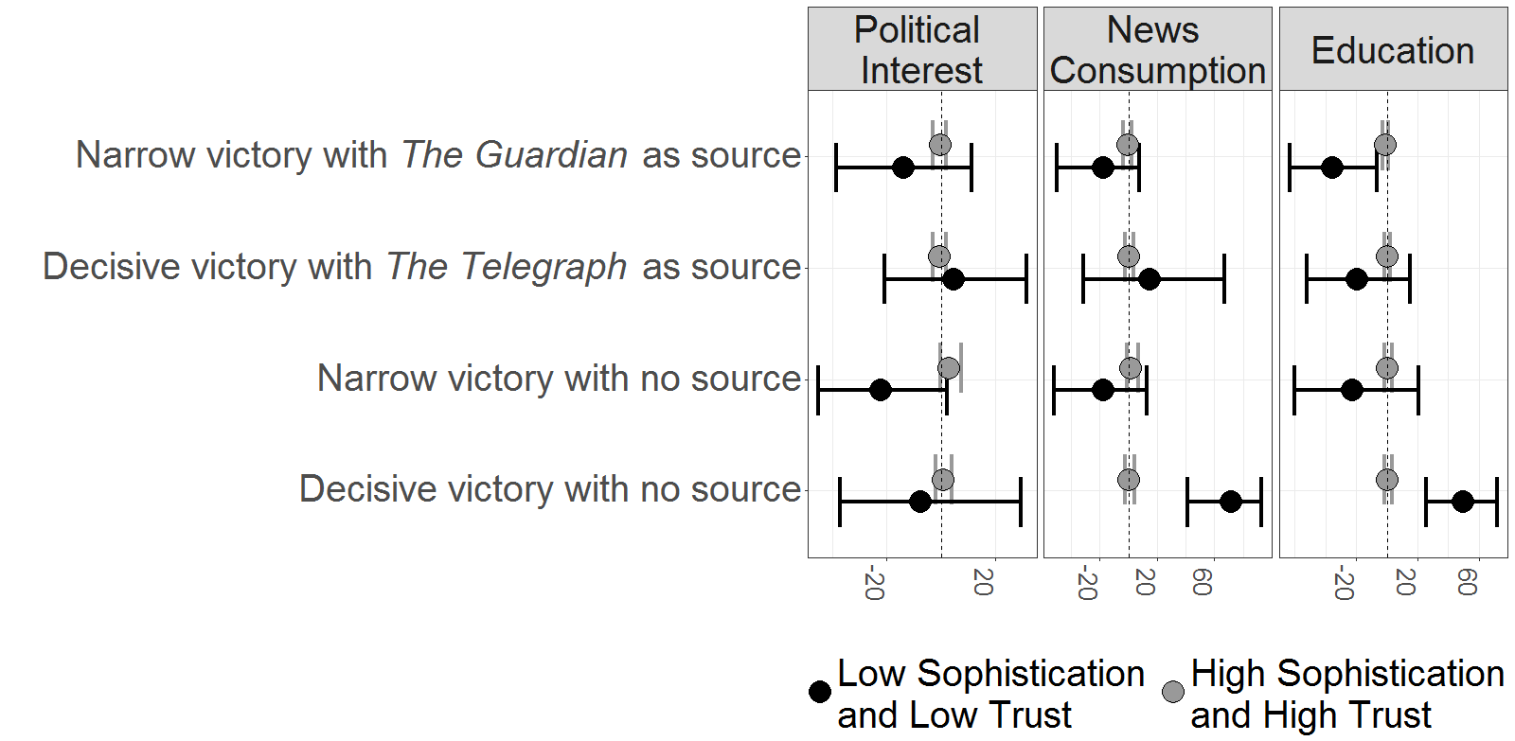
Notes: The figure plots differences in the probability of agreeing/strongly agreeing with the statement “The Conservative government will be able to fulfil all of its campaign promises” under each treatment vis-à-vis the control condition, for subjects with the lowest levels of political sophistication and trust in the mass media (in black) and those with the highest levels of sophistication and media trust (in grey). Political sophistication is measured by three alternative variables: political interest (left column), news consumption (middle column), and education (right column). “Trust in the Media” captures subjects’ confidence in the accuracy and fairness of the coverage of political affairs by newspapers, TV and radio (see Section A1). Circles represent point estimates, in percentage points; horizontal lines correspond to the 90% confidence intervals. Estimates are based on specifications analogous to those of Table A12, replacing “Trust in Newspapers” with “Trust in the Media”. As seen in the figure, the hypothesis that treatment effects are strongest among subjects with high levels of trust and sophistication – based on Miller and Krosnick (2000) – is not supported by the analysis, irrespective of the variable used as proxy for political sophistication.

Online Appendix References
ABC. 2015. National Newspapers Report. Accessed 18 July 2017. http://www.abc.org.uk/Certificates-Reports/Our-Reports.
Barabas, Jason, and Jennifer Jerit. 2010. “Are Survey Experiments Externally Valid?” American Political Science Review 104 (2): 226-242.
Benjamini, Yoav, and Yosef Hochberg. 1995. “Controlling the False Discovery Rate: A Practical and Powerful Approach to Multiple Testing.” Journal of the Royal Statistical Society Series B 57 (1): 289–300.
Benjamini, Yoav, and Daniel Yekutieli. 2001. “The Control of the False Discovery Rate in Multiple Testing Under Dependency.” Annals of Statistics 29 (4): 1165–1188.
Buhrmester, Michael, Tracy Kwang, and Samuel Gosling. 2011. “Amazon’s Mechanical Turk: A New Source of Inexpensive, Yet High-quality, Data?” Perspectives on Psychological Science 6 (1): 3-5.
Chong, Dennis, and James Druckman. 2007. “Framing Public Opinion in Competitive Democracies.” American Political Science Review 101 (4): 637-655.
Collins, Linda, John Dziak, Kari Kugler, and Jessica Trail. 2014. “Factorial Experiments – Efficient Tools for Evaluation of Intervention Components.” American Journal of Preventive Medicine 47 (4): 498-504.
Cowley, Philip, and Dennis Kavanagh. 2016. The British General Election of 2015. Basingstoke: Palgrave Macmillan.
Druckman, James. 2009. “Competing Frames in a Political Campaign”. In Winning with Words – The Origins & Impact of Political Framing, edited by Brian Schaffner and Patrick Sellers, 101-120. New York: Routledge.
Dumville, J., S. Hahn, J. Miles, and D. Torgerson. 2006. “The Use of Unequal Randomisation Ratios in Clinical Trials: A Review.” Contemporary Clinical Trials 27: 1-12.
Gerber, Alan, Dean Karlan, and Daniel Bergan. 2009. “Does the Media Matter? A Field Experiment Measuring the Effect of Newspapers on Voting Behavior and Political Opinions.” American Economic Journal: Applied Economics 1 (2): 35-52.
Hansen, Ben, and Jake Bowers. 2008. “Covariate Balance in Simple, Stratified and Clustered Comparative Studies.” Statistical Science 23 (2): 219-236.
Ho, Daniel E., Kosuke Imai, Gary King, and Elizabeth A. Stuart. 2007. “Matching as Nonparametric Preprocessing for Reducing Model Dependence in Parametric Causal Inference.” Political Analysis 15 (3): 199-236.
Hochberg, Yosef. 1988. “A Sharper Bonferroni Procedure for Multiple Tests of Significance.” Biometrika 75 (4): 800–803.
Holm, Sture. 1979. “A Simple Sequentially Rejective Multiple Test Procedure.” Scandinavian Journal of Statistics 6 (2): 65–70.
Hommel, G. 1988. “A Stagewise Rejective Multiple Test Procedure Based on a Modified Bonferroni Test.” Biometrika 75 (2): 383–386.
Imai, Kosuke, Gary King, and Elizabeth Stuart. 2008. “Misunderstandings Between Experimentalists and Observationalists about Causal Inference.” Journal of the Royal Statistical Society Series A 171 (2): 481-502.
Mason, Winter, and Siddharth Suri. 2012. “Conducting Behavioural Research on Amazon’s Mechanical Turk.” Behavioural Research Methods 44 (1): 1-23.
Miller, Joanne, and Jon Krosnick. 2000. “News Media Impact on the Ingredients of Presidential Evaluations: Politically Knowledgeable Citizens are Guided by a Trusted Source.” American Journal of Political Science 44 (2): 301-315.
Mullinix, Kevin, Thomas Leeper, James Druckman, and Jeremy Freese. 2015. “The Generalizability of Survey Experiments.” Journal of Experimental Political Science 2 (2): 109-138.
Sekhon, Jasjeet S. 2007. “Multivariate and Propensity Score Matching Software with Automated Balance Optimization: The Matching Package for R.” Journal of Statistical Software 42 (7): 1-52.
Smith, Matthew. 2017. “How Left or Right-Wing are Britain’s Newspapers?” The Times, March 16. Accessed 18 December 2017. https://www.thetimes.co.uk/article/how-left-or-right-wing-are-britain-s-newspapers-8vmlr27tm.
van Buuren, Stef, and Karin Groothuis-Oudshoorn. 2011 “mice: Multivariate Imputation by Chained Equations in R.” Journal of Statistical Software 45 (3): 1-67.
Zhu, Dongqing, and Ben Carterette. 2010. “An Analysis of Assessor Behaviour in Crowdsourced Preference Judgments”. In Proceedings of the ACM SIGIR 2010 Workshop on Crowdsourcing for Search Evaluations, edited by Vitor Carvalho, Matthew Lease, and Emine Yilmaz, 21-26. Geneva: SIGIR.

This variable exhibits a large proportion of missing values, and was thus not included in the model specifications that used list-wise deletion (see Section A3). However, it was included as a control in models fitted after conducting multiple imputation (van Buuren and Groothuis-Oudshoorn 2011) to deal with missing values, leading to similar substantive results. See the notes to Tables A8 – A12 below.
The criteria used by CrowdFlower to classify contributors’ judgments as “tainted” or “trusted” can be found at https://success.figure-eight.com/hc/en-us/articles/202703305-Glossary-of-Terms.
We use Benjamini and Hochberg (1995)’s method to account for multiple comparisons. Results are similar using alternative adjustments (e.g., Holm 1979; Hochberg 1988; Hommel 1988; Benjamini and Yekutieli 2001).
The exact wording for this question was: “How would you describe the tone used in this article to refer to the new Conservative government, on a scale from 1 (negative) to 10 (positive)?”
The exact question wording was “How much do you trust the source of this article, on a scale from 1 (very little) to 10 (a lot)?”

