Supplementary Information

Supplementary Tables
Supplementary Table 1. СytB gene sequences used for the phylogenetic analysis of the Numenius species
Species name | Accession number
Slender-billed curlew – N. tenuirostris | MK108195
Whimbrel – N. phaeopus variegatus | AF417930.1
Whimbrel – N. p. variegatus | NC_030507.1
Eurasian curlew – N. arquata | AF417929.1
Far Eastern curlew – N. madagascariensis | AF417925.1
Long-billed Bristle-thighed curlew – N. tahitiensis | KM218981.1
Long-billed Bristle-thighed curlew – N. tahitiensis | JQ963054.1
Long-billed curlew – N. americanus | JQ963052.1
Upland sandpiper – B. longicauda | EF373122.1
Pin-tailed snipe – G. stenura | NC_034741.1
Willet – T. semipalmata | NC_036016.1
Green sandpiper – T. ochropus | NC_033974.1
Spotted redshank – T. erythropus | NC_030585.1
Wood sandpiper – T. glareola | NC_039096.1
Terek sandpiper – Xenus cinereus | NC_033973.1
Spoon-billed sandpiper – Calidris pygmaea | NC_027496.1
Eurasian woodcock – Scolopax rusticola | NC_025521.1
Ruddy turnstone – Arenaria interpres | NC_003712.2
Bar-tailed godwit - Limosa lapponica | KX371106.1
Red-necked phalarope - Phalaropus lobatus | KY765409.1
Grey-headed lapwing – Vanellus cinereus (Charadriiformes: Charadriidae) | NC_025514.1
Northern lapwing – Vanellus vanellus (Charadriiformes: Charadriidae) | NC_025637.1

Supplementary Table 2. Mitogenome sequences (CDS) used for the phylogenetic analysis of the Scolopacidae species
Species name | Accession number
Slender-billed curlew – N. tenuirostris | MK108195
Whimbrel – N. phaeopus variegatus | NC_030507.1
Willet – T. semipalmata | NC_036016.1
Green sandpiper – T. ochropus | NC_033974.1
Spotted redshank – T. erythropus | NC_030585.1
Wood sandpiper – T. glareola | NC_039096.1
Pin-tailed snipe – G. stenura | NC_034741.1
Terek sandpiper – Xenus cinereus | NC_033973.1
Spoon-billed sandpiper – Calidris pygmaea | NC_027496.1
Eurasian woodcock – Scolopax rusticola | NC_025521.1
Ruddy turnstone – Arenaria interpres | NC_003712.2
Bar-tailed godwit - Limosa lapponica | KX371106.1
Red-necked phalarope - Phalaropus lobatus | KY765409.1
Grey-headed lapwing – Vanellus cinereus (Charadriiformes: Charadriidae) | NC_025514.1
Northern lapwing – Vanellus vanellus (Charadriiformes: Charadriidae) | NC_025637.1

Supplementary Table 3. Estimates of Evolutionary Divergence between Scolopacidae species. The number of base substitutions per site from between CDS sequences are shown. Analyses were conducted using the Maximum Composite Likelihood model

Numenius_tenuirostris
Numenius_phaeopus | 0,106
Limosa_lapponica | 0,173 | 0,171
Arenaria_interpres | 0,166 | 0,168 | 0,156
Calidris_pygmaea | 0,170 | 0,164 | 0,152 | 0,138
Tringa_ochropus | 0,172 | 0,177 | 0,160 | 0,156 | 0,149
Tringa_glareola | 0,171 | 0,169 | 0,155 | 0,149 | 0,143 | 0,128
Tringa_erythropus | 0,172 | 0,166 | 0,152 | 0,145 | 0,139 | 0,128 | 0,110
Tringa_semipalmata | 0,167 | 0,160 | 0,149 | 0,141 | 0,141 | 0,123 | 0,101 | 0,093
Xenus_cinereus | 0,177 | 0,172 | 0,161 | 0,158 | 0,156 | 0,157 | 0,150 | 0,149 | 0,142
Phalaropus_lobatus | 0,172 | 0,169 | 0,159 | 0,153 | 0,145 | 0,153 | 0,149 | 0,147 | 0,142 | 0,155
Gallinago_stenura | 0,186 | 0,181 | 0,172 | 0,173 | 0,163 | 0,170 | 0,163 | 0,161 | 0,162 | 0,176 | 0,172
Scolopax_rusticola | 0,194 | 0,188 | 0,176 | 0,172 | 0,172 | 0,171 | 0,169 | 0,167 | 0,166 | 0,176 | 0,177 | 0,175
Vanellus_cinereus | 0,210 | 0,205 | 0,208 | 0,197 | 0,196 | 0,203 | 0,202 | 0,194 | 0,189 | 0,205 | 0,204 | 0,214 | 0,207
Vanellus_vanellus | 0,206 | 0,205 | 0,207 | 0,203 | 0,198 | 0,206 | 0,201 | 0,199 | 0,197 | 0,211 | 0,206 | 0,213 | 0,217 | 0,128

Supplementaty Figures
Supplementary Figure 1. The reads length distribution for museum specimen of Numenius tenuirostris

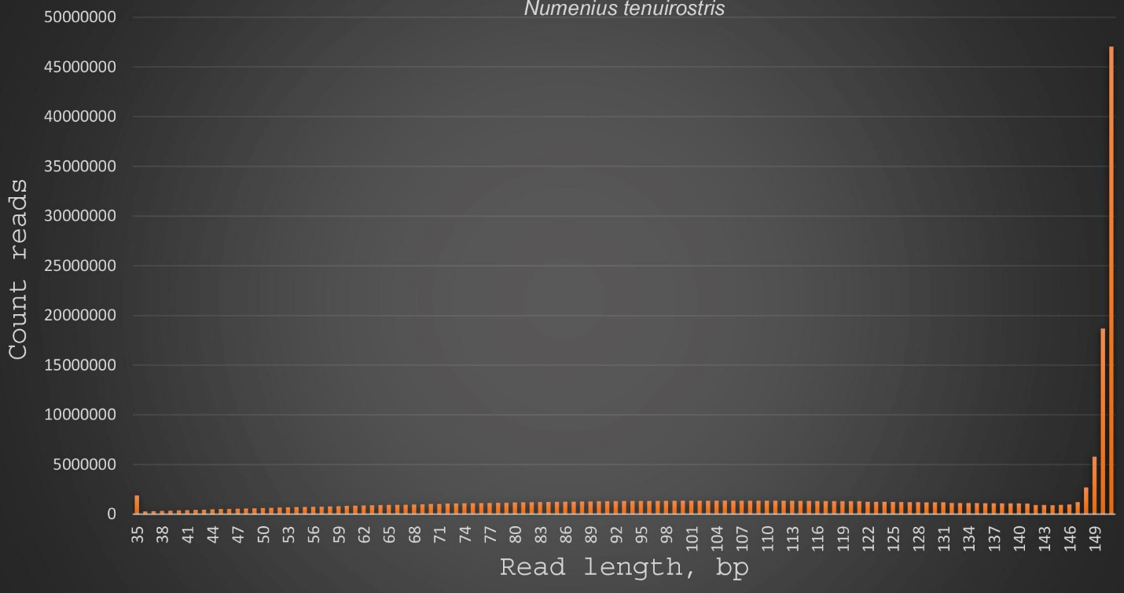

Supplementary Figure 2. Neighbour-Joining phylogenetic tree reconstruction of the Numenius species, including the presumably extinct slender-billed curlew based on nucleotide variability of cytB gene

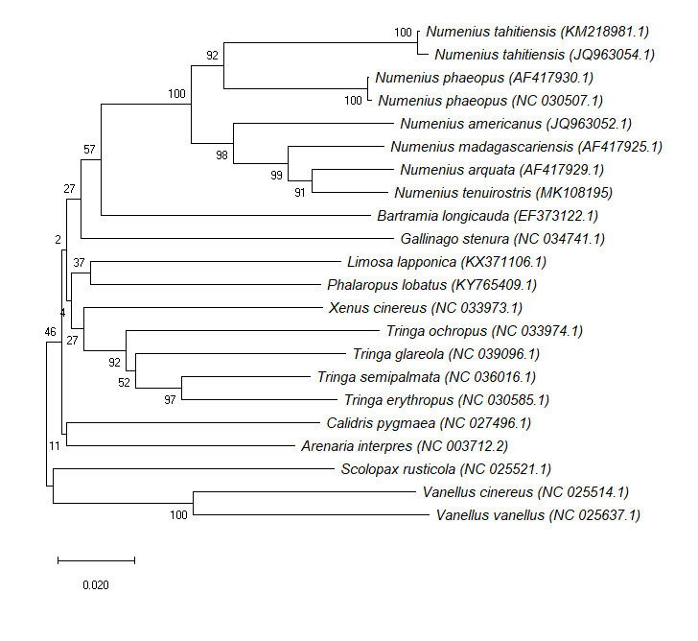
Supplementary Figure 3. Maximum likelihood phylogenetic tree reconstruction of the Numenius species, including the presumably extinct slender-billed curlew based on nucleotide variability of cytB gene

Supplementary Figure 4. Neighbour-Joining phylogenetic tree reconstruction of the Scolopacidae species, including the presumably extinct slender-billed curlew based on their CDS
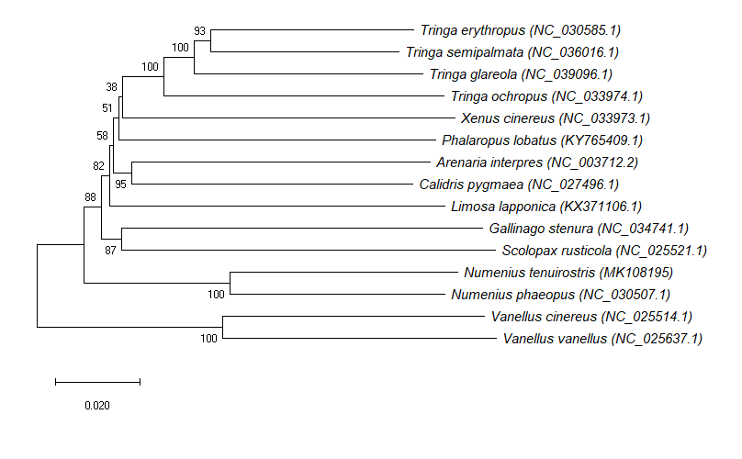
Supplementary Figure 5. Maximum likelihood phylogenetic tree reconstruction of the Scolopacidae species, including the presumably extinct slender-billed curlew based on their CDSreconstruction of the Scolopacidae species, including the presumably extinct slender-billed curlew based on their CDS

