Supporting information

Cyanoacrylate-encapsulated calcium peroxide achieved oxygen-sustained release and promoted wound healing
#Tao Zhang, #Zeye Han, Wei Zhang, Jian Wang, Liang Xu*
ªState Key Laboratory of Toxicology and Medical Countermeasures, Beijing Institute of Pharmacology and Toxicology, 27 Taiping Road, Beijing, 100850, China.
#These two authors contributed to the work equally.
*Corresponding author: xuliang24998@yahoo.com (Liang. Xu).

Figure S1. Monomer and biodegradable cross-linking cyanoacrylate (CA) copolymer

Figure S2. Schematic plan of our self-made equipment used in “Residual oxygen releasing capability test”. CaO₂ was obtained from Alfa Aesa. The volume of oxygen generated could be calculated by the shift in length of PEG600 indicator in the rubber hose.

Figure S3. Schematic plan of our self-made modified medical plasters used in “Wound healing test.”

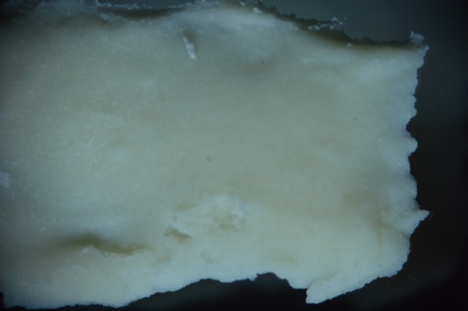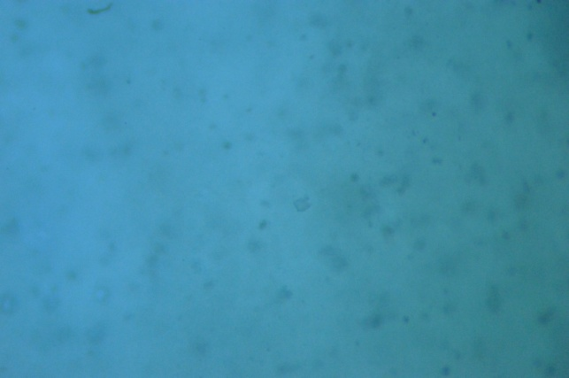
A
B
C
Figure S4. Images of poly-11-CaO₂ under a microscope. A and C, 20× magnification. B, 1× magnification.

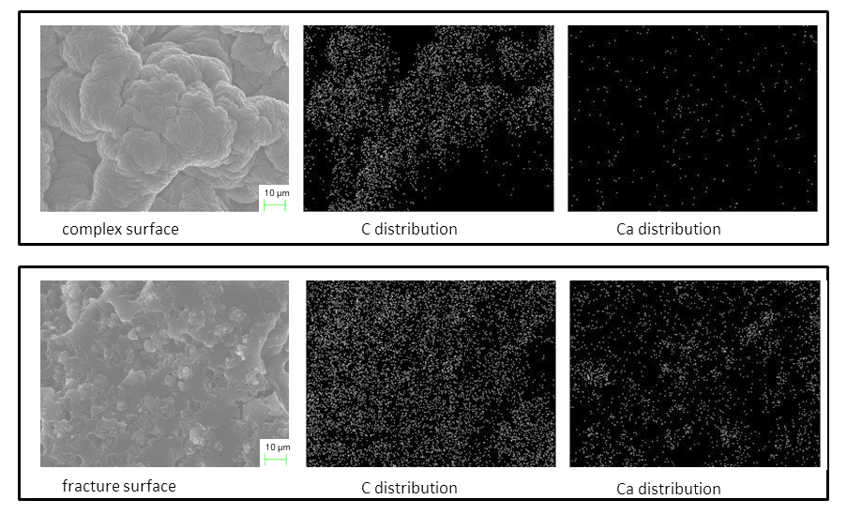
Figure S5. Elemental distribution EDS maps in the SEM test. Photographs on the top were the complex surface results under SEM; below were the fracture surface results.

Figure S6. DSC result of poly-11-CaO₂.

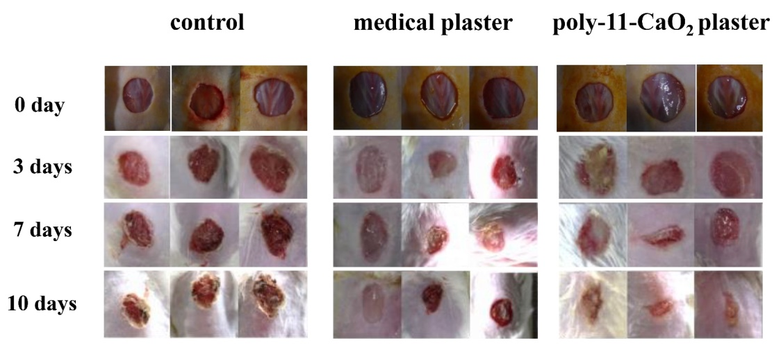
Figure S7. Photographs of wound healing for different groups at 0 day, 3 days, 7 days and 10 days, separately.

Figure S8. Histological sections stained with H&E at 10 days. The images were obtained by a Leica microscope at 100× magnification.

Table S1. The residue content of CaO₂ in poly-11-CaO₂ after placing on skin surface for 0, 1, 2, and 3 days.
Time (day) | Consumption of KMnO₄ (mL) | CaO₂ (mg)
0 | 0.48 ± 0.04 | 4.32 ± 0.39
1 | 0.34 ± 0.02 | 3.10 ± 0.18
2 | 0.23 ± 0.04 | 2.11 ± 0.34
3 | 0.09 ± 0.02 | 0.81 ± 0.16

Table S2. The pH of the skin-contacting surface of the medical plaster in the poly-11-CaO₂ group
 | Before use | 1d | 2d | 3d
pH value | 7.3 | 7.2 | 7.5 | 7.5

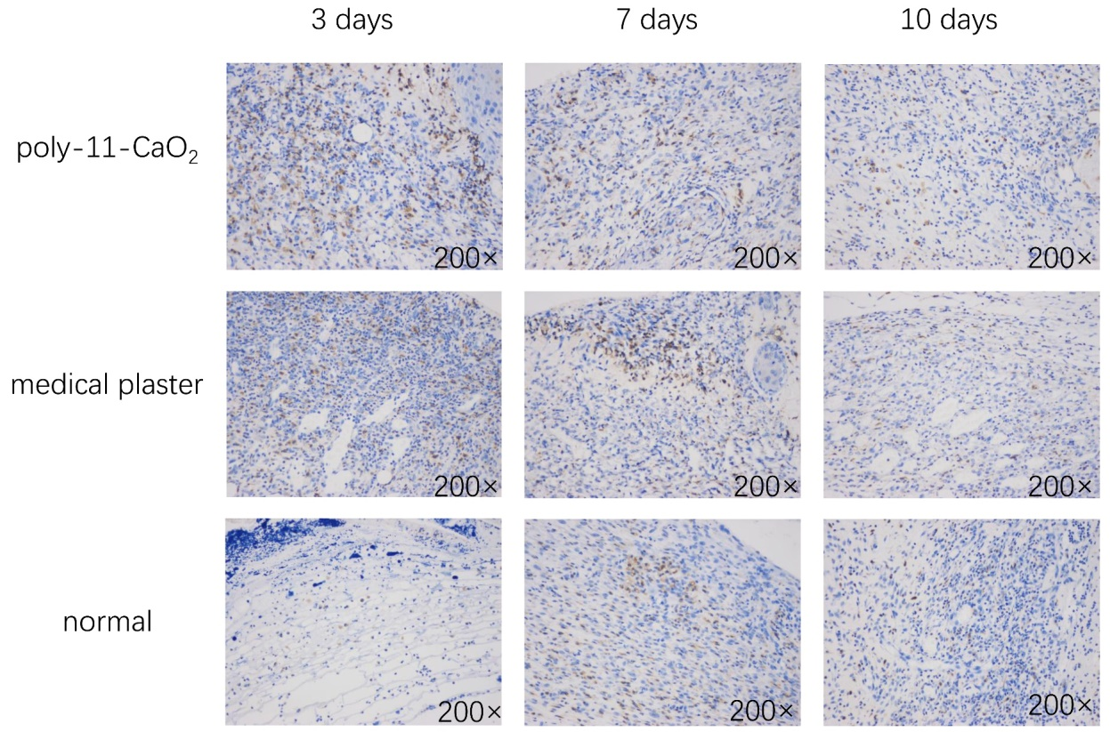
Figure S9. Immunohistochemical results of CD68 at 3 days, 7 days, and 10 days. The brown-yellow represents positive expression counterstained with 3,3′-diaminobenzidine (DAB).

Figure S10. Immunohistochemical results of EGF at 3 days, 7 days, and 10 days. The brown-yellow represents positive expression counterstained with 3,3′-diaminobenzidine (DAB).

Figure S11. Immunohistochemical results of TGF-β at 3 days, 7 days, and 10 days. The brown-yellow represents positive expression counterstained with 3,3′-diaminobenzidine (DAB).

