SUPPLEMENTARY MATERIAL

**QSPR MODELLING OF THE SOIL SORPTION COEFFICIENT FROM TRAINING SETS OF DIFFERENT SIZES**

### Carlos José Maria Olguina,*, Silvio César Sampaioa, Ralpho Rinaldo dos Reisa, Marcelo Bevilacqua Remora, Conceição de Fátima Alves Olguinb

a Graduate Program in Agricultural Engineering (PGEAGRI) – Agro-Environmental Sciences Research Group (Grupo de Pesquisa em Ciências Agro-Ambientais - PECAA) – Western Paraná State University (Universidade Estadual do Oeste do Paraná - UNIOESTE) – Cascavel, Paraná, Brazil.

b Department of Chemistry – Western Paraná State University (Universidade Estadual do Oeste do Paraná - UNIOESTE) – Toledo, Paraná, Brazil.

*Corresponding author: Carlos José Maria Olguin. E-mail: carlos.olguin@unioeste.br; Dept of Computer Science, 2069 Universitária St, 85819-110, Cascavel, PR, Brazil.

**Table S1.** Names, chemical classes, CAS numbers, experimental log ***K***oc values and log *P* values (ALOGPs algorithm) for training and test set compounds (adapted from Shao et al., 2014).

| **Mol ID** | **Status** | **Ord. Status** | **Name** | **Class** | **CAS** | **Exp log *K***oc | **ALOGPs** |
| --- | --- | --- | --- | --- | --- | --- | --- |
| 1 | training | 1 | bromotrifluoromethane | Haloalkane | 75-63-8 | 2.389 | 1.55 |
| 2 | training | 2 | carbon tetrabromide | Haloalkane | 558-13-4 | 3.237 | 3.30 |
| 3 | training | 3 | chlorotrifluoromethane | Haloalkane | 75-72-9 | 2.275 | 1.80 |
| 4 | training | 4 | dichlorodifluoromethane | Haloalkane | 75-71-8 | 2.552 | 2.06 |
| 5 | training | 5 | trichlorofluoromethane | Haloalkane | 75-69-4 | 2.753 | 2.25 |
| 6 | test | 1 | carbon tetrachloride | Haloalkane | 56-23-5 | 2.27 | 2.64 |
| 7 | training | 6 | carbon tetrafluoride | Haloalkane | 75-73-0 | 2.019 | 1.75 |
| 8 | training | 7 | bromoform | Haloalkane | 75-25-2 | 2.672 | 2.50 |
| 9 | test | 2 | chlorodifluoromethane | Haloalkane | 75-45-6 | 1.965 | 0.98 |
| 10 | training | 8 | dichlorofluoromethane | Haloalkane | 75-43-4 | 2.22 | 1.28 |
| 11 | test | 3 | chloroform | Haloalkane | 67-66-3 | 1.65 | 1.67 |
| 12 | test | 4 | fluoroform | Haloalkane | 75-46-7 | 1.725 | 0.97 |
| 13 | training | 9 | bromochloromethane | Haloalkane | 74-97-5 | 2.144 | 1.27 |
| 14 | training | 10 | dibromomethane | Haloalkane | 74-95-3 | 2.628 | 1.48 |
| 15 | training | 11 | chlorofluoromethane | Haloalkane | 593-70-4 | 1.654 | 0.62 |
| 16 | training | 12 | dichloromethane | Haloalkane | 75-09-2 | 2.057 | 1.12 |
| 17 | training | 13 | difluoromethane | Haloalkane | 75-10-5 | 1.486 | 0.29 |
| 18 | training | 14 | diiodomethane | Haloalkane | 75-11-6 | 2.737 | 2.25 |
| 19 | training | 15 | formaldehyde | Carbonyl Compounds | 50-00-0 | 1.567 | -0.68 |
| 20 | training | 16 | formic acid | Organic Acid | 64-18-6 | 1.083 | -0.47 |
| 21 | training | 17 | methyl bromide | Haloalkane | 74-83-9 | 0.79 | 0.68 |
| 22 | training | 18 | methyl chloride | Haloalkane | 74-87-3 | 1.872 | 0.67 |
| 23 | test | 5 | methyl fluoride | Haloalkane | 593-53-3 | 1.654 | 0.41 |
| 24 | test | 6 | methyl iodide | Haloalkane | 74-88-4 | 1.04 | 1.20 |
| 25 | training | 19 | formamide | Amide | 75-12-7 | 0.556 | -1.53 |
| 26 | training | 20 | nitromethane | Nitroalkane | 75-52-5 | 1.197 | -0.17 |
| 27 | training | 21 | methane | Alkane | 74-82-8 | 1.97 | -1.32 |
| 28 | training | 22 | methyl alcohol | Alcohol | 67-56-1 | 0.974 | -1.38 |
| 29 | test | 7 | methylamine | Amine | 74-89-5 | 1.067 | -1.06 |
| 30 | test | 8 | carbon disulfide | Organosulphur Comp. | 75-15-0 | 2.541 | 2.25 |
| 31 | test | 9 | 1.2-dichloro-1.1.2.2-tetrafluoroethane | Haloalkane | 76-14-2 | 2.911 | 2.57 |
| 32 | training | 23 | 1.1.2-trichloro-1.2.2-trifluoroethane | Haloalkane | 76-13-1 | 3.096 | 3.03 |
| 33 | training | 24 | tetrachloroethylene | Haloalkene | 127-18-4 | 2.31 | 3.13 |
| 34 | training | 25 | hexachloroethane | Haloalkane | 67-72-1 | 3.553 | 3.93 |
| 35 | training | 26 | hexafluoroethane | Haloalkane | 76-16-4 | 2.465 | 2.46 |
| 36 | test | 10 | halothane | Haloalkane | 151-67-7 | 2.628 | 2.50 |
| 37 | training | 27 | trichloroethylene | Haloalkene | 79-01-6 | 2.15 | 2.45 |
| 38 | training | 28 | trichloroacetaldehyde | Carbonyl Compounds | 75-87-6 | 1.916 | 1.38 |
| 39 | test | 11 | pentachloroethane | Haloalkane | 76-01-7 | 2.949 | 3.21 |
| 40 | test | 12 | acetylene | Alkenes and Alkynes | 74-86-2 | 1.578 | -0.03 |
| 41 | training | 29 | 1.1-dichloroethylene | Haloalkene | 75-35-4 | 2.536 | 1.97 |
| 42 | test | 13 | cis-1.2-dichloroethylene | Haloalkene | 156-59-2 | 2.389 | 1.85 |
| 43 | training | 30 | trans-1.2-dichloroethylene | Haloalkene | 156-60-5 | 2.427 | 1.85 |
| 44 | training | 31 | dichloroacetic acid | Organic Acid | 79-43-6 | 1.877 | 0.99 |
| 45 | training | 32 | 2.2.2-trichloroacetamide | Amide | 594-65-0 | 1.943 | 0.98 |
| 46 | training | 33 | 1.1.2.2-tetrachloroethane | Haloalkane | 79-34-5 | 2.677 | 2.57 |
| 47 | training | 34 | 1.1-difluoroethylene | Haloalkene | 75-38-7 | 2.052 | 1.56 |
| 48 | test | 14 | trifluoroacetamide | Amide | 354-38-1 | 1.442 | 0.08 |
| 49 | training | 35 | vinyl bromide | Haloalkene | 593-60-2 | 2.231 | 1.19 |
| 50 | training | 36 | bromoacetic acid | Organic Acid | 79-08-3 | 1.6 | 0.53 |
| 51 | training | 37 | vinyl chloride | Haloalkene | 75-01-4 | 2.128 | 1.43 |
| 52 | training | 38 | chloroacetic acid | Organic Acid | 79-11-8 | 1.497 | 0.18 |
| 53 | training | 39 | 1.1.1-trichloroethane | Haloalkane | 71-55-6 | 2.01 | 2.45 |
| 54 | training | 40 | 1.1.2-trichloroethane | Haloalkane | 79-00-5 | 1.8 | 2.02 |
| 55 | test | 15 | 2.2.2-trichloroethanol | Alcohol | 115-20-8 | 2.111 | 1.23 |
| 56 | test | 16 | 2.2.2-trifluoroethanol | Alcohol | 75-89-8 | 1.6 | 0.61 |
| 57 | test | 17 | acetonitrile | Nitrile | 75-05-8 | 1.192 | -0.04 |
| 58 | test | 18 | ethylene | Alkenes and Alkynes | 74-85-1 | 1.992 | 0.90 |
| 59 | training | 41 | 1.2-dibromoethane | Haloalkane | 106-93-4 | 2.443 | 2.08 |
| 60 | test | 19 | 1.1-dichloroethane | Haloalkane | 75-34-3 | 1.49 | 1.72 |
| 61 | training | 42 | 1.2-dichloroethane | Haloalkane | 107-06-2 | 1.65 | 1.48 |
| 63 | test | 20 | dichloroethane | Haloalkane | 1300-21-6 | 1.785 | 1.48 |
| 64 | training | 43 | 1.2-diiodoethane | Haloalkane | 624-73-7 | 2.851 | 2.72 |
| 65 | training | 44 | acetaldehyde | Carbonyl Compounds | 75-07-0 | 1.622 | -0.01 |
| 66 | training | 45 | ethylene oxide | Ether | 75-21-8 | 1.214 | -0.47 |
| 67 | test | 21 | acetic acid | Organic Acid | 64-19-7 | 1.285 | -0.12 |
| 68 | test | 22 | methyl formate | Ester | 107-31-3 | 1.393 | -0.31 |
| 69 | training | 46 | bromoethane | Haloalkane | 74-96-4 | 2.247 | 1.64 |
| 70 | test | 23 | ethyl chloride | Haloalkane | 75-00-3 | 2.155 | 1.47 |
| 71 | training | 47 | 2-chloroethanol | Alcohol | 107-07-3 | 1.393 | 0.00 |
| 72 | training | 48 | ethyl iodide | Haloalkane | 75-03-6 | 2.465 | 2.29 |
| 73 | training | 49 | acetamide | Amide | 60-35-5 | 0.692 | -1.10 |
| 74 | training | 50 | N-methylformamide | Amide | 123-39-7 | 0.849 | -1.31 |
| 75 | test | 24 | nitroethane | Nitroalkane | 79-24-3 | 1.475 | 0.45 |
| 76 | training | 51 | ethane | Alkane | 74-84-0 | 2.362 | 1.44 |
| 77 | test | 25 | ethyl alcohol | Alcohol | 64-17-5 | 1.214 | -0.40 |
| 78 | training | 52 | dimethyl ether | Ether | 115-10-6 | 1.431 | -0.16 |
| 79 | training | 53 | dimethyl sulfoxide | Organosulphur Comp. | 67-68-5 | 0.643 | -1.09 |
| 80 | training | 54 | ethylene glycol | Alcohol | 107-21-1 | 0.637 | -1.53 |
| 81 | training | 55 | dimethyl sulfone | Organosulphur Comp. | 67-71-0 | 0.61 | -0.95 |
| 82 | training | 56 | dimethyl sulfate | Organosulphur Comp. | 77-78-1 | 2.008 | -0.60 |
| 83 | training | 57 | dimethyl disulfide | Organosulphur Comp. | 624-92-0 | 2.34 | 1.15 |
| 84 | test | 26 | ethylamine | Amine | 75-04-7 | 1.306 | -0.20 |
| 85 | test | 27 | dimethylamine | Amine | 124-40-3 | 2.72 | -0.53 |
| 86 | test | 28 | monoethanolamine | Amine | 141-43-5 | 0.664 | -1.53 |
| 87 | training | 58 | ethylenediamine | Amine | 107-15-3 | 0.267 | -1.77 |
| 88 | training | 59 | cyanogen | Nitrile | 460-19-5 | 1.415 | -0.65 |
| 89 | training | 60 | hexafluoroacetone | Carbonyl Compounds | 684-16-2 | 2.171 | 1.77 |
| 90 | training | 61 | malononitrile | Nitrile | 109-77-3 | 1.051 | -0.84 |
| 91 | test | 29 | acrylonitrile | Nitrile | 107-13-1 | 1.513 | 0.20 |
| 92 | training | 62 | oxazole | Aromatic Heterocycle | 288-42-6 | 1.442 | -0.09 |
| 93 | training | 63 | thiazole | Aromatic Heterocycle | 288-47-1 | 1.616 | 0.89 |
| 94 | test | 30 | methylacetylene | Alkenes and Alkynes | 74-99-7 | 1.888 | 0.92 |
| 95 | training | 64 | allene | Alkenes and Alkynes | 463-49-0 | 2.166 | 1.67 |
| 96 | training | 65 | cis-1.2-dichloropropene | Haloalkene | 6923-20-2 | 2.481 | 2.10 |
| 97 | training | 66 | imidazole | Aromatic Heterocycle | 288-32-4 | 1.333 | -0.21 |
| 98 | training | 67 | 1H-pyrazole | Aromatic Heterocycle | 288-13-1 | 1.448 | 0.03 |
| 99 | training | 68 | acrolein | Carbonyl Compounds | 107-02-8 | 1.372 | 0.18 |
| 100 | test | 31 | propargyl alcohol | Alcohol | 107-19-7 | 1.17 | -0.70 |
| 101 | test | 32 | acrylic acid | Organic Acid | 79-10-7 | 1.567 | 0.46 |
| 102 | test | 33 | 3-bromo-1-propene | Haloalkene | 106-95-6 | 2.351 | 1.98 |
| 103 | test | 34 | 2-chloro-1-propene | Haloalkene | 557-98-2 | 2.465 | 1.88 |
| 104 | training | 69 | α-epichlorohydrin | Ether | 106-89-8 | 1.54 | 0.35 |
| 105 | training | 70 | 1.2.3-trichloropropane | Haloalkane | 96-18-4 | 2.612 | 2.29 |
| 106 | test | 35 | propionitrile | Nitrile | 107-12-0 | 1.464 | -0.01 |
| 107 | training | 71 | acrylamide | Amide | 79-06-1 | 0.953 | -0.65 |
| 108 | test | 36 | lactonitrile | Nitrile | 78-97-7 | 0.866 | -0.65 |
| 109 | training | 72 | nitroglycerine | Other compounds | 55-63-0 | 2.258 | 1.25 |
| 110 | test | 37 | cyclopropane | Alkane | 75-19-4 | 2.313 | 1.56 |
| 111 | test | 38 | propylene | Alkenes and Alkynes | 115-07-1 | 2.34 | 1.68 |
| 112 | training | 73 | 1.2-dichloropropane | Haloalkane | 78-87-5 | 2.465 | 2.13 |
| 113 | training | 74 | allyl alcohol | Alcohol | 107-18-6 | 1.469 | -0.03 |
| 114 | training | 75 | propionaldehyde | Carbonyl Compounds | 123-38-6 | 1.698 | 0.31 |
| 115 | test | 39 | acetone | Carbonyl Compounds | 67-64-1 | 1.246 | -0.29 |
| 116 | training | 76 | 1.2-propylene oxide | Ether | 75-56-9 | 1.393 | 0.04 |
| 117 | training | 77 | 1.3-propylene oxide | Ether | 503-30-0 | 1.301 | 0.05 |
| 119 | training | 78 | propanoic acid | Organic Acid | 79-09-4 | 1.557 | 0.31 |
| 120 | training | 79 | ethyl formate | Organic Acid | 109-94-4 | 1.502 | 0.38 |
| 121 | training | 80 | methyl acetate | Organic Acid | 79-20-9 | 1.475 | 0.18 |
| 122 | test | 40 | 3-mercaptopropionic acid | Organic Acid | 107-96-0 | 1.611 | 0.34 |
| 123 | test | 41 | lactic acid | Organic Acid | 50-21-5 | 0.985 | -0.79 |
| 124 | test | 42 | trioxane | Heterocycle | 110-88-3 | 1.143 | -0.95 |
| 125 | training | 81 | 1-bromopropane | Haloalkane | 106-94-5 | 2.519 | 2.18 |
| 126 | test | 43 | 2-bromopropane | Haloalkane | 75-26-3 | 2.411 | 1.83 |
| 127 | test | 44 | 1-chloropropane | Haloalkane | 540-54-5 | 2.487 | 2.09 |
| 128 | training | 82 | 2-chloropropane | Haloalkane | 75-29-6 | 2.411 | 1.49 |
| 129 | training | 83 | 1-iodopropane | Haloalkane | 107-08-4 | 2.737 | 2.65 |
| 130 | training | 84 | 2-iodopropane | Haloalkane | 75-30-9 | 2.949 | 2.59 |
| 131 | test | 45 | allylamine | Amine | 107-11-9 | 1.393 | -0.43 |
| 132 | training | 85 | N,N-dimethylformamide | Amide | 68-12-2 | 0.828 | -0.77 |
| 133 | training | 86 | N-methylacetamide | Amide | 79-16-3 | 0.806 | -1.06 |
| 134 | training | 87 | 1-nitropropane | Nitroalkane | 108-03-2 | 1.85 | 0.91 |
| 135 | training | 88 | 2-nitropropane | Nitroalkane | 79-46-9 | 1.883 | 0.71 |
| 136 | training | 89 | propane | Alkane | 74-98-6 | 2.661 | 2.19 |
| 137 | training | 90 | glyphosate | Organophosphorus Comp. | 1071-83-6 | 3.46 | -2.43 |
| 138 | training | 91 | propyl alcohol | Alcohol | 71-23-8 | 1.513 | 0.21 |
| 139 | training | 92 | isopropyl alcohol | Alcohol | 67-63-0 | 1.404 | 0.04 |
| 140 | training | 93 | 2-methoxyethanol | Alcohol | 109-86-4 | 0.958 | -0.78 |
| 141 | training | 94 | 1.2-propanediol | Alcohol | 57-55-6 | 0.877 | -1.10 |
| 142 | test | 46 | 1.3-propanediol | Alcohol | 504-63-2 | 0.811 | -1.18 |
| 143 | test | 47 | glycerol | Alcohol | 56-81-5 | 0.42 | -1.93 |
| 144 | test | 48 | propyl mercaptan | Organosulphur Comp. | 107-03-9 | 2.362 | 1.72 |
| 145 | training | 95 | methyl ethyl sulfide | Organosulphur Comp. | 624-89-5 | 2.215 | 1.16 |
| 146 | training | 96 | propylamine | Amine | 107-10-8 | 1.638 | 0.31 |
| 147 | training | 97 | isopropylamine | Amine | 75-31-0 | 1.518 | -0.05 |
| 148 | training | 98 | methylethylamine | Amine | 624-78-2 | 1.459 | 0.13 |
| 149 | training | 99 | trimethylamine | Amine | 75-50-3 | 1.464 | -0.14 |
| 150 | training | 100 | 1-amino-2-propanol | Amine | 78-96-6 | 0.855 | -1.03 |
| 151 | test | 49 | 3-amino-1-propanol | Amine | 156-87-6 | 0.768 | -1.01 |
| 152 | training | 101 | methylethanolamine | Amine | 109-83-1 | 0.866 | -1.05 |
| 153 | training | 102 | trimethyl phosphate | Organophosphorus Comp. | 512-56-1 | 1.023 | -0.61 |
| 154 | training | 103 | hexachloro-1.3-butadiene | Alkenes and Alkynes | 87-68-3 | 3.977 | 4.86 |
| 155 | test | 50 | succinonitrile | Nitrile | 110-61-2 | 0.838 | -0.75 |
| 156 | training | 104 | pyrimidine | Aromatic Heterocycle | 289-95-2 | 1.159 | -0.21 |
| 157 | test | 51 | furan | Aromatic Heterocycle | 110-00-9 | 2.106 | 1.24 |
| 158 | test | 52 | fumaric acid | Organic Acid | 110-17-8 | 1.627 | 0.21 |
| 159 | training | 105 | maleic acid | Organic Acid | 110-16-7 | 1.116 | 0.21 |
| 160 | training | 106 | thiophene | Aromatic Heterocycle | 110-02-1 | 2.362 | 1.89 |
| 161 | training | 107 | methacrylonitrile | Nitrile | 126-98-7 | 1.747 | 0.91 |
| 162 | test | 53 | vinylacetonitrile | Nitrile | 109-75-1 | 1.595 | 0.61 |
| 163 | training | 108 | pyrrole | Aromatic Heterocycle | 109-97-7 | 1.785 | 0.76 |
| 164 | training | 109 | methyl cyanoacetate | Organic Acid | 105-34-0 | 1.121 | -0.10 |
| 165 | training | 110 | dimethylacetylene | Alkenes and Alkynes | 503-17-3 | 2.171 | 1.70 |
| 166 | training | 111 | 1.3 butadiene | Alkenes and Alkynes | 106-99-0 | 2.46 | 1.94 |
| 167 | training | 112 | 2.5-dihydrofuran | Heterocycle | 1708-29-8 | 1.627 | 0.48 |
| 168 | training | 113 | γ-butyrolactone | Ester | 96-48-0 | 1.029 | -0.11 |
| 169 | training | 114 | methacrylic acid | Organic Acid | 79-41-4 | 1.883 | 0.63 |
| 170 | test | 54 | methyl acrylate | Organic Acid | 96-33-3 | 1.812 | 0.67 |
| 171 | training | 115 | vinyl acetate | Organic Acid | 108-05-4 | 1.774 | 0.83 |
| 172 | training | 116 | succinic acid | Organic Acid | 110-15-6 | 1.056 | -0.53 |
| 173 | training | 117 | butyronitrile | Nitrile | 109-74-0 | 1.703 | 0.59 |
| 174 | training | 118 | isobutyronitrile | Nitrile | 78-82-0 | 1.627 | 0.50 |
| 175 | training | 119 | 2-pyrrolidone | Amide | 616-45-5 | 0.915 | -0.90 |
| 176 | training | 120 | 1-butene | Alkenes and Alkynes | 106-98-9 | 2.683 | 2.21 |
| 177 | training | 121 | cis-2-butene | Alkenes and Alkynes | 590-18-1 | 2.645 | 2.32 |
| 178 | training | 122 | trans-2-butene | Alkenes and Alkynes | 624-64-6 | 2.634 | 2.32 |
| 179 | training | 123 | isobutene | Alkenes and Alkynes | 115-11-7 | 2.655 | 1.87 |
| 180 | training | 124 | bis(2-chloroethyl) ether | Ether | 111-44-4 | 1.986 | 1.23 |
| 181 | training | 125 | ethyl vinyl ether | Alkenes and Alkynes | 109-92-2 | 1.943 | 1.19 |
| 182 | training | 126 | butyraldehyde | Carbonyl Compounds | 123-72-8 | 1.856 | 1.10 |
| 183 | training | 127 | methyl ethyl ketone | Carbonyl Compounds | 78-93-3 | 1.535 | 0.41 |
| 184 | test | 55 | tetrahydrofuran | Ether | 109-99-9 | 1.627 | 0.35 |
| 185 | training | 128 | butyric acid | Organic Acid | 107-92-6 | 1.807 | 0.78 |
| 186 | training | 129 | isobutyric acid | Organic Acid | 79-31-2 | 1.888 | 0.78 |
| 187 | training | 130 | propyl formate | Ester | 110-74-7 | 1.829 | 0.93 |
| 188 | test | 56 | ethyl acetate | Ester | 141-78-6 | 1.774 | 0.74 |
| 189 | training | 131 | methyl propanoate | Ester | 554-12-1 | 1.834 | 0.68 |
| 190 | training | 132 | 1.4-dioxane | Heterocycle | 123-91-1 | 1.149 | -0.23 |
| 191 | test | 57 | sulfolane | Organosulphur Comp. | 126-33-0 | 0.958 | -0.65 |
| 192 | test | 58 | 1-bromobutane | Haloalkane | 109-65-9 | 2.873 | 2.73 |
| 193 | training | 133 | 1-chlorobutane | Haloalkane | 109-69-3 | 2.813 | 2.37 |
| 194 | test | 59 | 2-chlorobutane | Haloalkane | 78-86-4 | 2.645 | 2.34 |
| 195 | training | 134 | 1-fluorobutane | Haloalkane | 2366-52-1 | 2.781 | 1.79 |
| 196 | test | 60 | 1-iodobutane | Haloalkane | 542-69-8 | 3.009 | 3.11 |
| 197 | training | 135 | pyrrolidine | Heterocycle | 123-75-1 | 1.627 | 0.16 |
| 198 | training | 136 | N,N-dimethylacetamide | Amide | 127-19-5 | 0.958 | -0.59 |
| 199 | training | 137 | morpholine | Heterocycle | 110-91-8 | 0.398 | -0.75 |
| 200 | training | 138 | butanamide | Amide | 541-35-5 | 1.263 | -0.13 |
| 201 | training | 139 | 1-nitrobutane | Nitroalkane | 627-05-4 | 2.177 | 1.49 |
| 202 | training | 140 | butane | Alkane | 106-97-8 | 2.949 | 2.81 |
| 203 | training | 141 | piperazine | Heterocycle | 110-85-0 | 0.741 | -1.16 |
| 204 | training | 142 | butanol | Alcohol | 71-36-3 | 1.834 | 0.84 |
| 205 | test | 61 | isobutanol | Alcohol | 78-83-1 | 1.79 | 0.60 |
| 206 | training | 143 | sec-butanol | Alcohol | 78-92-2 | 1.731 | 0.66 |
| 207 | training | 144 | tert-butanol | Alcohol | 75-65-0 | 1.567 | 0.70 |
| 208 | test | 62 | diethyl ether | Ether | 60-29-7 | 1.861 | 1.12 |
| 209 | training | 145 | methyl propyl ether | Ether | 557-17-5 | 2.035 | 0.90 |
| 210 | test | 63 | 1.2-dimethoxyethane | Ether | 110-71-4 | 1.263 | 0.03 |
| 211 | test | 64 | 2-ethoxyethanol | Alcohol | 110-80-5 | 1.203 | -0.28 |
| 212 | training | 146 | 1.4-butanediol | Alcohol | 110-63-4 | 0.925 | -0.63 |
| 213 | training | 147 | diethyl sulfate | Organosulphur Comp. | 64-67-5 | 1.997 | -0.29 |
| 214 | test | 65 | butyl mercaptan | Organosulphur Comp. | 109-79-5 | 2.617 | 2.51 |
| 215 | test | 66 | diethyl sulfide | Organosulphur Comp. | 352-93-2 | 2.438 | 2.46 |
| 216 | training | 148 | butylamine | Amine | 109-73-9 | 1.845 | 0.85 |
| 217 | training | 149 | isobutylamine | Amine | 78-81-9 | 1.774 | 0.54 |
| 218 | training | 150 | tert-butylamine | Amine | 75-64-9 | 1.595 | 0.81 |
| 219 | test | 67 | diethylamine | Amine | 109-89-7 | 1.693 | 0.76 |
| 220 | test | 68 | diethanolamine | Amine | 111-42-2 | 0.599 | -1.41 |
| 221 | training | 151 | hexachlorocyclopentadiene | Alkenes and Alkynes | 77-47-4 | 4.119 | 4.85 |
| 222 | training | 152 | furfural | Aromatic Heterocycle | 98-01-1 | 1.6 | 0.43 |
| 223 | test | 69 | pyridine | Aromatic Heterocycle | 110-86-1 | 1.731 | 0.70 |
| 224 | training | 153 | glutaronitrile | Nitrile | 544-13-8 | 0.985 | -0.49 |
| 225 | training | 154 | 2-methylfuran | Aromatic Heterocycle | 534-22-5 | 2.383 | 1.75 |
| 226 | test | 70 | furfuryl alcohol | Aromatic Heterocycle | 98-00-0 | 1.529 | 0.25 |
| 227 | training | 155 | 2-methylthiophene | Aromatic Heterocycle | 554-14-3 | 2.645 | 2.30 |
| 228 | test | 71 | 3-methylthiophene | Aromatic Heterocycle | 616-44-4 | 2.65 | 2.28 |
| 229 | test | 72 | N-methylpyrrole | Aromatic Heterocycle | 96-54-8 | 2.035 | 1.31 |
| 230 | training | 156 | isoprene | Alkenes and Alkynes | 78-79-5 | 2.693 | 2.22 |
| 231 | training | 157 | cis-1.3-pentadiene | Alkenes and Alkynes | 1574-41-0 | 2.683 | 2.65 |
| 232 | training | 158 | trans-1.3-pentadiene | Alkenes and Alkynes | 2004-70-8 | 2.704 | 2.65 |
| 233 | training | 159 | 1.4-pentadiene | Alkenes and Alkynes | 591-93-5 | 2.726 | 2.39 |
| 234 | training | 160 | 1-pentyne | Alkenes and Alkynes | 627-19-0 | 2.454 | 2.13 |
| 235 | training | 161 | acetylacetone | Carbonyl Compounds | 123-54-6 | 1.595 | -0.20 |
| 236 | test | 73 | allyl acetate | Ester | 591-87-7 | 1.905 | 1.03 |
| 237 | training | 162 | ethyl acrylate | Ester | 140-88-5 | 2.095 | 1.24 |
| 238 | training | 163 | methyl methacrylate | Ester | 80-62-6 | 2.128 | 1.10 |
| 239 | training | 164 | 2-hydroxyethyl acrylate | Ester | 818-61-1 | 1.263 | 0.04 |
| 240 | test | 74 | levulinic acid | Organic Acid | 123-76-2 | 1.11 | -0.14 |
| 241 | training | 165 | glutaric acid | Organic Acid | 110-94-1 | 1.219 | -0.25 |
| 242 | training | 166 | valeronitrile | Nitrile | 110-59-8 | 1.888 | 1.10 |
| 243 | training | 167 | N-methyl-2-pyrrolidone | Amide | 872-50-4 | 1.17 | -0.72 |
| 244 | test | 75 | L-glutamic acid | Organic Acid | 56-86-0 | -0.63 | -3.54 |
| 245 | training | 168 | cyclopentane | Alkane | 287-92-3 | 3.009 | 2.88 |
| 246 | test | 76 | methyl propyl ketone | Carbonyl Compounds | 107-87-9 | 1.834 | 0.87 |
| 247 | training | 169 | diethyl ketone | Carbonyl Compounds | 96-22-0 | 1.823 | 1.19 |
| 248 | training | 170 | methyl isopropyl ketone | Carbonyl Compounds | 563-80-4 | 1.682 | 0.78 |
| 249 | test | 77 | 2-methyltetrahydrofuran | Ether | 96-47-9 | 2.383 | 0.96 |
| 250 | test | 78 | tetrahydropyran | Ether | 142-68-7 | 1.823 | 1.16 |
| 251 | training | 171 | pentanoic acid | Organic Acid | 109-52-4 | 2.133 | 1.34 |
| 252 | training | 172 | 3-methylbutanoic acid | Organic Acid | 503-74-2 | 2.008 | 1.26 |
| 253 | test | 79 | propyl acetate | Ester | 109-60-4 | 2.052 | 1.28 |
| 254 | training | 173 | ethyl propanoate | Ester | 105-37-3 | 2.035 | 1.32 |
| 255 | training | 174 | methyl butanoate | Ester | 623-42-7 | 2.079 | 1.22 |
| 256 | training | 175 | diethyl carbonate | Ester | 105-58-8 | 2.035 | 0.86 |
| 257 | training | 176 | 1-bromopentane | Haloalkane | 110-53-2 | 3.21 | 3.27 |
| 258 | test | 80 | 1-chloropentane | Haloalkane | 543-59-9 | 2.862 | 3.12 |
| 259 | training | 177 | 2-chloro-2-methylbutane | Haloalkane | 594-36-5 | 2.748 | 2.95 |
| 260 | training | 178 | 1-fluoropentane | Haloalkane | 592-50-7 | 2.645 | 2.93 |
| 261 | test | 81 | N-methylpyrrolidine | Heterocycle | 120-94-5 | 1.877 | 0.54 |
| 262 | training | 179 | piperidine | Heterocycle | 110-89-4 | 1.834 | 0.97 |
| 263 | training | 180 | 1-nitropentane | Nitroalkane | 628-05-7 | 2.47 | 2.00 |
| 264 | training | 181 | pentane | Alkane | 109-66-0 | 3.254 | 3.41 |
| 265 | training | 182 | isopentane | Alkane | 78-78-4 | 2.628 | 3.12 |
| 266 | training | 183 | neopentane | Alkane | 463-82-1 | 3.069 | 2.95 |
| 267 | training | 184 | dimethoate | Organophosphorus Comp. | 60-51-5 | 2.56 | 1.21 |
| 268 | training | 185 | 1-pentanol | Alcohol | 71-41-0 | 2.198 | 1.47 |
| 269 | training | 186 | 2-pentanol | Alcohol | 6032-29-7 | 2.057 | 1.18 |
| 270 | test | 82 | 3-pentanol | Alcohol | 584-02-1 | 2.035 | 1.22 |
| 271 | training | 187 | 2-methyl-1-butanol | Alcohol | 137-32-6 | 2.079 | 1.24 |
| 272 | training | 188 | 3-methyl-1-butanol | Alcohol | 123-51-3 | 2.073 | 1.33 |
| 273 | training | 189 | tert-pentyl-alcohol | Alcohol | 75-85-4 | 1.861 | 1.19 |
| 274 | test | 83 | 3-methyl-2-butanol | Alcohol | 598-75-4 | 2.073 | 0.89 |
| 275 | training | 190 | 2.2-dimethyl-1-propanol | Alcohol | 75-84-3 | 2.09 | 1.15 |
| 276 | test | 84 | methyl tert-butyl ether | Ether | 1634-04-4 | 1.888 | 1.53 |
| 277 | training | 191 | pentaerythritol | Alcohol | 115-77-5 | 0.458 | -1.92 |
| 278 | training | 192 | pentylamine | Amine | 110-58-7 | 2.188 | 1.39 |
| 279 | training | 193 | hexachlorobenzene | Halobenzene | 118-74-1 | 4.49 | 5.70 |
| 280 | training | 194 | hexafluorobenzene | Halobenzene | 392-56-3 | 2.764 | 2.33 |
| 281 | test | 85 | pentachlorobenzene | Halobenzene | 608-93-5 | 4.113 | 5.22 |
| 282 | test | 86 | pentachlorophenol | Phenols | 87-86-5 | 2.47 | 4.99 |
| 283 | training | 195 | 1.2.3.4-tetrachlorobenzene | Halobenzene | 634-66-2 | 3.52 | 4.62 |
| 284 | training | 196 | 1.2.3.5-tetrachlorobenzene | Halobenzene | 634-90-2 | 3.52 | 4.63 |
| 285 | test | 87 | 1.2.4.5-tetrachlorobenzene | Halobenzene | 95-94-3 | 3.72 | 4.61 |
| 286 | training | 197 | 2.3.4.5-tetrachlorophenol | Phenols | 4901-51-3 | 2.88 | 4.41 |
| 287 | test | 88 | 2.3.4.6-tetrachlorophenol | Phenols | 58-90-2 | 2.88 | 4.37 |
| 288 | training | 198 | 2.3.5.6-tetrachlorophenol | Phenols | 935-95-5 | 2.88 | 4.45 |
| 289 | test | 89 | 1-chloro-2.4-dinitrobenzene | Nitrobenzene | 97-00-7 | 2.557 | 2.29 |
| 290 | test | 90 | 1.2-dichloro-4-nitrobenzene | Nitrobenzene | 99-54-7 | 2.53 | 3.11 |
| 291 | test | 91 | 1.2.4-trichlorobenzene | Halobenzene | 120-82-1 | 3.11 | 4.08 |
| 292 | test | 92 | 1.2.3-trichlorobenzene | Halobenzene | 87-61-6 | 3.23 | 4.07 |
| 293 | training | 199 | 1.3.5-trichlorobenzene | Halobenzene | 108-70-3 | 2.85 | 4.08 |
| 295 | training | 200 | 2.3.4-trichlorophenol | Phenols | 15950-66-0 | 1.96 | 3.78 |
| 296 | training | 201 | 2.3.5-trichlorophenol | Phenols | 933-78-8 | 1.96 | 3.77 |
| 297 | test | 93 | 2.3.6-trichlorophenol | Phenols | 933-75-5 | 1.96 | 3.77 |
| 298 | training | 202 | 2.4.5-trichlorophenol | Phenols | 95-95-4 | 1.96 | 3.79 |
| 299 | training | 203 | 2.4.6-trichlorophenol | Phenols | 88-06-2 | 1.96 | 3.78 |
| 300 | test | 94 | 3.4.5-trichlorophenol | Phenols | 609-19-8 | 1.96 | 3.77 |
| 301 | test | 95 | nitrapyrin | Aromatic Heterocycle | 1929-82-4 | 2.24 | 3.87 |
| 302 | training | 204 | 1.3.5-trinitrobenzene | Nitrobenzene | 99-35-4 | 2.019 | 1.54 |
| 303 | test | 96 | 1-bromo-2-chlorobenzene | Halobenzene | 694-80-4 | 2.6 | 3.61 |
| 304 | training | 205 | 1-bromo-3-chlorobenzene | Halobenzene | 108-37-2 | 2.6 | 3.59 |
| 305 | training | 206 | 1-bromo-4-chlorobenzene | Halobenzene | 106-39-8 | 2.6 | 3.63 |
| 307 | test | 97 | 3-bromo-5-chlorophenol | Phenols | 56962-04-0 | 2.6 | 3.14 |
| 308 | training | 207 | 4-bromo-2-chlorophenol | Phenols | 3964-56-5 | 2.6 | 3.15 |
| 309 | training | 208 | 2-bromo-4-chlorophenol | Phenols | 695-96-5 | 2.6 | 3.12 |
| 310 | training | 209 | 1-bromo-2-nitrobenzene | Nitrobenzene | 577-19-5 | 2.42 | 2.59 |
| 311 | test | 98 | 1-bromo-3-nitrobenzene | Nitrobenzene | 585-79-5 | 2.42 | 2.61 |
| 312 | training | 210 | 1-bromo-4-nitrobenzene | Nitrobenzene | 586-78-7 | 2.42 | 2.66 |
| 313 | training | 211 | m-dibromobenzene | Halobenzene | 108-36-1 | 3.417 | 3.73 |
| 314 | training | 212 | m-chloronitrobenzene | Nitrobenzene | 121-73-3 | 2.715 | 2.49 |
| 315 | training | 213 | o-chloronitrobenzene | Nitrobenzene | 88-73-3 | 2.596 | 2.48 |
| 316 | test | 99 | p-chloronitrobenzene | Nitrobenzene | 100-00-5 | 2.677 | 2.56 |
| 317 | test | 100 | o-dichlorobenzene | Halobenzene | 95-50-1 | 2.78 | 3.45 |
| 318 | training | 214 | m-dichlorobenzene | Halobenzene | 541-73-1 | 2.78 | 3.45 |
| 319 | training | 215 | p-dichlorobenzene | Halobenzene | 106-46-7 | 2.78 | 3.46 |
| 320 | test | 101 | 2.3-dichlorophenol | Phenols | 576-24-9 | 2.55 | 3.15 |
| 321 | training | 216 | 2.4-dichlorophenol | Phenols | 120-83-2 | 2.55 | 3.14 |
| 322 | training | 217 | 2.5-dichlorophenol | Phenols | 583-78-8 | 2.55 | 3.13 |
| 323 | test | 102 | 2.6-dichlorophenol | Phenols | 87-65-0 | 2.55 | 3.15 |
| 324 | training | 218 | 3.4-dichlorophenol | Phenols | 95-77-2 | 2.55 | 3.12 |
| 325 | training | 219 | 3.5-dichlorophenol | Phenols | 591-35-5 | 2.55 | 3.09 |
| 326 | test | 103 | m-difluorobenzene | Halobenzene | 372-18-9 | 2.579 | 2.25 |
| 327 | test | 104 | o-difluorobenzene | Halobenzene | 367-11-3 | 2.666 | 2.24 |
| 328 | training | 220 | p-difluorobenzene | Halobenzene | 540-36-3 | 2.536 | 2.26 |
| 329 | test | 105 | m-dinitrobenzene | Nitrobenzene | 99-65-0 | 2.188 | 1.70 |
| 330 | training | 221 | o-dinitrobenzene | Nitrobenzene | 528-29-0 | 2.296 | 1.64 |
| 331 | test | 106 | p-dinitrobenzene | Nitrobenzene | 100-25-4 | 2.171 | 1.70 |
| 332 | training | 222 | bromobenzene | Halobenzene | 108-86-1 | 3.004 | 2.65 |
| 333 | test | 107 | o-bromophenol | Phenols | 95-56-7 | 2.41 | 2.52 |
| 334 | training | 223 | m-bromophenol | Phenols | 591-20-8 | 2.41 | 2.46 |
| 335 | training | 224 | p-bromophenol | Phenols | 106-41-2 | 2.41 | 2.50 |
| 337 | training | 225 | chlorobenzene | Halobenzene | 108-90-7 | 2.22 | 2.78 |
| 338 | training | 226 | m-chlorophenol | Phenols | 108-43-0 | 1.82 | 2.35 |
| 339 | training | 227 | o-chlorophenol | Phenols | 95-57-8 | 1.71 | 2.40 |
| 340 | test | 108 | p-chlorophenol | Phenols | 106-48-9 | 1.85 | 2.37 |
| 341 | training | 228 | 3.4-dichloroaniline | Anilines | 95-76-1 | 0.67 | 2.74 |
| 342 | training | 229 | 2.3-dichloroaniline | Anilines | 608-27-5 | 0.67 | 2.73 |
| 343 | test | 109 | 2.4-dichloroaniline | Anilines | 554-00-7 | 0.67 | 2.73 |
| 344 | training | 230 | 2.5-dichloroaniline | Anilines | 95-82-9 | 0.67 | 2.72 |
| 345 | training | 231 | 2.6-dichloroaniline | Anilines | 608-31-1 | 0.67 | 2.74 |
| 346 | test | 110 | 3.5-dichloroaniline | Anilines | 626-43-7 | 0.67 | 2.71 |
| 347 | training | 232 | fluorobenzene | Halobenzene | 462-06-6 | 2.612 | 2.18 |
| 348 | training | 233 | iodobenzene | Halobenzene | 591-50-4 | 3.161 | 3.00 |
| 349 | training | 234 | nitrobenzene | Nitrobenzene | 98-95-3 | 2.01 | 1.89 |
| 350 | training | 235 | o-nitrophenol | Phenols | 88-75-5 | 2.06 | 1.91 |
| 351 | test | 111 | m-nitrophenol | Phenols | 554-84-7 | 1.72 | 1.92 |
| 352 | training | 236 | p-nitrophenol | Phenols | 100-02-7 | 2.72 | 1.93 |
| 353 | test | 112 | benzene | Benzene and Alkylbenzene | 71-43-2 | 1.87 | 2.03 |
| 354 | training | 237 | o-bromoaniline | Anilines | 615-36-1 | 1.96 | 2.14 |
| 355 | training | 238 | m-bromoaniline | Anilines | 591-19-5 | 1.96 | 2.16 |
| 356 | test | 113 | p-bromoaniline | Anilines | 106-40-1 | 1.96 | 2.10 |
| 357 | training | 239 | m-chloroaniline | Anilines | 108-42-9 | 3.13 | 1.93 |
| 358 | training | 240 | o-chloroaniline | Anilines | 95-51-2 | 3.13 | 1.93 |
| 359 | test | 114 | p-chloroaniline | Anilines | 106-47-8 | 3.13 | 1.95 |
| 360 | test | 115 | 1α.2α.3ß.4α.5α.6ß-hexachlorocyclohexane | Haloalkane | 58-89-9 | 3.41 | 3.94 |
| 361 | test | 116 | 1α.2ß.3α.4ß.5α.6ß-hexachlorocyclohexane | Haloalkane | 319-85-7 | 3.12 | 3.94 |
| 362 | training | 241 | 1α.2α.3α.4ß.5α.6ß-hexachlorocyclohexane | Haloalkane | 319-86-8 | 3.3 | 3.94 |
| 364 | test | 117 | a-hexachlorocyclohexane | Haloalkane | 319-84-6 | 3.3 | 3.94 |
| 366 | test | 118 | m-nitroaniline | Anilines | 99-09-2 | 2.122 | 1.53 |
| 367 | training | 242 | o-nitroaniline | Anilines | 88-74-4 | 2.383 | 1.43 |
| 368 | test | 119 | p-nitroaniline | Anilines | 100-01-6 | 2.133 | 1.50 |
| 369 | training | 243 | phenol | Phenols | 108-95-2 | 1.74 | 1.39 |
| 370 | test | 120 | pyrocatechol | Phenols | 120-80-9 | 2.07 | 0.74 |
| 371 | test | 121 | resorcinol | Phenols | 108-46-3 | 1.02 | 0.70 |
| 372 | test | 122 | p-hydroquinone | Phenols | 123-31-9 | 1.698 | 0.71 |
| 373 | test | 123 | phenyl mercaptan | Organosulphur Comp. | 108-98-5 | 2.748 | 2.26 |
| 374 | training | 244 | aniline | Anilines | 62-53-3 | 1.867 | 0.89 |
| 375 | test | 124 | 2-methylpyridine | Aromatic Heterocycle | 109-06-8 | 1.981 | 1.25 |
| 376 | training | 245 | 3-methylpyridine | Aromatic Heterocycle | 108-99-6 | 2.03 | 1.11 |
| 377 | test | 125 | 4-methylpyridine | Aromatic Heterocycle | 108-89-4 | 2.041 | 1.14 |
| 378 | training | 246 | 1.4-cyclohexadiene | Alkenes and Alkynes | 628-41-1 | 2.721 | 2.31 |
| 379 | training | 247 | adiponitrile | Nitrile | 111-69-3 | 1.203 | -0.14 |
| 380 | training | 248 | m-phenylenediamine | Anilines | 108-45-2 | 1.197 | 0.01 |
| 381 | training | 249 | o-phenylenediamine | Anilines | 95-54-5 | 1.459 | -0.08 |
| 382 | training | 250 | p-phenylenediamine | Anilines | 106-50-3 | 1.214 | -0.01 |
| 383 | test | 126 | phenylhydrazine | Other compounds | 100-63-0 | 2.057 | 0.95 |
| 384 | test | 127 | 2-ethylfuran | Aromatic Heterocycle | 3208-16-0 | 2.683 | 2.50 |
| 385 | test | 128 | 2-cyclohexen-1-one | Carbonyl Compounds | 930-68-7 | 1.709 | 0.97 |
| 386 | training | 251 | 5-hexyn-2-one | Carbonyl Compounds | 2550-28-9 | 1.693 | 1.13 |
| 387 | test | 129 | ascorbic acid | Ester | 50-81-7 | 0.485 | -1.58 |
| 388 | training | 252 | citric acid | Organic Acid | 77-92-9 | 0.441 | -1.33 |
| 389 | training | 253 | cyclohexene | Alkenes and Alkynes | 110-83-8 | 2.933 | 2.77 |
| 390 | test | 130 | 1.5-hexadiene | Alkenes and Alkynes | 592-42-7 | 2.9 | 3.05 |
| 391 | training | 254 | cis-2,trans-4-hexadiene | Alkenes and Alkynes | 5194-50-3 | 2.9 | 3.24 |
| 392 | training | 255 | trans-2,trans-4-hexadiene | Alkenes and Alkynes | 5194-51-4 | 3.014 | 3.24 |
| 393 | training | 256 | 1-hexyne | Alkenes and Alkynes | 693-02-7 | 2.862 | 2.63 |
| 394 | training | 257 | cyclohexanone | Carbonyl Compounds | 108-94-1 | 1.818 | 1.03 |
| 395 | test | 131 | 5-hexen-2-one | Carbonyl Compounds | 109-49-9 | 1.932 | 1.08 |
| 396 | training | 258 | ethyl methacrylate | Ester | 97-63-2 | 2.432 | 1.69 |
| 397 | training | 259 | ethylacetoacetate | Ester | 141-97-9 | 1.513 | 0.19 |
| 398 | test | 132 | adipic acid | Organic Acid | 124-04-9 | 1.421 | 0.13 |
| 399 | test | 133 | diethyl oxalate | Ester | 95-92-1 | 1.682 | 1.15 |
| 400 | training | 260 | bromocyclohexane | Haloalkane | 108-85-0 | 3.118 | 3.63 |
| 401 | training | 261 | hexanenitrile | Nitrile | 628-73-9 | 2.247 | 1.64 |
| 402 | training | 262 | epsilon-caprolactam | Amide | 105-60-2 | 1.274 | -0.08 |
| 403 | training | 263 | cyclohexanone oxime | Other compounds | 100-64-1 | 1.834 | 1.52 |
| 404 | training | 264 | methylcyclopentane | Alkane | 96-37-7 | 3.21 | 3.15 |
| 405 | training | 265 | cyclohexane | Alkane | 110-82-7 | 3.248 | 3.46 |
| 406 | training | 266 | 1-hexene | Alkenes and Alkynes | 592-41-6 | 3.227 | 3.38 |
| 407 | test | 134 | 4-methyl-1-pentene | Alkenes and Alkynes | 691-37-2 | 2.737 | 3.08 |
| 408 | training | 267 | thiram | Organosulphur Comp. | 137-26-8 | 3.01 | 2.18 |
| 409 | training | 268 | cyclohexanol | Alcohol | 108-93-0 | 2.046 | 1.35 |
| 410 | training | 269 | hexanal | Carbonyl Compounds | 66-25-1 | 2.345 | 2.37 |
| 411 | test | 135 | 2-hexanone | Carbonyl Compounds | 591-78-6 | 2.128 | 1.45 |
| 412 | training | 270 | 3-methyl-2-pentanone | Carbonyl Compounds | 565-61-7 | 0.63 | 1.48 |
| 413 | test | 136 | 4-methyl-2-pentanone | Carbonyl Compounds | 108-10-1 | 0.63 | 1.31 |
| 414 | training | 271 | hexanoic acid | Organic Acid | 142-62-1 | 2.421 | 1.88 |
| 415 | test | 137 | 2-ethyl butyric acid | Organic Acid | 88-09-5 | 2.291 | 1.74 |
| 416 | training | 272 | butyl acetate | Ester | 123-86-4 | 2.367 | 1.84 |
| 417 | training | 273 | isobutyl acetate | Ester | 110-19-0 | 2.345 | 1.74 |
| 418 | training | 274 | sec-butyl acetate | Ester | 105-46-4 | 2.313 | 1.97 |
| 419 | training | 275 | tert-butyl acetate | Ester | 540-88-5 | 2.334 | 1.88 |
| 420 | test | 138 | hydroxycaproic acid | Organic Acid | 1191-25-9 | 1.818 | 0.29 |
| 421 | training | 276 | paraldehyde | Heterocycle | 123-63-7 | 1.741 | 0.33 |
| 422 | training | 277 | glucose | Other compounds | 50-99-7 | -0.386 | -2.57 |
| 423 | training | 278 | 1-bromohexane | Haloalkane | 111-25-1 | 3.444 | 3.88 |
| 424 | training | 279 | cyclohexylamine | Amine | 108-91-8 | 2.188 | 1.30 |
| 425 | test | 139 | hexane | Alkane | 110-54-3 | 3.553 | 4.02 |
| 426 | test | 140 | 2.2-dimethylbutane | Alkane | 75-83-2 | 3.455 | 3.74 |
| 427 | test | 141 | 2.3-dimethylbutane | Alkane | 79-29-8 | 3.471 | 2.84 |
| 428 | training | 280 | 3-methylpentane | Alkane | 96-14-0 | 3.335 | 3.98 |
| 429 | training | 281 | lysine | Organic Acid | 56-87-1 | -0.282 | -3.76 |
| 430 | training | 282 | 1-hexanol | Alcohol | 111-27-3 | 2.481 | 2.03 |
| 431 | test | 142 | 2-hexanol | Alcohol | 626-93-7 | 2.334 | 1.75 |
| 432 | training | 283 | 3-hexanol | Alcohol | 623-37-0 | 2.275 | 1.76 |
| 433 | test | 143 | 3.3-dimethyl-2-butanol | Alcohol | 464-07-3 | 2.182 | 1.75 |
| 434 | test | 144 | dipropyl ether | Ether | 111-43-3 | 2.481 | 2.04 |
| 435 | test | 145 | diisopropyl ether | Ether | 108-20-3 | 2.204 | 1.69 |
| 436 | training | 284 | ethyl butyl ether | Ether | 628-81-9 | 2.481 | 2.10 |
| 437 | test | 146 | acetal | Ether | 105-57-7 | 1.834 | 1.19 |
| 438 | training | 285 | 2-butoxyethanol | Alcohol | 111-76-2 | 1.829 | 0.78 |
| 439 | training | 286 | dipropyl sulfone | Organosulphur Comp. | 598-03-8 | 1.589 | 0.36 |
| 440 | training | 287 | diethylene glycol dimethyl ether | Ether | 111-96-6 | 1.181 | 0.12 |
| 441 | training | 288 | 2-(2-ethoxyethoxy)ethanol | Alcohol | 111-90-0 | 1.083 | -0.16 |
| 442 | training | 289 | trimethylolpropane | Alcohol | 77-99-6 | 0.572 | -0.76 |
| 443 | test | 147 | sorbitol | Alcohol | 50-70-4 | 0.18 | -2.68 |
| 444 | test | 148 | hexylamine | Amine | 111-26-2 | 2.498 | 1.98 |
| 445 | training | 290 | di-propylamine | Amine | 142-84-7 | 2.285 | 1.74 |
| 446 | training | 291 | diisopropylamine | Amine | 108-18-9 | 2.139 | 1.12 |
| 447 | test | 149 | triethylamine | Amine | 121-44-8 | 2.166 | 1.57 |
| 448 | test | 150 | diisopropanolamine | Amine | 110-97-4 | 0.931 | -0.40 |
| 449 | training | 292 | triethanolamine | Amine | 102-71-6 | 0.833 | -1.38 |
| 450 | training | 293 | triethyl phosphate | Organophosphorus Comp. | 78-40-0 | 1.812 | 0.71 |
| 451 | training | 294 | hexamethyl phosphoramide | Organophosphorus Comp. | 680-31-9 | 1.529 | 0.03 |
| 452 | test | 151 | hexamethyldisiloxane | Other compounds | 107-46-0 | 3.662 | 2.89 |
| 453 | test | 152 | 3-nitrobenzotrifluoride | Nitrobenzene | 98-46-4 | 2.802 | 2.55 |
| 454 | training | 295 | 2-bromobenzoic acid | Organic Acid | 88-65-3 | 2.574 | 2.54 |
| 455 | training | 296 | 3-bromobenzoic acid | Organic Acid | 585-76-2 | 2.938 | 2.42 |
| 456 | training | 297 | 4-bromobenzoic acid | Organic Acid | 586-76-5 | 2.933 | 2.43 |
| 457 | training | 298 | o-chlorobenzoic acid | Organic Acid | 118-91-2 | 2.492 | 2.39 |
| 458 | training | 299 | chloramben | Organic Acid | 133-90-4 | 1.25 | 2.05 |
| 459 | test | 153 | 4.5.6-trichloroguaiacol | Phenols | 2668-24-8 | 2.99 | 3.81 |
| 460 | test | 154 | benzotrifluoride | Halobenzene | 98-08-8 | 3.036 | 2.91 |
| 461 | test | 155 | benzonitrile | Benzene Derivatives | 100-47-0 | 2.226 | 1.55 |
| 462 | test | 156 | benzothiazole | Aromatic Heterocycle | 95-16-9 | 2.47 | 2.13 |
| 463 | test | 157 | 2.4.6-trinitrotoluene | Nitrobenzene | 118-96-7 | 2.247 | 1.50 |
| 464 | test | 158 | 2.4-dichlorotoluene | Halobenzene | 95-73-8 | 3.684 | 3.95 |
| 465 | training | 300 | 3.4-dichlorophenyl urea | Phenylurea | 2327-02-8 | 2.49 | 2.35 |
| 466 | training | 301 | 2-(trifluoromethyl)aniline | Anilines | 88-17-5 | 2.36 | 2.24 |
| 467 | test | 159 | 3-(trifluoromethyl)aniline | Anilines | 98-16-8 | 2.36 | 2.23 |
| 468 | training | 302 | 4-(trifluoromethyl)aniline | Anilines | 455-14-1 | 2.36 | 2.30 |
| 469 | training | 303 | 3-(trifluoromethoxy)aniline | Anilines | 1535-73-5 | 2.36 | 2.37 |
| 470 | test | 160 | 2-(trifluoromethoxy)aniline | Anilines | 1535-75-7 | 2.36 | 2.45 |
| 471 | training | 304 | 4-(trifluoromethoxy)aniline | Anilines | 461-82-5 | 2.36 | 2.34 |
| 472 | training | 305 | 3-(trifluoromethylthio)aniline | Anilines | 369-68-6 | 2.36 | 2.88 |
| 473 | test | 161 | 4-(trifluoromethylthio)aniline | Anilines | 372-16-7 | 2.36 | 2.89 |
| 474 | training | 306 | 1H-benzimidazole | Aromatic Heterocycle | 51-17-2 | 2.106 | 1.67 |
| 475 | training | 307 | 2-hydroxybenzimidazole | Other compounds | 615-16-7 | 1.986 | 0.74 |
| 476 | training | 308 | 2.4-dinitrotoluene | Nitrobenzene | 121-14-2 | 2.454 | 1.90 |
| 477 | training | 309 | 2.6-dinitrotoluene | Nitrobenzene | 606-20-2 | 2.519 | 1.81 |
| 478 | test | 162 | 3.4-dinitrotoluene | Nitrobenzene | 610-39-9 | 2.509 | 1.89 |
| 479 | training | 310 | benzaldehyde | Benzene Derivatives | 100-52-7 | 2.182 | 1.60 |
| 480 | training | 311 | benzoic acid | Organic Acid | 65-85-0 | 1.95 | 1.72 |
| 481 | training | 312 | p-hydroxybenzaldehyde | Benzene Derivatives | 123-08-0 | 2.111 | 1.27 |
| 482 | training | 313 | salicylaldehyde | Benzene Derivatives | 90-02-8 | 2.362 | 1.22 |
| 483 | training | 314 | 1.3-benzodioxole | Other compounds | 274-09-9 | 2.509 | 1.71 |
| 484 | training | 315 | phenyl formate | Ester | 1864-94-4 | 2.062 | 1.31 |
| 485 | test | 163 | salicylic acid | Organic Acid | 69-72-7 | 2.574 | 1.96 |
| 486 | test | 164 | p-bromotoluene | Halobenzene | 106-38-7 | 3.237 | 3.35 |
| 487 | test | 165 | (bromomethyl)benzene | Halobenzene | 100-39-0 | 2.965 | 2.76 |
| 488 | training | 316 | (4-bromophenyl)urea | Phenylurea | 1967-25-5 | 2.12 | 2.10 |
| 489 | training | 317 | benzyl chloride | Halobenzene | 100-44-7 | 2.628 | 2.51 |
| 490 | training | 318 | o-chlorotoluene | Halobenzene | 95-49-8 | 3.237 | 3.27 |
| 491 | test | 166 | p-chlorotoluene | Halobenzene | 106-43-4 | 3.189 | 3.30 |
| 492 | training | 319 | 2-chlorophenyl urea | Phenylurea | 114-38-5 | 1.61 | 1.74 |
| 493 | test | 167 | 3-chlorophenyl urea | Phenylurea | 1967-27-7 | 2.01 | 1.58 |
| 494 | training | 320 | p-fluorotoluene | Halobenzene | 352-32-9 | 2.781 | 2.65 |
| 495 | training | 321 | 2-fluorophenyl urea | Phenylurea | 656-31-5 | 1.31 | 1.20 |
| 496 | training | 322 | 3-fluorophenyl urea | Phenylurea | 770-19-4 | 1.77 | 1.07 |
| 497 | training | 323 | 4-fluorophenyl urea | Phenylurea | 659-30-3 | 1.52 | 1.13 |
| 498 | test | 168 | formanilide | Amide | 103-70-8 | 2.003 | 1.20 |
| 499 | test | 169 | m-nitrotoluene | Nitrobenzene | 99-08-1 | 2.71 | 2.32 |
| 500 | test | 170 | o-nitrotoluene | Nitrobenzene | 88-72-2 | 2.628 | 2.32 |
| 501 | training | 324 | p-nitrotoluene | Nitrobenzene | 99-99-0 | 2.693 | 2.34 |
| 502 | test | 171 | o-nitroanisole | Nitrobenzene | 91-23-6 | 2.318 | 2.02 |
| 503 | training | 325 | 4-methyl-3-nitrophenol | Phenols | 2042-14-0 | 2.61 | 2.33 |
| 504 | test | 172 | 3-methyl-4-nitrophenol | Phenols | 2581-34-2 | 2.61 | 2.27 |
| 505 | training | 326 | 3-methyl-2-nitrophenol | Phenols | 4920-77-8 | 2.61 | 2.28 |
| 506 | training | 327 | 2-methyl-3-nitrophenol | Phenols | 5460-31-1 | 2.61 | 2.28 |
| 507 | test | 173 | 5-methyl-2-nitrophenol | Phenols | 700-38-9 | 2.61 | 2.29 |
| 508 | training | 328 | toluene | Benzene and Alkylbenzene | 108-88-3 | 1.97 | 2.56 |
| 509 | training | 329 | 2-bromo-4-methylaniline | Anilines | 583-68-6 | 1.96 | 2.52 |
| 510 | training | 330 | 2-bromo-5-methylaniline | Anilines | 53078-85-6 | 1.96 | 2.51 |
| 511 | test | 174 | 3-bromo-4-methylaniline | Anilines | 7745-91-7 | 1.96 | 2.54 |
| 512 | training | 331 | 4-bromo-2-methylaniline | Anilines | 583-75-5 | 1.96 | 2.51 |
| 513 | training | 332 | 4-bromo-3-methylaniline | Anilines | 6933-10-4 | 1.96 | 2.55 |
| 514 | test | 175 | 5-bromo-2-methylaniline | Anilines | 39478-78-9 | 1.96 | 2.50 |
| 515 | training | 333 | 3-bromo-2-methylaniline | Anilines | 55289-36-6 | 1.96 | 2.50 |
| 516 | training | 334 | 3-chloroanisidine | Anilines | 5345-54-0 | 1.93 | 1.91 |
| 517 | training | 335 | phenylurea | Phenylurea | 64-10-8 | 1.35 | 0.85 |
| 518 | training | 336 | anisole | Benzene Derivatives | 100-66-3 | 2.525 | 2.10 |
| 519 | test | 176 | benzyl alcohol | Benzene Derivatives | 100-51-6 | 1.948 | 1.07 |
| 520 | test | 177 | m-cresol | Phenols | 108-39-4 | 1.54 | 1.93 |
| 521 | test | 178 | o-cresol | Phenols | 95-48-7 | 1.34 | 1.89 |
| 522 | training | 337 | p-cresol | Phenols | 106-44-5 | 1.69 | 1.95 |
| 524 | test | 179 | guaiacol | Phenols | 90-05-1 | 1.6 | 1.32 |
| 525 | test | 180 | p-methoxyphenol | Phenols | 150-76-5 | 1.75 | 1.31 |
| 526 | training | 338 | 3-methoxyphenol | Phenols | 150-19-6 | 1.55 | 1.32 |
| 527 | test | 181 | benzylamine | Benzene Derivatives | 100-46-9 | 1.97 | 0.90 |
| 528 | test | 182 | N-methylaniline | Anilines | 100-61-8 | 2.28 | 1.68 |
| 529 | training | 339 | m-toluidine | Anilines | 108-44-1 | 1.74 | 1.32 |
| 530 | test | 183 | o-toluidine | Anilines | 95-53-4 | 1.74 | 1.32 |
| 531 | training | 340 | p-toluidine | Anilines | 106-49-0 | 1.9 | 1.34 |
| 532 | training | 341 | 2.6-dimethylpyridine | Aromatic Heterocycle | 108-48-5 | 2.291 | 1.60 |
| 533 | test | 184 | m-toluenediamine | Benzene Derivatives | 95-80-7 | 1.453 | 0.37 |
| 534 | test | 185 | simazine | Aromatic Heterocycle | 122-34-9 | 2.08 | 2.48 |
| 535 | training | 342 | butyl acrylate | Ester | 141-32-2 | 2.661 | 2.20 |
| 536 | training | 343 | isobutyl acrylate | Ester | 106-63-8 | 2.585 | 2.14 |
| 537 | training | 344 | diethyl malonate | Ester | 105-53-3 | 1.899 | 0.93 |
| 538 | test | 186 | oxamyl | Organosulphur Comp. | 23135-22-0 | 0.9 | -0.16 |
| 539 | training | 345 | mevinphos | Organophosphorus Comp. | 7786-34-7 | 1.64 | 0.71 |
| 540 | training | 346 | methylcyclohexane | Alkane | 108-87-2 | 3.488 | 3.90 |
| 541 | training | 347 | cycloheptane | Alkane | 291-64-5 | 3.553 | 4.01 |
| 542 | training | 348 | 1-heptene | Alkenes and Alkynes | 592-76-7 | 3.548 | 4.00 |
| 543 | training | 349 | aldicarb | Organosulphur Comp. | 116-06-3 | 1.3 | 1.58 |
| 544 | test | 187 | 2-heptanone | Carbonyl Compounds | 110-43-0 | 2.454 | 1.92 |
| 545 | training | 350 | 5-methyl-2-hexanone | Carbonyl Compounds | 110-12-3 | 2.4 | 1.88 |
| 546 | training | 351 | 2.4-dimethyl-3-pentanone | Carbonyl Compounds | 565-80-0 | 2.389 | 1.91 |
| 547 | training | 352 | cis-2-methylcyclohexanol | Alcohol | 7443-70-1 | 2.378 | 1.80 |
| 548 | training | 353 | trans-2-methylcyclohexanol | Alcohol | 7443-52-9 | 2.367 | 1.80 |
| 549 | test | 188 | heptanoic acid | Organic Acid | 111-14-8 | 2.693 | 2.41 |
| 550 | training | 354 | 1-bromoheptane | Haloalkane | 629-04-9 | 3.749 | 4.40 |
| 551 | training | 355 | 1-chloroheptane | Haloalkane | 629-06-1 | 3.635 | 4.30 |
| 552 | training | 356 | heptane | Alkane | 142-82-5 | 3.825 | 4.33 |
| 553 | training | 357 | 1-heptanol | Alcohol | 111-70-6 | 2.802 | 2.53 |
| 554 | training | 358 | 2-heptanol | Alcohol | 543-49-7 | 2.634 | 2.34 |
| 555 | training | 359 | 3-heptanol | Alcohol | 589-82-2 | 2.596 | 2.29 |
| 556 | test | 189 | 4-heptanol | Alcohol | 589-55-9 | 2.585 | 2.26 |
| 557 | training | 360 | heptylamine | Amine | 111-68-2 | 2.775 | 2.57 |
| 558 | test | 190 | phorate | Organophosphorus Comp. | 298-02-2 | 2.82 | 3.71 |
| 559 | training | 361 | chlorothalonil | Benzene Derivatives | 1897-45-6 | 2.98 | 3.98 |
| 560 | training | 362 | phthalic anhydride | Benzene Derivatives | 85-44-9 | 2.247 | 0.89 |
| 561 | training | 363 | ethynylbenzene | Benzene Derivatives | 536-74-3 | 2.683 | 2.50 |
| 562 | training | 364 | 3.6-dichloro-2-methoxybenzoic acid | Organic Acid | 1918-00-9 | 0.99 | 2.65 |
| 563 | training | 365 | (2.4-dichlorophenoxy)acetic acid | Organic Acid | 94-75-7 | 2.11 | 2.82 |
| 564 | training | 366 | quinoxaline | Aromatic Heterocycle | 91-19-0 | 1.965 | 1.12 |
| 565 | test | 191 | benzofuran | Polyaromatic Heterocycle | 271-89-6 | 2.829 | 2.75 |
| 566 | training | 367 | isophthalic acid | Organic Acid | 121-91-5 | 2.28 | 1.04 |
| 567 | training | 368 | phthalic acid | Organic Acid | 88-99-3 | 1.774 | 1.22 |
| 568 | training | 369 | terephthalic acid | Organic Acid | 100-21-0 | 2.465 | 1.01 |
| 569 | training | 370 | benzothiophene | Polyaromatic Heterocycle | 95-15-8 | 3.074 | 3.24 |
| 570 | training | 371 | 3-(trifluoromethylphenyl) urea | Phenylurea | 13114-87-9 | 1.6 | 1.73 |
| 571 | training | 372 | indole | Aromatic Heterocycle | 120-72-9 | 2.541 | 2.29 |
| 572 | training | 373 | benzeneacetonitrile | Benzene Derivatives | 140-29-4 | 2.226 | 1.42 |
| 573 | training | 374 | styrene | Benzene Derivatives | 100-42-5 | 3.036 | 2.92 |
| 574 | training | 375 | 1.3.5.7-cyclooctatetraene | Alkenes and Alkynes | 629-20-9 | 3.053 | 3.10 |
| 575 | training | 376 | acetophenone | Benzene Derivatives | 98-86-2 | 2.264 | 1.65 |
| 576 | test | 192 | benzeneacetaldehyde | Benzene Derivatives | 122-78-1 | 2.345 | 1.75 |
| 577 | training | 377 | 2-methylbenzaldehyde | Benzene Derivatives | 529-20-4 | 2.606 | 1.91 |
| 578 | training | 378 | 2.3-dihydrobenzofuran | Benzene Derivatives | 496-16-2 | 2.541 | 2.16 |
| 579 | training | 379 | phenyloxirane | Benzene Derivatives | 96-09-3 | 2.253 | 1.72 |
| 580 | training | 380 | methyl benzoate | Ester | 93-58-3 | 2.574 | 1.98 |
| 581 | training | 381 | o-toluic acid | Organic Acid | 118-90-1 | 2.639 | 2.03 |
| 582 | training | 382 | p-toluic acid | Organic Acid | 99-94-5 | 2.65 | 2.12 |
| 583 | training | 383 | benzeneacetic acid | Organic Acid | 103-82-2 | 2.144 | 1.72 |
| 584 | training | 384 | phenyl acetate | Ester | 122-79-2 | 2.188 | 1.59 |
| 585 | training | 385 | m-toluic acid | Organic Acid | 99-04-7 | 2.666 | 2.08 |
| 586 | test | 193 | methyl salicylate | Ester | 119-36-8 | 2.764 | 2.07 |
| 587 | training | 386 | vanillin | Benzene Derivatives | 121-33-5 | 2.035 | 1.31 |
| 588 | test | 194 | acetanilide | Amide | 103-84-4 | 2.008 | 1.05 |
| 589 | test | 195 | ethylbenzene | Benzene and Alkylbenzene | 100-41-4 | 2.73 | 3.27 |
| 590 | training | 387 | o-xylene | Benzene and Alkylbenzene | 95-47-6 | 2.7 | 3.16 |
| 591 | test | 196 | m-xylene | Benzene and Alkylbenzene | 108-38-3 | 2.46 | 3.15 |
| 592 | training | 388 | p-xylene | Benzene and Alkylbenzene | 106-42-3 | 2.77 | 3.15 |
| 594 | training | 389 | methyl parathion | Organophosphorus Comp. | 298-00-0 | 2.64 | 2.97 |
| 596 | training | 390 | phenetole | Benzene Derivatives | 103-73-1 | 2.742 | 2.56 |
| 597 | training | 391 | 2-phenylethanol | Benzene Derivatives | 60-12-8 | 2.117 | 1.51 |
| 598 | training | 392 | 3-methylbenzenemethanol | Benzene Derivatives | 587-03-1 | 2.247 | 1.53 |
| 599 | training | 393 | 4-methylbenzenemethanol | Benzene Derivatives | 589-18-4 | 2.237 | 1.54 |
| 600 | training | 394 | 1-phenylethanol | Benzene Derivatives | 98-85-1 | 1.57 | 1.58 |
| 601 | test | 197 | o-ethylphenol | Phenols | 90-00-6 | 2.721 | 2.45 |
| 602 | training | 395 | m-ethylphenol | Phenols | 620-17-7 | 2.737 | 2.53 |
| 603 | training | 396 | p-ethylphenol | Phenols | 123-07-9 | 2.737 | 2.54 |
| 604 | test | 198 | 2.3-xylenol | Phenols | 526-75-0 | 2.66 | 2.34 |
| 605 | training | 397 | 2.4-xylenol | Phenols | 105-67-9 | 2.66 | 2.37 |
| 606 | training | 398 | 2.5-xylenol | Phenols | 95-87-4 | 2.66 | 2.35 |
| 607 | test | 199 | 2.6-xylenol | Phenols | 576-26-1 | 2.66 | 2.32 |
| 608 | training | 399 | 3.4-xylenol | Phenols | 95-65-8 | 2.66 | 2.41 |
| 609 | training | 400 | 3.5-xylenol | Phenols | 108-68-9 | 2.66 | 2.38 |
| 610 | training | 401 | benzyl methyl ether | Benzene Derivatives | 538-86-3 | 2.111 | 1.69 |
| 611 | training | 402 | 2-methylanisole | Benzene Derivatives | 578-58-5 | 2.868 | 2.60 |
| 612 | training | 403 | 3-methylanisole | Benzene Derivatives | 100-84-5 | 2.824 | 2.63 |
| 613 | training | 404 | 4-methylanisole | Benzene Derivatives | 104-93-8 | 2.906 | 2.63 |
| 614 | training | 405 | 1.2-dimethoxybenzene | Benzene Derivatives | 91-16-7 | 2.509 | 2.10 |
| 615 | test | 200 | endothall | Organic Acid | 145-73-3 | 2.14 | 0.55 |
| 616 | test | 201 | N,N-dimethylaniline | Anilines | 121-69-7 | 2.634 | 2.05 |
| 617 | training | 406 | o-ethylaniline | Anilines | 578-54-1 | 2.324 | 1.91 |
| 618 | test | 202 | 2.4.6-trimethylpyridine | Aromatic Heterocycle | 108-75-8 | 2.4 | 2.10 |
| 619 | test | 203 | benzeneethanamine | Benzene Derivatives | 64-04-0 | 2.144 | 1.41 |
| 620 | training | 407 | 1.5-cyclooctadiene | Alkenes and Alkynes | 111-78-4 | 3.096 | 3.58 |
| 621 | training | 408 | vinylcyclohexene | Alkenes and Alkynes | 100-40-3 | 3.515 | 3.49 |
| 622 | test | 204 | 2.5-dimethyl-2.4-hexadiene | Alkenes and Alkynes | 764-13-6 | 3.281 | 3.55 |
| 623 | training | 409 | butyl methacrylate | Ester | 97-88-1 | 2.944 | 2.59 |
| 624 | test | 205 | diethyl succinate | Ester | 123-25-1 | 2.03 | 1.25 |
| 625 | training | 410 | octanenitrile | Nitrile | 124-12-9 | 2.873 | 2.76 |
| 626 | test | 206 | cyclooctane | Alkane | 292-64-8 | 3.798 | 4.62 |
| 627 | training | 411 | 1-octene | Alkenes and Alkynes | 111-66-0 | 3.863 | 4.61 |
| 628 | test | 207 | 2.4.4-trimethyl-1-pentene | Alkenes and Alkynes | 107-39-1 | 3.852 | 4.03 |
| 629 | training | 412 | 2-octanone | Carbonyl Compounds | 111-13-7 | 2.666 | 2.54 |
| 630 | training | 413 | octanoic acid | Organic Acid | 124-07-2 | 3.036 | 2.92 |
| 631 | test | 208 | 1-bromooctane | Alkane | 111-83-1 | 4.037 | 4.91 |
| 632 | test | 209 | octane | Alkane | 111-65-9 | 4.179 | 4.73 |
| 633 | training | 414 | 1-octanol | Alcohol | 111-87-5 | 3.047 | 3.21 |
| 634 | test | 210 | 2-octanol | Alcohol | 123-96-6 | 2.955 | 2.96 |
| 635 | training | 415 | 4-octanol | Alcohol | 589-62-8 | 2.835 | 2.83 |
| 636 | training | 416 | dibutyl ether | Ether | 142-96-1 | 3.123 | 3.04 |
| 637 | training | 417 | diethylene glycol diethyl ether | Ether | 112-36-7 | 1.589 | 0.64 |
| 638 | training | 418 | diethylene glycol monobutyl ether | Ether | 112-34-5 | 1.682 | 0.63 |
| 639 | training | 419 | octylamine | Amine | 111-86-4 | 2.955 | 3.24 |
| 640 | training | 420 | dibutylamine | Amine | 111-92-2 | 2.917 | 2.71 |
| 641 | training | 421 | octamethylcyclotetrasiloxane | Other compounds | 556-67-2 | 4.151 | 3.56 |
| 642 | test | 211 | folpet | Organosulphur Comp. | 133-07-3 | 3.27 | 2.92 |
| 643 | training | 422 | 2H-1-benzopyran-2-one | Benzene Derivatives | 91-64-5 | 2.133 | 1.72 |
| 644 | training | 423 | 1H-indene-1.3(2H)-dione | Benzene Derivatives | 606-23-5 | 1.709 | 1.54 |
| 645 | test | 212 | isoquinoline | Polyaromatic Heterocycle | 119-65-3 | 2.509 | 2.14 |
| 646 | training | 424 | quinoline | Polyaromatic Heterocycle | 91-22-5 | 2.481 | 2.19 |
| 647 | training | 425 | cinnamonitrile | Benzene Derivatives | 4360-47-8 | 2.443 | 2.01 |
| 648 | training | 426 | 8-hydroxyquinoline | Polyaromatic Heterocycle | 148-24-3 | 2.476 | 1.91 |
| 649 | training | 427 | indene | Benzene Derivatives | 95-13-6 | 2.965 | 3.04 |
| 650 | test | 213 | captan | Organosulphur Comp. | 133-06-2 | 2.3 | 3.00 |
| 651 | training | 428 | 2-methylbenzofuran | Aromatic Heterocycle | 4265-25-2 | 3.129 | 3.07 |
| 652 | training | 429 | 2-propenophenone | Benzene Derivatives | 768-03-6 | 2.4 | 1.82 |
| 653 | test | 214 | cinnamic acid | Organic Acid | 621-82-9 | 2.536 | 2.38 |
| 654 | training | 430 | (4-chloro-2-methylphenoxy)acetic acid | Organic Acid | 94-74-6 | 3.86 | 2.41 |
| 655 | training | 431 | propanil | Amide | 709-98-8 | 2.48 | 3.04 |
| 656 | training | 432 | benzenepropanenitrile | Benzene Derivatives | 645-59-0 | 2.313 | 1.94 |
| 657 | training | 433 | cinnamamide | Amide | 621-79-4 | 2.144 | 1.19 |
| 658 | training | 434 | indane | Benzene Derivatives | 496-11-7 | 3.189 | 2.97 |
| 659 | training | 435 | α-methylstyrene | Benzene Derivatives | 98-83-9 | 3.27 | 3.31 |
| 660 | training | 436 | chlorbromuron | Phenylurea | 13360-45-7 | 2.58 | 3.02 |
| 661 | test | 215 | imidacloprid | Aromatic Heterocycle | 105827-78-9 | 2.64 | 0.65 |
| 662 | training | 437 | diuron | Phenylurea | 330-54-1 | 2.82 | 2.92 |
| 663 | training | 438 | linuron | Phenylurea | 330-55-2 | 2.43 | 2.82 |
| 664 | training | 439 | 2.3-dihydro-1H-inden-1-ol | Benzene Derivatives | 6351-10-6 | 4.06 | 1.59 |
| 665 | test | 216 | 2.3-dihydro-1H-inden-5-ol | Phenols | 1470-94-6 | 4.06 | 2.37 |
| 666 | test | 217 | 4-methylacetophenone | Benzene Derivatives | 122-00-9 | 2.568 | 2.11 |
| 667 | training | 440 | 1-phenyl-1-propanone | Benzene Derivatives | 93-55-0 | 2.568 | 2.15 |
| 668 | training | 441 | 1-phenyl-2-propanone | Benzene Derivatives | 103-79-7 | 2.16 | 1.70 |
| 669 | training | 442 | ethyl benzoate | Ester | 93-89-0 | 2.813 | 2.39 |
| 670 | test | 218 | benzyl acetate | Ester | 140-11-4 | 2.443 | 2.07 |
| 671 | training | 443 | 4-methylphenyl acetate | Ester | 140-39-6 | 2.525 | 1.96 |
| 672 | training | 444 | (±)-2-phenylpropionic acid | Organic Acid | 492-37-5 | 2.356 | 2.17 |
| 673 | training | 445 | ethyl vanillin | Benzene Derivatives | 121-32-4 | 2.237 | 1.82 |
| 674 | test | 219 | metobromuron | Phenylurea | 3060-89-7 | 2.02 | 2.18 |
| 675 | training | 446 | monuron | Phenylurea | 150-68-5 | 1.7 | 1.96 |
| 676 | training | 447 | 3-(4-chlorophenyl)-1-methoxy-1-methylurea | Phenylurea | 1746-81-2 | 1.84 | 1.99 |
| 677 | training | 448 | chlorpyrifos | Organophosphorus Comp. | 2921-88-2 | 3.79 | 5.15 |
| 678 | training | 449 | 1.1-dimethyl-3-(3-fluorophenyl) urea | Phenylurea | 330-39-2 | 1.73 | 1.32 |
| 679 | training | 450 | 1.1-dimethyl-3-(4-fluorophenyl) urea | Phenylurea | 332-33-2 | 1.43 | 1.46 |
| 680 | training | 451 | 1.2.3.4-tetrahydroquinoline | Benzene Derivatives | 635-46-1 | 2.623 | 2.27 |
| 681 | test | 220 | p-dimethylaminobenzaldehyde | Benzene Derivatives | 100-10-7 | 2.362 | 1.80 |
| 682 | training | 452 | cumene | Benzene and Alkylbenzene | 98-82-8 | 3.368 | 3.67 |
| 683 | training | 453 | m-ethyltoluene | Benzene and Alkylbenzene | 620-14-4 | 3.542 | 3.79 |
| 684 | training | 454 | o-ethyltoluene | Benzene and Alkylbenzene | 611-14-3 | 3.297 | 3.87 |
| 685 | training | 455 | p-ethyltoluene | Benzene and Alkylbenzene | 622-96-8 | 3.352 | 3.83 |
| 686 | test | 221 | 1.2.3-trimethylbenzene | Benzene and Alkylbenzene | 526-73-8 | 3.335 | 3.63 |
| 687 | training | 456 | 1.2.4-trimethylbenzene | Benzene and Alkylbenzene | 95-63-6 | 3.352 | 3.62 |
| 688 | training | 457 | mesitylene | Benzene and Alkylbenzene | 108-67-8 | 3.237 | 3.64 |
| 689 | test | 222 | propylbenzene | Benzene and Alkylbenzene | 103-65-1 | 3.384 | 3.86 |
| 690 | training | 458 | fenitrothion | Organophosphorus Comp. | 122-14-5 | 3.51 | 3.31 |
| 691 | training | 459 | benzyl ethyl ether | Benzene Derivatives | 539-30-0 | 2.552 | 2.38 |
| 692 | training | 460 | benzenepropanol | Benzene Derivatives | 122-97-4 | 2.4 | 2.00 |
| 693 | test | 223 | 2-propylphenol | Phenols | 644-35-9 | 2.971 | 2.95 |
| 694 | training | 461 | 4-propylphenol | Phenols | 645-56-7 | 3.118 | 3.01 |
| 695 | test | 224 | 2.3.4-trimethylphenol | Phenols | 526-85-2 | 3.76 | 2.75 |
| 696 | training | 462 | 2.3.5-trimethylphenol | Phenols | 697-82-5 | 3.76 | 2.73 |
| 697 | training | 463 | 2.3.6-trimethylphenol | Phenols | 2416-94-6 | 3.76 | 2.72 |
| 698 | test | 225 | 2.4.5-trimethylphenol | Phenols | 496-78-6 | 3.76 | 2.75 |
| 699 | training | 464 | 2.4.6-trimethylphenol | Phenols | 527-60-6 | 3.76 | 2.72 |
| 700 | training | 465 | 3.4.5-trimethylphenol | Phenols | 527-54-8 | 3.76 | 2.77 |
| 701 | training | 466 | bromacil | Aromatic Heterocycle | 314-40-9 | 1.97 | 1.20 |
| 702 | training | 467 | terbacil | Aromatic Heterocycle | 5902-51-2 | 1.63 | 1.78 |
| 703 | test | 226 | cyanazine | Triazines | 21725-46-2 | 2.26 | 2.05 |
| 704 | training | 468 | amphetamine | Benzene Derivatives | 300-62-9 | 2.334 | 1.85 |
| 705 | training | 469 | N,N-dimethylbenzylamine | Benzene Derivatives | 103-83-3 | 2.454 | 1.84 |
| 706 | training | 470 | isophorone | Carbonyl Compounds | 78-59-1 | 2.302 | 1.90 |
| 707 | test | 227 | glyceryl triacetate | Ester | 102-76-1 | 1.513 | 0.40 |
| 708 | test | 228 | propazine | Triazines | 139-40-2 | 2.19 | 2.94 |
| 709 | test | 229 | triethazine | Triazines | 1912-26-1 | 2.74 | 3.58 |
| 710 | test | 230 | azelaic acid | Organic Acid | 123-99-9 | 2.231 | 1.37 |
| 711 | training | 471 | ametryn | Triazines | 834-12-8 | 2.13 | 3.09 |
| 712 | training | 472 | 1-nonene | Alkenes and Alkynes | 124-11-8 | 4.179 | 5.14 |
| 713 | test | 231 | 2-nonanone | Carbonyl Compounds | 821-55-6 | 3.096 | 3.08 |
| 714 | training | 473 | 5-methyl-2-octanone | Carbonyl Compounds | 58654-67-4 | 2.965 | 3.07 |
| 715 | test | 232 | nonanoic acid | Organic Acid | 112-05-0 | 3.237 | 3.47 |
| 716 | test | 233 | nonane | Alkane | 111-84-2 | 4.451 | 5.24 |
| 717 | training | 474 | 1-nonanol | Alcohol | 143-08-8 | 3.564 | 3.76 |
| 718 | test | 234 | 2.6-dimethyl-4-heptanol | Alcohol | 108-82-7 | 3.053 | 3.03 |
| 719 | training | 475 | tripropylamine | Amine | 102-69-2 | 2.895 | 3.08 |
| 720 | training | 476 | terbufos | Organophosphorus Comp. | 13071-79-9 | 2.5 | 4.61 |
| 721 | training | 477 | ethion | Organophosphorus Comp. | 563-12-2 | 3.94 | 4.74 |
| 722 | training | 478 | chlordane | Other compounds | 57-74-9 | 5.15 | 6.02 |
| 724 | training | 479 | a-chlordan | Other compounds | 5103-71-9 | 5.15 | 6.02 |
| 725 | test | 235 | trans-chlordane | Other compounds | 5103-74-2 | 5.15 | 6.02 |
| 726 | training | 480 | 2-hydroxy-1.4-naphthalenedione | Benzene Derivatives | 83-72-7 | 2.171 | 0.99 |
| 727 | test | 236 | 1-chloronaphthalene | PAH | 90-13-1 | 3.499 | 3.95 |
| 728 | test | 237 | 2-chloronaphthalene | PAH | 91-58-7 | 3.542 | 3.91 |
| 729 | training | 481 | naphthalene | PAH | 91-20-3 | 3 | 3.33 |
| 730 | test | 238 | azulene | PAH | 275-51-4 | 3.129 | 3.51 |
| 731 | training | 482 | 1-naphthol | PAH | 90-15-3 | 2.922 | 2.79 |
| 732 | test | 239 | 2-naphthol | PAH | 135-19-3 | 2.846 | 2.93 |
| 733 | training | 483 | captafol | Other compounds | 2425-06-1 | 3.32 | 3.57 |
| 734 | test | 240 | 2-methylquinoline | Polyaromatic Heterocycle | 91-63-4 | 2.786 | 2.66 |
| 735 | test | 241 | 1-naphthylamine | PAH | 134-32-7 | 3.58 | 2.27 |
| 736 | training | 484 | 2-naphthylamine | PAH | 91-59-8 | 3.58 | 2.30 |
| 737 | test | 242 | metamitron | Aromatic Heterocycle | 41394-05-2 | 1.55 | 1.17 |
| 738 | training | 485 | benzalacetone | Benzene Derivatives | 122-57-6 | 2.503 | 2.23 |
| 739 | training | 486 | methyl cinnamate | Ester | 1754-62-7 | 2.802 | 2.58 |
| 740 | test | 243 | dimethyl phthalate | Ester | 131-11-3 | 1.63 | 1.96 |
| 741 | test | 244 | dimethyl terephthalate | Ester | 120-61-6 | 2.601 | 1.83 |
| 742 | training | 487 | Fluometuron | Phenylurea | 2164-17-2 | 1.96 | 2.16 |
| 743 | training | 488 | 1.2.3.4-tetrahydronaphthalene | Benzene Derivatives | 119-64-2 | 3.276 | 3.79 |
| 744 | training | 489 | 3-phenyl-1-cyclopropyl urea | Phenylurea | 13140-86-8 | 1.72 | 1.62 |
| 745 | training | 490 | azinphos-methyl | Organophosphorus Comp. | 86-50-0 | 2.69 | 2.75 |
| 746 | training | 491 | isopropyl benzoate | Ester | 939-48-0 | 3.107 | 2.72 |
| 747 | test | 245 | Chlorotoluron | Phenylurea | 15545-48-9 | 2.43 | 2.25 |
| 749 | training | 492 | isopropyl phenylcarbamate | Benzene Derivatives | 122-42-9 | 1.95 | 2.60 |
| 750 | training | 493 | butylbenzene | Benzene and Alkylbenzene | 104-51-8 | 3.694 | 4.34 |
| 751 | training | 494 | isobutylbenzene | Benzene and Alkylbenzene | 538-93-2 | 3.558 | 4.13 |
| 752 | test | 246 | sec-butylbenzene | Benzene and Alkylbenzene | 135-98-8 | 3.863 | 4.36 |
| 753 | training | 495 | tert-butylbenzene | Benzene and Alkylbenzene | 98-06-6 | 3.613 | 4.49 |
| 754 | training | 496 | m-cymene | Benzene and Alkylbenzene | 535-77-3 | 3.825 | 4.07 |
| 755 | test | 247 | o-cymene | Benzene and Alkylbenzene | 527-84-4 | 3.76 | 4.11 |
| 756 | training | 497 | p-cymene | Benzene and Alkylbenzene | 99-87-6 | 3.607 | 4.17 |
| 757 | training | 498 | o-diethylbenzene | Benzene and Alkylbenzene | 135-01-3 | 3.781 | 4.55 |
| 758 | training | 499 | m-diethylbenzene | Benzene and Alkylbenzene | 141-93-5 | 3.863 | 4.38 |
| 759 | test | 248 | p-diethylbenzene | Benzene and Alkylbenzene | 105-05-5 | 3.869 | 4.36 |
| 760 | test | 249 | 3-ethyl-o-xylene | Benzene and Alkylbenzene | 933-98-2 | 3.738 | 4.40 |
| 761 | test | 250 | 4-ethyl-o-xylene | Benzene and Alkylbenzene | 934-80-5 | 3.825 | 4.33 |
| 762 | training | 500 | 2-ethyl-m-xylene | Benzene and Alkylbenzene | 2870-04-4 | 3.705 | 4.40 |
| 763 | training | 501 | 4-ethyl-m-xylene | Benzene and Alkylbenzene | 874-41-9 | 3.809 | 4.32 |
| 764 | training | 502 | 5-ethyl-m-xylene | Benzene and Alkylbenzene | 934-74-7 | 3.852 | 4.34 |
| 765 | test | 251 | 2-ethyl-p-xylene | Benzene and Alkylbenzene | 1758-88-9 | 3.787 | 4.35 |
| 766 | training | 503 | 1.2.3.4-tetramethylbenzene | Benzene and Alkylbenzene | 488-23-3 | 3.553 | 4.07 |
| 767 | training | 504 | 1.2.3.5-tetramethylbenzene | Benzene and Alkylbenzene | 527-53-7 | 3.607 | 4.06 |
| 768 | test | 252 | 1.2.4.5-tetramethylbenzene | Benzene and Alkylbenzene | 95-93-2 | 3.607 | 4.05 |
| 769 | training | 505 | parathion | Organophosphorus Comp. | 56-38-2 | 3.02 | 3.76 |
| 770 | training | 506 | 1.1-dimethyl-3-(4-methoxy-phenyl) urea | Phenylurea | 28170-54-9 | 1.72 | 1.18 |
| 771 | test | 253 | 4-butylphenol | Phenols | 1638-22-8 | 3.363 | 3.55 |
| 772 | test | 254 | N,N-dietyhlaniline | Anilines | 91-66-7 | 3.178 | 3.43 |
| 773 | training | 507 | α-pinene | Alkenes and Alkynes | 80-56-8 | 4.005 | 3.66 |
| 774 | training | 508 | γ-terpinene | Alkenes and Alkynes | 99-85-4 | 3.825 | 4.36 |
| 775 | test | 255 | terpinolene | Alkenes and Alkynes | 586-62-9 | 3.809 | 3.82 |
| 776 | training | 509 | ipazine | Triazines | 1912-25-0 | 3.39 | 3.65 |
| 777 | training | 510 | methoxypropazine | Triazines | 1610-18-0 | 2.43 | 2.80 |
| 778 | training | 511 | prometryn | Triazines | 7287-19-6 | 2.8 | 3.31 |
| 779 | training | 512 | 2-decanone | Carbonyl Compounds | 693-54-9 | 3.428 | 3.63 |
| 780 | training | 513 | decanoic acid | Organic Acid | 334-48-5 | 3.602 | 3.93 |
| 781 | test | 256 | decane | Alkane | 124-18-5 | 4.777 | 5.87 |
| 782 | training | 514 | 2.2.3.3-tetramethylhexane | Alkane | 13475-81-5 | 4.113 | 5.64 |
| 783 | training | 515 | 1-decanol | Alcohol | 112-30-1 | 3.863 | 4.24 |
| 784 | test | 257 | 2-(2-furyl)benzimidazole | Polyaromatic Heterocycle | 3878-19-1 | 2.55 | 2.84 |
| 785 | training | 516 | 2-methyl-1.4-naphthalenedione | Benzene Derivatives | 58-27-5 | 2.574 | 1.91 |
| 786 | training | 517 | 2-hydroxy-3-methyl-1.4-naphthalenedione | Benzene Derivatives | 483-55-6 | 2.03 | 1.48 |
| 787 | test | 258 | 2-methoxy-1.4-naphthalenedione | Benzene Derivatives | 2348-82-5 | 2.111 | 1.70 |
| 788 | training | 518 | 4-phenylpyridine | Aromatic Heterocycle | 939-23-1 | 2.786 | 2.40 |
| 789 | training | 519 | 1-methylnaphthalene | PAH | 90-12-0 | 3.482 | 3.84 |
| 790 | test | 259 | 2-methylnaphthalene | PAH | 91-57-6 | 3.553 | 3.83 |
| 791 | test | 260 | 1-naphthalenemethanol | PAH | 4780-79-4 | 2.22 | 2.17 |
| 792 | training | 520 | 2-naphthalenemethanol | PAH | 1592-38-7 | 2.22 | 2.28 |
| 793 | training | 521 | chloramphenicol | Benzene Derivatives | 56-75-7 | 1.997 | 1.15 |
| 794 | training | 522 | butyl benzoate | Ester | 136-60-7 | 3.466 | 3.40 |
| 795 | test | 261 | methiocarb | Benzene Derivatives | 2032-65-7 | 2.25 | 2.54 |
| 796 | training | 523 | pentylbenzene | Benzene and Alkylbenzene | 538-68-1 | 4.043 | 4.81 |
| 797 | training | 524 | pentamethylbenzene | Benzene and Alkylbenzene | 700-12-9 | 3.858 | 4.42 |
| 798 | test | 262 | 2-undecanone | Carbonyl Compounds | 112-12-9 | 3.602 | 4.25 |
| 799 | test | 263 | methyl decanoate | Ester | 110-42-9 | 3.776 | 4.58 |
| 800 | test | 264 | 1-undecanol | Alcohol | 112-42-5 | 3.945 | 4.83 |
| 801 | test | 265 | decachlorobiphenyl | Biphenyl | 2051-24-3 | 5.87 | 8.59 |
| 802 | training | 525 | 2.2′.3.3′.4.5.5′.6.6′nonachlorobiphenyl | Biphenyl | 52663-77-1 | 5.816 | 8.34 |
| 803 | training | 526 | 2.2′.3.3′.5.5′.6.6′-octachlorobiphenyl | Biphenyl | 2136-99-4 | 5.239 | 8.07 |
| 804 | training | 527 | 2.2′.3.3′.4.4′.6-heptachlorobiphenyl | Biphenyl | 52663-71-5 | 5.022 | 7.69 |
| 805 | test | 266 | fiponil | Benzene Derivatives | 120068-37-3 | 3.08 | 4.40 |
| 806 | training | 528 | 2.2′.3.3′.4.4′hexachlorobiphenyl | Biphenyl | 38380-07-3 | 3.83 | 7.27 |
| 807 | test | 267 | 2.2′.4.4′.6.6′-hexachlorobiphenyl | Biphenyl | 33979-03-2 | 3.83 | 7.27 |
| 808 | training | 529 | 2.2′.3.3′.6.6′-hexachlorobiphenyl | Biphenyl | 38411-22-2 | 3.83 | 7.28 |
| 809 | training | 530 | 2.3.3′.4.4′.5-hexachlorobiphenyl | Biphenyl | 38380-08-4 | 3.83 | 7.26 |
| 810 | test | 268 | 2.2′.4.4′.5′5′-hexachloro-1.1′-biphenyl | Biphenyl | 35065-27-1 | 3.83 | 7.25 |
| 811 | training | 531 | 3.3′.4.4′.5.5′-hexachlorobiphenyl | Biphenyl | 32774-16-6 | 3.83 | 7.26 |
| 812 | training | 532 | 2.3.4.5.6-pentachlorobiphenyl | Biphenyl | 18259-05-7 | 4.804 | 6.79 |
| 813 | training | 533 | 2.2′.4.5.5′-pentachlorobiphenyl | Biphenyl | 37680-73-2 | 4.859 | 6.77 |
| 815 | training | 534 | 2.3.4.5-tetrachlorobiphenyl | Biphenyl | 33284-53-6 | 5.64 | 6.14 |
| 816 | training | 535 | 2.2′.4′.5-tetrachlorobiphenyl | Biphenyl | 41464-40-8 | 5.64 | 6.23 |
| 818 | training | 536 | 3.3′.4.4′-tetrachlorobiphenyl | Biphenyl | 32598-13-3 | 5 | 6.21 |
| 819 | test | 269 | 2.2′.3.3′-tetrachlorobiphenyl | Biphenyl | 38444-93-8 | 5 | 6.21 |
| 820 | training | 537 | 2.2′.5.5′-tetrachlorobiphenyl | Biphenyl | 35693-99-3 | 5.37 | 6.24 |
| 821 | test | 270 | 2.2′.6.6′-tetrachlorobiphenyl | Biphenyl | 15968-05-5 | 4.89 | 6.22 |
| 822 | test | 271 | 2.3′.4′.5-tetrachlorobiphenyl | Biphenyl | 32598-11-1 | 4.85 | 6.22 |
| 823 | training | 538 | 2.4.5-trichlorobiphenyl | Biphenyl | 15862-07-4 | 5.21 | 5.69 |
| 824 | test | 272 | 2.4.6-trichlorobiphenyl | Biphenyl | 35693-92-6 | 5.21 | 5.70 |
| 825 | training | 539 | 2.2′.5-trichlorobiphenyl | Biphenyl | 37680-65-2 | 5.21 | 5.71 |
| 826 | training | 540 | 2.3′.4′-trichlorobiphenyl | Biphenyl | 38444-86-9 | 5.21 | 5.69 |
| 827 | test | 273 | 2.3.5-trichlorobiphenyl | Biphenyl | 38444-81-4 | 5.21 | 5.70 |
| 828 | training | 541 | 2.4.4′-trichlorobiphenyl | Biphenyl | 7012-37-5 | 5.21 | 5.70 |
| 829 | training | 542 | 2.4′.5-trichlorobiphenyl | Biphenyl | 16606-02-3 | 5.21 | 5.70 |
| 831 | test | 274 | 2.5-dichlorobiphenyl | Biphenyl | 34883-39-1 | 4.7 | 5.14 |
| 832 | training | 543 | 2.6-dichlorobiphenyl | Biphenyl | 33146-45-1 | 4.7 | 5.15 |
| 833 | training | 544 | 3.3′-dichloro-1.1′-biphenyl | Biphenyl | 2050-67-1 | 4.7 | 5.13 |
| 834 | test | 275 | 4.4′-dichloro-1.1′-biphenyl | Biphenyl | 2050-68-2 | 5.27 | 5.12 |
| 835 | test | 276 | 2.2′-dichloro-1.1′-biphenyl | Biphenyl | 13029-08-8 | 4.7 | 5.15 |
| 836 | training | 545 | 3.4-dichloro-1.1′-biphenyl | Biphenyl | 2974-92-7 | 4.7 | 5.13 |
| 838 | training | 546 | 2.4′-dichloro-1.1′-biphenyl | Biphenyl | 34883-43-7 | 4.55 | 5.14 |
| 839 | training | 547 | dieldrin | Haloalkene | 60-57-1 | 4.11 | 4.98 |
| 840 | test | 277 | endrin | Haloalkene | 72-20-8 | 4.2 | 4.98 |
| 841 | test | 278 | 1.10-phenanthroline | Polyaromatic Heterocycle | 66-71-7 | 2.373 | 2.31 |
| 842 | test | 279 | phenazine | Polyaromatic Heterocycle | 92-82-0 | 2.922 | 2.82 |
| 843 | test | 280 | dibenzofuran | Polyaromatic Heterocycle | 132-64-9 | 3.618 | 3.92 |
| 844 | training | 548 | 2-chlorobiphenyl | Biphenyl | 2051-60-7 | 3.836 | 4.59 |
| 845 | training | 549 | 3-chlorobiphenyl | Biphenyl | 2051-61-8 | 3.869 | 4.57 |
| 846 | training | 550 | 4-chlorobiphenyl | Biphenyl | 2051-62-9 | 3.885 | 4.57 |
| 847 | test | 281 | norflurazon | Aromatic Heterocycle | 27314-13-2 | 2.66 | 2.66 |
| 848 | training | 551 | dibenzopyrrole | Polyaromatic Heterocycle | 86-74-8 | 3.401 | 3.69 |
| 849 | test | 282 | acenaphthene | PAH | 83-32-9 | 3.531 | 4.01 |
| 850 | test | 283 | phenylbenzene | Biphenyl | 92-52-4 | 3.04 | 4.02 |
| 852 | training | 552 | azobenzene | Benzene Derivatives | 17082-12-1 | 3.13 | 4.30 |
| 853 | training | 553 | diphenyl ether | Benzene Derivatives | 101-84-8 | 3.667 | 3.68 |
| 854 | training | 554 | diphenyl sulfide | Benzene Derivatives | 139-66-2 | 3.798 | 4.36 |
| 855 | test | 284 | p-aminodiphenyl | Biphenyl | 92-67-1 | 2.933 | 2.89 |
| 856 | test | 285 | diphenylamine | Anilines | 122-39-4 | 2.78 | 3.34 |
| 857 | training | 555 | carbaryl | Benzene Derivatives | 63-25-2 | 2.02 | 2.45 |
| 858 | training | 556 | p-aminoazobenzene | Benzene Derivatives | 60-09-3 | 3.232 | 4.02 |
| 859 | training | 557 | 1.2-dimethylnaphthalene | PAH | 573-98-8 | 3.722 | 4.38 |
| 860 | training | 558 | 1.3-dimethylnaphthalene | PAH | 575-41-7 | 3.781 | 4.36 |
| 861 | training | 559 | 1.4-dimethylnaphthalene | PAH | 571-58-4 | 3.754 | 4.37 |
| 862 | training | 560 | 1.5-dimethylnaphthalene | PAH | 571-61-9 | 3.76 | 4.37 |
| 863 | training | 561 | 1.7-dimethylnaphthalene | PAH | 575-37-1 | 3.792 | 4.36 |
| 864 | training | 562 | 2.3-dimethylnaphthalene | PAH | 581-40-8 | 3.771 | 4.37 |
| 865 | training | 563 | 2.6-dimethylnaphthalene | PAH | 581-42-0 | 3.722 | 4.37 |
| 866 | training | 564 | 1-ethylnaphthalene | PAH | 1127-76-0 | 3.771 | 4.47 |
| 867 | training | 565 | 2-ethylnaphthalene | PAH | 939-27-5 | 3.76 | 4.47 |
| 868 | training | 566 | hydrazobenzene | Benzene Derivatives | 122-66-7 | 2.976 | 2.88 |
| 869 | training | 567 | p-benzidine | Biphenyl | 92-87-5 | 5.36 | 1.59 |
| 870 | training | 568 | chlorfenvinphos | Organophosphorus Comp. | 470-90-6 | 2.47 | 4.05 |
| 871 | training | 569 | 4-phenylcyclohexanone | Carbonyl Compounds | 4894-75-1 | 2.71 | 2.62 |
| 872 | training | 570 | diethyl phthalate | Ester | 84-66-2 | 2.721 | 2.60 |
| 873 | training | 571 | carbofuran | Benzene Derivatives | 1563-66-2 | 1.79 | 2.08 |
| 874 | training | 572 | hexylbenzene | Benzene and Alkylbenzene | 1077-16-3 | 4.38 | 5.27 |
| 875 | test | 286 | hexamethylbenzene | Benzene and Alkylbenzene | 87-85-4 | 3.928 | 4.71 |
| 876 | training | 573 | isoproturon | Phenylurea | 34123-59-6 | 2.35 | 2.63 |
| 877 | training | 574 | diazinon | Organophosphorus Comp. | 333-41-5 | 2.36 | 4.45 |
| 878 | training | 575 | cyclododecanone | Carbonyl Compounds | 830-13-7 | 3.607 | 4.45 |
| 879 | test | 287 | dodecanoic acid | Organic Acid | 143-07-7 | 3.879 | 5.13 |
| 880 | training | 576 | dodecane | Alkane | 112-40-3 | 4.695 | 6.42 |
| 881 | training | 577 | 1-dodecanol | Alcohol | 112-53-8 | 4.168 | 5.36 |
| 882 | test | 288 | diethylene glycol dibutyl ether | Ether | 112-73-2 | 2.421 | 2.48 |
| 883 | test | 289 | hexachlorophene | Benzene Derivatives | 70-30-4 | 3.515 | 6.77 |
| 884 | training | 578 | 9H-fluoren-9-one | PAH | 486-25-9 | 3.325 | 3.45 |
| 885 | training | 579 | acridine | Polyaromatic Heterocycle | 260-94-6 | 3.227 | 3.51 |
| 886 | training | 580 | fluorene | PAH | 86-73-7 | 3.662 | 4.26 |
| 887 | training | 581 | mantuamycin | Organophosphorus Comp. | 21609-90-5 | 5.07 | 6.37 |
| 888 | training | 582 | benzophenone | Benzene Derivatives | 119-61-9 | 2.64 | 3.03 |
| 889 | test | 290 | phenyl benzoate | Ester | 93-99-2 | 3.33 | 3.38 |
| 890 | test | 291 | N-phenylbenzamide | Amide | 93-98-1 | 2.802 | 2.43 |
| 891 | training | 583 | diphenylmethane | Benzene Derivatives | 101-81-5 | 3.629 | 4.33 |
| 892 | training | 584 | 4-methylbiphenyl | Biphenyl | 644-08-6 | 3.896 | 4.42 |
| 893 | training | 585 | 4-phenoxyphenyl urea | Phenylurea | 78508-44-8 | 2.56 | 2.49 |
| 894 | training | 586 | benzyl phenyl ether | Benzene Derivatives | 946-80-5 | 3.439 | 3.63 |
| 895 | training | 587 | diphenylmethanol | Benzene Derivatives | 91-01-0 | 2.829 | 2.76 |
| 896 | test | 292 | 4-biphenylmethanol | Biphenyl | 3597-91-9 | 2.69 | 3.18 |
| 897 | training | 588 | imazapyr | Organic Acid | 81334-34-1 | 2.35 | 1.52 |
| 899 | training | 589 | trifluralin | Anilines | 1582-09-8 | 4.49 | 5.09 |
| 900 | training | 590 | 3-phenyl-1-cyclohexyl urea | Phenylurea | 886-59-9 | 2.07 | 3.25 |
| 901 | test | 293 | fenamiphos | Organophosphorus Comp. | 22224-92-6 | 2.52 | 3.05 |
| 902 | training | 591 | 1-tridecanol | Alcohol | 112-70-9 | 4.543 | 5.71 |
| 903 | test | 294 | anthraquinone | Benzene Derivatives | 84-65-1 | 3.221 | 2.83 |
| 904 | test | 295 | anthracene | PAH | 120-12-7 | 3.858 | 4.56 |
| 905 | test | 296 | diphenylacetylene | Benzene Derivatives | 501-65-5 | 3.977 | 4.17 |
| 906 | test | 297 | phenanthrene | PAH | 85-01-8 | 3.77 | 4.55 |
| 907 | test | 298 | 2-anthracenamine | PAH | 613-13-8 | 4.48 | 3.69 |
| 908 | training | 592 | trans-stilbene | Benzene Derivatives | 103-30-0 | 3.994 | 4.58 |
| 909 | training | 593 | 1-methylfluorene | PAH | 1730-37-6 | 4.081 | 4.56 |
| 910 | training | 594 | 2-phenylacetophenone | Benzene Derivatives | 451-40-1 | 3.107 | 3.15 |
| 911 | training | 595 | benzyl benzoate | Ester | 120-51-4 | 3.537 | 3.43 |
| 912 | training | 596 | 1.2-diphenylethane | Benzene Derivatives | 103-29-7 | 3.934 | 4.74 |
| 913 | training | 597 | 4.4′-dimethylbiphenyl | Biphenyl | 613-33-2 | 4.146 | 4.97 |
| 914 | training | 598 | dibenzyl ether | Benzene Derivatives | 103-50-4 | 3.178 | 3.42 |
| 915 | test | 299 | triadimenol | Other compounds | 55219-65-3 | 1.95 | 2.88 |
| 916 | test | 300 | alachlor | Benzene Derivatives | 15972-60-8 | 2.48 | 3.02 |
| 917 | training | 599 | octylbenzene | Benzene and Alkylbenzene | 2189-60-8 | 4.804 | 6.46 |
| 918 | training | 600 | tetradecanoic acid | Organic Acid | 544-63-8 | 4.695 | 6.10 |
| 919 | test | 301 | tetradecane | Alkane | 629-59-4 | 5.294 | 7.70 |
| 920 | training | 601 | 1-tetradecanol | Alcohol | 112-72-1 | 4.657 | 6.21 |
| 921 | training | 602 | 9-anthracenecarboxylic acid | Organic Acid | 723-62-6 | 2.54 | 3.84 |
| 922 | training | 603 | 2-phenyl-1H-indene-1.3(2H)-dione | Benzene Derivatives | 83-12-5 | 2.955 | 3.10 |
| 923 | training | 604 | 2-methylanthracene | PAH | 613-12-7 | 4.179 | 5.06 |
| 924 | training | 605 | 9-methylanthracene | PAH | 779-02-2 | 4.135 | 5.06 |
| 925 | training | 606 | 1-methylphenanthrene | PAH | 832-69-9 | 4.173 | 5.05 |
| 926 | test | 302 | 9-anthracenemethanol | PAH | 1468-95-7 | 3.43 | 3.55 |
| 927 | test | 303 | prochloraz | Aromatic Heterocycle | 67747-09-5 | 4.13 | 3.78 |
| 928 | training | 607 | bisphenol a | Phenols | 80-05-7 | 3.183 | 3.81 |
| 929 | training | 608 | imazamethabenz | Other compounds | 100728-84-5 | 2.04 | 2.26 |
| 930 | training | 609 | nicosulfuron | Other compounds | 111991-09-4 | 2.26 | 0.59 |
| 931 | training | 610 | metalaxyl | Benzene Derivatives | 57837-19-1 | 1.66 | 1.47 |
| 932 | training | 611 | metolachlor | Benzene Derivatives | 51218-45-2 | 2.2 | 3.37 |
| 933 | training | 612 | nonylbenzene | Benzene and Alkylbenzene | 1081-77-2 | 5.245 | 7.00 |
| 934 | test | 304 | 2.6-di-tert-butyl-p-cresol | Phenols | 128-37-0 | 4.151 | 5.25 |
| 935 | training | 613 | Fluoranthene | PAH | 206-44-0 | 4.135 | 5.04 |
| 936 | test | 305 | pyrene | PAH | 129-00-0 | 4.8 | 5.19 |
| 937 | training | 614 | 9.10-dimethylphenanthrene | PAH | 604-83-1 | 4.472 | 5.40 |
| 938 | training | 615 | dibutyl phthalate | Ester | 84-74-2 | 3.945 | 4.53 |
| 939 | test | 306 | tebuconazole | Other compounds | 107534-96-3 | 2.67 | 3.60 |
| 940 | test | 307 | decylbenzene | Benzene and Alkylbenzene | 104-72-3 | 5.375 | 7.60 |
| 941 | training | 616 | hexadecanoic acid | Organic Acid | 57-10-3 | 5.277 | 7.23 |
| 942 | training | 617 | 11H-benzo[a]fluorene | PAH | 238-84-6 | 4.315 | 5.46 |
| 943 | training | 618 | 11H-benzo[b]fluorene | PAH | 243-17-4 | 4.505 | 5.31 |
| 944 | training | 619 | ciprofloxacin | Other compounds | 85721-33-1 | 4.79 | -0.57 |
| 945 | test | 308 | morphine | Other compounds | 57-27-2 | 1.829 | 0.99 |
| 946 | training | 620 | napropamide | Amide | 15299-99-7 | 2.54 | 3.43 |
| 947 | test | 309 | undecylbenzene | Benzene and Alkylbenzene | 6742-54-7 | 5.805 | 8.02 |
| 948 | test | 310 | chrysene | PAH | 218-01-9 | 4.494 | 5.71 |
| 949 | test | 311 | benz[a]anthracene | PAH | 56-55-3 | 4.592 | 5.72 |
| 950 | test | 312 | naphthacene | PAH | 92-24-0 | 4.51 | 5.71 |
| 951 | test | 313 | triphenylene | PAH | 217-59-4 | 4.364 | 5.77 |
| 952 | training | 621 | 2.2′-biquinoline | Polyaromatic Heterocycle | 119-91-5 | 4.26 | 4.31 |
| 953 | test | 314 | 6-chrysenamine | PAH | 2642-98-0 | 5.58 | 4.81 |
| 954 | training | 622 | p-terphenyl | Benzene Derivatives | 92-94-4 | 4.657 | 5.70 |
| 955 | training | 623 | triphenylamine | Benzene Derivatives | 603-34-9 | 4.5 | 5.03 |
| 956 | training | 624 | triphenyl phosphate | Organophosphorus Comp. | 115-86-6 | 3.874 | 4.16 |
| 957 | training | 625 | triphenylphosphine | Organophosphorus Comp. | 603-35-0 | 4.472 | 5.46 |
| 958 | training | 626 | dicumyl peroxide | Other compounds | 80-43-3 | 4.369 | 5.43 |
| 959 | training | 627 | dodecylbenzene | Benzene and Alkylbenzene | 123-01-3 | 6.083 | 8.38 |
| 960 | training | 628 | linolenic acid | Organic Acid | 463-40-1 | 4.891 | 6.62 |
| 961 | test | 315 | linoleic acid | Organic Acid | 60-33-3 | 5.212 | 7.06 |
| 962 | training | 629 | oleic acid 2027-47-6 | Organic Acid | 112-80-1 | 5.533 | 7.68 |
| 963 | training | 630 | octadecanoic acid | Organic Acid | 57-11-4 | 5.854 | 8.02 |
| 964 | test | 316 | fluridone | Aromatic Heterocycle | 59756-60-4 | 3.01 | 4.11 |
| 965 | training | 631 | triphenylmethanol | Benzene Derivatives | 76-84-6 | 3.379 | 4.31 |
| 966 | training | 632 | pencycuron | Other compounds | 66063-05-6 | 3.33 | 4.77 |
| 967 | training | 633 | enrofloxacin | Other compounds | 93106-60-6 | 4.85 | 0.58 |
| 968 | training | 634 | tridecylbenzene | Benzene and Alkylbenzene | 123-02-4 | 6.469 | 8.63 |
| 969 | training | 635 | perylene | PAH | 198-55-0 | 4.777 | 6.34 |
| 970 | training | 636 | benzo[a]pyrene | PAH | 50-32-8 | 4.75 | 6.39 |
| 971 | test | 317 | 13H-dibenzo[a,i]carbazole | Polyaromatic Heterocycle | 239-64-5 | 6.1 | 6.10 |
| 973 | training | 637 | 7.12-dimethylbenz[a]anthracene | PAH | 57-97-6 | 5.29 | 6.61 |
| 974 | training | 638 | 5.8.11.14-eicosatetraenoic acid | Organic Acid | 506-32-1 | 5.174 | 6.80 |
| 975 | training | 639 | eicosanoic acid | Organic Acid | 506-30-9 | 6.431 | 8.53 |
| 976 | training | 640 | 1.2-dihydro-3-methylbenz[j]aceanthrylene | PAH | 56-49-5 | 6.1 | 6.49 |
| 978 | training | 641 | cis-permethrin | Other compounds | 61949-76-6 | 3.19 | 6.24 |
| 982 | test | 318 | trans-permethrin | Other compounds | 61949-77-7 | 3.19 | 6.24 |
| 985 | test | 319 | strychnine | Other compounds | 57-24-9 | 4.14 | 1.68 |
| 986 | test | 320 | benzo[ghi]perylene | PAH | 191-24-2 | 5.131 | 7.11 |
| 987 | training | 642 | dibenz[a,h]anthracene | PAH | 53-70-3 | 6.07 | 6.93 |
| 988 | test | 321 | coronene | PAH | 191-07-1 | 4.668 | 7.26 |
| 989 | training | 643 | dioctyl phthalate | Ester | 117-84-0 | 5.511 | 7.76 |

**Table S2.** Number of compounds, by class, in the training sets (i.e., A, H1-H2, F1-F4 and E1-E8),and the test set (TST)

|  |  |  |  |  |  |  |  |  |  |  |  |  |  |  |  |  |
| --- | --- | --- | --- | --- | --- | --- | --- | --- | --- | --- | --- | --- | --- | --- | --- | --- |
| **Class Data set** | **A** | **H1** | **H2** | **F1** | **F2** | **F3** | **F4** | **E1** | **E2** | **E3** | **E4** | **E5** | **E6** | **E7** | **E8** | **TST** |
| **G1**=Organic Acid | 48 | 24 | 24 | 13 | 9 | 11 | 15 | 6 | 4 | 4 | 8 | 7 | 5 | 7 | 7 | 19 |
| **G2**=Alkane | 16 | 7 | 9 | 4 | 3 | 3 | 6 | 2 | 2 | 2 | 2 | 2 | 1 | 1 | 4 | 10 |
| **G3**=Haloalkane | 43 | 21 | 22 | 13 | 14 | 8 | 8 | 9 | 8 | 5 | 4 | 4 | 6 | 3 | 4 | 21 |
| **G4**=Haloalkene | 9 | 6 | 3 | 3 | 2 | 3 | 1 | 1 | 1 | 3 | --- | 2 | 1 | --- | 1 | 4 |
| **G5**=Alkenes and Alkynes | 29 | 14 | 15 | 4 | 6 | 10 | 9 | 3 | 2 | 3 | 3 | 1 | 4 | 7 | 6 | 9 |
| **G6**=Alcohol | 37 | 19 | 18 | 9 | 12 | 10 | 6 | 4 | 5 | 4 | 3 | 5 | 7 | 6 | 3 | 16 |
| **G7**=Amide | 13 | 6 | 7 | 2 | 4 | 4 | 3 | 1 | 2 | 1 | 1 | 1 | 2 | 3 | 2 | 3 |
| **G8**=Amine | 19 | 8 | 11 | 3 | 4 | 5 | 7 | 2 | 3 | 4 | 4 | 1 | 1 | 1 | 3 | 11 |
| **G9**=Anilines | 28 | 13 | 15 | 8 | 8 | 5 | 7 | 5 | 3 | 2 | 4 | 3 | 5 | 3 | 3 | 16 |
| **G10**=Benzene and Alkylbenzene | 23 | 11 | 12 | 5 | 4 | 6 | 8 | 3 | 1 | 2 | 4 | 2 | 3 | 4 | 4 | 13 |
| **G11**=Halobenzene | 18 | 9 | 9 | 5 | 5 | 4 | 4 | 2 | 1 | 2 | 2 | 3 | 4 | 2 | 2 | 13 |
| **G12**=Biphenyl | 27 | 13 | 14 | 8 | 7 | 5 | 7 | 5 | 3 | 2 | 3 | 3 | 4 | 3 | 4 | 14 |
| **G13**=Carbonyl Compounds | 26 | 13 | 13 | 7 | 6 | 6 | 7 | 1 | 1 | 2 | 5 | 6 | 5 | 4 | 2 | 9 |
| **G14**=Benzene Derivatives | 68 | 36 | 32 | 16 | 16 | 20 | 16 | 7 | 9 | 14 | 8 | 9 | 7 | 6 | 8 | 17 |
| **G15**=Ester | 31 | 16 | 15 | 4 | 10 | 12 | 5 | 1 | 6 | 8 | 2 | 3 | 4 | 4 | 3 | 14 |
| **G16**=Ether | 12 | 6 | 6 | 5 | 1 | 1 | 5 | --- | 1 | --- | 4 | 5 | --- | 1 | 1 | 8 |
| **G17**=Phenylurea | 21 | 12 | 9 | 6 | 6 | 6 | 3 | 2 | 4 | 2 | 3 | 4 | 2 | 4 | --- | 3 |
| **G18**=Phenols | 36 | 20 | 16 | 8 | 8 | 12 | 8 | 4 | 4 | 6 | 2 | 4 | 4 | 6 | 6 | 30 |
| **G19**=Heterocycle | 6 | 4 | 2 | 2 | --- | 2 | 2 | 1 | --- | 1 | 2 | 1 | --- | 1 | --- | 4 |
| **G20**=Aromatic Heterocycle | 19 | 6 | 13 | 2 | 7 | 4 | 6 | 2 | 4 | 3 | 3 | --- | 3 | 1 | 3 | 16 |
| **G21**=Polyaromatic Heterocycle | 6 | 3 | 3 | 1 | 2 | 2 | 1 | 1 | 2 | 1 | --- | --- | --- | 1 | 1 | 8 |
| **G22**=PAH | 29 | 13 | 16 | 9 | 8 | 4 | 8 | 5 | 4 | 1 | 5 | 4 | 4 | 3 | 3 | 20 |
| **G23**=Nitrile | 10 | 7 | 3 | 4 | 3 | 3 | --- | 2 | 1 | 2 | --- | 2 | 2 | 1 | --- | 6 |
| **G24**=Nitroalkane | 5 | 2 | 3 | --- | --- | 2 | 3 | --- | --- | 1 | 2 | --- | --- | 1 | 1 | 1 |
| **G25**=Nitrobenzene | 10 | 4 | 6 | 4 | 2 | --- | 4 | 3 | 2 | --- | 4 | 1 | --- | --- | --- | 12 |
| **G26**=Organophosphorus Compounds | 17 | 7 | 10 | 7 | 5 | --- | 5 | 4 | 3 | --- | 1 | 3 | 2 | --- | 4 | 2 |
| **G27**=Organosulphur Compounds | 9 | 7 | 2 | 3 | 1 | 4 | 1 | 2 | --- | 2 | --- | 1 | 1 | 2 | 1 | 9 |
| **G28**=Triazines | 4 | 3 | 1 | 1 | 1 | 2 | --- | 1 | --- | --- | --- | --- | 1 | 2 | --- | 3 |
| **G29**=Others Compounds | 20 | 9 | 11 | 4 | 6 | 5 | 5 | 2 | 3 | 3 | 1 | 2 | 3 | 2 | 4 | 10 |
| **Total** | **639** | **319** | **320** | **160** | **160** | **159** | **160** | **81** | **79** | **80** | **80** | **79** | **81** | **79** | **80** | **321** |
|  |  |  |  |  |  |  |  |  |  |  |  |  |  |  |  |  |

**Table S3.** Minimum and maximum log ***K***oc values, by class, for each considered set (training and test)

|  |  |  |  |  |  |  |  |  |  |  |  |  |  |  |  |  |
| --- | --- | --- | --- | --- | --- | --- | --- | --- | --- | --- | --- | --- | --- | --- | --- | --- |
| **Class Data set** | **A** | **H1** | **H2** | **F1** | **F2** | **F3** | **F4** | **E1** | **E2** | **E3** | **E4** | **E5** | **E6** | **E7** | **E8** | **TST** |
| **G1**=Organic Acid | -0.282  6.431 | -0.282  6.431 | 0.441  5.854 | -0.282  5.533 | 1.497  5.854 | 1.250  6.431 | 1.600  5.277 | 1.121  5.533 | 1.883  5.854 | 1.250  6.431 | 1.600  4.891 | -0.282  3.602 | 1.497  3.860 | 1.502  2.574 | 1.083  5.277 | -0.630  5.212 |
| **G2**=Alkane | 1.970  4.695 | 1.970  3.553 | 2.628  4.695 | 1.970  3.254 | 2.628  4.113 | 2.362  3.553 | 2.949  4.695 | 2.661  3.254 | 3.488  4.113 | 2.362  3.553 | 2.949  3.825 | 1.970  3.248 | 2.628(*) | 3.069(*) | 3.009  4.695 | 2.313  5.294 |
| **G3**=Haloalkane | 0.790  3.749 | 0.790  3.635 | 1.650  3.749 | 0.790  3.553 | 1.650  3.749 | 1.654  3.635 | 1.800  3.210 | 0.790  3.553 | 1.650  3.749 | 1.654  3.635 | 2.057  3.118 | 1.486  3.300 | 2.019  3.444 | 2.010  3.096 | 1.800  3.210 | 1.040  3.410 |
| **G4**=Haloalkene | 2.052  4.110 | 2.128  4.110 | 2.052  2.427 | 2.128  2.536 | 2.052  2.427 | 2.150  4.110 | 2.310(*) | 2.481(*) | 2.052(*) | 2.150  4.110 | --- | 2.128  2.536 | 2.427(*) | --- | 2.310(*) | 2.351  4.200 |
| **G5**=Alkenes and Alkynes | 1.943  4.179 | 1.943  4.119 | 2.166  4.179 | 1.943  2.933 | 2.171  3.227 | 2.460  4.119 | 2.166  4.179 | 1.943  2.933 | 2.634  3.227 | 2.655  4.005 | 2.693  3.825 | 2.645(*) | 2.171  2.900 | 2.460  4.119 | 2.166  4.179 | 1.578  3.852 |
| **G6**=Alcohol | 0.458  4.657 | 0.458  4.657 | 0.637  3.564 | 0.572  4.657 | 0.637  3.564 | 0.458  1.393 | 1.083  2.378 | 0.958  2.802 | 0.925  3.564 | 1.513  3.863 | 1.404  2.073 | 0.572  4.657 | 0.637  3.047 | 0.458  1.393 | 1.083  2.378 | 0.180  2.111 |
| **G7**=Amide | 0.556  2.540 | 0.556  1.170 | 0.806  2.540 | 0.692  0.828 | 0.806  1.274 | 0.556  1.170 | 0.958  2.540 | 0.692(*) | 0.849  1.263 | 0.556(*) | 2.540(*) | 0.828(*) | 0.806  1.274 | 0.915  1.170 | 0.958  1.943 | 1.442  2.802 |
| **G8**=Amine | 0.267  2.955 | 0.866  2.955 | 0.267  2.917 | 0.866  1.774 | 0.267  2.285 | 1.464  2.955 | 0.833  2.917 | 0.866  1.774 | 0.267  2.285 | 1.464  2.955 | 0.833  2.917 | 1.518(*) | 1.595(*) | 2.188(*) | 1.638  2.775 | 0.599  2.720 |
| **G9**=Anilines | 0.670  4.490 | 0.670  4.490 | 0.670  3.130 | 0.670  4.490 | 0.670  2.383 | 0.670  3.130 | 0.670  3.130 | 0.670  4.490 | 1.214  2.383 | 1.740  1.960 | 0.670  1.900 | 1.459  2.360 | 0.670  2.360 | 0.670  3.130 | 1.197  3.130 | 0.670  3.178 |
| **G10**=Benzene and Alkylbenzene | 1.970  6.083 | 3.239  6.083 | 1.970  4.380 | 3.237  3.809 | 3.297  3.852 | 3.352  6.083 | 1.970  4.380 | 3.542  3.809 | 3.781(*) | 3.863  4.043 | 3.368  4.380 | 3.237  3.607 | 3.297  3.852 | 3.352  6.083 | 1.970  3.825 | 1.870  5.805 |
| **G11**=Halobenzene | 2.220  4.490 | 2.220  4.490 | 2.536  3.520 | 2.220  4.490 | 2.600  3.237 | 2.780  3.520 | 2.536  3.520 | 2.600  2.628 | 2.764(*) | 3.417  3.520 | 2.536  3.520 | 2.220  4.490 | 2.600  3.237 | 2.780  2.850 | 2.612  2.781 | 2.579  4.113 |
| **G12**=Biphenyl | 3.830  5.816 | 3.830  5.816 | 3.830  5.640 | 3.830  5.816 | 3.830  5.640 | 3.830  5.640 | 3.830  5.210 | 4.146  5.816 | 3.830  5.210 | 3.830  5.210 | 3.836  5.210 | 3.830  5.370 | 3.885  5.640 | 4.700  5.640 | 3.830  5.000 | 2.690  5.870 |
| **G13**=Carbonyl Compounds | 0.630  3.607 | 1.535  3.607 | 0.630  3.428 | 1.595  2.965 | 0.630  2.400 | 1.535  3.607 | 1.372  3.428 | 2.345(*) | 1.682(*) | 1.693  1.698 | 1.372  2.666 | 1.595  2.965 | 0.630  2.400 | 1.535  3.607 | 2.111  3.428 | 0.630  3.602 |
| **G14**=Benzene Derivatives | 1.570  6.469 | 1.709  4.804 | 1.570  6.469 | 1.997  3.667 | 1.570  6.469 | 1.709  4.804 | 1.950  5.245 | 2.030  2.509 | 1.570  4.657 | 1.790  4.500 | 1.950  5.245 | 1.997  3.667 | 1.660  6.469 | 1.709  4.804 | 2.171  3.994 | 1.453  3.977 |
| **G15**=Ester | 1.029  5.511 | 1.029  5.511 | 1.263  3.466 | 1.029  2.944 | 1.829  3.466 | 1.513  5.511 | 1.263  2.574 | 2.035(*) | 1.829  3.466 | 1.513  3.537 | 1.263  2.574 | 1.029  2.944 | 2.079  2.802 | 2.035  5.511 | 1.899  2.367 | 0.485  3.776 |
| **G16**=Ether | 1.181  3.123 | 1.181  2.035 | 1.393  3.123 | 1.214  2.035 | 1.682(*) | 1.181(*) | 1.393  3.123 | --- | 1.682(*) | --- | 1.393  2.481 | 1.214  2.035 | --- | 1.181(*) | 3.123(*) | 1.263  2.481 |

|  |  |  |  |  |  |  |  |  |  |  |  |  |  |  |  |  |
| --- | --- | --- | --- | --- | --- | --- | --- | --- | --- | --- | --- | --- | --- | --- | --- | --- |
| **Class Data set** | **A** | **H1** | **H2** | **F1** | **F2** | **F3** | **F4** | **E1** | **E2** | **E3** | **E4** | **E5** | **E6** | **E7** | **E8** | **TST** |
| **G17**=Phenylurea | 1.310  2.820 | 1.310  2.820 | 1.430  2.580 | 1.310  2.820 | 1.430  2, 430 | 1.350  1.960 | 2.120  2.580 | 2.350  2.820 | 1.430  2, 070 | 1.520  1.600 | 2.120  2.580 | 1.310  2.560 | 1.700  2, 430 | 1.350  1.960 | --- | 2.010  2, 430 |
| **G18**=Phenols | 1.550  3.760 | 1.690  3.760 | 1.550  3.760 | 1.690  3.760 | 1.550  3.760 | 1.710  3.760 | 1.960  3.760 | 2.610  3.118 | 1.550  2.550 | 1.710  2.737 | 2.720  2.737 | 1.690  3.760 | 2.610  3.760 | 2.410  3.760 | 1.960  3.760 | 1.020  4.151 |
| **G19**=Heterocycle | 0.398  1.834 | 0.398  1.834 | 1.149  1.741 | 0.398  0.741 | --- | 1.627  1.834 | 1.149  1.741 | 0.741(*) | --- | 1.834(*) | 1.149  1.741 | 0.398(*) | --- | 1.627(*) | --- | 1.143  2.383 |
| **G20**=Aromatic Heterocycle | 1.159  3.129 | 1.448  2.645 | 1.159  3.129 | 2.030  2.291 | 1.333  2.786 | 1.448  2.645 | 1.159  3.129 | 2.030  2.291 | 1.333  2.383 | 1.448  2.645 | 1.785  3.129 | --- | 1.442  2.786 | 1.616(*) | 1.159  1.627 | 1.529  4.130 |
| **G21**=Polyaromatic Heterocycle | 2.476  4.260 | 3.227  4.260 | 2.476  3.074 | 4.260(*) | 2.476  3.074 | 3.227  3.401 | 2.481(*) | 4.260(*) | 2.476  3.074 | 3.227(*) | --- | --- | --- | 3.401(*) | 2.481(*) | 2.373  6.100 |
| **G22**=PAH | 2.220  6.100 | 3.000  5.290 | 2.220  6.100 | 3.000  5.290 | 2.922  6.070 | 3.482  4.777 | 2.220  6.100 | 3.722  5.290 | 2.922  4.472 | 3.722(*) | 3.580  6.100 | 3.000  4.315 | 3.325  6.070 | 3.482  4.777 | 2.220  4.750 | 2.220  5.580 |
| **G23**=Nitrile | 0.985  2.873 | 0.985  2.247 | 1.627  2.873 | 0.985  2.247 | 1.627  2.873 | 1.203  1.747 | --- | 1.703  2.247 | 2.873(*) | 1.415  1.747 | --- | 0.985  1.501 | 1.627  1.888 | 1.203(*) | --- | 0.838  1.595 |
| **G24**=Nitroalkane | 1.197  2.470 | 1.850  2.177 | 1.197  2.470 | --- | --- | 1.850  2.177 | 1.197  2.470 | --- | --- | 2.177(*) | 1.197  2.470 | --- | --- | 1.850(*) | 1.883(*) | 1.475(*) |
| **G25**=Nitrobenzene | 2.010  2.715 | 2.296  2.596 | 2.010  2.715 | 2.296  2.596 | 2.010  2.420 | --- | 2.019  2.715 | 2.296  2.596 | 2.010  2.420 | --- | 2.019  2.715 | 2.420(*) | --- | --- | --- | 2.171  2.802 |
| **G26**=Organophosphorus Compounds | 1.023  5.070 | 1.640  5.070 | 1.023  3.874 | 1.640  5.070 | 1.023  3.510 | --- | 2.470  3.874 | 1.812  5.070 | 2.360  3.510 | --- | 2.500(*) | 1.640  4.472 | 1.023  1.529 | --- | 2.470  3.874 | 2.520  2.820 |
| **G27**=Organosulphur Compounds | 0.610  3.010 | 0.610  3.010 | 1.589  2.008 | 0.643  2.340 | 1.589(*) | 0.610  3.010 | 2.008(*) | 1.300  2.340 | --- | 1.997  3.010 | --- | 0.643(*) | 1.589(*) | 0.610  2.215 | 2.008(*) | 0.900  3.270 |
| **G28**=Triazines | 2.130  3.390 | 2.130  3.390 | 2.430(*) | 3.390(*) | 2.430(*) | 2.130  2.800 | --- | 3.390(*) | --- | --- | --- | --- | 2.430(*) | 2.130  2.800 | --- | 2.190  2.740 |
| **G29**=Others Compounds | -0.386  5.150 | -0.386  5.150 | 2.040  5.150 | -0.386  4.151 | 2.106  5.150 | 1.834  5.150 | 2.040  3.934 | -0.386  4.151 | 2.106  3.178 | 1.986  3.379 | 3.934(*) | 2.260  3.190 | 2.976  5.150 | 1.834  5.150 | 2.040  3.330 | 1.829  5.150 |

**(*) 1 compound**

**Table S4.** Classification criteria for chemical compounds.

|  |  |  |
| --- | --- | --- |
| **Group** | **General Structure** | **Comments** |
| Organic Acid (G1) |  | R = alkyl group with halogen, ester group, OH, SH, amino acids, aromatic ring or CN as substituent. |
| Alkane (G2) |  | Open and closed chain. |
| Haloalkane (G3) | (X= F, Cl, Br, I) | Open and closed chain. |
| Haloalkene (G4) | (X= F, Cl, Br, I) | Open and closed chain. |
| Alkenes and Alkynes (G5) | R-C≡C-R | Open and closed chain.  R = alkyl group with ethoxy substituent. |
| Alcohol (G6) |  | R = alkyl, alkene or alkyne group with halogen, ether. |
| Amide (G7) |  | Open and closed chain (lactam).  R = alkyl with halogen, with substituent in nitrogen, aromatic ring. |
| Amine (G8) |  | R = alkyl group with halogen, hydroxyl substituent, with substituent in nitrogen. |
| Anilines (G9) |  | R = alkyl group with halogen, hydroxyl substituent, with substituent in nitrogen. |
| Benzene and Alkylbenzene (G10) |  | R = alkyl group or hydrogen. |
| Halobenzene (G11) | (X= F, Cl, Br, I) | R = alkyl substituent. |
| Biphenyl (G12) |  | R = alkyl group, halogen, amine, hydroxyl (rings with more than one substituent). |
| Carbonyl Compounds (G13) | Aldeído cetona | Open or closed chain.  R = alkyl, alkene or alkyne group with halogen substituent. |
| Benzene Derivatives (G14) |  | Y = alkyl, alkene, alcohol, amine, ether, nitryl, aldehyde, ketone, carbamate (more than one Y substituent) substituent. |
| Ester (G15) |  | Open and closed chain (lactones).  R = alkyl group with carboxylic acid, with aromatic ring. |
| Ether (G16) |  | Cyclic and open chain. |
| Phenylurea (G17) |  | R = alkyl group. |
| Phenols (G18) |  | R = alkyl group with halogen, nitro, hydroxyl, methoxyl substituent and other rings linked to benzene. |
| Heterocycle (G19) |  | Cyclic compounds with at least one atom other than C in the ring (for instance, dioxane, trioxane, pyrrolidine, morpholine). |
| Aromatic Heterocycle (G20) |  | Azoles, pyridine, thiazole, with alkyl, halogen, hydroxyl substituents. |
| Polyaromatic Heterocycle (G21) |  | With alkyl, halogen, hydroxyl substituents. |
| PAH (Polycyclic Aromatic Hydrocarbon) (G22) |  | With and without alkyl, OH substituents. |
| Nitrile (G23) | R-C≡N | R = alkyl group with OH substituent. |
| Nitroalkane (G24) |  | R = alkyl group. |
| Nitrobenzene (G25) |  | R = alkyl group with halogen substituent. |
| Organophosphorus Compounds (G26) |  | Any compound containing one phosphorus atom (phosphates, phosphines). |

|  |  |  |
| --- | --- | --- |
| Organosulphur Compounds (G27) |  | Any compound with at least one sulphur atom (thiols, thioesters, thioethers, disulphides, sulphone derivatives, sulphite derivatives). |
| Triazines (G28) |  | Could be 1, 2.3; 1.2.4 or 1.3.5 with various substituents in the ring. |
| Other Compounds (G29) |  | Triol, trinitrate, hydrazines, oximes, siloxanes, benzothiazole, benzimidazole, benzodioxole, diazo, sugar. |

**Observations about Table S4**

1. The 960 compounds were organised into 29 groups according to their structural similarities. For compounds whose structures contained more than one functional group, one was considered to be the main group. This was true, for example, in the cases of esters, phenols, nitriles, alcohols, amines, anilines nitrobenzene and organic acids.
2. The compounds considered to be benzene derivatives contained at least one aromatic ring in their structure, regardless of the number of substituents.
3. Those considered to be organophosphorus compounds presented at least one phosphorus atom, regardless of the functional group (phosphate, phosphine, etc.).
4. Those compounds considered to be organosulphur compounds presented at least one sulphur atom, regardless of its group (thiol, thioester, sulphone, etc.).
5. In some cases, when the amount of a certain compound was too small, it was placed in the most similar group in terms of polarity, which was the case for the alkenes and alkynes.
6. The group named “Other Compounds” consisted of compounds with very diverse structures.

**Table S5.** Statistical formulas used in QSARINS (adapted from Gramatica et al., 2013 and Gramatica and Sangion, 2016)

**Formulas used for fitting**

|  |  |  |
| --- | --- | --- |
| **Statistic** | **Definition** | **Equations and terms** |
| RMSEtr | Root Mean Square Error in fitting  Known also as SDEC, standard deviation in calculation | = observed dependent variable  = calculated dependent variable |
| RSStr | Residual Sum of Squares in fitting |  |
| R2 | Coefficient of determination | = mean value of the dependent variable |
| R2adj | Adjusted | *n*= number of objects  *p* = number of predictor variables |
| F | F-value |  |
| CCCtr | Concordance correlation coefficient calculated over the training set |  |

**Formulas used for cross validation**

|  |  |  |
| --- | --- | --- |
| **Statistic** | **Definition** | **Equations and terms** |
| PRESScv | Predictive Residual Sum of Squares (cross validation) | = observed response for the *i-th* object  = response of the *i-th* object estimated by using a model obtained without using the *i-th* object |
| RMSEcv | Root Mean Square Error using cross validation prediction (also known as SDEP, Standard Deviation in Prediction) | *n* = number of objects |
| Q2LOO | Explained variance in prediction LOO (Leave One Out) |  |
| CCCcv | Concordance correlation coefficient calculated in cross validation | is the average of all |

**Formulas used for external validation**

|  |  |  |
| --- | --- | --- |
| **Statistic** | **Definition** | **Equations and terms** |
| PRESSext | Predictive Residual Sum of Squares (external validation) | = external observed response for the *i-th* object  = external response predicted using the model |
| RMSEext | Root Mean Square Error in external prediction | symbols as above |
| CCCext | Concordance correlation coefficient | is the average of all |
| R2ext | External determination coefficient |  |
| Q2F1 | Variance explained in external prediction |  |
| Q2F2 | Variance explained in external prediction |  |
| Q2F3 | Variance explained in external prediction |  |
|  | Roy criteria: average |  |
|  | Roy criteria: delta | symbols as above |

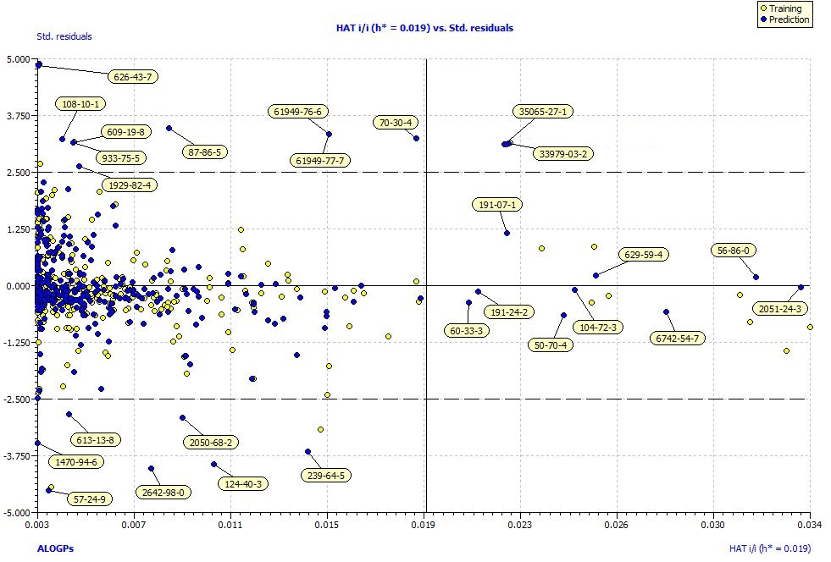

**FigureS1.** Williams plot of model H1.

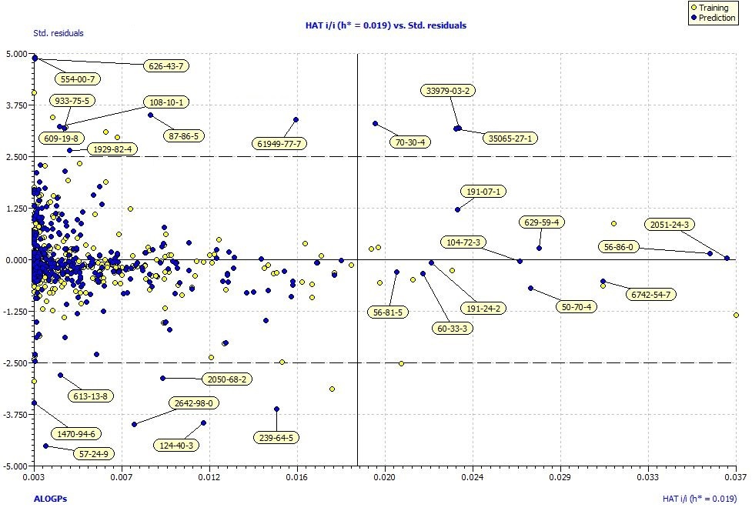

**FigureS2.** Williams plot of model H2.

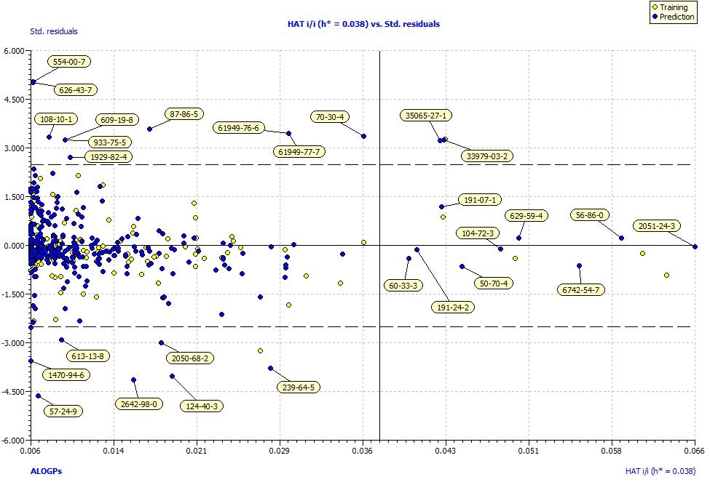

**FigureS3.** Williams plot of model F1.

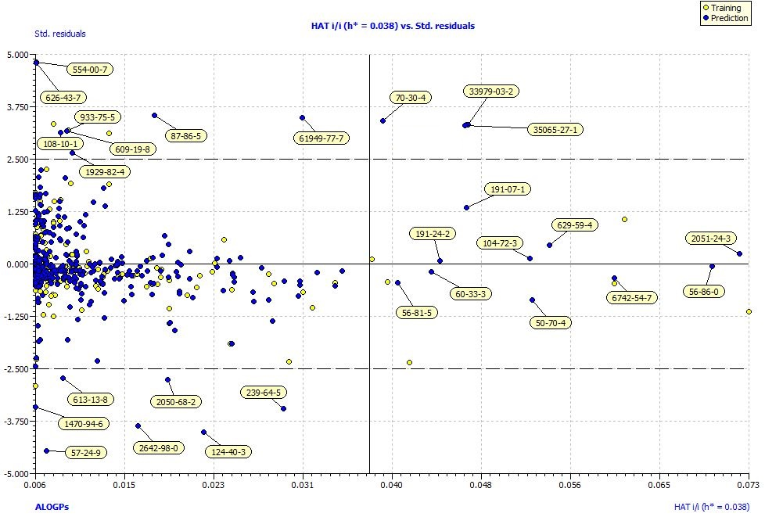

**FigureS4.** Williams plot of model F2.

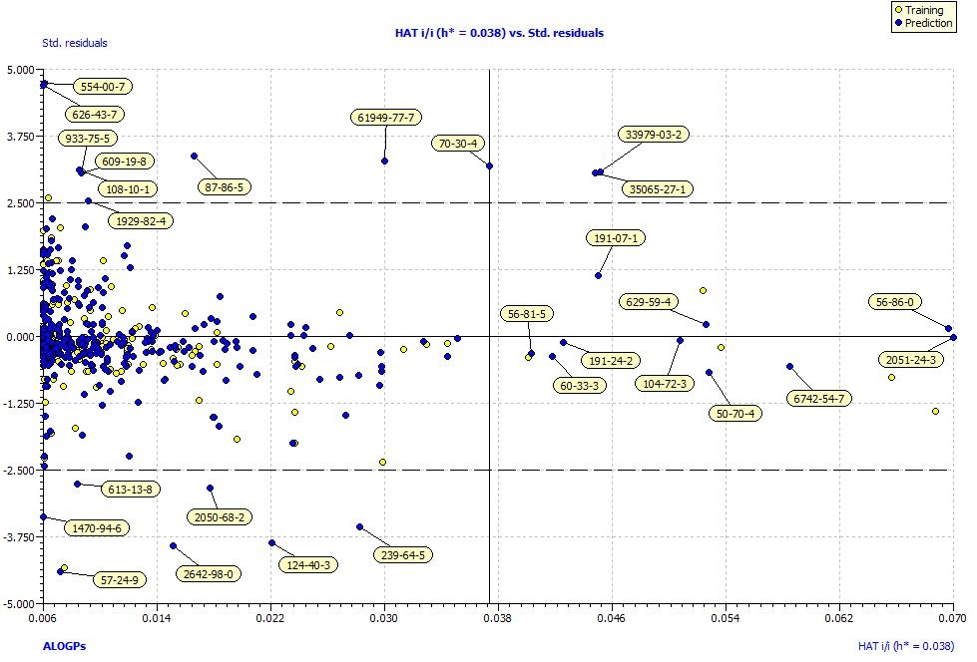

**FigureS5.** Williams plot of model F3.

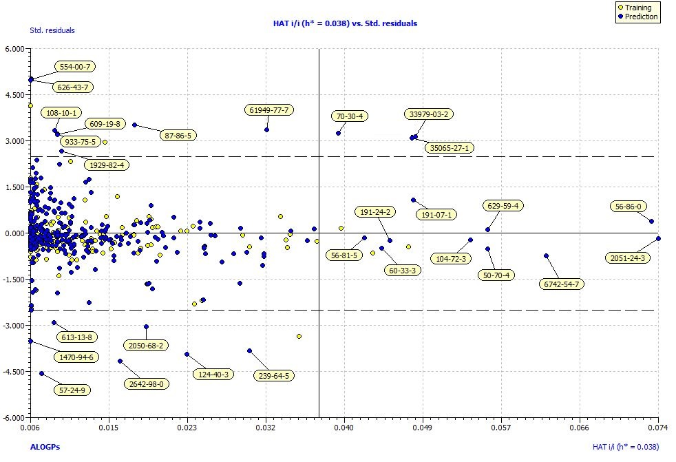

**FigureS6.** Williams plot of model F4.

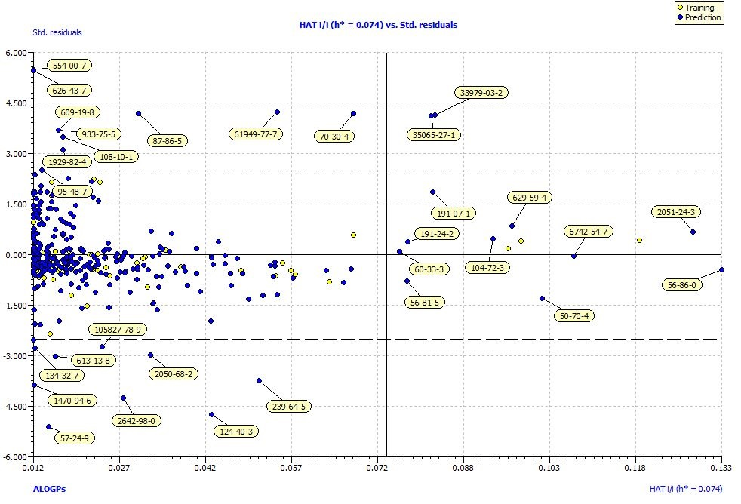

**FigureS7.** Williams plot of model E1.

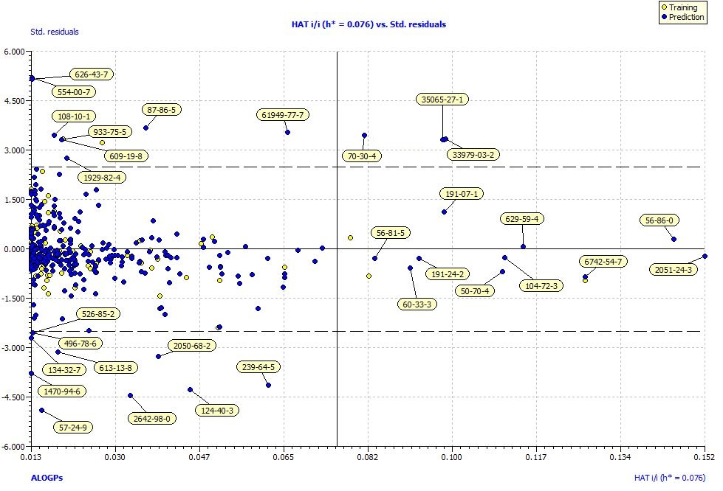

**FigureS8.** Williams plot of model E2.

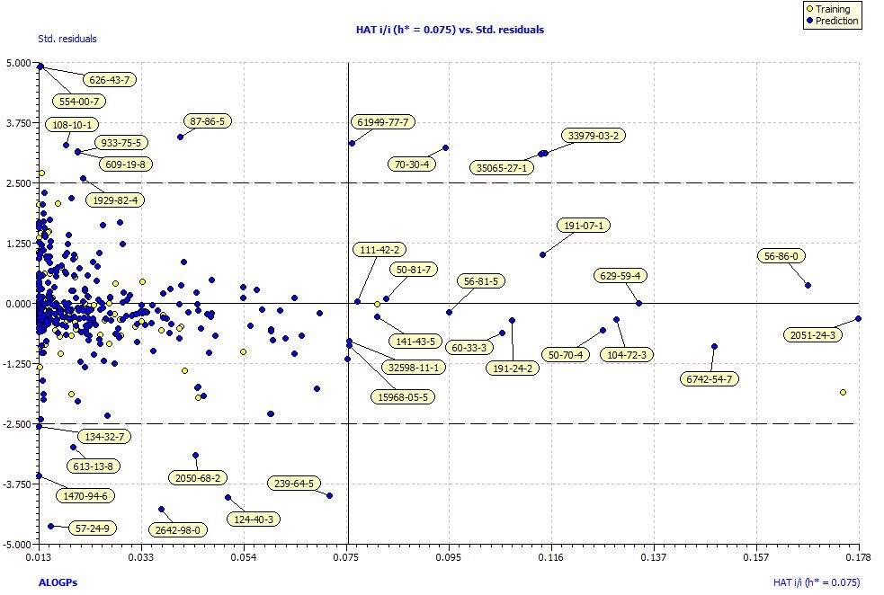

**FigureS9.** Williams plot of model E3.

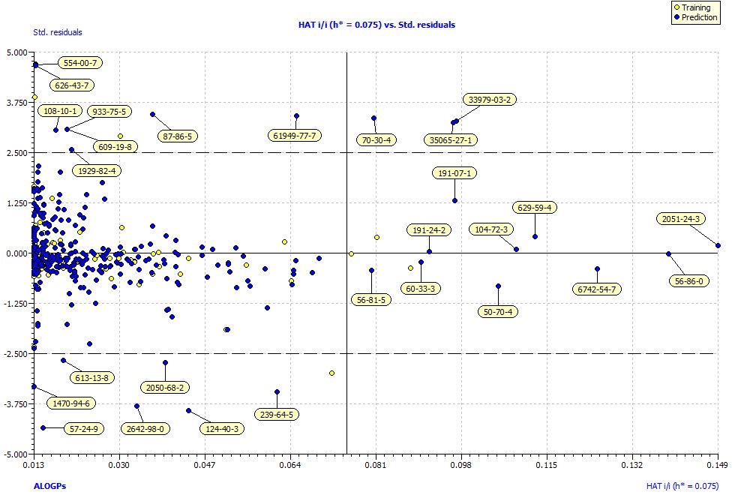

**FigureS10.** Williams plot of model E4.

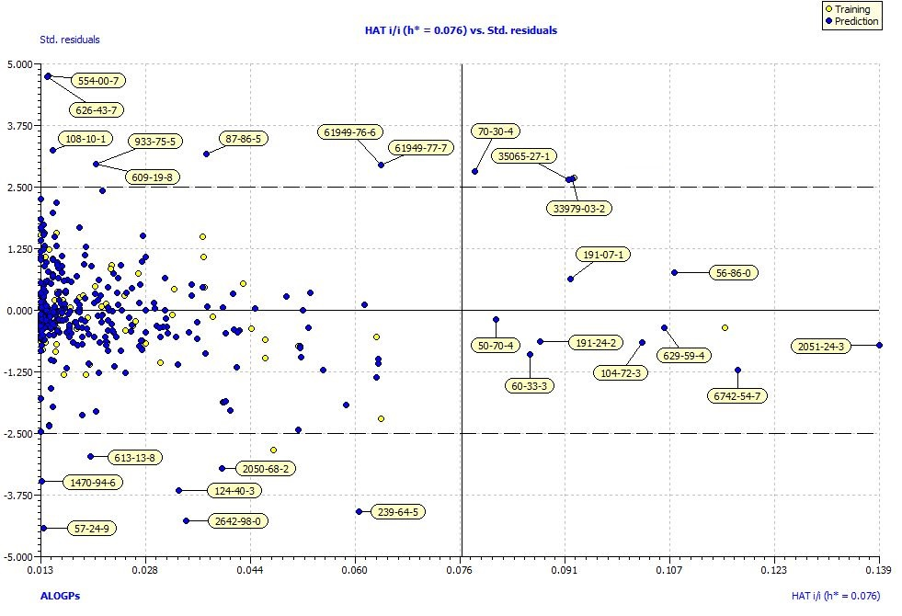

**FigureS11.** Williams plot of model E5.

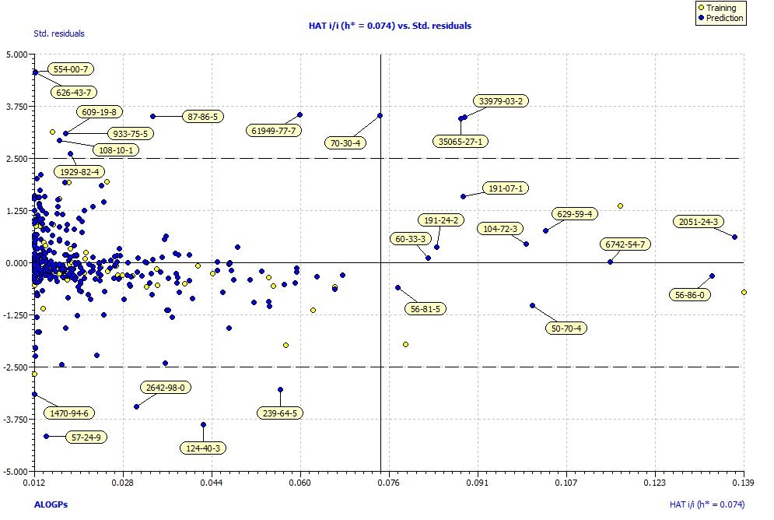

**FigureS12.** Williams plot of model E6.

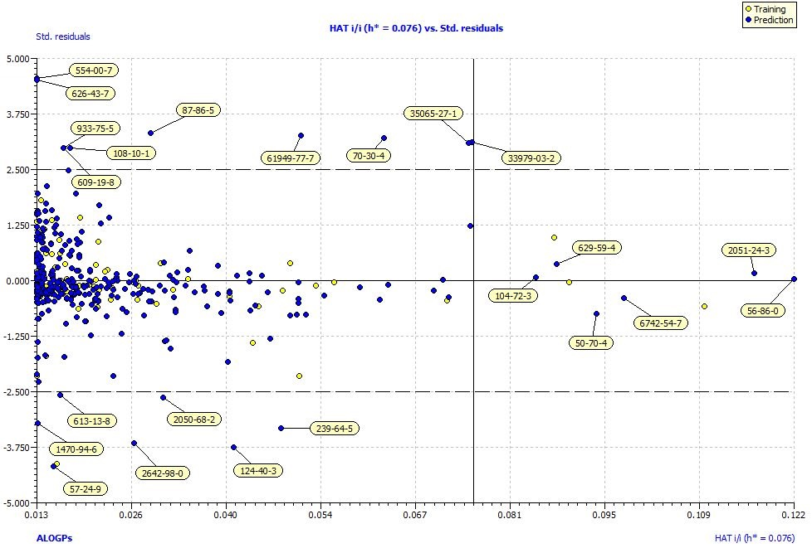

**FigureS13.** Williams plot of model E7.

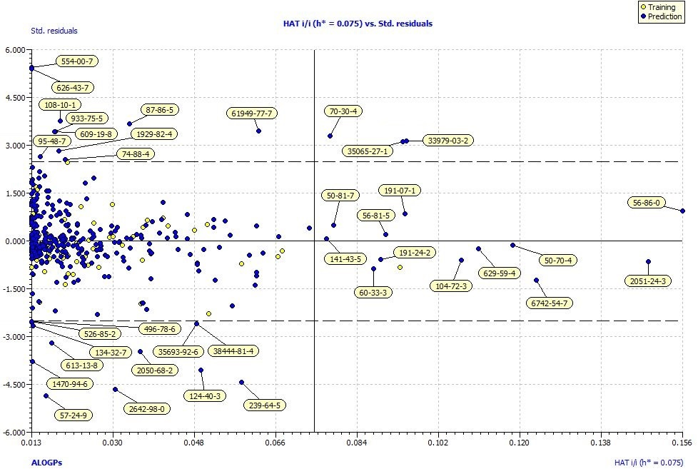

**FigureS14.** Williams plot of model E8.