

**Figure S1.** Measurement of reduced and oxidized glutathione ratio in P19 cells: differentiated (P19dCs) and undifferentiated (P19SCs), growing in glucose (Glu)- and in galactose (Gal)- containing media. Data are means ± S.D. from n=6. Significant p-values from analysis of variance and post hoc comparisons between the different types of p19 cells are displayed in the graph.



**A**



**B**



**Figure S2**. Cell proliferation in P19 cells treated with hydrogen peroxide. (**A**) Effect of 2-, 4- and 6-h exposure to hydrogen peroxide on P19 cells: differentiated (P19dCs) and undifferentiated (P19SCs), growing in glucose (Glu)- and in galactose (Gal)- containing media. Data are expressed as percentage of the control (vehicle only) at time 0. Data are means ± S.E.M. from n=5. Significant p-values from analysis of variance and post hoc comparisons are displayed in the graph. (**B**) Comparison of cell viability between the different types of P19 cells for each incubation time point (2, 4 and 6 h). Data are means ± S.E.M. from n=5. Significant p-values from analysis of variance and post hoc comparisons between the different types of p19 cells are displayed in the graph. Although 1 mM H2O2 affected cell viability after 2 and 4 h of incubation in the 4 groups of P19 cells, after 6 h of incubation, Glu-P19SCs were able to partially recover their more elevated proliferation rate.

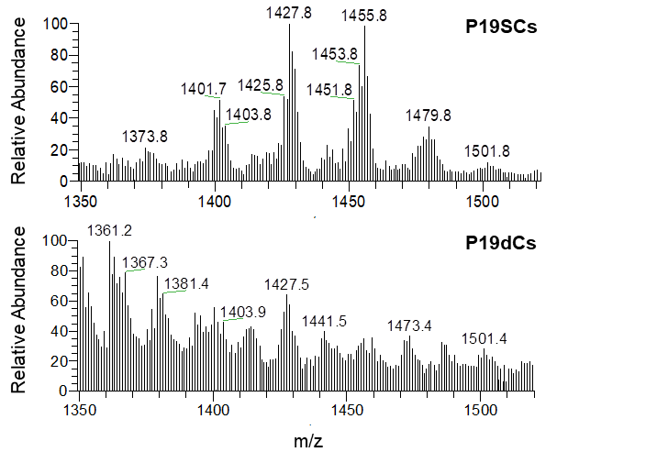

**A**

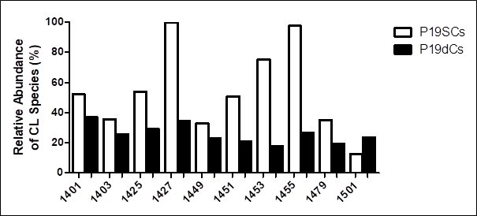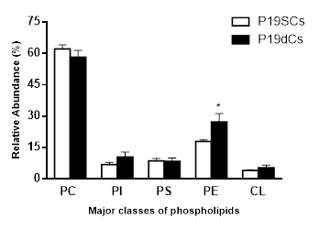

**B**

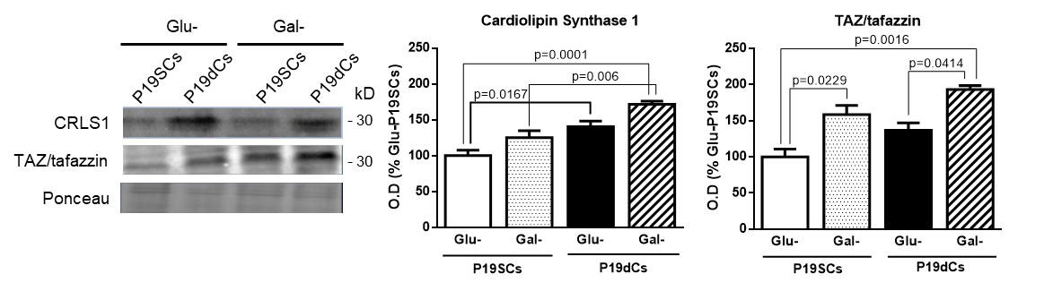

**Figure S3**. Evaluation of cardiolipin (CL) molecular species, synthesis and remodeling. (**A**) Representative ESI-MS spectra in negative mode of CL molecular species of P19SCs and P19dCs. The bar chart compares the relative abundance of CL species in both types of P19 cells. (**B**) Protein levels of cardiolipin synthase 1 (CRLS1) and TAZ/taffazin in P19 cells: differentiated (P19dCs) and undifferentiated (P19SCs), growing in glucose (Glu)- and in galactose (Gal)-containing media. Data are means of optical density (O.D.) ± S.D. expressed as percentage of Glu-P19SCs, from at least 3 separate experiments. Significant p-values from analysis of variance and post hoc comparisons between the different types of p19 cells are displayed in the graph.