Electronic Supplementary Information

Tromethamine Organocatalyzed Efficient Tandem-Multicomponent Synthesis of New Thiazolyl-4-Thiazolidinones in Aqueous Medium
Manisha R. Bhosle,ª* Sayali A. Kharote,ª Giribala M. Bondle,ª Jyotirling R. Mali^{b}
ªDepartment of Chemistry, Dr. Babasaheb Ambedkar Marathwada University, Aurangabad 431004, Maharashtra, India
^{b}College of Pharmacy, Dongguk University-Seoul, Goyang-10326, Republic of Korea.
E-mail: d.manisha11@gmail.com

Table of contents
1.General Information.....................................................................................................S2
2.Experimental Procedures.............................................................................................S2
3. Characterization Data for the Products.......................................................................S3-S6
4. Copies of IR and ¹H NMR Spectra of the Products ………………………………….S7-S11

Materials and methods
General: All the chemicals used were of laboratory grade. Melting points of all the synthesized compounds were determined in open capillary tubes and are uncorrected. ¹H NMR spectra were recorded with a Bruker Avance 400 spectrometer operating at 400 MHz using DMSO solvent and tetramethylsilane (TMS) as the internal standard and chemical shift in δ ppm. Mass spectra were recorded on a Sciex, Model; API 3000 LCMS/MS Instrument. The elemental analysis was done on Thermofisher EA1112 series CHNS Elemental Analyser. The purity of each compound was checked by TLC using silica-gel, 60F₂₅₄ aluminum sheets as adsorbent and visualization was accomplished by iodine/ultraviolet light.
General Procedure for the Synthesis of 3-(substituted phenyl)-2-(4-((2-phenylthiazol-4-yl)methoxy) phenyl) thiazolidin-4-ones (3a-l)
The mixture of 4-((2-phenylthiazol-4-yl)methoxy)benzaldehyde (1) (4 mmol) and substituted anilines (2a-l) (4.1 mmol) in water (20 ml) containing tris-hydroxymethylaminomethane (Tromethamine) (30 mol%) was stirred at 80 °C for 15 min. Then thioglycolic acid (8 mmol) was added and stirred at 80 ̊C. Progress of the reaction was monitored by thin layer chromatography ethyl acetate:hexane (3:7) as solvent. After 45 min. of stirring reaction mixture was cooled at room temperature, saturated sodium bicarbonate was added till gate pink color, to remove thioglycolic acid. Sticky compound was extracted with ethyl acetate and evaporated organic layer under reduced pressure. Thus obtained solid was filtered, dried and purified by crystallization using ethanol as solvent.
Recycling of reaction media
The mixture of 4-((2-phenylthiazol-4-yl)methoxy)benzaldehyde (1) (8 mmol) and anilines (2a) (8 mmol) in water (40 ml) containing tris-hydroxymethylaminomethane (Tromethamine) (30 mol%) was stirred at 80 °C for 15 min. Then thioglycolic acid (16 mmol) was added and stirred at 80 ̊C. Progress of the reaction was monitored by thin layer chromatography ethyl acetate:hexane (3:7) as solvent. After 45 min. of stirring reaction mixture was cooled at room temperature. Sticky compound was extracted with ethyl acetate and evaporated organic layer under reduced pressure. The aqueous layer having soluble tromethamine was further reused for next cycle.
Spectral analysis of compounds
3-Phenyl-2-(4-((2-phenylthiazol-4-yl)methoxy)phenyl)thiazolidin-4-one (3a)
Yellow solid, Yield 82%. Melting point 146-148 ºC. IR (ATR, υ cm⁻¹) Characteristic absorptions: 3250, 3193, 3076, 2888, 2343, 1641, 1480, 1490, 1325, 1171, 947, 747. ¹H NMR (400 MHz, DMSO δ_{ppm}):4.37-4.43 (dd, 2H, CH₂), 5.20 (s, 2H, CH₂), 6.08 (s, 1H, CH), 7.38-7.51 (m, 2H, Ar-H), 7.55-7.70 (m, 4H, Ar-H), 7.77-7.96 (m, 4H, Ar-H), 8.04-8.46 (m, 5H, Ar-H). MS (Scanning mode, ESI⁺) m/z: 445.5 (M⁺). Elemental Anal. calcd. for C₂₅H₂₀N₂O₂S₂: C: 67.54; H: 4.53; N: 6.30; S: 14.43; Found: C: 67.53; H: 4.55; N: 6.37; S: 14.41.
3-(4-Methylphenyl)-2-(4-((2-phenylthiazol-4-yl)methoxy)phenyl)thiazolidin-4-one (3b)
Off White solid, Yield 79%. Melting point 98-100 ºC. IR (ATR, υ cm⁻¹) Characteristic absorptions: 3365, 3185, 2850, 2312, 1652, 1447, 1108, 833, 754. ¹H NMR (400 MHz, DMSO δ_{ppm}): 2.85 (s, 3H, CH₃), 4.36-4.40 (dd, 2H, CH₂), 5.24 (s, 2H, CH₂), 6.25 (s, 1H, CH), 7.30-7.40 (m, 3H, Ar-H), 7.52-7.57 (m, 4H, Ar-H), 7.72-7.75 (m, 2H, Ar-H), 7.87-8.0 (m, 6H, Ar-H). MS (Scanning mode, ESI⁺) m/z: 459 (M⁺). Elemental Anal. calcd. for C₂₆H₂₂N₂O₂S₂: C: 68.09; H: 4.84; N: 6.11; S: 13.98; Found: C: 68.12; H: 4.81; N: 6.18; S: 14.00
3-(4-Methoxyphenyl)-2-(4-((2-phenylthiazol-4-yl)methoxy)phenyl)thiazolidin-4-one (3c)
Pale Yellow solid, Yield 81%. Melting point 134-136 ºC. IR (ATR, υ cm⁻¹) Characteristic absorptions: 3127, 2869, 1751, 1655, 1437, 1267, 1039, 805, 723. ¹H NMR (400 MHz, DMSO δ_{ppm}): 3.83 (s, 3H, OCH₃), 4.36-4.40 (dd, 2H, CH₂), 5.23 (s, 2H, CH₂), 6.05 (s, 1H, CH), 7.05-7.07 (m, 3H, Ar-H), 7.14-7.25 (m, 3H, Ar-H), 7.35-7.40 (m, 3H, Ar-H), 7.52-7.99 (m, 5H, Ar-H). MS (Scanning mode, ESI⁺) m/z: 475 (M⁺). Elemental Anal. calcd. for C₂₆H₂₂N₂O₃S₂: C: 65.80; H: 4.67; N: 5.90; S: 13.51; Found: C: 65.86; H: 4.61; N: 5.93; S: 13.52.
3-(4-Clorophenyl)-2-(4-((2-phenylthiazol-4-yl)methoxy)phenyl)thiazolidin-4-one (3d)
Yellow solid, Yield 89%. Melting point 103-105 ºC. IR (ATR, υ cm⁻¹) Characteristic absorptions: 3043, 2852, 1744, 1602, 1250, 1034, 830, 753. ¹H NMR (400 MHz, DMSO δ_{ppm}): 4.36-4.43 (dd, 2H, CH₂), 5.21 (s, 2H, CH₂), 6.04 (s, 1H, CH), 7.23-7.37 (m, 4H, Ar-H), 7.52-7.59 (m, 3H, Ar-H), 7.71-7.97 (m, 4H, Ar-H), 8.20-8.51 (m, 3H, Ar-H). MS (Scanning mode, ESI⁺) m/z: 480 (M⁺). Elemental Anal. calcd. for C₂₅H₁₉ClN₂O₂S₂: C: 62.68; H: 4.00; N: 5.85; S: 13.39; Found: C: 62.61; H: 4.07; N: 5.84; S: 13.41.
3-(4-Bromophenyl)-2-(4-((2-phenylthiazol-4-yl)methoxy)phenyl)thiazolidin-4-one (3e)
Yellow solid, Yield 80%. Melting point 107-109 ºC. IR (ATR, υ cm⁻¹) Characteristic absorptions: 3156, 2851, 1738, 1675, 1257, 1038, 827, 745. ¹H NMR (400 MHz, DMSO δ_{ppm}): 4.37-4.44 (dd, 2H, CH₂), 5.23 (s, 2H, CH₂), 6.05 (s, 1H, CH), 7.21-7.35 (m, 4H, Ar-H), 7.50-7.58 (m, 3H, Ar-H), 7.69-7.87 (m, 4H, Ar-H), 7.91-8.23 (m, 3H, Ar-H). MS (Scanning mode, ESI⁺) m/z: 524 (M⁺). Elemental Anal. calcd. for C₂₅H₁₉BrN₂O₂S₂: C: 57.36; H: 3.66; N: 5.35; S: 12.25; Found: C: 57.39; H: 3.63; N: 5.37; S: 12.25.
3-(4-Flurophenyl)-2-(4-((2-phenylthiazol-4-yl)methoxy)phenyl)thiazolidin-4-one (3f)
Yellow solid, Yield 76%. Melting point 121-123 ºC. IR (ATR, υ cm⁻¹) Characteristic absorptions: 3342, 3157, 2855, 1740, 1609, 1256, 1075, 858, 732. ¹H NMR (400 MHz, DMSO δ_{ppm}): 4.36-4.43 (dd, 2H, CH₂), 5.25 (s, 2H, CH₂), 6.05 (s, 1H, CH), 7.15-7.25 (m, 2H, Ar-H), 7.32-7.39 (m, 2H, Ar-H), 7.49-7.54 (m, 3H, Ar-H), 7.68-7.76 (m, 3H, Ar-H), 7.95-8.07 (m, 4H, Ar-H). MS (Scanning mode, ESI⁺) m/z: 463 (M⁺). Elemental Anal. calcd. for C₂₅H₁₉FN₂O₂S₂: C: 64.91; H: 4.14; N: 6.06; S: 13.86 Found: C: 64.97; H: 4.15; N: 6.01; S: 13.89.
4-(4-oxo-2-(4-((2-phenylthiazol-4-yl)methoxy)phenyl)thiazolidin-3-yl)benzenesulfonamide (3g)
Yellow solid, Yield 86%. Melting point 187-189 ºC. IR (ATR, υ cm⁻¹) Characteristic absorptions: 3264, 3176, 3074, 2875, 2357, 1723, 1608, 1486, 1321, 1089, 841, 746. ¹H NMR (400 MHz, DMSO δ_{ppm}):4.37-4.44 (dd, 2H, CH₂), 5.21 (s, 2H, CH₂), 6.06 (s, 1H, CH), 7.29-7.48 (m, 4H, Ar-H), 7.51-7.69 (m, 4H, Ar-H), 7.72-7.81 (m, 2H, Ar-H), 7.92-8.02 (m, 4H, Ar-H). MS (Scanning mode, ESI⁺) m/z: 524 (M⁺). Elemental Anal. calcd. for C₂₅H₂₁N₃O₄S₃: C: 57.34; H: 4.04; N: 8.02; S: 18.37; Found: C: 57.38; H: 4.09; N: 8.04; S: 18.40.
3-(2,4-Dimethylphenyl)-2-(4-((2-phenylthiazol-4-yl)methoxy)phenyl)thiazolidin-4-one (3h)
Pale Yellow solid, Yield 80%. Melting point 154-156 ºC. IR (ATR, υ cm⁻¹) Characteristic absorptions: 3365, 3185, 2850, 2312, 1652, 1447, 1108, 833, 754. ¹H NMR (400 MHz, DMSO δ_{ppm}): 2.26 (s, 3H, CH₃), 2.42 (s, 3H, CH₃), 4.37-4.42 (dd, 2H, CH₂), 5.20 (s, 2H, CH₂), 6.06 (s, 1H, CH), 7.32-7.40 (m, 2H, Ar-H), 7.48-7.56 (m, 4H, Ar-H), 7.71-7.74 (m, 2H, Ar-H), 7.84-7.96 (m, 6H, Ar-H). MS (Scanning mode, ESI⁺) m/z: 473 (M⁺). Elemental Anal. calcd. For C₂₇H₂₄N₂O₂S₂: C: 68.61; H: 5.12; N: 5.93; S: 13.57; Found: C: 68.65; H: 5.16; N: 5.98; S: 13.61.
3-(2-Methoxyphenyl)-2-(4-((2-phenylthiazol-4-yl)methoxy)phenyl)thiazolidin-4-one (3i)
Yellow solid, Yield 86%. Melting point 143-144 ºC. IR (ATR, υ cm⁻¹) Characteristic absorptions: 3175, 2854, 1746, 1650, 1436, 1254, 1138, 1040, 854, 787. ¹H NMR (400 MHz, DMSO δ_{ppm}): 3.87 (s, 3H, OCH₃), 4.36-4.41 (dd, 2H, CH₂), 5.21 (s, 2H, CH₂), 6.07 (s, 1H, CH), 7.12-7.18 (m, 2H, Ar-H), 7.21-7.27 (m, 3H, Ar-H), 7.34-7.45 (m, 4H, Ar-H), 7.51-7.87 (m, 5H, Ar-H). MS (Scanning mode, ESI⁺) m/z: 475 (M⁺). Elemental Anal. calcd. for C₂₆H₂₂N₂O₃S₂: C: 65.80; H: 4.67; N: 5.90; S, 13.51; Found: C: 65.84; H: 4.70; N: 5.95; S, 13.52.
3-(2-Hydroxyphenyl)-2-(4-((2-phenylthiazol-4-yl)methoxy)phenyl)thiazolidin-4-one (3j)
Yellow solid, Yield 89%. Melting point 136-137 ºC. IR (ATR, υ cm⁻¹) Characteristic absorptions: 3421, 3132, 2854, 1730, 1643, 1251, 1038, 836, 758. ¹H NMR (400 MHz, DMSO δ_{ppm}): 4.37-4.45 (dd, 2H, CH₂), 5.25 (s, 2H, CH₂), 6.05 (s, 1H, CH), 7.26-7.39 (m, 4H, Ar-H), 7.51-7.59 (m, 3H, Ar-H), 7.73-7.95 (m, 4H, Ar-H), 7.99-8.14 (m, 3H, Ar-H). MS (Scanning mode, ESI⁺) m/z: 461 (M⁺). Elemental Anal. calcd. for C₂₅H₂₀N₂O₃S₂: C: 65.20; H: 4.38; N: 6.08; S: 13.92; Found: C: 65.24; H: 4.31; N: 6.07; S: 13.99.
2-(4-((2-Phenylthiazol-4-yl)methoxy)phenyl)-3-(pyridin-2-yl)thiazolidin-4-one (3k)
Yellow solid, Yield 82%. Melting point 157-159 ºC. IR (ATR, υ cm⁻¹) Characteristic absorptions: 3335, 3137, 2853, 1737, 1642, 1256, 1037, 833, 751. ¹H NMR (400 MHz, DMSO δ_{ppm}): 4.36-4.44 (dd, 2H, CH₂), 5.22 (s, 2H, CH₂), 6.08 (s, 1H, CH), 7.37-7.49 (m, 2H, Ar-H), 7.51-7.59 (m, 2H, Ar-H), 7.71-7.86 (m, 4H, Ar-H), 7.98-8.18 (m, 2H, Ar-H) 8.34-8.62 (m, 4H, Ar-H). MS (Scanning mode, ESI⁺) m/z: 446 (M⁺). Elemental Anal. calcd. for C₂₄H₁₉N₃O₂S₂: C: 64.70; H: 4.30; N: 9.43; S: 14.39; Found: C: 64.75; H: 4.32; N: 9.44; S: 14.43.
N-(4-Oxo-2-(4-((2-phenylthiazol-4-yl)methoxy)phenyl)thiazolidin-3-yl)isonicotinamide (3l)
Yellow solid, Yield 87%. Melting point 176-178 ºC. IR (ATR, υ cm⁻¹) Characteristic absorptions: 3361, 3034, 2806, 2314, 1658, 1597, 1450, 1232, 1109, 992, 831, 764. ¹H NMR (400 MHz, DMSO δ_{ppm}): 4.37-4.43 (dd, 2H, CH₂), 5.25 (s, 2H, CH₂), 6.07 (s, 1H, CH), 7.32-7.50 (m, 2H, Ar-H), 7.51-7.58 (m, 2H, Ar-H), 7.72-7.88 (m, 4H, Ar-H), 7.96-8.20 (m, 2H, Ar-H) 8.32-8.60 (m, 4H, Ar-H). MS (Scanning mode, ESI⁻): m/z (% intensity): 487 (M⁻). Elemental Anal. calcd. For C₂₅H₂₀N₄O₃S₂: C: 61.46; H: 4.13; N: 11.47; S: 13.13; Found: C: 61.44; H: 4.12; N: 11.50; S: 13.19.

General Procedure for the Synthesis of 1,3-disubstituted-4-thiazolidinones (5a-l) [1,2].
The mixture of substituted aldehydes (4a-f) (4 mmol) and substituted anilines (2a-b) (4.1 mmol) in water (20 ml) containing tris-hydroxymethylaminomethane (Tromethamine) (30 mol%) was stirred at 80 °C for 15 min. Then thioglycolic acid (8 mmol) was added and stirred at 80 ̊C. Progress of the reaction was monitored by thin layer chromatography ethyl acetate:hexane (3:7) as solvent. After 45 min. of stirring reaction mixture was cooled at room temperature, saturated sodium bicarbonate was added till gate pink color, to remove thioglycolic acid. Sticky compound was extracted with ethyl acetate and evaporated organic layer under reduced pressure. Thus obtained solid was filtered, dried and purified by crystallization using ethanol as solvent.
Synthesized compounds characterized by IR, ¹H NMR and Melting points are in good agreement with those reported in the literature [1,2].
3-Phenyl-2-(4-tolyl)thiazolidin-4-one (5b) [1,2].
White solid, Yield 89%. Melting point 103-105 ºC. IR (ATR, υ cm⁻¹) Characteristic absorptions: 3202, 2975, 2827, 2357, 1725, 1453, 1149, 1008, 857, 759. ¹H NMR (400 MHz, DMSO δ_{ppm}): 2.26 (s, 3H, CH₃), 3.83-4.02 (dd, 2H, CH₂), 5.99 (s, 1H, CH), 7.01-7.29 (m, 9H, Ar-H). MS (Scanning mode, ESI⁺): m/z (% intensity): 270 (M⁺). Elemental Anal. calcd. For C₁₆H₁₅NOS: C: 71.34; H: 5.61; N: 5.20; S: 11.90; Found: C: 71.35; H: 5.60; N: 5.25; S: 11.93.

IR of Compound (3a)
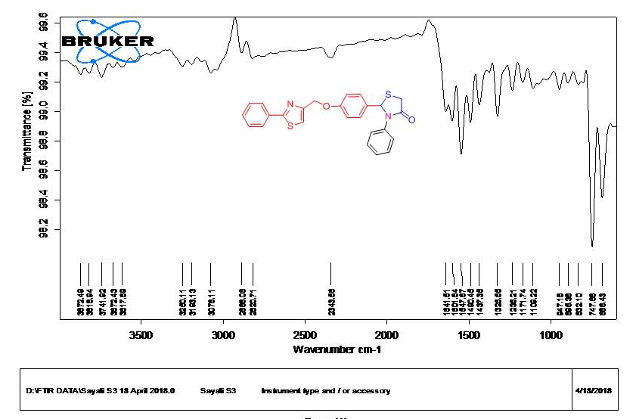
¹H NMR of Compound (3a)
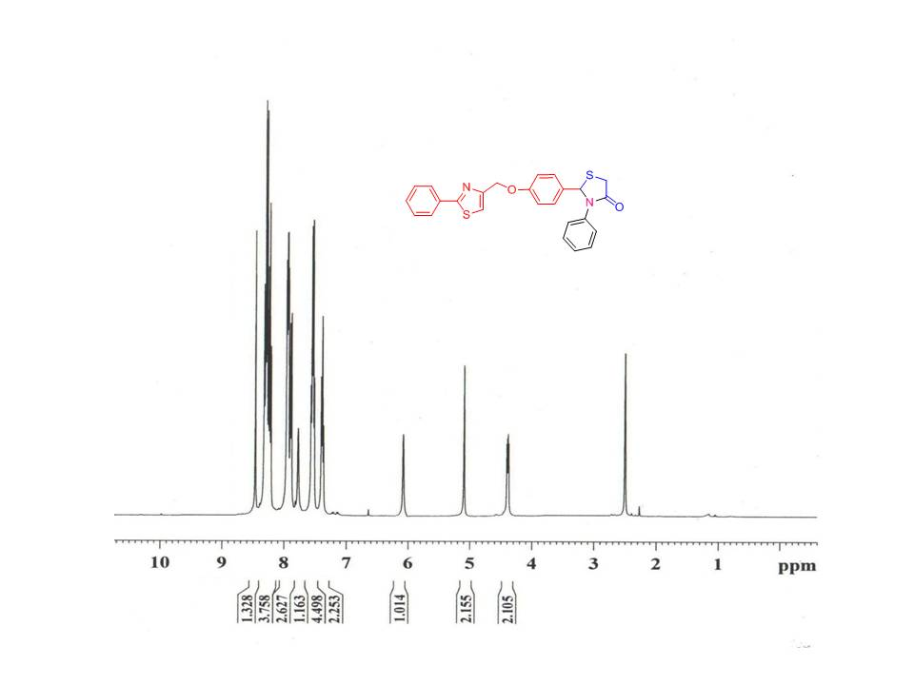
IR of Compound (3b)
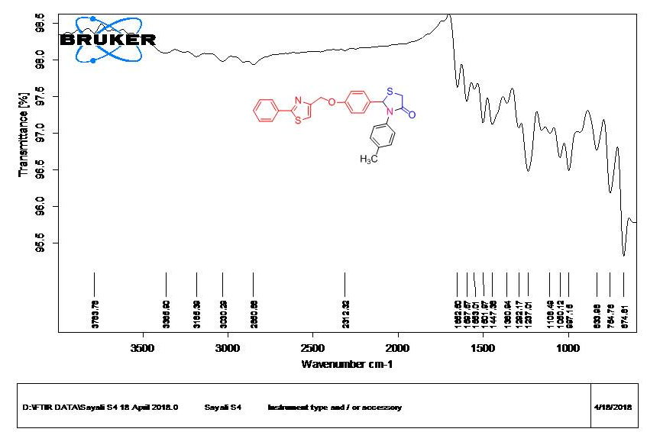
¹H NMR of Compound (3b)
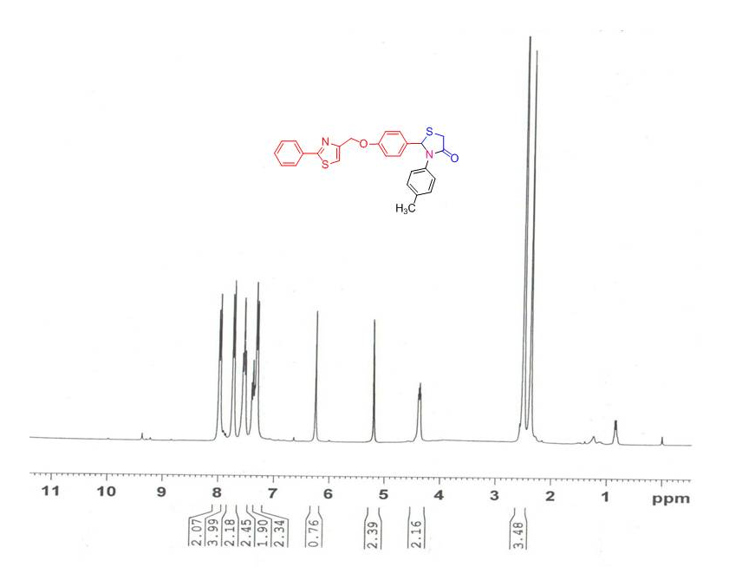
IR of Compound (3c)
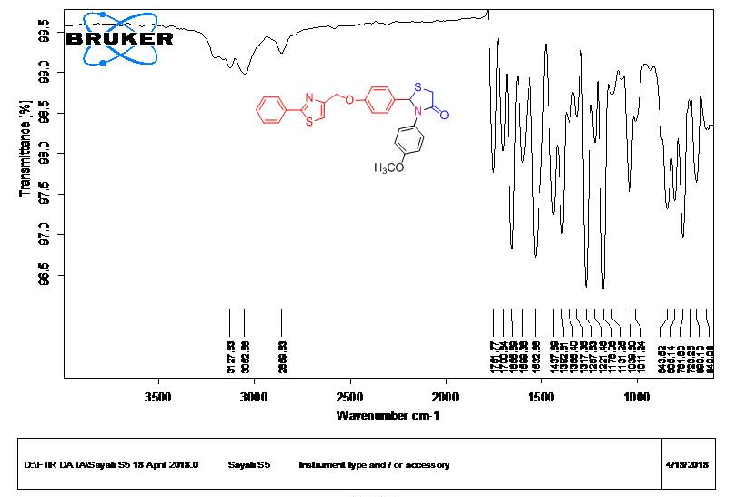
¹H NMR of Compound (3c)
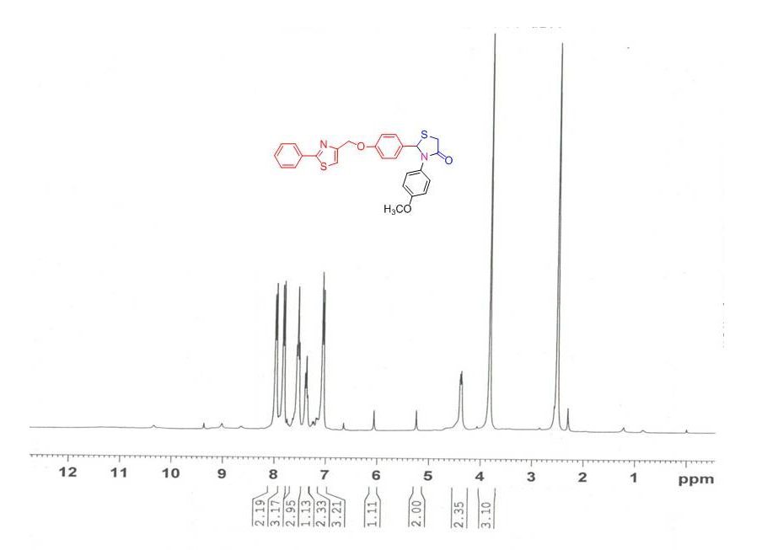
IR of Compound (3d)
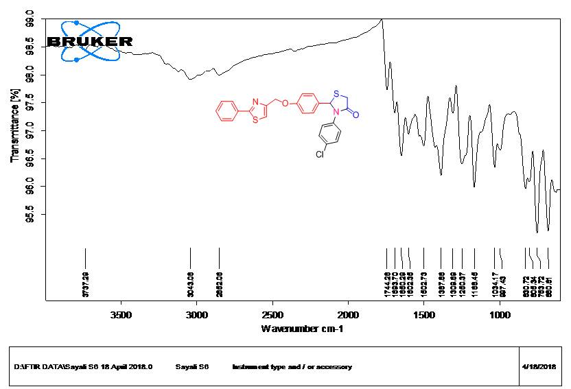
¹H NMR of Compound (3d)
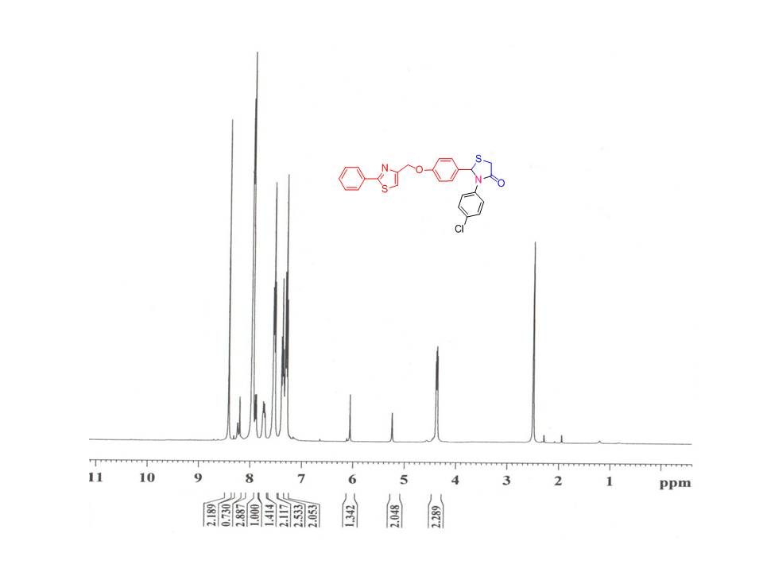
IR of Compound (5b)
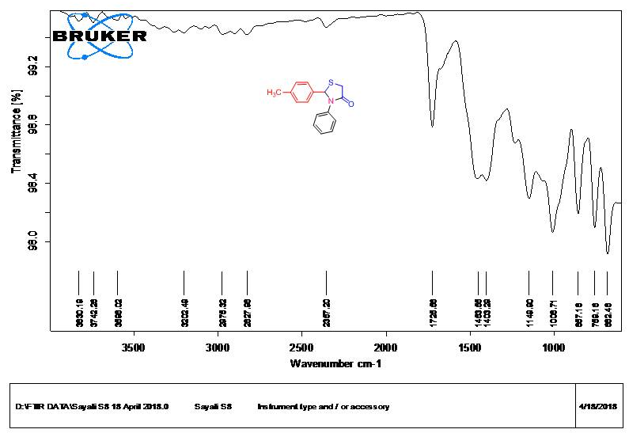
¹H NMR of Compound (5b)
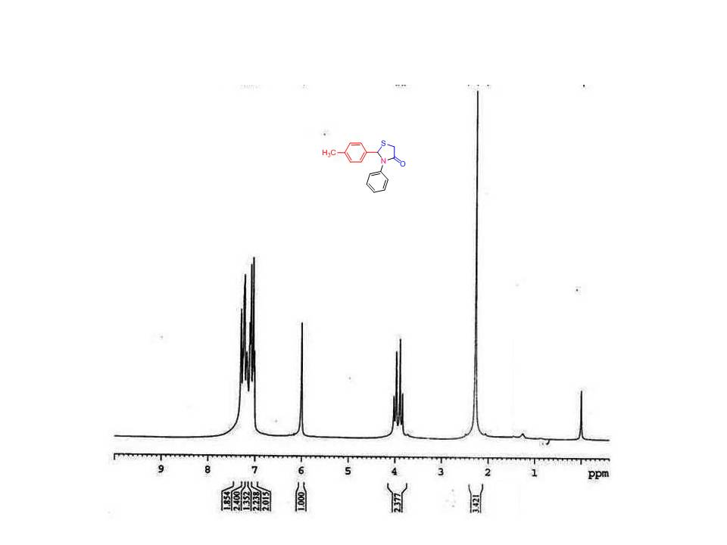
References
- (a) Harale, R. R.; Shitre, P. V.; Sathe, B. R.; Shingare, M. S. Res Chem Intermed. 2016, 42, 6695; (b) Chaudhari, M. A.; Gujar, J. B.; Kawade, D. S.; Shinde, P. V.; Shingare, M. S. Res Chem Intermed. 2015, 41, 10027.
- Pratap, U. R.; Jawale, D. V.; Bhosle, M. R.; Mane, R. A. Tetrahedron Lett. 2011, 52, 1689

