Syntheses, structural diversity and properties of three coordination polymers built by chlorophenyl imidazole dicarboxylate
Zhifang Yue,ª Feng Wang,^{a,b} Xianqiang Li,ª Zhenna Chen,ª Yanyan Zhuª, Gang Liª*

Supporting Information
Table S1. Hydrogen bonds distances (Å) and angles (deg) for 1- 3.
D-H...A | d(H...A) | d(D...A) | ∠(DHA)
1
O(5)-H(5A)... N(1)#3 | 2.08 | 2.819(7) | 150.7
2
O(1)-H(1) ...O(9) | 1.72 | 2.552(3) | 177.2
O(13)-H(14)...O(5) | 1.65 | 2.476(3) | 178.5
O(15)-H(16) ...O(12)#3 | 1.86(7) | 2.672(4) | 176.2(5)
O(15)-H(15) ...O(4)#3 | 2.46(4) | 2.787(4) | 111(4)
3
O(3)-H(3)...O(19)#3 | 1.90 | 2.680(5) | 159.2
O(9)-H(9)...O(21) | 1.87 | 2.676(5) | 168.7
O(12)-H(12)...O(20) | 1.87 | 2.680(5) | 167.4
O(17)-H(107) ...O(11) | 1.904(18) | 2.734(5) | 162(5)
O(17)-H(107) ...O(7) | 2.51(4) | 3.028(4) | 119(4)
O(16)-H(101) ...Cl(2)#3 | 2.62(5) | 3.245(4) | 130(5)
O(16)-H(101) ...Cl(3)#5 | 2.86(5) | 3.441(4) | 126(5)
O(18)-H(103) ...O(15) | 1.91(2) | 2.737(5) | 160(6)
O(18)-H(103) ...O(2) | 2.61(5) | 3.017(5) | 111(4)
O(18)-H(104) ...Cl(1) | 2.70(6) | 3.243(4) | 122(5)
O(18)-H(104) ...Cl(1)#7 | 2.86(4) | 3.442(4) | 127(4)
O(19)-H(106) ...O(10)#8 | 2.09(3) | 2.866(5) | 150(6)
O(9)-H(114) ...O(8) | 1.92(7) | 2.755(4) | 163(6)
O(9)-H(114) ...O(7)  O(21)-H(113) ...O(18)#3 | 2.32(7)  2.09(4) | 2.960(4)  2.829(6) | 132(6)  143(6)
O(16)-H(115) ...O(5) | 1.92(2) | 2.734(4) | 158(5)
O(17)-H(116) ...N(6) | 2.05(3) | 2.862(5) | 156(5)
O(17)-H(116) ...O(7) | 2.51(4) | 3.028(4) | 119(4)
O(3)-H(118) ...O(13)#3 | 1.96(7) | 2.767(4) | 173(7)
O(3)-H(118) ...O(4) | 2.51(7) | 2.949(4) | 115(6)
O(20)-H(150) ...O(16) | 2.09(3) | 2.833(5) | 145(5)
O(20)-H(151) ...O(6)#8 | 2.07(3) | 2.858(5) | 153(6)
O(21)-H(153) ...O(14) | 2.10(6) | 2.862(5) | 147(10)
Symmetry transformations used to generate equivalent atoms: For 1: #3: -x+1, -y, -z+1. For 2: #3: x-1, y, z. For 3: #3: x, y, z-1; #5: x+1/2, -y+1/2, z+1/2; #7: x, -y, z+1/2; #8: x, y, z+1.

Table S2. Selected bond distances (Å) and angles (deg) for 1-3

1
Sr(1)-O(2)#1 | 2.488(4) | Sr(1)-O(5) | 2.733(5) | Sr(1)-O(1)#2 | 2.542(4)
Sr(1)-O(4)#4 | 2.779(4) | Sr(1)-O(1) | 2.697(4) | Sr(1)-O(4) #1 | 2.545(4)
Sr(1)-O(3) #4 | 2.710(4) | Sr(1)-O(3)#3 | 2.676(4) | Sr(1)-O(2) | 2.734(4)
O(2)#1-Sr(1)-O(1)#2 | 157.18(14) | O(3)#1-Sr(1)-O(2) | 70.49(12) | O(2)#1-Sr(1)-O(4) #1 | 70.48(14)
O(1)-Sr(1)-O(2) | 48.47(12) | O(1)#2-Sr(1)-O(4) #1 | 97.37(13) | O(3) #4-Sr(1)-O(2) | 61.61(12)
O(2)#1-Sr(1)-O(3)#3 | 65.24(14) | O(1)#2-Sr(1)-O(5) | 68.52(13) | O(1)#2-Sr(1)-O(3)#1 | 105.36(12)
O(4) #1-Sr(1)-O(5) | 69.28(14) | O(4)-Sr(1)-O(3)#3 | 114.53(13) | O(3)#3-Sr(1)-O(5) | 64.31(13)
O(2)#1-Sr(1)-O(1) | 75.49(13) | O(1)-Sr(1)-O(5) | 131.64(13) | O(1)#2-Sr(1)-O(1) | 121.68(10)
O(3) #4-Sr(1)-O(5) | 137.72(12) | O(4) #1-Sr(1)-O(1) | 139.60(13) | O(5)-Sr(1)-O(2) | 108.33(14)
O(3)#3-Sr(1)-O(1) | 67.60(12) | O(2)#1-Sr(1)-O(4)#4 | 109.85(14) | O(2)#1-Sr(1)-O(3) #4 | 132.98(14)
O(1)#2-Sr(1)-O(4)#4 | 81.14(13) | O(1)#2-Sr(1)-O(3) #4 | 69.29(13) | O(4) #1-Sr(1)-O(4)#4 | 66.95(15)
O(4) #1-Sr(1)-O(3) #4 | 113.97(13) | O(3)#3-Sr(1)-O(4)#4 | 172.78(13) | O(2)#1-Sr(1)-O(5) | 88.89(14)
O(3)#3-Sr(1)-O(3) #4  O(1)-Sr(1)-O(3) #4  O(2)#1-Sr(1)-O(2) | 131.48(6)  75.12(12)  118.31(11) | O(1)-Sr(1)-O(4)#4  O(3) #4-Sr(1)-O(4)#4  O(2)-Sr(1)-O(4)#4 | 106.47(13)  47.44(12)  109.05(13) | O(4) #1-Sr(1)-O(2)  O(5)-Sr(1)-O(4)#4  O(1)#2-Sr(1)-O(2) | 171.13(12)  121.86(13)  73.97(12)
2
Cd(2)-N(2) | 2.326(2) | Cd(2)-N(1)#2 | 2.237(2) | Cd(1)-N(6) | 2.271(2)
Cd(2)-O(3) | 2.275(2) | Cd(1)-O(9) | 2.398(2) | Cd(2)-O(15) | 2.285(3)
Cd(2)-O(4)#2 | 2.504(2) | Cd(2)-O(4)#3 | 2.3060(19) | Cd(1)-O(12) | 2.401(2)
N(6)#1-Cd(1)-N(6) | 180.00(8) | N(1)#2-Cd(2)-O(3) | 108.87(8) | N(6)#1-Cd(1)-O(9) | 91.55(8)
N(1)#2-Cd(2)-O(15) | 99.54(9) | N(6)-Cd(1)-O(9) | 88.45(8) | O(3)-Cd(2)-O(15) | 151.50(9)
N(2)-Cd(2)-O(4)#2 | 175.24(7) | N(1)#2-Cd(2)-O(4)#3 | 140.62(8) | O(9)-Cd(1)-O(9)#1 | 180.000(1)
O(3)-Cd(2)-O(4)#3  N(6)-Cd(1)-O(12)  O(3)-Cd(2)-N(2)  O(12)-Cd(1)-O(12)#1  N(1)#2-Cd(2)-O(4)#2 | 81.69(8)  72.62(7)  74.14(8)  180.0  69.71(7) | N(6)#1-Cd(1)-O(12)  N(1)#2-Cd(2)-N(2)  O(9)#1-Cd(1)-O(12)  O(4)#3-Cd(2)-N(2)  O(15)-Cd(2)-O(4)#2 | 107.38(7)  105.86(9)  104.71(8)  113.50(8)  78.71(9) | O(15)-Cd(2)-O(4)#3  O(9)-Cd(1)-O(12)  O(15)-Cd(2)-N(2)  O(4)#3-Cd(2)-O(4)#2  O(3)-Cd(2)-O(4)#2 | 74.75(9)  75.29(8)  100.67(9)  70.97(8)  108.67(7)
3
Co(1)-O(1) | 2.070(3) | Co(2)-O(6) | 2.102(3) | Co(1)-O(11) | 2.075(3)
Co(2)-O(4) | 2.156(3) | Co(1)-O(9) | 2.076(3) | Co(2)-N(2) | 2.223(3)
Co(1)-O(10)  Co(3)-O(15)  Co(2)-O(5)  Co(3)-O(2) | 2.098(3)  2.067(3)  2.065(3)  2.163(3) | Co(3)-O(13)  Co(1)-N(5)  Co(3)-O(14)  Co(2)-O(8) | 2.063(3)  2.226(4)  2.103(3)  2.072(3) | Co(1)-O(7)  Co(3)-O(12)  Co(2)-O(3)  Co(3)-N(3) | 2.163(3)  2.077(3)  2.066(3)  2.223(3)
O(1)-Co(1)-O(11) | 90.53(12) | O(3)-Co(2)-O(4) | 88.58(12) | O(1)-Co(1)-O(9) | 91.26(12)
O(8)-Co(2)-O(4) | 83.55(11) | O(11)-Co(1)-O(9) | 174.23(13) | O(6)-Co(2)-O(4) | 94.45(11)
O(1)-Co(1)-O(10) | 178.10(13) | O(5)-Co(2)-N(2) | 87.81(12) | O(11)-Co(1)-O(10) | 89.42(12)
O(3)-Co(2)-N(2) | 97.04(13) | O(9)-Co(1)-O(10) | 88.61(12) | O(8)-Co(2)-N(2) | 104.99(12)
O(1)-Co(1)-O(7) | 83.86(12) | O(6)-Co(2)-N(2) | 77.02(12)
Symmetry transformations used to generate equivalent atoms. For 1: #1: -x+1, y+1/2, -z+1/2; #2: -x+1, y-1/2, -z+1/2; #3: -x+1, -y, -z+1; #4: x, -y-1/2, z-1/2; #5: x, -y-1/2, z+1/2. For 2: #1: -x+1, -y, -z+2; #2: -x+1, -y+1, -z+2; #3: x-1, y, z; #4: x+1, y, z. For 3: #1: x-1/2, -y+1/2, z-1/2; #2: x+1/2, -y+1/2, z-1/2; #3: x, y, z-1; #4: x, -y, z-1/2; #5: x+1/2, -y+1/2, z+1/2; #6: x-1/2, -y+1/2, z+1/2; #7: x, -y, z+1/2; #8: x, y, z+1.

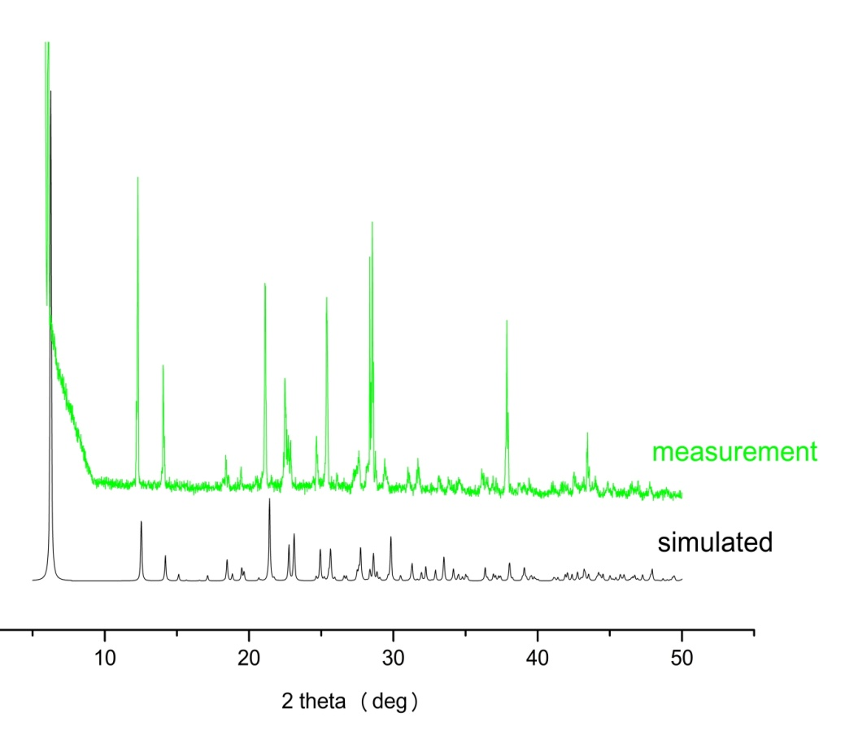
Figure S1a PXRD pattern of compound 1 at room temperature
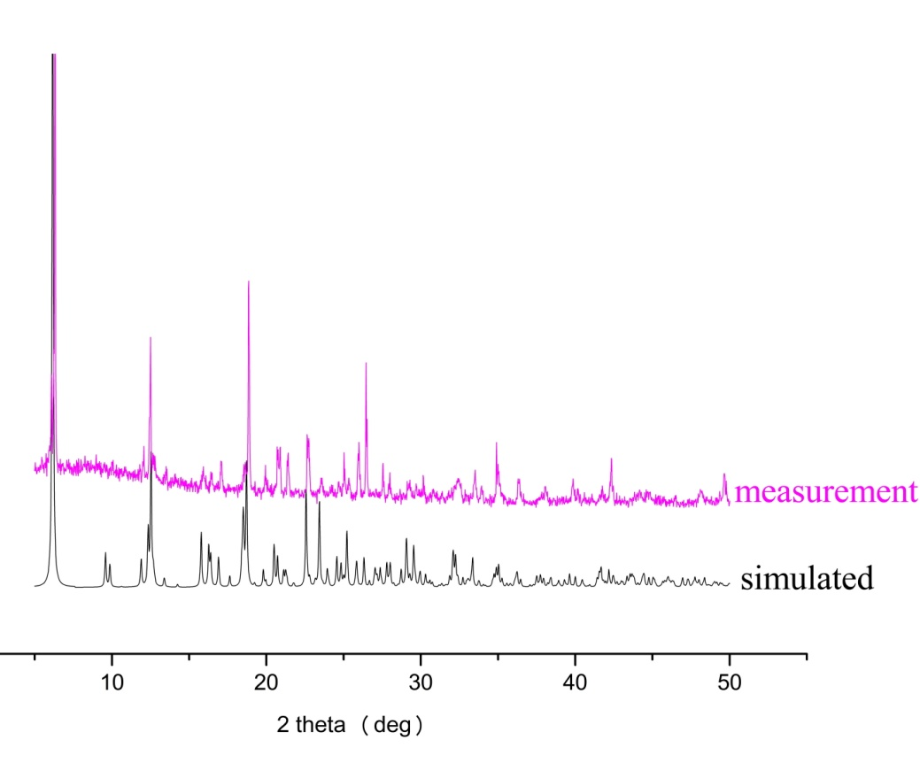
Figure S1b PXRD pattern of compound 2 at room temperature
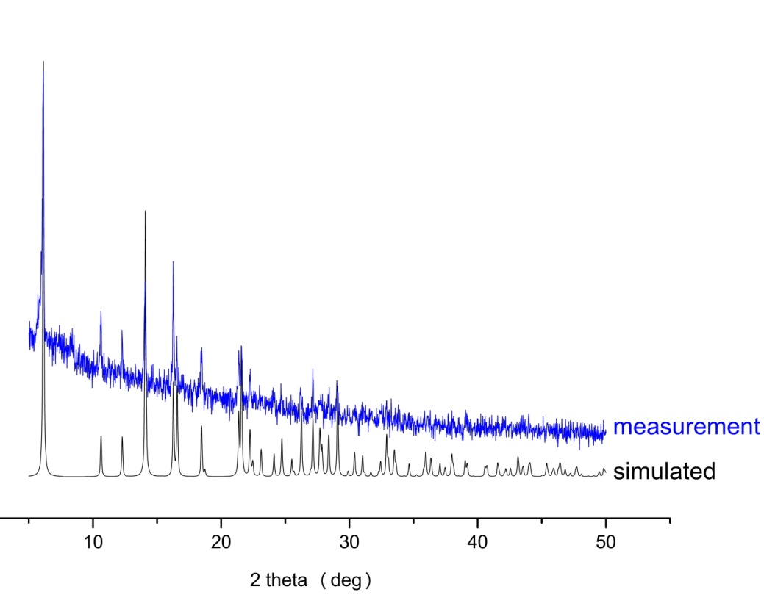
Figure S1c PXRD pattern of compound 3 at room temperature

* Corresponding author. Email address: gangli@zzu.edu.cn (G. Li).

