Supplementary material

Appendix 1. Unpublished data series

 |  | Ota  2018 | Andersen  2018
Country |  | Japan | Denmark
N |  | 17 | 21
Age | Median | 68 | 62
 | Lower range | 40 | 38
 | Upper range | 86 | 75
Gender | Male | 7 | 17
 | Female | 10 | 4
ECOG | 0 | 3 | 7
 | 1 | 4 | 11
 | 2 | 7 | 3
 | > 2 | 3 | 0
Primary site of tumor | Colon | 8 | 14
 | Rectum | 9 | 7
RAS mutation | No | 9 | 10
 | Yes | 6 | 11
 | Unknown | 2 | 0
Time from diagnose of metastatic disease | <18 months | 2 | 9
 | ≥ 18 months | 15 | 10
 | Unknown | 0 | 2
Number of prior regimens | 1 | 1 | 0
 | 2 | 2 | 0
 | 3 | 4 | 21
 | ≥ 4 | 10 | 0
Prior anticancer agents for metastatic disease | Fluorpyrimidines | 13 | 21
 | Oxaliplatin | 16 | 21
 | Irinotecan | 8 | 21
 | Bevacizumab/ramucirumab | 13 | 21
 | Anti-EGFR monoclonal antibody | 13 | 9
 | Aflibercept | 0 | 0
 | Regorafenib | 4 | 0

Kaplan Meier curves Ota 2018
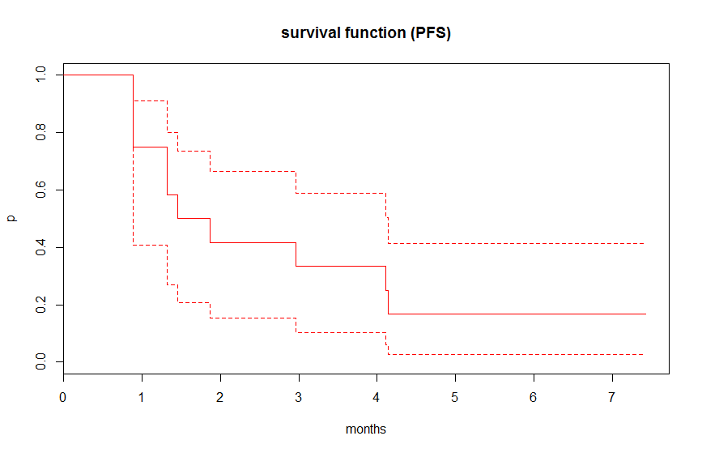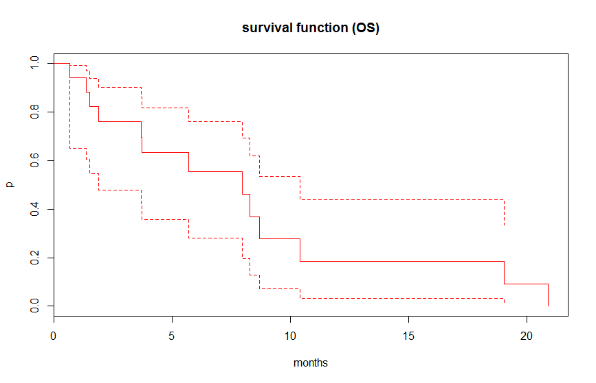

Kaplan Meier curves Andersen 2018
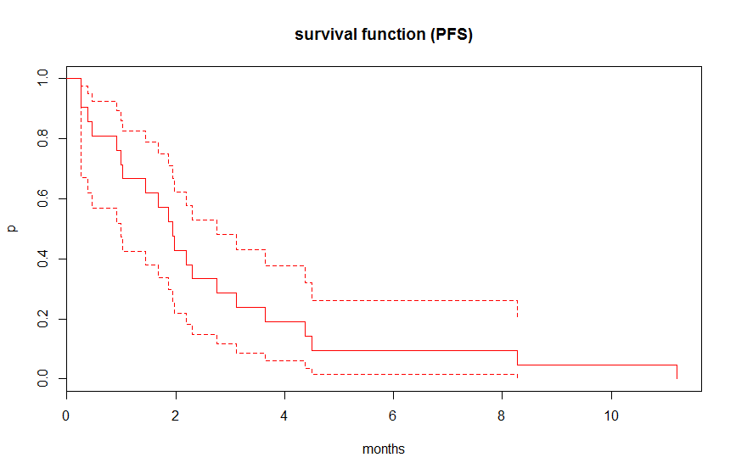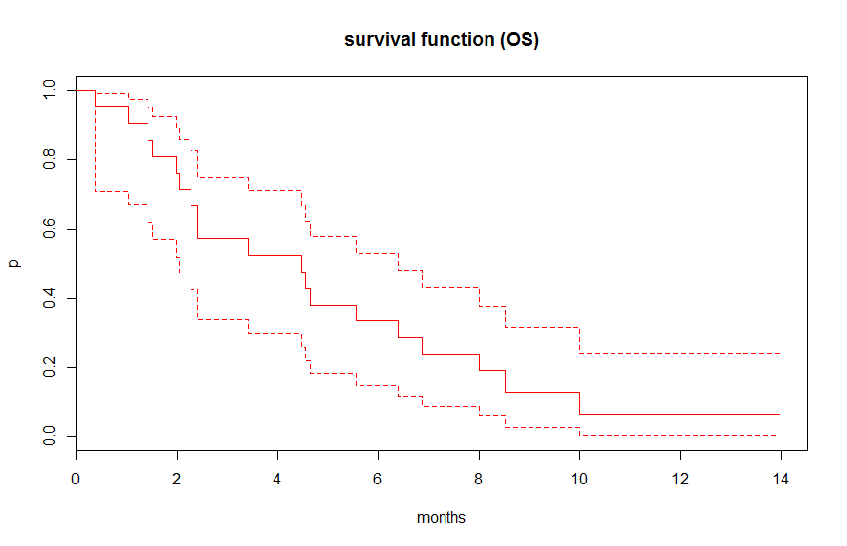

Appendix 2. Appraisal of study quality
No | Question | Cremolini  2018 | Kwakman  2018 | Moriwaki  2018 | Masuishi  2017 | Sueda  2016 | Arita  2016 | Kotani  2016
1 | Were the two groups similar and  recruited from the same population? | Not relevant | Not relevant | Not relevant | Not relevant | Not relevant | Not relevant | Not relevant |  | Yes
2 | Were the exposures measured  similarly to assign people to both exposed and unexposed groups? | Not relevant | Not relevant | Not relevant | Not relevant | Not relevant | Not relevant | Not relevant |  | Unclear
3 | Was the exposure measured in  a valid and reliable way? | No details on actual  dose intensity | No details on actual  dose intensity | No details on actual  dose intensity | No details on actual  dose intensity |  |  |  |  | No
4 | Were confounding factors identified?
5 | Were strategies to deal with  confounding factors stated? | Multivariable  regression | Multivariable  regression | Multivariable  regression | Multivariable  regression |  | Multivariable  regression
6 | Were the groups/participants  free of the outcome at the start of the study (or at the moment of exposure)?
7 | Were the outcomes measured  in a valid and reliable way? | Radiological  RECIST | Assessment of  progression not described | Assessment of  progression not described | Radiological  RECIST | Radiological  RECIST | Radiological  RECIST | Radiological  RECIST
8 | Was the follow up time reported  and sufficient to be long enough for outcomes to occur? |  |  |  |  |  | Median  follow-up time not described
9 | Was follow up complete, and if not,  were the reasons to loss to follow up described and explored?
10 | Were strategies to address incomplete  follow up utilized? | Not relevant | Not relevant | Not relevant | Not relevant | Not relevant | Not relevant | Not relevant
11 | Was appropriate statistical analysis used?

Appendix 3.
Search history PubMed

Search ((((Trifluridine) AND tipiracil)) OR Lonsurf) OR TAS-102

