Supplementary material
Table S1. Convective depth for Lake Onego, March 2017.
Date | Time (h) | Convective Depth (m) | Time (h) | Convective Depth (m)
15 Mar  2017 | 08:00 | 12.84 | 14:00 | 12.48
16 Mar  2017 | 08:00 | 13.29 | 14:00 | 13.74
17 Mar  2017 | 08:00 | 14.04 | 14:00 | 14.04

Table S2. Vertical light attenuation coefficient (K_{w}) and euphotic depth (Z_{eu}) for Lake Onego in March 2017. Values in this table correspond to the average between 08:00 - 09:00 h for the morning (AM) and 14:00 - 15:00 h for the afternoon (PM) measurements. In brackets -the standard deviation.
Date | Time | K_{w} (m⁻¹) |  | Z_{eu}(m)
15 Mar  2017 | AM | 2.73 | (0.14) | 1.69 | (0.09)
 | PM | 2.66 | (0.05) | 1.73 | (0.03)
16 Mar  2017 | AM | 2.71 | (0.11) | 1.70 | (0.07)
 | PM | 2.76 | (0.02) | 1.67 | (0.01)
17 Mar  2017 | AM | 2.77 | (0.12) | 1.67 | (0.07)
 | PM | 2.65 | (0.05) | 1.74 | (0.03)
Total Average |  | 2.71 | (0.05) | 1.70 | (0.03)

Table S3. Chemical methods for nutrient concentration quantification. Winter and Spring Lake Onego campaigns 2017.Methods based on Lozovik and Efremenko (2017).
Characteristic | Analytical method
Si | Spectrophotometric determination to form a yellow silicomolybdenum heteropolyacid
NH₄-N | Spectrophotometric indophenol method with phenol and hypochlorite, λ=630 nm
NO₂-N | Spectrophotometric method with sulfanilamide and N-(1-Naphthyl)-ethylenediamine-dihydrochloride, λ=543 nm
NO₃-N | Reduction to NO₂⁻ on the Cd-reductor and determine NO₂⁻
N_{org} | Calculated as the difference between TN and sum NH₄-N + NO₃-N + NO₂-N
TN | Spectrometric method with mineralization of samples in a thermostat
P_{min} | Spectrophotometric method with ammonium molybdate and ascorbinic acid reduce phosphatomolybdic heteropolyacid λ=882 nm
TP | Oxidation of organic matter by K₂S₂O₈ in acidic media and determine P_{react}

Table S4. Chemical analysis of nutrients for water samples taken in Lake Onego, March 2017. This data was taken at the Ice camp station (P2).
Station |  | Time | Depth  (m) |  | NO₃⁻+NO₂⁻ (mg N L⁻¹) | PO₄³⁻+P_{react} (μg P L⁻¹) | TN  (mg N L⁻¹) |  | TP  (μg P L⁻¹) | Si  (mg Si L⁻¹)
15  Mar  2017 | 08:00h |  | 0 | 0.18 |  | 6.0 | 0.41 | 18.0 |  | 1.1
 |  |  | 1 | 0.15 |  | 8.0 | 0.44 | 18.0 |  | 1.15
 |  |  | 5 | 0.17 |  | 7.0 | 0.4 | 18.0 |  | 1.21
 |  |  | 10 | 0.18 |  | 7.0 | 0.44 | 19.0 |  | 1.15
 | 14:00h |  | 0 | 0.18 |  | 7.0 | 0.42 | 17.0 |  | 1.11
 |  |  | 1 | 0.16 |  | 7.0 | 0.43 | 17.0 |  | 1.15
 |  |  | 5 | 0.19 |  | 7.0 | 0.44 | 18.0 |  | 1.13
 |  |  | 10 | 0.16 |  | 7.0 | 0.43 | 18.0 |  | 1.14
16  Mar  2017 | 08:00h |  | 0 | 0.16 |  | 7.0 | 0.44 | 16.0 |  | 1.14
 |  |  | 1 | 0.14 |  | 7.0 | 0.47 | 16.0 |  | 1.09
 |  |  | 5 | 0.18 |  | 6.0 | 0.45 | 14.0 |  | 1.13
 |  |  | 10 | 0.14 |  | 6.0 | 0.45 | 14.0 |  | 1.09
 | 14:00h |  | 0 | 0.17 |  | 6.0 | 0.43 | 14.0 |  | 1.13
 |  |  | 1 | 0.14 |  | 9.0 | 0.42 | 10.0 |  | 1.13
 |  |  | 5 | 0.17 |  | 7.0 | 0.44 | 14.0 |  | 1.08
 |  |  | 10 | 0.14 |  | 6.0 | 0.43 | 16.0 |  | 1.08
17  Mar  2017 | 08:00h |  | 0 | 0.16 |  | 5.0 | 0.43 | 16.0 |  | 1.22
 |  |  | 1 | 0.18 |  | 4.0 | 0.46 | 16.0 |  | 1.18
 |  |  | 5 | 0.14 |  | 5.0 | 0.44 | 15.0 |  | 1.16
 |  |  | 10 | 0.18 |  | 5.0 | 0.45 | 15.0 |  | 1.14
 | 14:00h |  | 0 | 0.18 |  | 5.0 | 0.45 | 17.0 |  | 1.15
 |  |  | 1 | 0.19 |  | 6.0 | 0.45 | 16.0 |  | 1.26
 |  |  | 5 | 0.17 |  | 6.0 | 0.43 | 15.0 |  | 1.19
 |  |  | 10 | 0.19 |  | 6.0 | 0.44 | 16.0 |  | 1.17

Table S5. Nutrient analysis for water samples taken in Lake Onego, spring 2017. C3 corresponds to the open water station and T0708 to the inshore station.
Station | Time | Depth  (m) |  | NO₃⁻+NO₂⁻ (mg N L⁻¹) | PO₄³⁻/P_{react} (μg P L⁻¹) | TP  (μg P L⁻¹ ) | Si  (mg Si L⁻¹)
C3 | 08:00h | 1 | 0.17 |  | 1 | 3 | 0.38
 |  | 6 | 0.15 |  | 1 | 3 | 0.41
 |  | 13 | 0.16 |  | 1 | 3 | 0.43
 |  | 20 | 0.17 |  | 1 | 3 | 0.39
 |  | 30 | 0.15 |  | 1 | 3 | 0.45
 | 15:00h | 1 | 0.18 |  | 1 | 3 | 0.46
 |  | 6 | 0.16 |  | 2 | 3 | 0.43
 |  | 13 | 0.18 |  | 1 | 3 | 0.37
 |  | 20 | 0.16 |  | 1 | 3 | 0.4
 |  | 30 | 0.18 |  | 1 | 2 | 0.41
T0708 | 08:00h | 1 | 0.12 |  | 0 | 6 | 0.44
 |  | 5.5 | 0.14 |  | 1 | 3 | 0.32
 |  | 8 | 0.14 |  | 1 | 4 | 0.37
 |  | 11 | 0.15 |  | 1 | 4 | 0.44
 |  | 14 | 0.14 |  | 1 | 3 | 0.28
 |  | 20 | 0.1 |  | 1 | 2 | 0.3
 | 15:00h | 1 | 0.12 |  | 1 | 5 | 0.58
 |  | 4 | 0.04 |  | 0 | 3 | 0.6
 |  | 6 | 0.04 |  | 0 | 5 | 0.58
 |  | 9.5 | 0.1 |  | 1 | 3 | 0.47
 |  | 12 | 0.1 |  | 0 | 3 | 0.28
 |  | 20 | 0.06 |  | 0 | 4 | 0.18

Figure S1
Diurnal variation in the vertical water temperature profiles (0 – 26 m) from Lake Onego in March 2017 at the Ice Camp station. Each color represents a different sampling day. The solid lines correspond to the morning sampling between 08:00 - 09:00 h and the dashed lines to the average temperature between 14:00 - 15:00 h for the afternoon (PM) measurements.

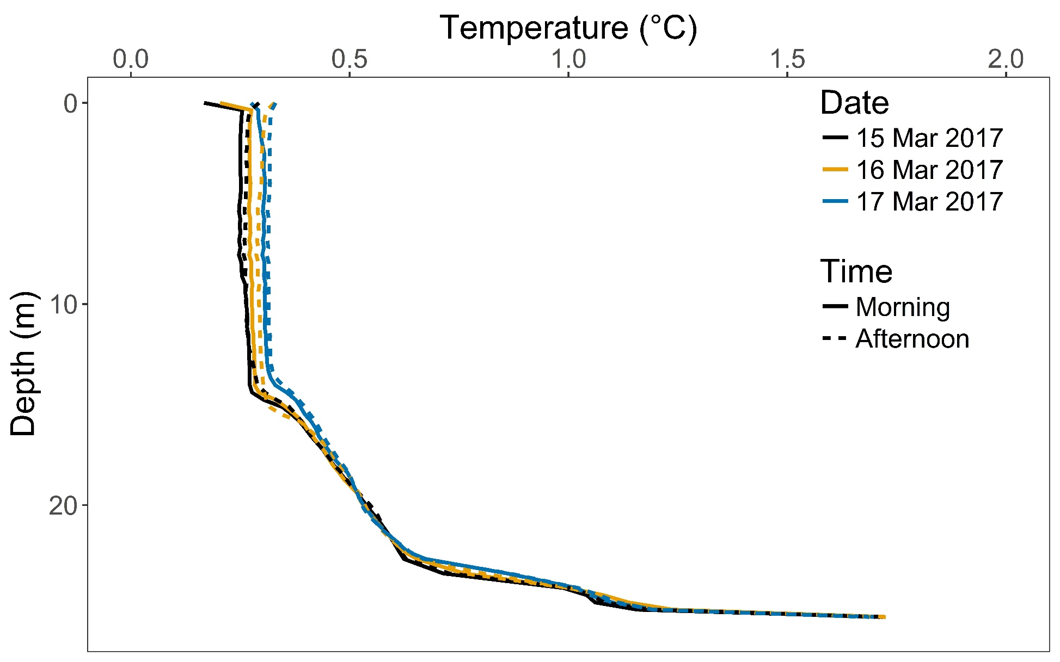

Figure S2.
The concentration of chlorophyll-a per unit area was calculated at Zeu, Zm and at the maximum sampling depth (color scale) at each site and time (line-type scale). Chlorophyll-a depth distribution shows more differences between the day, with more chlorophyll in the morning that in the afternoon in winter, the opposite for the inshore side in spring and no dial variations at the open lake side in spring.

