Appendix I. Modification of the original profiler, skin irritation/corrosion inclusion rules by BfR.
Category Name | Original Definition in literature* | Modification
 | 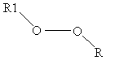  R1 = alkyl chain  R = H or alkyl chain | The original profiler can cover only peroxides in which both Rs are alkyl. We modified it to allow hydro peroxides in which R or R1 is H.
Acyl halides | 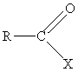  X = halogen  R = alkyl, arylalkyl or aryl group | The original profiler does not cover acyl halides in which R has different functional groups (e.g., –OH). We modified it to allow R linked to any other atom.
Aliphatic acids and (Met)acrylic acids | R ≤ C8 aliphatic chain and no other subgroups  R = H or CH₃ | In the definition, H is not included in R. However, we modified it to add H in R.
Aliphatic halogenated saturated acids | 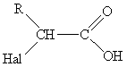  R=aliphatic chain  Hal =Cl, Br | We modified the original profiler to allow R linked to any other atom.
Aliphatic iso(thio)cyanates | 1. Isocyanates  2. Isothiocyanate  R = alkyl (aliphatic chain)  Some isocyanates/isothiocyanates hydrolyse rapidly when getting in contact with water; the resulting metabolite may cause only mild skin irritation. | We modified the original profiler to cover not only primary iso(thio)cyanates but also secondary and tertiary iso(thio)cyanates. We also modified it to allow R linked to any other atom.
Allyl halides,sulfonates | 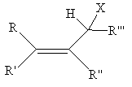  X = Cl,Br or F or sulfon (OSO₂-−R^{IV} )  R, R',R",R"' = H, alkyl, arylalkyl or aryl group  R^{IV} = alkyl, arylalkyl or aryl group | We modified the original profiler to allow R, R', R", R''' linked to any other atom.
Alpha-carbamoyl halogen compounds (α-halo-carbamoyl) | 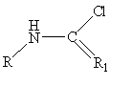  R= alkyl, aryl  R₁ = O, S | We modified the original profiler to allow R linked to any other atom.
Alpha-halogenated aldehydes/ketones or thioaldehydes/thio-ketones | 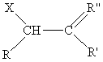  R, R’ = H, alkyl, arylalkyl or aryl group  R" = O, S | We modified the original profiler to allow R, R' linked to any other atom.
Aromatic amines | 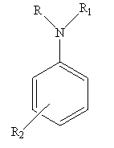  R and R₁ = H or aliphatic chain  R₂ = any | The original profiler does not cover tertiary amines. We modified it to cover tertiary amines.
Aziridines | 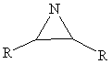  R = H or alkyl | The original profiler can cover only aziridines in which both Rs are alkyl. We modified it to allow H as R.
Benzyl halides | 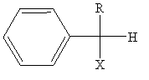  R = alkyl, arylalkyl or aryl  X = halo (F, Cl, Br, I) or -OSO₂  Compounds with good leaving group at alpha position of an aromatic bond belong to this group. | In the definition, H is not included in R. However, we modified it to add H in R.
Disulfides | 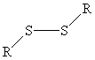  R= alkyl | We modified the original profiler to allow R linked to any other atom.
Epoxides (=oxiranes) | 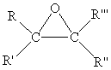  R, R', R'', R''' = H, alkyl, arylalkyl or aryl group | We modified the original profiler to allow R, R', R", R''' linked to any other atom.
Esters including acrylic and methacrylic esters | 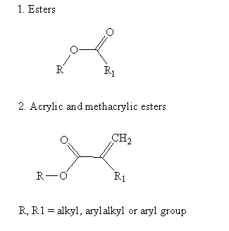 | The original profiler does not cover esters in which R has different functional groups (e.g. –OH). We modified it to allow R linked to any other atom.
Halogenated alkanes | R = aliphatic  Hal = F, Cl, Br | We modified the original profiler to allow R linked to any other atom.
Lactones | 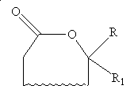  R, R₁ = H, alkyl, arylalkyl or aryl group | We modified the original profiler to allow ring with other functional groups.
Organic silicon halides | R, R₁, R₂ can be any kind of groups  Hal = F, Cl, Br or I | We modified the original profiler to cover di- and tri- halogens.
Primary and secondary aliphatic amines | 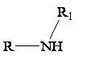  Primary, secondary R and R₁ = H and /or aliphatic chain or non-aromatic ring | The original profiler does not cover primary and secondary amines in which R has different functional groups. We modified it to cover these chemicals (e.g., diamine).
Silicon ether (alkoxysilanes) | 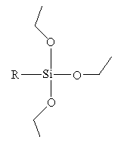  R can be any kind of group  Some alkoxysilanes hydrolyse rapidly when getting in contact with water, the resulting metabolite may cause only mild skin irritation. | We modified the original profiler to allow R linked to any other atom. We also included methoxysilane into this category.
Silicon ethers (alkoxysilanes) with alpha keton groups | 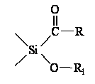  R and R₁ can be any kind of group | We modified the original profiler to allow R linked to any other atom.
Substituted dihalogen-benzoic acids | 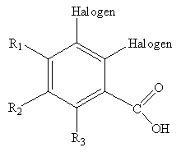  R₁-₃ = Halogen (F, Cl, Br or I) or alkyl (aliphatic chain) | The original one does not cover cases in which R₁, R₂ or R₃ is a halogen. We modified it to cover these chemicals.
* Etje Hulzebos, John D. Walker, Ingrid Gerner, and Kerstin Schlegel, Use of structural alerts to develop rules for identifying chemical substances with skin irritation or skin corrosion potential, QSAR Comb. Sci. 24 (2005) pp. 332-342

