The second ACTRIS inter-comparison (2016) for Aerosol Chemical Speciation Monitors (ACSM): Calibration protocols and instrument performance evaluations.

Evelyn FRENEY1*, Yunjiang ZHANG2,3, Philip CROTEAU4, Tanguy AMODEO2, Leah WILLIAMS4, François TRUONG3, Jean-Eudes PETIT3, Jean SCIARE5, Roland SARDA-ESTEVE3, Nicolas BONNAIRE3, Tarvo ARUMAE6, Minna AURELA7, Aikaterini BOUGIATIOTI8, Nikolaos MIHALOPOULOS8, Esther COZ9, Begoña ARTINANO9,Vincent CRENN3¥, Thomas ELSTE10, Liine HEIKKINEN11, Laurent POULAIN12, Alfred WIEDENSOHLER12, Hartmut HERRMANN12, Max PRIESTMAN13, Andres ALASTUEY14, Iasonas STAVROULAS5, Anna TOBLER15, Jeni VASILESCU16, Nicola ZANCA17, Manjula CANAGARATNA3, Claudio CARBONE17, Harald FLENTJE10, David GREEN13, Marek MAASIKMETS6, Luminita MARMUREANU16, Maria Cruz MINGUILLON14, Andre S.H. PREVOT15, Valerie GROS3, John JAYNE4, Olivier FAVEZ2

*1 Laboratoire de Météorologie Physique (LaMP), Aubiere France*

*2 Institut National de l’Environnement Industriel et des Risques (INERIS), Verneuil-en-Halatte, FranceFrance*

*3 Laboratoire des Sciences du Climat et de l’Environnement(LSCE), CNRS-CEA-UVSQ, Gif-sur-Yvette, France*

*4‘Aerodyne Research, Inc., Billerica, Massachusetts, USA*

*5 The Cyprus Institute, Environment Energy and Water Research Center, Nicosia, Cyprus*

*6 Estonian Environmental Research Center (EERC), Tallinn, Estonia*

*7 Finnish meteorological institute (FMI), Helsinki, Finland*

*8 IERSD, National Observatory of Athens, Athens Greece*

*9 Centre for Energy, Environment and Technology Research (CIEMAT), Department of the Environment, Madrid, Spain*

*10 Deutscher Wetterdienst, Meteorologisches Observatorium Hohenpeißenberg, Hohenpeißenberg, Germany*

*11 Institute for Atmospheric and Earth System Research (INAR)/Physics, Faculty of Science, University of Helsinki, Finland*

*12 Leibniz Institute for Tropospheric Research, Leipzig, Germany*

*13 Environmental Research Group, MRC-HPA Centre for Environment and Health, King’s College London, London, UK*

*14 Institute of Environmental Assessment and Water Research (IDAEA-CSIC), Barcelona, Spain*

*15 Laboratory of Atmospheric Chemistry, Paul Scherrer Institute, Villigen PSI, Switzerland*

*16 National Institute of R&D for Optoelectronics (INOE), Ilfov, Romania*

*17 Proambiente S.c.r.l., CNR Research Area, Bologna, Italy*

¥*now at ADDAIR, 189 rue Audemars, BP 70207, 78530 BUC, France*

*\*Contact: evelyn.freney@uca.fr*

**Supplementary material**

**Table S1: Calibration factors for each instrument in both Jump Scan (JS) and Full Scan (FS) mode. The RF NO3 is calculated using the FS calibration mode.**

|  |  |  |  |  |  |
| --- | --- | --- | --- | --- | --- |
| Int. No | RF NO3 (10-11)  amps/μg m-3 | RIE SO4 JS | RIE SO4 FS | RIENH4 JS | RIE NH4 FS |
| 1 | 5.49 | 0.47 | 0.86 | 5.68 | 4.9 |
| 2 | 3.39 | 0.93 | 1.4 | 4.55 | 4.2 |
| 3 | 7.38 | 0.32 | 0.47 | 5.4 | 3 |
| 4 | 6.97 | 0.97 | 1 | 4.52 | 3.7 |
| 5 | 3.76 | 0.59 | 1.09 | 5.1 | 2.9 |
| 6 | 2.83 | 0.57 | 0.84 | 4.81 | 4.9 |
| 7 | 3.07 | 0.81 | 1.2 | 8.26 | 7.5 |
| 8 | 4.59 | 0.44 | 0.48 | 8.26 | 7.2 |
| 9 | 3.01 | 0.49 | 0.68 | 5.19 | 5 |
| 10 | 6.97 | 0.74 | 1.05 | 5.61 | 5.6 |
| 11 | 3.34 | 0.44 | 0.62 | 7.42 | 7.6 |
| 12 | 4.65 | 0.58 | 1.04 | 6.13 | 5.7 |
| 13 | 4.03 | 0.41 | 0.71 | 5.52 | 4.6 |
| 14 | 3.15 | 0.58 | 0.85 | 4.7 | 4.6 |
| 15 | 2.93 | 0.4 | 0.56 | 5.98 | 4.9 |

# Supplementary figures:



**Figure S1: PM1 concentrations compared between a) PILS + OM (Sunset) against TEOM PM1 mass concentrations and b) fractional aerosol composition determined from the PILS + OCEC instrument.**



**Figure S2. a) 72-hour air mass back trajectories calculated using HYSPLIT and displayed using the ZeFir toolkit; color scale represents the trajectory density (with higher values meaning a higher occurrence), b) temperature and relative humidity, and c) wind speed and direction during the post intercomparison period.**



**Figure S3: Temporal coverage of the 15 instruments that participated in the post calibration intercomparison period.**

  
**Figure S4: Composition dependent collection efficiency (CDCE) calculated for each instrument (using RIE values from the FS mode) participating in the intercomparison campaign using the parameterization in Middlebrook et al. (2012).**



**Figure S5. Comparison of NO3 concentrations measured by each instrument with median NO3 concentration calculated from the combined 15 instruments. Slopes values vary ±0.15. The center dotted line represents a 1:1 relationship. The two outer dotted lines represent +/- 30%. Fits are orthogonal fits and are not forced through 0.**



**Figure S6. Comparison of SO4 concentrations measured by each instrument with median SO4 concentration calculated from the combined 15 instruments. Slopes values vary ± 0.40. The center dotted line represents a 1:1 relationship. The two outer dotted lines represent +/- 30%. Fits are orthogonal fits and are not forced through 0.**



**Figure S7. Comparison of NH4 concentrations measured by each instrument with median NH4 concentration calculated from the combined 15 instruments. Slopes values vary ± 0.40. The center dotted line represents a 1:1 relationship. The two outer dotted lines represent +/- 30%.** **Fits are orthogonal fits and are not forced through 0.**



**Figure S8. Comparison of Org concentrations measured by each instrument with median Org concentration calculated from the combined 15 instruments, analyzed using the standard fragmentation table. Slopes values vary ± 0.30. The center dotted line represents a 1:1 relationship. The two outer dotted lines represent +/- 30%. Fits are orthogonal fits and are not forced through 0.**

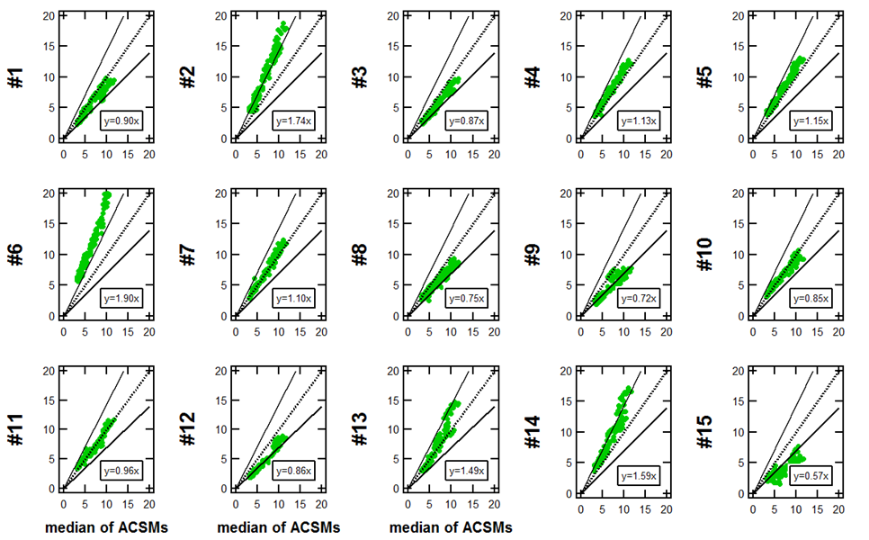

**Figure S9. Comparison of Org concentrations measured by each instrument with median Org concentration calculated from the combined 15 instruments after fragmentation table correction following Pieber et al. (2016). Slopes values vary ± 0.50. The center dotted line represents a 1:1 relationship. The two outer dotted lines represent +/- 30%. Fits are orthogonal fits and are not forced through 0.**



**Figure S10. Z-scores of the prominent fragments and b) Average *f44* vs *f43* concentrations for all participating instruments with the default fragmentation table with the Pieber correction applied.**



**Figure S11. Comparison of Org concentrations measured by each instrument with median Org concentration calculated from the combined 15 instruments after using a time varying correction based on NO3_MF in Eq. 2. Slopes values vary ± 0.3.**