**Supplemental Information**

Utilization of converter off-gas based on a chemical-looping combustion process

Yongjian Wua, Chunhuan Luoa,b, Xiuli Zhangc, Xiaoming Zhengc, Tanjin Zhua, Qingquan Sua,d,*

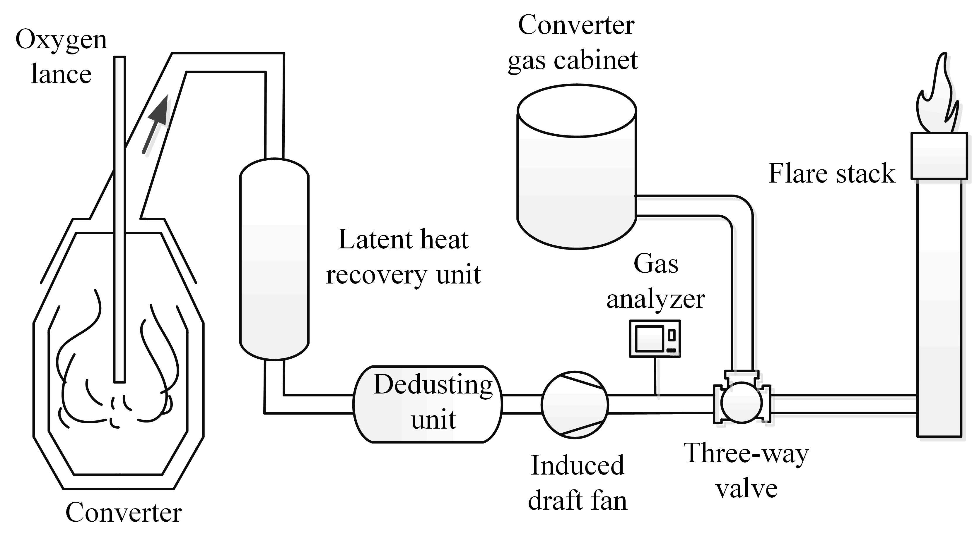

**Figure S1.** Schematic of a typical converter gas recovery process.

**1. Error and uncertainty analysis**

The experimental errors were mainly due to the accuracy and stability of flowrates of the simulating converter off-gas, and the concentration measurements of each component in the outlet gas during redox reactions. Gas mass flow controllers (MFCs, Beijing HORIBA METRON Instruments Co., Ltd.) were used to regulate flowrates of the simulating converter off-gas, and the accuracy and repeatability precision for MFCs were ±1.0% F.S and ±0.2 % F.S, respectively. A gas chromatograph (GC6820, Agilent Technology) equipped with a thermal conductivity detector (TCD) was used to analyze the gas volume concentrations, and the lowest detectable limit was 0.01 vol. %. The calibrating gas contained 10.10 vol.% CO, 49.90 vol.% CO2, 1.50 vol.% O2 and 38.50 vol.% N2, and the analysis method showed excellent linearity and accuracy.

For all the performance evaluations of the redox reactions, repeatability verification experiments were carried out for three times. For example, the repeatability verification experiments results for the reduction reaction of CuO/Al2O3 with 10% CO/CO2 at 300 ℃ in Figure 4 in the manuscript are shown in the following Table S1 and Figure S2.

**Table S1.** Repeatability experiments for the reduction reaction at 300 ℃ in Figure 4.

|  |  |  |  |  |  |
| --- | --- | --- | --- | --- | --- |
| Reaction time (min) | Outlet CO concentration (%) | | | | |
| 1st | 2nd | 3rd | Mean | Standard deviation |
| 0 | 0 | 0 | 0 | 0 | 0 |
| 2 | 0 | 0 | 0 | 0 | 0 |
| 5 | 0 | 0 | 0 | 0 | 0 |
| 8 | 0 | 0 | 0 | 0 | 0 |
| 11 | 0.87 | 0.78 | 0.90 | 0.85 | 0.06 |
| 14 | 3.81 | 3.73 | 3.86 | 3.80 | 0.07 |
| 17 | 7.43 | 7.35 | 7.52 | 7.43 | 0.08 |
| 20 | 9.75 | 9.84 | 9.87 | 9.82 | 0.06 |

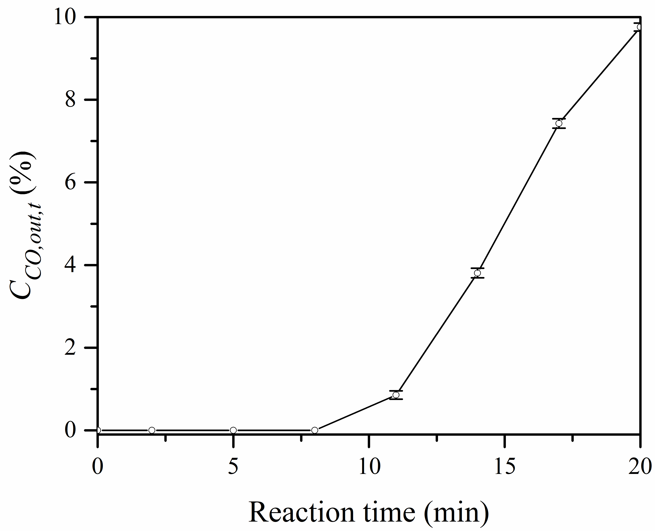

**Figure S2.**  with error bar versus reaction time in the repeatability experiments for the reduction reactions of CuO/Al2O3 with a simulating converter off-gas at 2000 h-1.

As shown in Table S1 and Figure S2, the results showed that the experiments had excellent repeatability.

|  |  |
| --- | --- |
| Figure 8a | Figure 8b |

**Figure S3.** (a) and versus reaction time at 250 ℃; (b) versus temperature for CuO/Al2O3 with 2% O2 and without O2 in the converter off-gas.

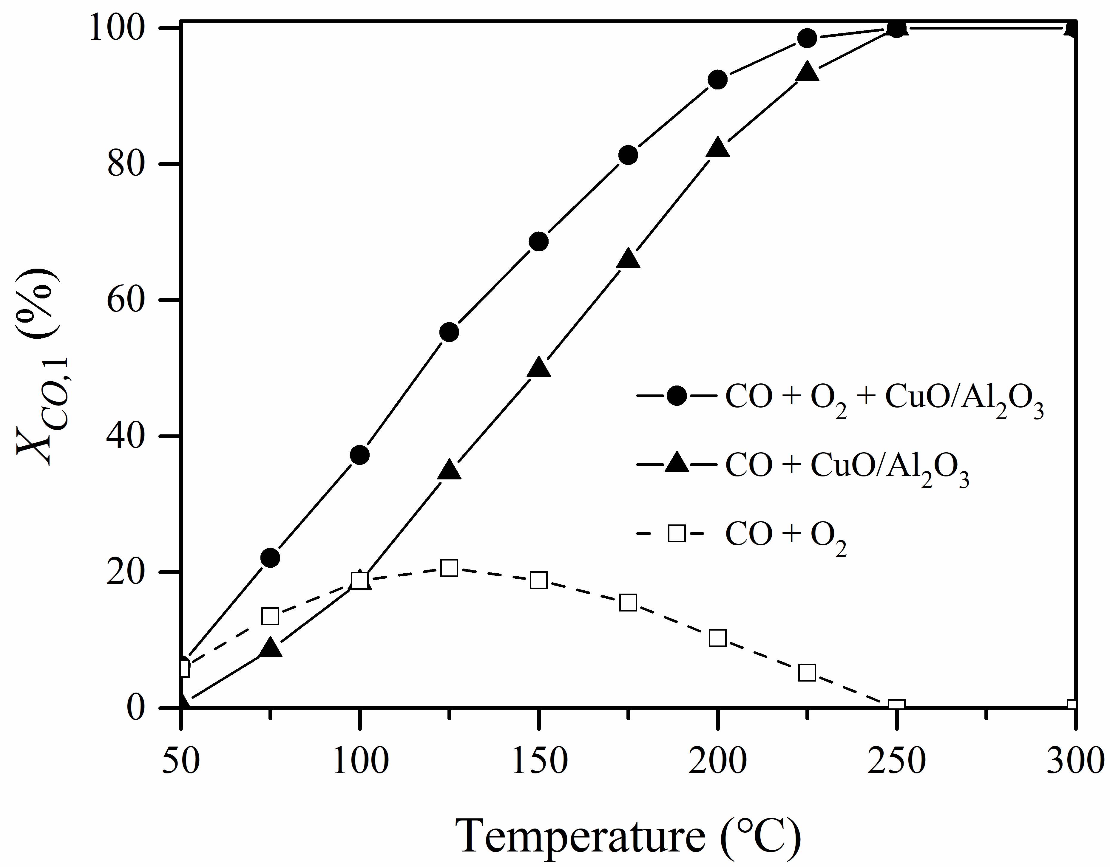

**Figure S4.** versus temperature for CuO/Al2O3 with 2% O2 and without O2

in the converter off-gas.

**2. Influence of O2 on the reduction performance of CuO/Al2O3**

Considering that a small amount of O2 is simultaneously contained in the converter off-gas, further experiments were carried out over CuO/Al2O3 with a simulating off-gas containing 2% O2, 10% CO, and 88% CO2, at 2000 h-1 and 100-400 °C. The results are shown in Figure 8.

As shown in Figure S3a, the outlet CO concentration with 2% O2 was lower than that without O2,  was prolonged from 9 min without O2 to 17 min with 2% O2, and  increased from 66.0% without O2 to 71.7% with 2% O2. Moreover, from Figure S3b, the lowest temperature required for  longer than 2 min could be reduced from 225 ℃ without O2 to 150 ℃ with 2% O2. Thus,

When the converter off-gas contains O2, the combustion of CO could include not only the chemical-looping combustion reaction between CO and CuO (reaction 1), but also the direct catalytic combustion reaction between CO and O2 (reaction 7). The contributions of reaction (1) and (7) to the combustion of CO were further discussed. Figure S4 shows the comparison of  between the reaction of CuO/Al2O3 with an off-gas containing 10% CO, 90% CO2 and the reaction of CuO/Al2O3 with an off-gas containing 10% CO, 2% O2, 88% CO2 at 2000 h-1 and 50-300 ℃.

|  |  |  |
| --- | --- | --- |
| CuO + CO = Cu + CO2 | = -129.24 kJ/mol | (1) |
| CO + 0.5 O2 = CO2 | = -283.64 kJ/mol | (**7**) |

In Figure S4, if the curve ● and the curve **▲** overlap, it means that the catalytic reaction (7) did not occur and there was no contribution of catalytic combustion, and if the curve ●is on the left side of the curve ▲, it means the catalytic reaction (7) and the chemical-looping combustion reaction (1) occurred simultaneously. In this case, the CO conversion (curve □) based on the catalytic reaction (7) could be obtained by subtracting the value of  on the curve **▲** from the value of  on the curve ●at the same temperature.

It can be seen that the CO conversion based on the catalytic combustion reaction (7) was greater than that based on the chemical-looping combustion reaction (1) when the temperature was below 100 ℃, while the CO conversion based on the chemical-looping combustion reaction (1) was greater than that based on the catalytic combustion reaction (7) when the temperature was above 100 ℃. Thus, when the converter off-gas contained O2, the combustion of the converter off-gas over CuO/Al2O3 included both the chemical-looping combustion mechanism and catalytic combustion mechanism, whereas the chemical-looping combustion mechanism was dominant when the reaction temperature was higher than 100 ℃.