Support Information of manuscript
Catalytic CO₂-MEA absorptions with the aid of CaCO₃, MgCO₃ and BaCO₃ in the batch and semi-batch processes
Theory:
- The proposed mechanism of heterogeneous catalysis on solid surface:
We completed the Figure of proposed mechanism of heterogeneous catalysis of CO₂-MEA with 4 elementary steps. The mechanism is similar to the Eley-Rideal model of Gas-Solid absorption. The mechanism study will be conducted in the near future.
Fig. S1 Proposed mechanism of catalytic carbamate formation for MEA: Eley-Rideal Model.
Table 1 (manuscript) listed the proposed elementary steps (E1 to E4) of the catalytic CO₂ – amine absorption with aid of catalysts, where (*) represents the active sites on the surface.
Table 1. The elementary steps of catalytic CO₂ absorption
Elementary Steps | Reaction Scheme | Description
E1 | RNH₂ + (*) RNH_{2(*)} | Amine adsorption
E2 | RNH_{2(*)} + CO₂ RNH₂⁺-COO⁻_{(*)} | Zwitterion formation
E3 | RNH₂⁺-COO⁻_{(*)} + RNH₂ RNH₂⁺-COO⁻_{(*)} + RNH₃⁺ | Carbamate formation
E4 | RNH₂⁺-COO⁻_{(*)} RNH₂⁺-COO⁻ + (*) | Carbamate desorption

The brief reaction mechanism of catalytic absorption from Table 1: 4 steps
The MEA molecules were pre-adsorbed onto the solid surface via amine adsorption (E1). Then, when CO₂ was approaching the solid surface, it reacts with MEA (RNH₂) via N-C bond formation and generate Zwitterion (E2). Later on, the Zwitterion transfer a proton to other MEA or water to generate Carbamate (E3) and release heat. The released reaction heat facilitated the desorption of Carbamate apart from the solid surface (E4).

Experiments:
- The AAD% analysis of Chittick analysis:
The value of 2.5% is a typical AAD% of the Chittck apparatus. The CO₂ was released out of the loaded amine solutions by titration, and then collected and measured properly.
Typically, the CO₂ loading (α) was calculated with the equation below:
α = $\frac{VCO2}{24.45 C V} \frac{{10}^{-3} ml gas}{\frac{L}{mol gas} {10}^{-3} mol Amine }$ (24.45 is L/mol for ideal gas at 298K)
The titration method is highly accurate, with an AAD% of 0.2%, which is negligible.
Then, the calculation of CO₂ loading was based on the CO₂ gas collected in the apparatus. The gas for each test is around 10~50 ±0.5 ml. The minimum measurement of gas volume is 1 ml, the deviation is around ±0.5 ml. Under experiments, we pipette many 2 ml samples for analysis, the volume of CO₂ is within 20-50 ml. We considered 20 ml CO₂ was collected in the apparatus as maximum error.
The AAD% is calculated below:
AAD% = 0.5 / 20.0 * 100% = 2.5 %.

- The picture of semi-batch process of CO₂ absorber with catalytic packing.
This is the real process, corresponding to Fig 1 B.
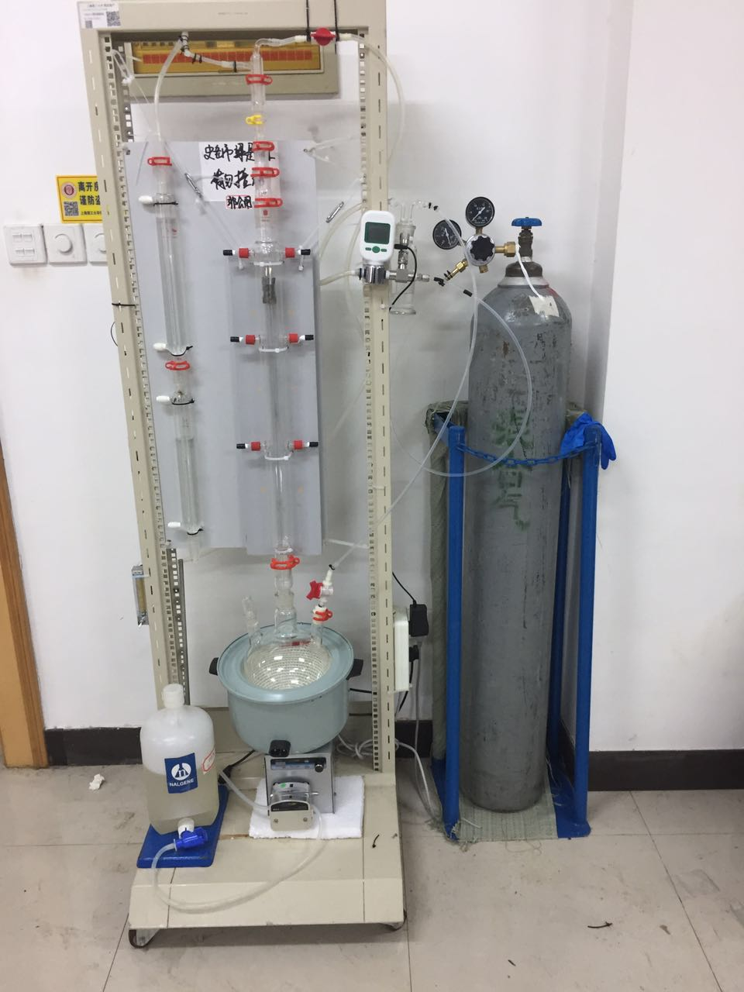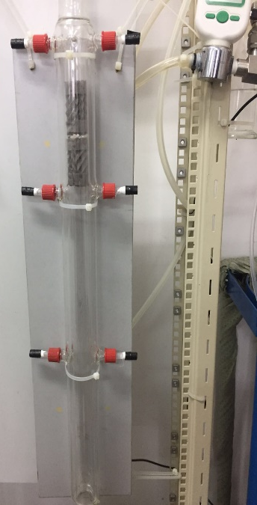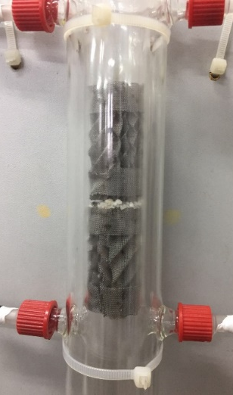

- The size of pelletized solid and balls of catalysts:
From the photos below, these solids were pelletized at size on 2-3mm first, and then wrapped into several balls with similar sizes, and then they are suspended onto the gas-liquid interface. The intersection area of two solid balls are about 9.05 cm² (2.4 cm diameter each). The uncertainty is estimated to be around 0.1 cm (~ 4%).
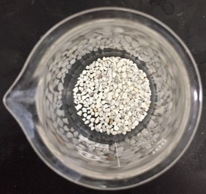
The solid chemicals were also paved into one layer of two structured packing materials in the absorber of Semi-Batch Process. The size was also 2-3 mm, same as that in batch process.
Results: Summary of CO₂ absorption profiles in a batch process.
- The summarized Table S1 of absorption profiles Fig 3-5.
Table S1. The overall time period of CO₂ absorption with different catalysts.
1M MEA | Reaction time period (min)
 | Types of Catalyst
Mass of Catalyst (g) | MgCO₃ | CaCO₃ | BaCO₃
0 | 14.0 | 14.0 | 14.0
5 | 9.0 | 12.0 | 13.0
10 | 8.5 | 9.0 | 12.0
15 | 7.0 | 8.0 | 11.0
20 | 8.0 | 7.0 | 10.0
25 |  |  | 8.0
Overall reduction of time % | 50.0% | 50.0% | 42.9%
3M MEA | Reaction time period (min)
 | Types of Catalyst
Mass of Catalyst (g) | MgCO₃ | CaCO₃ | BaCO₃
0 | 38.0 | 38.0 | 38.0
5 | 32.0 | 32.0 | 32.0
10 | 29.0 | 29.0 | 30.0
15 | 24.5 | 25.0 | 29.0
20 | 24.0 | 23.0 | 26.0
25 |  | 26.0 | 24.0
Overall reduction of time % | 36.8% | 39.5% | 36.8%
5M MEA | Reaction time period (min)
 | Types of Catalyst
Mass of Catalyst (g) | MgCO₃ | CaCO₃ | BaCO₃
0 | 47.0 | 47.0 | 47.0
5 | 42.0 | 40.0 | 40.0
10 | 40.0 | 37.0 | 38.0
15 | 38.0 | 35.0 | 37.0
20 | 39.0 | 31.9 | 35.0
25 |  | 35.0 | 34.5
Overall reduction of time % | 19.1% | 31.9% | 26.6%

