**SUPPORTING INFORMATION**

**4-​Amino-3-pentadecyl-3*H*-​1,​2,​4-​triazole-​3-​thiones and 3-pentadecyl-1,3,4-oxadiazole-2(3*H*)-thione for the preparation of dimeric palladium(II) complexes and their applications in Tsuji-Trost and Mizoroki-Heck reactions**

Manel Chehrouri,a Adil Ali Othman,a* Samuel Jiménez-Cecilia,b Cristina Moreno-Cabrerizo,b and José M. Sansano,*b

*aLaboratoire de Synthèse Organique Bioactive, Département de Chimie Organique Industrielle, Faculté de Chimie, Université des Sciences et de la Technologie d’Oran, Mohamed Boudiaf-USTO-MB, BP. 1505, El-M’naouer, 31003 Oran, Algeria.*

*bDepartamento de Química Orgánica, Centro de Innovación en Química Avanzada (ORFEO-CINQA), Instituto de Síntesis Orgánica (ISO). Facultad de Ciencias, Universidad de Alicante, 03080-Alicante, Spain.*

* Adil Ali Othman: [adelaliothman@gmail.com](mailto:adelaliothman@gmail.com); José M. Sansano: [jmsansano@ua.es](mailto:jmsansano@ua.es)

**Table of contents**

1. **General S1**
2. **Synthesis of heterocycles 1 and 2 S2**
3. **Synthesis of the palladium complexes 3a-d S3**
4. **Synthesis of Tsuji-Trost product 6 S4**
5. **Synthesis of Mizoroki-Heck product [(*E*)-stilbene 9]. S5**
6. **NMR Spectra S6**
7. **ESI experiments of complexes 3a, 3b, 3c and 3b S12**
8. **References S13**

**1. General**

Melting points were determined with a Marienfeld melting point meter (MPM-H2) apparatus and are uncorrected. For flash chromatography, silica gel 60 (40-60 µm) was employed. 1H NMR (300, 400 MHz or 500 MHz) and 13C NMR (75, 101 or 126 MHz) spectra were recorded using Bruker AV300, Bruker AV400 and Bruker ADVANCE DRX500, respectively, with CDCl3 as solvent and TMS as internal standard and chemical shifts are given in ppm. Low-resolution electron impact (GC-EI) mass spectra were obtained at 70 eV using an Agilent 6890N Network GC system and Agilent 5973Network Mass Selective Detector.High-resolution mass spectra (HRMS) were also carried out in the electron impact mode (EI) at 70 eV using a Finnigan VG Platform or a Finnigan MAT 95S.Analytical TLC was performed using ALUGRAM® Xtra SIL G/UV254 silica gel plates, and the spots were determined under UV light (λ=254 nm). Microanalyses were performed in a Thermo Finnigan Flash 1112 Series and Micro TruSpec of LECO equipments. Microwave irradiation experiments were performed in a CEM-Discover reactor operating at 50 W.

**2. Synthesis of heterocycles 1 and 2[1]**

Following the reported procedures, to a solution of palmitic acid (5.57g, 20 mmol) in methanol (50 ml),H2SO4 (concentrated 98% w/w, 1.5 mL)was added dropwise and the mixture was refluxed for 5h. The mixture was cooled down and a saturated solution of NaHCO3 was added to pH = 7. Then, the resulting aqueous solution was washed with dichloromethane (3 x 20 mL) and the organic phase was dried, evaporated under vacuum and the residue was used in the next step without purification. Colourless oil (5.13g, 88% yield). IR, υmax (cm-1 ):2915, 2843, 1739cm-1).1H-NMR, δH (ppm): 3.66 (s, 3H, COOCH3), 2.30 (t, 2H, CH2COO); 1.62 (m, 2H, CH2CH2COO), 1.28 (m, 24H, 12xCH2), 0.88 (t,*J* = 7.8 Hz, 3H, CH3). 13C-NMR, δC(ppm): 174.13 (CO), 51.4 (COOCH3), 34.2-22.8 (14xCH2), 14.1 (CH3). MS(DIP) *m/z*: 270(M+, 100%).HRMS required for C17H34O2requires: 270.2559; found: 270.2555.

Next, a solution of methyl palmitate (4’90 g, 10 mmol) in methanol (30 ml)was placed in a pressure flask and hydrazine hydrate (99%, 4 ml, 82 mmol) was added. The resulting mixture was allowed to reach a temperature of 130°C for 4h. The mixture was cooled to room temperature and the solvent and volatile substances were evaporated under vacuum. The resulting crude compound was recrystallized from ethanol affording the expected hydrazide (4.5g, 92% yield). Mp = 110 °C. IR, υmax(cm-1): 3315, 3289, 2918, 2848; 1627. 1H-NMRδH (ppm): 6.84 (s, 1H, NH), 3.74(s, 2H, NH2), 2.14 (deform. t,*J* =7.5 Hz, CH2CONH), 1.62 (m, 2H, CH2CH2CO), 1.37-1.21 (m, 24H, 12xCH2), 0.87 (t,*J* 7.8 Hz, 3H, CH3). 13C-NMR,δC (ppm): 174.1 (CO), 34.16-22.74 (14xCH2), 13.9 (CH3). MS (DIP) *m/z*: 270 (M+, 50%).HRMS required for C16H34N2O requires: 270.2671; found: 270.2675.

**4-Amino-5-pentadecyl-3,4-dihydro-2*H*-(1,2,4)triazol-3-tiol (1)**

To a solution of palmitic hydrazide (1.5g, 4 mmol) in ethanol (10 ml) and potassium hydroxide (225 mg, 4.1 mmol) carbon disulphide (5 ml, 80 mmol) was added dropwise. The mixture was stirred at room temperature for 18 h. Then, dry diethyl ether was added (20 mL) and a precipitate was formed, which was washed with diethyl ether. The resulting potassium salt was dissolved in water (30 ml) and hydrazine hydrate was added (7ml, 100 mmol) and the mixture was refluxed for 16h. Then, the solution was allowed to reach room temperature and hydrochloric acid was added to acid pH. A white precipitate appeared and it was filtered and washed with water. After recrystallization from cyclohexane/acetone a white powder was obtained (1.33g, 74% yield). Mp = 65°C. IR, υmax (cm-1): 3311, 3239, 2915-2849, 2622, 1570. 1H-NMRδH (ppm): 4.66 (s, 2H, NH2), 2.75 (t, *J* = 8.0 Hz, 2H, CH2), 1.73 (m, 2H, CH2), 1.25-1.42 (m, 24H, 12xCH2), 0.88 (t, *J* = 7.5 Hz, 3H, CH3).13C-NMR, δC (ppm): 166.1 (CS), 153.5 (N=C-N), 31.9-22.6 (14xCH2), 13’9 (CH3). MS (DIP) *m/z*: 326(M+, 6%). HRMS required for C17H34N4Srequires:326.2504; found: 326.2505.

**5-Pentadecyl-3*H*-(1,3,4)-oxadiazol-2-thione (2)**

A solution of palmitic hydrazide (0.91 g, 3.36 mmol) in EtOH was slowly added to another solution containing KOH (0.29 g, 5.0 mmol) dissolved in the minimum amount of water with EtOH (10 ml).Carbon disulphide (6 ml, 100 mmol) was added dropwise at room temperature and the reflux is maintained for 24 h. Ice was added followed by hydrochloric acid to get acid pH.A white precipitate appeared and it was filtered, dried and recrystallized in EtOH/H2O obtaining pure heterocycle (0.92g, 89% yield). Mp = 60°C from EtOH/H2O. IR,υmax (cm-1): 3141, 2915-2849, 1618, 1176. 1H-NMR,δH (ppm): 11.31 (s, 1H, NH), 2.71 (t, *J* = 7.8 Hz, 2H, CH2), 1.74 (m, 2H, CH2); 1.26-1.40 (m, 24H, CH2), 0.88 (t, *J* = 7.5 MHz,3H, CH3).13C-NMR, δC (ppm): 164.9 (N=CO), 32.2-22.7 (14xCH2), 14.4 (CH3). MS (DIP) *m/z*: 312 (M+, 34%).HRMS required for C17H32N2OSrequires: 312.2235; found: 312.2239.

**3. Synthesis of the palladium complexes 3a-d**

Palladium complexes were generated *in situ* using the same procedure. The ligand **1** or **2** (0.011mol) were dissolved in chloroform (5 mL) and added to a suspension of the corresponding palladium salt [Pd(OAc)2 or K2PdCl4][2] (0.01 mol) in chloroform (10 ml). The mixture was stirred for 24 h at room temperature. The mixture was evaporated and complexes were employed without any further purification. Spectroscopic and physical data follows:



**Table 1.** Microanalysis of the palladium complexes obtained in this work.

|  |  |  |  |
| --- | --- | --- | --- |
| Sample | Observed (%) | Theoretical (%) | Compositiona |
| **3a** | C: 55.50  H: 8.35  N: 14.55  S: 8.85 | C: 53.91  H: 8.78  N: 14.79  S: 8.46 | C34H66N8PdS2 |
| **3b** | C: 45.15  H: 7.10  Cl: 8.15  N: 11.45  S: 6.50 | C: 44.68  H: 7.12  Cl: 7.58  N: 11.99  S: 6.86 | C34H66Cl2N8Pd2S2 |
| **3c** | C: 56.30  H: 8.15  N: 7.75  S: 8.40 | C: 55.98  H: 8.57  N: 7.68  S: 8.79 | C34H62N4O2PdS2 |
| **3d** | C: 46.20  H: 7.05  Cl: 8.85  N: 5.90  S: 6.80 | C: 45.4  H: 6.89  Cl: 7.82  N: 6.18  S: 7.07 | C34H62Cl2N4O2Pd2S2 |

a Structure drawn according to the closer observed and theoretical values. Complexes were washed with metanol/water and dried under *vacuo*. For these experiments a 1:1 heterocycle:palladium salt ratio was used.

|  |  |  |  |  |  |
| --- | --- | --- | --- | --- | --- |
| Complex | Mp(°C) | IRsignals (cm-1) | | | |
| υ(NH, NH2) | υ(C-SH) | υ(C=N) | (C=S) |
| **3a** | ˃300 | 3152 | - | 1542 | - |
| **3b** | ˃300 | 3136 | 2622 | 1692 | - |
| **3c** | ˃300 | - | - | 1779 | 1185 |
| **3d** | 281 | ----- | - | 1598 | 1186 |

|  |  |  |  |  |  |  |
| --- | --- | --- | --- | --- | --- | --- |
| Complex | 1H-NMR (δH, ppm) | | 13C-NMR (δC, ppm) | | | |
| N-H, | S-H | C=S | C-SH | N=C-O | N-C=N |
| **3a** | - | - | - | 180.81 | - | 167.12 |
| **3b** | - | - | - | 177.08 | - | 167.03 |
| **3c** | - | - | 175.48 | - | - | - |
| **3d** | - | - | 173.43 | - | 167.86 | - |

MS data for **3a**

ESI (*m/z*): 940[L2Pd2(H2O)2MeCN-H+]

MS data for **3b**

ESI (*m/z*): 935 (L2Pd2Cl2)

MS data for **3c**.

ESI (*m/z*): 936.6 [L2Pd2H2O(MeCN)2]

MS data for **3d**.

ESI (*m/z*): 916(L2Pd2Cl2·MeCN-CH2-CH3+1)

**4. Synthesis of Tsuji-Trost product 6.**

Method A: Cinnamyl acetate (40 mg, 0.2 mmol), morpholine(35 mg, 0.4 mmol) K2CO3 (55.2 mg, 0.4 mmol), complex**3a** or **3b** (0.004 mmol, 2 mol%), and PPh3 (2.1 mg, 0.008 mmol, 4mol%) were suspended in dry MeCN (1 mL, 0.2M) in a pressure tube for 1 h. The mixture was heated at 110 ºC in a sand bath for 19 h. Water was added (5 mL) and it was extracted with ethyl acetate (3x5 mL). The organic solvent was dried, filtered, evaporated and purified by column chromatography.

Method B: Cinnamyl acetate (40 mg, 0.2 mmol), morpholine (35 mg, 0.4 mmol) K2CO3 (55.2 mg, 0.4 mmol), complex**3a** or **3b** (0.004 mmol, 2 mol%), and PPh3 (2.1 mg, 0.008 mmol, 4mol%) were suspended in dry MeCN (1 mL, 0.2M). The mixture was heated at 100 ºC in the microwave oven at 50W for 1 h. Water was added (5 mL) and it was extracted with ethyl acetate (3x5 mL). The organic solvent was dried, filtered, evaporated and purified by column chromatography.

**4-[(2*E*)-3-Phenylprop-2-en-1-yl]morpholine or 4-cinnamylmorpholine (6):[3]**IR, υmax (cm-1): 2853, 1451, 1116 .1H-NMR, (400 MHz, CDCl3) δH (ppm): 7.42–7.19 (m, 5H, ArH), 6.55 (d, *J* = 15.9 Hz, 1H, C=CHPh), 6.27 (dt, *J* = 15.8, 6.8 Hz, 1H, C=C*H*CH), 3.76 (dd, *J*=4Hz, 4H, 2xCH2O), 3.19 (dd, *J* = 6.9, 1.2 Hz, 4H, C=CCH2N), 2.55 (m, 4H, 2xNCH2). 13C-NMR (101 MHz, CDCl3) δC: 52.6 (2xNCH2), 60.4 (C=CNCH2), 65.8 (2xCH2O), 124.4, 125.5 (HC=CH), 126.8, 127.7, 133.0, 135.2 (ArC).MS (DIP) *m/z*: 203 (M+, 100%). HRMS required for C13H17NOrequires:203.1310; found: 203.1313.

**5. Synthesis of Mizoroki-Heck product [(*E*)-stilbene 9].[4]**

Iodobenzene (41 mg, 0.2 mmol), styrene (21 mg, 0.2mmol) K2CO3 (55.2 mg, 0.4 mmol), complex**3a** or **3b** (0.004 mmol, 2 mol%), and PPh3 (2.1 mg, 0.008 mmol, 4mol%) were suspended in toluene (3 mL) in a pressure tube. The mixture was heated at 110 ºC in a sand bath for 24 h. Water was added (5 mL) and it was extracted with ethyl acetate (3x5 mL). The organic solvent was dried, filtered, evaporated and purified by column chromatography.

**[(*E*)-stilbene 9].** IR, υmax (cm-1): 2803, 1425, 1123. 1H-NMR, (400 MHz, CDCl3) δH (ppm): 7.51 (deform. dd, *J* = 8.0, 1.5 Hz, 4H, ArH), 7.35 (dt, *J* = 8.0, 1.5 Hz 4H, ArH), 7.25 (m, 2H, ArH), 7.10 (s, 2H, CH=CH). 13C-NMR (101 MHz, CDCl3) δC: 137.5, 128.8, 128.8, 127.7, 126.7 (HC=CHandArC).MS (GC) *m/z*: 180 (M+, 100%).

**6. NMR Spectra**

**Product 6**





**Product 9**





**Complex 3a**

Complexes **3a**-**3d** were analysed by 1H and 13C NMR obtaining little information from them. Signals of CO groups cannot be distinguished because of the existence of several aggregates in solution.







**Complex 3b**







**Complex 3c**





**Complex 3d**







**7. ESI experiments**

**Complex 3a**

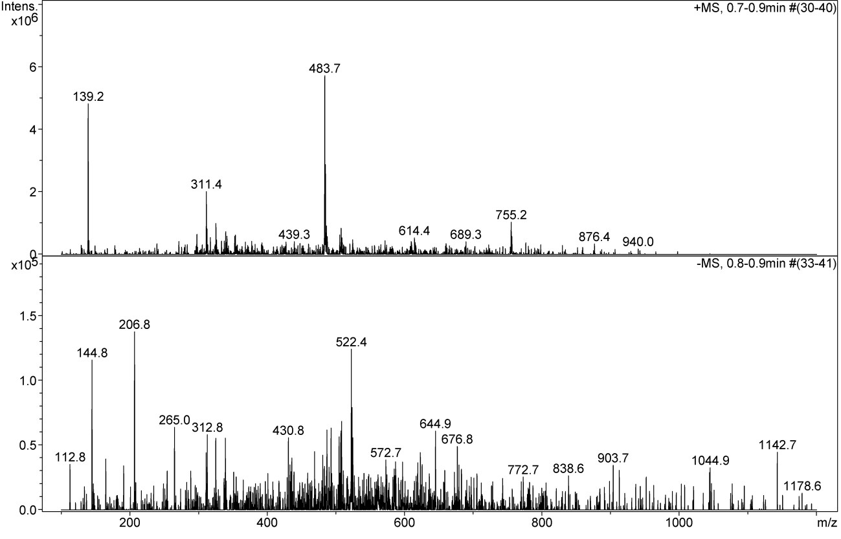

**Complex3b.**

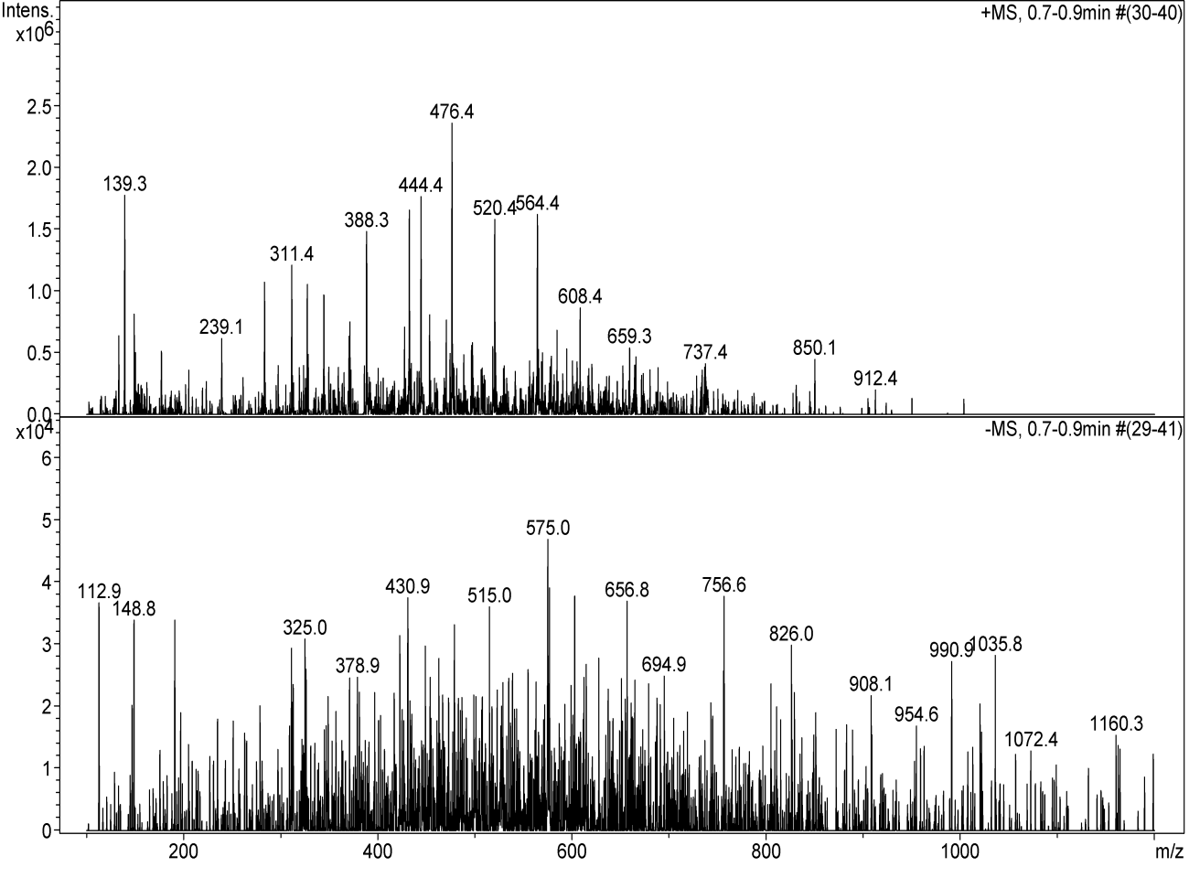

**Complex 3c**

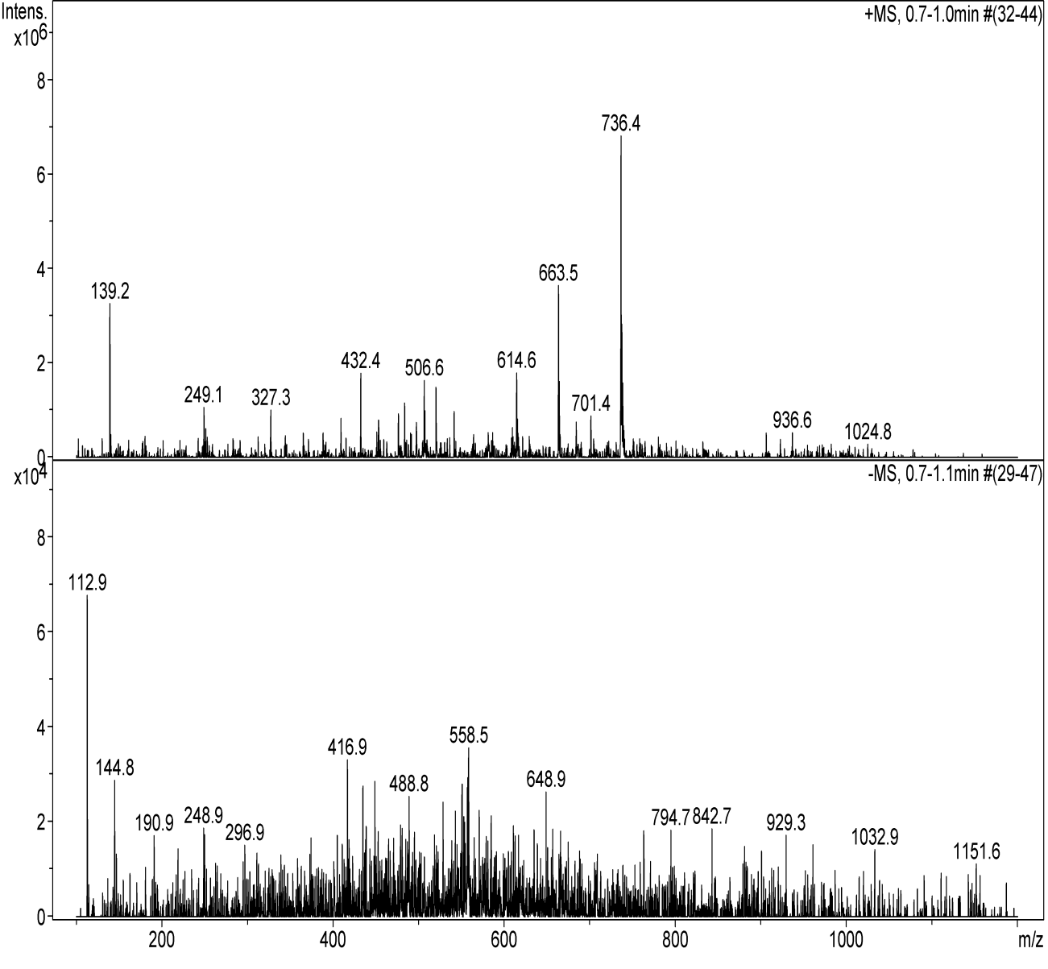

**Complex 3d**

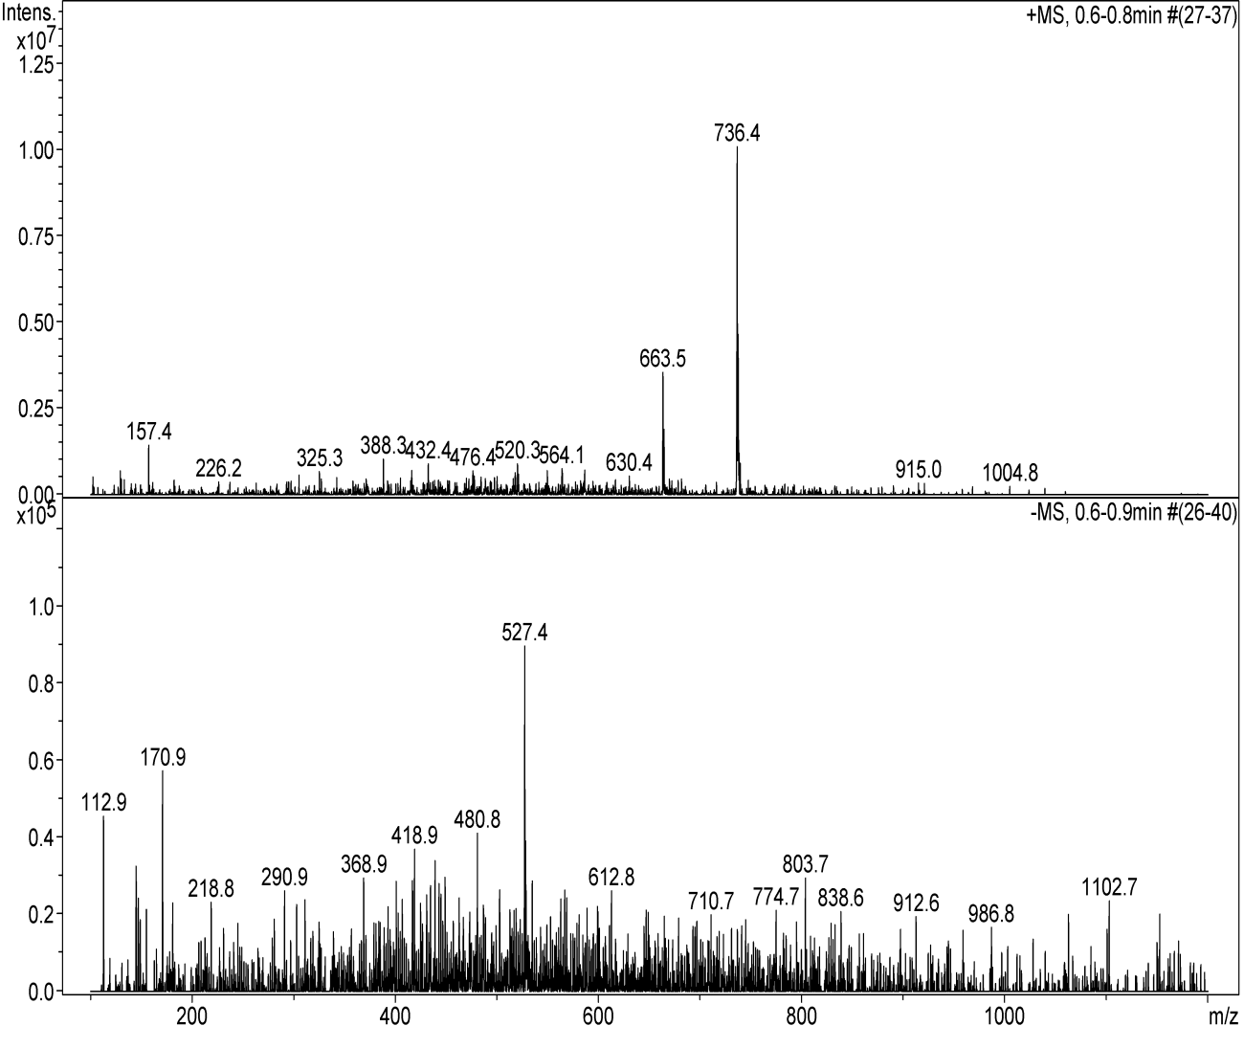

1. **8. References**

   Ahmad, A.; Varshney, H.; Rauf, A.; Sherwani, A.; Owais, M. Synthesis and anticancer activity of long chain substituted 1,3,4-oxadiazol-2-thione, 1,2,4-triazol-3-thione and 1,2,4-triazolo[3,4-b]-1,3,4-thiadiazine derivatives. *Arab. J. Chem.***2014,***10,* S3347-S3357.
2. Nadeem, S.; Rauf, M. K.; Ahmad, S.; Eibahara, M.; Tirmizi, S. A.; Bashir, S. A.; Badshah, A. Synthesis, spectral characterization and antibacterial studies of palladium(II) complexes of heterocyclic thiones. *Transition Met. Chem.***2009,***34* (2), 197-202.
3. a) Billamboz, M.; Mangin, F.; Drillaud, N.; Chevrin-Villette, C.; Banaszak-Léonard, E.; Len, C. *J. Org.Chem.***2013**, *79*, 493-500. b) Cazorla, C.; Billamboz, M.; Bricout, H.; Monflier, E.; Len, C. *Eur. J. Org. Chem*. **2017**, 1078-1085.
4. This compound is commercially available.