Supplementary Material

Article: Acclimation at high temperatures increases the ability of Raphidiopsis raciborskii (Cyanobacteria) to withstand phosphate deficiency and reveals distinct strains responses

Elena F. Galvanese^{1*}, André Andrian Padial¹, Luis Aubriot²

¹ Laboratório de Análise e Síntese em Biodiversidade; Departamento de Botânica. Pós-graduação em Ecologia e Conservação, Universidade Federal do Paraná, Curitiba, PR, Brazil. Av. Cel. Francisco H. dos Santos, s/n, Centro Politécnico, P.O.box 19031, CEP 81531-990.
² Grupo de Ecología y Fisiología de Fitoplancton, Sección Limnología, Facultad de Ciencias, Universidad de la República, Iguá 4255, 11400 Montevideo, Uruguay
*Corresponding author email: elenagalvanese@gmail.com

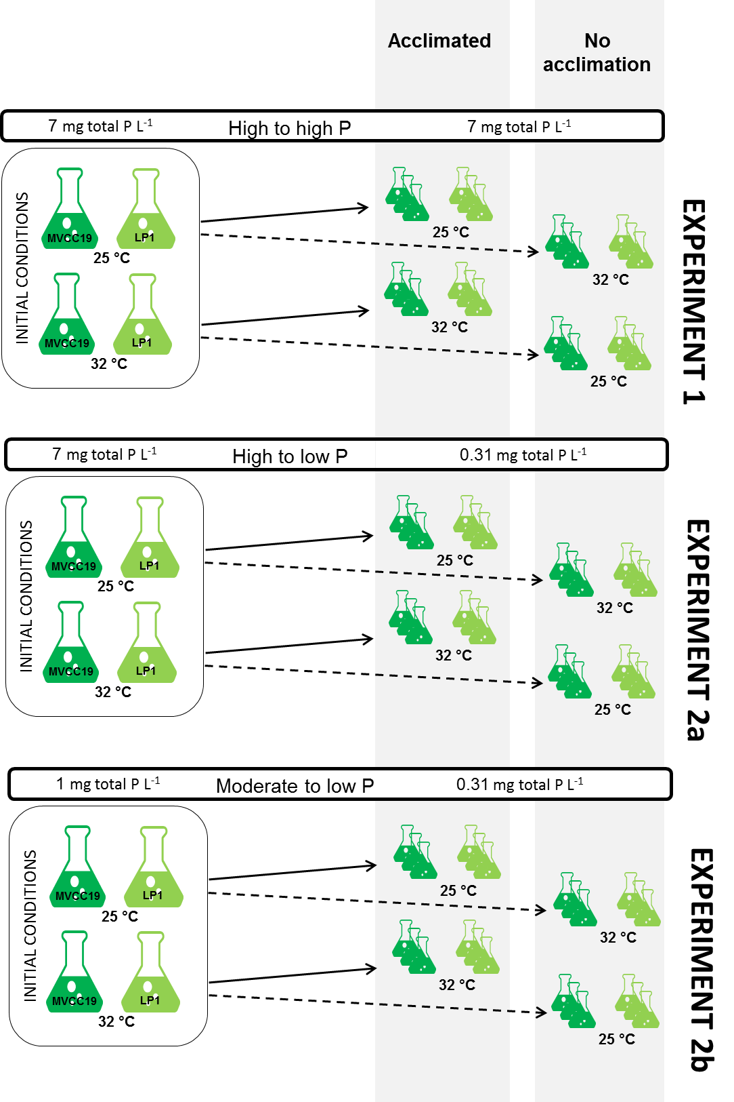
Figure S1. Summary of the experimental design described in Material and Methods.

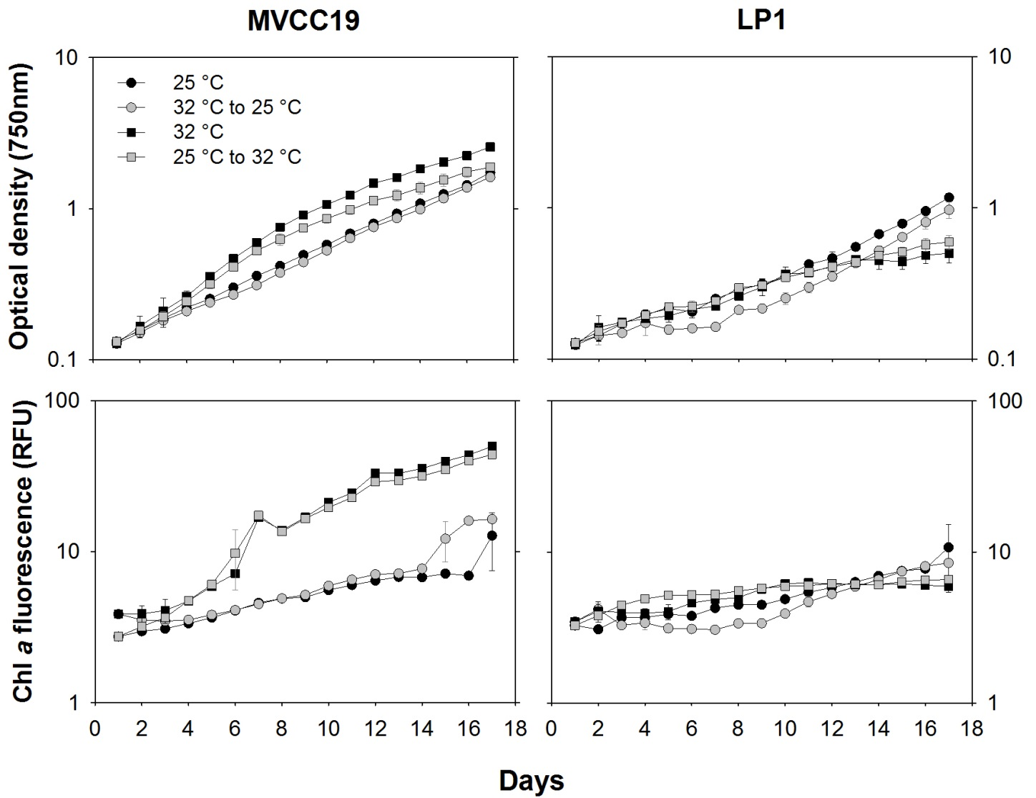

Figure S2. Averaged optical density and in vivo chlorophyll a fluorescence measured during experiment 1 (n=3, ± standard deviation; error bars are smaller than the size of the symbols if not visible). Temperature shifts were performed at time zero.

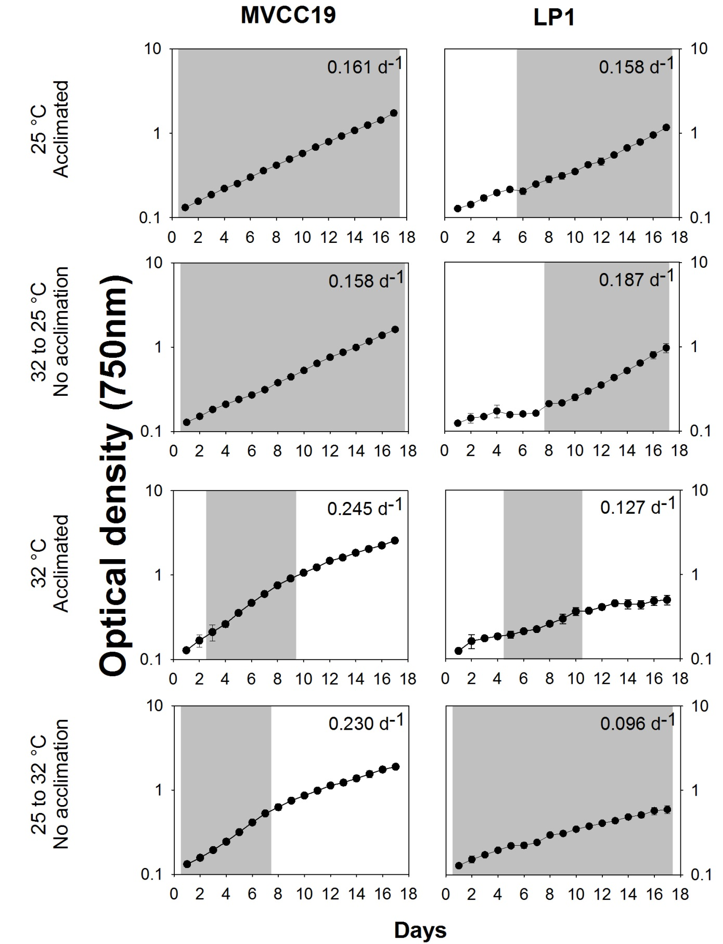
Figure S3. Averaged optical density data of experiment 1 (n=3, ± standard deviation; error bars are smaller than the size of the symbols if not visible). Selected days to the calculus of growth rates comprise the grey area. The selection of days was based on linear regression. Corresponding averaged growth rate is shown.
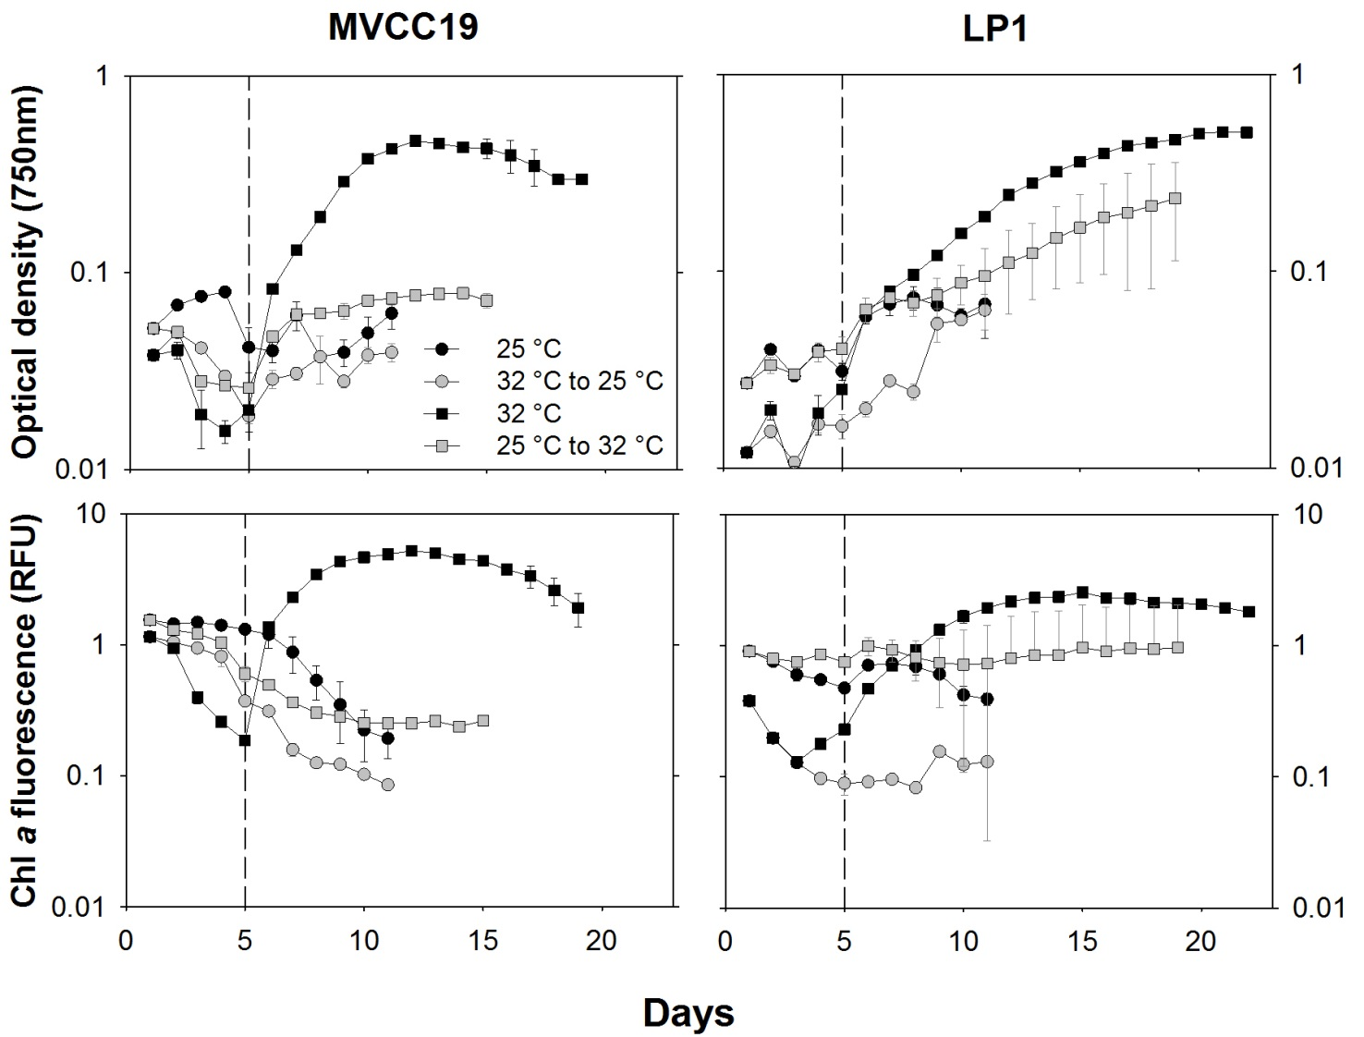
Figure S4. Averaged optical density and in vivo chlorophyll a fluorescence measured during experiment 2a) (n=3, ± standard deviation; error bars are smaller than the size of the symbols if not visible). The dashed line separates the data before and after the 1:1 growth medium renewal. Temperature shifts were performed at time zero.

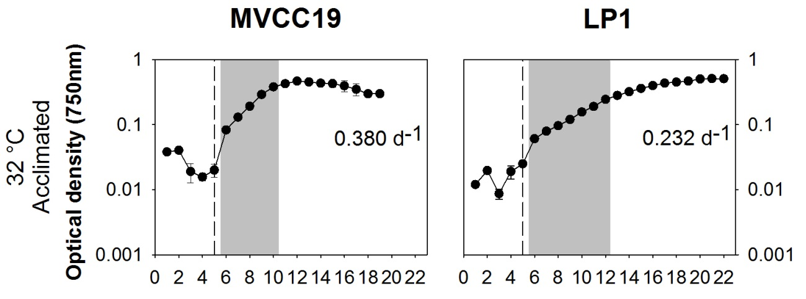

Figure S5. Averaged optical density data of experiment 2a) (n=3, ± standard deviation; error bars are smaller than the size of the symbols if not visible). Selected days to the calculus of growth rates comprise the grey area. The selection of days was based on linear regression. Corresponding averaged growth rate is shown. The dashed line separates the data before and after the 1:1 growth medium renewal.

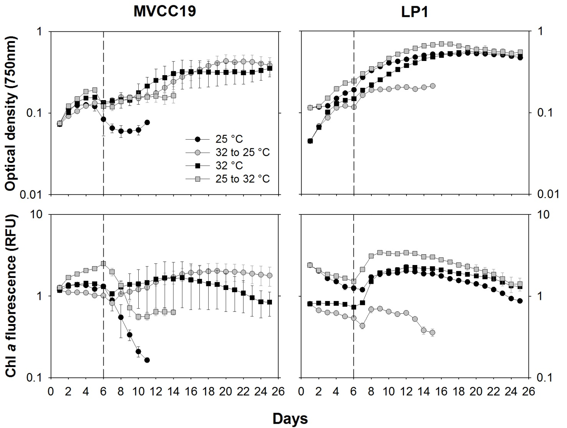
Figure S6. Averaged optical density and in vivo chlorophyll a fluorescence measured during experiment 2b) (n=3, ± standard deviation; error bars are smaller than the size of the symbols if not visible). The dashed line separates the data before and after the 1:1 growth medium renewal. Temperature shifts were performed at time zero.

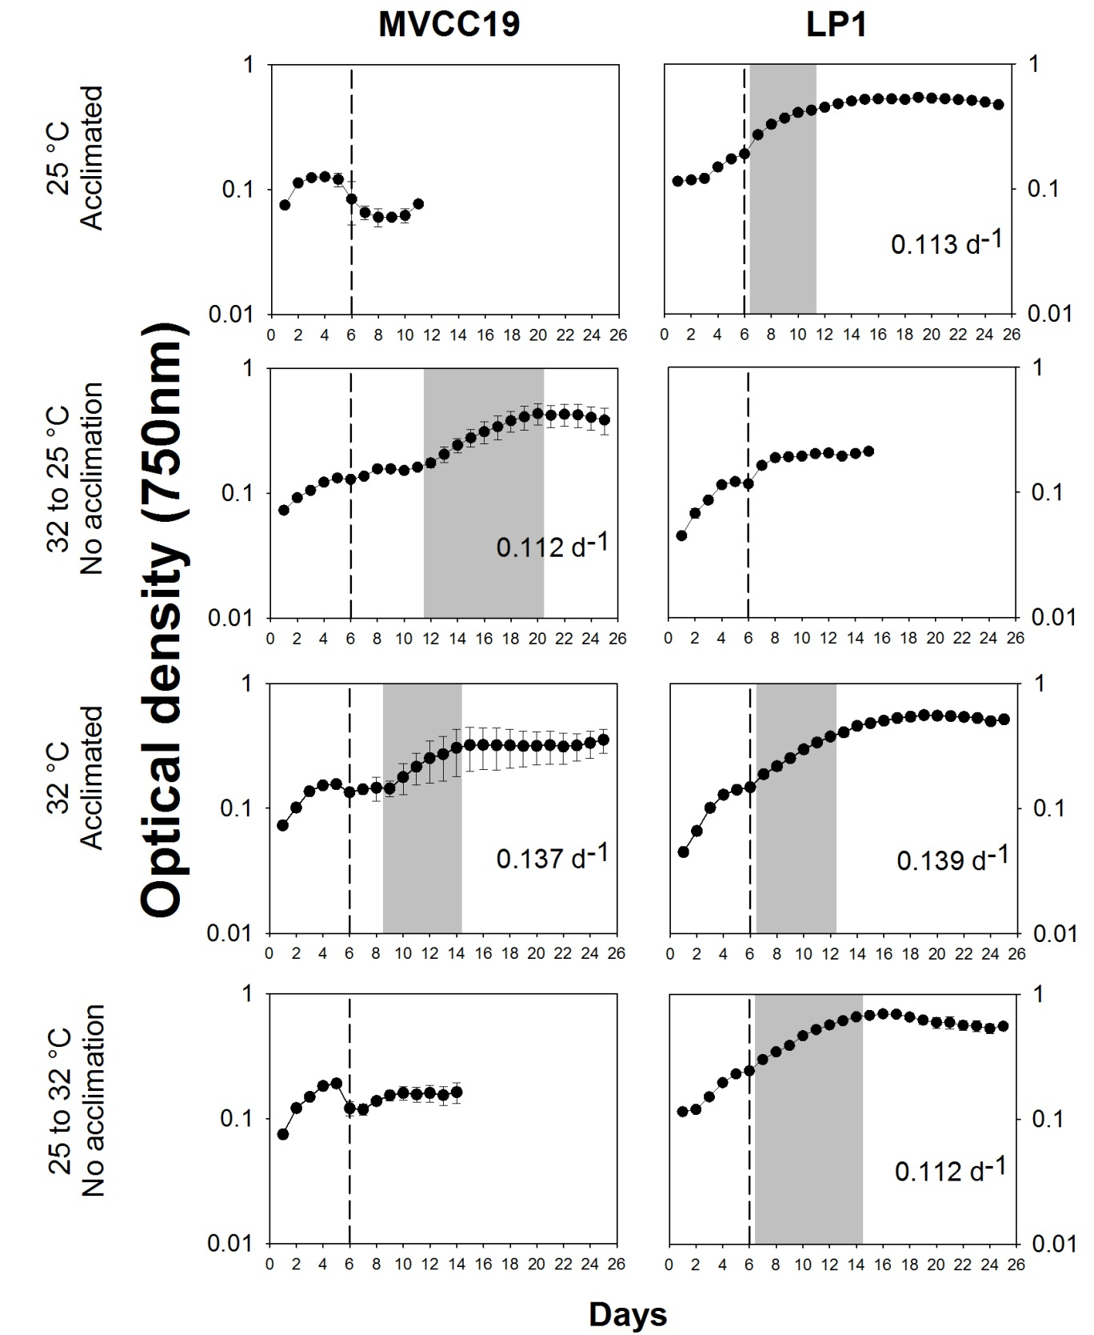
Figure S7. Averaged optical density data of experiment 2b) (n=3, ± standard deviation; error bars are smaller than the size of the symbols if not visible). Selected days to the calculus of growth rates comprise the grey area. The selection of days was based on linear regression. Corresponding averaged growth rate is shown. The dashed line separates the data before and after the 1:1 growth medium renewal.

