**BIOACTIVE HETERO BIMETALLIC Ni(II)/Zn(II) COMPLEXES WITH COMPARTMENTAL SCHIFF BASES AND TRIPHENYLPHOSPHINE AS CO-LIGAND: SYNTHESIS, CHARACTERIZATION AND THERMAL DECOMPOSITION**

S. JONE KIRUBAVATHY*, S. CHITRA, V. PRAVEENA, M. G. PRAVEENA,

R. PUNITHA RAGAVI, S. PRIYANKA

Department of Chemistry, P. S. G. R. Krishnammal College for Women, Coimbatore, India.

**Table: S.I-1: Weight percentage distribution of the elements of bimetallic complexes**

|  |  |  |  |  |  |  |
| --- | --- | --- | --- | --- | --- | --- |
| **Complex** | **% C** | | **%Ni** | | **%Zn** | |
| **Calcd** | **observed** | **Calcd** | **Observed** | **Calcd** | **Observed** |
| NiZnC22H14N4S2O2PPh3 | 27.01 | 27.38 | 6.8 | 6.38 | 11.45 | 11.11 |
| NiZnC26H16N4S2O2PPh3 | 29.11 | 29.80 | 6.51 | 6.43 | 11.32 | 11.23 |

**Table:S.I-2: FT-IR stretching bands of the complexes in cm-1**

|  |  |  |  |
| --- | --- | --- | --- |
| **Complex** | **C=N** | **C-O** | **N=C=S** |
| Ni(SCN)2(PPh3)2 | - | - | 2075 |
| NiZnC22H14N4S2O2PPh3 | 1600 | 1189 | 2074 |
| NiZnC26H16N4S2O2PPh3 | 1598 | 1163 | 2076 |

**Fig. S.I-1: FT-IR Spectrum of Complex 1**

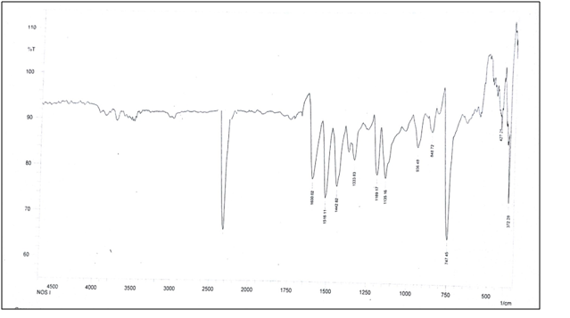



**Fig.S.I-2: FT-IR Spectrum of Complex 2**

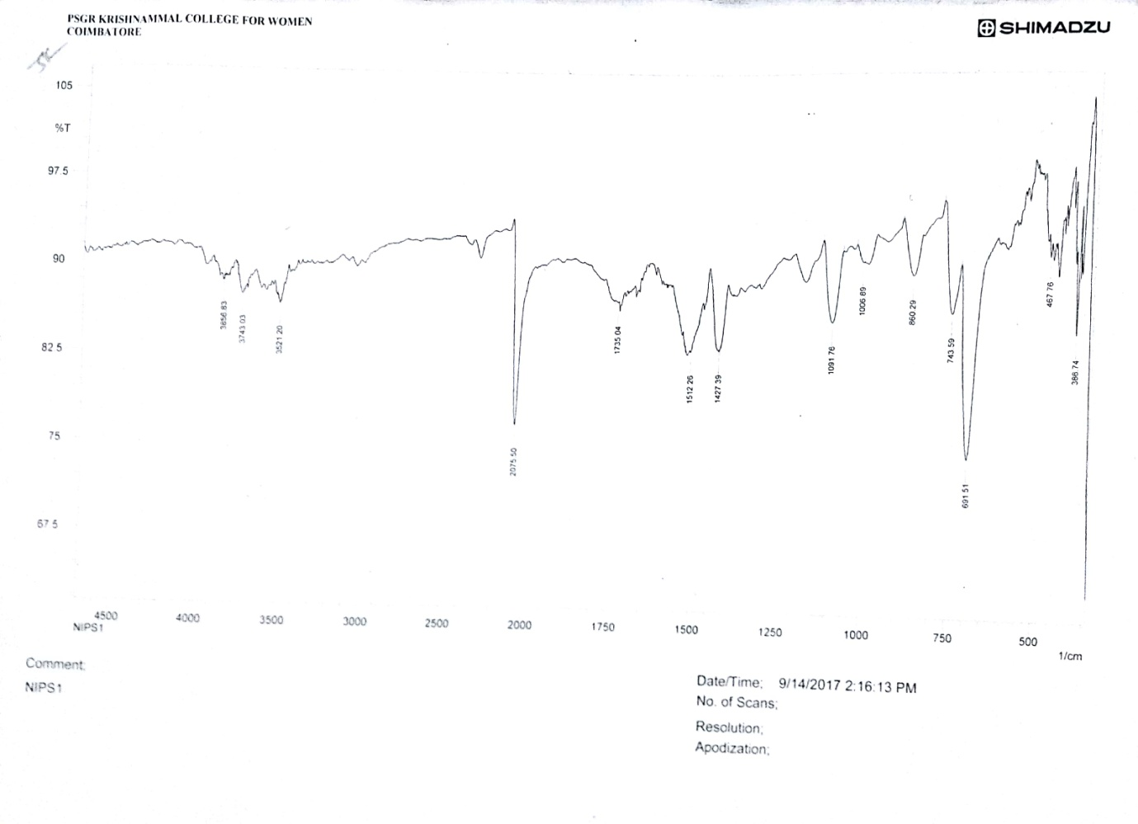

**Fig.SI. 3: Zone of Inhibition in mm for Staphyococcus aureus**

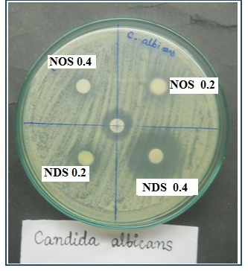

**Staphyococcus aureus**

**Fig.SI. 4: Zone of Inhibition in mm for K. Pneumonia**

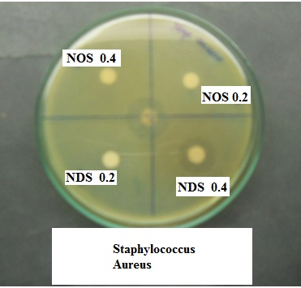

***K. pneumonia***